**Tab 1**

|  | **MINISTRY OF EDUCATION AND TRAINING** |
| --- | --- |

**FPT UNIVERSITY**

CAPSTONE PROJECT REPORT

Application to Support Group Formation and Capstone Thesis Development for Information Technology Students at FPT University

| **SEP490.3** | |
| --- | --- |
| **Group Member** | * Lê Minh Vương - QE170148 **(Leader)** * Đinh Quốc Chương - QE170097 * Hồ Trọng Nghĩa - QE170173 * Nguyễn Thị Thúy - QE170033 * Hứa Đức Bình - QE170217 |
| **Supervisor** | * Nguyễn Thị Cẩm Hương * Nguyễn Thiện Phúc |
| **Capstone Project code** | * SU25QN10 |

**- Quy Nhơn, 05/2025 -**

# Table of Contents

**Table of Contents 1**

**List of Table 9**

**List of Figure 12**

**Acknowledgement 20**

**Definition and Acronyms 21**

**I. Project Introduction 24**

A. Overview 24

1. Project Information 24

2. Project Team 24

a) Supervisor 24

b) Team member 24

B. Product Background 25

C. Business Opportunity 25

1. Overview 25

2. Opportunities 25

D. Software Product Vision 26

1. Goal 26

2. Target Users 26

3. Key Features 26

E. Project Scope & Limitations 26

1. Major Features 26

a) For Admin Role 26

b) For Lecturer / Moderator Role 28

c) For Student Role 29

2. Limitations & Exclusions 31

a) Limitations 31

b) Exclusions 32

**II. Project Management Plan 33**

A. Overview 33

1. Scope & Estimation 33

2. Project Objectives 35

3. Project Risks 35

B. Management Approach 37

1. Project Process 37

2. Quality Management 38

3. Training Plan 38

C. Project Deliverables 39

D. Responsibility Assignments 40

E. Project Communications 42

1. Communication Plan 42

2. External Interface 42

F. Configuration Management 43

1. Document Management 43

2. Source Code Management 43

3. Tools & Infrastructures 44

**III. Software Requirements Specification 45**

A. Product Overview 45

B. User Requirements 47

1. Actors 47

2. Use Cases 50

a. Diagram 50

b. Descriptions 52

C. Functional Requirements 61

1. System Functional Overview 61

a) Website Screen Flow 61

b) Website Screen Descriptions 61

c) Website Screen Authorization 74

d) Non-Screen Functions 79

e) Entity Relationship Diagram 82

2. Website for Students 92

a) Login 92

b) Change password 93

c) Update personal information 95

d) Student Dashboard 96

e) Chatbot 97

f) Join group 99

g) Get suggest member by AI 101

h) Apply Thesis Request 102

i) Get suggest thesis by AI 104

j) Tracking progress 105

3. Website for Lecturer and Moderator 107

a) Login 107

b) Change Password 108

c) Update personal information: 110

d) Dashboard 111

e) Thesis Management: 113

f) Create Thesis 116

g) Request apply Thesis: 118

h) Group Progress 121

i) Group Review 123

j) Moderator Dashboard 127

k) Theses Registration 130

l) Publish Thesis 132

m) Group Management 135

n) Assign Supervisor 137

o) Assign Reviewer 140

p) Checklist Management 143

q) Create Checklist: 146

4. Website for Admin 151

a) Login 151

b) Change Password 152

c) Dashboard 153

d) Student Management 156

e) Create new student (manual && import from excel) 157

f) Group Management 159

g) Assign Student 161

h) Lecturer Management 162

i) Create new lecturer (manual && import from excel) 163

j) Milestone Management 165

k) Capstone Defense Results 168

l) Semester Setting 169

D. Non-Functional Requirements 171

1. External Interfaces 171

a) Authentication & Authorization Service 171

b) Email Notification Service 171

c) AI Recommendation Engine 171

d) Database Service (PostgreSQL/Supabase) 171

e) Client Applications 172

2. Quality Attributes 172

a) Performance 172

b) Scalability 172

c) Reliability & Availability 172

d) Security 173

e) Maintainability 173

f) Usability 173

g) Portability 173

h) Interoperability 174

E. Requirement Appendix 174

1. Business Rules 174

2. System Messages List 184

**IV. Software Design Description 198**

A. System Design 198

1. System Architecture 198

2. Package Diagram 199

a) Backend Package Diagram 199

b) Web Application Package Diagram 200

B. Database design 202

1. Conceptual ERD 202

2. Logical ERD 202

3. Entities Description 203

C. Detail Design 212

1. Authentication Feature 212

a) Class Diagram 212

b) Class Diagram Specification 212

c) Sequence Diagram 217

2. Admin Manage Student Accounts 221

a) Class Diagram 221

b) Class Diagram Specification 221

c) Sequence Diagram 224

3. Admin Manage Lecturer Accounts 229

a) Class Diagram 229

b) Class Diagram Specification 229

c) Sequence Diagram 231

4. Admin Manage Semesters Settings 236

a) Class Diagram 236

b) Class Diagram Specification 236

c) State Diagram 239

d) Sequence Diagram 240

5. Admin Manage Milestones 245

a) Class Diagram 245

b) Class Diagram Specification 245

c) Sequence Diagram 247

6. Admin Generate Reports and Statistics 249

a) Class Diagram 249

b) Class Diagram Specification 249

c) Sequence Diagram 251

7. Admin Update Capstone Defense Results 254

a) Class Diagram 254

b) Class Diagram Specification 254

c) Sequence Diagram 256

8. Lecturer View Dashboard 258

a) Class Diagram 258

b) Class Diagram Specification 258

c) Sequence Diagram 260

9. Lecturer Manage Thesis 262

a) Class Diagram 262

b) Class Diagram Specification 262

c) State Diagram 267

d) Sequence Diagram 267

10. Moderator Review Thesis Registrations 274

a) Class Diagram 274

b) Class Diagram Specification 275

c) Sequence Diagram 276

11. Lecturer Monitor Groups Progress 278

a) Class Diagram 278

b) Class Diagram Specification 278

c) Sequence Diagram 280

12. Lecturer Evaluate and Comment on Submissions 282

a) Class Diagram 282

b) Class Diagram Specification 283

c) Sequence Diagram 285

13. Moderator View Moderator’s Dashboard 288

a) Class Diagram 288

b) Class Diagram Specification 288

c) Sequence Diagram 291

14. Moderator Publish Thesis 292

a) Class Diagram 292

b) Class Diagram Specification 294

c) Sequence Diagram 296

15. Moderator Manage Groups 297

a) Class Diagram 297

b) Class Diagram Specification 297

c) Sequence Diagram 301

16. Moderator Assign Supervision 304

a) Class Diagram 304

b) Class Diagram Specification 305

c) Sequence Diagram 307

17. Moderator Assign Reviewer 309

a) Class Diagram 309

b) Class Diagram Specification 309

c) Sequence Diagram 313

18. Moderator Manage Checklist for each Milestone 315

a) Class Diagram 315

b) Class Diagram Specification 316

c) Sequence Diagram 321

19. Student Discover Suggested Theses (AI-Based) 325

a) Class Diagram 325

b) Class Diagram Specification 325

c) Sequence Diagram 329

20. Student Join Groups 330

a) Class Diagram 330

b) Class Diagram Specification 330

c) Sequence Diagram 335

21. Student Send Request to Apply Thesis 342

a) Class Diagram 342

b) Class Diagram Specification 342

c) Sequence Diagram 348

22. Student Track Progress and Submit Milestones 354

a) Class Diagram 354

b) Class Diagram Specification 355

c) Sequence Diagram 363

23. Student View Group Dashboard 368

a) Class Diagram 368

b) Class Diagram Specification 368

c) Sequence Diagram 374

24. User Manage Personal Account 382

a) Class Diagram 382

b) Class Diagram Specification 382

c) Sequence Diagram 385

25. Admin Create Empty Groups For Student 390

a) Class Diagram 390

b) Class Diagram Specification 390

c) Sequence Diagram 394

26. Supervisor Review Request Apply Thesis 399

a) Class Diagram 399

b) Class Diagram Specification 399

c) Sequence Diagram 403

27. Student Invite Members To Group 407

a) Class Diagram 407

b) Class Diagram Specification 408

c) Sequence Diagram 413

**V. Software Testing Documentation 418**

A. Scope of Testing 418

B. Test Strategy 431

1. Testing Types 431

2. Test Levels 433

3. Supporting Tools 433

C. Test Plan 433

1. Human Resources 433

2. Test Environment 434

3. Test Milestones 434

4. Test Case 434

a) Unit Test Cases 434

b) Test Report 436

**VI. Release Package & User Guides 436**

A. Deliverable Package 436

B. Installation Guides 437

1. System Requirements 437

a) Hardware requirements 437

b) Software requirements 437

2. Installation Instruction 438

a) Backend 438

b) Frontend 439

C. User Manual 439

1. Overview 439

a) Workflow 1: Semester status: Preparing 439

b) Workflow 2: Semester status: Picking 440

c) Workflow 3: Semester status: Ongoing 440

2. Workflow 1 441

a) Role: Admin 441

b) Role: Lecturer 446

c) Role: Moderator 450

d) Role: Student 455

e) Role: Student (Leader) 460

f) Role: Admin 466

3. Workflow 2 468

a) Role: Student (Leader) 468

b) Role: Lecturer (Supervisor) 472

4. Workflow 3 474

a) Role: Admin 474

b) Role: Moderator 475

c) Role: Student (Leader) 479

d) Role: Lecturer 481

e) Role: Admin 483

# 

# List of Table

**Table of Contents 1**

**List of Table 9**

**List of Figure 12**

**Acknowledgement 20**

**Definition and Acronyms 21**

Table - List of Definition and Acronyms word 23

**I. Project Introduction 24**

Table I.A.2.a - Supervisor 24

Table I.A.2.b - Team member 24

Table I.F.1.a - Major Features For Admin Role 28

Table I.F.1.b - Major Features For Moderator / Lecture Role 29

Table I.F.1.c - Major Features For Student Role 31

Table I.F.2.a - Limitations 32

Table I.F.2.b - Exclusions 33

**II. Project Management Plan 33**

Table II.A.1 - Estimation Table 35

Table II.A.2 - Project Risks 37

Table II.B.3 - Training Plan 39

Table II.C - Project Deliverables 40

Table II.D - Responsibility Assignments 42

Table II.E.1 - Project Communications 42

Table II.E.2 - External Interface 43

Table II.F.3 - Tools & Infrastructures 45

**III. Software Requirements Specification 45**

Table III.B.1 - List of actors 50

Table III.B.1.b - Uses case description 61

Table III.C.1.b - Website Screen Description 74

Table III.C.1.c - Website Screen Authorization 79

Table III.C.1.d - Non-Screen Functions Description 82

Table III.C.1.e.(3) - Entities Description 92

Table III.E.1 - Business Rules for System 184

Table III.E.2 - Messages List in System 198

**IV. Software Design Description 198**

Table IV.B.3 - Entities Description 212

Table IV.C.1.b - Authentication Feature Class Diagram Specification 217

Table IV.C.2.b - Admin Manage Student Accounts Class Diagram Specification 223

Table IV.C.3.b - Admin Manage Lecturer Accounts Class Diagram Specification 231

Table IV.C.4.b - Admin Manage Semesters Settings Class Diagram Specification 238

Table IV.C.5.b - Admin Manage Milestones Class Diagram Specification 247

Table IV.C.6.b - Admin Generate Reports and Statistics Class Diagram Specification 251

Table IV.C.7.b - Admin Update Capstone Defense Results Class Diagram Specification 256

Table IV.C.8.b - Lecturer View Dashboard Class Diagram Specification 260

Table IV.C.9.b - Lecturer Manage Thesis Class Diagram Specification 266

Table IV.C.10.b - Moderator Review Thesis Registrations Class Diagram Specification 276

Table IV.C.11.b - Lecturer Monitor Groups Progress Class Diagram Specification 280

Table IV.C.12.b - Lecturer Evaluate and Comment on Submissions Class Diagram Specification 285

Table IV.C.13.b - Moderator View Moderator’s Dashboard Class Diagram Specification 290

Table IV.C.14.b - Moderator Publish Thesis Class Diagram Specification 295

Table IV.C.15.b - Moderator Manage Groups Class Diagram Specification 301

Table IV.C.16.b - Moderator Assign Supervision Class Diagram Specification 306

Table IV.C.17.b - Moderator Assign Reviewer Class Diagram Specification 2140

Table IV.C.18.b - Moderator Manage Checklist for each Milestone Class Diagram Specification 2147

Table IV.C.19.b - Student Discover Suggested Theses Class Diagram Specification 2154

Table IV.C.20.b - Student Join Group Class Diagram Specification 2161

Table IV.C.21.b - Student Send Request to Apply Thesis Class Diagram Specification 2174

Table IV.C.22.b - Student Track Progress and Submit Milestones Class Diagram Specification 2189

Table IV.C.23.b - Student View Group Dashboard Class Diagram Specification 2199

Table IV.C.24.b - User Manage Personal Account Class Diagram Specification 2211

Table IV.C.25.b - Admin Create Empty Groups For Student Class Diagram Specification 2220

Table IV.C.26.b - Supervisor Review Request Apply Thesis Class Diagram Specification 2229

Table IV.C.27.b - Student Invite Members To Group Class Diagram Specification 2239

**V. Software Testing Documentation 2244**

Table V.A - Scope of testing 2257

Table V.B.1 - Testing Types 2259

Table V.B.2 - Test Levels 2259

Table V.B.3 - Supporting Tools 2259

Table V.C.1 - Human Resources 2260

Table V.C.2 - Test Environment 2260

Table V.C.3 - Test Milestones 2260

**VI. Release Package & User Guides 2262**

Table VI.A - Deliverable Package 2263

Table VI.B.1.a - Hardware requirements 2263

Table VI.B1.b - Software requirements 2264

# List of Figure

**Table of Contents 1**

**List of Table 9**

**List of Figure 12**

**Acknowledgement 20**

**Definition and Acronyms 21**

**I. Project Introduction 24**

**II. Project Management Plan 33**

Figure II.B.1 - Project Process 37

**III. Software Requirements Specification 45**

Figure III.A - Project Overview 47

Figure III.B.2.a - Use cases diagram 52

Figure III.C.1.a - Website Screen Flow 61

Figure III.C.1.e.(1) - Conceptual ERD 83

Figure III.C.1.e.(2) - Logical ERD 83

Figure III.C.2.a - Login 93

Figure III.C.2.b - Change password 95

Figure III.C.2.c.(1) - Update personal information 96

Figure III.C.2.c.(2) - Update personal information 96

Figure III.C.2.d - Student Dashboard 97

Figure III.C.2.e - Chatbot 99

Figure III.C.2.f.(1) - Join group 101

Figure III.C.2.f.(2) - Join group 101

Figure III.C.2.g.(1) - Get suggest member by AI 102

Figure III.C.2.g.(2) - Get suggest member by AI 102

Figure III.C.2.h.(1) - Apply Thesis Request 103

Figure III.C.2.h.(2) - Apply Thesis Request 104

Figure III.C.2.i - Get suggest thesis by AI 105

Figure III.C.2.j.(1) - Tracking progress 107

Figure III.C.2.j.(2) - Tracking progress 107

Figure III.C.3.a - Login 108

Figure III.C.3.b - Change Password 110

Figure III.3.c - Update personal information 111

Figure III.3.d.(1) - Dashboard 113

Figure III.3.d.(2) - Dashboard 113

Figure III.3.e - Thesis Managerment 116

Figure III.3.f - Create Thesis 118

Figure III.3.g - Request apply Thesis 121

Figure III.3.h - Group Progress 123

Figure III.3.i.(1) - Group Review 126

Figure III.3.i.(2) - Group Review 126

Figure III.3.i.(3) - Group Review 127

Figure III.3.j - Moderator Dashboard 130

Figure III.3.k - Theses Registration 132

Figure III.3.l - Publish Thesis 135

Figure III.3.m - Group Management 137

Figure III.3.n -Assign Supervisor 140

Figure III.3.o - Assign Reviewer 143

Figure III.3.p - Checklist Management 146

Figure III.3.q.(1) - Create Checklist 150

Figure III.3.q.(2) - Create Checklist 151

Figure III.C.4.a - Login 152

Figure III.C.4.b - Change password 153

Figure III.C.4.c.(1) - Dashboard 155

Figure III.C.4.c.(2) - Dashboard 155

Figure III.C.4.c.(3) - Dashboard 156

Figure III.C.4.c.(4) - Dashboard 156

Figure III.C.4.d - Student Management 157

Figure III.C.4.e.(1) - Create new student (manual && import from excel) 159

Figure III.C.4.e.(2) - Create new student (manual && import from excel) 159

Figure III.C.4.f.(1) - Group Management 160

Figure III.C.4.f.(2) - Group Management 161

Figure III.C.4.g.(1) - Assign Student 162

Figure III.C.4.g.(2) - Assign Student 162

Figure III.C.4.h - Lecturer Management 163

Figure III.C.4.i.(1)- Create new lecturer (manual && import from excel) 165

Figure III.C.4.i.(2) - Create new lecturer (manual && import from excel) 165

Figure III.C.4.j.(1)- Milestone Management 167

Figure III.C.4.j.(2)- Milestone Management 168

Figure III.C.4.k - Capstone Defense Results 169

Figure III.C.4.l - Semester Setting 171

**IV. Software Design Description 198**

Figure IV.A.1 - System Architecture 199

Figure IV.A.2.a - Backend Package Diagram 200

Figure IV.A.2.b - Web Application Package Diagram 202

Figure IV.B.1 - Conceptual ERD 202

Figure IV.B.2 Logical ERD 203

Figure IV.C.1.a - Authentication Feature Class Diagram 212

Figure IV.C.1.c.(1) - Login Sequence Diagram 218

Figure IV.C.1.c.(2) - Logout Sequence Diagram 219

Figure IV.C.1.c.(3) - Forgot & Reset Password Sequence Diagram 221

Figure IV.C.2.a - Admin Manage Student Accounts Class Diagram 221

Figure IV.C.2.c.(1) - Create Student Accounts Sequence Diagram 224

Figure IV.C.2.c.(2) - Import Students Accounts Sequence Diagram 225

Figure IV.C.2.c.(3) - Update Student Accounts Sequence Diagram 226

Figure IV.C.2.c.(4) - Toggle Status Accounts Sequence Diagram 227

Figure IV.C.2.c.(5) - Delete Student Accounts Sequence Diagram 228

Figure IV.C.2.c.(6) - View Student Accounts Sequence Diagram 229

Figure IV.C.3.a - Admin Manage Lecturer Accounts Class Diagram 229

Figure IV.C.3.c.(1) - Create Lecturer Accounts Sequence Diagram 232

Figure IV.C.3.c.(2) - Import Lecturer Accounts Sequence Diagram 233

Figure IV.C.3.c.(3) - Update Lecturer Accounts Sequence Diagram 233

Figure IV.C.3.c.(4) - Toggle Status Lecturer Accounts Sequence Diagram 234

Figure IV.C.3.c.(5) - Delete Lecturer Accounts Sequence Diagram 234

Figure IV.C.3.c.(6) - View Lecturer Accounts Sequence Diagram 236

Figure IV.C.4.a - Admin Manage Semesters Settings Class Diagram 236

Figure IV.C.4.c - Semester State Diagram 240

Figure IV.C.4.d.(1) - Create Semester Sequence Diagram 240

Figure IV.C.4.d.(2) - Update Semester Sequence Diagram 241

Figure IV.C.4.d.(3) - Configure Academic Rules Sequence Diagram 241

Figure IV.C.4.d.(4).(a) - Update Semester Status To Picking Sequence Diagram 242

Figure IV.C.4.d.(4).(b) - Update Semester Status To Ongoing Sequence Diagram 243

Figure IV.C.4.d.(4).(c) - Update Semester Status To End Sequence Diagram 244

Figure IV.C.4.d.(4).(d) - Update Semester Status To Scope Locked Phase Sequence Diagram 245

Figure IV.C.5.a - Admin Manage Milestones Class Diagram 245

Figure IV.C.5.c.(1) - Create Milestone Sequence Diagram 247

Figure IV.C.5.c.(2) - Update Milestone Sequence Diagram 248

Figure IV.C.5.c.(3) - View List Milestones Sequence Diagram 248

Figure IV.C.5.c.(4) - Delete Milestone Sequence Diagram 249

Figure IV.C.6.a - Admin Generate Reports and Statistics Class Diagram 249

Figure IV.C.6.c.(1) - Generate Thesis Registration Report Sequence Diagram 251

Figure IV.C.6.c.(2) - View Supervisor Workload Report Sequence Diagram 252

Figure IV.C.6.c.(3) - View Student Participation Statistics Sequence Diagram 252

Figure IV.C.6.c.(4) - Export Report Sequence Diagram 254

Figure IV.C.7.a - Admin Update Capstone Defense Results Class Diagram 254

Figure IV.C.7.c.(1) - Bulk Update Defense Results Sequence Diagram 256

Figure IV.C.7.c.(2) - Individual Update Defense Results Sequence Diagram 258

Figure IV.C.8.a - Lecturer View Dashboard Class Diagram 258

Figure IV.C.8.c.(1) - View Overall Report Sequence Diagram 261

Figure IV.C.8.c.(2) - View Milestones Timeline Sequence Diagram 261

Figure IV.C.8.c.(3) - View List Of Supervised Groups Sequence Diagram 262

Figure IV.C.9.a - Lecturer Manage Thesis Class Diagram 262

Figure IV.C.9.c - Thesis State Diagram 267

Figure IV.C.9.d.(1) - Create New Thesis Sequence Diagram 268

Figure IV.C.9.d.(2) - Edit Thesis Sequence Diagram 269

Figure IV.C.9.d.(3) - View Thesis Details Sequence Diagram 271

Figure IV.C.9.d.(4) - View Thesis Versions Sequence Diagram 273

Figure IV.C.9.d.(5) - Duplicate thesis Detection Sequence Diagram 274

Figure IV.C.10.a - Moderator Review Thesis Registrations Class Diagram 275

Figure IV.C.10.c.(1) - View Pending Thesis Registrations Sequence Diagram 276

Figure IV.C.10.c.(2) - Review Thesis Sequence Diagram 278

Figure IV.C.11.a - Lecturer Monitor Groups Progress Class Diagram 278

Figure IV.C.11.c.(1) - View Timeline Sequence Diagram 280

Figure IV.C.11.c.(2) - View Deliverables by Milestone Sequence Diagram 281

Figure IV.C.11.c.(3) - View Group Submission Status Sequence Diagram 282

Figure IV.C.12.a - Lecturer Evaluate and Comment on Submissions Class Diagram 283

Figure IV.C.12.c.(1) - Open Submitted Files Sequence Diagram 286

Figure IV.C.12.c.(2) - Load Review Form Sequence Diagram 286

Figure IV.C.12.c.(3) - Submit Review Sequence Diagram 287

Figure IV.C.12.c.(4) - Update Review Sequence Diagram 288

Figure IV.C.13.a - Moderator View Moderator’s Dashboard Class Diagram 288

Figure IV.C.13.c - Moderator View Moderator’s Dashboard Sequence Diagram 292

Figure IV.C.14.a - Moderator Publish Thesis Class Diagram 294

Figure IV.C.14.c - Moderator Publish Thesis Sequence Diagram 297

Figure IV.C.15.a - Moderator Manage Groups Class Diagram 297

Figure IV.C.15.c.(1) - View Current List Groups & Ungrouped Students Sequence Diagram 302

Figure IV.C.15.c.(2) - View Group Details & Assign Student to Group Sequence Diagram 304

Figure IV.C.16.a - Moderator Assign Supervision Class Diagram 305

Figure IV.C.16.c.(1) - View List Supervisor Sequence Diagram 307

Figure IV.C.16.c.(2) - Assign Single Supervisor Sequence Diagram 308

Figure IV.C.16.c.(3) - Remove Supervisor Sequence Diagram 308

Figure IV.C.16.c.(4) - Change Supervisor Sequence Diagram 308

Figure IV.C.16.c.(5) - Bulk Assign Supervisors Sequence Diagram 309

Figure IV.C.17.a - Moderator Assign Reviewer Class Diagram 309

Figure IV.C.17.c.(1) - View Milestone Information Sequence Diagram 313

Figure IV.C.17.c.(2) - Load Submissions by Milestone Sequence Diagram 314

Figure IV.C.17.c.(3) - Get Eligible Reviewers Sequence Diagram 314

Figure IV.C.17.c.(4) - Assign Reviewers Sequence Diagram 315

Figure IV.C.17.c.(5) - Change Reviewer Assignment Sequence Diagram 315

Figure IV.C.18.a - Moderator Manage Checklist for each Milestone Class Diagram 316

Figure IV.C.18.c.(1) - Create New Checklist Sequence Diagram 321

Figure IV.C.18.c.(2) - View Checklist Details Sequence Diagram 322

Figure IV.C.18.c.(3) - Update Checklist Sequence Diagram 322

Figure IV.C.18.c.(4) - Delete Checklist Sequence Diagram 323

Figure IV.C.18.c.(5) - Create Multiple Checklist Items Sequence Diagram 324

Figure IV.C.18.c.(6) - Update Multiple Checklist Items Sequence Diagram 324

Figure IV.C.18.c.(7) - Delete Checklist Item Sequence Diagram 325

Figure IV.C.19.a - Student Discover Suggested Theses Class Diagram 325

Figure IV.C.19.c - Student Discover Suggested Theses Sequence Diagram 330

Figure IV.C.20.a - Student Join Group Class Diagram 330

Figure IV.C.20.c.(1) - Join Existing Group Sequence Diagram 336

Figure IV.C.20.c.(2) - Send Join Request Sequence Diagram 337

Figure IV.C.20.c.(3) - AI Group Suggestions Sequence Diagram 338

Figure IV.C.20.c.(4) - Accept Invitation Sequence Diagram 339

Figure IV.C.20.c.(5) - Cancel Join Request Sequence Diagram 340

Figure IV.C.20.c.(6) - View Group Members Sequence Diagram 342

Figure IV.C.21.a - Student Send Request to Apply Thesis Class Diagram 342

Figure IV.C.21.c.(1) -Send Request Apply Thesis from Thesis List Sequence Diagram 349

Figure IV.C.21.c.(2) - View Thesis Details Sequence Diagram 350

Figure IV.C.21.c.(3) - View Thesis Applications Status Sequence Diagram 351

Figure IV.C.21.c.(4) - Cancel Thesis Application Sequence Diagram 352

Figure IV.C.21.c.(5) - Unpick Thesis Sequence Diagram 354

Figure IV.C.22.a - Student Track Progress and Submit Milestones Class Diagram 355

Figure IV.C.22.c.(1) - View Milestone Deadlines Sequence Diagram 364

Figure IV.C.22.c.(2) - Upload Deliverables Sequence Diagram 365

Figure IV.C.22.c.(3) - View Reviewer Feedback and Checklist Sequence Diagram 366

Figure IV.C.22.c.(4) - View Reviewer for each Milestone Sequence Diagram 367

Figure IV.C.22.c.(5) - Update Milestone Submission Sequence Diagram 368

Figure IV.C.23.a - Student View Group Dashboard Class Diagram 368

Figure IV.C.23.c.(1) - View Group Dashboard Sequence Diagram 374

Figure IV.C.23.c.(2) - Assign Leader Sequence Diagram 375

Figure IV.C.23.c.(3) - Remove Member Sequence Diagram 376

Figure IV.C.23.c.(4) - Leave Group Sequence Diagram 378

Figure IV.C.23.c.(5) - View Thesis Information Sequence Diagram 380

Figure IV.C.23.c.(6) - View Supervisors Information Sequence Diagram 380

Figure IV.C.23.c.(7) - View Progress Overview Sequence Diagram 382

Figure IV.C.24.a - User Manage Personal Account Class Diagram 382

Figure IV.C.24.c.(1) - Student Update Personal Information Sequence Diagram 387

Figure IV.C.24.c.(2) - Lecturer Update Personal Profile Sequence Diagram 387

Figure IV.C.24.c.(3) - Admin Update Account Settings Sequence Diagram 389

Figure IV.C.24.c.(4) - Change Password Sequence Diagram 390

Figure IV.C.25.a - Admin Create Empty Groups For Student Class Diagram 390

Figure IV.C.25.c.(1) - Bulk Create Empty Groups Sequence Diagram 395

Figure IV.C.25.c.(2) - Format Groups Sequence Diagram 396

Figure IV.C.25.c.(3) - Delete Empty Group Sequence Diagram 397

Figure IV.C.25.c.(4) - Assign Student to Group Sequence Diagram 399

Figure IV.C.26.a - Supervisor Review Request Apply Thesis Class Diagram 399

Figure IV.C.26.c.(1) - View List Application Thesis from Groups Sequence Diagram 404

Figure IV.C.26.c.(2) - Approve Request Apply Thesis Sequence Diagram 405

Figure IV.C.26.c.(3) - Reject Request Apply Thesis Sequence Diagram 407

Figure IV.C.27.a - Student Invite Members To Group Class Diagram 408

Figure IV.C.27.c.(1) - AI Suggest Members Sequence Diagram 414

Figure IV.C.27.c.(2) - Send Multiple Invitations Sequence Diagram 415

Figure IV.C.27.c.(3) - Accept Join Request Sequence Diagram 416

Figure IV.C.27.c.(4) - Reject Join Request Sequence Diagram 417

Figure IV.C.27.c.(5) - Cancel Invitation Sequence Diagram 418

**V. Software Testing Documentation 418**

Figure V.C.4.a.(1,2,3) - Unit Test Cases 436

Figure V.C.4.b.(1,2) - Test Report 436

**VI. Release Package & User Guides 436**

Figure VI.C.2.a - Create semester - Step 1 442

Figure VI.C.2.a - Create semester - Step 2 442

Figure VI.C.2.a - Import students & lecturers - Step 1 443

Figure VI.C.2.a - Import students & lecturers - Step 2 444

Figure VI.C.2.a - Import students & lecturers - Step 3 444

Figure VI.C.2.a - Import students & lecturers - Step 4 445

Figure VI.C.2.a - Create empty groups - Step 1 446

Figure VI.C.2.a - Create empty groups - Step 2 446

Figure VI.C.2.b - Create thesis - Step 1 447

Figure VI.C.2.b - Create thesis - Step 2 448

Figure VI.C.2.b - Create thesis - Step 3 448

Figure VI.C.2.b - Submit thesis - Step 1 449

Figure VI.C.2.b - Submit thesis - Step 2 450

Figure VI.C.2.c - Approval / Reject thesis - Step 1 451

Figure VI.C.2.c - Approval / Reject thesis - Step 2 451

Figure VI.C.2.c - Assign supervisors - Step 1 452

Figure VI.C.2.c - Assign supervisors - Step 2 453

Figure VI.C.2.c - Assign supervisors - Step 3 453

Figure VI.C.2.c - Publish thesis - Step 1 454

Figure VI.C.2.c - Publish thesis - Step 2 455

Figure VI.C.2.d - Update profile - Step 1 456

Figure VI.C.2.d - Update profile - Step 2 456

Figure VI.C.2.d - Join group - Step 1 457

Figure VI.C.2.d - Join group - Step 2 458

Figure VI.C.2.d - Join group - Step 3 458

Figure VI.C.2.d - Accept / Reject invitations - Step 1 459

Figure VI.C.2.d - Accept / Reject invitations - Step 2 460

Figure VI.C.2.d - Accept / Reject invitations - Step 3 460

Figure VI.C.2.e - Update group information - Step 1 461

Figure VI.C.2.e - Update group information - Step 2 462

Figure VI.C.2.e - Update group information - Step 3 462

Figure VI.C.2.e - Invite members - Step 1 463

Figure VI.C.2.e - Invite members - Step 2 464

Figure VI.C.2.e - Invite members - Step 3 464

Figure VI.C.2.e - Invite members - Step 4 465

Figure VI.C.2.e - Accept / Reject join requests - Step 1 466

Figure VI.C.2.e - Accept / Reject join requests - Step 2 466

Figure VI.C.2.f - Assign students without group - Step 1 467

Figure VI.C.2.f - Assign students without group - Step 2 468

Figure VI.C.2.f - Assign without group - Step 3 468

Figure VI.C.3.a - Choose thesis - Step 1 469

Figure VI.C.3.a - Choose thesis - Step 2 470

Figure VI.C.3.a - Choose thesis - Step 3 470

Figure VI.C.3.a - Send request to supervisors for applying thesis - Step 1 471

Figure VI.C.3.a - Send request to supervisors for applying thesis - Step 2 472

Figure VI.C.3.b - Approval / Reject requests from groups - Step 1 473

Figure VI.C.3.b - Approval / Reject requests from groups - Step 2 473

Figure VI.C.3.b - Approval / Reject requests from groups - Step 3 474

Figure VI.C.4.a - Create milestones - Step 1 475

Figure VI.C.4.a - Create milestones - Step 2 475

Figure VI.C.4.b - Create checklists for reviewing - Step 1 476

Figure VI.C.4.b - Create checklists for reviewing - Step 2 477

Figure VI.C.4.b - Create checklists for reviewing - Step 3 477

Figure VI.C.4.b - Assign lecturers for each group in each milestone - Step 1 478

Figure VI.C.4.b - Assign lecturers for each group in each milestone - Step 2 479

Figure VI.C.4.b - Assign lecturers for each group in each milestone - Step 3 479

Figure VI.C.4.c - Submit deliverables - Step 1 480

Figure VI.C.4.c - Submit deliverables - Step 2 481

Figure VI.C.4.d - Review, submit checklist review and feedback - Step 1 482

Figure VI.C.4.d - Review, submit checklist review and feedback - Step 2 482

Figure VI.C.4.d - Review, submit checklist review and feedback - Step 3 483

Figure VI.C.4.e - Export thesis registration file - Step 1 483

Figure VI.C.4.e - Update defense results for all students - Step 1 484

Figure VI.C.4.e - Update defense results for all students - Step 2 485

Figure VI.C.4.e - Update defense results for all students - Step 3 485

# Acknowledgement

First and foremost, we would like to express our sincere gratitude to our supervisors, Ms. Nguyen Thi Cam Huong and Mr. Nguyen Thien Phuc, for their continuous support, guidance, and insightful feedback throughout the entire project. Their expertise and suggestions have greatly contributed to the improvement and successful completion of this capstone.

We would also like to extend our heartfelt appreciation to:

* **All FPT University lecturers** who have equipped us with valuable knowledge and skills, laying the foundation for this project.
* **Our families and friends**, whose encouragement and unwavering support motivated us to overcome challenges during this journey.

Lastly, we humbly acknowledge that, as students, our limited experience with certain technologies may have led to inevitable mistakes. We sincerely hope for your understanding and forgiveness for any shortcomings.

Thank you all for being part of our learning journey.

**Respectfully**,

The Project Team

# 

# Definition and Acronyms

| **Acronym** | **Definition** |
| --- | --- |
| GCIF | Abbreviation of Project: Support Group Formation and Capstone Thesis Development for FPT University Quy Nhon Campus IT student |
| BA | Business Analysis |
| BR | Business Rule |
| ERD | Entity Relationship Diagram |
| GUI | Graphical User Interface |
| PM | Project Manager |
| SDD | Software Design Description |
| SPMP | Software Project Management Plan |
| SRS | Software Requirement Specification |
| UC | Use Case |
| API | Application Program Interface |
| RBAC | Role-Based Access Control |
| WCAG 2.1 | Web Content Accessibility Guidelines 2.1 |
| DB | Database |
| ORM | Object-Relational Mapping |
| REST | Representational State Transfer |
| SE | Software Engineering |
| AI | Artificial Intelligence |
| IT | Information Technology |
| LMS | Learning Management System |
| FAP | FPT University Academic Portal |
| UI | User Interface |
| UX | User Experience |
| CI/CD | Continuous Integration and Continuous Delivery/Deployment |
| UAT | User Acceptance Testing |
| QA | Quality Assurance |
| SQL | Structured Query Language |
| XSS | Cross-site Scripting |
| RBAC | Role-based Access Control |
| OTP | One-time Password |
| JWT | JSON Web Token |
| ID | Identification |
| CSRF | Cross-Site Request Forgery |
| CORS | Cross-Origin Resource Sharing |
| HSTS | HTTP Strict Transport Security |
| CSP | Content Security Policy |
| HTTP | Hypertext Transfer Protocol |
| NLP | Natural Language Processing |
| PDF | Portable Document Format |
| CSV | Comma-Separated Values |
| SMTP | Simple Mail Transfer Protocol |
| AWS SES | Amazon Simple Email Service |
| AWS S3 | Amazon Simple Storage Service |
| CDN | Content Delivery Network |
| PWA | Progressive Web App |
| PK | Primary Key |
| FK | Foreign key |
| FAQ | Frequently asked questions |
| DOC/DOCX | Word processing document |
| N/A | Not applicable/Not available |
| VPC | Virtual Private Cloud |
| JSON | JavaScript Object Notation |
| TTL | Time to Live |

##### Table - List of Definition and Acronyms word

# Project Introduction

## Overview

### Project Information

* **Project name**: GCIF - Application to Support Group Formation and Capstone Thesis Development for Information Technology Students at FPT University.
* **Target audience:** Students in the IT field (Software Engineering and Artificial Intelligence).
* **Project code**: SU25QN10
* **Group name**: FiveLogic
* **Software type**: Web Application
* **Project Duration**: From 12/05/2025 To 30/08/2025

### Project Team

#### Supervisor

| **Full Name** | **Role** | **Email** | **Mobile** |
| --- | --- | --- | --- |
| Nguyễn Thị Cẩm Hương | Supervisor | huongntc2@fpt.edu.vn | 0909912347 |
| Nguyễn Thiện Phúc | Supervisor | phucnt77@fpt.edu.vn | 0969007688 |

##### Table I.A.2.a - Supervisor

#### Team member

| **Full Name** | **Role** | **Email** | **Mobile** |
| --- | --- | --- | --- |
| Lê Minh Vương | Leader | vuonglmqe170148@fpt.edu.vn | 0333382420 |
| Đinh Quốc Chương | Member | chuongdqqe170097@fpt.edu.vn | 0363475716 |
| Hồ Trọng Nghĩa | Member | nghiahtqe170173@fpt.edu.vn | 0333824745 |
| Nguyễn Thị Thúy | Member | thuyntqe170033@fpt.edu.vn | 0366640761 |
| Hức Đức Bình | Member | binhhdqe170217@fpt.edu.vn | 0918955649 |

##### Table I.A.2.b - Team member

## 

## Product Background

At FPT University – Quy Nhon Campus, final-year Information Technology students (including both Software Engineering – SE and Artificial Intelligence – AI majors) are required to complete a capstone project as a critical component of their graduation requirements. In practice, the process begins with lecturers publicly posting available thesis theses, after which students manually register and communicate with lecturers to discuss the details. This manual approach often leads to inefficiencies, such as delays in communication, a mismatch between selected theses and student competencies, low engagement, and a high rate of thesis duplication.

Forming effective project teams also remains a major challenge. Many students struggle to find peers with complementary skills, compatible working styles, and aligned development goals. As a result, teams may lack professional balance, encounter ineffective task allocation, and face conflicts during the project.

These challenges highlight the need for a more streamlined, data-driven, and collaborative approach. GCIF is proposed as an innovative AI-powered web platform that optimizes early stages of the capstone process — from check for duplicate thesis, intelligently recommending thesis topics that match each student’s profile, to suggesting balanced team compositions based on radar chart analysis, and providing lecturers with tools for efficient supervision and progress tracking. By digitizing and enhancing the current manual workflow, GCIF aims to improve project quality, foster better collaboration, and create a more efficient and transparent graduation experience for all stakeholders at Quy Nhon Campus.

## Business Opportunity

### Overview

Currently, selecting a suitable capstone project thesis and forming a compatible group is a major challenge for final-year students, especially in technical fields such as Software Engineering & Artificial Intelligence. This process is often manual, subjective, and based on existing relationships, leading to:

* Mismatched thesis with students' abilities or interests
* Uneven skill distribution among team members
* Inefficient supervision from instructors

### Opportunities

* Automating thesis recommendation based on expected responsibility and personal skills
* Optimizing team formation using data-driven matching techniques
* Assisting lecturers in monitoring student progress and providing support
* Increasing transparency and fairness in thesis distribution and evaluation

## Software Product Vision

Product Name: GCIF - Application to Support Group Formation and Capstone Thesis Development for Information Technology Students at FPT University Quy Nhon Campus.

### Goal

GCIF is an intelligent platform designed to assist final-year students in selecting suitable capstone thesis theses, support the formation of balanced teams based on student profiles, and provide lecturers and administrators with effective tools to manage and monitor project progress.

### Target Users

* Students: Receive thesis suggestions, join pre-created groups, automatically become the leader if joining first, register for projects, and track milestones.
* Lecturers: Create and manage theses, supervise progress, review submissions, and assess results.
* Moderator: Manage student groups and lecturers, assign supervisors, and distribute reviewers for each milestone.
* Administrators: Manage system settings, roles, and reports, create milestones, and bulk-create empty groups (with a fixed maximum of five members) for students to join.

### Key Features

* Thesis creation and management.
* Group formation and thesis registration.
* AI-assisted thesis and team/member suggestions.
* Milestone tracking and feedback loop.
* Multi-role access with smart dashboards.

## Project Scope & Limitations

### Major Features

#### For Admin Role

As a user in the Admin role using TheSync (Group & Capstone Information Facilitator) platform offers centralized management features, including user and account administration, semester and milestone configuration, bulk creation of empty groups, report generation, and updating capstone defense results:

| **#** | **Key Feature** | | **Sub Feature** |
| --- | --- | --- | --- |
| FE-01 | Authentication | | * Sign In With Username/Password * Log out * Forgot Password * Remember Me |
| FE-02 | Manage Personal Account | | * Update Personal Information  (Change Password) |
| FE-03 | Manage User (Student, Lecturer) Accounts | | * Create User Account (Student, Lecturer) * Bulk Import via Excel (Student, Lecturer) * Enable/Disable Active status of User * Assign Role Moderator for Lecturer |
| FE-04 | Create Empty Groups For Student | | * Bulk Create Empty Groups * Format Groups (Sort and automatically update group codes in a standard format) * Delete Groups * Assign student to group |
| FE-05 | Manage Semesters Settings | | * Create New Semester * Edit Semester Info * Set Semester Status (Preparing, Ongoing, End) * Configure Academic Rules (e.g: default & max thesis per Lecturer,...) |
| FE-06 | Manage Milestones | | * Create Milestones (Review 1, 2, Final, etc.) * Edit Milestone Details * View Milestone List per Semester * Delete Milestone |
| FE-07 | Generate Reports and Statistics | | * Generate Thesis Registration Report * View Supervisor Workload Report * View Student Participation Statistics * Export Report (Excel) * Filter by Semester/Status |
| FE-08 | Update Capstone Defense Results | | * Update Final Result (Passed / Not Pass) |

##### Table I.F.1.a - Major Features For Admin Role

#### For Lecturer / Moderator Role

Users in the Supervisor/Lecturer role (typically academic staff or capstone project mentors) have access to features supporting thesis management, student guidance, and evaluation throughout the capstone project lifecycle:

| **#** | **Feature Name** | | **Description** |
| --- | --- | --- | --- |
| FE-09 | Authentication | | * Sign In With Email/Password * Log out * Forgot Password * Remember Me |
| FE-10 | Manage Personal Account | | * View Personal Profile * Update Contact Information * Change Password |
| FE-11 | Lecturer Dashboard | | * View overall report of them (theses created, groups supervise,...) * View Milestones Timeline * View list groups assigned supervise |
| FE-12 | Thesis Management | | * Create New Thesis thesis (set orientation) * Edit Thesis * View Thesis Details * View Thesis Version * Duplicate thesis Detection use AI |
| FE-13 | Review Request Apply Thesis (is Supervisor of Thesis) | | * View list application thesis from groups * Approve / Reject request apply thesis |
| FE-14 | Review Thesis Registrations (is Moderator) | | * View Pending Thesis Registrations from Lecturers * Approve/Reject Submitted theses * Duplicate thesis Detection use AI |
| FE-15 | Monitor Groups Progress | | * Access Group Dashboard * View Deliverables by Milestone * View Timeline and Submission Status |
| FE-16 | Evaluate and Comment on Submissions | | * Open Submitted Files * Leave Comments on Each Milestone |
| FE-17 | Moderator Dashboard (is Moderator) | | * View summary system report * View Semester Progress Overview * View Supervisor Load Distribution |
| FE-18 | Publish Thesis (is Moderator) | | * View list Theses approved * Publish a series of theses to prepare for group picking |
| FE-19 | Group Management (is Moderator) | | * View current list group & list student ungrouped * View detail group & assign student ungrouped into that group |
| FE-20 | Assign Supervision (is Moderator) | | * View Group and Thesis Information * Assign Self as Supervisor * Assign Other Lecturer as Supervisor (if authorized) * Edit Supervisor Assignment * View Supervisor WorkLoad Report |
| FE-21 | Assign Reviewer (is Moderator) | | * View Milestone Information * Assign Reviewer (Self or Other Lecturer) * Update Reviewer Assignment |
| FE-22 | Manager Checklist for each Milestone (is Moderator) | | * View the Checklist corresponding to the Milestone * Create Checklist for each Milestone * Update Checklist * Delete Checklist |

##### Table I.F.1.b - Major Features For Moderator / Lecture Role

#### For Student Role

Students interact with TheSync platform to manage their profiles, collaborate with peers, and complete capstone requirements. Key capabilities include:

| **#** | **Feature Name** | | **Description** |
| --- | --- | --- | --- |
| FE-23 | Authentication | | * Sign In With Email/Password * Sign Out * Forgot Password * Remember Me |
| FE-24 | Manage Personal Account | | * View Personal Profile * Update Personal Information  (Set responsibility) * Change Password |
| FE-25 | Discover Suggested Theses (AI-Based) | | * View AI-Recommended Thesis * Filter Theses Based on orientation * View Thesis Details |
| FE-26 | Join Groups | | * Join an existing group * Allow AI to suggest groups * Send a join request * Accept/Reject invitations * Cancel join requests * View group members |
| FE-27 | Invite Member | | * Allow AI to suggest members * Send an invitation to join the group * Accept/Reject join requests * Cancel invitations |
| FE-28 | Send Request to Apply Thesis | | * Send request apply thesis from Thesis List * View Thesis Detail * View Thesis Version |
| FE-29 | Manage Apply Thesis Request | | * View list request apply thesis * Cancel request if you change your mind |
| FE-30 | Track Progress and Submit Milestones | | * View Milestone Deadlines * Upload Deliverables * View Reviewer Feedback and Checklist * View Reviewer for each Milestone |
| FE-31 | View Group Dashboard & Manage Roles | | * View Group Composition (Members, Supervisor, Thesis) * Track Submission and Feedback History * Assign/Reassign Group Leader (if allowed) |
| FE-32 | AI Chatbot | | * Interactive Guidance |

##### Table I.F.1.c - Major Features For Student Role

### Limitations & Exclusions

#### Limitations

| **#** | **Limitation Name** | | **Description** |
| --- | --- | --- | --- |
| LI-01 | Limited Scope of AI Suggestions | | AI-based features like thesis recommendations and member/group suggestions rely solely on profile data (major, responsibility). They cannot capture subjective preferences, long-term goals, gpa or soft skills. |
| LI-02 | No Integration with External LMS Systems | | GCIF operates as a standalone platform. It does not integrate with external academic systems (e.g., LMS, FAP). |
| LI-03 | No Real-Time Collaboration | | The platform lacks collaborative tools such as shared document editing or real-time group messaging. Students must use external tools to coordinate. |
| LI-04 | AI Chatbot Cannot Replace Human Advisors | | The chatbot (FE-28) handles only standard inquiries. Complex academic issues still require intervention from supervisors or academic staff. |
| LI-05 | No Automated Evaluation of Thesis Quality | | The system can suggest theses but does not assess their academic quality. Final evaluation remains manual and supervisor-based. |
| LI-06 | Internet Dependency | | All features (login, registration, submissions, AI chatbot, thesis suggestions) require a stable internet connection. Offline usage is not supported. |

##### Table I.F.2.a - Limitations

#### Exclusions

| **#** | **Exclusion Name** | | **Description** |
| --- | --- | --- | --- |
| EX-01 | Offline Mode | | The system does not support offline operations. Users cannot access or interact with GCIF without an internet connection. |
| EX-02 | Live Chat / Real-Time Messaging | | The platform does not include direct messaging or chat features between students, lecturers, or admins. Communication occurs via milestone feedback or chatbot assistance only. |
| EX-03 | Automated Grading | | GCIF does not automatically grade or evaluate submissions. All assessments are performed manually by assigned lecturers. |
| EX-04 | Calendar Integration | | GCIF does not support syncing milestone schedules with external calendar systems (e.g., Google Calendar, Outlook). Students must track deadlines manually. |
| EX-05 | Soft-Skill & Teamwork Evaluation | | There is no module to assess teamwork quality, communication, or individual contributions within groups. |
| EX-06 | Integration with External File Repositories | | GCIF does not integrate with third-party platforms like Google Drive, OneDrive, or GitHub. All files must be uploaded directly to the platform. |

##### Table I.F.2.b - Exclusions

# Project Management Plan

## Overview

### Scope & Estimation

| **#** | **WBS Item** | | **Complexity** | **Est. Effort (man-days)** |
| --- | --- | --- | --- | --- |
| 1 | **Initiating** | | | **43** |
| 1.1 | Collect Requirements | Medium | 14 |
| 1.2 | Deliver Report 1 – Project Introduction | Simple | 7 |
| 1.3 | Deliver Report 2 – Project Management Plan | Simple | 7 |
| 1.4 | Deliver Report 3 – System Requirement Specification | Medium | 15 |
| 2 | **Design** | | | **28** |
| 2.1 | Design UI/UX mockups & information flow | Complex | 10 |
| 2.2 | Deliver Report 4 – Software Design Description | Medium | 18 |
| 3 | **Training & Research** | | | **24** |
| 3.1 | Learn assigned stacks (FE, BE, AI, Mobile) | Medium | 5 |
| 3.2 | Study AI models for smart suggestion | Complex | 8 |
| 3.3 | Research role-based access control, DB schema optimization | Medium | 6 |
| 3.4 | Explore GitHub Actions for CI/CD | Medium | 5 |
| 4 | **Implementation – Core System** | | | **93** |
| 4.1 | Backend API development (Admin, Student, Lecturer, AI) | Complex | 35 |
| 4.2 | Frontend development (Web app for all roles) | Complex | 30 |
| 4.3 | AI Integration (Suggest Group, Suggest thesis, Duplication) | Complex | 18 |
| 4.4 | Document upload, checklist, and milestone flow | Medium | 10 |
| 5 | **Testing** | | | **39** |
| 5.1 | Write and run unit tests for API endpoints | Medium | 10 |
| 5.2 | Perform integration testing across all modules | Complex | 12 |
| 5.3 | Conduct UAT and performance optimization | Medium | 10 |
| 5.4 | Deliver Report 5 – Software Test Documentation | Medium | 7 |
| 6 | **Deployment** | | | **15** |
| 6.1 | Dockerize backend and deploy to cloud | Medium | 6 |
| 6.2 | Deploy frontend to Vercel | Medium | 4 |
| 6.3 | Configure GitHub Actions for auto deployment | Medium | 5 |
| 7 | **Closing** | | | **21** |
| 7.1 | Deliver Report 6 – Software User Guide | Medium | 7 |
| 7.2 | Deliver Report 7 – Final Project Report | Simple | 14 |

**Total Estimated Effort: 263 (man-days)**

##### Table II.A.1 - Estimation Table

### Project Objectives

* Milestone Timeliness (%): **90%**
* Allocated Effort (man-days): **5** (members) * **4** (months) * **22** (days/month) = **440** man-days

### Project Risks

| **#** | **Risk Description** | **Impact** | **Possibility** | **Response Plans** |
| --- | --- | --- | --- | --- |
| 1 | Out-of-scope changes in requirements from stakeholders without prior notice | High | Medium | Define clear deliverables early, frequently communicate with mentors and stakeholders. |
| 2 | Inability to complete on time due to personnel or resource issues | Critical | Low | Reduce scope, make assumptions if needed, optimize task assignments and timeline. |
| 3 | Changes in group member availability (e.g., illness, military duty, personal commitments) | High | Medium | Reassign tasks when available, maintain a flexible backlog, prioritize critical path tasks. |
| 4 | Insufficient testing leading to undetected bugs in core features | High | High | Include testing phases in each sprint; automate unit/integration tests; assign QA responsibility within the team. |
| 5 | Hosting server becomes unavailable or crashes | Medium | Low | Use reliable services (e.g., Vercel, Azure), configure backups and health checks; prepare fallback options. |
| 6 | Security attacks (SQL Injection, XSS, Brute Force...) | High | High | Apply security best practices (e.g., validation, sanitization), enable firewall, regularly test vulnerabilities. |
| 7 | Account security unsafe (e.g., password leaks, session hijack) | High | High | Implement and monitor unusual login behavior, and limit session duration. |
| 8 | Personal information leakage (student data, thesis thesis, etc.) | High | Low | Encrypt sensitive data, restrict API access, enforce RBAC (Role-based Access Control). |
| 9 | AI features (e.g., suggestion, recommendation) return inaccurate or delayed results | Medium | Medium | Allow user feedback on AI results; improve training datasets; provide manual override options. |
| 10 | System errors interrupt milestone submissions or review process | High | Medium | Implement retry logic, monitor background jobs, notify admin on failure. |
| 11 | Background services (e.g., reminder emails, auto status updates) fail to run or retry | Medium | Medium | Aggregate failed tasks and retry within timeframe; notify admin if threshold exceeded. |
| 12 | Email service fails to send important notifications (e.g., submission deadlines, feedback alerts) | High | Medium | Log failed attempts and retry via scheduled job; escalate if repeated failures. |
| 13 | Bugs or unfriendly UI/UX reduce student/lecturer engagement | Medium | High | Collect user feedback frequently, iterate UI improvements in sprints. |

##### Table II.A.2 - Project Risks

## Management Approach

### Project Process

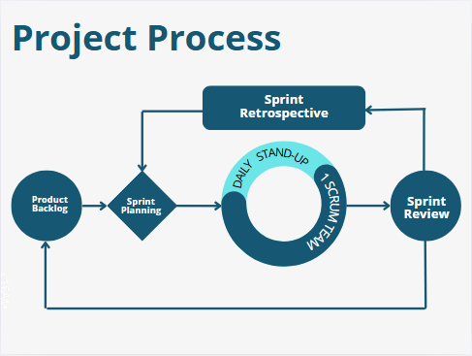

###### Figure II.B.1 - Project Process

The team uses the Scrum model, an Agile methodology, to manage and develop the GCIF project. This method is chosen for the following reasons:

* **Flexibility:** Scrum allows the team to quickly adapt to changing requirements, adjust the backlog, and reassign tasks flexibly within each sprint.
* **Effective Collaboration:** Daily Scrum meetings enable team members to update progress, identify obstacles, and support each other.
* **Reasonable Task Breakdown:** Each sprint lasts from 1 to 2 weeks, focusing on a specific feature group such as thesis management, group creation, or AI integration,...
* **Transparency and Clarity:** All members are aware of what they are doing, the deadlines, and the expected outcomes in each sprint.

Key activities in each Sprint include:

* **Sprint Planning**: Plan tasks for the upcoming sprint.
* **Daily Stand-up**: Short daily meetings to update progress and identify any difficulties.
* **Sprint Review**: Present the completed results and gather feedback from the supervising lecturer.
* **Sprint Retrospective**: Reflect on the sprint to improve team workflows.

### Quality Management

To ensure product quality, the team applies the following measures:

* **User-Centered Design:** Conduct surveys and interviews with target users (students, lecturers) to identify essential needs.
* **Acceptance Testing by Sprint:** Each feature, once completed, is tested and reviewed based on feedback from users or lecturers.
* **Code Review:** Every piece of code is cross-checked among team members to minimize logic errors and ensure standardization.
* **CI/CD & Version Control:** Use GitHub for source code management with clear branching strategies and implement CI/CD for automated testing upon code push.
* **Quick Feedback Handling:** Bugs or feedback are recorded and addressed in the nextsprint to ensure responsiveness and continuous improvement.

### Training Plan

| **#** | **Training Area** | **Participants** | **When, Duration** | **Waiver Criteria** |
| --- | --- | --- | --- | --- |
| 1 | NodeJS (Back-end API) | Lê Minh Vương  Đinh Quốc Chương | 1 weeks | Mandatory |
| 2 | Next.js (Front-end Web) | Hồ Trọng Nghĩa  Đinh Quốc Chương  Nguyễn Thị Thúy  Hứa Đức Bình | 1 weeks | Mandatory |
| 3 | Supabase (PostgreSQL) | Lê Minh Vương  Đinh Quốc Chương | 1 weeks | Mandatory |
| 4 | Prompt Engineering & OpenAI API | Lê Minh Vương | 1-2 weeks | Mandatory |
| 5 | Git, GitHub, CI/CD | All members | 1 weeks | Mandatory |

##### Table II.B.3 - Training Plan

## Project Deliverables

| **#** | **Deliverable** | **Due Date** | **Deliverable Scope** |
| --- | --- | --- | --- |
| 1 | Software Project Management Plan | May 20, 2025 | Overall plan including task assignment, timeline, tools, risks, and management process |
| 2 | Document | August 10, 2025 | Functional and non-functional requirements, use case diagrams, and data models  System architecture, ERD, UI wireframes, sequence diagrams, and logical structure |
| 3 | Web UI Prototype | June 24, 2025 | A functional prototype demonstrating key system features |
| 4 | Backend System (API) | July 30, 2025 | Backend services including login, thesis registration, group formation, and AI suggestions |
| 5 | Testing Documentation (Test Plan + Report) | July 25, 2025 | Test plan, test cases, testing results, and system quality evaluation |
| 6 | User Guide | August 12, 2025 | User manuals for students, lecturers, and administrators |
| 7 | System Deployment Package | August 7, 2025 | Full source code, deployment instructions, demo accounts, and sample data |
| 8 | Final Project Report | August 15, 2025 | Complete report prepared for project defense and final submission |

##### Table II.C - Project Deliverables

## Responsibility Assignments

***D****~Do;* ***R****~Review;* ***S****~Support;* ***I****~Informed; <blank>- Omitted*

| **Responsibility** | VuongLM | ChuongDQ | NghiaHT | ThuyNT | BinhHD | Nguyễn Thị Cẩm Hương | Nguyễn Thiện Phúc |
| --- | --- | --- | --- | --- | --- | --- | --- |
| Project Planning & Tracking | **D** | **R** | **D** | **R** | **R** | **I** | **I** |
| Prepare Project Introduction Document | **R** | **S** | **R** | **D** | **R** | **I** | **I** |
| Prepare SRS Document (Overview Part) | **S** | **S** | **D** | **D** | **D** | **I** | **I** |
| Prepare SRS Document (User Requirements) | **R** | **S** | **D** | **D** | **D** | **I** | **I** |
| Create and Prioritize Backlog | **D** | **S** | **S** | **S** | **S** | **I** | **I** |
| Sprint Planning | **D** | **S** | **S** | **R** | **R** | **I** | **I** |
| Daily Stand-ups | **D** | **D** | **D** | **D** | **D** | **I** | **I** |
| Development of Features | **D** | **D** | **D** | **D** | **D** | **I** | **I** |
| Testing & Quality Assurance | **R** | **S** | **S** | **D** | **D** | **I** | **I** |
| Sprint Review | **D** | **S** | **S** | **R** | **R** | **I** | **I** |
| Release Planning | **D** | **S** | **S** | **R** | **R** | **I** | **I** |

##### Table II.D - Responsibility Assignments

## Project Communications

### Communication Plan

| **#** | **Communication Item** | **Target** | **Purpose** | **Frequency** | **Type, Tool, Methods** |
| --- | --- | --- | --- | --- | --- |
| 1 | Daily meeting | Team members | Report task progress  Identify obstacles | 1 time per day | Discord |
| 2 | Weekly Report | Supervisors  Team members | Discuss project’s status, solution  Review diagram, document | 1 time per week | Zalo  Google meet  Offline meetings |
| 3 | Weekly meeting | Team members | Summarize the work of the week and adjust the plan for the next week | 1 time per week | Discord |

##### Table II.E.1 - Project Communications

### External Interface

| **Function** | **Contact Person**  **(name, position)** | **Contact address**  **(email, telephone)** | **Responsibility** |
| --- | --- | --- | --- |
| Supervisor | Ms. Nguyễn Thị Cẩm Hương | huongntc2@fpt.edu.vn  0909912347 | * Provide document template * Give instructions to the project team * Review deliverables * Supervise project status |
| Mr. Nguyễn Thiện Phúc | phucnt77@fpt.edu.vn  0969007688 |

##### Table II.E.2 - External Interface

## Configuration Management

### Document Management

All project-related documents will be organized and stored using Google Workspace tools to ensure transparency, collaboration, and traceability during the entire development lifecycle:

* Google Docs will be utilized for drafting and editing project documents collaboratively in real-time, including requirement analysis, technical specifications, and testing reports.
* GitHub Projects will be used to log meeting notes, progress updates, and task allocations.
* All files, including diagrams, wireframes, and architectural designs, will be categorized and saved into structured folders in Google Drive, grouped by content type (e.g., SRS, Design, Testing).

### Source Code Management

The source code of the GCIF system will be managed using GitHub, ensuring version control, team collaboration, and traceability of every development activity.

* The repository will follow a branching strategy (e.g., main, dev, feature/*) to separate development stages.
* Team members are expected to:
  + - Commit frequently, with clear and descriptive messages that reflect the nature of each update.
    - Review code thoroughly before merging into the develop branch to prevent bugs and maintain code quality.
    - Regularly pull and resolve merge conflicts, especially when working on shared features.
* All source code and configuration files will be maintained in private repositories under the team’s GitHub organization for security and easy access.

### Tools & Infrastructures

| **#** | **Category** | **Tools / Infrastructure** |
| --- | --- | --- |
| 1 | Technology | * TypeScript (Front-end & Back-end) * Ant Design (UI Library) * Redis (Caching) * Swagger (API Documentation) * Nginx (Reverse Proxy) * BullMQ (Message Queue) |
| 2 | Framework | * NestJS (Back-end Web API) * Next.js (Web Frontend) |
| 3 | Database | * PostgreSQL (Relational Database for user, project, group, and supervisor data) |
| 4 | IDEs / Editors | * Visual Studio Code * Cursor |
| 5 | Diagramming | * Draw.io (System Architecture, Use Case, Activity Diagrams) * DbDiagram (Database ERD) |
| 6 | Documentation | * Google Docs (Specifications, Reports) * Google Sheets (Tracking & Report for Testing) |
| 7 | Version Control | * GitHub (Source Code Management with branching strategy) |
| 8 | Deployment Server | * Render, Azure for Backend * Vercel for Frontend * Supabase for Database |
| 9 | Project Management | * GitHub Projects (Timeline, Task Assignment, Progress Tracking and sprint boards) * GitHub Issues (optional for issue tracking) |

##### Table II.F.3 - Tools & Infrastructures

# Software Requirements Specification

## Product Overview

* **Group Formation and Capstone Thesis Development** (GCIF)/ **TheSync** is a web-based platform developed to support final-year Information Technology students at FPT University – Quy Nhon Campus in forming project groups and managing their capstone thesis development. GCIF addresses recurring challenges such as finding compatible teammates, selecting appropriate thesis theses, and coordinating with supervisors and reviewers throughout the capstone journey.
* Leveraging Artificial Intelligence (AI), the platform analyzes students' academic profiles based on a radar chart—to help recommend optimal team members or groups and suggest suitable dissertations based on orientation.
* TheSync supports the early stages of the graduate thesis lifecycle, from team formation and thesis registration to assigning advisors, tracking milestones, and submitting feedback. In addition, TheSync also helps provide faculty with the ability to track project progress, review deliverables, and manage thesis proposals more efficiently through a centralized dashboard and automated tools.
* The platform implements a role-based access system, with tailored functionalities for Students, Lecturers/Supervisors, Moderators, and Admins, ensuring responsibilities are clearly distributed and workflows remain streamlined.
* Key Features:
* Simplify manual group formation and thesis register
* AI-powered proposal for member/group proposal and thesis registration
* Thesis supervision management with structured milestone tracking
* Role-based access control and academic workflow enforcement
* Centralized reporting for group status, supervision load, and progress analytics
* Support simple, easy-to-use web platforms to meet user needs.
* A key innovation of GCIF is its integration of AI recommendation systems—employing pre-trained embedding models and clustering algorithms—to suggest optimal thesis theses and team structures based on contextual relevance and academic compatibility. These AI features are embedded as microservices and integrated via RESTful APIs to ensure scalability and modularity.
* Ultimately, GCIF enhances the quality, efficiency, and transparency of the capstone project process—for both students and academic staff—and is designed with the potential for adaptation across other campuses within FPT University or similar institutions nationwide.

[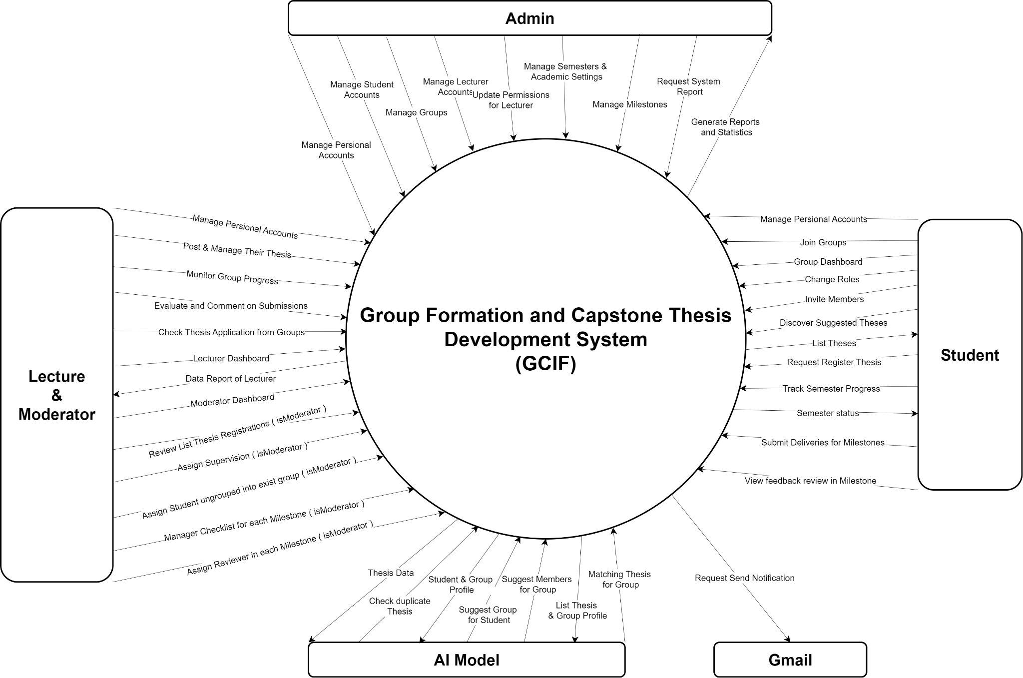](https://drive.google.com/file/d/1Zy2ZTtN_WyP2tKeDrhfiSqQ424hh38hX/view?usp=sharing)

###### Figure III.A - Project Overview

## User Requirements

### Actors

| **#** | **Actor** | **Description** |
| --- | --- | --- |
| 1 | Student | * Ability to log in and update personal profiles, including responsibilities. * Ability to join new groups or search for and request to join existing groups. * Receive AI-powered recommendations for compatible groups or members. * Receive AI-powered thesis recommendations based on skills * Track document versions and submission history * Rquest register for a thesis. * Submit, update, or cancel a thesis registration as a group. * View and track group progress, assigned mentors, and upcoming milestones. * Upload required documents for each stage of thesis assessment (Review 1, Review 2, etc.). * Manage detailed skill profiles and competencies * Receive email notifications for important updates |
|
| 2 | Lecturer | * Create, edit, or remove their thesis & view AI duplicate detection for thesis management * View groups that have requested registration of their thesis. * Accept approval to assign topics to groups. * Access a timeline of reviews and deadlines for groups they supervise or review. * Evaluate student submissions using predefined checklists. * Track student progress across assigned groups. * Manage document versions and review history * Receive automated notifications for deadlines |
| 3 | Moderator | * Inherit all Lecturer functionalities. * Approve or reject, Publish thesis submitted by lecturers. * Assign supervisors and reviewers to registered thesis theses. * Assign students to existing groups when necessary. * Generate and manage review checklists for each evaluation phase. * View system-wide reports such as group formation status and lecturer supervision load. * View supervisor workload distribution analytics * Manage draft assignments with preview capabilities * Control system-wide thesis publication status * Access cross-lecturer coordination tools |
| 4 | Admin | * Manage academic semesters and their statuses (Preparing, Picking, Ongoing, End). * Create, update, or disable student and lecturer accounts, either individually or via bulk Excel import. * Create an empty group with a maximum of 5 members per group. * Assign the Moderator role to Lecturers. * Assign students to existing groups when necessary. * Set default & max thesis per lecturer in each semester. * Create and manage milestone reviews. * View centralized reports on system usage, group formation, and supervision distribution. * Manage capstone defense results with bulk operations * Export data with advanced Excel formatting * Monitor AI system usage and performance |

##### Table III.B.1 - List of actors

### Use Cases

#### Diagram

[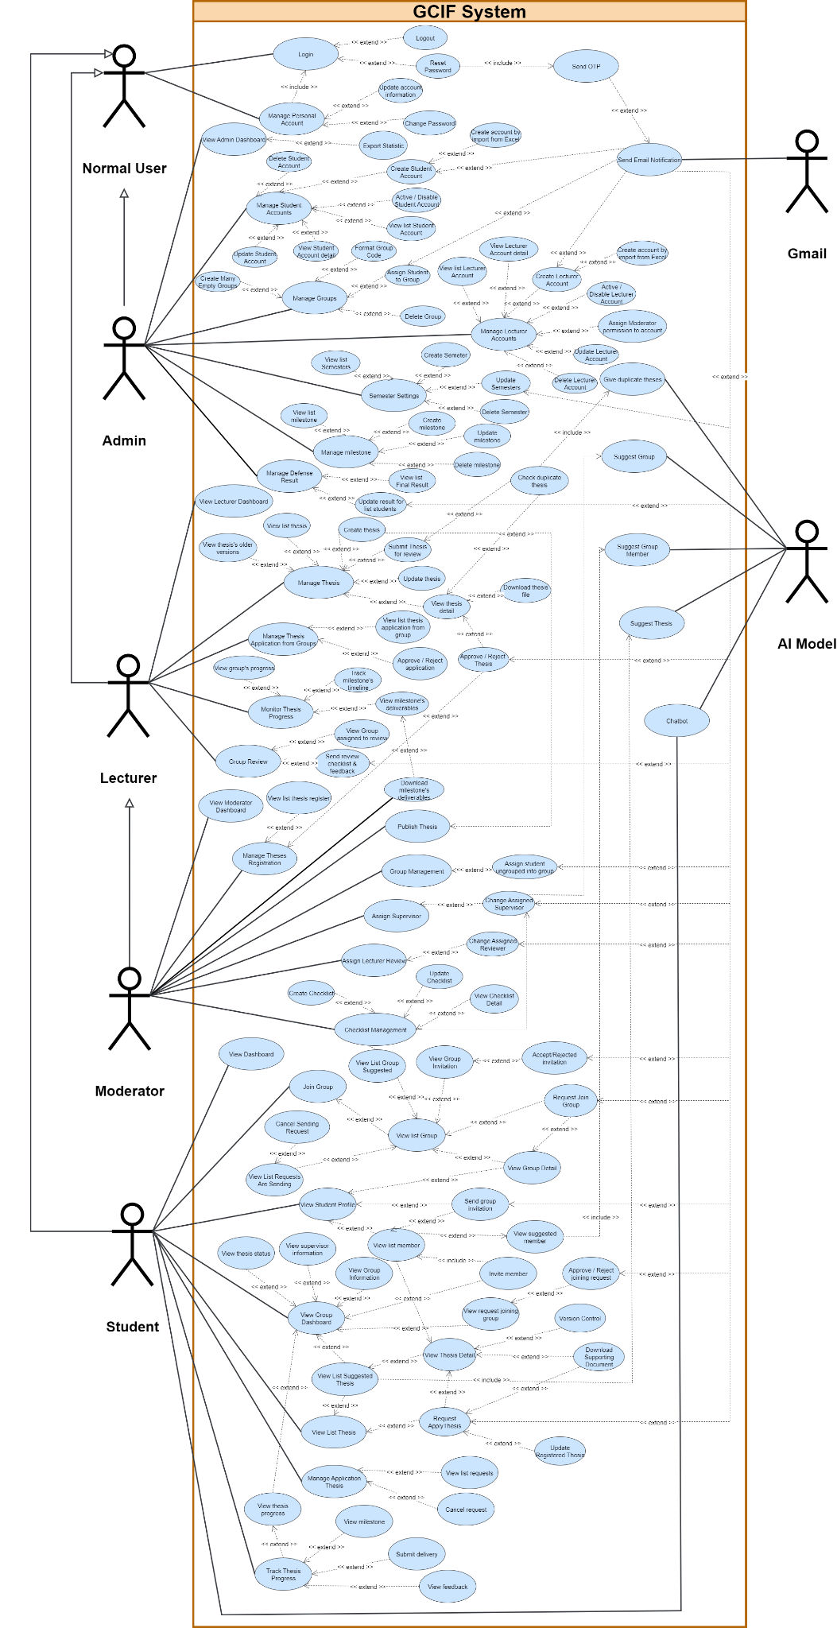](https://drive.google.com/file/d/1VoLt8vmtjIownRGooPBB39jPEAwVfwed/view?usp=sharing)

###### Figure III.B.2.a - Use cases diagram

#### Descriptions

| **#** | **Use Case** | **Actors** | **Use Case Description** |
| --- | --- | --- | --- |
| 1 | Login | Admin, Lecturer, Moderator, Student | The user enters email/username and password to access the system based on their role. |
| 2 | Logout | Admin, Lecturer, Moderator, Student | The user logs out to end the session and returns to the login page. |
| 3 | Reset Password | Admin, Lecturer, Moderator, Student | User resets account password. System verifies via email/OTP before allowing password change. |
| 4 | Send OTP | Gmail (external) | The system sends OTP to the user's email for authentication during password reset. |
| 5 | Manage Personal Account | Admin, Lecturer, Moderator, Student | Users view and manage their personal account details. |
| 6 | Update Account Information | Admin, Lecturer, Moderator, Student | User edits and saves profile info (name, phone, skills, etc.). |
| 7 | Change Password | Admin, Lecturer, Moderator, Student | User updates password in account settings. |
| 8 | Report Statistic | Normal User, Admin | User/Admin exports or views system statistics such as user count, groups, and thesis data. |
| 9 | View Admin Dashboard | Admin | Admin accesses the dashboard showing overall system status. |
| 10 | Manage Student Accounts | Admin | Admin views, searches, filters student accounts. |
| 11 | Create Student Account | Admin | Admin manually creates new student accounts. |
| 12 | Create Student Accounts by Import from Excel | Admin | Admin uploads Excel files to bulk-create student accounts. |
| 13 | Activate/Disable Student Account | Admin | Admin activates or disables student accounts. |
| 14 | View List of Student Accounts | Admin | Admin views all student accounts in the system. |
| 15 | View Student Account Detail | Admin | Admin views detailed student info. |
| 16 | Update Student Account | Admin | Admin updates student account information. |
| 17 | Delete Student Account | Admin | Admin deletes a student account. |
| 18 | Create Bulk Group for Students | Admin | Admin creates groups automatically with generated codes. |
| 19 | Manage Lecturer Accounts | Admin | Admin manages lecturer accounts. |
| 20 | Create Lecturer Account | Admin | Admin manually creates a new lecturer account. |
| 21 | Create Lecturer Accounts by Import from Excel | Admin | Admin uploads Excel to bulk-create lecturer accounts. |
| 22 | Activate/Disable Lecturer Account | Admin | Admin controls access by activating/disabling accounts. |
| 23 | Assign Moderator Permission | Admin | Admin assigns moderator role to lecturer accounts. |
| 24 | View List of Lecturer Accounts | Admin | Admin views all lecturer accounts. |
| 25 | View Lecturer Account Detail | Admin | Admin views full details of a lecturer account. |
| 26 | Update Lecturer Account | Admin | Admin updates lecturer account information. |
| 27 | Delete Lecturer Account | Admin | Admin deletes lecturer account. |
| 28 | Manage Semesters | Admin | Admin manages academic semesters. |
| 29 | Create Semester | Admin | Admin creates a new semester. |
| 30 | Update Semester | Admin | Admin edits semester details. |
| 31 | View List of Semesters | Admin | Admin views all semesters. |
| 32 | Delete Semester | Admin | Admin deletes a semester. |
| 33 | Manage Milestones | Admin | Admin manages thesis review milestones. |
| 34 | Create Milestone | Admin | Admin creates a milestone with details (name, due date). |
| 35 | View List of Milestones | Admin | Admin views milestones of a semester. |
| 36 | Update Milestone | Admin | Admin updates milestone info. |
| 37 | Delete Milestone | Admin | Admin removes milestones. |
| 38 | Manage Defense Results | Admin | Admin manages results of thesis defense. |
| 39 | View List of Final Results | Admin | Admin views compiled list of final defense results. |
| 40 | Update Results for Students | Admin | Admin updates multiple student defense results. |
| 41 | Manage Groups | Admin | Admin manages all student groups (view, update, delete). |
| 42 | Support Group | Admin, Moderator, AI Model | System/AI suggests support for group activities and assignments. |
| 43 | View Lecturer Dashboard | Lecturer, Moderator | Lecturer/Moderator views dashboard with assigned groups and theses. |
| 44 | Manage Thesis | Lecturer, Moderator | Users manage thesis topics they supervise or propose. |
| 45 | Create Thesis | Lecturer, Moderator | The lecturer creates a new thesis topic. |
| 46 | Check Duplicate Thesis | Lecturer, Moderator, AI Model | AI checks similarity with existing theses. |
| 47 | View Thesis Older Versions | Lecturer, Moderator | User views previous versions of thesis. |
| 48 | Update Thesis | Lecturer, Moderator | Lecturer updates thesis information. |
| 49 | View Thesis Detail | Lecturer, Moderator | User views full thesis details. |
| 50 | View Registered Thesis Groups | Lecturer, Moderator | User views groups registered for their thesis. |
| 51 | Approve/Reject Thesis Applications | Lecturer, Moderator | The lecturer approves or rejects student group applications. |
| 52 | Download Thesis File | Lecturer, Moderator | User downloads submitted thesis files. |
| 53 | Approve/Reject Thesis | Moderator | Moderator approves/rejects submitted thesis from lecturer. |
| 54 | View List of Theses | Lecturer, Moderator | The user views all thesis topics related to them. |
| 55 | Monitor Thesis Progress | Lecturer, Moderator | User monitors assigned group progress. |
| 56 | View Group’s Progress | Lecturer, Moderator | Users view specific group’s progress. |
| 57 | View Milestone Deliverables | Lecturer, Moderator | User views files submitted for milestones. |
| 58 | Download Milestone Deliverables | Lecturer, Moderator | User downloads milestone submissions. |
| 59 | Review Groups | Lecturer, Moderator | The user evaluates groups using a checklist. |
| 60 | View Group Assigned to Review | Lecturer, Moderator | Lecturer/Moderator views list of groups they review. |
| 61 | Send Review Checklist & Feedback | Lecturer, Moderator | The user sends structured feedback via checklist. |
| 62 | Manage Thesis Applications from Groups | Lecturer | Lecturer manages thesis applications submitted by groups. |
| 63 | Submit Thesis | Lecturer | Lecturer submits or uploads thesis materials. |
| 64 | Approve/Reject Thesis Application | Lecturer | Lecturers approve or reject thesis applications from groups. |
| 65 | View Moderator Dashboard | Moderator | Moderator views dashboard for groups and theses. |
| 66 | Publish Thesis | Moderator | The moderator publishes approved theses for students. |
| 67 | Group Management | Moderator | The moderator manages student groups. |
| 68 | Assign Student to Group | Moderator, Admin | Assign ungrouped students to existing groups. |
| 69 | Assign Supervisor to Group | Moderator | Assign a lecturer as group supervisor. |
| 70 | Change Assigned Supervisor | Moderator | Update/change group supervisor. |
| 71 | Assign Review Lecturer | Moderator | Assign lecturer as reviewer for group thesis. |
| 72 | Change Assigned Reviewer | Moderator | Update reviewer for a group thesis. |
| 73 | Checklist Management | Moderator | Manage all evaluation checklists. |
| 74 | Create Checklist | Moderator | Create a new evaluation checklist. |
| 75 | Update Checklist | Moderator | Edit checklist information. |
| 76 | View Checklist Detail | Moderator | View checklist details. |
| 77 | View Student Dashboard | Student | Students view overview of group, thesis, and progress. |
| 78 | Join Group | Student | Student requests to join a group. |
| 79 | Request Join Group | Student | Students send a join request to a group. |
| 80 | Cancel Join Request | Student | Student cancels pending join request. |
| 81 | View List of Groups | Student | Students view all available groups. |
| 82 | View List of Suggested Groups | Student | The system suggests compatible groups. |
| 83 | View Group Detail | Student | Student views detailed info of a group. |
| 84 | View Group Invitation | Student | Students view invitations from groups. |
| 85 | Accept/Reject Invitation | Student | Students accept or reject invitations. |
| 86 | View Student Profile | Student | Students view their personal profile. |
| 87 | Invite Member | Student | The group leader invites students to join. |
| 88 | View List of Group Members | Student | Student views group members. |
| 89 | Send Group Invitation | Student | The group leader sends an invitation to a student. |
| 90 | View Suggested Member | Student | Students view suggested members. |
| 91 | View Group Dashboard | Student | Students view the group’s thesis, members, and milestones. |
| 92 | View Thesis Status | Student | Student views status of thesis. |
| 93 | View Join Requests | Student | The group leader views requests from students. |
| 94 | Approve/Reject Join Requests | Student | Group leader accepts/declines requests. |
| 95 | View Group Information | Student | View full group details. |
| 96 | View Supervisor Information | Student | View supervisor assigned to the group. |
| 97 | View List of Theses | Student | View all theses in the system. |
| 98 | View Thesis Detail | Student | View full details of selected thesis. |
| 99 | Version Control | Student | Track/manage thesis versions. |
| 100 | Download Supporting Documents | Student | Download documents related to the thesis. |
| 101 | Register Thesis | Student | The group registers a thesis. |
| 102 | Update Registered Thesis | Student | Group updates registered thesis. |
| 103 | View List of Suggested Theses | Student | The system suggests theses for groups. |
| 104 | Manage Application | Student | Manage thesis applications submitted by group. |
| 105 | Request Apply Thesis | Student | Group requests to apply for thesis. |
| 106 | Track Thesis Progress | Student | Track thesis progress and milestones. |
| 107 | View Milestones | Student | View list/details of milestones. |
| 108 | Submit Delivery | Student | Submit documents/files for milestones. |
| 109 | View Feedback | Student | View lecturer feedback for submissions. |
| 110 | Chatbot | Student | Students interact with chatbots for support. |
| 111 | Email Notification | Gmail (external) | The system sends email notifications via Gmail API. |
| 112 | Suggest Suitable Group Members | AI Model | AI suggests group members based on profiles. |
| 113 | Suggest Thesis | AI Model | AI recommends thesis topics. |
| 114 | Support Group | AI Model | AI provides group assistance. |
| 115 | Check Duplicate Thesis | AI Model | AI checks thesis duplication. |

##### Table III.B.1.b - Uses case description

## Functional Requirements

### System Functional Overview

#### Website Screen Flow

[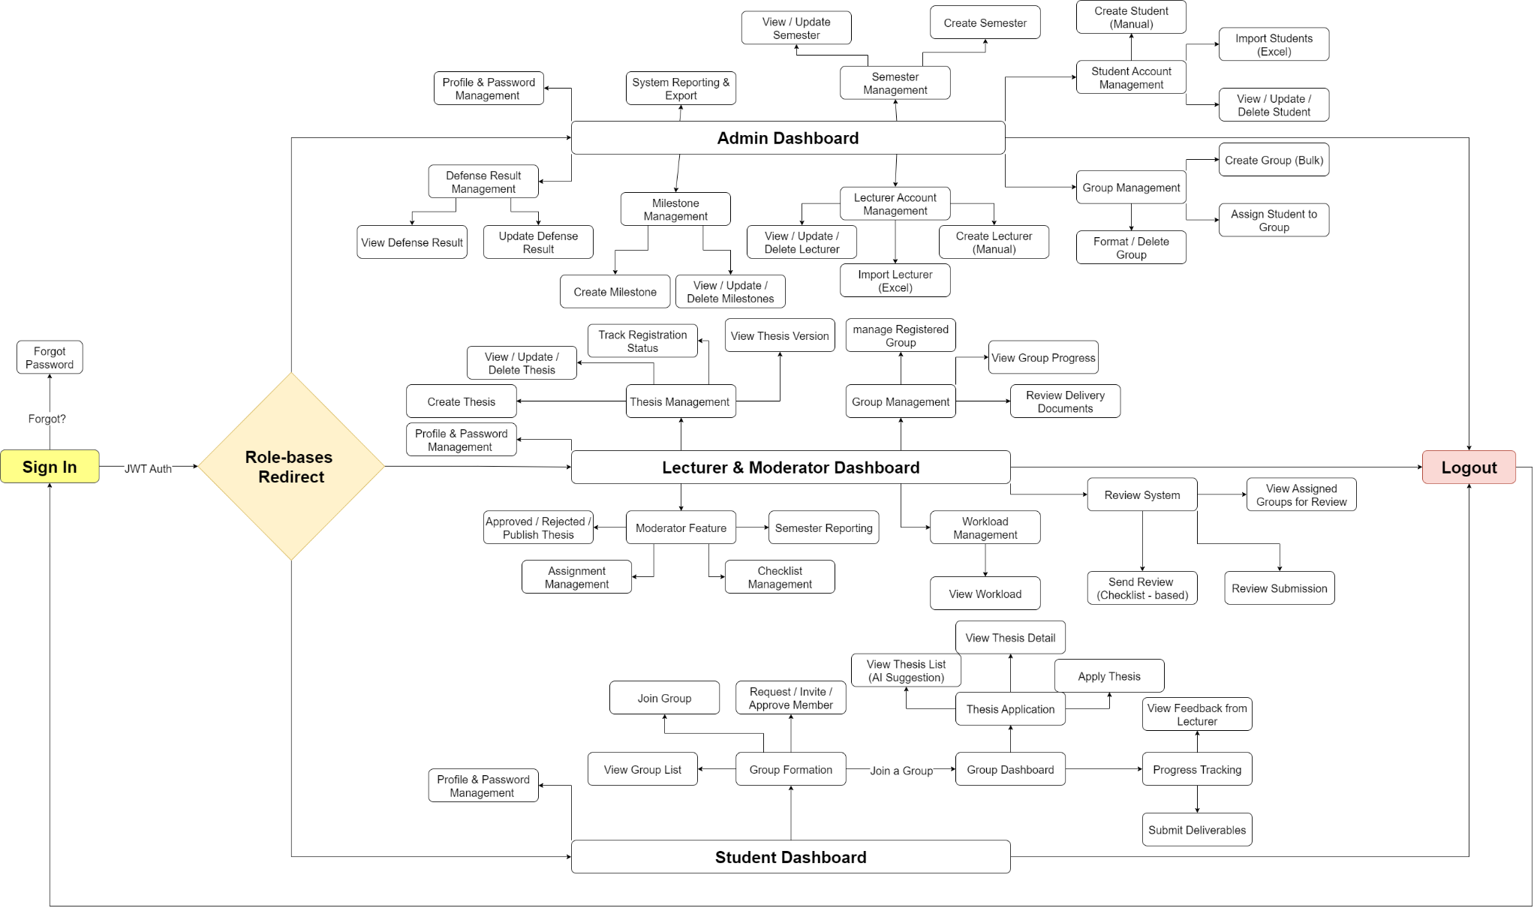](https://drive.google.com/file/d/1TGhQcNxNGRPxWhpCANrvhV3KN_X2Qtgs/view?usp=sharing)

###### Figure III.C.1.a - Website Screen Flow

#### Website Screen Descriptions

| **#** | **Feature** | **Screen** | **Description** |
| --- | --- | --- | --- |
| 1 | Authentication | Sign In | Provides an interface for users to enter their email/username and password in order to access the system according to their role (Admin, Lecturer/Moderator, Student). The system validates the input, performs authentication with a JWT token, and redirects the user to the appropriate dashboard upon successful login. Security errors are displayed if incorrect credentials are provided or the account is disabled. |
| 2 | Logout | Ends the active session, clears authentication data and the JWT token, and redirects the user back to the login page. |
| 3 | Forgot Password | Provides a form for users to request a password reset. Sends a reset link via email to allow the user to set a new password that complies with security standards. Displays a success or failure notification based on the process outcome. |
| 4 | Remember Me | Keeps the user logged in for a defined duration without requiring re-entry of credentials. |
| 5 | Session Management | Manages active login sessions using the useSessionData hook, handles token refresh, and manages cookies with CookieUtils, ensuring session security and integrity. |
| 6 | Admin Profile Management | Admin Profile Management & Change Password | Interface to view and update Admin personal information (email, full name) and change password. Validates data format, requires entering the old password, checks new password strength, and confirms successful changes. |
| 7 | Admin Dashboard | Admin Dashboard | Dashboard displaying system statistics such as number of users, groups, theses, semester status, milestones, lecturer workload allocation, AI usage statistics. Provides quick access to key administration functions with interactive charts. |
| 8 | System Reporting | Generate, view, and export system-wide reports: number of theses, groups, group/thesis status per semester, number of lecturers, SupervisorLoadChart, AIUsageChart, and export to Excel with filters. |
| 9 | Semester Management | Create Semester | Allows admin to define a new academic semester for thesis activities. Admin can set semester name, code, start and end date, description, configurations, number of milestones, and evaluation criteria. After creation, the semester becomes available for student registration and global scheduling. |
| 10 | Update Semester | Allows admin to modify details of existing semesters such as timeline, description, configurations. Restrictions may apply if the semester has started or contains active groups. All changes are logged with timestamp and admin ID, and notifications are sent to stakeholders if affected. |
| 11 | View Semesters | Centralized dashboard to view all semesters in the system. Admin can filter by status (upcoming, ongoing, completed), view key statistics (groups, submitted theses, pass rate), and access semester-specific configurations. |
| 12 | Student Account Management | Student Account Management | Display student list with search, filter, view details, activate/deactivate accounts, edit personal info. Ensures compliance with school email format and account status. Integrated AI suggestions for group formation. |
| 13 | Create Student Manual | Allows admin to manually create student accounts with required info: semester, major, full name, school email, student code. Validates duplicate email, ensures data accuracy, and sends account details to student’s email. |
| 14 | Import Student List via Excel | Bulk import of student accounts via standardized Excel template. Validates each row, skips errors, generates import reports, and sends account details to valid students via email. |
| 15 | Update Student Information | Allows updating student personal info (full name, email, student code, status, etc.) with admin authorization and data validation before saving. |
| 16 | Delete Student | Deletes student accounts from the system. |
| 17 | Update Student Status | Changes student account status between Active and Inactive. |
| 18 | Lecturer Account Management | Lecturer Account Management | Similar to student management. Admin can view, search, create, update, activate/deactivate lecturer accounts, and assign moderator roles. |
| 19 | Create Lecturer Manual | Form for manually adding new lecturers with info: full name, email, phone, gender. Validates duplicate email and sends account details via email. |
| 20 | Import Lecturer List via Excel | Bulk import of lecturer accounts from Excel. Validates data, verifies school email format, generates import reports, and sends account details via email. |
| 21 | Update Lecturer Information | Edit lecturer personal info, phone number, and email with validation and admin authorization. |
| 22 | Delete Lecturer | Deletes lecturer accounts from the system. |
| 23 | Update Lecturer Status | Changes lecturer account status between Active and Inactive. |
| 24 | Milestone Management | Create Milestone | Allows admin to define new project milestones in the thesis timeline. Includes milestone name, description, start and end dates, required deliverables, and role assignments (Supervisor, Moderator). |
| 25 | Update Milestone | Allows editing milestone details (dates, description, requirements). Updates trigger notifications to related users (groups, lecturers) and log changes. Restrictions apply if a milestone is ongoing or completed. |
| 26 | View Milestones | Dashboard for viewing all defined milestones, their status (upcoming, ongoing, completed), related groups, and submission statistics. Helps track thesis progress and identify overdue or at-risk milestones. |
| 27 | Delete Milestone | Allows deletion only if the milestone has not started. |
| 28 | Manage Defense Result | View Defense Result | Admin manages thesis defense results: view, organize, and update defense results for each group or student per semester. |
| 29 | Update Defense Result | Admin updates final results for multiple students after thesis defense. Includes input of grades, feedback, approval status, and exporting results with advanced formatting. |
| 30 | Group Management | Create Group (Bulk) | Allows admin to create multiple student groups at once using predefined criteria with CreateForm component, reducing manual work. AI-powered student suggestions for optimized grouping. |
| 31 | Delete Group | Deletes student groups via GroupsTable interface. |
| 32 | Format Group | Reorganizes existing groups and updates their group codes to a standard format. |
| 33 | Assign Student to Group | Assigns one or more students to specific groups for thesis or project, supported by AI suggestions. |
| 34 | Advanced Group Analytics | SupervisorLoadChart to track supervisor workload, analyze group performance, and export group data to Excel with advanced formatting. |
| 35 | AI-Powered Features | AI Duplicate Detection | AI automatically detects duplicate theses by comparing content and issuing alerts before approval. |
| 36 | AI Usage Analytics | AIUsageChart shows statistics of AI feature usage across the system, tracking AI suggestion efficiency. |
| 37 | AI Thesis Suggestions | AI suggests suitable theses for students based on skills, interests, and academic performance. |
| 38 | AI Student Suggestions | AI suggests compatible students for group formation based on compatibility and complementary skills. |
| 39 | Lecturer Dashboard | Lecturer Dashboard | Lecturer dashboard: shows list of supervised groups, guided theses, milestones requiring evaluation, deadline reminders, and quick access to related functions with real-time updates. |
| 40 | Lecturer Profile Management | Lecturer Profile Management & Change Password | Interface for lecturers to view and update personal information, change password, validate phone number format, confirm changes, and log password change actions. |
| 41 | Thesis Management | Thesis Management | Manage list of theses created by lecturer: create, edit, view details, check status, upload documents, run AI duplicate check, and view version history. |
| 42 | Create Thesis | Form to create new thesis: input English/Vietnamese title, description, required skills, related documents. Validate input data, save draft, submit for approval, AI duplicate detection. |
| 43 | Update Thesis | Edit existing thesis (only if not yet approved or assigned to a group). Each edit creates a new version and logs history for moderator approval via ThesisDocumentVersionDialog. |
| 44 | View Thesis Detail | View thesis details: full information, approval status, assigned group, lecturer, attachments, and edited versions via versioning system. |
| 45 | Delete Thesis | Delete theses created by the lecturer. |
| 46 | Track Registration Status | Track thesis registration status: whether selected by a group, pending approval, approved, or rejected. Only the Moderator can approve/reject. |
| 47 | View Thesis Version | View thesis version history, compare differences, forward or approve new versions. Moderators approve each version with version comparison features. |
| 48 | Group Management | Manage Registered Groups | Lecturers can view, approve, or reject student groups registered for their thesis with an enhanced approval workflow. |
| 49 | Group Progress | View Group Progress | Track group progress by milestone: submission status, lecturer comments, feedback, required tasks, and deadline alerts with real-time updates. |
| 50 | Review Delivery Documents for each Milestone | Interface for lecturers and moderators to review milestone submissions. Shows file list, submission time, submitter, and current status. Files can be downloaded with the ReviewerInfo component. |
| 51 | Review System | View List Group Review Assigned | Reviewer interface to evaluate assigned groups using a checklist. Saves comments and sends them to the group via the ExistingReviewsList component. |
| 52 | Review Submission for Reviewer | Reviewers assess detailed submissions, comment, and score each part based on the milestone checklist using ViewReviewModal and MilestoneStepFilter. |
| 53 | Send Review based on Checklist | Lecturers send official reviews based on checklists, confirm completion, and lock editing after the deadline using ReviewGroupSearchTable. |
| 54 | Workload Management | View Workload | WorkloadDialog displays lecturer workload: number of supervised groups and theses pending review. |
| 55 | Workload Analytics | Supervisor workload tracking with analytics charts, comparing workloads among lecturers, and suggesting workload balancing. |
| 56 | Moderator Dashboard | Moderator Dashboard | Moderator dashboard: displays group status, assignments, pending theses, milestone list, workload, and provides access to approval, reviewer assignment, and checklist creation. |
| 57 | Semester Reporting | – | Moderator’s consolidated reporting page: charts of group count, thesis, group progress, completed/pending milestones, with advanced analytics export. |
| 58 | Thesis Approval | Approve / Reject Thesis | Interface for moderators to review final thesis submissions and approve/reject. Includes thesis details, attachments, supervisor’s evaluation, and version history. Rejections require clear reasons or feedback. |
| 59 | Publishing | Publish Thesis | Allows moderators to officially publish approved final thesis versions. Ensures required documents, supervisor and reviewer evaluations, and marks thesis as completed. |
| 60 | Assignment Management | Assign Students to Groups | Moderator assigns ungrouped students: select students, create new groups, or merge into existing groups. Ensures rules are not violated with AI-powered suggestions. |
| 61 | Assign Supervisor for Thesis | Moderator assigns lecturers to groups/theses from the list, ensuring maximum workload configuration is not exceeded. |
| 62 | Assign Lecturer Review | Moderator assigns lecturers as reviewers for groups or milestones with draft or bulk assignment. Prevents duplicate reviewers and notifies assigned lecturers. |
| 63 | Checklist Management | Create Checklist | Form to create new evaluation checklists for milestones: input criteria and descriptions applicable to multiple groups. |
| 64 | Update Checklist | Edit created checklist (only if milestone has not started). Logs change history. |
| 65 | View Checklist | View milestone checklist list, criteria details, and previous checklists. Only Admin/Moderator can edit. |
| 66 | Request Apply System | Request Apply Thesis Management | RequestApplyThesisTable and ThesisRequestsModal manage thesis registration systems with enhanced workflow. |
| 67 | Thesis Application Review | ThesisApplicationTable with duplicate detection to review and approve/reject thesis applications from students. |
| 68 | Student Dashboard | Student Dashboard | Student dashboard: shows group status, registered theses, milestone progress, latest feedback, deadline notifications, and quick access to frequently used functions with AI features. |
| 69 | Student Profile Management | Student Profile Management & Change Password | Allows students to view/update personal info (name, avatar, skills, desired role) and change password with validation and security checks. |
| 70 | Group Formation | Join Group | Join a new group or request to join an existing one (via AI suggestions or manual search). View group list and pending requests, send/receive invitations. |
| 71 | View List Group | Display list of groups by semester: empty groups, registered thesis groups, pending approval groups with advanced filters. |
| 72 | View Group Detail | View group details: members, leader, chosen thesis, progress status, milestones, supervisor, reviewer, and invitation/change history. |
| 73 | Request Invite / Join Group | Send requests to join a group or accept/reject invitations. Track request status and cancel if needed. |
| 74 | Approve/Reject Group Join Request | Group leaders can view, accept, or reject join requests. |
| 75 | Group Dashboard | Group Dashboard | Group overview: thesis, progress, members, milestones, received feedback, group management rights, leader transfer (if allowed). |
| 76 | Invite Member | Group leader can invite other students manually (by email/student code) or through AI suggestions. Leader can track invitation status and cancel pending invites. Invited students can accept or reject. |
| 77 | Thesis Registration | View List Thesis | Students can view available theses, search/filter by skills, fields, thesis status, and view details with AI thesis suggestions. |
| 78 | View Thesis Detail | View thesis details: description, required skills, supervisor, version history, approval status, registered groups, attachments. |
| 79 | Register Thesis | Groups send thesis registration requests with description and additional documents, pending moderator approval. Track status with enhanced workflow. |
| 80 | View Thesis Version | View thesis versions registered/edited by group/lecturer, compare changes, and check final approved version. |
| 81 | Progress Tracking | Tracking Progress | Students and teams track project progress: milestone status, upcoming deadlines, completion rate, alerts for overdue or pending milestones with real-time updates. |
| 82 | View Milestone | Displays milestone list for the semester, submission deadlines, submission/review status, and detailed checklists with enhanced submission system. |
| 83 | Submission | Submit Deliverables | Group leaders upload reports and deliverables per milestone using drag-and-drop. Validates file formats, shows upload status, allows resubmission before deadlines with advanced file management. |
| 84 | Feedback | View Feedback from Lecturer Review | Students view lecturer/reviewer feedback and comments for each milestone or entire thesis with an enhanced feedback system. |
| 85 | File Management | Advanced File Upload | Drag-and-drop file upload with validation, progress tracking, and versioning system. |
| 86 | Template Management | Template downloads for Excel imports and document templates for submissions. |
| 87 | Search & Filter | Advanced Search Controls | SearchAndFilterControls component with advanced filtering across all tables, including semester-based filters. |
| 88 | Enhanced Table Views | Advanced table interfaces with sorting, pagination, and real-time updates for all entities. |
| 89 | Notification System | Real-time Notifications | Real-time notifications for deadlines, approvals, assignments, and status changes. |
| 90 | Email Integration | Automated emails for account creation, notifications, reminders, with customizable templates. |
| 91 | Export System | Advanced Excel Export | Export functionality with custom formatting for groups, students, lecturers, defense results, and analytics reports. |
| 92 | Custom Reports | Generate custom reports with filters, date ranges, statistical analysis, and visualization charts. |

##### Table III.C.1.b - Website Screen Description

#### Website Screen Authorization

| **Screen** | **Guest** | **Student** | **Lecturer** | **Moderator** | **Admin** |
| --- | --- | --- | --- | --- | --- |
| Sign In | x | x | x | x | x |
| Forgot Password | x | x | x | x | x |
| Admin Profile Management & Change Password |  |  |  |  | x |
| Admin Dashboard |  |  |  |  | x |
| System Reporting |  |  |  |  | x |
| Create Semester |  |  |  |  | x |
| Update Semester |  |  |  |  | x |
| View Semesters |  |  |  |  | x |
| Student Account Management |  |  |  |  | x |
| Create Student Manual |  |  |  |  | x |
| Import List Student via Excel |  |  |  |  | x |
| Update Student Information |  |  |  |  | x |
| Delete Student |  |  |  |  | x |
| Update Student Status |  |  |  |  | x |
| Lecturer Account Management |  |  |  |  | x |
| Create Lecturer Manual |  |  |  |  | x |
| Import List Lecturer via Excel |  |  |  |  | x |
| Update Lecturer Information |  |  |  |  | x |
| Delete Lecturer |  |  |  |  | x |
| Update Lecturer Status |  |  |  |  | x |
| Milestone Management |  |  |  |  | x |
| Create Milestone |  |  |  |  | x |
| Update Milestone |  |  |  |  | x |
| View Milestones |  |  |  |  | x |
| Delete Milestone |  |  |  |  | x |
| View Defense Result |  |  |  |  | x |
| Update Defense Result |  |  |  |  | x |
| Create Group (Bulk) |  |  |  |  | x |
| Delete Group |  |  |  |  | x |
| Format Group |  |  |  |  | x |
| Assign Student To Group |  |  |  |  | x |
| AI Duplicate Detection |  |  |  |  | x |
| AI Usage Analytics |  |  |  |  | x |
| AI Student Suggestions |  | x |  |  |  |
| Supervisor Load Chart |  |  |  |  | x |
| Advanced Export Functions |  |  |  |  | x |
| Lecturer Dashboard |  |  | x | x |  |
| Lecturer Profile Management & Change Password |  |  | x | x |  |
| Thesis Management |  |  | x | x |  |
| Create Thesis |  |  | x | x |  |
| Update Thesis |  |  | x | x |  |
| View Thesis Detail |  | x | x | x |  |
| Delete Thesis |  |  | x | x |  |
| Track Registration Status |  |  | x | x |  |
| View Thesis Version |  | x | x | x |  |
| Manage Registered Groups |  |  | x | x |  |
| Group Progress |  | x | x | x |  |
| Review Delivery Documents |  |  | x | x |  |
| View List Group Review assigned |  |  | x | x |  |
| Review Submission for Reviewer |  |  | x | x |  |
| Send review based on checklist |  |  | x | x |  |
| View Workload |  |  | x | x |  |
| Workload Dialog |  |  | x | x |  |
| Existing Reviews List |  |  | x | x |  |
| View Review Modal |  |  | x | x |  |
| Review Group Search Table |  |  | x | x |  |
| Thesis Document Version Dialog |  |  | x | x |  |
| Moderator Dashboard |  |  |  | x |  |
| Semester Reporting |  |  |  | x |  |
| Approve / Reject Thesis |  |  |  | x |  |
| Publish Thesis |  |  |  | x |  |
| Assign Students to Groups |  |  |  | x |  |
| Assign Supervisor for Thesis |  |  |  | x |  |
| Assign Reviewer for Group |  |  |  | x |  |
| Create Checklist |  |  |  | x |  |
| Update Checklist |  |  |  | x |  |
| View Checklist |  |  |  | x |  |
| RequestApplyThesisTable |  |  |  | x |  |
| ThesisRequestsModal |  |  |  | x |  |
| ThesisApplicationTable |  |  |  | x |  |
| Draft Reviewer Assignment |  |  |  | x |  |
| Bulk Reviewer Assignment |  |  |  | x |  |
| Student Dashboard |  | x |  |  |  |
| Student Profile Management & Change Password |  | x |  |  |  |
| Join Group |  | x |  |  |  |
| View List Group |  | x |  |  |  |
| View Group Detail |  | x |  |  |  |
| Request Invite / Join Group |  | x |  |  |  |
| Approve/Reject Group Join Request |  | x |  |  |  |
| Group Dashboard |  | x |  |  |  |
| Invite Member |  | x |  |  |  |
| View List Thesis |  | x |  |  |  |
| Register Thesis |  | x |  |  |  |
| Tracking Progress |  | x |  |  |  |
| View Milestone |  | x |  |  |  |
| Submit Deliverables |  | x |  |  |  |
| View Feedback from Lecturer Review |  | x |  |  |  |
| AI Thesis Suggestions |  | x |  |  |  |
| AI Group Member Suggestions |  | x |  |  |  |
| View Semesters (Read-only) |  | x | x | x |  |
| View Milestones (Read-only) |  | x | x | x |  |
| Advanced Search & Filter |  | x | x | x | x |
| Notification System |  | x | x | x | x |
| File Upload/Download |  | x | x | x | x |

##### Table III.C.1.c - Website Screen Authorization

#### Non-Screen Functions

| **#** | **Feature** | **System Function** | **Description** |
| --- | --- | --- | --- |
| 1 | Authentication & Authorization | JWT Token Generation | Manage login and user role authorization (Student, Lecturer, Moderator, Admin) via JWT tokens, ensuring strict access control for APIs and UI resources. |
| 2 | Session Management | Manage login sessions with useSessionData hook, handle auto token refresh, cookie management (CookieUtils), and timeout handling. |
| 3 | Role-Based Access Control (RBAC) | Detailed role-based permission system with middleware checks, dynamic route protection, and component-level access control. |
| 4 | Security | Data Encryption & Validation | Encrypt sensitive data (passwords, tokens), comprehensive input validation & sanitization to prevent SQL Injection, XSS, CSRF. |
| 5 | Password Security | Hash passwords with bcrypt/argon2, validate password strength, secure reset flow with time-limited tokens. |
| 6 | CORS & Security Headers | Configure CORS policy, HSTS, CSP, X-Frame-Options headers, and request origin validation. |
| 7 | API Management | RESTful API Design | Standard RESTful API structure with correct HTTP methods, status codes, error handling, and standardized response format. |
| 8 | API Documentation | Swagger/OpenAPI documentation, interactive API explorer, versioning, deprecation notices. |
| 9 | Data Processing | File Upload & Management | Secure file uploads with validation (size, type), virus scanning, versioning, and cleanup policies. |
| 10 | Excel Import/Export Engine | Handle Excel import/export with template validation, error reporting, batch processing, and progress tracking. |
| 11 | Data Validation Engine | Comprehensive engine with custom rules, cross-field & business logic validation, and real-time feedback. |
| 12 | AI Services | AI Duplicate Detection Engine | Detecting duplicate theses with NLP, similarity algorithms, document fingerprinting, threshold-based matching. |
| 13 | AI Thesis Suggestion System | Recommend suitable theses for students based on skills, interests, academic performance using collaborative filtering. |
| 14 | AI Student Matching | Suggest compatible students for group formation via compatibility & skill complementarity analysis. |
| 15 | AI Analytics Engine | Analyze patterns, predictive analytics for success rates, insights, and recommendation improvements. |
| 16 | AI Usage Tracking | Track AI usage, measure effectiveness, identify usage patterns, optimize performance. |
| 17 | Notification Service | Email & Multi-channel Notification | Send notifications via email, web push, or mobile for events (feedback, deadlines, group changes). |
| 18 | Email Template Engine | Dynamic templates with personalization, multi-language support, responsive design, and tracking. |
| 19 | Real-time Notification System | WebSocket-based push notifications with preferences and delivery confirmation. |
| 20 | Notification Queue Management | Manage bulk notifications with retry logic, failure handling, and priority-based delivery. |
| 21 | Communication Logs | Log all communications with audit trails, delivery tracking, and compliance reporting. |
| 22 | Analytics & Reporting | Real-time Analytics Engine | Real-time dashboards, trend analysis, performance metrics. |
| 23 | Custom Report Generator | Generate reports with custom filters, export formats (PDF, Excel, CSV), schedule reports. |
| 24 | Statistical Analysis Engine | Advanced statistical & comparative analysis, trend prediction, visualization. |
| 25 | External Integrations | Email Service Integration | Integrate with email providers (SMTP, SendGrid, AWS SES), delivery tracking, bounce handling. |
| 26 | Cloud Storage Integration | Integrate with AWS S3, Google Cloud, CDN for file distribution. |
| 27 | Academic System Integration | Possible integration with Student Information Systems, grade management. |
| 28 | Performance Optimization | Caching System | Multi-level caching (Redis, in-memory), invalidation, warming, optimization. |
| 29 | Load Balancing & Scaling | Horizontal scaling, load balancing algorithms, auto-scaling policies. |
| 30 | Mobile Optimization | Responsive Design System | Mobile-first responsive UI, touch-optimized, PWA capabilities. |

##### Table III.C.1.d - Non-Screen Functions Description

#### Entity Relationship Diagram

* + - * 1. Conceptual ERD

[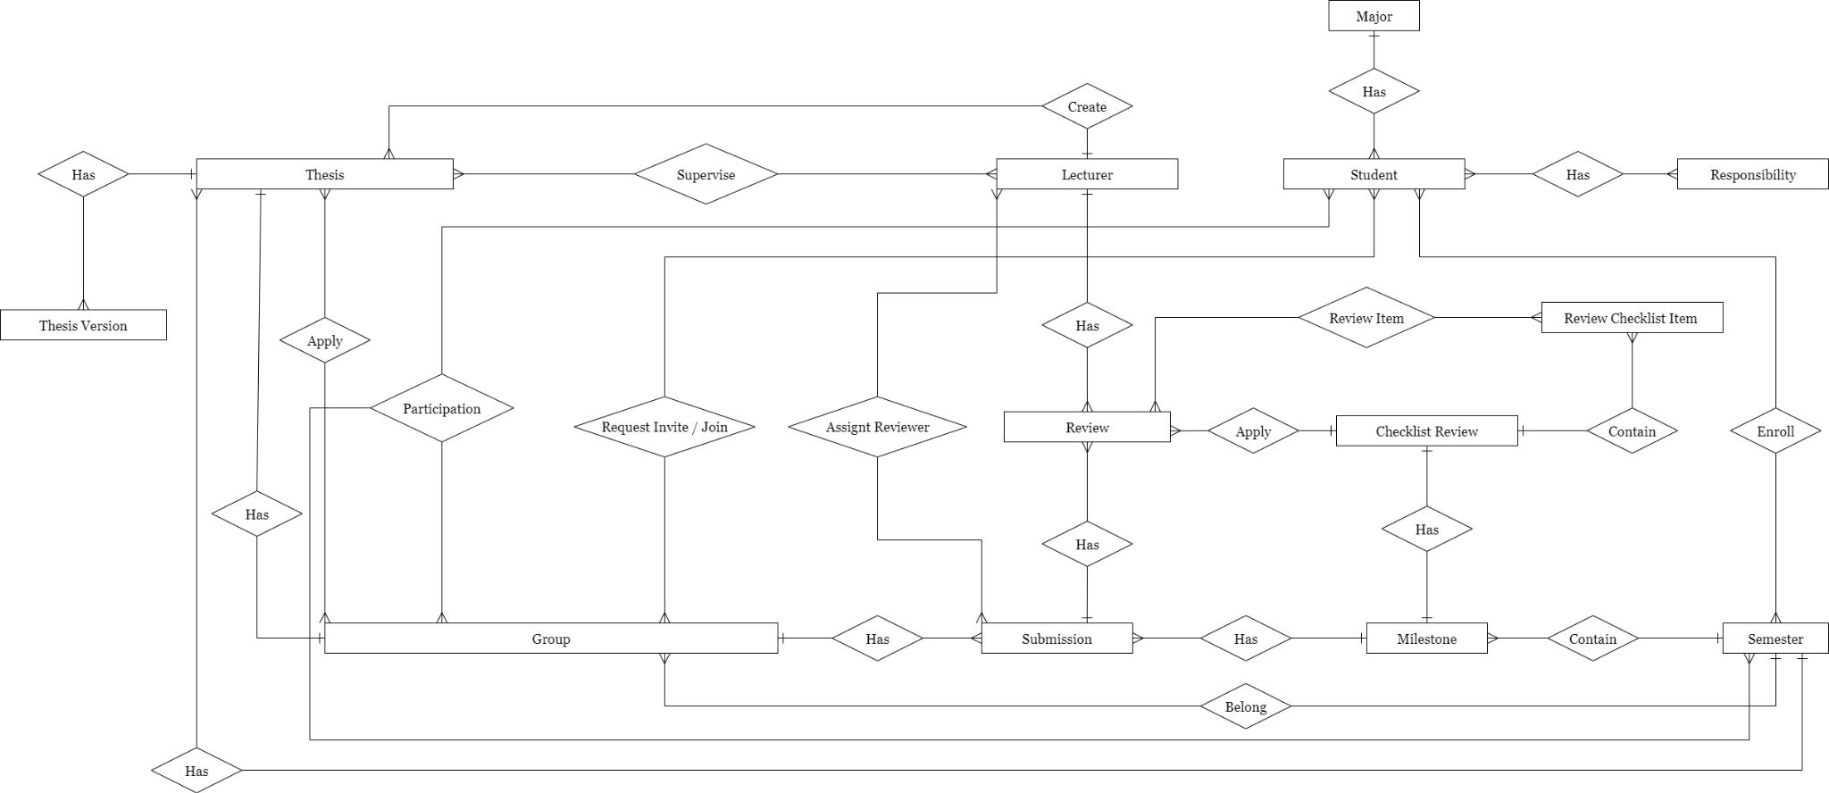](https://drive.google.com/file/d/1wYx7NRKplO0h8ynxYGzTbJV_8RbO47CU/view?usp=sharing)

###### Figure III.C.1.e.(1) - Conceptual ERD

* + - * 1. Logical ERD

[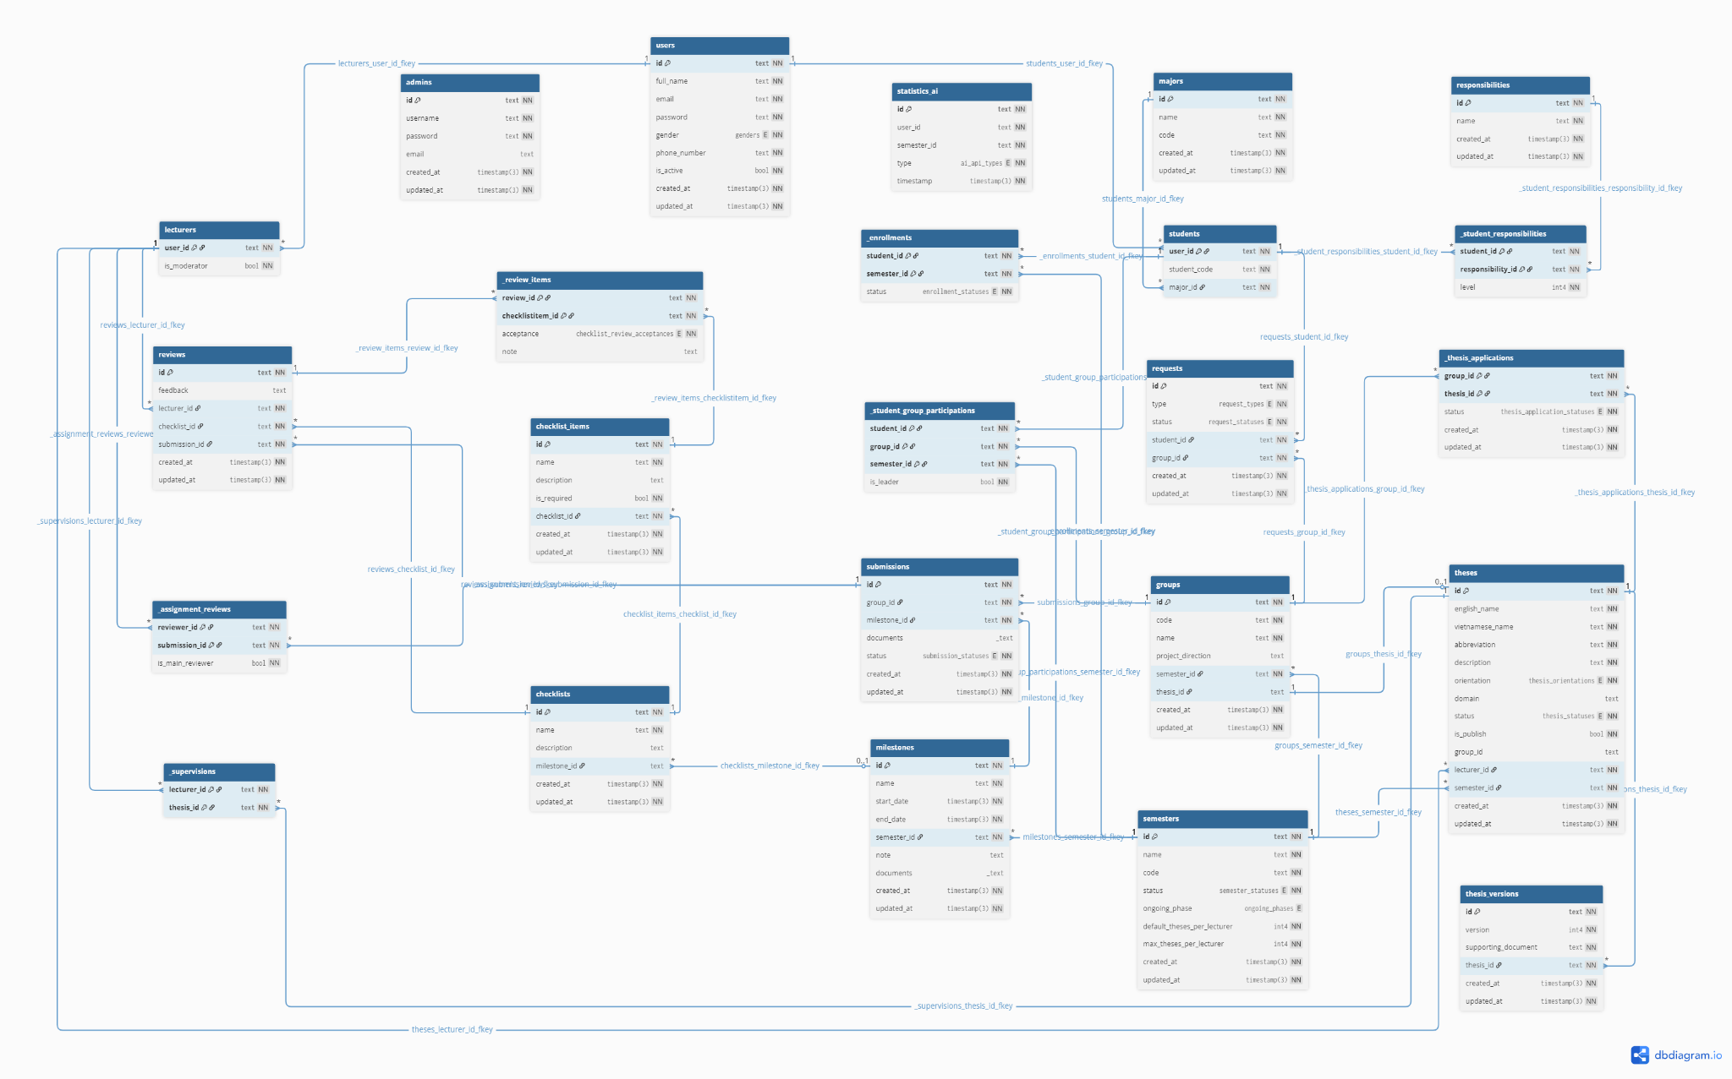](https://drive.google.com/file/d/1o4xU_ZBW2I8z2xsv_ElKVuIhHWO0BCIp/view?usp=sharing)

###### Figure III.C.1.e.(2) - Logical ERD

* + - * 1. Entities Description

| **#** | **Entity** | **Field** | **Description** |
| --- | --- | --- | --- |
| 1 | admins | id | text, Primary Key |
| 2 | username | text, unique, NOT NULL |
| 3 | password | text, NOT NULL |
| 4 | email | text, nullable |
| 5 | created_at | timestamp, default CURRENT_TIMESTAMP, NOT NULL |
| 6 | updated_at | timestamp, NOT NULL |
| 7 | users | id | text, Primary Key |
| 8 | full_name | text, NOT NULL |
| 9 | email | text, unique, NOT NULL |
| 10 | password | text, NOT NULL |
| 11 | gender | enum(male, female), NOT NULL |
| 12 | phone_number | text, NOT NULL |
| 13 | is_active | boolean, default true, NOT NULL |
| 14 | created_at | timestamp, default CURRENT_TIMESTAMP, NOT NULL |
| 15 | updated_at | timestamp, NOT NULL |
| 16 | lecturers | user_id | text, PK, FK → users(id) |
| 17 | is_moderator | boolean, default false, NOT NULL |
| 18 | students | user_id | text, PK, FK → users(id) |
| 19 | student_code | text, unique, NOT NULL |
| 20 | major_id | text, FK → majors(id), NOT NULL |
| 21 | majors | id | text, Primary Key |
| 22 | name | text, NOT NULL |
| 23 | code | text, unique, NOT NULL |
| 24 | created_at | timestamp, default CURRENT_TIMESTAMP, NOT NULL |
| 25 | updated_at | timestamp, NOT NULL |
| 26 | responsibilities | id | text, Primary Key |
| 27 | name | text, NOT NULL |
| 28 | created_at | timestamp, default CURRENT_TIMESTAMP, NOT NULL |
| 29 | updated_at | timestamp, NOT NULL |
| 30 | semesters | id | text, Primary Key |
| 31 | name | text, unique, NOT NULL |
| 32 | code | text, unique, NOT NULL |
| 33 | status | enum(not_yet, preparing, picking, ongoing, end), default not_yet, NOT NULL |
| 34 | ongoing_phase | enum(scope_adjustable, scope_locked), nullable |
| 35 | default_theses_per_lecturer | int4, default 4, NOT NULL |
| 36 | max_theses_per_lecturer | int4, default 6, NOT NULL |
| 37 | created_at | timestamp, default CURRENT_TIMESTAMP, NOT NULL |
| 38 | updated_at | timestamp, NOT NULL |
| 39 | groups | id | text, Primary Key |
| 40 | code | text, unique, NOT NULL |
| 41 | name | text, NOT NULL |
| 42 | project_direction | text, nullable |
| 43 | semester_id | text, FK → semesters(id), NOT NULL |
| 44 | thesis_id | text, FK → theses(id), nullable, unique |
| 45 | created_at | timestamp, default CURRENT_TIMESTAMP, NOT NULL |
| 46 | updated_at | timestamp, NOT NULL |
| 47 | theses | id | text, Primary Key |
| 48 | english_name | text, NOT NULL |
| 49 | vietnamese_name | text, NOT NULL |
| 50 | abbreviation | text, NOT NULL |
| 51 | description | text, NOT NULL |
| 52 | orientation | enum(se, ai, neutral), default neutral, NOT NULL |
| 53 | domain | text, nullable |
| 54 | status | enum(new, pending, approved, rejected), default new, NOT NULL |
| 55 | is_publish | boolean, default false, NOT NULL |
| 56 | group_id | text, FK → groups(id), nullable |
| 57 | lecturer_id | text, FK → lecturers(user_id), NOT NULL |
| 58 | semester_id | text, FK → semesters(id), NOT NULL |
| 59 | created_at | timestamp, default CURRENT_TIMESTAMP, NOT NULL |
| 60 | updated_at | timestamp, NOT NULL |
| 61 | thesis_versions | id | text, Primary Key |
| 62 | version | int4, NOT NULL |
| 63 | supporting_document | text, NOT NULL |
| 64 | thesis_id | text, FK → theses(id), NOT NULL |
| 65 | created_at | timestamp, default CURRENT_TIMESTAMP, NOT NULL |
| 66 | updated_at | timestamp, NOT NULL |
| 67 | milestones | id | text, Primary Key |
| 68 | name | text, NOT NULL |
| 69 | start_date | timestamp, NOT NULL |
| 70 | end_date | timestamp, NOT NULL |
| 71 | semester_id | text, FK → semesters(id), NOT NULL |
| 72 | note | text, nullable |
| 73 | documents | text[], nullable |
| 74 | created_at | timestamp, default CURRENT_TIMESTAMP, NOT NULL |
| 75 | updated_at | timestamp, NOT NULL |
| 76 | checklists | id | text, Primary Key |
| 77 | name | text, NOT NULL |
| 78 | description | text, nullable |
| 79 | milestone_id | text, FK → milestones(id), nullable, unique |
| 80 | created_at | timestamp, default CURRENT_TIMESTAMP, NOT NULL |
| 81 | updated_at | timestamp, NOT NULL |
| 82 | checklist_items | id | text, Primary Key |
| 83 | name | text, NOT NULL |
| 84 | description | text, nullable |
| 85 | is_required | boolean, default false, NOT NULL |
| 86 | checklist_id | text, FK → checklists(id), NOT NULL |
| 87 | created_at | timestamp, default CURRENT_TIMESTAMP, NOT NULL |
| 88 | updated_at | timestamp, NOT NULL |
| 89 | requests | id | text, Primary Key |
| 90 | type | enum(invite, join), NOT NULL |
| 91 | status | enum(cancelled, pending, approved, rejected), NOT NULL |
| 92 | student_id | text, FK → students(user_id), NOT NULL |
| 93 | group_id | text, FK → groups(id), NOT NULL |
| 94 | created_at | timestamp, default CURRENT_TIMESTAMP, NOT NULL |
| 95 | updated_at | timestamp, NOT NULL |
| 96 | submissions | id | text, Primary Key |
| 97 | group_id | text, FK → groups(id), NOT NULL |
| 98 | milestone_id | text, FK → milestones(id), NOT NULL |
| 99 | documents | text[], default empty array, nullable |
| 100 | status | enum(not_submitted, submitted), default not_submitted, NOT NULL |
| 101 | created_at | timestamp, default CURRENT_TIMESTAMP, NOT NULL |
| 102 | updated_at | timestamp, NOT NULL |
| 103 | (group_id, milestone_id) | unique constraint |
| 104 | reviews | id | text, Primary Key |
| 105 | feedback | text, nullable |
| 106 | lecturer_id | text, FK → lecturers(user_id), NOT NULL |
| 107 | checklist_id | text, FK → checklists(id), NOT NULL |
| 108 | submission_id | text, FK → submissions(id), NOT NULL |
| 109 | created_at | timestamp, default CURRENT_TIMESTAMP, NOT NULL |
| 110 | updated_at | timestamp, NOT NULL |
| 111 | _review_items | review_id | text, PK, FK → reviews(id) |
| 112 | checklistitem_id | text, PK, FK → checklist_items(id) |
| 113 | acceptance | enum(accepted, rejected, not_available), default not_available, NOT NULL |
| 114 | note | text, nullable |
| 115 | _enrollments | student_id | text, PK, FK → students(user_id) |
| 116 | semester_id | text, PK, FK → semesters(id) |
| 117 | status | enum(not_yet, failed, ongoing, passed), default not_yet, NOT NULL |
| 118 | _student_responsibilities | student_id | text, PK, FK → students(user_id) |
| 119 | responsibility_id | text, PK, FK → responsibilities(id) |
| 120 | level | int4, default 0, NOT NULL |
| 121 | _supervisions | thesis_id | text, PK, FK → theses(id) |
| 122 | lecturer_id | text, PK, FK → lecturers(user_id) |
| 123 | _assignment_reviews | submission_id | text, PK, FK → submissions(id) |
| 124 | reviewer_id | text, PK, FK → lecturers(user_id) |
| 125 | is_main_reviewer | boolean, default false, NOT NULL |
| 126 | _student_group_participations | student_id | text, PK, FK → students(user_id) |
| 127 | group_id | text, PK, FK → groups(id) |
| 128 | semester_id | text, PK, FK → semesters(id) |
| 129 | is_leader | boolean, default false, NOT NULL |

##### 

##### Table III.C.1.e.(3) - Entities Description

### Website for Students

#### Login

* **Function Description:** The login page allows students to log in using their email and password. This page also provides options to forgot password, remember login information.
* **Function Trigger:** When the user is not logged in, the Login page will display the Login form:
* Log in with Email + Password
* **Button/Navigation:** There is an input field for Email and Password, along with a “Sign In” button.
* **Trigger:** After entering valid credentials and clicking the “Sign In” button.
* **Function:** The system authenticates the provided credentials. If valid, the user is redirected to the dashboard according to their role (e.g., Student). If invalid, an error message is displayed (“Invalid email or password”).
* Remember Me
* **Button/Navigation:** A checkbox labeled “Remember Me” is displayed below the login form.
* **Trigger:** When checked before clicking “Sign In.”
* **Function:** The system remembers the user’s credentials for future sessions until manually logged out.
* Forgot Password
* **Button/Navigation:** A “Forgot password?” link is displayed below the login form.
* **Trigger:** When clicked, then enters email and clicks "Sending..." button
* **Function:** The system redirects the user to the Forgot Password page. The user enters their registered email and the OTP received via email. After successful verification, a new password is automatically generated and sent to the user’s email. The system then displays a confirmation message “Password Reset Successful!” with options to check email or return to the login page.
* **Business Rules**: BR-078, BR-079, BR-080, BR-081, BR-082, BR-083, BR-096, BR-101, BR-134, BR-137, BR-139, BR-140

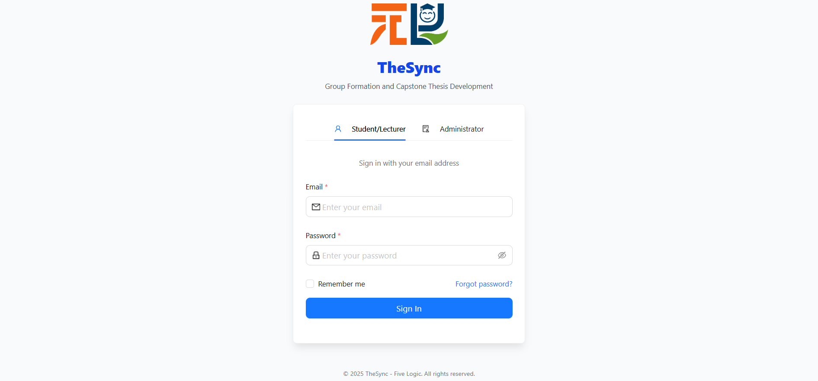

###### Figure III.C.2.a - Login

#### Change password

* **Function Description:** The Change Password function, located within the Account Settings page, allows logged-in students to update their password by providing the current password and setting a new one that meets the system’s security requirements.
* **Function Trigger:** When the user navigates to the Account Settings page, the Change Password form is displayed in the right panel.
* Enter Current Password
* **Button/Navigation:** Input field for *Current Password*.
* **Trigger:** User enters the current password.
* **Function:** The system verifies the provided password. If incorrect, an error message is displayed (“Current password is incorrect”).
* Enter New Password and Confirm New Password
* **Button/Navigation:** Input fields for *New Password* and *Confirm New Password*.
* **Trigger:** User enters a new password and re-enters it for confirmation.
* **Function:** The system validates that the new password meets complexity rules (minimum 12 characters, including uppercase, lowercase, numbers, and special characters) and matches the confirmation. If invalid, an error message is displayed.
* Update Password
* **Button/Navigation:** **Update Password** button.
* **Trigger:** After filling in required fields, the user clicks Update Password.
* **Function:** If valid, the system updates the password and displays a success notification. The new password must be used for the next login.
* Additional Options
* **Button/Navigation:** *Clear* button and *Eye icon*.
* **Trigger:**
  + *Clear* → When clicked, all fields are reset.
  + *Eye icon* → When clicked, toggles password visibility.
* **Function:** Provides convenience for entering password fields.
* **Business Rules**: BR-009, BR-010, BR-013, BR-014, BR-015, BR-096, BR-101, BR-137, BR-140, BR-151

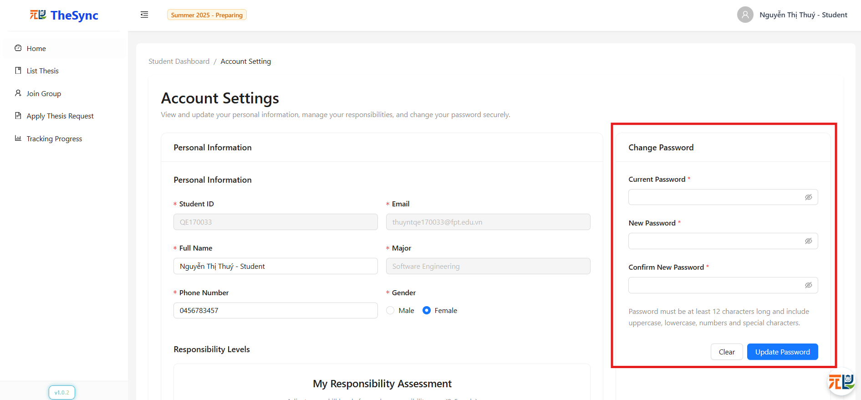

###### Figure III.C.2.b - Change password

#### Update personal information

* **Function Description:** The Personal Information section, located within the *Account Settings* page, allows users to view their registered details such as full name, email, and role. This section is view-only and does not allow direct edits to ensure data integrity.
* **Function Trigger:** When the user navigates to the *Account Settings* page, the Personal Information panel is displayed on the left side.
* View Information
* **Button/Navigation:** Static display fields (*StudentID, Email, Full Name, Email,...*).
* **Trigger:** Page load.
* **Function:** The system fetches and displays the user’s information from the database.
* Update Information
* **Button/Navigation:** Editable input fields (Full Name, Phone Number, etc.), non-editable fields (Email, Major).
* **Trigger:** User clicks directly on an editable field to modify its value.
* **Function:** The system accepts user input, and when the Save Changes button is clicked, it validates the data and updates the database. A success/failure notification is displayed accordingly.
* **Business Rules**: BR-088, BR-089, BR-096, BR-101, BR-137, BR-143, BR-144, BR-148, BR-152

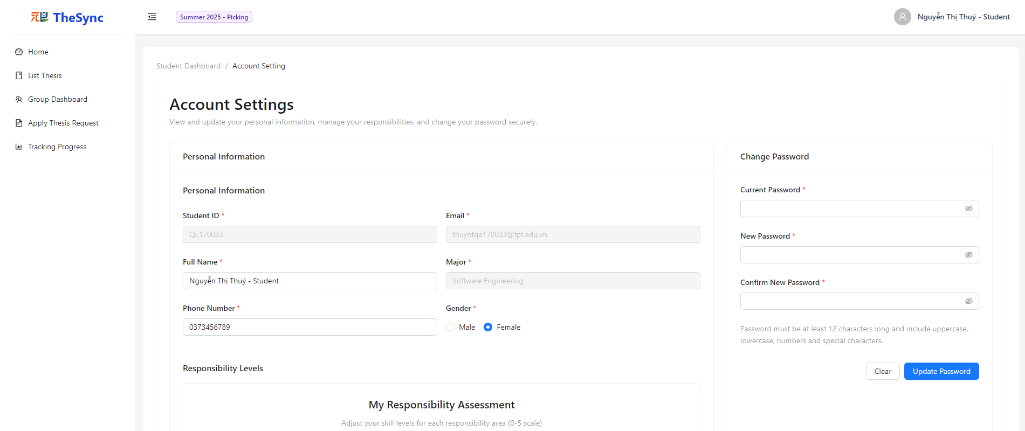

###### Figure III.C.2.c.(1) - Update personal information

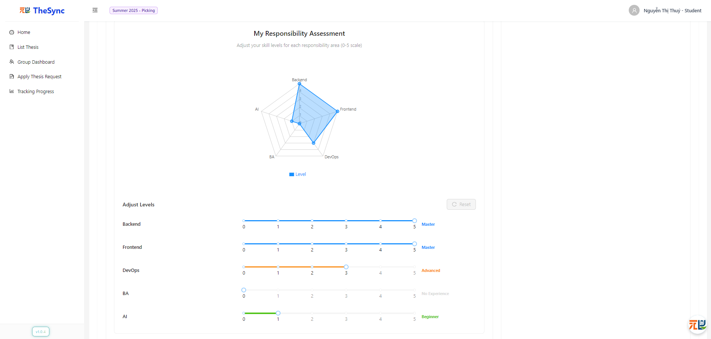

###### Figure III.C.2.c.(2) - Update personal information

#### Student Dashboard

* **Function Description:** Displays the main interface after a successful login, providing students with key navigation and information such as thesis list, group creation/joining, thesis registration, and progress tracking.
* **Function Trigger:** Triggered when the user logs in successfully and the system redirects to the Student Dashboard screen.
* Button/Navigation – Trigger – Function
* Home (Sidebar) → Click Home → Displays the Student Dashboard welcome screen with main options.
* List Thesis (Sidebar) → Click List Thesis → Redirects to the thesis list page.
* Join Group (Sidebar or Browse Groups button on Student Dashboard) → Click Join Group/Browse Groups → Redirects to the group join page.
* AI Group Suggestion (Find Match button on Dashboard) → Click Find Match → System suggests a suitable group based on AI algorithm.
* Register Thesis Request (Sidebar) → Click Register Thesis Request → Redirects to the thesis registration page.
* Tracking Progress (Sidebar) → Click Tracking Progress → Redirects to the progress tracking page.
* User Profile (Student name – top right corner) → Click avatar/name → Redirects to Account Settings page (edit personal information, change password).
* **Business Rules**: BR-134, BR-135, BR-136, BR-137, BR-138, BR-149, BR-150, BR-159, BR-160, BR-163, BR-171, BR-179, BR-180, BR-181, BR-182

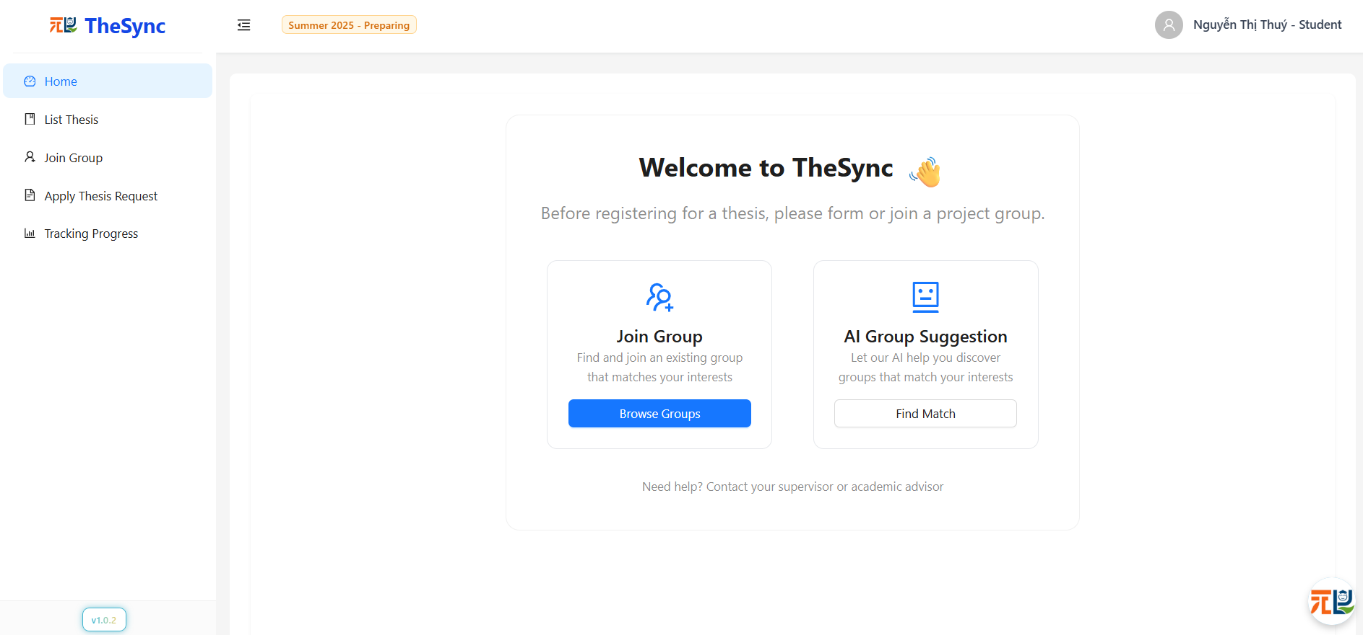

###### Figure III.C.2.d - Student Dashboard

#### Chatbot

* **Function Description:** Provides students with an AI-powered assistant (Syncus) to answer questions, guide them through capstone project workflows, and offer quick access to FAQs. Chatbot supports free-text input and suggested quick replies for faster navigation.
* **Function Trigger:** Students access chatbot via system interface to ask questions or request guidance.
* **Button/Navigation**
* Chatbot Icon → Opens chatbot window.
* Send Button → Sends student’s message.
* Quick Reply Buttons → Suggested FAQs for instant responses.
* Close Button → Ends chatbot session.
* Trigger – Function
* Open Chatbot
  + **Trigger:** Student clicks chatbot icon.
  + **Function:** Opens chatbot window and initializes a new conversation.
* Send Question / Message
  + **Trigger**: Student enters a message and clicks Send.
  + **Function**: Validates input, forwards request to chatbot engine, and displays student’s message.
* Receive Response
  + **Trigger**: Chatbot processes student query.
  + **Function**: Returns AI-generated or FAQ-based response, displayed in chat window.
* Use Quick Replies
  + **Trigger**: Student clicks a suggested FAQ button (e.g., “How do I create a new group?”).
  + **Function**: Instantly provides predefined response and related links (if applicable).
* View Chat History
  + **Trigger**: Student reopens chatbot during session.
  + **Function**: Displays previous chat messages for context.
* End Chatbot Session
  + **Trigger**: Student clicks Close button.
  + **Function**: Ends session and clears temporary conversation data.
* **Business Rules:** BR-094, BR-096, BR-101, BR-104, BR-150

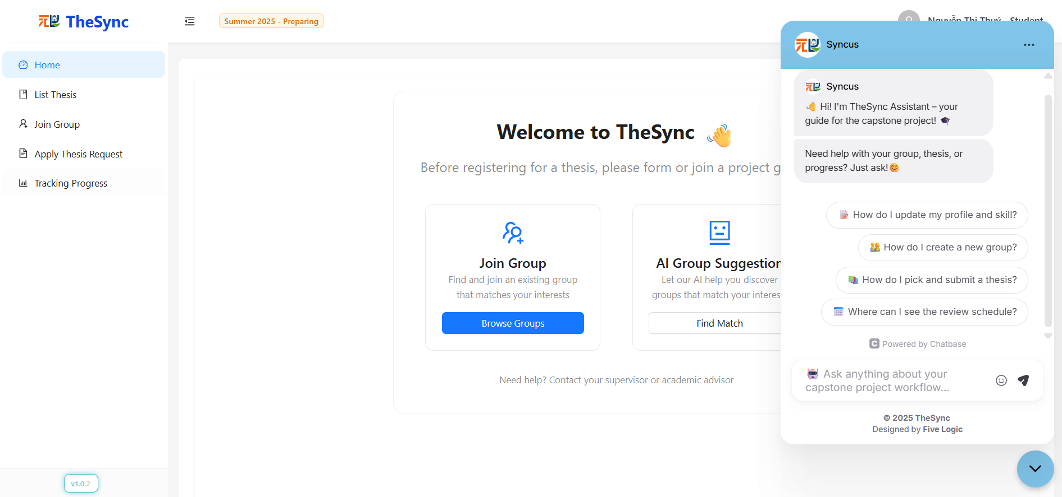

###### Figure III.C.2.e - Chatbot

#### Join group

* **Function Description:** Allows students to join, request to join, or manage group membership. Groups can be empty (no members) or already have members. Students can also manage roles, invitations, membership requests, as well as update their group.
* **Function Trigger:** Triggered when the student navigates to the Join Group page from the sidebar or Browse Groups from the Dashboard.
* Button/Navigation – Trigger – Function
* **Join Now** (on an empty group card) → First student to join becomes Leader.
* **Request to Join** (on a group with existing members) → Sends a join request to the group leader for approval.
* **View Group Detail** (on group card) → Opens detailed view of the selected group (members, leader,...).
* **Invite Member** (inside group detail, if member) → Leader sends an invitation to another student to join the group. Invitation can be canceled before acceptance.
* **Cancel Invitation** (inside group detail, if inviter) → Cancel a previously sent invitation.
* **Change Leader** (inside group detail, leader only) → Assign leadership to another member in the group.
* **Leave Group** 
  + If member (not leader) → Click Leave Group → Leave immediately.
  + If leader and group has ≥ 2 members → Must assign leadership to another member before leaving.
  + If leader and only member in group → Can leave → group becomes empty again.
* **Request to Join Group** (from another group’s detail) → Send request to group. Can cancel request later.
* **Cancel Join Request** (pending requests) → Cancel a previously submitted join request.
* **Accept Request** (leader only, inside group detail) → Approve a pending join request, student is notified, student becomes group member.
* **Reject Request** (leader only, inside group detail) → Reject a pending join request, student is notified.
* **Edit Group** (leader only, inside group detail) → Leader can update group information (e.g., group name,...).
* **Business Rules**: BR-153, BR-154, BR-155, BR-156, BR-157, BR-158, BR-159, BR-160, BR-161, BR-162, BR-163, BR-176

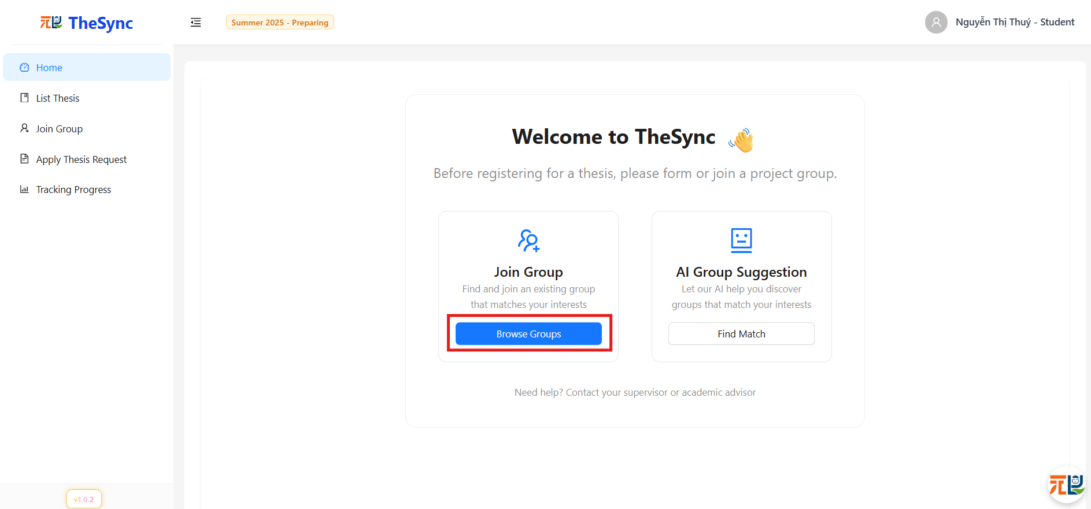

###### Figure III.C.2.f.(1) - Join group

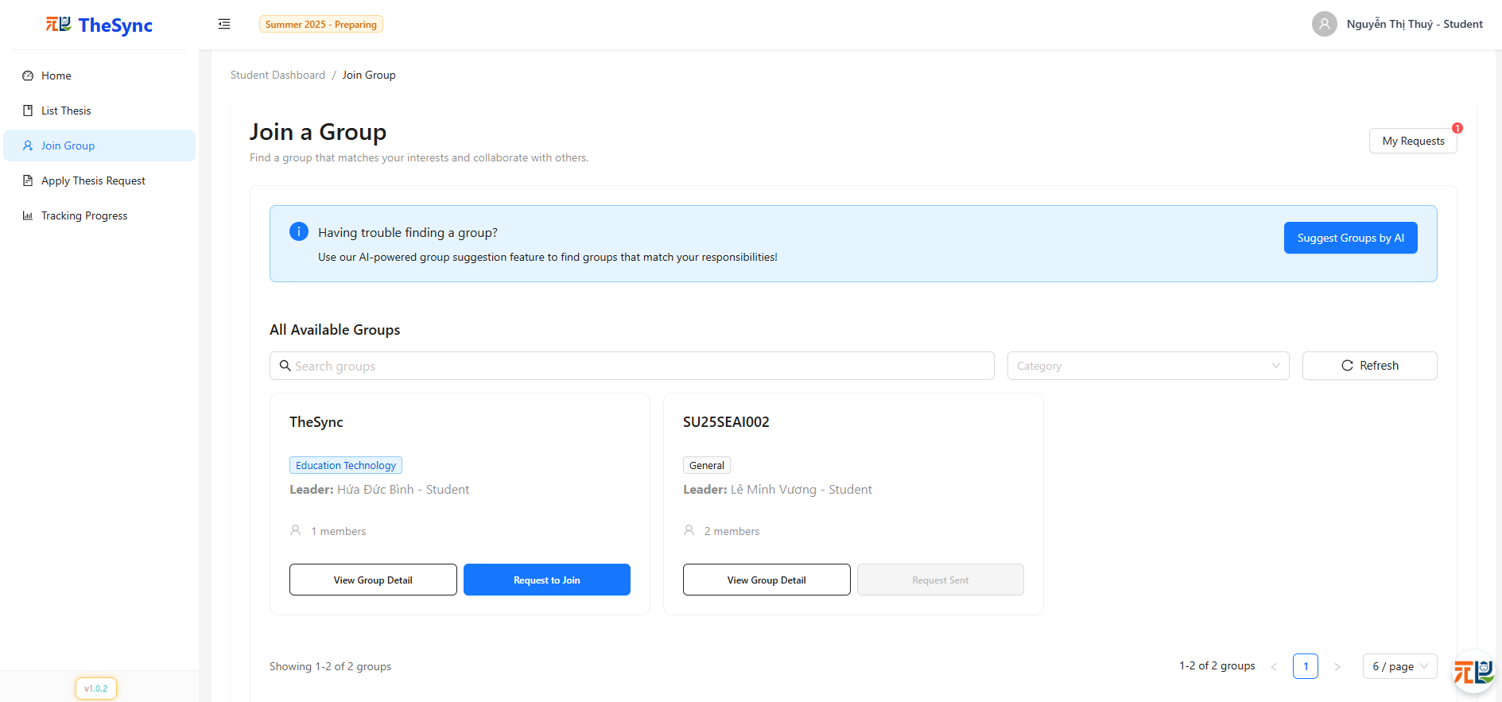

###### Figure III.C.2.f.(2) - Join group

#### Get suggest member by AI

* **Function Description:**  Helps the group leader find suitable members for their group by using AI recommendations. Based on responsibilities, the system suggests a list of students that are likely to be a good fit for the group. The leader can then select students from the suggestion list and send invitations to join the group.
* **Function Trigger:** Triggered when the Group Leader clicks “Invite Members” in the group detail page and then selects “Get Suggestions” by AI.
* Button/Navigation – Trigger – Function
* **Invite Members** (inside group detail, leader only) → Opens the "Invite Members to Group" modal.
* **Get Suggested by AI** (inside modal) → System generates and displays a list of suggested students that match the group’s needs.
* **Select Suggested Students** (select from the list of suggestions) → Leader selects one or more students from the AI suggestions and clicks the “Add” button.
* **Send Invitation** (after selecting students) → Sends invitations to the selected students.
* **Cancel** → Close the modal without sending invitations.
* **Business Rules**: BR-143, BR-144, BR-145, BR-146, BR-147, BR-148, BR-149, BR-150, BR-154, BR-155, BR-156, BR-157, BR-159, BR-160, BR-163, BR-176

###### 

###### Figure III.C.2.g.(1) - Get suggest member by AI

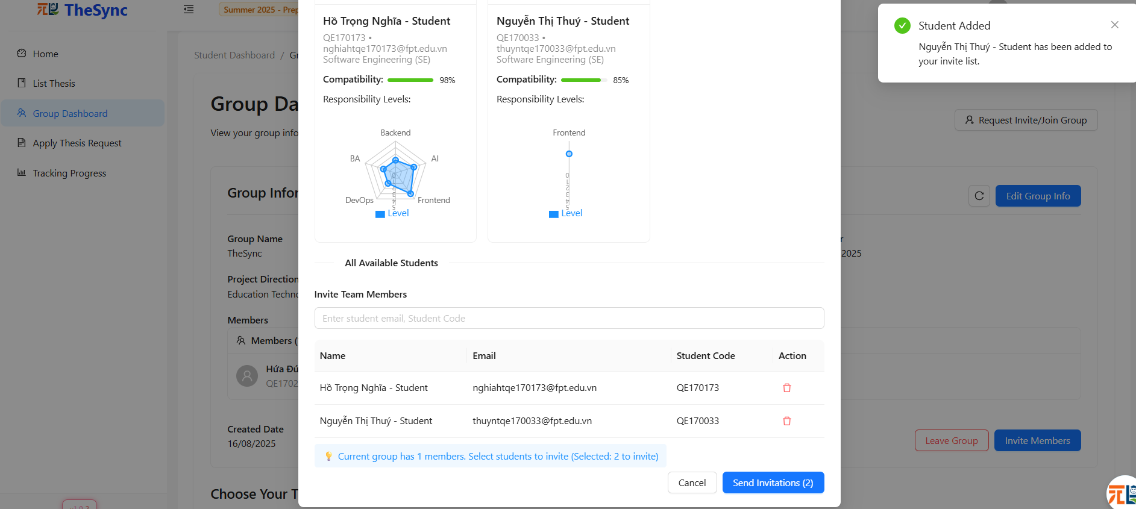

###### Figure III.C.2.g.(2) - Get suggest member by AI

#### Apply Thesis Request

* **Function Description:** Allows a student group to send a request to apply for a thesis.  
  The request will be reviewed by the lecturer and moderator before being officially approved or rejected.  
  In addition, the Register Thesis Request page (in the sidebar) displays all thesis requests submitted by the group along with their status (Approved, Rejected) so students can track their applications.
* **Function Trigger:** Triggered when the student selects a thesis from the list and clicks Register Thesis Request.  
  Also accessible via the sidebar navigation → Register Thesis Request page, which shows the group’s submitted thesis requests and their statuses.
* Button/Navigation – Trigger – Function
* Thesis List Page → Student views available thesis.
* Select Thesis → View Thesis Detail → Opens the detailed thesis information page.
* Register Thesis Request (button) → Sends a request to apply for the selected thesis to the system.
* Cancel Application →Allows the student to cancel their application for this thesis.
* **Business Rules**: BR-171, BR-172, BR-173, BR-174, BR-175, BR-177

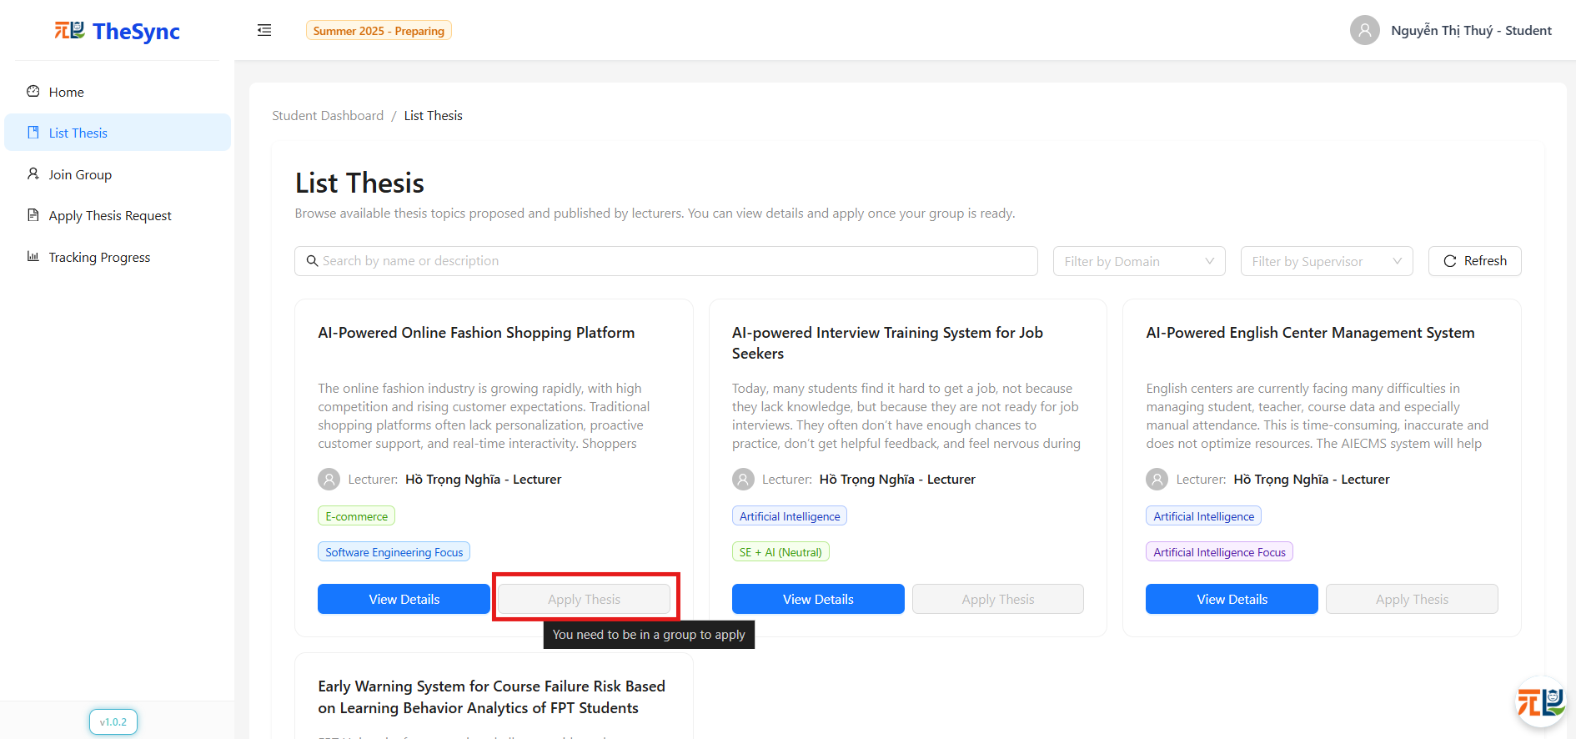

###### Figure III.C.2.h.(1) - Apply Thesis Request

###### 

###### Figure III.C.2.h.(2) - Apply Thesis Request

#### Get suggest thesis by AI

* **Function Description:** Allows students to receive thesis suggestions generated by AI, based on the group’s profile
* **Function Trigger:** Triggered when the student clicks the AI Suggest button on the top-right corner of the List Thesis page.
* **Button/Navigation – Trigger – Function**
* List Thesis (page) → Displays all available theses.
* AI Suggest (button, top-right) → Sends a request to the AI system to generate tailored thesis suggestions.
* System Response → Displays suggested theses.
* View Details → Opens full thesis details.
* Send Request to Apply for Thesis → Allows the group to send an application request for that suggested thesis.
* Unregister (if already applied) → Allows the group to cancel their thesis application.
* **Business Rules**: BR-143, BR-144, BR-145, BR-146, BR-147, BR-148, BR-149, BR-150, BR-171, BR-172, BR-173, BR-174, BR-175, BR-177

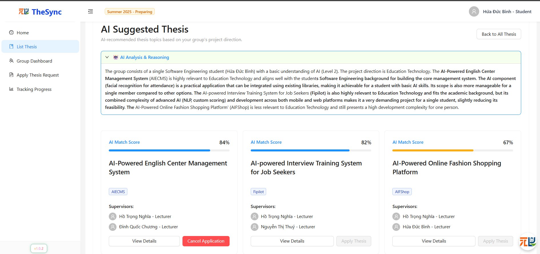

###### Figure III.C.2.i - Get suggest thesis by AI

#### Tracking progress

* **Function Description:** Allows students to view their thesis progress by milestones, including schedule, status, and detailed requirements. If no data is available, the system displays the message *“No milestones found for current semester.”* Students can also:
* Navigate to the thesis detail page.
* Submit deliverables for each milestone.
* View feedback & comments from their lecturer after submission.
* **Function Trigger:** Students click Track Progress from the sidebar.
* **Button/Navigation:**
* Tracking Progress (sidebar).
* View Thesis Details (button in the Progress Overview section).
* Submit Deliverables (button inside each milestone card).
* View Feedback & Comments (button inside each milestone card, displayed only if lecturer feedback exists).
* **Trigger:**
* Clicking Tracking Progress → the system displays the “Track Progress” page.
* Clicking Submit Deliverables → system opens upload form to submit files.
* Clicking View Feedback & Comments → system shows lecturer’s feedback and comments for that milestone.
* Clicking View Thesis Details → the system redirects to the thesis detail page.
* **Function:**
* The system displays the Track Progress interface with two main sections
  + Project Milestones: shows the list of milestones with status (In Progress, Upcoming, Completed).
  + Progress Overview: shows progress details and deadlines.
* If there is no progress data → display message *“No milestones found for current semester.”*
* If data is available
  + Display the timeline of each milestone (Review 1, Review 2, Review 3, Final Review) and deadlines.
  + Allow students to Submit Deliverables for each milestone.
  + Allow students to View Feedback & Comments given by lecturer (if any).
* Students can click View Thesis Details to access the thesis detail page.
* **Business Rules**: BR-164, BR-165, BR-166, BR-167, BR-168, BR-169, BR-170, BR-181, BR-182, BR-185, BR-186

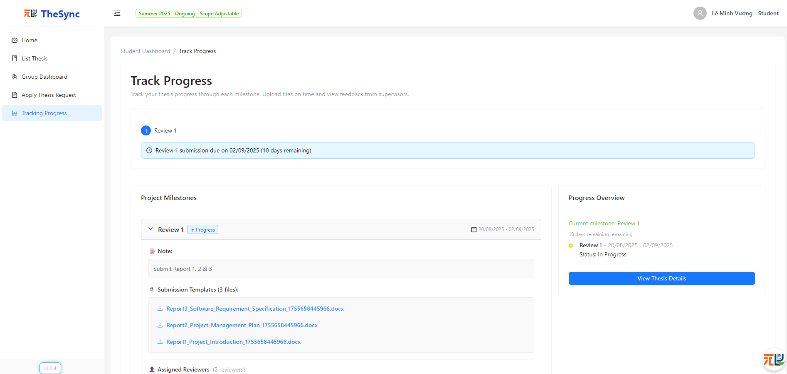

###### Figure III.C.2.j.(1) - Tracking progress

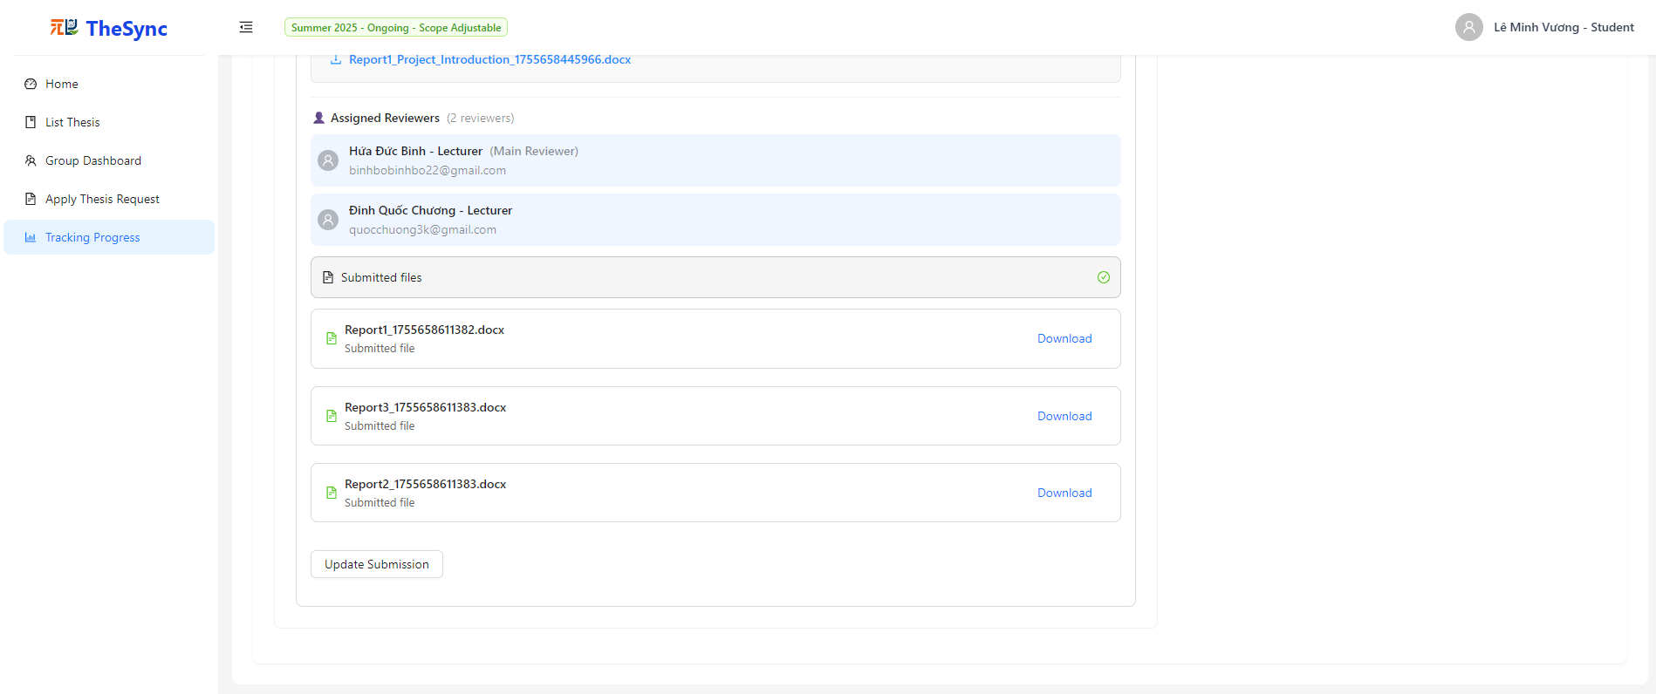

###### Figure III.C.2.j.(2) - Tracking progress

### Website for Lecturer and Moderator

#### Login

* **Function Description:** The login page allows lecturers to securely log in using their registered email and password. The interface provides role-based authentication with additional options to recover forgotten passwords, remember login sessions, and toggle password visibility.
* **Function Trigger:** When the user is not logged in, the Login page will display the Login form:
* Log in with Email + Password
  + **Button/Navigation:** There is an input field for Email and Password, along with a “Sign In” button.
    - **Trigger:** After entering valid credentials and clicking the “Sign In” button.
    - **Function:** The system authenticates the provided credentials. If valid, the user is redirected to the dashboard according to their role (e.g., Lecturer). If invalid, an error message is displayed (“Invalid username/email or password”).
* Remember Me
  + - **Button/Navigation:** A checkbox labeled “Remember Me” is displayed below the login form.
    - **Trigger:** When checked before clicking “Sign In.”
    - **Function:** The system remembers the user’s credentials for future sessions until manually logged out.
* Forgot Password
  + - **Button/Navigation:** A “Forgot password?” link is displayed below the login form.
    - **Trigger:** When clicked, then enters email and clicks "Sending..." button
    - **Function:** The system redirects the user to the Forgot Password page. The user enters their registered email and the OTP received via email. After successful verification, a new password is automatically generated and sent to the user’s email. The system then displays a confirmation message “Password Reset Successful!” with options to check email or return to the login page.
* **Business Rules**: BR-078, BR-079, BR-080, BR-081, BR-082, BR-083, BR-096, BR-101, BR-105, BR-106, BR-107, BR-108, BR-110, BR-111, BR-112

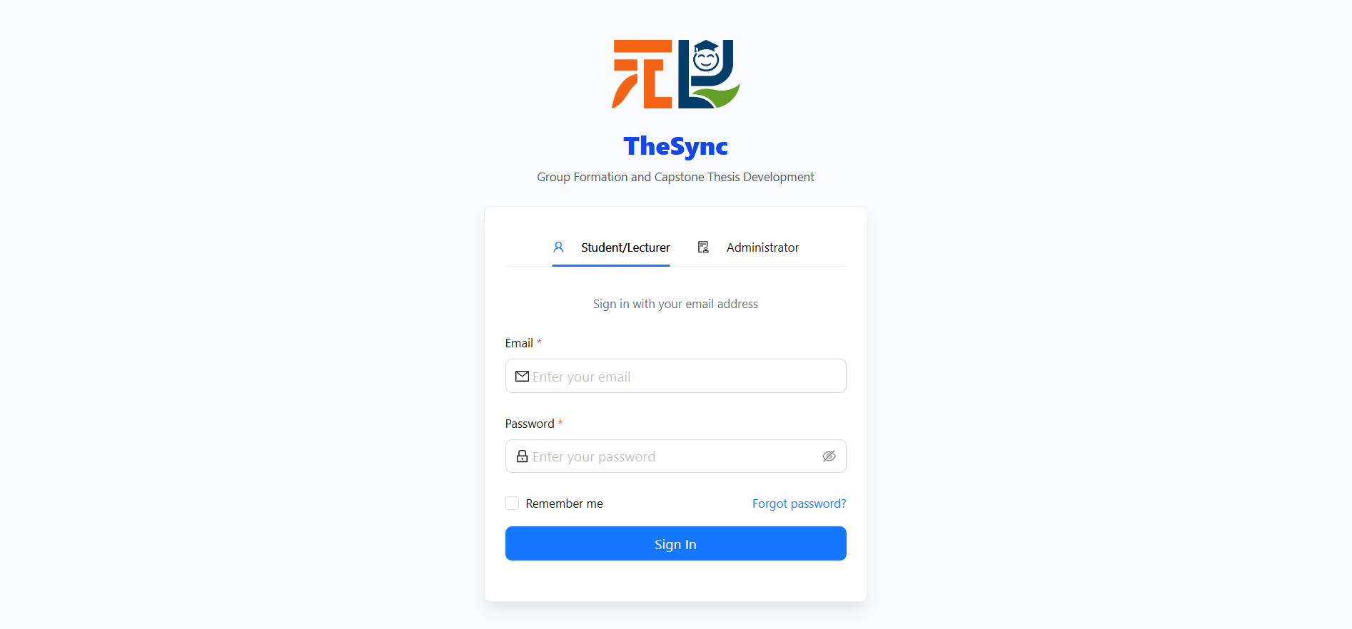

###### Figure III.C.3.a - Login

#### Change Password

* **Function Description:** The Change Password function, located within the Account Settings page, allows logged-in students to update their password by providing the current password and setting a new one that meets the system’s security requirements.
* **Function Trigger:** When the user navigates to the Account Settings page, the Change Password form is displayed in the right panel.
* Enter Current Password
* **Button/Navigation:** Input field for *Current Password*.
* **Trigger:** User enters the current password.
* **Function:** The system verifies the provided password. If incorrect, an error message is displayed (“Current password is incorrect”).
* Enter New Password and Confirm New Password
* **Button/Navigation:** Input fields for *New Password* and *Confirm New Password*.
* **Trigger:** User enters a new password and re-enters it for confirmation.
* **Function:** The system validates that the new password meets complexity rules (minimum 12 characters, including uppercase, lowercase, numbers, and special characters) and matches the confirmation. If invalid, an error message is displayed.
* Update Password
* **Button/Navigation:** Update Password button.
* **Trigger:** After filling in required fields, the user clicks Update Password.
* **Function:** If valid, the system updates the password and displays a success notification. The new password must be used for the next login.
* Additional Options
* **Button/Navigation:** *Clear* button and *Eye icon*.
* **Trigger:**
  + *Clear* → When clicked, all fields are reset.
  + *Eye icon* → When clicked, toggles password visibility.
* **Function:** Provides convenience for entering password fields.
* **Business Rules**: BR-009, BR-010, BR-013, BR-014, BR-015, BR-096, BR-101, BR-111, BR-112, BR-151

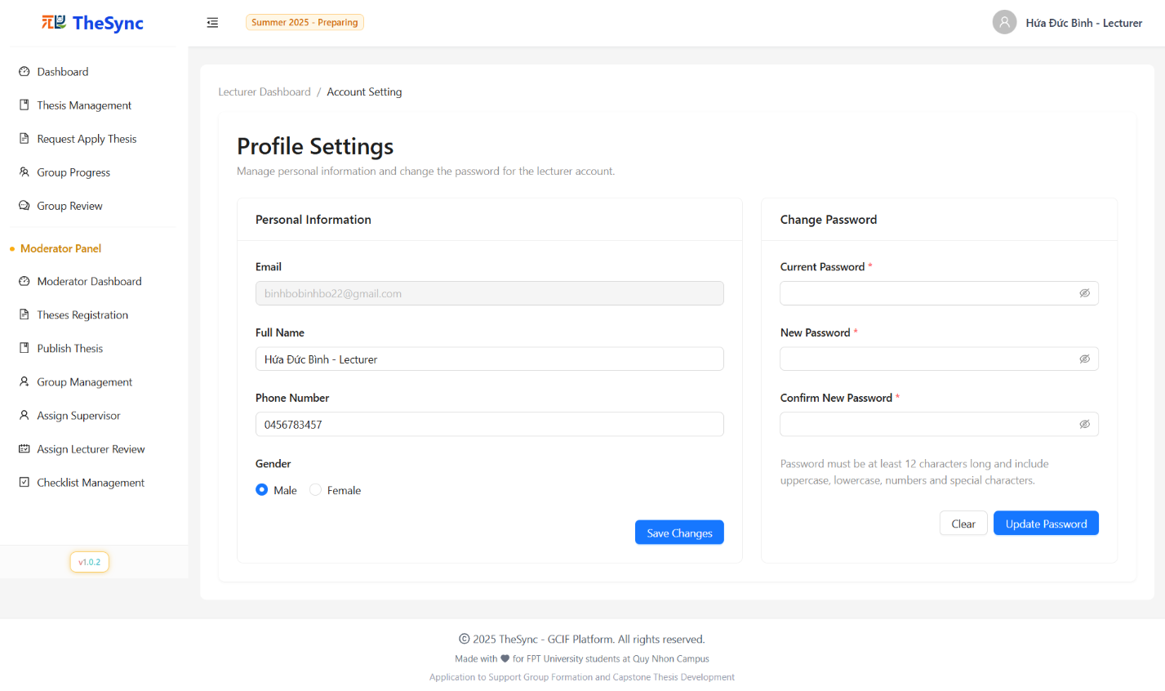

###### Figure III.C.3.b - Change Password

#### Update personal information:

* **Function Description:** The Personal Information section, located within the *Account Settings* page, allows users to view their registered details such as full name, email phone number and gender. This section is view-only and does not allow direct edits to ensure data integrity.
* **Function Trigger:** When the user navigates to the *Account Settings* page, the Personal Information panel is displayed on the left side.
* View Information
* **Button/Navigation:** Static display fields (*Email, Full Name, Phone Number, Gender...*).
* **Trigger:** Page load.
* **Function:** The system fetches and displays the user’s information from the database.
* Update Information
* **Button/Navigation:** Editable input fields (Full Name, Phone Number, Gender), non-editable fields (Email).
* **Trigger:** User clicks directly on an editable field to modify its value.
* **Function:** The system accepts user input, and when the Save Changes button is clicked, it validates the data and updates the database. A success/failure notification is displayed accordingly.
* **Business Rules:** BR-048, BR-052, BR-088, BR-089, BR-096, BR-101, BR-106, BR-107, BR-108



###### Figure III.3.c - Update personal information

#### Dashboard

* **Function Description:** The Dashboard provides lecturers with a comprehensive overview of their thesis supervision and academic responsibilities through an interactive interface. It displays key metrics, thesis project information, assigned groups, milestone timelines, and workload distribution with quick access to critical information and actions.
* **Function Trigger:** When the lecturer navigates to the Dashboard page from the main navigation menu or lands on it as the default page after successful login.
* View Dashboard Statistics
* **Button/Navigation:** Dashboard statistics cards displaying key metrics and summary information.
* **Trigger:** Page load automatically displays current supervision statistics.
* **Function:** The system presents key summary metrics including total number of supervised theses, student assignment counts, supervision workload and capacity indicators, and recent activity status updates.
* View My Thesis Section
* **Button/Navigation:** My Thesis section with thesis project cards and information display.
* **Trigger:** Page load displays all assigned thesis projects in a dedicated section.
* **Function:** The system displays thesis project cards containing project titles and descriptions, student assignments and group information, status indicators and progress tracking, with action buttons for detailed access to each thesis project.
* View Assigned Groups Table
* Button/Navigation: Assigned Groups table with student group information and management options.
* Trigger: Page load displays tables of all assigned student groups.
* Function: The system presents student assignment and group formation data in tabular format, showing group compositions, assignments status, and providing access to group management functions and detailed group information.
* View Milestones Timeline
* Button/Navigation: Milestones Timeline section displaying project milestones and deadlines.
* Trigger: Page load displays timeline of important milestones and deadlines.
* Function: The system shows upcoming deadlines and important dates, recent activities and status changes, milestone progress tracking across all supervised projects, with visual timeline representation of key academic milestones.
* Access Quick Actions
* Button/Navigation: Action buttons within thesis project cards and dashboard elements.
* Trigger: User clicks on action buttons or interactive elements within dashboard components.
* Function: The system provides direct access to common functions such as viewing detailed project information, updating project status, accessing project documents, and navigating to related sections for deeper functionality.
* **Business Rules:** BR-106, BR-107, BR-108, BR-109, BR-113, BR-114, BR-115, BR-116, BR-117, BR-118, BR-119, BR-120

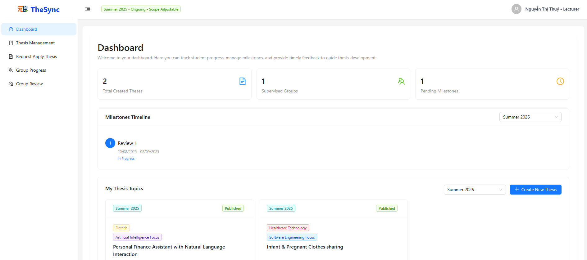

###### Figure III.3.d.(1) - Dashboard

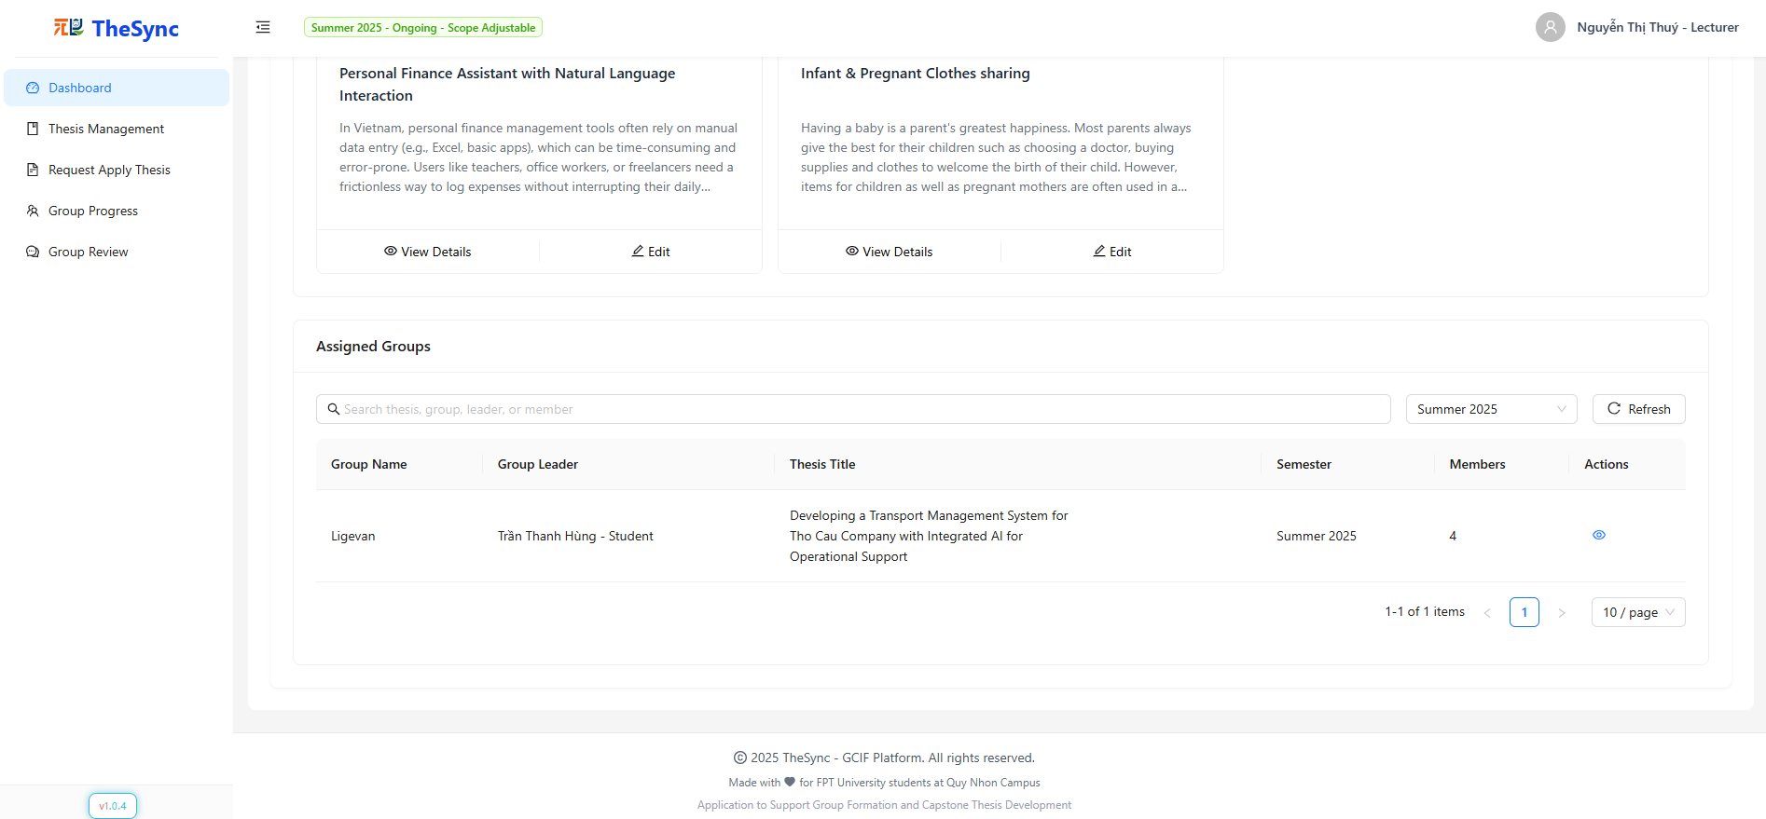

###### Figure III.3.d.(2) - Dashboard

#### Thesis Management:

* **Function Description:** The Thesis Management page allows lecturers to manage their thesis proposals throughout the academic lifecycle. Lecturers can create, view, edit, delete, and submit thesis proposals for approval. The system provides comprehensive filtering, status tracking, and ownership-based access control to ensure proper thesis workflow management.
* **Function Trigger:** When a lecturer successfully logs into the system and selects "Thesis Management" from the sidebar navigation.
* **Button/Navigation:**
* Filter Bar:
* Search input - Filter theses by title or content
* Status dropdown - Filter by thesis status (New, Pending, Approved, Rejected)
* Owned filter - Toggle to show only lecturer's own theses
* Semester dropdown - Filter by academic semester
* Refresh button - Reload thesis list from database
* Create Thesis button - Navigate to thesis creation page
* Table Actions:
* Submit button (Send icon) - Submit thesis for approval/review
* More actions dropdown (MoreOutlined icon):
* View Details (Eye icon) - View thesis details
* Edit Thesis (Edit icon) - Modify thesis information
* Delete (Delete icon) - Remove thesis from system
* **Trigger:**
* Filter/Search Operations:
* Select search input → Filter displayed theses by title/content matching
* Select status filter → Display theses matching selected status
* Toggle owned filter → Show only lecturer's own theses or all theses
* Select semester filter → Display theses from selected semester
* Click refresh → Reload and display updated thesis list
* Navigation Actions:
  + Click "Create Thesis" → Navigate to thesis creation form page
  + Click "View Details" → Navigate to thesis detail view page
  + Click "Edit Thesis" → Navigate to thesis editing form page
* Thesis Management Actions:
  + Click Submit button → Show confirmation modal → Confirm → Submit thesis for approval (status changes to Pending)
  + Click Delete → Show confirmation modal → Confirm → Remove thesis from system
  + Click Edit → Navigate to edit form → Update thesis information
  + Click View → Display detailed thesis information
* **Function:**
* Data Display:
* Thesis Table: Displays comprehensive thesis list with columns for title, owner, semester, status, creation date, and actions
* Status Indicators: Color-coded status badges (New, Pending, Approved, Rejected) for visual status recognition
* Ownership Control: Security-based access control ensuring lecturers can only modify their own theses
* Status-Based Actions:
* New Status: Full edit access, can submit for approval, can delete
* Rejected Status: Can edit and resubmit, can delete
* Pending Status: Read-only access, cannot edit or delete while under review
* Approved Status: Can edit but cannot delete, can resubmit if changes needed
* Security Features:
* Ownership Validation: Ensures lecturers can only access and modify their own theses
* Role-based Access: Actions disabled for theses not owned by current lecturer
* Status-based Permissions: Edit/delete permissions based on current thesis status
* **Business Rules**: BR-097, BR-098, BR-106, BR-121, BR-122, BR-123, BR-124, BR-125, BR-126, BR-127, BR-128, BR-129

###### Figure III.3.e - Thesis Managerment

#### Create Thesis

* **Function Description:** The Create Thesis page allows lecturers to create new thesis proposals for students to review and register. The system provides a comprehensive form with file upload capabilities, validation, and duplicate detection. The form includes both English and Vietnamese titles, domain selection, orientation specification, detailed descriptions, and supporting document uploads with template downloads available.
* **Function Trigger:** When a lecturer successfully logs into the system and selects "Create Thesis" from the thesis management section or clicks the "Create Thesis" button from the filter bar.
* **Button/Navigation:**
  + Form Fields:
* English/Vietnamese Title inputs - Required thesis titles
* Abbreviation input - Required thesis code
* Domain dropdown - Searchable thesis field selection
* Description textarea - Required detailed description
* Orientation dropdown - Optional thesis focus area
* Supporting Document upload - Required file upload area
* File Actions:
* Upload area (drag-and-drop) - Upload DOC/DOCX files
* Download Template button - Get thesis template
* Replace/Download/Delete buttons - Manage uploaded files
* Form Actions:
* Create Thesis button - Submit and create new thesis
* **Trigger:**
  + Form Operations:
* Type in fields → Real-time validation and change detection
* Select domain/orientation → Set thesis categorization
* Upload file → Validate type/size → Store document
* Click "Download Template" → Download official template
* Click "Create Thesis" → Validate → Upload file → Create thesis record
* **Function:**
  + Form Management:
* Field Validation: Real-time validation with error messages
* Change Detection: Tracks modifications for submit button state
* Character Limits: Description counter and validation
* Searchable Fields: Domain dropdown with search functionality
* File Upload System:
* Drag-and-Drop: Visual upload area with file validation
* File Restrictions: DOC/DOCX only
* Template Support: Official template download for formatting
* File Management: Replace, download, delete operations
* **Business Rules**: BR-086, BR-095, BR-096, BR-099, BR-106, BR-121, BR-122, BR-185, BR-186

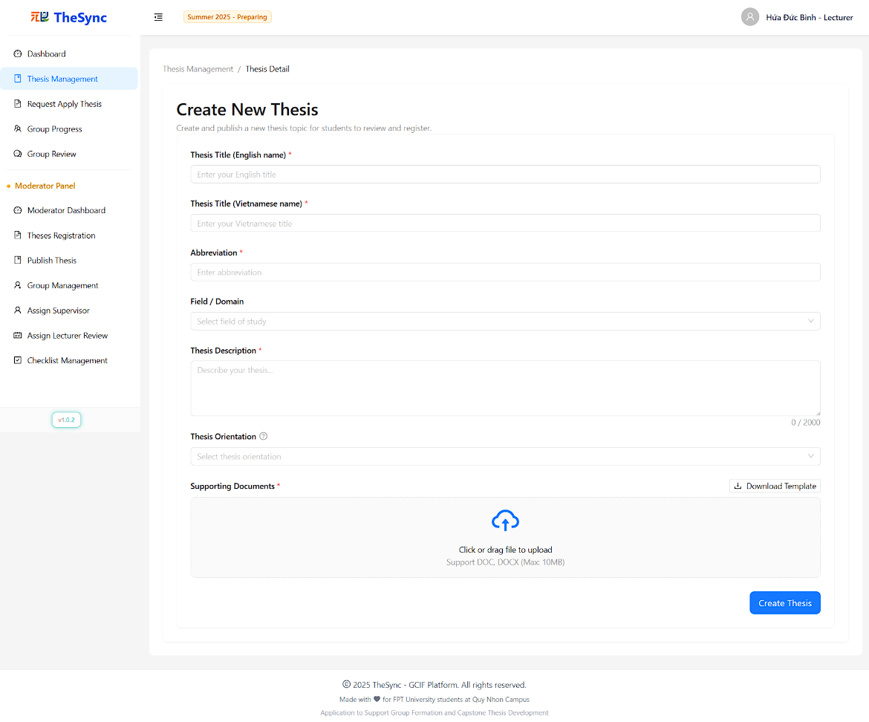

###### Figure III.3.f - Create Thesis

#### Request apply Thesis:

* **Function Description:** The Request Apply Thesis page allows lecturers to review and manage thesis application requests from student groups. Lecturers can view thesis details, examine student group information, and approve or reject applications to assign theses to groups. The system provides comprehensive filtering, detailed modal views, and status tracking to facilitate efficient thesis assignment workflow management.
* **Function Trigger:** When a lecturer successfully logs into the system and selects "Request Apply Thesis" from the sidebar navigation.
* **Button/Navigation:**
* Filter Bar:
* Search input - Filter theses by name, abbreviation, or other criteria
* Orientation dropdown - Filter by thesis orientation (e.g., Research, Application, etc.)
* Domain dropdown - Filter by thesis domain/field
* Refresh button - Reload thesis requests from database
* Table Actions:
* View Details button (Eye icon) - View comprehensive thesis information
* View Requests button (List icon) - View and manage application requests for specific thesis
* Badge indicator - Shows pending requests count for each thesis
* Thesis Requests Modal:
* Search input - Filter requests by group name, code, leader information
* Status filter - Filter by request status (Pending, Approved, Rejected)
* Approve button (Check icon) - Approve thesis application
* Reject button (Close icon) - Reject thesis application
* Refresh button - Reload requests data
* Group Detail Modal:
* Group information display - View group name and code
* Member list - View all group members with details
* **Trigger:**
* Filter/Search Operations:
* Select search input → Filter displayed theses by name/abbreviation matching
* Select orientation filter → Display theses matching selected orientation
* Select domain filter → Display theses from selected domain
* Click refresh → Reload and display updated thesis list with requests
* Thesis Information Access:
* Click "View Details" → Open thesis detail modal → Display comprehensive thesis information
* Click "View Requests" → Open thesis requests modal → Display all applications for selected thesis
* Click group name link → Open group detail modal → Display group members and information
* Request Management Actions:
* Click Approve button → Show confirmation modal → Confirm → Approve application and assign thesis to group
* Click Reject button → Show confirmation modal → Confirm → Reject application and update status
* Search in requests modal → Filter requests by group/student information
* Filter by status → Display requests matching selected status
* **Function:**
* Data Display:
* Thesis Table: Displays lecturer's theses with application information including thesis details, assigned groups, and action buttons
* Status Tracking: Shows assigned groups and pending request counts with badge indicators
* Comprehensive Filtering: Multi-level filtering by orientation, domain, and search criteria
* Thesis Detail Modal:
* Complete thesis information (English/Vietnamese names, abbreviation, orientation, domain, status)
* Lecturer information with moderator status indication
* Semester details and thesis limits
* Full description and timestamps
* Thesis Requests Modal:
* Group information with leader details
* Request timestamps and status tracking
* Individual approve/reject actions with confirmations
* Group Detail Modal:
* Group name and code display
* Complete member list with roles (Leader identification)
* Student information (name, code, email, phone, gender)
* Visual member count and organization
* Application Management:
* Status-based Actions: Approve/reject buttons only enabled for pending requests
* Confirmation Modals: Safety confirmations for all approval/rejection actions
* Loading States: Individual loading indicators for approval/rejection actions
* Security Features:
* Lecturer Ownership: Only displays theses belonging to the current lecturer
* Status Validation: Actions restricted based on current application status
* Data Integrity: Prevents duplicate approvals and maintains request consistency
* **Business Rules**: BR-092, BR-095, BR-096, BR-097, BR-098, BR-106, BR-123, BR-172, BR-173, BR-174, BR-177

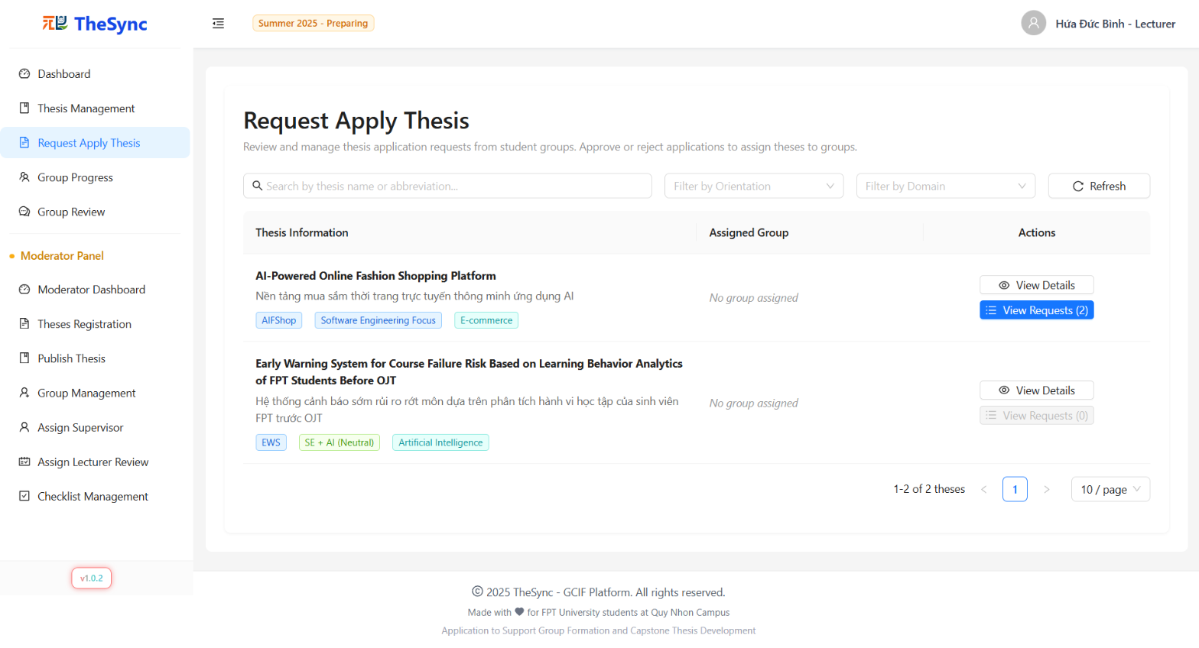

###### Figure III.3.g - Request apply Thesis

#### Group Progress

* **Function Description:** The Group Progress page allows lecturers to monitor supervised student groups and track their milestone progress throughout the semester. Lecturers can view group details, thesis assignments, milestone submissions, and review feedback to evaluate group performance and provide guidance.
* **Function Trigger:** When a lecturer successfully logs into the system and selects "Group Progress" from the sidebar navigation.
* **Button/Navigation:**
* Filter Bar:
* Search input - Filter groups by name, code, project direction, or thesis title
* Semester dropdown - Select semester to view groups from specific academic period
* Refresh button - Reload group and milestone data from database
* Group Table Actions:
* View button (Eye icon) - Select and view detailed group information
* Row selection - Click any row to select group for detailed view
* Group Detail Actions:
* Track Milestones button - Navigate to milestone tracking interface
* View Thesis Details button - Navigate to thesis information page
* Milestone Navigation:
* Milestone Steps - Click on milestone steps to switch between different milestones
* Document download buttons - Download submitted files from groups
* **Trigger:**
* Group Selection Operations:
  + Type in search → Filter groups by multiple criteria (name, code, direction, thesis)
  + Select semester → Load groups and milestones for selected semester
  + Click refresh → Reload current semester data

information

* Milestone Tracking:
* Click milestone step → Switch to selected milestone view
* Navigate between milestones → Update submission and review data
* Click document link → Download submitted files
* **Function:**
* Group Management:
* Search & Filter: Multi-criteria search across group properties with semester filtering
* Group Overview: Comprehensive table showing group name, code, thesis title, project direction, and member count
* Group Detail Display:
* Group Information: Complete group details including members, skills, responsibilities, and semester info
* Supervisor Information: Display assigned thesis supervisor with contact details
* Thesis Status: Current thesis assignment status with progress indicators
* Progress Overview: Milestone timeline with current/next milestone highlights
* Milestone Tracking:
* Step Navigation: Interactive milestone steps with visual progress indicators
* Submission Management: Display submitted documents with download capabilities
* Review Integration: Show existing reviews with detailed feedback access
* Date Tracking: Milestone periods with start/end dates and time remaining
* Security Features:
* Supervisor Validation: Only displays groups supervised by current lecturer
* User Context: Automatic cache clearing on user changes
* Session Management: Validates user authentication before data access
* Data Isolation: Prevents data leakage between different user sessions
* **Business Rules**: BR-095, BR-097, BR-098, BR-106, BR-114, BR-115, BR-116, BR-164, BR-165, BR-166, BR-167, BR-168, BR-185, BR-186

###### Figure III.3.h - Group Progress

#### Group Review

* **Function Description:** The Group Review page allows lecturers to review and evaluate student group submissions using structured checklists for different milestones. Lecturers can view assigned review tasks, complete checklist evaluations, provide feedback, and manage existing reviews throughout the thesis development process.
* **Function Trigger:** When a lecturer successfully logs into the system and selects "Group Review" from the sidebar navigation.
* **Button/Navigation:**
* Filter Bar:
* Search input - Filter groups by name, English name, or project direction
* Semester dropdown - Select semester to view review assignments
* Milestone Steps - Interactive steps to filter by specific milestones
* Refresh button - Reload review assignments from database
* Group Table Actions:
* View button (Eye icon) - Select group for detailed review interface
* Row selection - Click any row to view group review details
* Review Interface:
* Checklist Response Options:
* Yes/No/N/A radio buttons - Answer checklist questions
* Notes input fields - Add detailed comments for each item
* General Feedback textarea - Provide overall submission feedback
* Review Management:
* Submit Review button - Complete and submit review evaluation
* Edit Review button (Pencil icon) - Modify existing reviews
* Download buttons - Access submitted files and documents
* **Trigger:**
* Group Selection & Filtering:
* Type in search → Filter groups by multiple criteria
* Select semester → Load review assignments for selected period
* Click milestone step → Filter by specific milestone phase
* Click refresh → Reload current assignments and data
* Review Submission Process:
* Select group → Display review interface with checklist and files
* Answer checklist items → Complete required and optional evaluations
* Enter feedback → Provide comprehensive submission assessment
* Click "Submit Review" → Validate responses → Submit completed review
* Review Management:
* Click "Edit Review" → Open edit modal → Modify existing evaluations
* Save changes → Update review with modified responses and feedback
* View existing reviews → Display completed evaluations with timestamps
* **Function:**
* Assignment Management:
* Review Distribution: Displays groups assigned for review with main/secondary reviewer roles
* Semester Integration: Filters assignments by academic semester with milestone tracking
* Supervisor Information: Shows thesis supervisors with loading states for complete context
* Review Interface:
* Structured Checklists: Milestone-specific evaluation criteria with required/optional items
* File Access: Direct download links to submitted documents and supporting materials
* Response Validation: Ensures all mandatory questions are answered before submission
* Role-based Access: Different permissions for main reviewers (view-only) vs secondary reviewers (submit)
* Review Process:
* Checklist Evaluation: Yes/No/N/A responses with individual notes for each criterion
* General Feedback: Comprehensive text feedback for overall submission assessment
* Priority Indicators: Visual tags showing required vs optional checklist items
* Time Validation: Submission only allowed during active milestone periods
* Review Management:
* Existing Reviews Display: List of completed reviews with reviewer information and timestamps
* Edit Functionality: Modify responses and feedback for submitted reviews
* Change Detection: Tracks modifications to enable/disable save actions
* Reviewer Attribution: Clear identification of main vs secondary reviewers
* Data Security & Validation:
* Assignment Verification: Only displays groups assigned to current lecturer for review
* Mandatory Validation: Prevents submission without completing required checklist items
* Feedback Requirements: Enforces general feedback before review submission
* Time Restrictions: Validates milestone periods before allowing review submissions
* Review Workflow:
* Assignment Display: Shows reviewer role (main/secondary) with appropriate permissions
* Milestone Context: Displays current milestone period with active/inactive status
* File Integration: Direct access to submission documents for evaluation
* **Business Rules**: BR-051, BR-086, BR-092, BR-095, BR-096, BR-097, BR-098, BR-106, BR-114, BR-164, BR-165, BR-166, BR-167, BR-185, BR-186

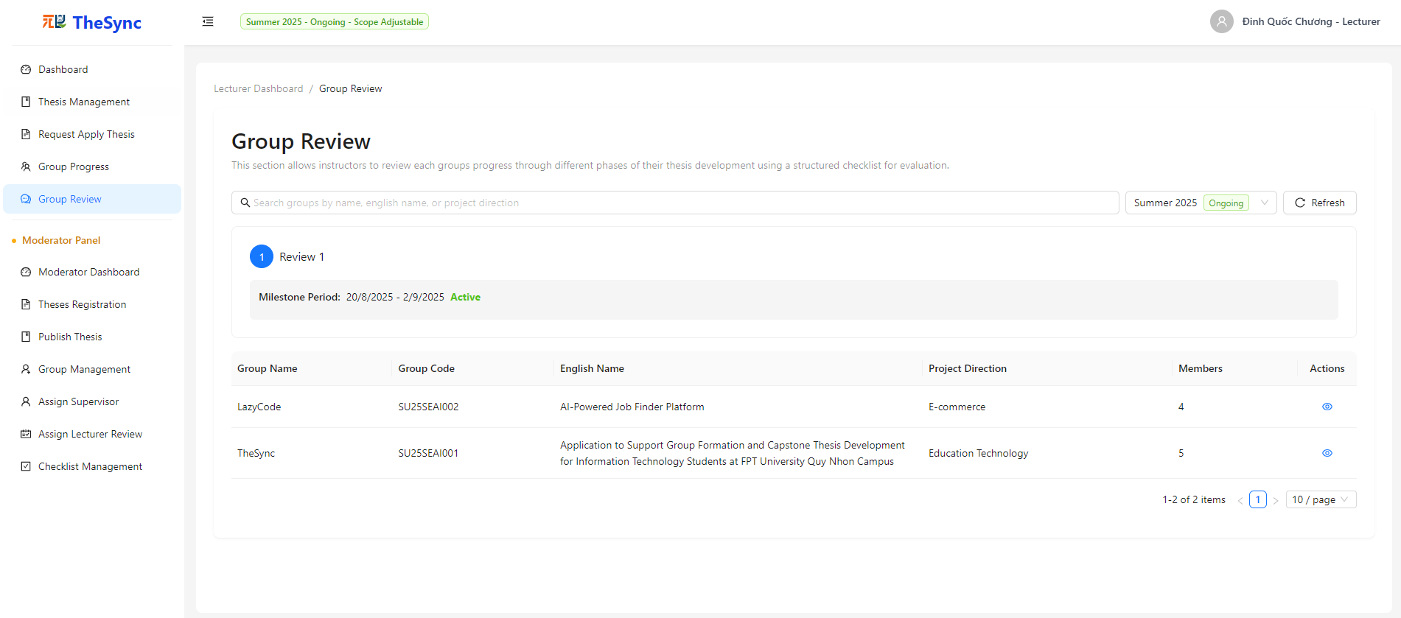

###### Figure III.3.i.(1) - Group Review

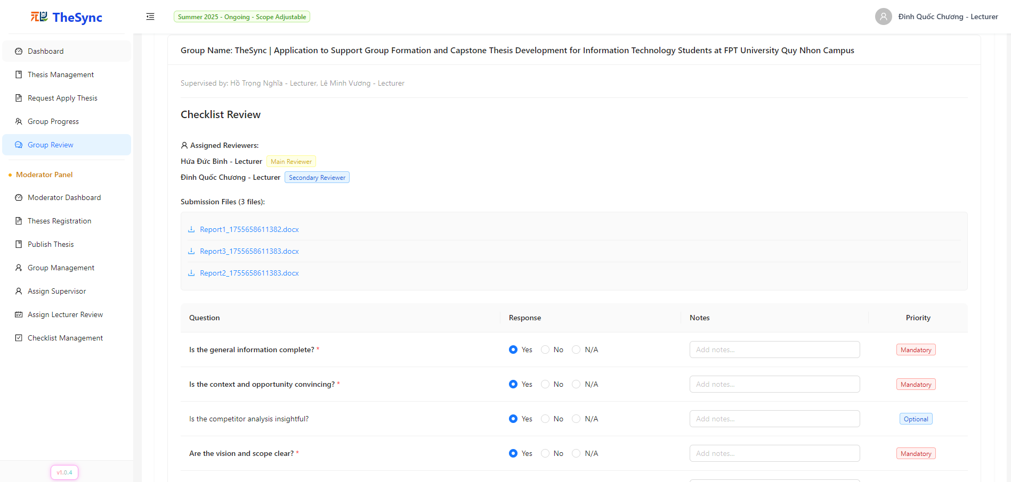

###### Figure III.3.i.(2) - Group Review

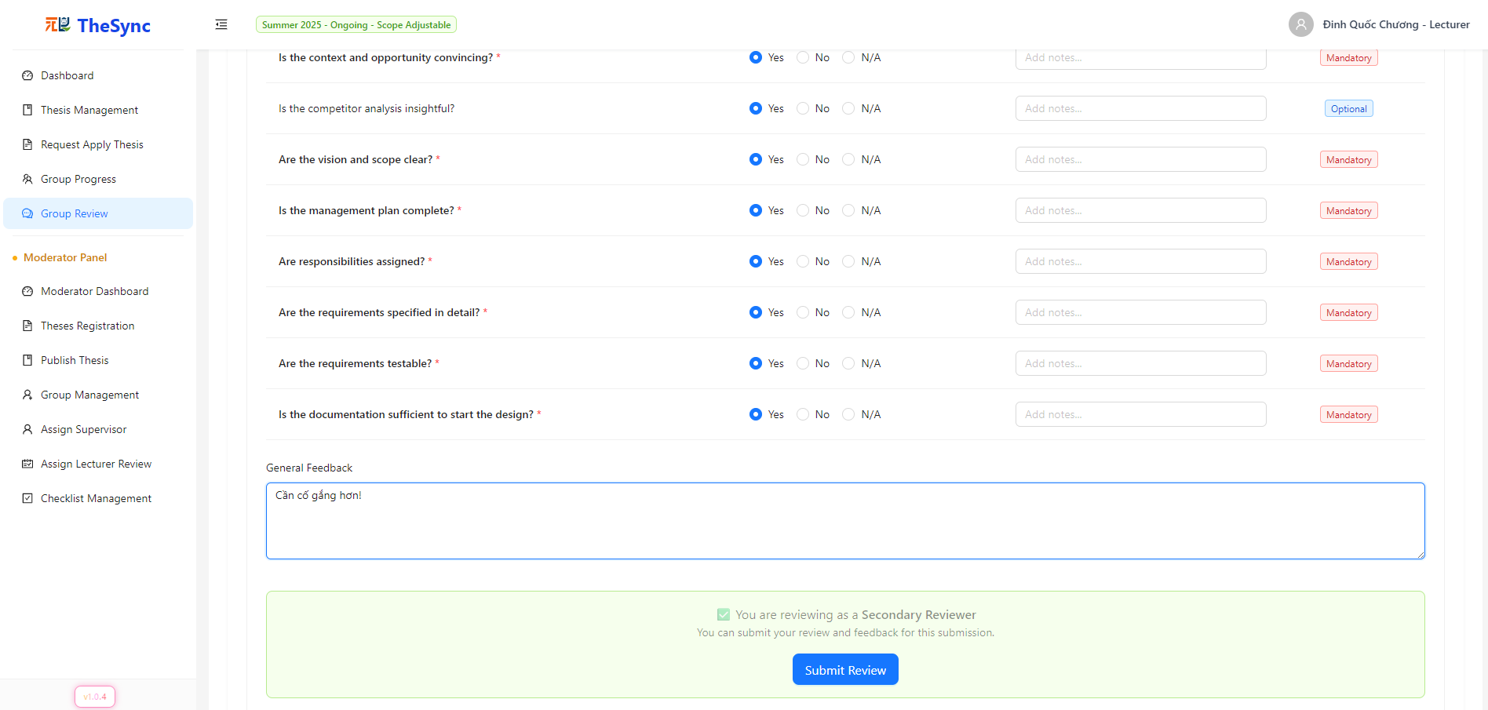

###### Figure III.3.i.(3) - Group Review

#### Moderator Dashboard

* **Function Description:** The Dashboard provides moderators with a comprehensive overview of thesis management progress for the selected semester. It displays key metrics (students, lecturers, theses, groups), semester statistics, progress tracking, and supervisor load distribution. Interactive charts and real-time updates support effective system monitoring and decision-making for thesis supervision coordination.
* **Function Trigger:** When a moderator successfully logs into the system and selects the Dashboard option from the sidebar.
* **Button/Navigation:**
* Semester Controls:
  + Semester dropdown - Select academic semester to view data
* Auto-selection - Automatically selects active semester (Preparing, Picking, or Ongoing)
* Supervisor Load Chart:
  + Search input - Filter supervisors by name or thesis count
  + Category filter dropdown - Filter by load category (Over Load, High Load, Moderate Load, Low Load)
  + Results counter - Shows filtered count vs total supervisors
* Interactive Elements:
* Progress bars - Clickable tooltips showing detailed metrics
* Supervisor load bars - Hover effects with detailed load information
* Statistics cards - Display summary metrics with loading states
* **Trigger:**
* Data Loading Operations:
* Select semester → Load all dashboard data for selected semester
* Page load → Auto-select active semester → Fetch dashboard metrics
* Dashboard refresh → Reload statistics, progress, and supervisor data
* Chart Interactions:
* Type in supervisor search → Filter supervisor load chart by name/count
* Select load category → Display supervisors matching selected load level
* Hover over progress bars → Show detailed completion tooltips
* Hover over supervisor bars → Display individual load information
* **Function:**
* Statistics Overview:
  + Summary Cards: Display total students, lecturers, theses, and groups with clean numeric indicators
* Semester Progress Tracking:
  + Students Grouped: Percentage of students who have formed groups
  + Groups with Thesis: Percentage of groups that have selected thesis topics
  + Thesis Approved: Percentage of submitted theses that have been approved
  + Assigned Supervisors: Percentage of lecturers assigned as thesis supervisors
  + Progress Visualization: Color-coded progress bars with interactive tooltips
* Load Categorization:
  + Low Load (0-1 theses) - Green gradient
  + Moderate Load (2-3 theses) - Blue gradient
  + High Load (4-5 theses) - Orange gradient
  + Over Load (6+ theses) - Red gradient
  + Interactive Chart: Horizontal bar chart with hover effects and value labels
  + Search & Filter: Real-time filtering by supervisor name and load category
* Data Management:
  + Semester Integration: Synchronized data loading across all components when semester changes
  + Progressive Loading: Individual component loading states for better user experience
* Business Intelligence:
  + Load Balancing Insights: Visual identification of supervisor workload distribution
  + Progress Monitoring: Track semester milestones and completion rates
* **Business Rules**: BR-095, BR-097, BR-107, BR-108, BR-109, BR-117, BR-118, BR-119, BR-120

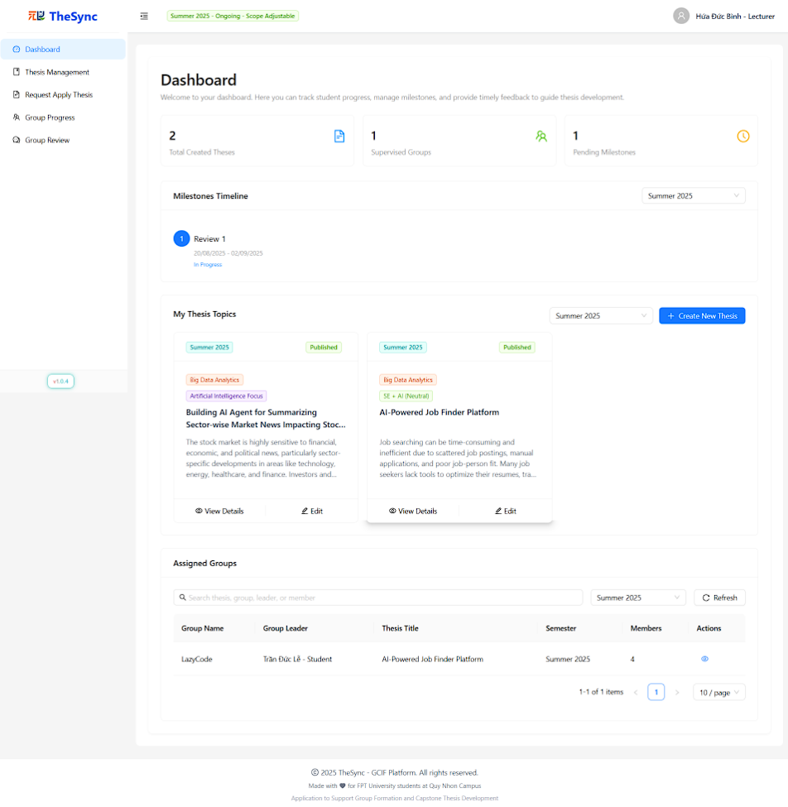

###### Figure III.3.j - Moderator Dashboard

#### Theses Registration

* **Function Description:** The Theses Registration page allows moderators to review and approve/reject pending thesis submissions from lecturers. The system provides a comprehensive review interface with filtering capabilities, detailed thesis information, and streamlined approval workflow to manage thesis registration efficiently.
* **Function Trigger:** When a moderator successfully logs into the system and selects "Theses Registration" from the sidebar navigation.
* **Button/Navigation:**
* Filter Bar:
  + Search input - Filter theses by title, description, domain, or abbreviation
  + Semester dropdown - Filter by academic semester
  + Refresh button - Reload pending thesis submissions from database
* Table Actions:
  + View Details button (Eye icon) - Navigate to detailed thesis information page
  + Approve button (Check icon) - Approve pending thesis submission
  + Reject button (Close icon) - Reject pending thesis submission
* Status Display:
  + Status badges - Color-coded status indicators for thesis states
  + Empty state message - Shows when no pending submissions are available
* **Trigger:**
* Filter Operations:
  + Type in search → Filter theses by multiple criteria (title, description, domain, abbreviation)
  + Select semester → Display theses from selected academic period
  + Click refresh → Reload current pending submissions
* Review Actions:
  + Click "View Details" → Navigate to comprehensive thesis information page
  + Click "Approve" → Show confirmation modal → Confirm → Approve thesis and update status
  + Click "Reject" → Show confirmation modal → Confirm → Reject thesis and update status
* Confirmation Process:
  + Approve/Reject actions → Display confirmation modals with action descriptions
  + User confirms → Execute review action → Show success/error notification
  + User cancels → Reset loading state and return to table
* **Function:**
* Data Management:
  + Automatic Filtering: Only displays theses with "Pending" status for review
* Review Workflow:
  + Status Validation: Only pending theses are available for review actions
  + Confirmation Modals: Safety confirmations for all approve/reject actions
  + Action Feedback: Success/error notifications after each review action
* Table Features:
  + Comprehensive Columns: Title, owner, semester, status, creation date, and actions
  + Pagination: Standard table pagination for large datasets
* Security & Validation:
  + Role-based Access: Only moderators can access thesis registration page
  + Action Validation: Prevents multiple simultaneous actions on same thesis
  + Status Consistency: Ensures only pending theses can be reviewed
* Business Logic:
  + Status Progression: Approved theses move to active status for student selection
  + Rejection Handling: Rejected theses return to lecturer for revision
  + Semester Integration: Links thesis approval to specific academic periods
  + Owner Attribution: Maintains thesis ownership by original lecturer
* Navigation Integration:
  + Detail View: Seamless navigation to detailed thesis information
  + Loading Management: Consistent navigation loading states
  + State Preservation: Maintains filter states during navigation
* **Business Rules**: BR-092, BR-095, BR-097, BR-098, BR-107, BR-108, BR-109, BR-130, BR-131

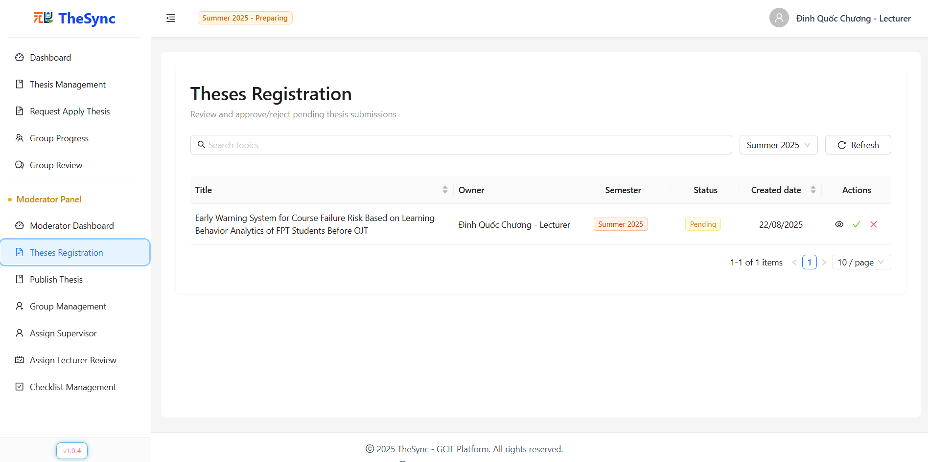

###### Figure III.3.k - Theses Registration

#### Publish Thesis

* **Function Description:** The Assign List Publish Thesis page allows moderators to manage the publication status of approved thesis topics, making them available for student selection. Moderators can view all approved theses, toggle individual publication status, perform bulk publish operations, and filter theses by various criteria to control thesis visibility to students.
* **Function Trigger:** When a moderator successfully logs into the system and selects "Assign List Publish Thesis" from the sidebar navigation.
* **Button/Navigation:**
* Filter Bar:
  + Search input - Filter by thesis name or lecturer name
  + Semester dropdown - Filter by academic semester
  + Public Access dropdown - Filter by publication status (Published/Unpublished)
  + Refresh button - Reload thesis data from database
* Table Actions:
  + Checkbox Selection: Select individual theses for bulk operations
  + Public Access Switch: Toggle individual thesis publication status
  + View Detail button (Eye icon): Navigate to detailed thesis information
  + Publish Selected button: Bulk publish operation for selected theses
* Status Controls:
  + Published/Unpublished switches - Individual thesis publication control
  + Bulk selection checkboxes - Multi-thesis selection for batch operations
* **Trigger:**
* Filter Operations:
  + Type in search → Filter theses by name or lecturer
  + Select semester → Display theses from selected academic period
  + Select publication status → Filter by published/unpublished state
  + Click refresh → Reload current thesis data
* Publication Management:
  + Toggle individual switch → Show confirmation modal → Update thesis publication status
  + Select multiple theses → Click "Publish Selected" → Confirm bulk operation → Publish all selected unpublished theses
  + Click "View Detail" → Navigate to comprehensive thesis information page
* Confirmation Workflow:
  + Individual publish/unpublish → Display confirmation with thesis name
  + Bulk publish → Show confirmation with count of theses to be published
  + User confirms → Execute operation → Show success notification
* **Function:**
* Data Management:
  + Auto-filtering: Only displays approved theses eligible for publication
  + Default Semester: Automatically filters to current semester on page load
  + Smart Selection: Auto-deselects published items from bulk selection
* Publication Controls:
  + Individual Toggle: Immediate switch control for each thesis
  + Bulk Operations: Multi-select functionality with batch publishing
  + Status Validation: Prevents publishing already published theses
  + Assignment Protection: Cannot unpublish theses assigned to student groups
* Filter System:
  + Multi-criteria Search: Search across thesis names and lecturer names
  + Semester Integration: Filter by specific academic semesters
  + Publication Status: Filter by published/unpublished state
  + Domain Options: Dynamic domain list extracted from available theses
* Security & Business Rules:
  + Assignment Protection: Theses assigned to groups cannot be unpublished
  + Role Validation: Only moderators can access publication controls
  + Status Consistency: Maintains proper thesis lifecycle states
  + Group Relationship: Validates thesis-group assignments before unpublishing
* Table Features:
  + Checkbox Management: Smart selection with disabled states for published items
  + Status Indicators: Color-coded publication status switches
  + Action Buttons: Contextual actions based on thesis state
* Navigation Integration:
  + Detail View: Seamless navigation to thesis detail pages
  + State Preservation: Maintains filter and selection states during navigation
* Bulk Operations:
  + Smart Counting: Only counts unpublished theses in bulk operations
  + Selective Processing: Skips already published items in bulk operations
  + Progress Feedback: Loading states and completion notifications
* **Business Rules**: BR-092, BR-095, BR-097, BR-098, BR-107, BR-108, BR-109, BR-132, BR-133

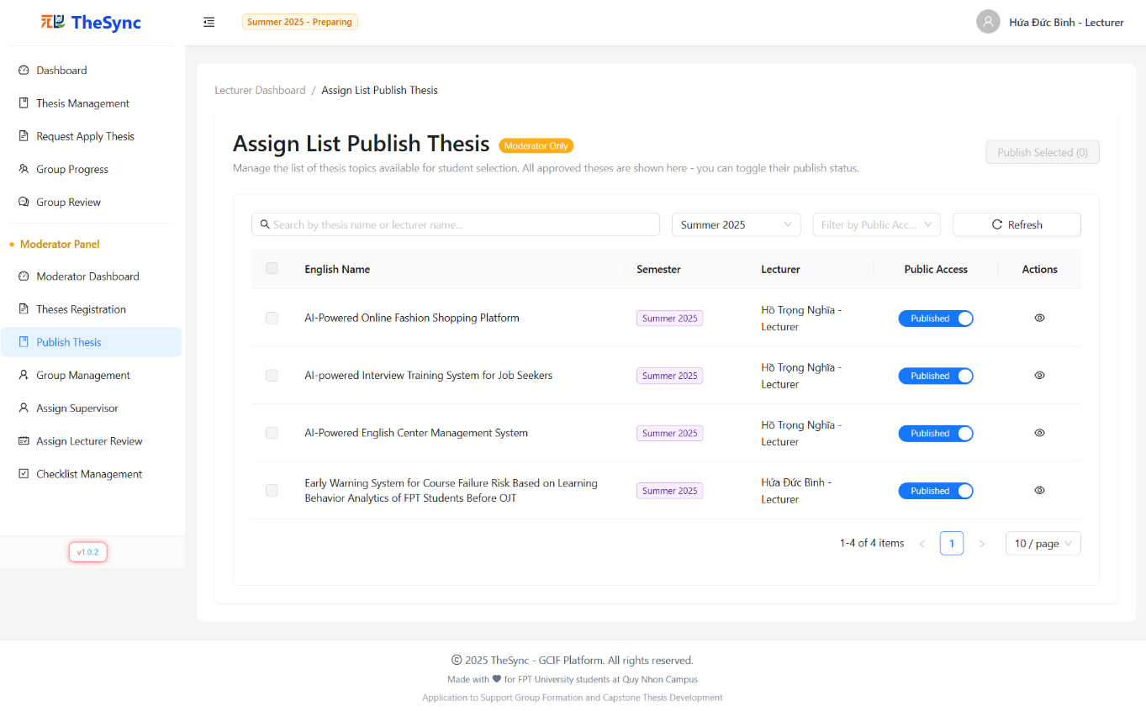

###### Figure III.3.l - Publish Thesis

#### Group Management

* **Function Description:** The Group Management page allows moderators to manage student groups and assignments throughout the thesis process. Moderators can view all groups, manage group members, assign ungrouped students to existing groups, and perform administrative actions like group deletion and formatting. The system provides comprehensive filtering and search capabilities for efficient group administration.
* **Function Trigger:** When a moderator successfully logs into the system and selects "Group Management" from the sidebar navigation.
* **Button/Navigation:**
* Group Management Section:
  + Search input - Filter groups by code, name, or leader name
  + Semester dropdown - Filter groups by academic semester
  + Refresh button - Reload group data from database
* Group Actions:
  + View button (Eye icon) - Navigate to group detail/assignment page
* Ungrouped Students Section:
  + Search input - Filter students by name or email
  + Major dropdown - Filter students by academic major
  + Refresh button - Reload student data
  + Radio selection - Select student for group assignment
* **Trigger:**
* Group Management Operations:
  + Type in search → Filter groups by code, name, or leader information
  + Select semester → Display groups from selected academic period
  + Click refresh → Reload current group and student data
* Group Assignment Actions:
  + Click "View" (group) → Navigate to detailed group management interface
  + Select student (radio) → Choose ungrouped student for assignment
* **Function:**
* Group Overview:
  + Active Groups Table: Displays all groups with code, name, member count, leader, and actions
  + Smart Sorting: Group codes sorted numerically (e.g., SU25SE001, SU25SE002, etc.)
  + Semester Integration: Auto-selects active semester
* Student Management:
  + Ungrouped Students Card: Shows all active students not assigned to groups
  + Major Filtering: Filter students by academic department/major
  + Contact Information: Complete student details including email and phone
  + Assignment Ready: Radio selection for quick group assignment
* Search & Filter System:
  + Multi-criteria Search: Search across group codes, names, and leader names
  + Real-time Filtering: Instant results as user types
  + Major Classification: Filter students by academic department
  + Semester History: Access to all semester groups, not just active ones
* Data Management:
  + Auto-refresh: Smart data loading with forced refresh capabilities
* Security & Validation:
  + Role Verification: Only moderators can access group management
  + Data Integrity: Validates group assignments and member relationships
* **Business Rules**: BR-088, BR-092, BR-095, BR-097, BR-098, BR-107, BR-108, BR-109, BR-153, BR-154, BR-155, BR-160

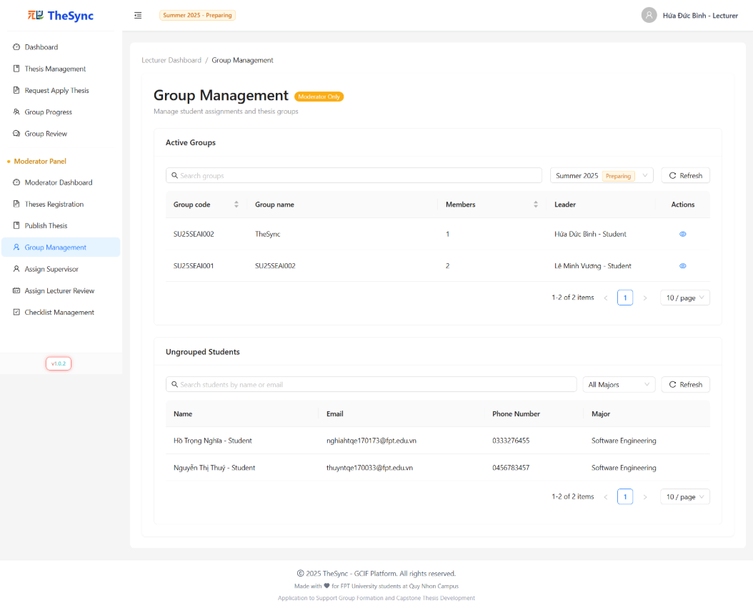

###### Figure III.3.m - Group Management

#### Assign Supervisor

* **Function Description:** The Assign Supervisor page allows moderators to assign thesis supervisors to student groups and manage supervisor workload distribution. The system provides draft assignment capabilities, bulk operations, intelligent assignment logic, and workload monitoring to ensure balanced supervision allocation across lecturers.
* **Function Trigger:** When a moderator successfully logs into the system and selects "Assign Supervisor" from the sidebar navigation.
* **Button/Navigation:**
* Filter Bar:
  + Search input - Filter by thesis abbreviation or title
  + Semester dropdown - Filter assignments by academic semester (defaults to current semester)
  + Status dropdown - Filter by thesis pick status (All/Picked/Not picked)
  + Refresh button - Reload assignment data from database
  + View Workload button - Open lecturer workload distribution chart
  + Assign All Drafts button - Bulk assign all pending draft assignments
* Table Actions:
  + Assign/Change button - Open supervisor assignment modal
  + Delete Draft button (X icon) - Remove individual draft assignments
  + Checkbox selection - Multi-select for bulk operations
* Assignment Modal:
  + Supervisor 1/2 dropdowns - Select lecturers with search functionality
  + Save Draft button - Save assignment as draft for later processing
  + Assign Now button - Immediately assign supervisors
  + Change button - Modify existing supervisor assignments
* **Trigger:**
* Filter Operations:
  + Type in search → Filter theses by abbreviation or title
  + Select semester → Load assignments for selected academic period
  + Select status → Filter by thesis selection status
  + Click refresh → Reload current assignment data
* Assignment Operations:
  + Click "Assign" → Open assignment modal → Select supervisors → Save as draft or assign immediately
  + Click "Change" → Open modal with current supervisors → Modify assignments → Confirm changes
  + Click "Save Draft" → Store assignment for bulk processing later
  + Click "Assign Now" → Immediately process supervisor assignment
* Bulk Operations:

Click "Assign All Drafts" → Show confirmation modal → Process all pending drafts simultaneously

* + Select multiple theses → Perform batch operations on selected items
* Workload Management:
  + Click "View Workload" → Open workload distribution dialog → Select semester → View supervisor load chart
* **Function:**
* Assignment Management:
  + Draft System: Save assignments as drafts for later batch processing
  + Intelligent Assignment: Automatically determines whether to use assign or change API based on current state
  + Supervisor Validation: Prevents duplicate supervisor assignments within same thesis
  + Load Balancing: Visual indicators for supervisor workload distribution
* Modal Operations:
  + Dynamic Options: Supervisor dropdowns exclude already selected lecturers
  + Search Functionality: Real-time filtering of lecturer options by name
  + Change Detection: Enables/disables buttons based on modifications from initial values
  + Validation Rules: Ensures both supervisors are selected and different from each other
* Workload Monitoring:
  + Visual Charts: Horizontal bar chart showing supervisor load distribution
  + Semester Filtering: View workload across different academic periods
  + Category Indicators: Color-coded load levels (Low/Moderate/High/Over Load)
  + Search & Filter: Real-time filtering of supervisors by name or load category
* Data Management:
  + Auto-refresh: Smart data loading with forced refresh capabilities
* Security & Validation:
  + Role Verification: Only moderators can access supervisor assignment
  + Assignment Rules: Validates supervisor limits and assignment constraints
  + Confirmation Modals: Safety confirmations for all critical operations
  + Data Integrity: Maintains consistency between drafts and actual assignments
* Business Logic:
  + Assignment Lifecycle: Manages progression from draft to finalized assignments
  + Supervisor Limits: Enforces maximum supervision load per lecturer
  + Change Management: Handles modification of existing supervisor assignments
  + Semester Context: Assignments organized by academic semester periods
* **Business Rules**: BR-025, BR-026, BR-092, BR-095, BR-097, BR-098, BR-107, BR-108, BR-109, BR-117, BR-118, BR-119, BR-120, BR-174, BR-175

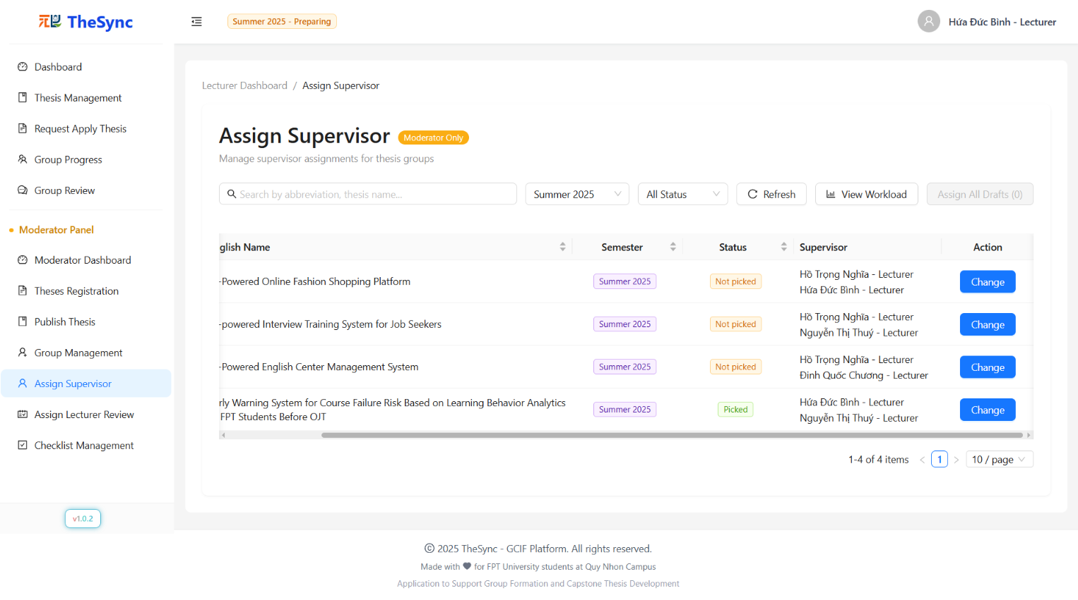

###### Figure III.3.n -Assign Supervisor

#### Assign Reviewer

* **Function Description:** The Assign Reviewer page allows moderators to assign main and secondary reviewers to student group submissions for specific milestones. The system provides draft assignment capabilities, intelligent reviewer filtering, workload balancing, and bulk operations to efficiently manage the review assignment process across different academic milestones.
* **Function Trigger:** When a moderator successfully logs into the system and selects "Assign Reviewer" from the sidebar navigation.
* **Button/Navigation:**
* Filter Bar:
  + Search input - Filter by group name or thesis title
  + Semester dropdown - Select academic semester for review assignments
  + Milestone dropdown - Select specific milestone phase for assignments
  + Refresh button - Reload assignment data from database
  + Assign All Drafts button - Bulk assign all pending draft reviewer assignments
* Table Actions:
  + Assign/Change button - Open reviewer assignment modal for group
  + Delete Draft button (X icon) - Remove individual draft reviewer assignments
  + Status indicators - Show current reviewers and draft assignments with labels
* Assignment Modal:
  + Main Reviewer dropdown - Select primary reviewer with search functionality
  + Secondary Reviewer dropdown - Select secondary reviewer with duplicate prevention
  + Save Draft button - Save assignment as draft for later processing
  + Assign/Change button - Immediately assign reviewers to submission
* **Trigger:**
* Filter Operations:
  + Type in search → Filter groups by name or thesis title
  + Select semester → Load groups and milestones for selected academic period
  + Select milestone → Display submissions for specific milestone phase
  + Click refresh → Reload current assignment data
* Assignment Operations:
  + Click "Assign" → Open assignment modal → Select main/secondary reviewers → Save as draft or assign immediately
  + Click "Change" → Open modal with current reviewers → Modify assignments → Confirm changes
  + Click "Save Draft" → Store assignment for bulk processing later
  + Click "Assign/Change" → Immediately process reviewer assignment
* Bulk Operations:
  + Click "Assign All Drafts" → Show confirmation modal → Process all pending drafts simultaneously
  + Click "Delete Draft" → Remove specific draft assignment from queue
* **Function:**
* Draft Assignment System:
  + Draft Management: Save assignments as drafts for later batch processing
  + Draft Indicators: Visual labels showing "(Draft)" status in reviewer columns
  + Bulk Processing: Single API call for efficient bulk assignment of all drafts
  + Draft Validation: Ensures both main and secondary reviewers are selected and different
* Milestone Integration:
  + Phase-based Filtering: Displays submissions for selected milestone only
  + Semester Context: Organizes assignments by academic semester periods
  + Submission Tracking: Links reviewer assignments to specific milestone submissions
* Assignment Validation:
  + Reviewer Requirements: Validates that both main and secondary reviewers are selected
  + Duplicate Prevention: Ensures main and secondary reviewers are different persons
  + Supervisor Exclusion: Automatically excludes thesis supervisors from reviewer options
  + Assignment Rules: Prevents assigning reviewers to groups they already supervise
* Data Management:
  + Real-time Updates: Automatic refresh after assignment operations
* Security & Business Logic:
  + - * Role Verification: Only moderators can access reviewer assignment
      * Assignment Constraints: Enforces business rules for reviewer eligibility
      * Confirmation Protection: Safety confirmations for bulk operations
* Advanced Features:
  + - * Change Mode Detection: Automatically determines assign vs change operations
      * Reviewer Merging: Combines current and eligible reviewers in change mode
      * Form Validation: Real-time validation with error messages
      * Bulk Confirmation: Detailed confirmation modals for bulk operations
* **Business Rules**: BR-051, BR-092, BR-095, BR-097, BR-098, BR-107, BR-108, BR-109, BR-114, BR-164, BR-165, BR-166, BR-167

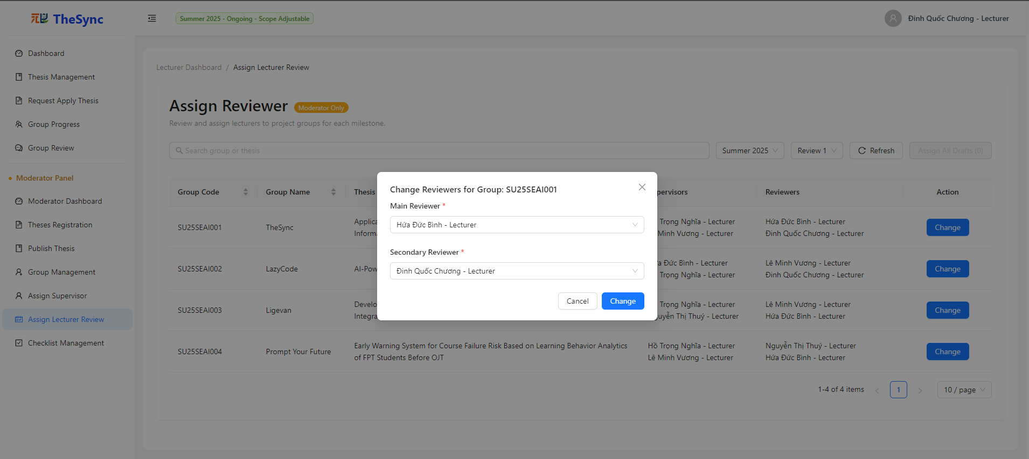

###### Figure III.3.o - Assign Reviewer

#### Checklist Management

* **Function Description:** The Checklist Management page allows moderators to create, view, edit, and delete evaluation checklists for different thesis milestones. The system provides comprehensive checklist organization with milestone-based filtering, search capabilities, and item count tracking to ensure consistency, transparency, and progress tracking throughout the thesis evaluation process.
* **Function Trigger:** When a moderator successfully logs into the system and selects "Checklist Management" from the sidebar navigation.
* **Button/Navigation:**
* Toolbar Controls:
  + Search input - Filter checklists by name or description
  + Milestone dropdown - Filter checklists by specific milestone phase (with "All Milestones" option)
  + Refresh button - Reload checklist data from database
  + Create New Checklist button - Navigate to checklist creation page
* Table Actions:
  + View Details button (Eye icon) - Navigate to detailed checklist view
  + Edit button (Pencil icon) - Navigate to checklist editing interface
  + Delete button (Trash icon) - Remove checklist from system (with restrictions)
* Status Indicators:
  + Items count column - Shows total number of checklist items
  + Milestone association - Displays linked milestone name or dash if none
* **Trigger:**
* Filter Operations:
  + Type in search → Filter checklists by name or description matching
  + Select milestone → Display checklists associated with selected milestone phase
  + Select "All Milestones" → Show all checklists regardless of milestone
  + Click refresh → Reload current checklist data
* Navigation Actions:
  + Click "Create New Checklist" → Navigate to checklist creation form
  + Click "View Details" → Navigate to detailed checklist view with items
  + Click "Edit" → Navigate to checklist editing interface
  + Click column headers → Sort checklists by name or item count
* Management Actions:
  + Click "Delete" → Show confirmation modal → Confirm → Remove checklist permanently
  + Delete validation → Check for existing items → Prevent deletion if items exist
* **Function:**
* Checklist Overview:
  + Comprehensive Table: Displays checklist name, description, milestone, item count, and actions
  + Smart Sorting: Sortable columns for name (alphabetical) and item count (numerical)
* Search & Filter System:
  + Real-time Search: Instant filtering by checklist name or description
  + Milestone Filtering: Filter by specific milestone or view all checklists
  + Combined Filtering: Search and milestone filters work together
  + Clear Options: Allow clearing of filters to return to full view
* Data Management:
  + Auto-refresh: Smart data loading with forced refresh capabilities
* Item Tracking:
  + Item Count Display: Shows total checklist items for each checklist
  + Deletion Protection: Prevents deletion of checklists containing items
* Security & Validation:
  + Role Verification: Only moderators can access checklist management
  + Deletion Rules: Cannot delete checklists with existing items
  + Confirmation Protection: Safety confirmations for destructive operations
  + Data Integrity: Maintains consistency between checklists and items
* Navigation Integration:
  + Seamless Routing: Smooth navigation to detail and edit pages
  + Loading Management: Consistent navigation loading states
  + State Preservation: Maintains context when navigating between pages
  + Breadcrumb Support: Clear navigation hierarchy for user orientation
* Business Logic:
  + Milestone Association: Links checklists to specific thesis phases
  + Item Dependency: Enforces proper relationship between checklists and items
  + Lifecycle Management: Manages checklist creation, editing, and deletion workflow
* **Business Rules**: BR-092, BR-095, BR-097, BR-098, BR-107, BR-108, BR-109, BR-164, BR-165, BR-166, BR-167

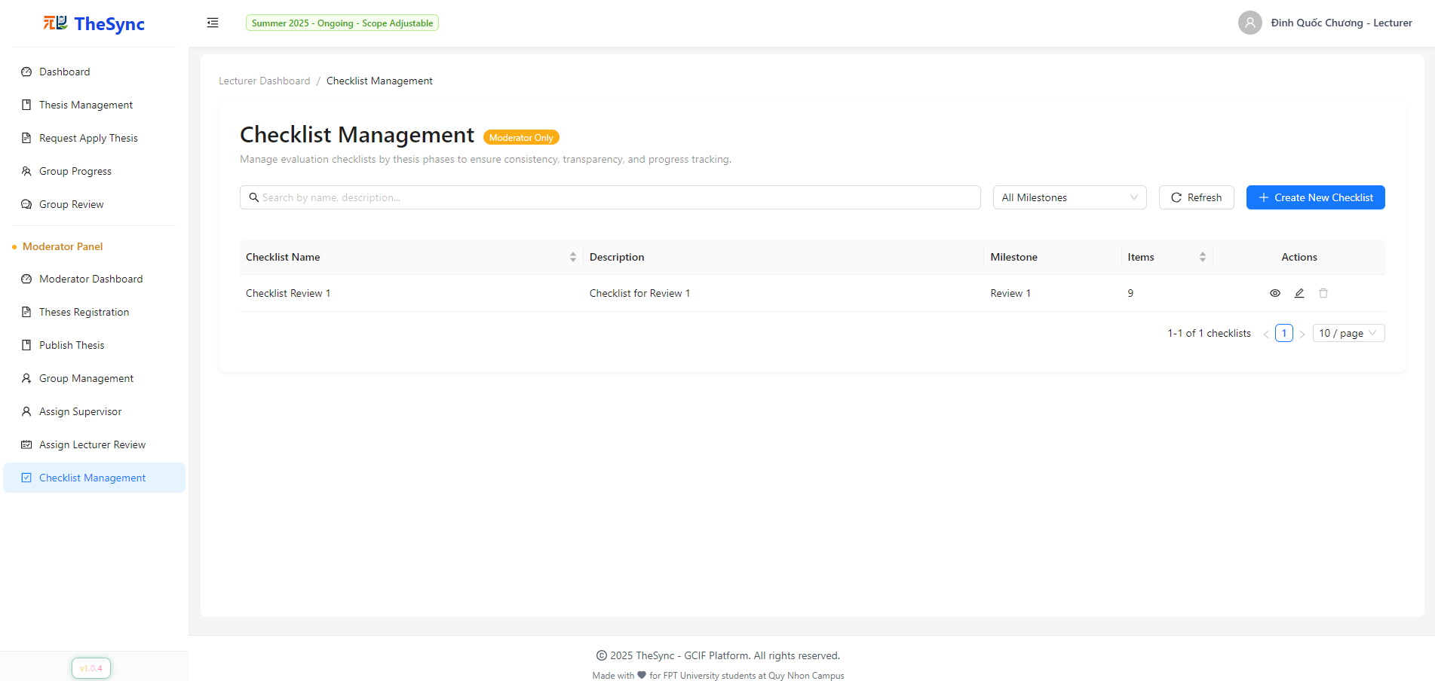

###### Figure III.3.p - Checklist Management

#### Create Checklist:

* **Function Description:** The Create Checklist page allows moderators to create evaluation checklists for thesis milestones using either manual entry or Excel import. The system provides comprehensive checklist creation with item management, priority settings, and validation to ensure structured evaluation processes for student submissions.
* **Function Trigger:** When a moderator successfully logs into the system and clicks "Create New Checklist" from the Checklist Management page.
* **Button/Navigation:**
* Tab Navigation:
  + Manual tab - Create checklist items manually using form interface
  + Excel tab - Import checklist items from Excel template file
* Checklist Info Section:
  + Milestone dropdown - Select target milestone for checklist
  + Checklist Name input - Required checklist title
  + Description textarea - Optional checklist description
* Manual Mode:
  + Add New Item button - Add blank checklist item row
  + Item Name input - Required item title
  + Description input - Required item description
  + Priority switch - Toggle between Mandatory/Optional
  + Delete button (Trash icon) - Remove individual items
* Excel Import Mode:
  + Download Template button - Get Excel template file
  + File upload area (drag-and-drop) - Upload Excel file with checklist items
  + Auto-import - Immediately processes uploaded file
* Form Actions:
  + Back button - Return to Checklist Management page
  + Save All button - Create checklist with all items
  + Import All Checklist button - Process Excel import
* **Trigger:**
* Mode Selection:
  + Click Manual tab → Enable manual item creation interface
  + Click Excel tab → Enable Excel file import interface
  + Switch tabs → Preserve common checklist info (name, description, milestone)
* Manual Creation Process:
  + Select milestone → Set checklist context
  + Enter name/description → Define checklist metadata
  + Click "Add New Item" → Create new item row → Fill item details → Set priority
  + Click "Save All" → Validate all fields → Create checklist → Navigate to management page
* Excel Import Process:
  + Click "Download Template" → Download structured Excel template
  + Fill template → Upload file to drag-and-drop area → Auto-validate and import items
  + Click "Import All Checklist" → Create checklist with imported items
* **Function:**
* Dual Creation Modes:
  + Manual Mode: Interactive table interface for creating individual checklist items
  + Excel Import: Bulk import using standardized template with validation
  + Mode Preservation: Maintains checklist info when switching between modes
* Form Management:
  + Field Validation: Real-time validation for required fields with error indicators
  + Dynamic Table: Add/remove items with form validation for each row
  + Priority Control: Switch between Mandatory/Optional for each checklist item
  + Error Handling: Comprehensive validation before submission
* Excel Import Features:
  + Template System: Structured Excel template with Name, Description, Priority columns
  + File Validation: Validates file type (.xlsx, .xls), size (max 100MB), and format
  + Data Processing: Advanced Excel parsing with Unicode handling and data cleaning
  + Duplicate Detection: Prevents duplicate item names within same checklist
  + Auto-validation: Real-time validation during import with detailed error reporting
* Business Logic:
  + Milestone Association: Links checklist to specific thesis evaluation phase
  + Two-step Creation: Creates checklist first, then adds items to maintain data integrity
  + Item Requirements: Ensures at least one item before allowing checklist creation
* Data Validation:
  + Required Fields: Milestone, checklist name, and at least one item required
  + Item Validation: Name and description required for each checklist item
  + Length Validation: Character limits with detailed error messages
  + Duplicate Prevention: Checks for duplicate item names during creation
* Security & Performance:
  + Data Sanitization: Cleans Excel data to prevent formatting issues
  + Memory Management: Efficient processing of large Excel files
* Navigation Integration:
  + Form Reset: Clears all data when navigating back to management page
* **Business Rules**: BR-075, BR-076, BR-077, BR-086, BR-092, BR-095, BR-096, BR-097, BR-107, BR-108, BR-109, BR-164, BR-165, BR-166, BR-167, BR-185, BR-186

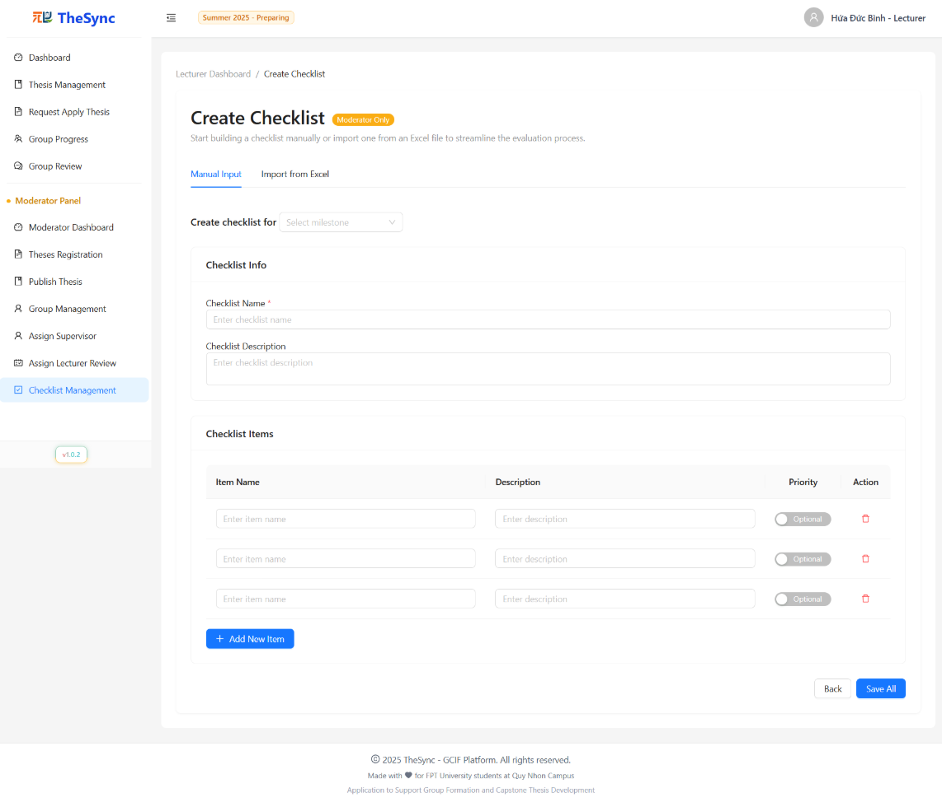

###### Figure III.3.q.(1) - Create Checklist

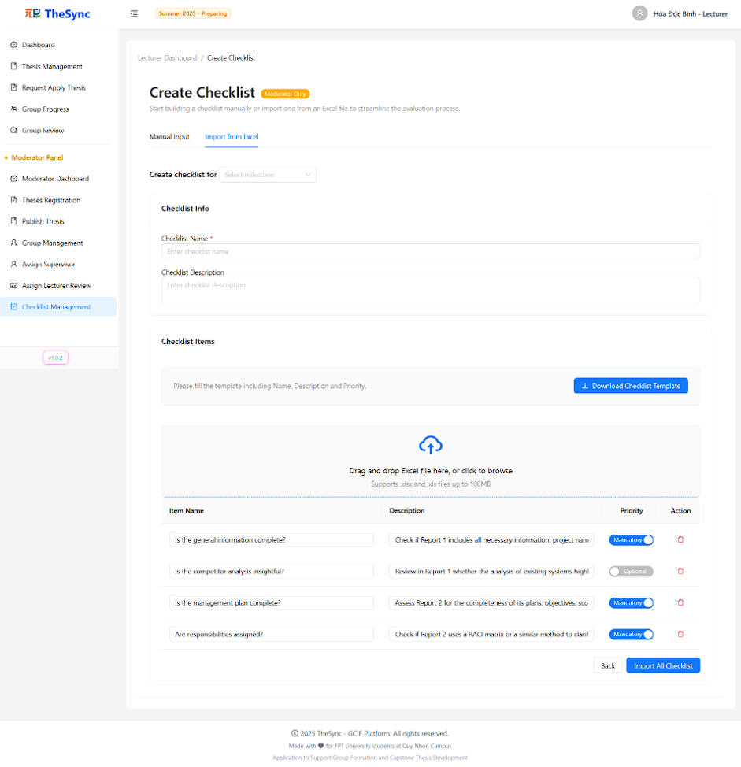

###### Figure III.3.q.(2) - Create Checklist

### Website for Admin

#### Login

* **Function Description:** The login page allows admins to log in using their email and password. This page also provides options to forgot password, remember login information.
* **Function Trigger:** When the user is not logged in, the Login page will display the Login form:
* Log in with Username + Password
* **Button/Navigation**: There is an input field for Username and Password, along with a “Sign In” button.
* **Trigger:** After entering valid credentials and clicking the “Sign In” button.
* **Function:** The system authenticates the provided credentials. If valid, the user is redirected to the Admin Dashboard.. If invalid, an error message is displayed (“Invalid username or password”).
* Remember Me
* **Button/Navigation**: A checkbox labeled “Remember Me” is displayed below the login form.
* **Trigger**: When checked before clicking “Sign In.”
* **Function**: The system remembers the user’s credentials for future sessions until manually logged out.
* Forgot Password
* **Button/Navigation**: A “Forgot password?” link is displayed below the login form.
* **Trigger**: When clicked, then enters email and clicks "Sending..." button
* **Function**: The system redirects the user to the Forgot Password page. The user enters their registered email and the OTP is received via email. After successful verification, a new password is automatically generated and sent to the user’s email. The system then displays a confirmation message “Password Reset Successful!” with options to check email or return to the login page.
* **Business Rules**:BR-001, BR-005, BR-006, BR-007, BR-078, BR-079, BR-080, BR-081, BR-082, BR-083, BR-096, BR-101, BR-105

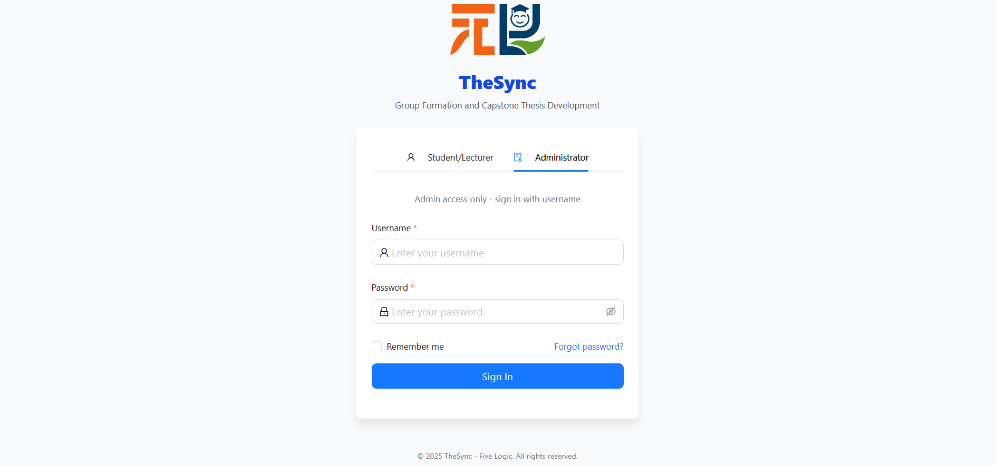

###### Figure III.C.4.a - Login

#### Change Password

* **Function Description:** The Change Password function, located within the Account Settings page, allows logged-in students to update their password by providing the current password and setting a new one that meets the system’s security requirements.
* **Function Trigger:** When the user navigates to the Settings page, the Change Password form is displayed as a popup.
* Enter Current Password
* **Button/Navigation:** Input field for *Current Password*.
* **Trigger:** User enters the current password.
* **Function:** The system verifies the provided password. If incorrect, an error message is displayed (“Current password is incorrect”).
* Enter New Password and Confirm New Password
* **Button/Navigation:** Input fields for *New Password* and *Confirm New Password*.
* **Trigger:** User enters a new password and re-enters it for confirmation.
* **Function:** The system validates that the new password meets complexity rules (minimum 12 characters, including uppercase, lowercase, numbers, and special characters) and matches the confirmation. If invalid, an error message is displayed.
* Update Password
* **Button/Navigation:** Save Changes button.
* **Trigger:** After filling in required fields, the user clicks Save Changes.
* **Function:** If valid, the system updates the password and displays a success notification. The new password must be used for the next login.
* Additional Options
* **Button/Navigation:** *Clear* button and *Eye icon*.
* **Trigger:**
  + *Clear* → When clicked, all fields are reset.
  + *Eye icon* → When clicked, toggles password visibility.
* **Function:** Provides convenience for entering password fields.
* **Business Rules**: BR-006, BR-008, BR-009, BR-010, BR-012, BR-013, BR-014, BR-015, BR-016, BR-096, BR-101

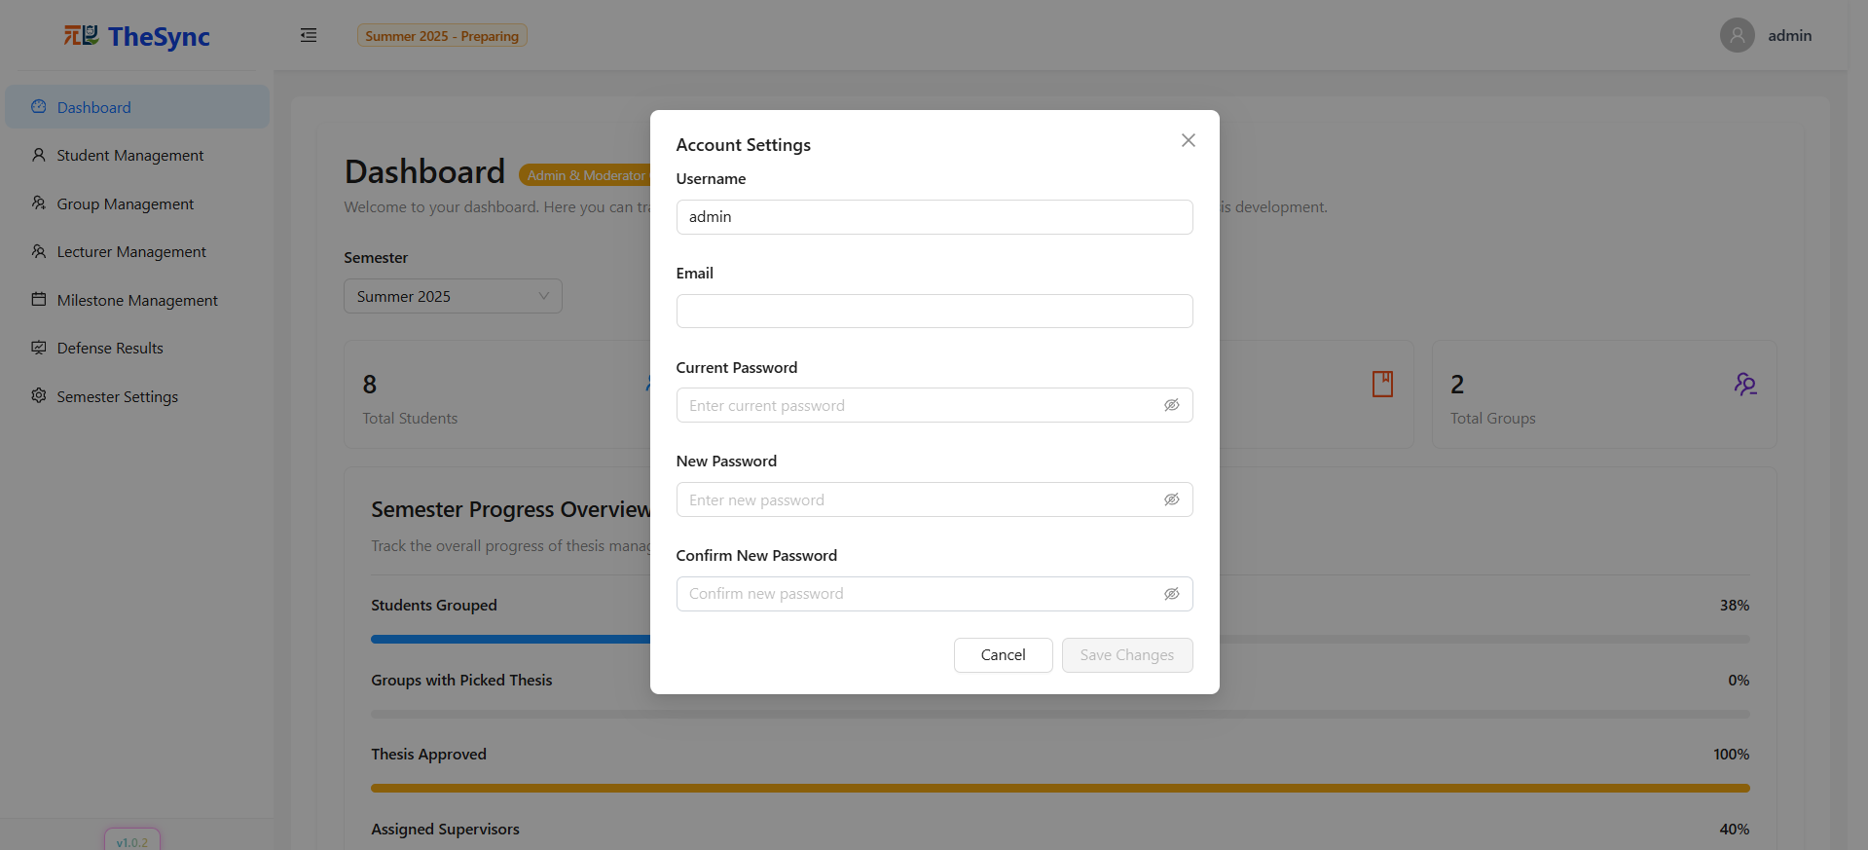

###### Figure III.C.4.b - Change password

#### Dashboard

* **Function Description:** The dashboard provides administrators with a comprehensive overview of thesis management progress. It displays key metrics (students, lecturers, theses, groups), semester statistics, progress tracking, and supervisor load distribution. Interactive charts and real-time updates support effective system monitoring and decision-making.
* **Function Trigger:** When the administrator successfully logs into the system and selects the Dashboard option from the sidebar.
* **Button/Navigation**
* Menu Item: “Dashboard” in the sidebar (highlighted when active).
* Search Bar: Allows searching supervisors or filtering data.
* Filter Dropdowns: Category filters for refining data (e.g., semester, status).
* Interactive Charts: Supervisor load distribution, progress bars, and summary cards are clickable for deeper insights.
* **Trigger**
* Clicking on the Dashboard sidebar will retrieve and compile all relevant data from the database.
* When the search/filter options are used, the dashboard updates the displayed statistics and charts in real time.
* **Function**
* Statistics Overview (Top Cards): Displays total students, lecturers, theses, and groups with clean numeric indicators.
* Semester Progress Overview: Shows current semester tracking with summarized description (e.g., “Summer 2025”).
* Progress Metrics (Progress Bars): Visualizes completion levels for group formation, thesis assignment, approvals, and supervisor allocation.
* Supervisor Load Distribution: Horizontal bar chart comparing supervision workload among lecturers.
* AI Usage Statistics: Tracks AI feature usage across the system for the current semester, providing insights into frequency, most-used modules, and user adoption.
* Groups Table: Displays a list of student groups that have selected and been assigned thesis topics. Provides group details with filtering and sorting options.
* Real-time Updates: Ensures displayed data reflects the most current system state.
* **Business Rules**: BR-002, BR-003, BR-084, BR-085, BR-093, BR-094, BR-095, BR-097, BR-098, BR-104

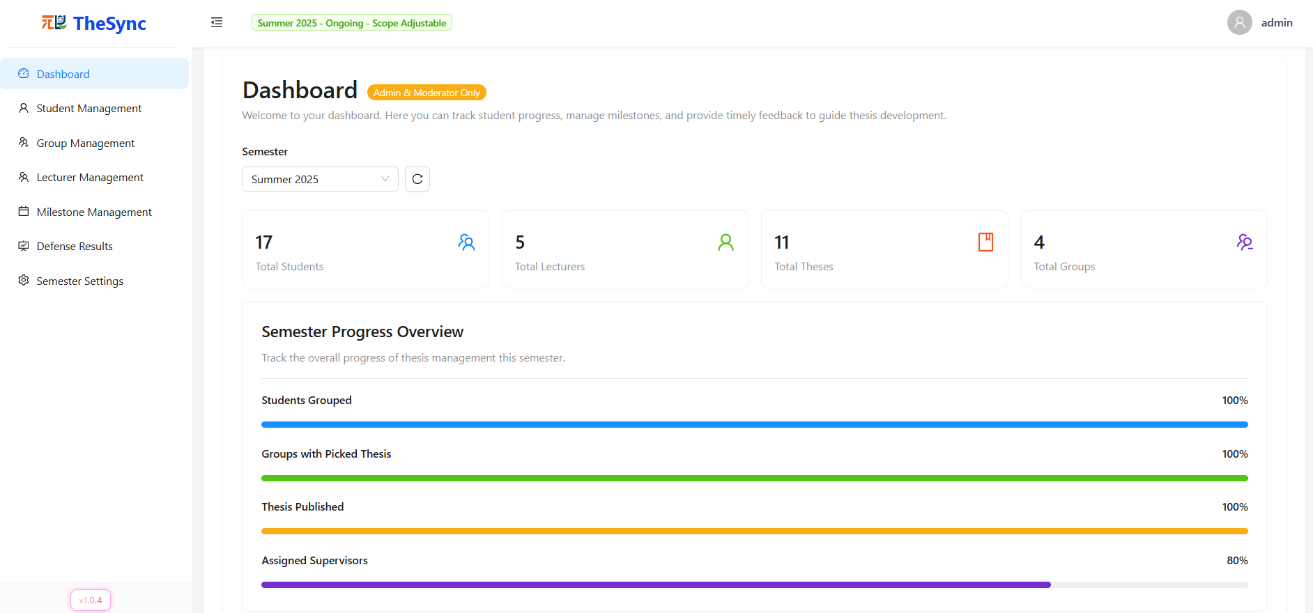

###### Figure III.C.4.c.(1) - Dashboard

###### Figure III.C.4.c.(2) - Dashboard

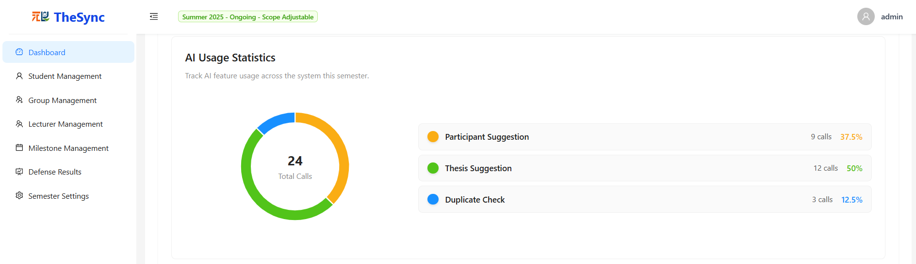

###### Figure III.C.4.c.(3) - Dashboard

###### Figure III.C.4.c.(4) - Dashboard

#### Student Management

* **Function Description**: Allows Admin to manage student accounts in the system. Admin can view the list of students, search, filter by semester/major, refresh data, create new students, edit student information, delete student accounts, and update student status (active/inactive).
* **Function Trigger**: When the administrator selects “Student Management” from the sidebar.
* **Button/Navigation**:
* Filter/Search bar – filter by semester, major, status; search by name/email, student code.
* Refresh button – reload student list from database.
* Create New Student button - Add students to the system.
* Edit button – modify selected student information.
* Delete button – remove student account from system.
* Status toggle – update active/inactive status of a student.
* **Trigger – Function**:
* Select filter/search → Display filtered student list.
* Click refresh → Reload and display the updated list.
* Click create new student → Navigate to the create new student page.
* Click edit → Open edit form for student info → Update.
* Click delete → Show confirmation popup → Confirm → Student account deleted.
* Toggle status → Update student status in system.
* **Business Rules**: BR-034, BR-035, BR-036, BR-037, BR-038, BR-039, BR-040, BR-041, BR-042, BR-043, BR-044, BR-045, BR-088, BR-089, BR-092, BR-097, BR-098

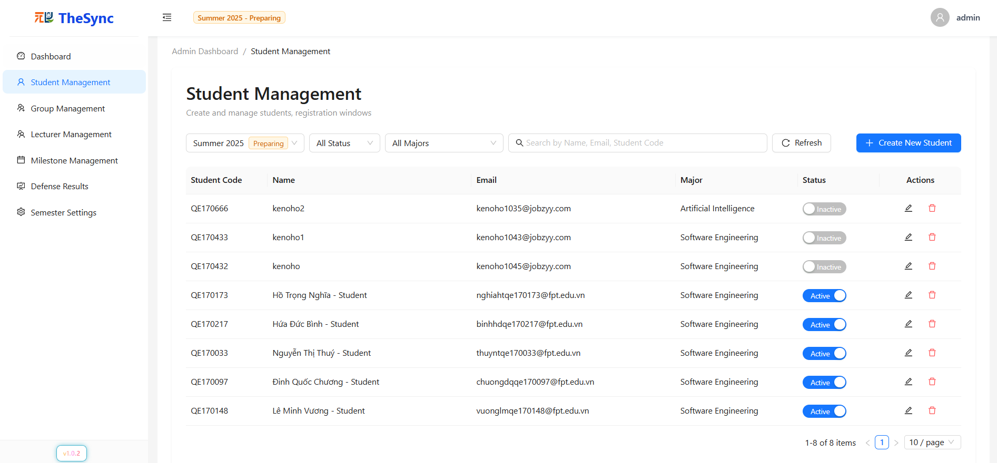

###### Figure III.C.4.d - Student Management

#### Create new student (manual && import from excel)

* **Function Description**: This function allows administrators to create new student accounts through two methods. The first is manual input, where individual student details are entered via a form with real-time validation. The second is Excel import, which enables bulk creation of student accounts by uploading a formatted Excel file, with built-in validation and error handling.
* **Function Trigger**: Admin navigates to Student Management → Create New Student.
* **Button/Navigation**:
* Create New Student button → Opens student creation module
* Tabs:
  + Manual Input → Displays student information form
  + Import from Excel → Displays Excel upload interface
* **Trigger – Function**:
* Manual Input
  + **Trigger**: Admin selects Manual Input tab and fills out the student form
  + **Function**: When the admin fills out the student form, the system validates all required fields (Name, Student ID, Email, Major, etc.), checks for duplicates in Student ID and Email, then stores the valid record in the database. After successful creation, the student list is updated and a confirmation message is displayed.
* Import from Excel
  + **Trigger**: Admin selects Import from Excel tab and uploads an Excel file
  + **Function:** When the admin uploads an Excel file, the system validates the file format and required columns, then processes multiple student records in batch. It reports the import results, including both successful entries and detailed errors, adds the valid student accounts to the database, and finally updates the student list with the imported records.
* **Business Rules**: BR-034, BR-035, BR-036, BR-042, BR-043, BR-075, BR-076, BR-077, BR-088, BR-089, BR-091, BR-092

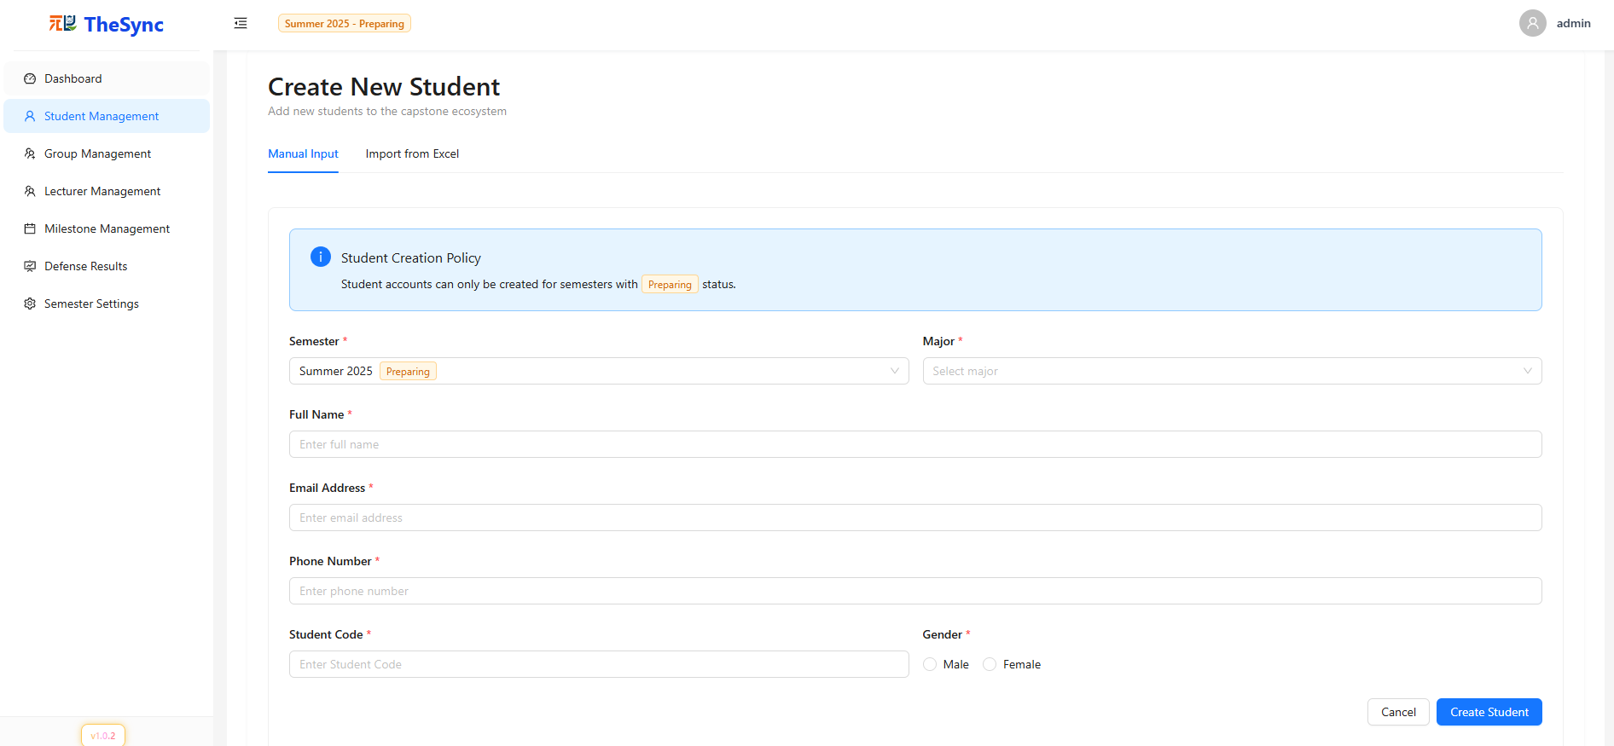

###### Figure III.C.4.e.(1) - Create new student (manual && import from excel)

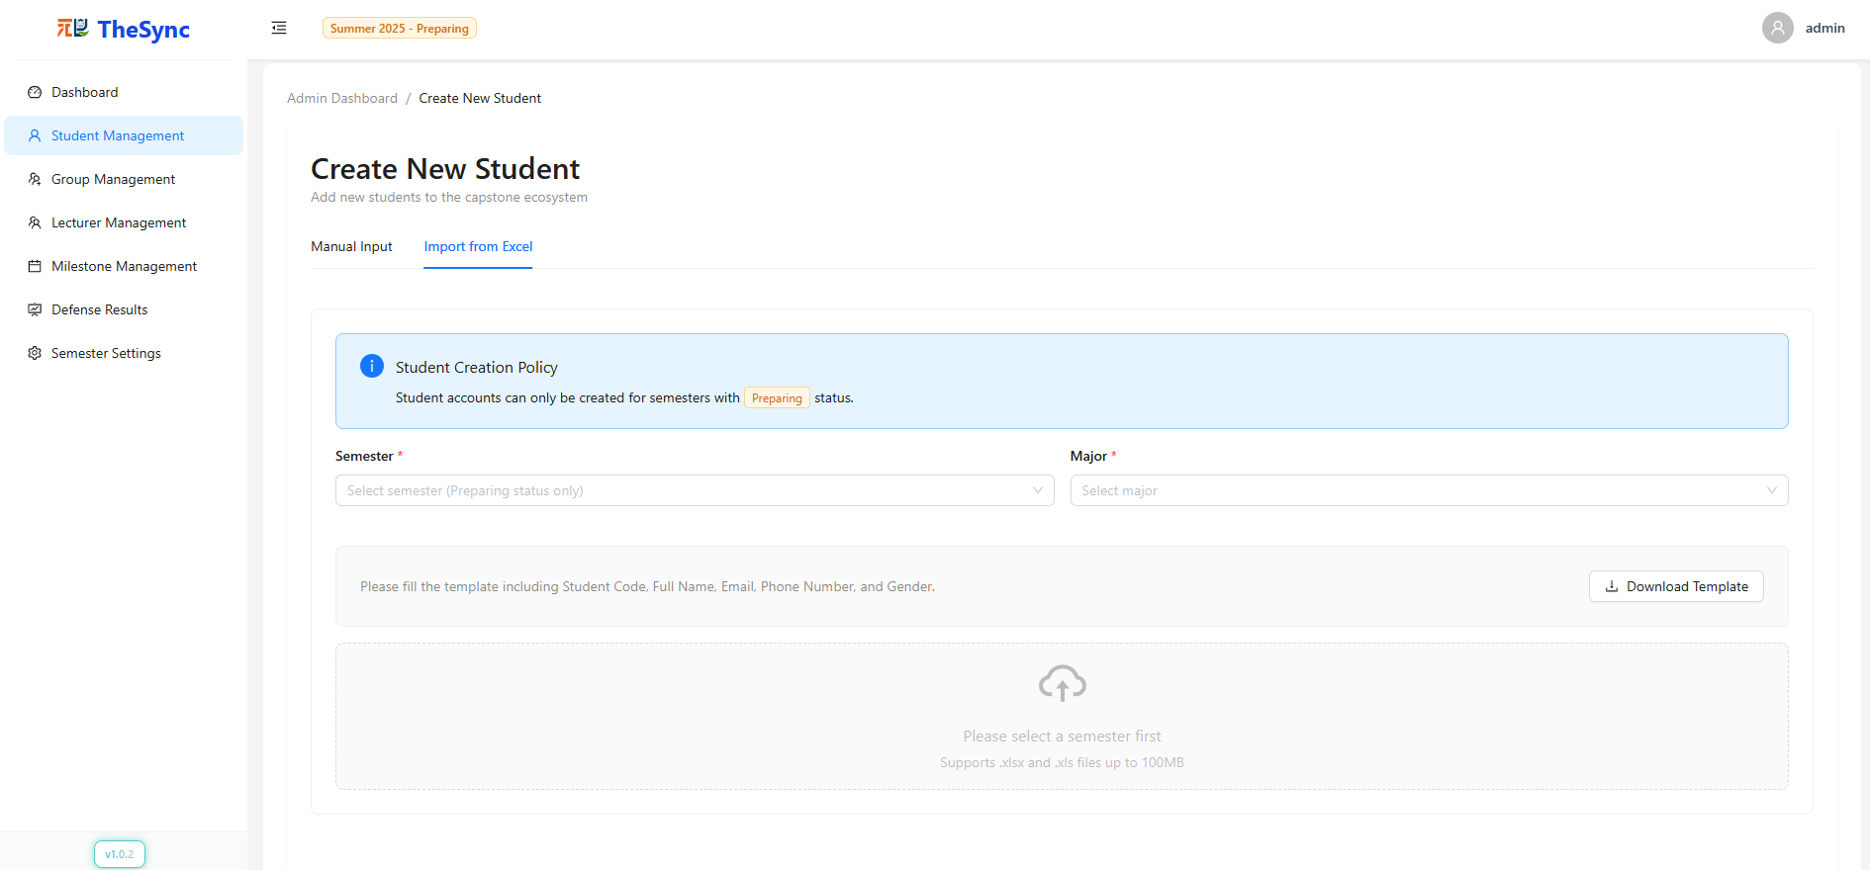

###### Figure III.C.4.e.(2) - Create new student (manual && import from excel)

#### Group Management

* **Function Description**: Allows the admin to manage student groups for thesis projects, including creating, deleting, and formatting group codes. This ensures consistent group structures across semesters and helps streamline the thesis management process.
* **Function Trigger**: When the administrator selects “Group Management” from the sidebar.
* **Button/Navigation**
* Generate Group: Create a new empty group after filling in all the fields (with *Generate* and *Reset* buttons).
* Search Group: Find groups by name or code.
* Filter Semester: Display groups belonging to a selected semester.
* Refresh: Reload the list of groups.
* Format: Reorder groups and regenerate student codes within the group list.
* Delete Group: Permanently remove a group.
* Assign Student: Redirect to the "Assign Student to Group" page.
* **Trigger – Function**
* Click “Generate”→ The system validates the fields and creates a new empty group.
* Click “Reset” → The system clears all fields.
* Select semester filter, enter keyword search → Display filtered group list.
* Click “Refresh” → The system reloads the current group list.
* Click “Format” → The system sorts all groups and regenerates student codes.
* Click “Delete” → The system confirms and removes the selected group.
* Click “Assign Student” → The system redirects the admin to the Assign Student to Group page.
* **Business Rules**: BR-002, BR-092, BR-095, BR-097, BR-098, BR-153, BR-154, BR-155, BR-156, BR-160

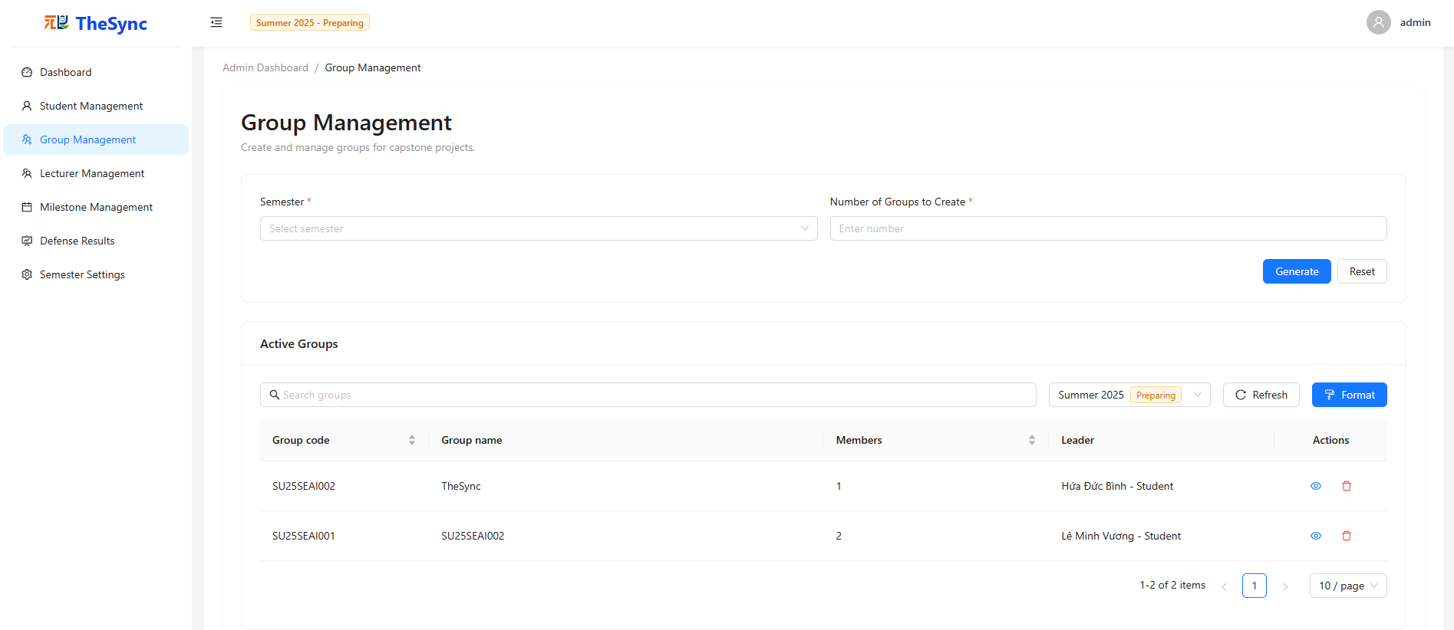

###### Figure III.C.4.f.(1) - Group Management

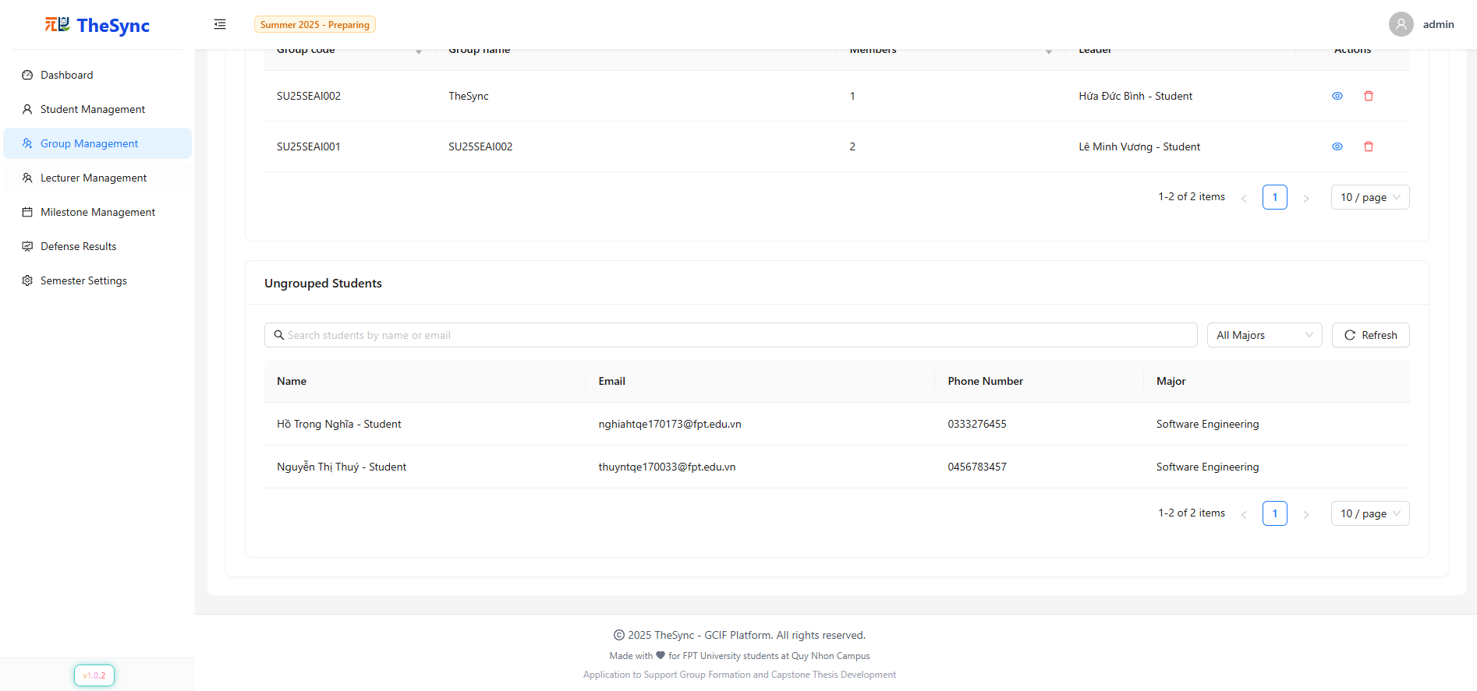

###### Figure III.C.4.f.(2) - Group Management

#### Assign Student

* **Function Description:** Provides tools for the admin to manage ungrouped students and assign them to groups. The admin can search, filter, and review ungrouped students before assigning them to an existing group.
* **Function Trigger:** Admin navigates to Group Management → Assign students to any specific group button in Active Groups-> Navigates to the page assigning students to groups
* **Button/Navigation**
* Assign Student to Group: Display all students without a group.
* Search Student: Search ungrouped students by name or email.
* Filter Major: Filter ungrouped students by major.
* Refresh: Reload the student list.
* “Assign To Student” button: Select a student and assign them to a chosen group.
* **Trigger – Function**
* View group details →
* View Assign Student to Group table→ The system displays all information of the group, including thesis, members, etc.
* Enter keyword Search → The system filters ungrouped students by name or email.
* Select Major in filter → The system displays students of that specific major.
* Click “Refresh” → The system reloads the ungrouped student list.
* Click “Assign To Group” button → The system will allocate the selected students to the selected group (not exceeding the allowed limit) and update the group information.
* **Business Rules**: BR-002, BR-088, BR-089, BR-092, BR-095, BR-097, BR-098, BR-153, BR-154, BR-155, BR-156, BR-160

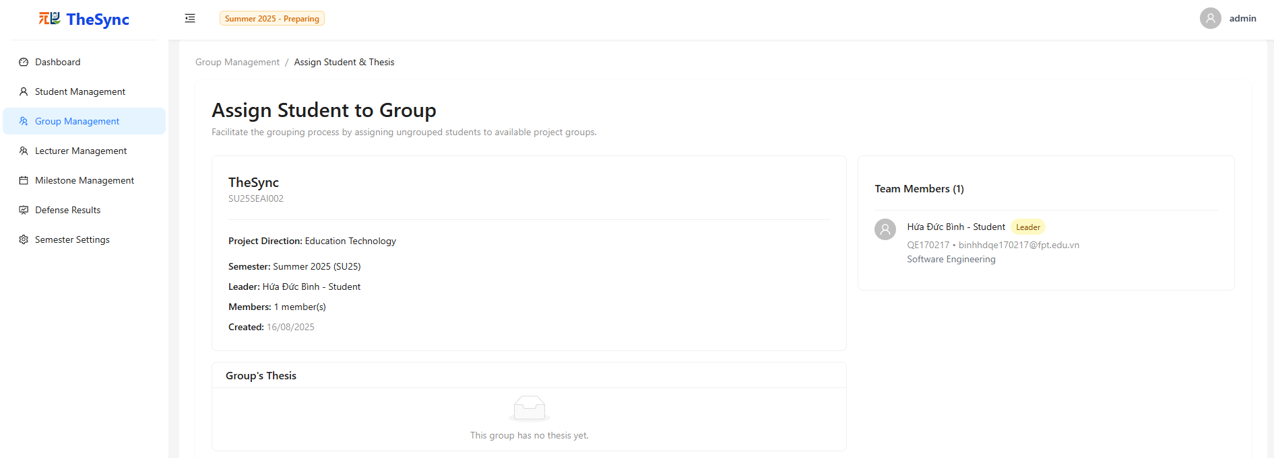

###### Figure III.C.4.g.(1) - Assign Student

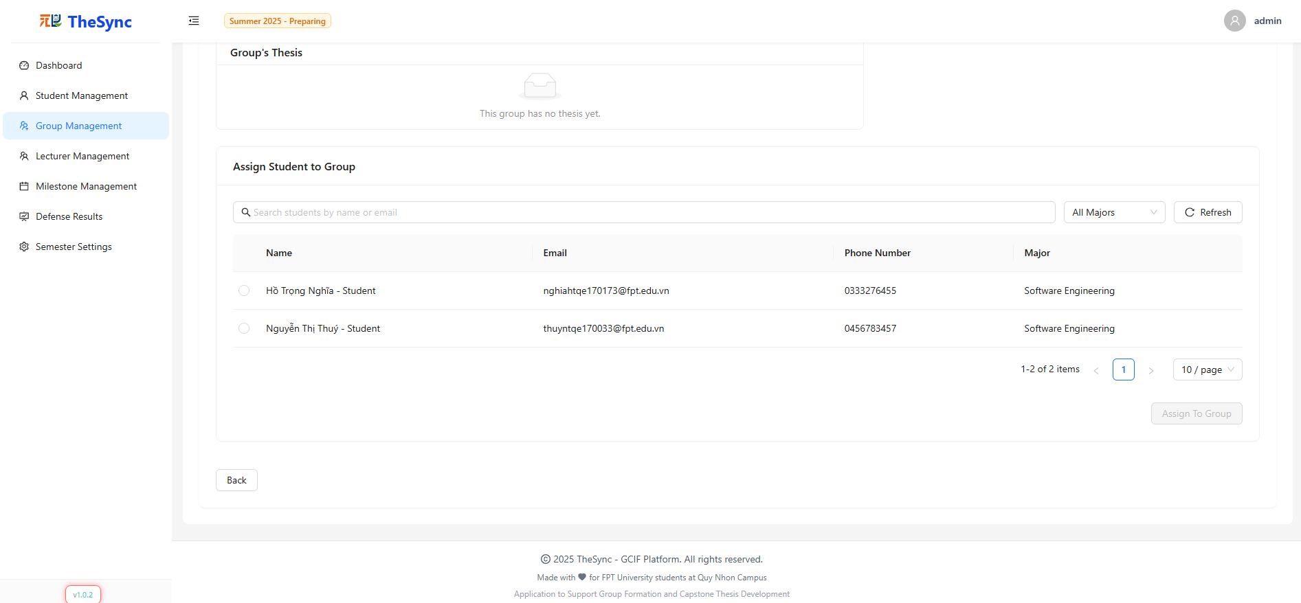

###### Figure III.C.4.g.(2) - Assign Student

#### Lecturer Management

* **Function Description**: Allows administrators to create, update, activate/inactivate, assign moderator roles, and delete lecturer accounts. The system provides a searchable and filterable lecturer table with status control, role assignment, and management actions.
* **Function Trigger**: When the administrator selects “Lecturer Management” from the sidebar.
* **Button/Navigation**:
* **Filter/Search bar** – filter by status/ lecturer; search by name/email.
* **Refresh button** – reload lecturer list from database.
* **Create New Lecturer button** - Add lecturers to the system.
* **Edit button** – modify selected lecturer information.
* **Delete button** – remove lecturer account from system.
* **Status toggle** – update active/inactive status of a lecturer.
* **Moderator toggle** → Assign/remove moderator role
* **Trigger – Function**:
* Select filter/search → Display filtered lecturer list.
* Click refresh → Reload and display the updated list.
* Click create new lecturer → Navigate to the create new lecturer page.
* Click edit → Open edit form for lecturer info → Update.
* Click delete → Show confirmation popup → Confirm → Lecturer account deleted.
* Toggle status switch→ Update lecturer status in system (active/ inactive).
* Admin toggles Moderator switch → Assign or unassign moderator role
* **Business Rules**: BR-002, BR-046, BR-047, BR-048, BR-049, BR-050, BR-051, BR-052, BR-053, BR-054, BR-055, BR-056, BR-057, BR-088, BR-089, BR-092, BR-097, BR-098

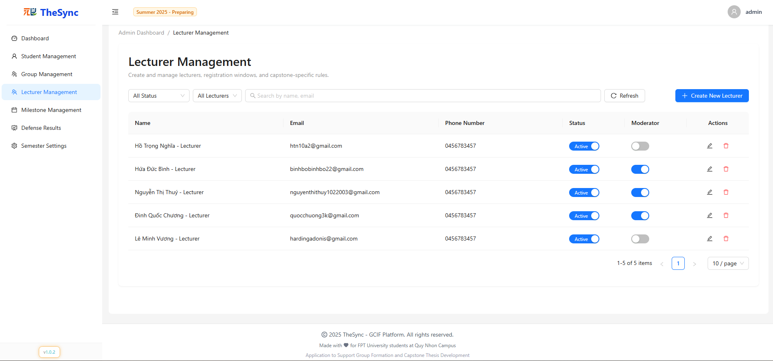

###### Figure III.C.4.h - Lecturer Management

#### Create new lecturer (manual && import from excel)

* **Function Description**: This function allows administrators to create new lecturer accounts through two methods. The first is manual input, where individual lecturer details are entered via a form with real-time validation. The second is Excel import, which enables bulk creation of lecturer accounts by uploading a formatted Excel file, with validation and error handling to ensure data accuracy.
* **Function Trigger**: When the administrator clicks Create New Lecturer button in the Lecturer Management page.
* **Button/Navigation**:
* Create New Lecturer button → Opens lecturer creation module
* Tabs:
  + Manual Input → Displays lecturer information form
  + Import from Excel → Displays Excel upload interface
* **Trigger – Function**:
* Manual Input
  + **Trigger**: Admin selects Manual Input tab and fills in lecturer details.
  + **Function**: The system validates all required fields such as Name, Email, and Phone, checks for duplicate emails before saving, stores the lecturer information in the database, and finally confirms success while updating the lecturer list.
* Import from Excel
  + **Trigger**: Admin selects Import from Excel tab and uploads an Excel file.
  + **Function:** The system validates the file format and required columns, processes multiple lecturer records in batch, reports the import results including both success and error details, adds the valid lecturer accounts to the database, and updates the lecturer list with the imported records.
* **Business Rules**: BR-046, BR-047, BR-048, BR-049, BR-050, BR-051, BR-052, BR-053, BR-054, BR-055, BR-056, BR-057, BR-088, BR-089, BR-092, BR-097, BR-098

###### 

###### Figure III.C.4.i.(1)- Create new lecturer (manual && import from excel)

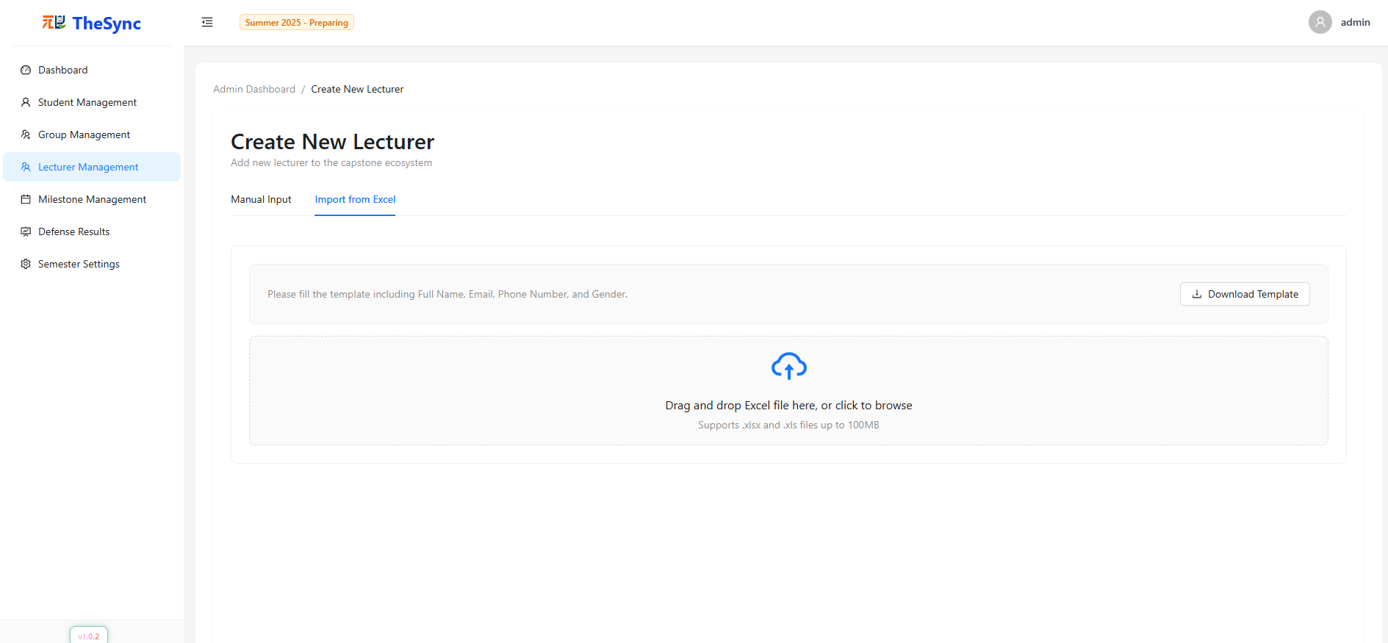

###### Figure III.C.4.i.(2) - Create new lecturer (manual && import from excel)

#### Milestone Management

* **Function Description**: Allows administrators to create, configure, and manage project milestones for each semester. Admin can define milestone names, duration (start/end date), upload template documents for students, and manage milestone lifecycle (edit, delete, search, filter).
* **Function Trigger**: When the administrator selects “Milestone Management” from the sidebar.
* **Button/Navigation**
* Milestone Management (sidebar) → Opens milestone management interface.
* Create New Milestone button → Save milestone with required details.
* Upload Template Documents button → Attach milestone-related template files.
* Edit button → Modify existing milestone details.
* Delete button → Remove milestone from the system.
* Search bar → Search milestones by name.
* Semester Filter → Filter milestones by semester.
* Refresh button → Reload milestone list.
* **Trigger – Function**
* Add New Milestone
  + **Trigger**: Admin enters milestone details (Milestone Name, Semester, Duration, optional note) and clicks Create New Milestone.
  + **Function**: Validates required fields (Milestone Name, Semester, Duration), saves milestones to the database, and updates the milestone list with the new entry.
* Upload Template Documents
  + **Trigger**: Admin clicks Upload Template Documents and selects file(s).
  + **Function**: Validates file type (PDF, DOC, DOCX, XLS, XLSX, PPT, PPTX, TXT) and file size (≤ 10MB), then attaches document(s) to milestones for students to download.
* Edit Milestone
  + **Trigger**: Admin clicks Edit on an existing milestone.
  + **Function**: Loads milestone details into the form, allows modifications (name, duration, notes, template files), and saves updates after validation.
* Delete Milestone
  + **Trigger**: Admin clicks Delete on an existing milestone.
  + **Function**: Confirms deletion to prevent accidental removal, removes the milestone from the database, and updates the milestone list.
* Search Milestone
  + **Trigger**: Admin types into the search bar.
  + **Function**: Filters the milestone list to display only matching milestone names.
* Filter by Semester
  + **Trigger**: Admin selects a semester from the dropdown.
  + **Function**: Filters the milestone list by the selected semester.
* Refresh List
  + **Trigger**: Admin clicks the Refresh button.
  + **Function**: Reloads the milestone list from the database.
* **Business Rules**: BR-062, BR-063, BR-064, BR-065, BR-066, BR-067, BR-068, BR-069, BR-087, BR-092, BR-097, BR-098, BR-185, BR-186

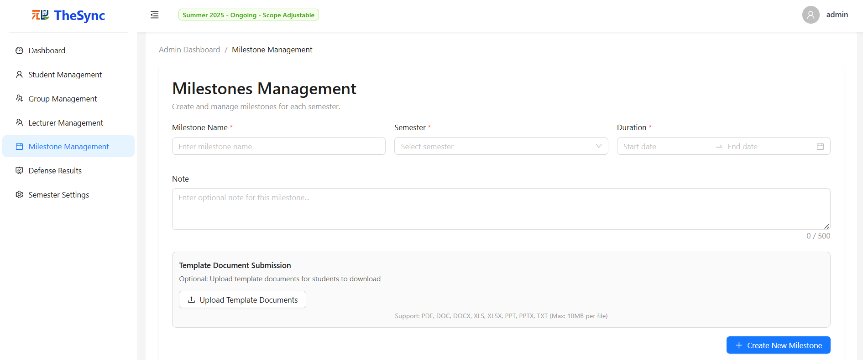

###### Figure III.C.4.j.(1)- Milestone Management

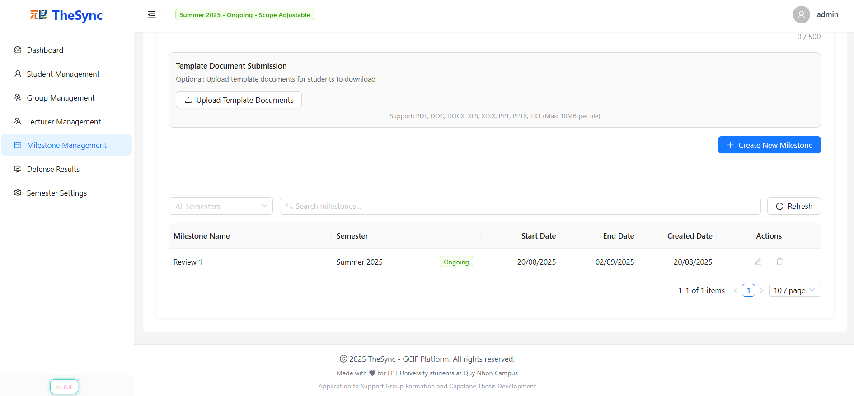

###### Figure III.C.4.j.(2)- Milestone Management

#### Capstone Defense Results

* **Function Description:** Allows administrators to manage capstone defense results with Excel import/export, manual editing, status tracking (Pass/Not Pass), and reporting features. Supports validation of defense results, integration into academic records, and provides comprehensive logs of result management actions.
* **Function Trigger**: When the administrator selects “Defense Results” from the sidebar.
* **Button/Navigation**
* Import Results → Upload Excel file containing defense results.
* Export Results → Download current results to Excel for reporting/archival.
* Edit Result → Manually update defense scores and outcomes.
* Save Changes → Commit defense result changes to the database.
* **Trigger**
* Selecting Import Results triggers the Excel upload interface.
* Uploading Excel triggers file validation (format, required columns, student/group matching).
* Selecting Export Results triggers Excel file generation.
* Clicking Edit Result enables inline/manual editing of student outcomes.
* Clicking Save triggers validation and final commit to academic records.
* **Function**
* View Results: Display existing defense results with student, thesis, supervisor, and outcome data.
* Import Processing: Validate and parse uploaded Excel defense results.
* Manual Editing: Allow corrections/updates for student results and outcomes.
* Bulk Operations: Enable batch updates for multiple defense outcomes.
* Export & Reporting: Generate Excel reports and maintain defense logs for institutional auditing.
* **Business Rules**: BR-002, BR-075, BR-076, BR-077, BR-086, BR-088, BR-091, BR-092, BR-095, BR-097, BR-098

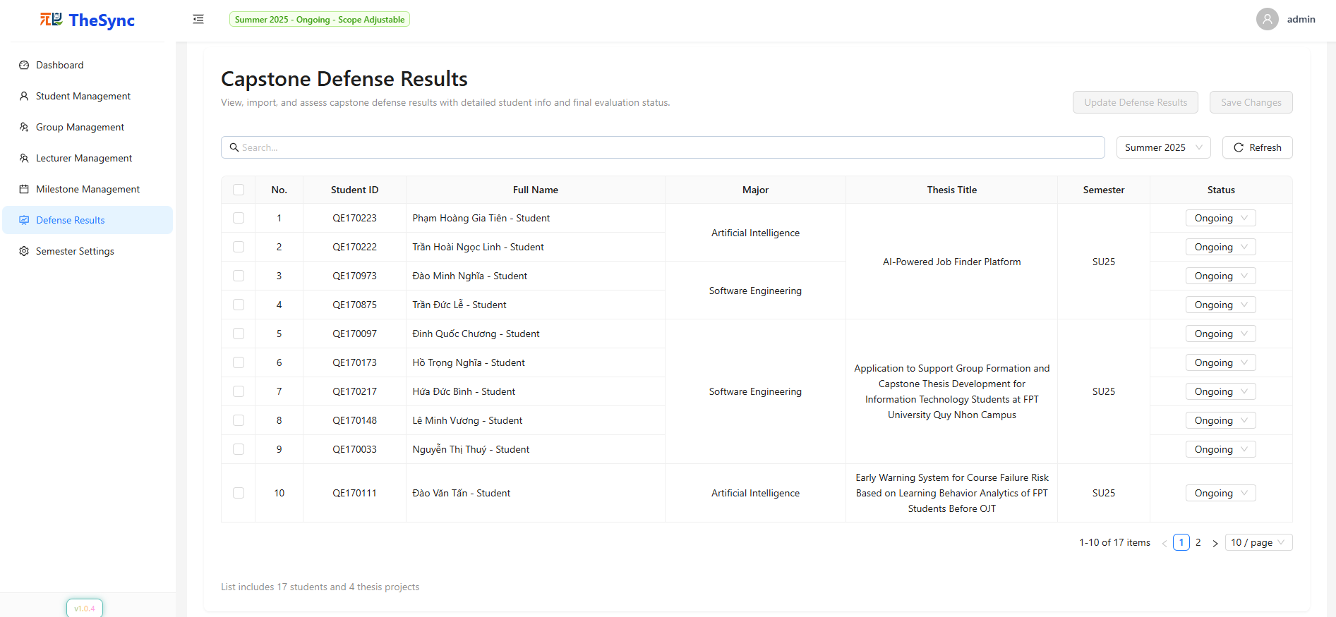

###### Figure III.C.4.k - Capstone Defense Results

#### Semester Setting

* **Function Description**: Allows administrators to create, configure, and manage academic semesters. Includes defining semester name/code, setting thesis supervision policies (default and maximum theses per lecturer), and managing semester status.
* **Function Trigger**: When the administrator selects “Semester Settings” from the sidebar.
* **Button/Navigation**
* Semester Settings (sidebar) → Opens semester management interface.
* Create Semester button → Create new semester.
* Clear Form button → Reset all input fields in semester creation form.
* Edit button → Modify existing semester information.
* Delete button → Remove semester (only available under certain conditions, e.g., not started).
* Refresh button → Reload semester list.
* Search bar / Filter → Filter by status; search by name or code.
* **Trigger – Function**

1. Add New Semester

* **Trigger**: Admin fills in required fields (Semester Name, Semester Code) and clicks Create Semester.
* **Function**:
  + Validates required fields (cannot be empty).
  + Ensures Semester Code is unique.
  + Stores semester data in database.
  + Create a semester list with the new entry.
* **Clear Form:**
  + **Trigger:** Admin clicks Clear Form.
  + **Function:** Resets all semester form fields to blank/default values.
* **Edit Semester**
  + **Trigger:** Admin clicks Edit on an existing semester.
  + **Function:** Allows modification of semester details (Semester Name, Semester Code, Default Theses Per Lecturer, Max Theses Per Lecturer, Status) → Saves updates to the database after validation.
* **Delete Semester**
  + **Trigger:** Admin clicks Delete on an existing semester.
  + **Function**: Validates if semester can be deleted (e.g., not already ended) → Removes semester from database → Updates semester list.
* **Search & Filter Semester**
  + **Trigger:** Admin enters semester name/code in search bar or selects status filter.
  + **Function:** Filters semester list to display matching records.
* **Refresh List**
  + **Trigger:** Admin clicks Refresh button.
  + **Function:** Reloads and updates semester list from database.
* **Business Rules**: BR-017, BR-018, BR-019, BR-020, BR-021, BR-022, BR-023, BR-024, BR-025, BR-026, BR-027, BR-028, BR-029, BR-030, BR-031, BR-032, BR-033, BR-087, BR-088, BR-092, BR-097, BR-098

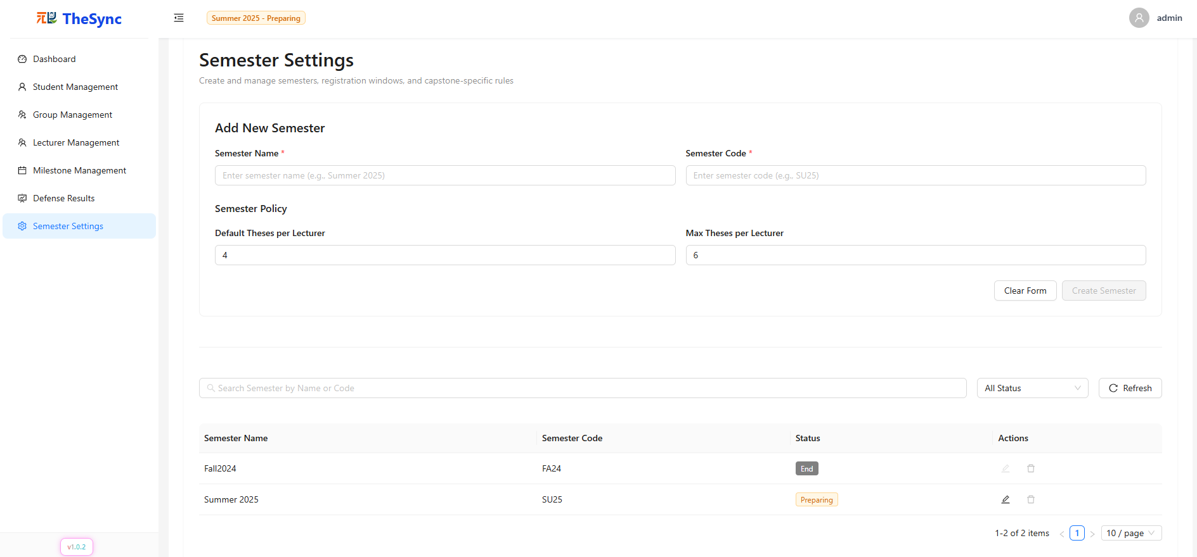

###### Figure III.C.4.l - Semester Setting

## Non-Functional Requirements

### External Interfaces

#### Authentication & Authorization Service

* **Interface**: RESTful API over HTTPS
* **Purpose**: Securely authenticate users (students, lecturers, admins) via email/password,
* **Input**: Credentials (email, password), OTP code.
* **Output**: JWT access token, user profile information.
* **Security**: All traffic is encrypted via HTTPS, sensitive information is hashed/encrypted, and industry-standard protocols (JWT) are enforced.

#### Email Notification Service

* **Interface**: Gmail API or SendGrid REST API
* **Purpose**: Deliver critical system notifications (account verification, password reset, project deadline reminders, milestone status updates) to end-users.
* **Input**: Recipient email address, message subject and content.
* **Output**: Email delivery status (success/failure).
* **Security**: Authentication for API usage, robust email validation, delivery logging, and throttling to prevent abuse.

#### AI Recommendation Engine

* **Interface**: Internal RESTful API, cloud-based or within a secure VPC/subnet.
* **Purpose**: Generate personalized project and team recommendations for students based on their skill profile, responsibility, and academic goals.
* **Input**: Student profile (skills, responsibility, preferences), available project and group data.
* **Output**: Ranked list of project/team suggestions, including a compatibility score.
* **Performance**: Target response time <2 seconds for 95% of requests.
* **Security**: Access-restricted endpoint, API rate limiting, strict access controls and detailed request/response auditing.

#### Database Service (PostgreSQL/Supabase)

* **Interface**: ORM (e.g., Sequelize for NodeJS/NestJS) or direct Supabase REST API.
* **Purpose**: Persistent storage and retrieval for all core data (users, projects, teams, milestones, activity logs).
* **Input/Output**: Structured data in JSON/SQL format.
* **Security**: Role-Based Access Control (RBAC), encryption at rest for sensitive fields, daily automated backups with rapid restore capabilities.

#### Client Applications

* **Web Application**: Built with Next.js, responsive across all modern browsers (Chrome, Firefox, Edge, Safari).
* **Mobile Application**: Developed in React Native, supporting Android (≥8.0) and iOS (≥13).
* **Purpose**: Deliver the main user experience and real-time interactivity for students, lecturers, and administrators.
* **Security**: Secure session handling, encrypted local storage (where used), all API calls authenticated via JWT.

### Quality Attributes

#### Performance

* **Response Time:** Critical user actions (authentication, dashboard load, project/team assignment) should complete within 2 seconds for at least 95% of cases under typical load.
* **Concurrency**: System must support a minimum of 400 simultaneous users during peak periods (e.g., semester registration or milestone deadlines) without service degradation or timeouts.
* **Throughput**: Capable of handling at least 1,000 read/write transactions per minute to support real-time updates, notifications, and collaborative group activities.

#### Scalability

* **Horizontal Scalability**: Modular microservices architecture allows independent scaling of subsystems (AI, notification, group management) to accommodate increased load per academic term.
* **Cloud-Native Deployment**: Supports containerized deployment (Docker/Kubernetes) for easy scaling and high availability on cloud platforms (e.g., Render, Vercel, Supabase).
* **Codebase Modularity**: Clearly separated codebases for backend, frontend, and AI modules enable rapid integration of new features or third-party services.

#### Reliability & Availability

* **Horizontal Scalability**: Modular microservices architecture allows independent scaling of subsystems (AI, notification, group management) to accommodate increased load per academic term.
* **Cloud-Native Deployment**: Supports containerized deployment (Docker/Kubernetes) for easy scaling and high availability on cloud platforms (e.g., Render, Vercel, Supabase).
* **Codebase Modularity**: Clearly separated codebases for backend, frontend, and AI modules enable rapid integration of new features or third-party services.

#### Security

* **Authentication & Access Control**: Detailed RBAC at both API and UI layers.
* **Data Encryption**: All sensitive data (passwords, tokens, emails) are encrypted using strong cryptographic standards (argon2).
* **Vulnerability Mitigation**: Protection against common web threats (SQL Injection, XSS, CSRF), login rate limiting.
* **Audit Logging**: Comprehensive, immutable logs of all critical data changes and access events, with tools for forensic analysis.

#### Maintainability

* **Code Quality**: Enforced linting and formatting (ESLint, Prettier), mandatory code reviews, and automated CI/CD pipelines for continuous testing and deployment.
* **Technical Documentation**: Up-to-date API documentation (Swagger/OpenAPI), architectural diagrams, and developer guides maintained for each major release.
* **Component Reusability**: Shared UI component library, modular backend services, and reusable business logic with high test coverage.

#### Usability

* **User-Centered Design**: Intuitive, task-focused UI/UX, readable fonts, responsive layouts for desktop and mobile.
* **Support & Onboarding**: Step-by-step user guides, video tutorials, FAQ resources, and an integrated AI-powered chatbot for 24/7 assistance.
* **Accessibility**: Compliance with major accessibility standards (WCAG 2.1), including keyboard navigation, alt-text for images, and screen reader support.

#### Portability

* **Cross-Platform Support**: Seamless deployment to multiple cloud providers or on-premises, environment configuration via standard environment variables.
* **Browser & Device Compatibility**: Verified compatibility with all mainstream browsers and mobile devices; fallback mechanisms for legacy support.
* **Offline Awareness**: User-friendly notifications when the device is offline, with automatic data sync upon reconnection.

#### Interoperability

* **Cross-Platform Support**: Seamless deployment to multiple cloud providers or on-premises, environment configuration via standard environment variables.
* **Browser & Device Compatibility**: Verified compatibility with all mainstream browsers and mobile devices; fallback mechanisms for legacy support.
* **Offline Awareness**: User-friendly notifications when the device is offline, with automatic data sync upon reconnection.

## Requirement Appendix

### Business Rules

| **ID** | **Business Rule** |
| --- | --- |
| BR-001 | Admin must authenticate using username with valid credentials |
| BR-002 | Admin role provides full system access across all modules and data |
| BR-003 | Admin can access all protected routes without additional permission checks |
| BR-004 | Admin sessions include role verification and token management with TTL caching |
| BR-005 | Admin authentication uses separate login endpoint /auth/admin/login with JWT tokens |
| BR-006 | Admin password must be at least 12 characters with uppercase, numbers, and special characters |
| BR-007 | Admin login tokens cached with 7-day TTL and proper identifier management |
| BR-008 | Admin can update their own profile including email and password changes |
| BR-009 | Password updates require current password verification before setting new password |
| BR-010 | New passwords must be at least 12 characters with uppercase, lowercase, numbers, and special characters |
| BR-011 | Email changes must use valid email format and be unique in the system |
| BR-012 | Admin profile updates trigger session refresh when password is changed |
| BR-013 | Password validation enforced with regex pattern for security requirements |
| BR-014 | Admin password changes require both oldPassword and newPassword to be provided |
| BR-015 | New password must be different from current password with verification |
| BR-016 | Password hashing uses Argon2 algorithm for secure storage |
| BR-017 | Admin can create new semesters with name, code, start/end dates, and enrollment limits |
| BR-018 | Semester status transitions must follow business rules: NotYet → Preparing → Picking → Ongoing → End |
| BR-019 | Only semesters with "NotYet" status can be deleted |
| BR-020 | Semesters with "End" status cannot be edited |
| BR-021 | Transition from "Ongoing" to "End" requires "ScopeLocked" phase |
| BR-022 | Ongoing status requires ongoingPhase field (ScopeAdjustable, ScopeLocked) |
| BR-023 | Only one semester can be in "Ongoing" status at any time |
| BR-024 | Admin can search and filter semesters by status and text |
| BR-025 | Admin can set thesis limits per lecturer (default and maximum) for each semester |
| BR-026 | Semester creation blocked if another semester is active unless current is Ongoing + ScopeLocked |
| BR-027 | Preparing → Picking requires all students grouped and sufficient approved public theses (minimum = number of groups + 20% number of groups) |
| BR-028 | Picking → Ongoing requires all groups to have selected thesis, auto-sets phase to ScopeAdjustable |
| BR-029 | Ongoing → End requires phase to be ScopeLocked and all students have completed enrollment status |
| BR-030 | Groups with less than 4 members block Preparing → Picking transition |
| BR-031 | ScopeAdjustable → ScopeLocked requires all groups have thesis, unpicked theses reset to New/unpublished |
| BR-032 | Status transitions trigger automated email notifications to relevant users |
| BR-033 | All public theses must have exactly 2 supervisors before status transitions |
| BR-034 | Admin can create individual student accounts with personal information |
| BR-035 | Admin can bulk import students from Excel files with validation |
| BR-036 | Student accounts require: full name, email (unique), phone number, student code (unique), major, and semester enrollment |
| BR-037 | Admin can toggle student account status (active/inactive) with confirmation |
| BR-038 | Admin can edit student information including profile updates and major changes |
| BR-039 | Student filtering available by semester, major, status, and keyword search |
| BR-040 | Admin can view students grouped by semester for management efficiency |
| BR-041 | Student management requires semester selection before displaying data |
| BR-042 | Student passwords auto-generated with 32-character strong password using symbols and mixed case |
| BR-043 | Student accounts sent via email notifications with temporary passwords |
| BR-044 | Student deletion only allowed from specific semester enrollments, not global deletion |
| BR-045 | Student status changes immediately affect login capabilities and system access |
| BR-046 | Admin can create lecturer accounts with personal and professional information |
| BR-047 | Admin can bulk import lecturers from Excel files with role assignments |
| BR-048 | Lecturer accounts require: full name, email (unique), phone number, and gender |
| BR-049 | Admin can toggle lecturer status (active/inactive) with confirmation modal |
| BR-050 | Admin can assign/revoke moderator privileges to lecturers |
| BR-051 | Moderator role provides additional permissions for thesis supervision and review assignment |
| BR-052 | Admin can edit lecturer profiles including contact information and role changes |
| BR-053 | Lecturer management includes search and filter capabilities |
| BR-054 | Lecturer passwords auto-generated and sent via email with account creation notifications |
| BR-055 | Lecturer deletion only allowed if no active supervisions, reviews, or thesis assignments |
| BR-056 | isModerator flag grants additional permissions beyond basic lecturer role |
| BR-057 | Lecturer status toggle affects login access and all system permissions immediately |
| BR-058 | Admin can create groups automatically with specified number per semester (maximum = number of students / 4.5 * 1.2) |
| BR-059 | Admin can manage ungrouped students and assign them to groups |
| BR-060 | Admin can view and export group data with Excel functionality |
| BR-061 | Admin can delete groups with proper validation checks |
| BR-062 | Admin can create milestones for specific semesters with start/end dates |
| BR-063 | Milestone dates must not overlap within the same semester |
| BR-064 | Milestone creation includes document requirements and submission guidelines |
| BR-065 | Admin can edit existing milestones including date adjustments and document updates |
| BR-066 | Milestone management supports file upload for reference documents |
| BR-067 | Admin can search milestones by semester and keyword |
| BR-068 | Milestone validation prevents creation of conflicting time periods |
| BR-069 | Admin can specify milestone requirements and evaluation criteria |
| BR-070 | Admin can view and manage capstone defense results for all students |
| BR-071 | Defense results support individual and bulk status updates |
| BR-072 | Status options include: Pass, Fail, Conditional Pass, Re-defense Required |
| BR-073 | Bulk updates require confirmation with detailed change summary |
| BR-074 | Admin can filter defense results by semester and search criteria |
| BR-075 | Admin can download Excel templates for student and lecturer bulk imports |
| BR-076 | Import processes include data validation and error reporting |
| BR-077 | Excel imports support error handling with detailed feedback |
| BR-078 | Password reset system uses OTP codes sent to email with 10-minute expiry |
| BR-079 | OTP codes are 8-digit numeric codes generated securely and cached with TTL |
| BR-080 | Password reset generates new 32-character strong passwords automatically |
| BR-081 | New passwords sent to user email after successful OTP verification |
| BR-082 | OTP cache keys removed after successful password reset to prevent reuse |
| BR-083 | Password reset only available for active users with valid email addresses |
| BR-084 | Admin can view system-wide statistics and dashboard metrics |
| BR-085 | Dashboard includes student count, lecturer count, active groups, and thesis statistics |
| BR-086 | All forms include comprehensive validation with error messages |
| BR-087 | Date validations ensure logical sequences and no conflicts |
| BR-088 | Unique constraints enforced for email addresses and student codes |
| BR-089 | Phone numbers validated for Vietnamese format standards |
| BR-090 | Status transitions include business rule validation |
| BR-091 | Bulk operations include transaction-like consistency checks |
| BR-092 | Data modifications require confirmation for destructive operations |
| BR-093 | Admin has access to dedicated admin dashboard with role-based navigation |
| BR-094 | All admin pages include breadcrumb navigation and contextual help |
| BR-095 | Loading states and progress indicators provided for long-running operations |
| BR-096 | Error messages include actionable information and recovery options |
| BR-097 | Search functionality supports debounced input for performance |
| BR-098 | Tables include pagination, sorting, and filtering capabilities |
| BR-099 | Forms support auto-save functionality and change detection |
| BR-100 | Admin operations integrate with backend APIs using standardized response handling |
| BR-101 | API calls include error handling with user-friendly notifications |
| BR-102 | Data fetching supports caching and background refresh capabilities |
| BR-103 | Bulk operations use optimized API endpoints for performance |
| BR-104 | Real-time updates supported for collaborative admin activities |
| BR-105 | API integration includes retry mechanisms and error recovery |
| BR-106 | Only authenticated users with "lecturer" or "moderator" role can access lecturer features |
| BR-107 | Lecturers with isModerator: true flag get additional moderator-specific privileges |
| BR-108 | Direct "moderator" role users have full access to all lecturer and moderator features |
| BR-109 | All moderator-specific features display "Moderator Only" badge in the UI |
| BR-110 | Lecturer authentication uses /auth/user/login endpoint with email and password |
| BR-111 | Lecturer password must meet the same complexity as admin |
| BR-112 | Lecturer tokens managed separately from admin tokens with role-based access control |
| BR-113 | Regular lecturers see a dashboard with an overview of assigned groups, thesis statistics, and milestone progress |
| BR-114 | Dashboard displays lecturer's supervised thesis count, group assignments, and review assignments |
| BR-115 | Lecturers can view statistics of their assigned groups' progress through milestones |
| BR-116 | Dashboard shows upcoming deadlines and milestone dates for supervised groups |
| BR-117 | Moderators have a dedicated dashboard route at /lecturer/dashboard-moderator |
| BR-118 | Moderator dashboard shows system-wide statistics: total groups, supervisor workload distribution |
| BR-119 | Moderators can view supervisor load charts and overall progress overview |
| BR-120 | Moderator dashboard displays milestone timeline and system health metrics |
| BR-121 | Lecturers can create new thesis proposals during the "Preparing" semester status |
| BR-122 | Thesis creation requires: English name, Vietnamese name, description (max 2000 chars), domain, required skills |
| BR-123 | Lecturers can only edit their own thesis proposals |
| BR-124 | Thesis editing is allowed when the status is "New", "Rejected", or "Approved" |
| BR-125 | Thesis editing is blocked when the status is "Pending" (under review) |
| BR-126 | Thesis editing is allowed during "Preparing", "Picking", or "Ongoing" with ScopeAdjustable semester phases |
| BR-127 | Lecturers can delete their own thesis when the status is "New" or "Rejected" |
| BR-128 | Thesis deletion is blocked if the thesis has been assigned to a student group |
| BR-129 | Lecturers can submit a thesis for moderation approval (changes status to "Pending") |
| BR-130 | Only moderators can approve/reject thesis proposals with "Pending" status |
| BR-131 | Moderators cannot moderate their own submitted thesis proposals |
| BR-132 | Moderators can perform an AI duplicate check on thesis proposals |
| BR-133 | Moderators can publish/unpublish approved theses for student selection |
| BR-134 | Students must authenticate to access the system using email and password |
| BR-135 | Students can only access student role features and dashboard |
| BR-136 | Students cannot access admin, lecturer, or moderator specific features |
| BR-137 | Student sessions must be maintained throughout their usage of the system |
| BR-138 | Students can only view and modify their own profile and group data |
| BR-139 | Student authentication uses the same /auth/user/login endpoint as lecturers but with the STUDENT role |
| BR-140 | Student passwords must meet the same complexity requirements |
| BR-141 | Student account creation includes an email verification and activation process |
| BR-142 | Students receive auto-generated temporary passwords via email upon account creation |
| BR-143 | Students must complete their profile setup, including personal info, skills, and expected responsibilities |
| BR-144 | Students must provide full name, email, student ID, major, phone number, and gender |
| BR-145 | Students can define their skills with proficiency levels |
| BR-146 | Each skill must have an associated level indicated by color-coded progress bars |
| BR-147 | Students must select expected responsibilities from predefined options |
| BR-148 | Students can update their profile information, skills, and responsibilities at any time |
| BR-149 | Student majors are displayed with full names (e.g., SE = Software Engineering) |
| BR-150 | Student profile data is used for AI-powered group and thesis matching algorithms |
| BR-151 | Students can change passwords using the unified /auth/change-password endpoint with verification |
| BR-152 | Profile changes must be validated before saving to ensure data integrity |
| BR-153 | Students can either create new groups or join existing groups |
| BR-154 | When creating a group, the student automatically becomes the group leader |
| BR-155 | Groups have a maximum size of 5 members |
| BR-156 | Students can request to join existing groups |
| BR-157 | Group leaders must approve join requests from other students |
| BR-158 | Students can only be members of one group per semester |
| BR-159 | Group creation is only allowed during the PREPARING semester status |
| BR-160 | Join requests require validation: student is enrolled, not in a group, and the semester is in the Preparing status |
| BR-161 | Cannot leave a group if it has an assigned thesis until the thesis is unassigned |
| BR-162 | Leaders cannot remove themselves—must transfer leadership first |
| BR-163 | All group operations are restricted to the PREPARING semester phase, except for viewing |
| BR-164 | Students can view all milestones for their current semester |
| BR-165 | Milestone progress is displayed as sequential steps with status indicators |
| BR-166 | The system shows upcoming deadlines and the time remaining for submissions |
| BR-167 | Students can see the status of their milestone submissions (NotSubmitted, Submitted) |
| BR-168 | Students can upload multiple files for each milestone submission |
| BR-169 | Students can update submissions before the deadline |
| BR-170 | The system provides alerts for approaching milestone deadlines |
| BR-171 | Students can browse all published theses during "Picking" semester status |
| BR-172 | Groups can only select one thesis per semester |
| BR-173 | Thesis selection is restricted to theses with available supervisor capacity |
| BR-174 | Selected thesis automatically assigns both supervisors to the group |
| BR-175 | Groups can change thesis selection during "Picking" & “Ongoing” phase “ScopeAdjustable” only |
| BR-176 | Students receive email notifications for group invitations and requests |
| BR-177 | Students receive notifications for thesis selection confirmations |
| BR-178 | Students receive notifications for semester status changes |
| BR-179 | Student dashboard shows current semester progress and status |
| BR-180 | Dashboard displays group information, assigned thesis, and supervisor contacts |
| BR-181 | Dashboard shows milestone completion status and upcoming deadlines |
| BR-182 | Students can view their submission history and feedback |
| BR-183 | Admin can export comprehensive reports for all entities (students, lecturers, groups, theses) |
| BR-184 | Reports can be filtered by semester, status, and date ranges |
| BR-185 | File size limits enforced (documents: 10MB, images: 5MB) |
| BR-186 | Allowed file types restricted to: PDF, DOC, DOCX, XLS, XLSX, JPG, PNG |

##### Table III.E.1 - Business Rules for System

### 2. System Messages List

| **Code** | **Type** | **Context** | **Content** |
| --- | --- | --- | --- |
| **AUTHENTICATION MESSAGES** | | | |
| Auth.Success01 | Toast message | Login | Login successful |
| Auth.Success02 | Toast message | Logout | Logout successful |
| Auth.Success03 | Toast message | Password change | Password changed successfully |
| Auth.Error01 | Toast message | Login failed | Invalid email or password |
| Auth.Error02 | Toast message | Unauthorized | You don't have permission to access this feature |
| Auth.Error03 | Toast message | Session expired | Session expired, please login again |
| Auth.Error04 | Inline error | Invalid email | Please enter a valid email address |
| Auth.Error05 | Inline error | Weak password | Password must be at least 12 characters with uppercase, lowercase, numbers and special characters |
| Auth.Warning01 | Form validation | Password confirmation | Passwords do not match |
| **ADMIN MESSAGES** | | | |
| Admin.Success01 | Toast message | Student creation | Student created successfully |
| Admin.Success02 | Toast message | Lecturer creation | Lecturer created successfully |
| Admin.Success03 | Toast message | User update | User information updated successfully |
| Admin.Success04 | Toast message | Bulk import | Import successful: <0> students, <1> lecturers |
| Admin.Success05 | Toast message | Semester creation | Semester created successfully |
| Admin.Success06 | Toast message | Status change | Status changed successfully |
| Admin.Success07 | Toast message | Export data | Data exported successfully |
| Admin.Success08 | Toast message | Milestone creation | Milestone created successfully |
| Admin.Success09 | Toast message | Account toggle | Account status updated successfully |
| Admin.Error01 | Toast message | Duplicate email | Email already exists in the system |
| Admin.Error02 | Toast message | Duplicate student code | Student code already exists |
| Admin.Error03 | Toast message | Invalid file format | Invalid Excel file format |
| Admin.Error04 | Toast message | Import failure | Import failed: <0> |
| Admin.Error05 | Toast message | Semester conflict | Only one semester can be in 'Ongoing' status |
| Admin.Error06 | Toast message | Invalid transition | Cannot change status from <0> to <1> |
| Admin.Error07 | Toast message | Delete restriction | Cannot delete semester with enrolled students |
| Admin.Error08 | Toast message | Phone validation | Please enter a valid phone number |
| Admin.Warning01 | Confirmation modal | User deletion | Are you sure you want to delete this account? This action cannot be undone. |
| Admin.Warning02 | Confirmation modal | Status change | Changing semester status will affect all students. Are you sure? |
| Admin.Warning03 | Toast message | Data validation | Invalid data at row <0>: <1> |
| Admin.Info01 | Helper text | File template | Download template for bulk import |
| **LECTURER MESSAGES** | | | |
| Lecturer.Success01 | Toast message | Thesis creation | Thesis thesis created successfully |
| Lecturer.Success02 | Toast message | Thesis update | Thesis updated successfully |
| Lecturer.Success03 | Toast message | Thesis submission | Thesis submitted for approval |
| Lecturer.Success04 | Toast message | Review submission | Review submitted successfully |
| Lecturer.Success05 | Toast message | Checklist creation | Evaluation checklist created successfully |
| Lecturer.Success06 | Toast message | Profile update | Profile updated successfully |
| Lecturer.Success07 | Toast message | Thesis deletion | Thesis deleted successfully |
| Lecturer.Error01 | Toast message | Thesis limit exceeded | You have reached the thesis limit for this semester |
| Lecturer.Error02 | Toast message | Edit restriction | Cannot edit thesis with 'Pending' status |
| Lecturer.Error03 | Toast message | Delete restriction | Cannot delete assigned thesis |
| Lecturer.Error04 | Toast message | Review deadline | Cannot submit review after deadline |
| Lecturer.Error05 | Toast message | Incomplete review | Please complete all required review items |
| Lecturer.Error06 | Toast message | Description limit | Description cannot exceed 2000 characters |
| Lecturer.Warning01 | Confirmation modal | Thesis deletion | Are you sure you want to delete this thesis? |
| Lecturer.Warning02 | Toast message | Deadline approaching | Review deadline in <0> days |
| Lecturer.Info01 | Helper text | Character count | <0>/2000 characters |
| **MODERATOR MESSAGES** | | | |
| Moderator.Success01 | Toast message | Thesis approval | Thesis approved successfully |
| Moderator.Success02 | Toast message | Thesis rejection | Thesis rejected successfully |
| Moderator.Success03 | Toast message | Thesis publishing | Thesis published successfully |
| Moderator.Success04 | Toast message | Supervisor assignment | Supervisor assigned successfully |
| Moderator.Success05 | Toast message | Reviewer assignment | Reviewer assigned successfully |
| Moderator.Success06 | Toast message | Bulk assignment | Bulk assignment successful: <0> groups |
| Moderator.Success07 | Toast message | Group management | Group management successful |
| Moderator.Success08 | Toast message | Publish toggle | Publish status updated successfully |
| Moderator.Error01 | Toast message | Self moderation | Cannot moderate your own thesis |
| Moderator.Error02 | Toast message | Assignment conflict | Cannot assign lecturer to their own thesis |
| Moderator.Error03 | Toast message | Reviewer conflict | Reviewer cannot be the same as supervisor |
| Moderator.Error04 | Toast message | Workload exceeded | Lecturer has reached maximum group limit |
| Moderator.Error05 | Toast message | Duplicate check failed | AI duplicate check failed |
| Moderator.Warning01 | Confirmation modal | Thesis rejection | Are you sure you want to reject this thesis? |
| Moderator.Warning02 | Alert message | Duplicate detection | High similarity detected: <0>% |
| Moderator.Info01 | Status badge | Moderator only | Moderator Only |
| **STUDENT MESSAGES** | | | |
| Student.Success01 | Toast message | Profile setup | Profile setup completed successfully |
| Student.Success02 | Toast message | Group creation | Group created successfully |
| Student.Success03 | Toast message | Group join | Joined group successfully |
| Student.Success04 | Toast message | Thesis registration | Thesis registered successfully |
| Student.Success05 | Toast message | Submission upload | Submission uploaded successfully |
| Student.Success06 | Toast message | Invitation sent | Invitation sent successfully |
| Student.Success07 | Toast message | Join request | Join request sent successfully |
| Student.Success08 | Toast message | Skills update | Skills updated successfully |
| Student.Success09 | Toast message | Responsibilities update | Responsibilities updated successfully |
| Student.Error01 | Toast message | Group size limit | Group has reached maximum limit of 5 members |
| Student.Error02 | Toast message | Already in group | You are already in another group |
| Student.Error03 | Toast message | Phase restriction | Cannot perform this action in current phase |
| Student.Error04 | Toast message | File size limit | File exceeds maximum size of 10MB |
| Student.Error05 | Toast message | Invalid file type | File type not supported |
| Student.Error06 | Toast message | Submission deadline | Submission deadline has passed |
| Student.Error07 | Toast message | Incomplete profile | Please complete your profile to use this feature |
| Student.Error08 | Toast message | Group leader required | Only group leader can perform this action |
| Student.Error09 | Toast message | No group membership | You must be in a group to register thesis |
| Student.Warning01 | Confirmation modal | Leave group | Are you sure you want to leave this group? |
| Student.Warning02 | Alert message | Profile incomplete | Profile incomplete - some features may be limited |
| Student.Warning03 | Alert message | Deadline approaching | Submission deadline in <0> hours |
| Student.Info01 | Helper text | Group formation | Create a new group or join existing one |
| Student.Info02 | Helper text | AI suggestion | AI suggestions require complete profile |
| **GROUP MANAGEMENT MESSAGES** | | | |
| Group.Success01 | Toast message | Group creation | Group created successfully |
| Group.Success02 | Toast message | Group join | Successfully joined group |
| Group.Success03 | Toast message | Group leave | Successfully left group |
| Group.Success04 | Toast message | Leadership change | Group leadership transferred successfully |
| Group.Success05 | Toast message | Member removal | Member removed from group successfully |
| Group.Success06 | Toast message | Group deletion | Group deleted successfully |
| Group.Success07 | Toast message | Group update | Group information updated successfully |
| Group.Error01 | Toast message | Group full | Group has reached maximum capacity of 5 members |
| Group.Error02 | Toast message | Already member | Student is already a member of this group |
| Group.Error03 | Toast message | Wrong phase | Cannot perform this action during current semester phase |
| Group.Error04 | Toast message | Not group leader | Only group leaders can perform this action |
| Group.Error05 | Toast message | Group not found | Requested group could not be found |
| Group.Error06 | Toast message | Cannot leave assigned | Cannot leave group while thesis is assigned |
| Group.Error07 | Toast message | Leadership transfer required | Must transfer leadership before leaving group |
| Group.Warning01 | Confirmation modal | Leave group | Are you sure you want to leave this group? |
| Group.Warning02 | Confirmation modal | Delete group | Are you sure you want to delete this group? This action cannot be undone. |
| Group.Warning03 | Alert message | Phase restriction | Group operations restricted during current phase |
| **REQUEST MANAGEMENT MESSAGES** | | | |
| Request.Success01 | Toast message | Join request sent | Join request sent successfully |
| Request.Success02 | Toast message | Invite sent | Invitation sent successfully |
| Request.Success03 | Toast message | Request approved | Request approved successfully |
| Request.Success04 | Toast message | Request rejected | Request rejected successfully |
| Request.Success05 | Toast message | Request cancelled | Request cancelled successfully |
| Request.Error01 | Toast message | Pending request exists | You already have a pending request for this group |
| Request.Error02 | Toast message | Request not found | Request could not be found |
| Request.Error03 | Toast message | Already in group | Cannot send request - already in a group |
| Request.Error04 | Toast message | Group capacity exceeded | Cannot invite - group would exceed capacity |
| Request.Error05 | Toast message | Not group leader | Only group leaders can manage requests |
| Request.Error06 | Toast message | Invalid request status | Cannot update request with current status |
| Request.Warning01 | Confirmation modal | Reject request | Are you sure you want to reject this request? |
| Request.Warning02 | Confirmation modal | Cancel request | Are you sure you want to cancel this request? |
| **THESIS MANAGEMENT MESSAGES** | | | |
| Thesis.Success01 | Toast message | Thesis picked | Thesis assigned to group successfully |
| Thesis.Success02 | Toast message | Thesis unpicked | Thesis removed from group successfully |
| Thesis.Success03 | Toast message | Thesis published | Thesis published successfully |
| Thesis.Success04 | Toast message | Thesis approved | Thesis approved successfully |
| Thesis.Success05 | Toast message | Thesis rejected | Thesis rejected successfully |
| Thesis.Error01 | Toast message | Thesis not found | Requested thesis could not be found |
| Thesis.Error02 | Toast message | Already assigned | Thesis is already assigned to another group |
| Thesis.Error03 | Toast message | Not published | Thesis is not available for selection |
| Thesis.Error04 | Toast message | Not approved | Only approved theses can be selected |
| Thesis.Error05 | Toast message | Group has thesis | Group already has a thesis assigned |
| Thesis.Error06 | Toast message | Wrong semester | Thesis belongs to a different semester |
| Thesis.Error07 | Toast message | Phase restriction | Thesis selection not allowed in current phase |
| Thesis.Warning01 | Confirmation modal | Thesis selection | Are you sure you want to select this thesis? |
| Thesis.Warning02 | Confirmation modal | Unpick thesis | Are you sure you want to remove this thesis? |
| **SUBMISSION MANAGEMENT MESSAGES** | | | |
| Submission.Success01 | Toast message | Submission created | Submission created successfully |
| Submission.Success02 | Toast message | Submission updated | Submission updated successfully |
| Submission.Success03 | Toast message | Review submitted | Review submitted successfully |
| Submission.Error01 | Toast message | Submission not found | Submission could not be found |
| Submission.Error02 | Toast message | Not group leader | Only group leaders can manage submissions |
| Submission.Error03 | Toast message | Timeline violation | Submission not allowed at this time |
| Submission.Error04 | Toast message | Milestone ended | Cannot submit after milestone deadline |
| Submission.Error05 | Toast message | Invalid documents | All documents must be valid file references |
| Submission.Warning01 | Confirmation modal | Update submission | Are you sure you want to update this submission? |
| **SEMESTER STATUS MESSAGES** | | | |
| Semester.Success01 | Toast message | Status changed | Semester status updated successfully |
| Semester.Success02 | Toast message | Phase transition | Phase transition completed successfully |
| Semester.Error01 | Toast message | Invalid transition | Cannot transition from current status |
| Semester.Error02 | Toast message | Ungrouped students | Cannot transition with ungrouped students |
| Semester.Error03 | Toast message | Unassigned theses | Cannot transition with unassigned theses |
| Semester.Error04 | Toast message | Insufficient theses | Not enough approved theses for transition |
| Semester.Error05 | Toast message | Groups without thesis | Some groups have not selected theses |
| Semester.Warning01 | Confirmation modal | Status transition | This will affect all students. Are you sure? |
| Semester.Warning02 | Alert message | Transition deadline | Transition deadline in <0> days |
| **AI SERVICE MESSAGES** | | | |
| AIService.Success01 | Toast message | Group suggestion | Group suggestions generated successfully |
| AIService.Success02 | Toast message | Thesis recommendation | Thesis recommendations generated successfully |
| AIService.Success03 | Toast message | Student matching | Student matching completed successfully |
| AIService.Success04 | Toast message | Compatibility analysis | Compatibility analysis completed successfully |
| AIService.Error01 | Toast message | Service unavailable | AI service temporarily unavailable |
| AIService.Error02 | Toast message | Insufficient data | Insufficient data for recommendations |
| AIService.Error03 | Toast message | Analysis failed | Analysis failed, please try again |
| AIService.Warning01 | Alert message | Profile requirement | Complete profile required for accurate suggestions |
| AIService.Warning02 | Alert message | Low confidence | Low confidence score - please review carefully |
| AIService.Info01 | Helper text | Compatibility score | Compatibility: <0>% |
| **SYSTEM MESSAGES** | | | |
| System.Success01 | Toast message | Data export | Data exported successfully |
| System.Success02 | Toast message | Cache refresh | Data refreshed successfully |
| System.Success03 | Toast message | File upload | File uploaded successfully |
| System.Success04 | Toast message | Operation complete | Operation completed successfully |
| System.Error01 | Toast message | Network error | Network error, please try again |
| System.Error02 | Toast message | Server error | Server error, please contact administrator |
| System.Error03 | Toast message | File upload failed | File upload failed |
| System.Error04 | Toast message | Data corruption | Data error, cannot proceed |
| System.Error05 | Toast message | API timeout | Request timeout, please try again |
| System.Warning01 | Banner message | Maintenance mode | System under maintenance - some features may be limited |
| System.Info01 | Banner message | Version update | New version available |
| **VALIDATION MESSAGES** | | | |
| Validation.Error01 | Inline error | Required field | This field is required |
| Validation.Error02 | Inline error | Invalid email | Please enter a valid email address |
| Validation.Error03 | Inline error | Invalid phone | Please enter a valid phone number |
| Validation.Error04 | Inline error | Password mismatch | Passwords do not match |
| Validation.Error05 | Inline error | String too long | Content exceeds <0> characters |
| Validation.Error06 | Inline error | Invalid date | Please enter a valid date |
| Validation.Error07 | Inline error | Date range invalid | End date must be after start date |
| Validation.Error08 | Inline error | Number out of range | Value must be between <0> and <1> |
| Validation.Error09 | Inline error | Invalid format | Invalid format |
| **FILE MANAGEMENT MESSAGES** | | | |
| File.Success01 | Toast message | Upload complete | File uploaded successfully |
| File.Success02 | Toast message | Download complete | File downloaded successfully |
| File.Success03 | Toast message | File deleted | File deleted successfully |
| File.Error01 | Toast message | File too large | File exceeds maximum size of <0>MB |
| File.Error02 | Toast message | Unsupported format | File format not supported |
| File.Error03 | Toast message | Upload failed | File upload failed |
| File.Error04 | Toast message | File not found | File not found |
| File.Warning01 | Confirmation modal | File replace | File already exists, do you want to replace it? |
| **LOADING & PROGRESS MESSAGES** | | | |
| Loading.Info01 | Loading spinner | Data fetching | Loading data... |
| Loading.Info02 | Progress bar | File upload | Uploading: <0>% |
| Loading.Info03 | Loading spinner | Processing | Processing request... |
| Loading.Info04 | Progress indicator | Bulk operation | Processing: <0>/<1> |
| Loading.Info05 | Loading text | Please wait | Please wait... |
| **STATUS MESSAGES** | | | |
| Status.Info01 | Status badge | Active | Active |
| Status.Info02 | Status badge | Inactive | Inactive |
| Status.Info03 | Status badge | Pending | Pending |
| Status.Info04 | Status badge | Approved | Approved |
| Status.Info05 | Status badge | Rejected | Rejected |
| Status.Info06 | Status badge | Published | Published |
| Status.Info07 | Status badge | Draft | Draft |

##### Table III.E.2 - Messages List in System

# Software Design Description

## System Design

### System Architecture

[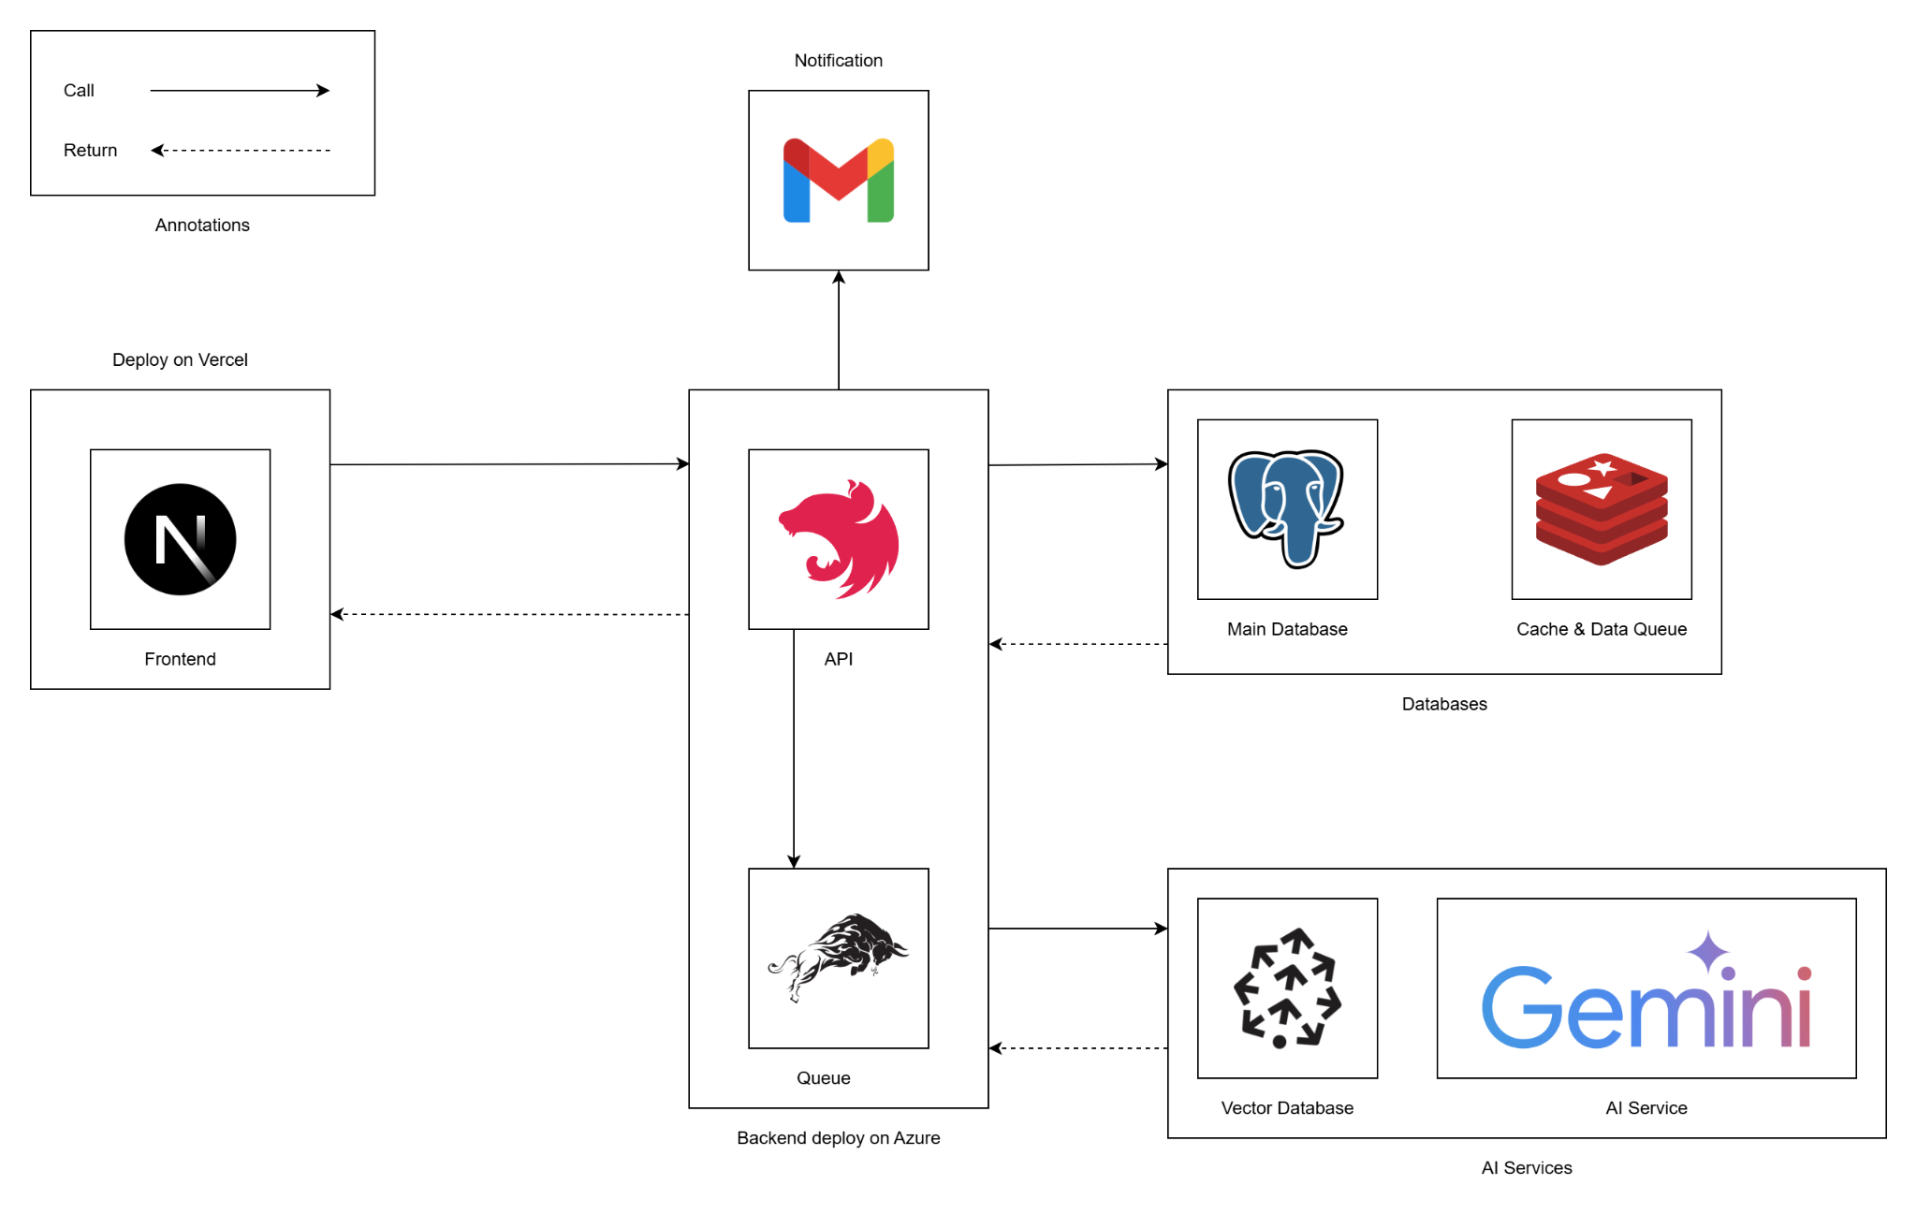](https://drive.google.com/file/d/1UXnih-Kfm-rtvHY22cMyyccG2-zGXHP-/view?usp=drive_link)

###### Figure IV.A.1 - System Architecture

### Package Diagram

#### Backend Package Diagram

[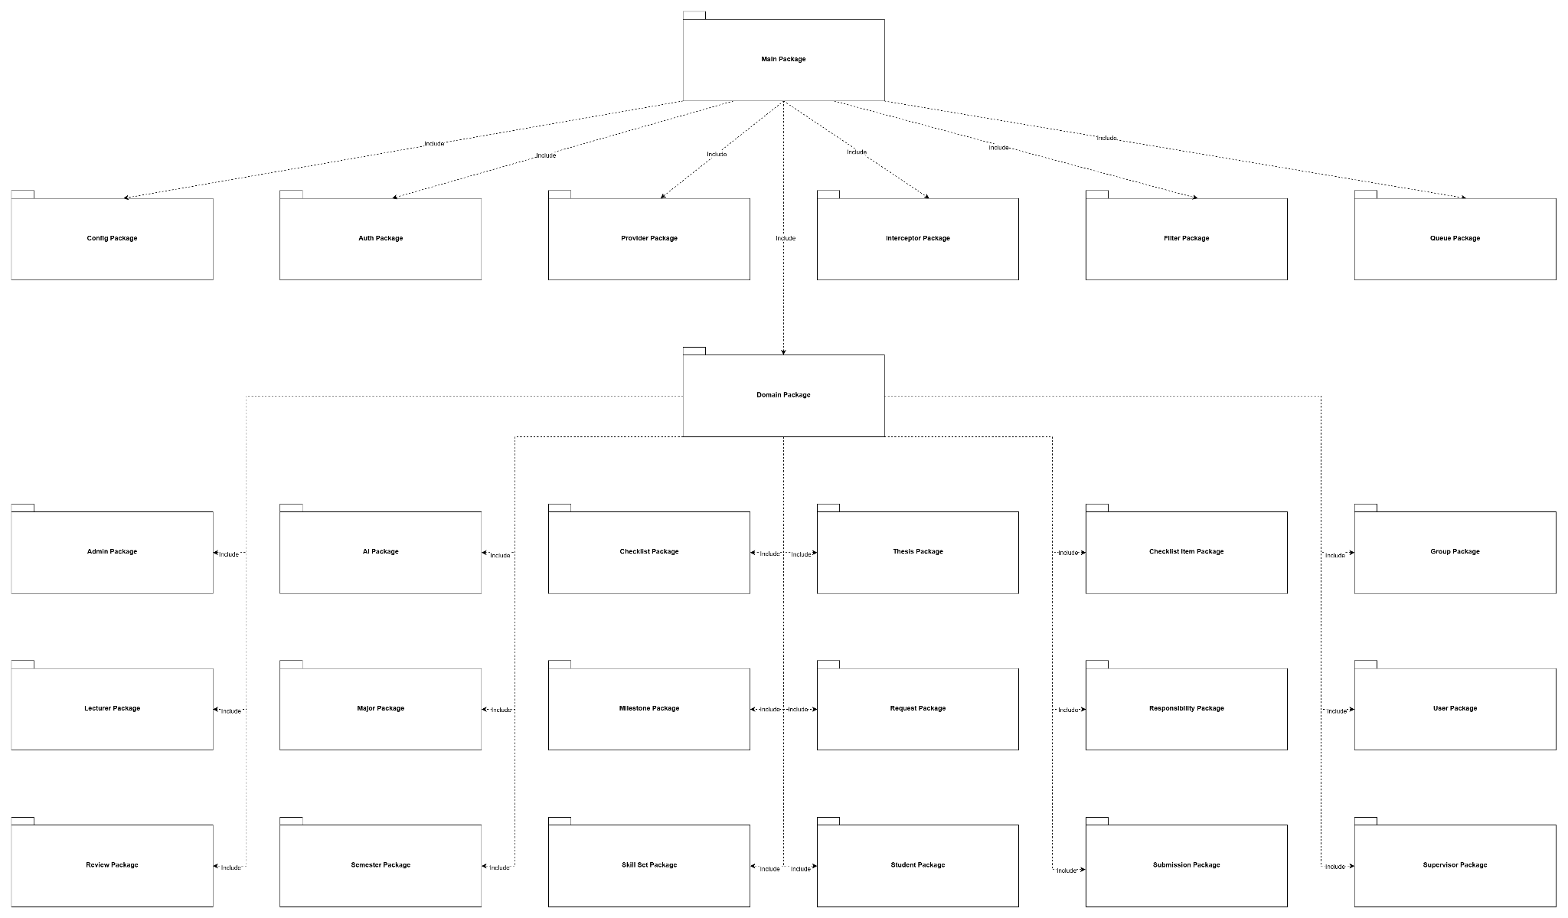](https://drive.google.com/file/d/1sPdSVlqZp7wB6zjLt6CfogeCHeAc0F0i/view?usp=drive_link)

###### Figure IV.A.2.a - Backend Package Diagram

#### Web Application Package Diagram

[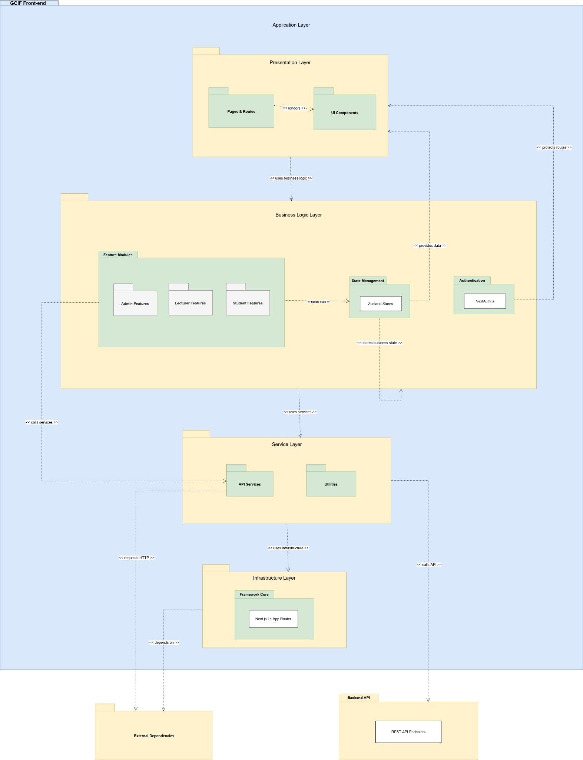](https://drive.google.com/file/d/160ktLG3Hav-BoS6tEK5S09RFS53aYlsF/view?usp=drive_link)

###### Figure IV.A.2.b - Web Application Package Diagram

## Database design

### Conceptual ERD

[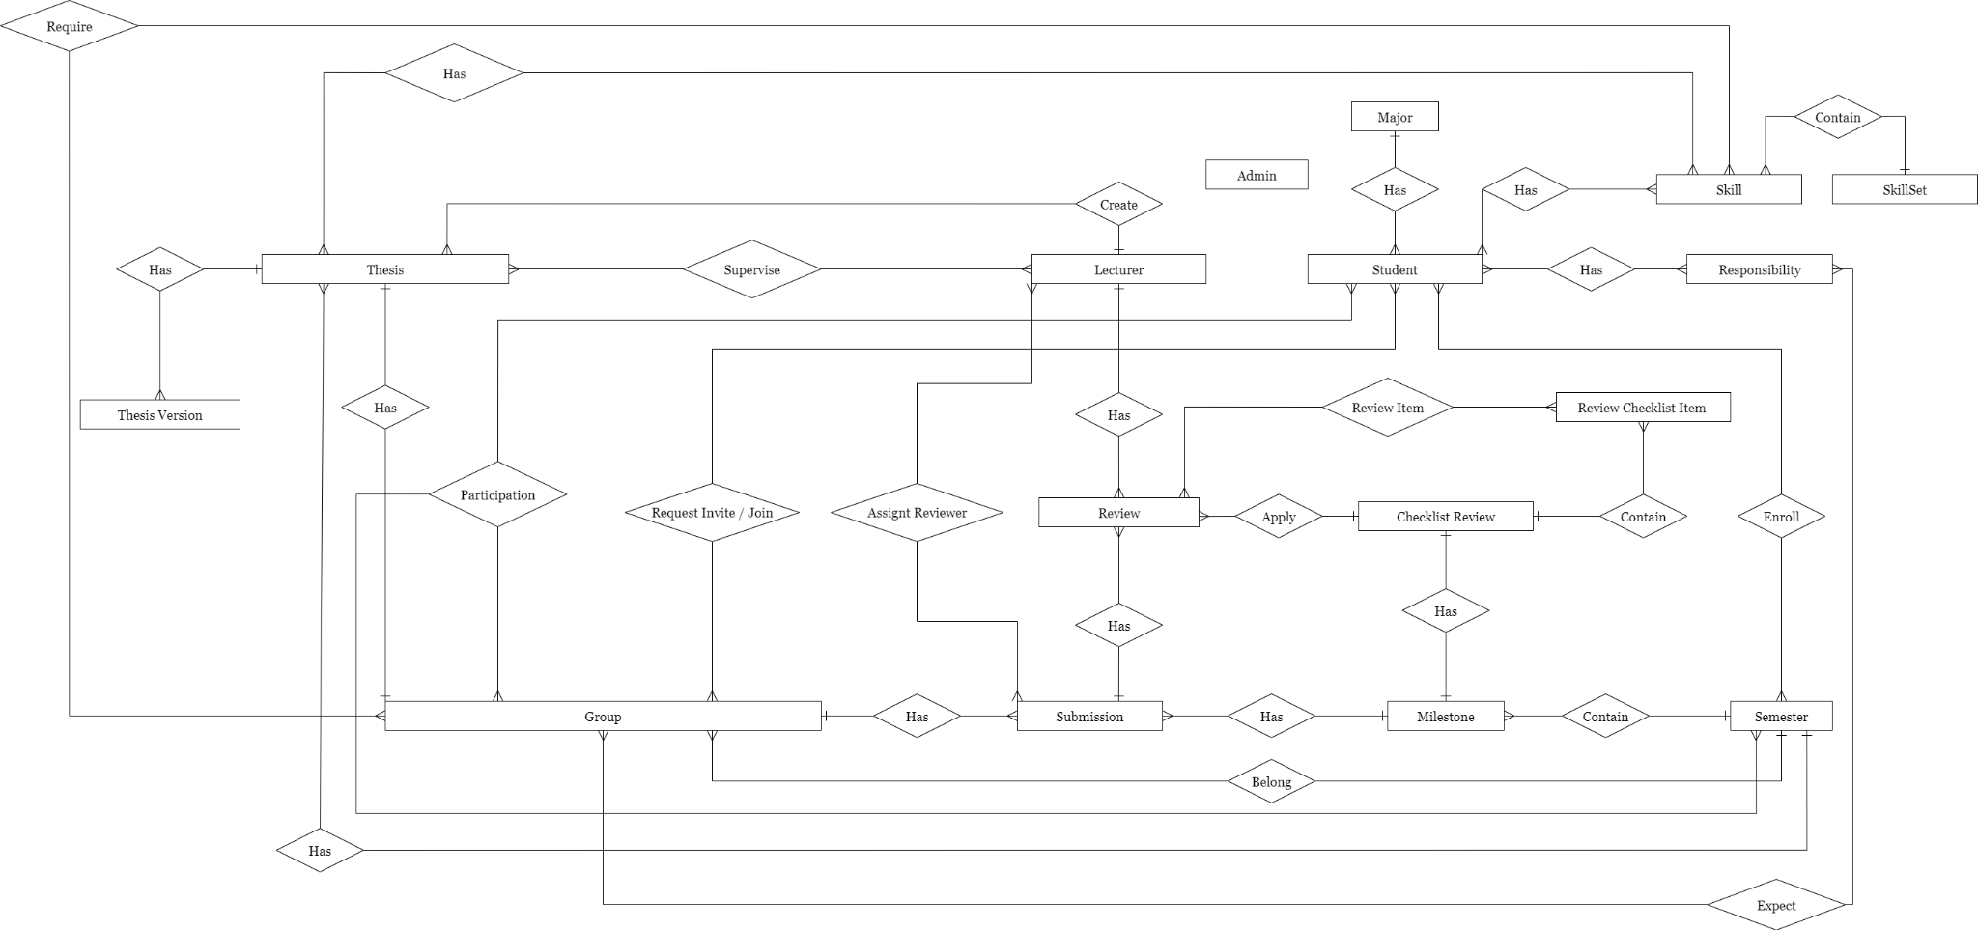](https://drive.google.com/file/d/1OdsrybRNanrW5jSSNl2q0fya1tn0tjEc/view?usp=sharing)

###### Figure IV.B.1 - Conceptual ERD

### Logical ERD

[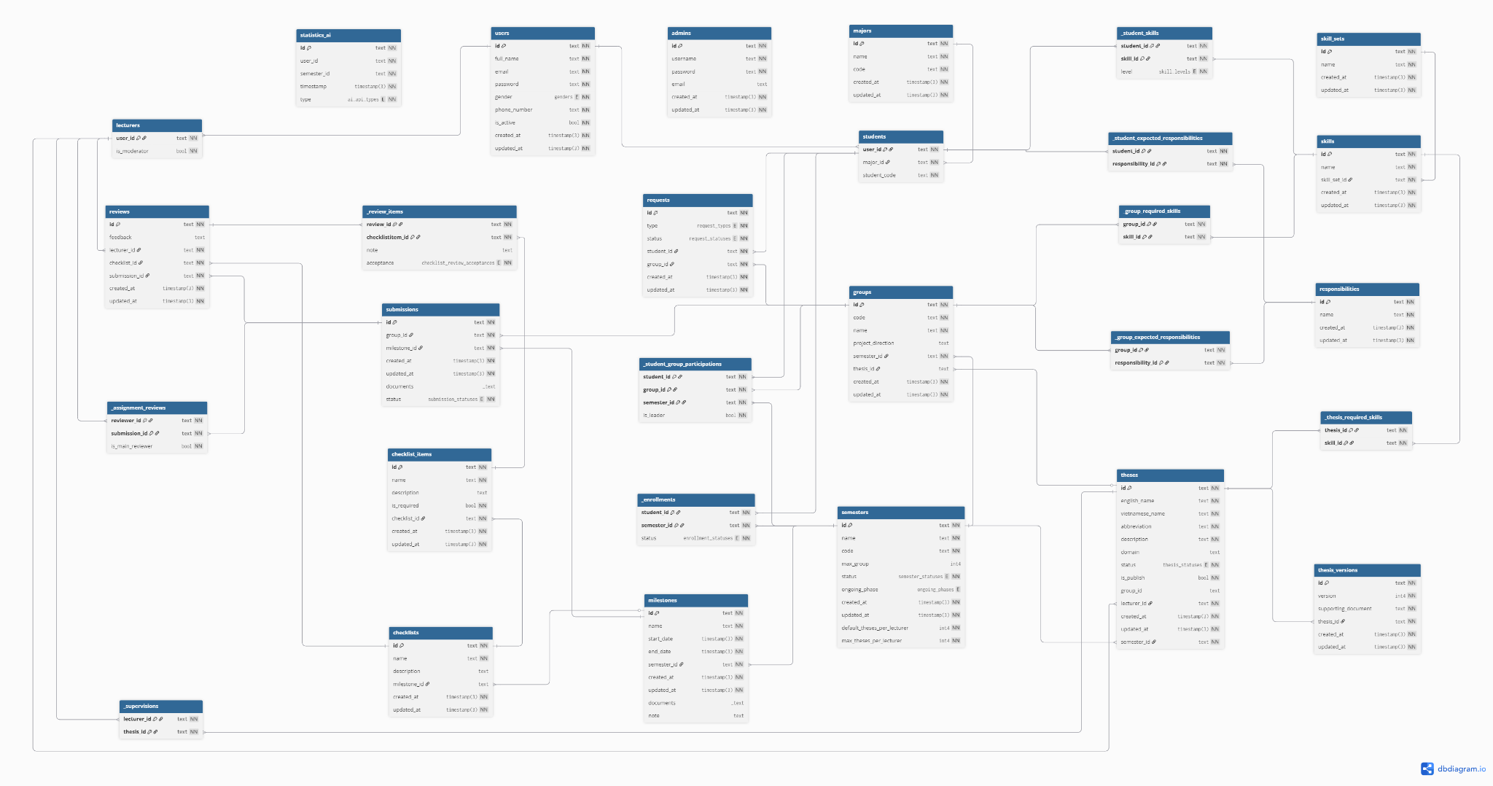](https://drive.google.com/file/d/1oMvAjiX0crqt_a7WKe0GK_arUOkXLkX-/view?usp=sharing)

###### Figure IV.B.2 Logical ERD

### Entities Description

| **#** | **Entity** | **Field** | **Description** |
| --- | --- | --- | --- |
| 1 | admins | id | text, Primary Key |
| 2 | username | text, unique, NOT NULL |
| 3 | password | text, NOT NULL |
| 4 | email | text, nullable |
| 5 | created_at | timestamp, default CURRENT_TIMESTAMP, NOT NULL |
| 6 | updated_at | timestamp, NOT NULL |
| 7 | users | id | text, Primary Key |
| 8 | full_name | text, NOT NULL |
| 9 | email | text, unique, NOT NULL |
| 10 | password | text, NOT NULL |
| 11 | gender | enum(male, female), NOT NULL |
| 12 | phone_number | text, NOT NULL |
| 13 | is_active | boolean, default true, NOT NULL |
| 14 | created_at | timestamp, default CURRENT_TIMESTAMP, NOT NULL |
| 15 | updated_at | timestamp, NOT NULL |
| 16 | lecturers | user_id | text, PK, FK → users(id) |
| 17 | is_moderator | boolean, default false, NOT NULL |
| 18 | students | user_id | text, PK, FK → users(id) |
| 19 | student_code | text, unique, NOT NULL |
| 20 | major_id | text, FK → majors(id), NOT NULL |
| 21 | majors | id | text, Primary Key |
| 22 | name | text, NOT NULL |
| 23 | code | text, unique, NOT NULL |
| 24 | created_at | timestamp, default CURRENT_TIMESTAMP, NOT NULL |
| 25 | updated_at | timestamp, NOT NULL |
| 26 | responsibilities | id | text, Primary Key |
| 27 | name | text, NOT NULL |
| 28 | created_at | timestamp, default CURRENT_TIMESTAMP, NOT NULL |
| 29 | updated_at | timestamp, NOT NULL |
| 30 | semesters | id | text, Primary Key |
| 31 | name | text, unique, NOT NULL |
| 32 | code | text, unique, NOT NULL |
| 33 | status | enum(not_yet, preparing, picking, ongoing, end), default not_yet, NOT NULL |
| 34 | ongoing_phase | enum(scope_adjustable, scope_locked), nullable |
| 35 | default_theses_per_lecturer | int4, default 4, NOT NULL |
| 36 | max_theses_per_lecturer | int4, default 6, NOT NULL |
| 37 | created_at | timestamp, default CURRENT_TIMESTAMP, NOT NULL |
| 38 | updated_at | timestamp, NOT NULL |
| 39 | groups | id | text, Primary Key |
| 40 | code | text, unique, NOT NULL |
| 41 | name | text, NOT NULL |
| 42 | project_direction | text, nullable |
| 43 | semester_id | text, FK → semesters(id), NOT NULL |
| 44 | thesis_id | text, FK → theses(id), nullable, unique |
| 45 | created_at | timestamp, default CURRENT_TIMESTAMP, NOT NULL |
| 46 | updated_at | timestamp, NOT NULL |
| 47 | theses | id | text, Primary Key |
| 48 | english_name | text, NOT NULL |
| 49 | vietnamese_name | text, NOT NULL |
| 50 | abbreviation | text, NOT NULL |
| 51 | description | text, NOT NULL |
| 52 | orientation | enum(se, ai, neutral), default neutral, NOT NULL |
| 53 | domain | text, nullable |
| 54 | status | enum(new, pending, approved, rejected), default new, NOT NULL |
| 55 | is_publish | boolean, default false, NOT NULL |
| 56 | group_id | text, FK → groups(id), nullable |
| 57 | lecturer_id | text, FK → lecturers(user_id), NOT NULL |
| 58 | semester_id | text, FK → semesters(id), NOT NULL |
| 59 | created_at | timestamp, default CURRENT_TIMESTAMP, NOT NULL |
| 60 | updated_at | timestamp, NOT NULL |
| 61 | thesis_versions | id | text, Primary Key |
| 62 | version | int4, NOT NULL |
| 63 | supporting_document | text, NOT NULL |
| 64 | thesis_id | text, FK → theses(id), NOT NULL |
| 65 | created_at | timestamp, default CURRENT_TIMESTAMP, NOT NULL |
| 66 | updated_at | timestamp, NOT NULL |
| 67 | milestones | id | text, Primary Key |
| 68 | name | text, NOT NULL |
| 69 | start_date | timestamp, NOT NULL |
| 70 | end_date | timestamp, NOT NULL |
| 71 | semester_id | text, FK → semesters(id), NOT NULL |
| 72 | note | text, nullable |
| 73 | documents | text[], nullable |
| 74 | created_at | timestamp, default CURRENT_TIMESTAMP, NOT NULL |
| 75 | updated_at | timestamp, NOT NULL |
| 76 | checklists | id | text, Primary Key |
| 77 | name | text, NOT NULL |
| 78 | description | text, nullable |
| 79 | milestone_id | text, FK → milestones(id), nullable, unique |
| 80 | created_at | timestamp, default CURRENT_TIMESTAMP, NOT NULL |
| 81 | updated_at | timestamp, NOT NULL |
| 82 | checklist_items | id | text, Primary Key |
| 83 | name | text, NOT NULL |
| 84 | description | text, nullable |
| 85 | is_required | boolean, default false, NOT NULL |
| 86 | checklist_id | text, FK → checklists(id), NOT NULL |
| 87 | created_at | timestamp, default CURRENT_TIMESTAMP, NOT NULL |
| 88 | updated_at | timestamp, NOT NULL |
| 89 | requests | id | text, Primary Key |
| 90 | type | enum(invite, join), NOT NULL |
| 91 | status | enum(cancelled, pending, approved, rejected), NOT NULL |
| 92 | student_id | text, FK → students(user_id), NOT NULL |
| 93 | group_id | text, FK → groups(id), NOT NULL |
| 94 | created_at | timestamp, default CURRENT_TIMESTAMP, NOT NULL |
| 95 | updated_at | timestamp, NOT NULL |
| 96 | submissions | id | text, Primary Key |
| 97 | group_id | text, FK → groups(id), NOT NULL |
| 98 | milestone_id | text, FK → milestones(id), NOT NULL |
| 99 | documents | text[], default empty array, nullable |
| 100 | status | enum(not_submitted, submitted), default not_submitted, NOT NULL |
| 101 | created_at | timestamp, default CURRENT_TIMESTAMP, NOT NULL |
| 102 | updated_at | timestamp, NOT NULL |
| 103 | (group_id, milestone_id) | unique constraint |
| 104 | reviews | id | text, Primary Key |
| 105 | feedback | text, nullable |
| 106 | lecturer_id | text, FK → lecturers(user_id), NOT NULL |
| 107 | checklist_id | text, FK → checklists(id), NOT NULL |
| 108 | submission_id | text, FK → submissions(id), NOT NULL |
| 109 | created_at | timestamp, default CURRENT_TIMESTAMP, NOT NULL |
| 110 | updated_at | timestamp, NOT NULL |
| 111 | _review_items | review_id | text, PK, FK → reviews(id) |
| 112 | checklistitem_id | text, PK, FK → checklist_items(id) |
| 113 | acceptance | enum(accepted, rejected, not_available), default not_available, NOT NULL |
| 114 | note | text, nullable |
| 115 | _enrollments | student_id | text, PK, FK → students(user_id) |
| 116 | semester_id | text, PK, FK → semesters(id) |
| 117 | status | enum(not_yet, failed, ongoing, passed), default not_yet, NOT NULL |
| 118 | _student_responsibilities | student_id | text, PK, FK → students(user_id) |
| 119 | responsibility_id | text, PK, FK → responsibilities(id) |
| 120 | level | int4, default 0, NOT NULL |
| 121 | _supervisions | thesis_id | text, PK, FK → theses(id) |
| 122 | lecturer_id | text, PK, FK → lecturers(user_id) |
| 123 | _assignment_reviews | submission_id | text, PK, FK → submissions(id) |
| 124 | reviewer_id | text, PK, FK → lecturers(user_id) |
| 125 | is_main_reviewer | boolean, default false, NOT NULL |
| 126 | _student_group_participations | student_id | text, PK, FK → students(user_id) |
| 127 | group_id | text, PK, FK → groups(id) |
| 128 | semester_id | text, PK, FK → semesters(id) |
| 129 | is_leader | boolean, default false, NOT NULL |

##### Table IV.B.3 - Entities Description

## Detail Design

### Authentication Feature

#### Class Diagram

[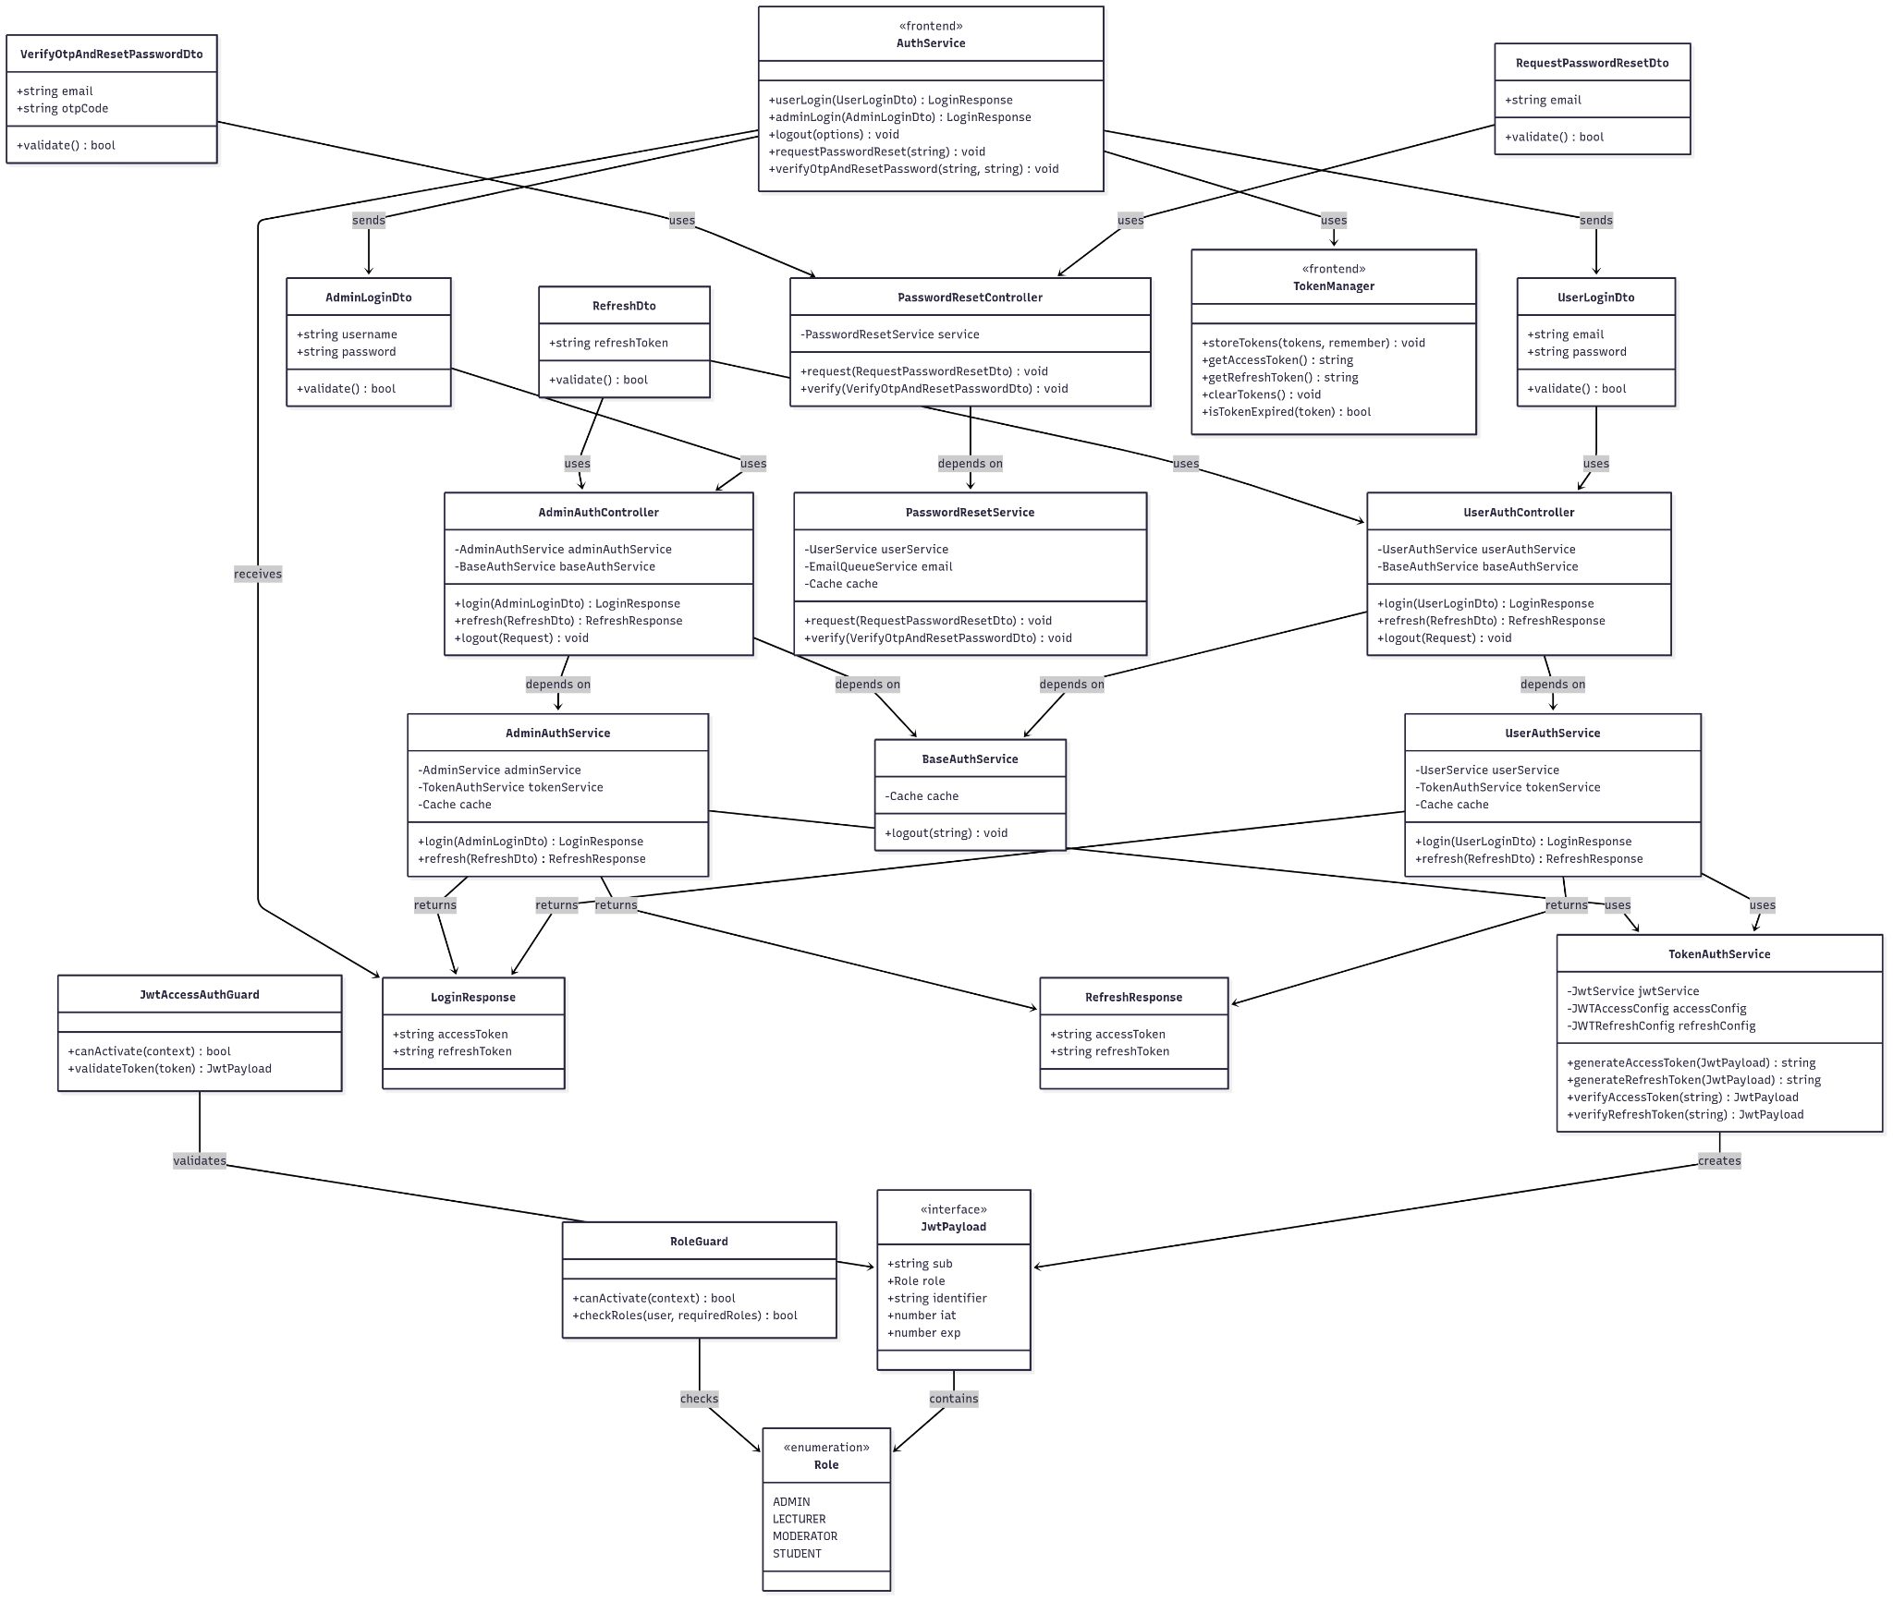](https://drive.google.com/file/d/1jk4ueC_sx35hv4QGW1AcRxP4MaJe_ckT/view?usp=drive_link)

###### Figure IV.C.1.a - Authentication Feature Class Diagram

#### Class Diagram Specification

| **No** | **Class** | **Method** | **Description** |
| --- | --- | --- | --- |
| **CONTROLLERS** | | | |
| 1 | UserAuthController | login(UserLoginDto) | Authenticates user with email/password, validates credentials, generates JWT tokens (access + refresh), stores token identifiers in Redis cache, returns LoginResponse with tokens |
| 2 | UserAuthController | refresh(RefreshDto) | Validates refresh token, generates new access token, updates token identifiers in cache, returns RefreshResponse with new tokens |
| 3 | UserAuthController | logout(Request) | Extracts user info from JWT token, calls BaseAuthService to clear token identifiers from cache, invalidates current session |
| 4 | AdminAuthController | login(AdminLoginDto) | Authenticates admin with username/password, validates credentials, generates JWT tokens with ADMIN role, stores identifiers in cache, returns LoginResponse |
| 5 | AdminAuthController | refresh(RefreshDto) | Validates admin refresh token, generates new access token with ADMIN role, updates cache, returns RefreshResponse |
| 6 | AdminAuthController | logout(Request) | Extracts admin info from JWT token, calls BaseAuthService to invalidate tokens, clears admin session from cache |
| 7 | PasswordResetController | request(RequestPasswordResetDto) | Validates user email exists and is active, generates 8-digit numeric OTP, stores OTP in Redis with 10-minute TTL, queues email job to send OTP |
| 8 | PasswordResetController | verify(VerifyOtpAndResetPasswordDto) | Validates OTP from cache, generates strong 32-character password, updates user password in database, deletes OTP from cache, sends new password via email |
| **SERVICES** | | | |
| 9 | UserAuthService | login(UserLoginDto) | Validates user credentials via UserService, checks user role dynamically, generates unique identifiers, creates JWT payloads, generates tokens, caches identifiers |
| 10 | UserAuthService | refresh(RefreshDto) | Verifies refresh token signature and expiration, validates cached identifiers, generates new access token, updates cache with new identifiers |
| 11 | AdminAuthService | login(AdminLoginDto) | Validates admin credentials via AdminService, generates unique identifiers, creates JWT payloads with ADMIN role, generates tokens, caches identifiers |
| 12 | AdminAuthService | refresh(RefreshDto) | Verifies admin refresh token, validates cached identifiers, generates new access token with ADMIN role, updates cache |
| 13 | BaseAuthService | logout(string) | Constructs cache key using user ID, deletes token identifiers from Redis cache, logs logout attempts and errors, handles cache deletion failures |
| 14 | PasswordResetService | request(RequestPasswordResetDto) | Finds user by email, validates user is active, generates 8-digit numeric OTP, stores in cache with email key and 10-minute TTL, queues SEND_OTP email job |
| 15 | PasswordResetService | verify(VerifyOtpAndResetPasswordDto) | Validates user exists, retrieves and validates OTP from cache, generates 32-character strong password, updates database password, deletes OTP, queues SEND_RESET_PASSWORD email |
| 16 | TokenAuthService | generateAccessToken(JwtPayload) | Signs JWT payload with access token secret, sets expiration time from configuration, returns signed access token string |
| 17 | TokenAuthService | generateAccessToken(JwtPayload) | Signs JWT payload with access token secret, sets expiration time from configuration, returns signed access token string |
| 18 | TokenAuthService | verifyAccessToken(string) | Verifies token signature using access token secret, validates expiration, returns decoded JwtPayload or throws error |
| 19 | TokenAuthService | verifyRefreshToken(string) | Verifies token signature using refresh token secret, validates expiration, returns decoded JwtPayload or throws error |
| **SECURITY GUARDS** | | | |
| 20 | JwtAccessAuthGuard | canActivate(context) | Extracts Bearer token from request headers, validates token using TokenAuthService, checks token identifiers in cache, attaches user payload to request |
| 21 | JwtAccessAuthGuard | validateToken(token) | Calls TokenAuthService to verify token signature and expiration, validates cached identifiers match token, returns JwtPayload or throws UnauthorizedException |
| 22 | RoleGuard | canActivate(context) | Extracts user payload from request, gets required roles from @Roles decorator, validates user role against required roles, returns boolean access result |
| 23 | RoleGuard | checkRoles(user, requiredRoles) | Compares user role with array of required roles, handles role hierarchy (MODERATOR includes LECTURER permissions), returns access permission boolean |
| **FRONTEND SERVICES** | | | |
| 24 | AuthService | userLogin(UserLoginDto) | Calls backend /auth/user/login endpoint, handles API response and errors, stores tokens using TokenManager, returns LoginResponse or error |
| 25 | AuthService | adminLogin(AdminLoginDto) | Calls backend /auth/admin/login endpoint, handles API response and errors, stores admin tokens, returns LoginResponse or error |
| 26 | AuthService | logout(options) | Clears tokens from TokenManager (localStorage/sessionStorage), calls NextAuth signOut, handles redirect options, manages logout errors |
| 27 | AuthService | requestPasswordReset(string) | Calls backend /auth/password-reset/request with email, handles validation errors, manages API response, returns success/error status |
| 28 | AuthService | verifyOtpAndResetPassword(string, string) | Calls backend /auth/password-reset/verify with email and OTP, handles verification errors, manages password reset response |
| 29 | TokenManager | storeTokens(tokens, remember) | Stores access/refresh tokens in localStorage (remember=true) or sessionStorage (remember=false), handles storage errors |
| 30 | TokenManager | getAccessToken() | Retrieves access token from localStorage or sessionStorage, handles missing tokens, returns token string or null |
| 31 | TokenManager | getRefreshToken() | Retrieves refresh token from appropriate storage, handles missing tokens, returns token string or null |
| 32 | TokenManager | clearTokens() | Removes all tokens from both localStorage and sessionStorage, handles clearing errors, ensures complete cleanup |
| 33 | TokenManager | isTokenExpired(token) | Decodes JWT token, compares expiration time with current time, handles malformed tokens, returns boolean expiration status |
| **DATA TRANSFER OBJECTS** | | | |
| 34 | UserLoginDto | validate() | Validates email format using @IsEmail decorator, checks password meets security requirements (min 12 chars, uppercase, digit, special char), returns validation result |
| 35 | AdminLoginDto | validate() | Validates username is non-empty string, checks password meets security requirements (min 12 chars, uppercase, digit, special char), returns validation result |
| 36 | RefreshDto | validate() | Validates refresh token is non-empty string, checks token format, returns validation result for token refresh operations |
| 37 | RequestPasswordResetDto | validate() | Validates email format using @IsEmail decorator, ensures email is not empty, returns validation result for password reset requests |
| 38 | VerifyOtpAndResetPasswordDto | validate() | Validates email format, validates OTP is exactly 8 digits, ensures both fields are non-empty, returns validation result for OTP verification |

##### Table IV.C.1.b - Authentication Feature Class Diagram Specification

#### Sequence Diagram

* + - * 1. Login

[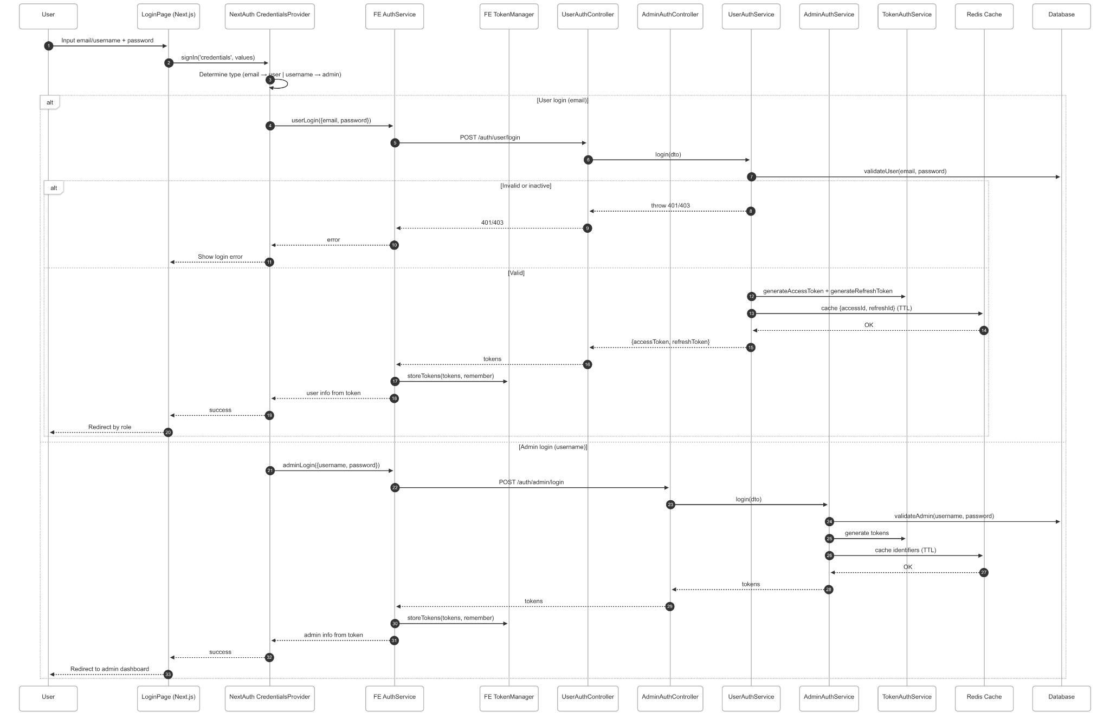](https://drive.google.com/file/d/1QCdnHeWcDiyvCuMGAgmIRbHX6-OU3LEc/view?usp=drive_link)

###### Figure IV.C.1.c.(1) - Login Sequence Diagram

* + - * 1. Logout

[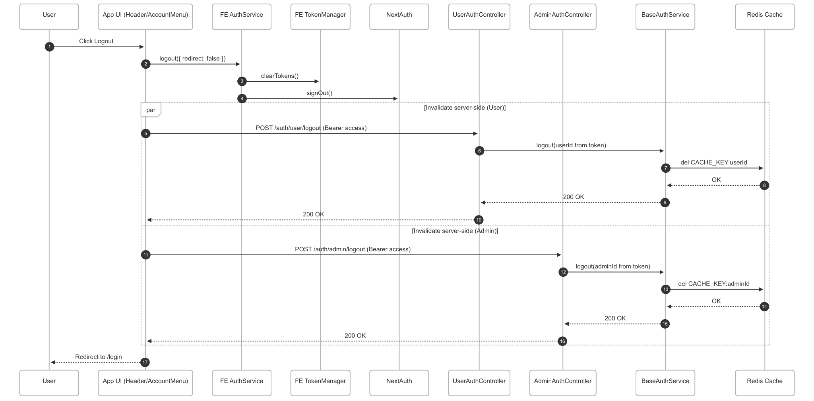](https://drive.google.com/file/d/1PLhSMLAFYqyHInxKUlrTxgX-a8K_QQUT/view?usp=drive_link)

###### Figure IV.C.1.c.(2) - Logout Sequence Diagram

* + - * 1. Forgot & Reset Password

[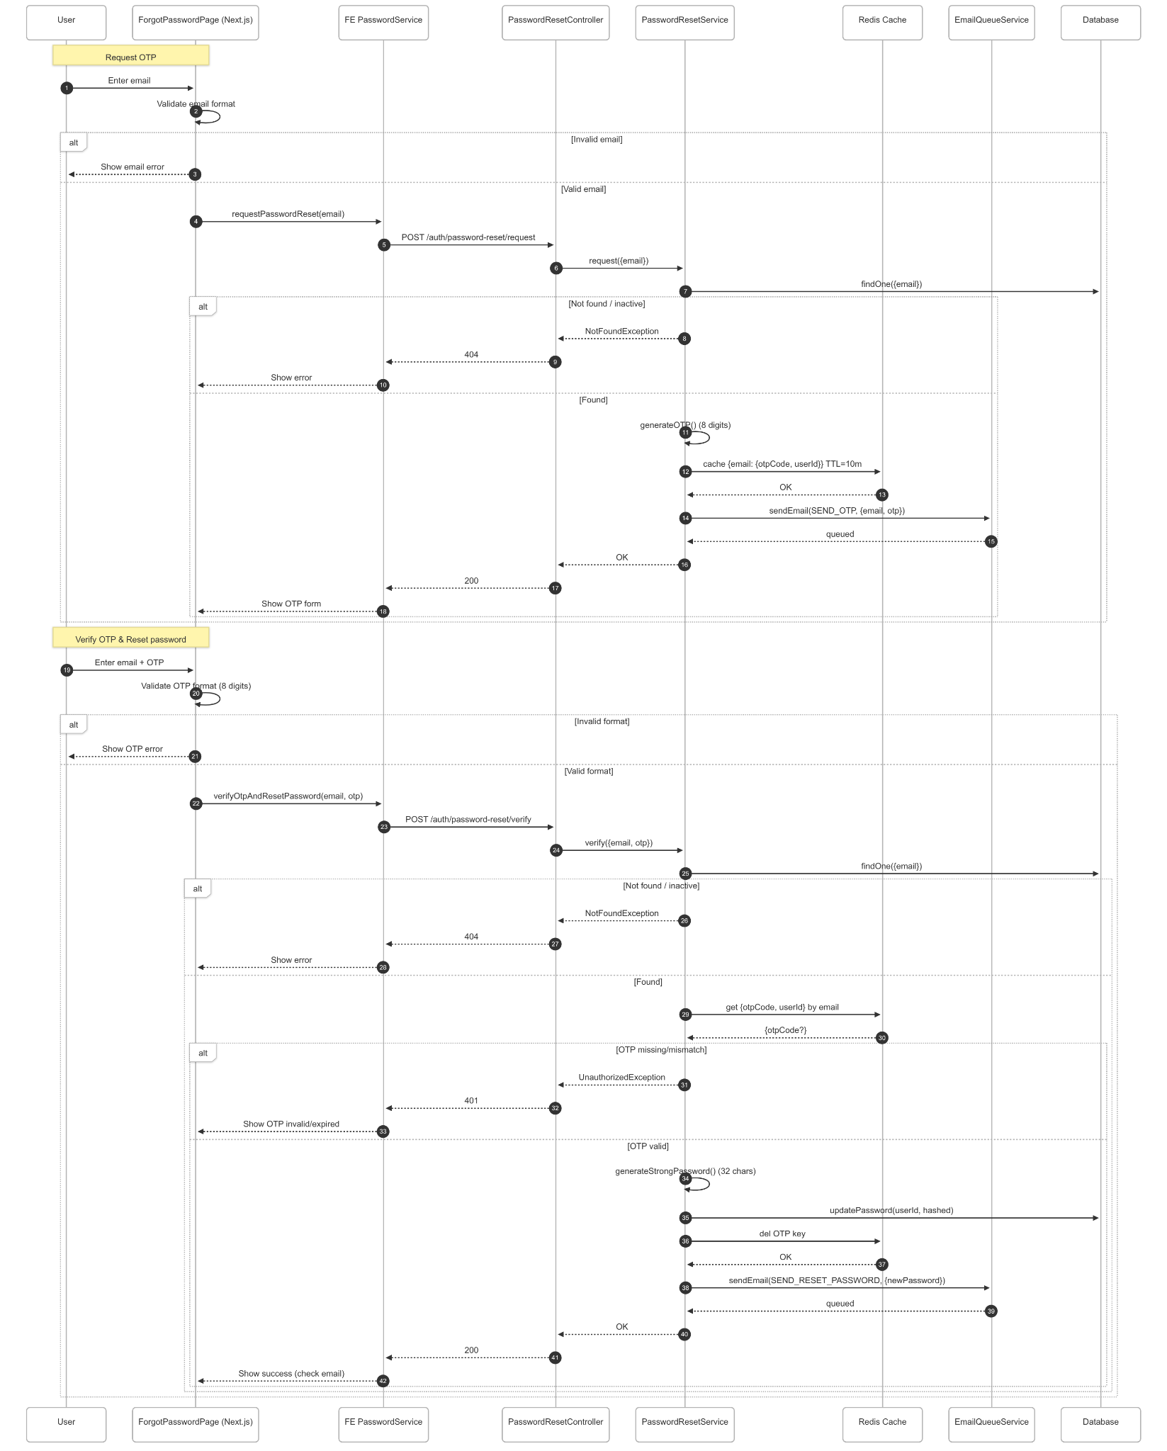](https://drive.google.com/file/d/11YqsY1M4XrlXjZ40X_JIyHYEiWSIpha1/view?usp=drive_link)

###### Figure IV.C.1.c.(3) - Forgot & Reset Password Sequence Diagram

### Admin Manage Student Accounts

#### Class Diagram

[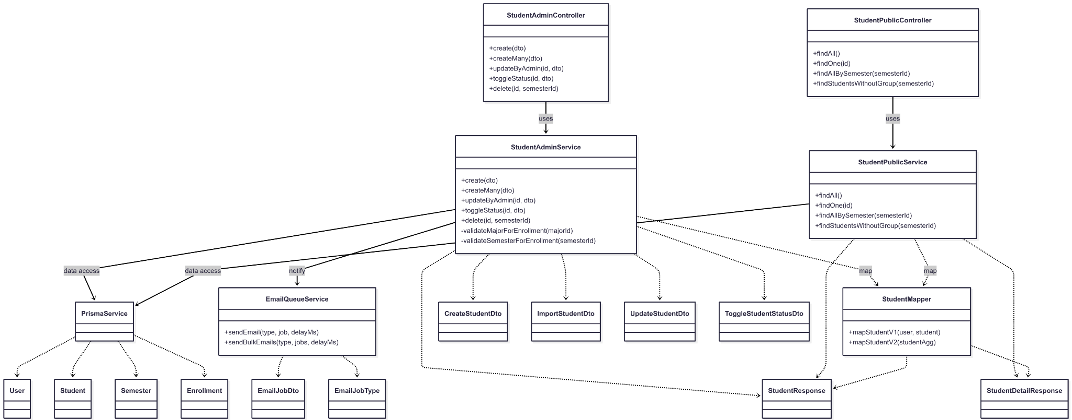](https://drive.google.com/file/d/1SP9vlEgk3Hhd_GqzZaU7dEidm00wqCqZ/view?usp=drive_link)

###### Figure IV.C.2.a - Admin Manage Student Accounts Class Diagram

#### Class Diagram Specification

| **No** | **Class** | **Method** | **Description** |
| --- | --- | --- | --- |
| 1 | StudentAdminController | create(dto) | Create new students or enroll existing students by studentCode; returns StudentResponse. |
| 2 | StudentAdminController | createMany(dto) | Bulk import students for a semester/major; returns list of StudentResponse. |
| 3 | StudentAdminController | updateByAdmin(id, dto) | Update user/student info (email, fullName, gender, phone, studentCode, majorId). |
| 4 | StudentAdminController | toggleStatus(id, dto) | Enable/disable student account (isActive). |
| 5 | StudentAdminController | delete(id, semesterId) | Remove enrollment for a semester or fully delete students if last enrollment. |
| 6 | StudentPublicController | findAll() | List all students (ordered by createdAt desc). |
| 7 | StudentPublicController | findOne(id) | Get a detailed student profile by id. |
| 8 | StudentPublicController | findAllBySemester(semesterId) | List students in a semester. |
| 9 | StudentPublicController | findStudentsWithoutGroup(semesterId) | List students of a semester not in any group. |
| 10 | StudentAdminService | create(dto) | Validates conflicts, semester (Preparing), major; creates user/student, enrolls, sets random password, emails credentials; transactional. |
| 11 | StudentAdminService | createMany(dto) | Validates batch conflicts; creates/enrolls each student; sets passwords; bulk emails; transactional. |
| 12 | StudentAdminService | updateByAdmin(id, dto) | Checks email/studentCode conflicts; updates user and student; maps to StudentResponse; transactional. |
| 13 | StudentAdminService | toggleStatus(id, dto) | Updates user.isActive; returns mapped StudentResponse; transactional. |
| 14 | StudentAdminService | delete(id, semesterId) | Validates semester (Preparing), enrollment exists, no group participation; removes only enrollment or deletes user/student; transactional. |
| 15 | StudentAdminService | validateMajorForEnrollment(majorId) | Ensures major exists; throws NotFound if missing. |
| 16 | StudentAdminService | validateSemesterForEnrollment(semesterId) | Ensures semester exists and status is Preparing; else Conflict. |
| 17 | StudentPublicService | findAll() | Fetches students with user include; maps via mapStudentV2. |
| 18 | StudentPublicService | findOne(id) | Fetches detailed profile aggregates; maps to StudentDetailResponse. |
| 19 | StudentPublicService | findAllBySemester(semesterId) | Fetches students filtered by semester; maps list. |
| 20 | StudentPublicService | findStudentsWithoutGroup(semesterId) | Fetches students in semester with no group participation. |
| 21 | StudentMapper | mapStudentV1(user, student) | Compose StudentResponse from User + Student. |
| 22 | StudentMapper | mapStudentV2(studentAgg) | Compose StudentResponse from aggregated student-with-user query. |
| 23 | EmailQueueService | sendEmail(type, job, delayMs) | Queue a single email (e.g., SEND_STUDENT_ACCOUNT) with context (fullName, email, password, studentCode, semesterName). |
| 24 | EmailQueueService | sendBulkEmails(type, jobs, delayMs) | Queue multiple account emails efficiently post-import. |
| 25 | PrismaService | $transaction(callback) | Executes multi-step DB operations atomically for consistency. |
| 26 | CreateStudentDto | validate() | email, fullName, gender, phoneNumber (from CreateUserDto); plus required studentCode, majorId (UUID), semesterId (UUID). |
| 27 | ImportStudentDto | validate() | Required semesterId, majorId; students[] as ImportStudentItemDto validated. |
| 28 | ImportStudentItemDto | validate() | Inherits user fields; requires studentCode. |
| 29 | UpdateStudentDto | validate() | Partial of CreateStudentDto (omits semesterId); optional email, fullName, gender, phoneNumber, studentCode, majorId. |
| 30 | ToggleStudentStatusDto | validate() | Optional isActive boolean. |
| 31 | StudentResponse | shape() | id, email, fullName, studentCode, majorId, isActive, timestamps (read model). |
| 32 | StudentDetailResponse | shape() | Detailed profile projection (student + user + related aggregates). |

##### Table IV.C.2.b - Admin Manage Student Accounts Class Diagram Specification

#### Sequence Diagram

* + - * 1. Create Student

[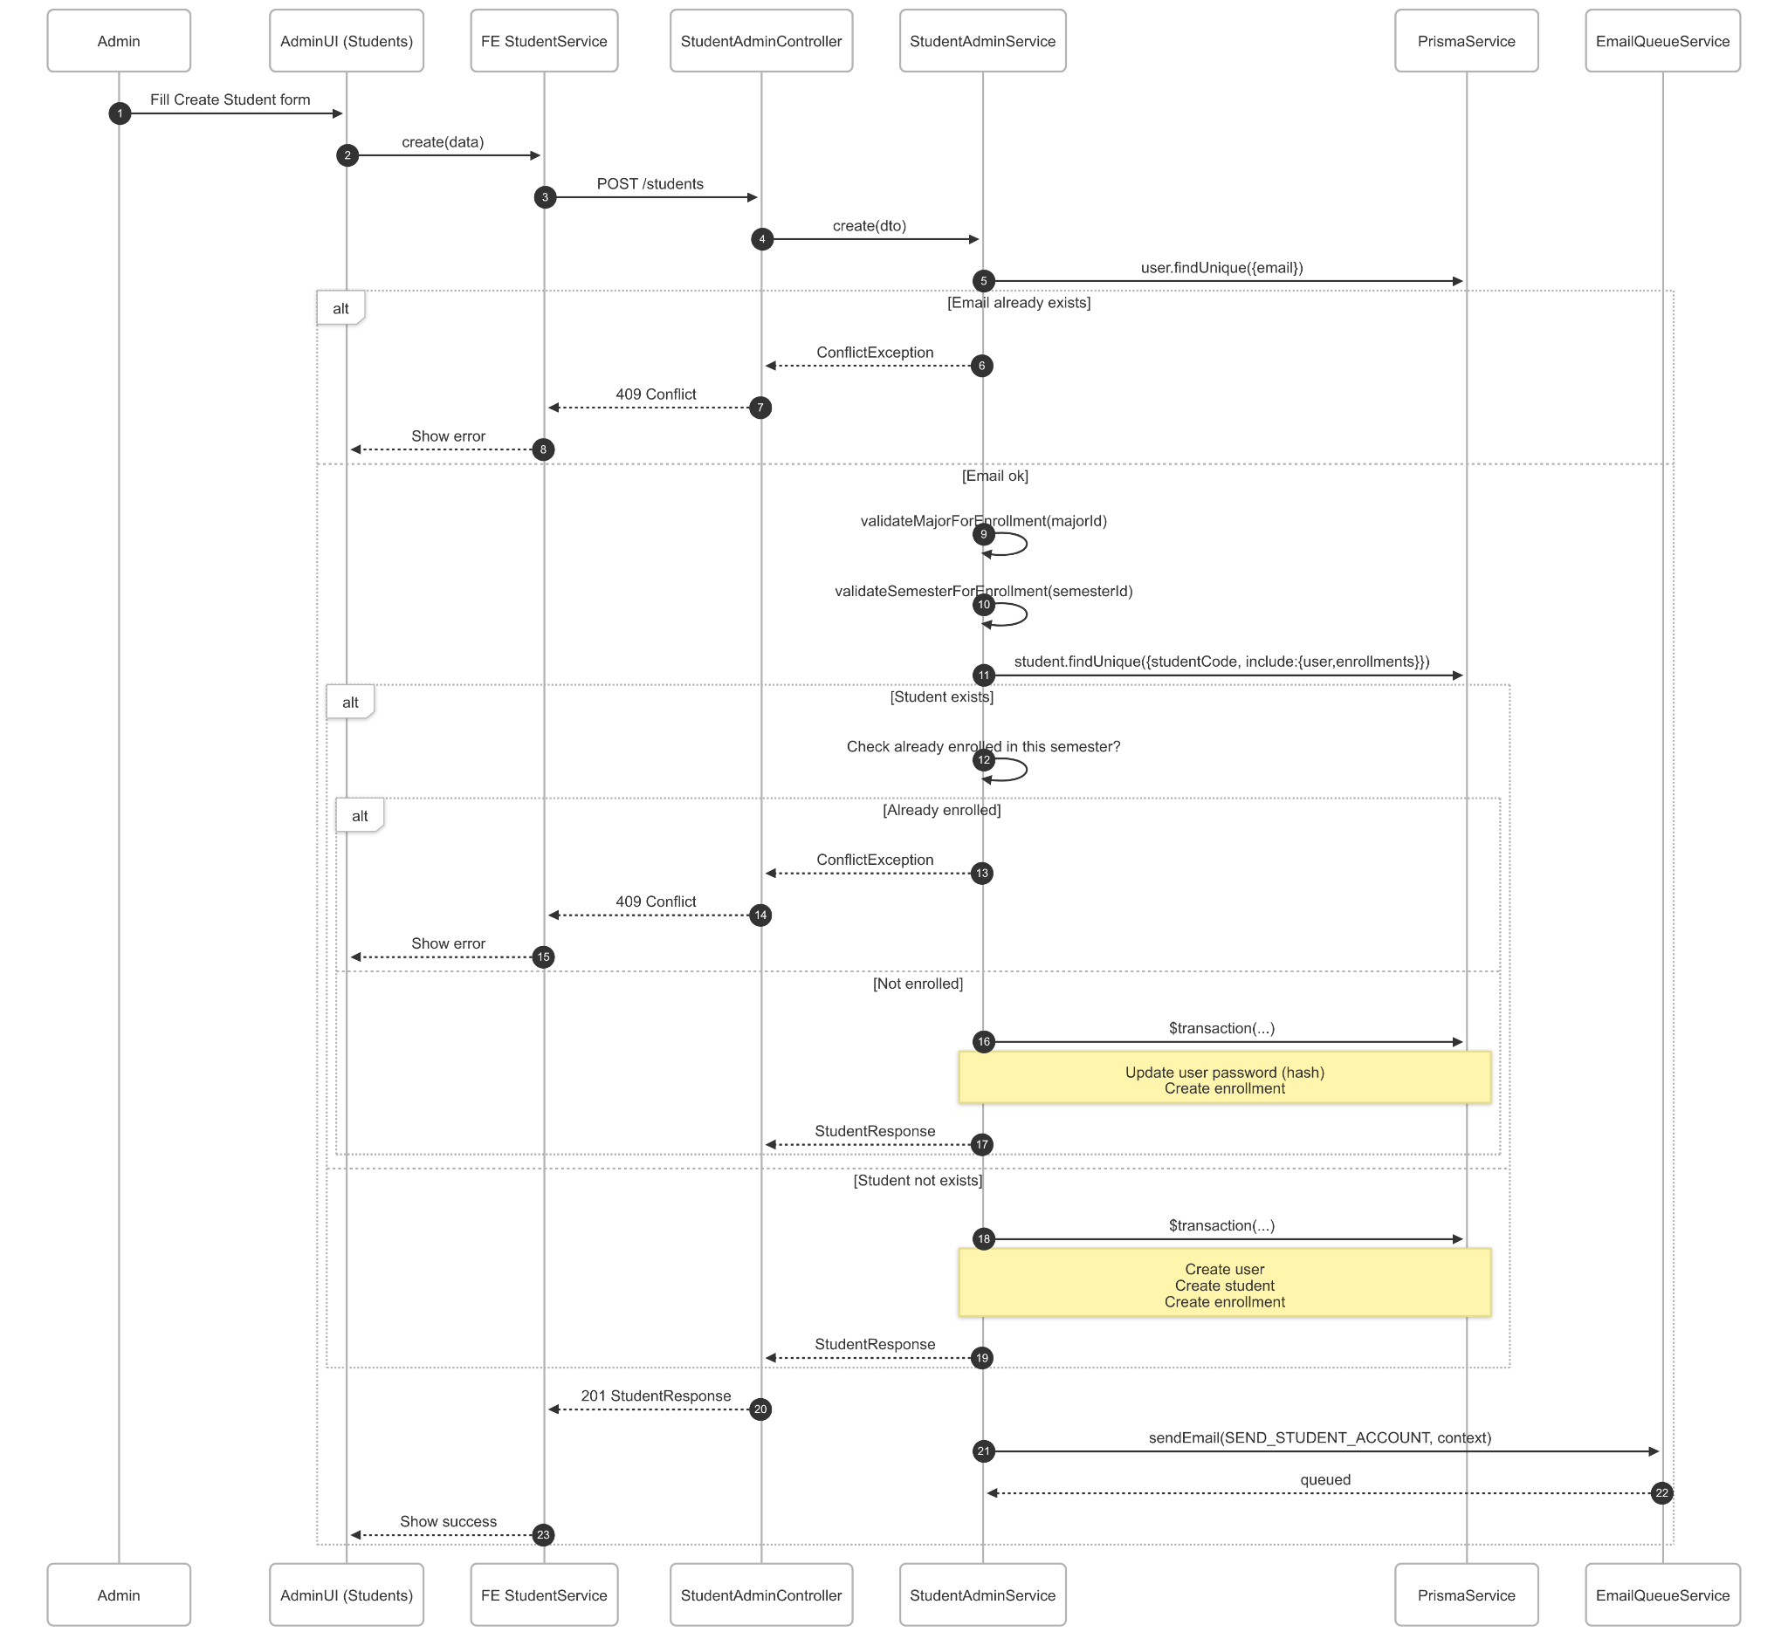](https://drive.google.com/file/d/1kRvAvTK9Y0YCP7J5wyhhXjHcW_QuTjnf/view?usp=drive_link)

###### Figure IV.C.2.c.(1) - Create Student Accounts Sequence Diagram

* + - * 1. Import Students

[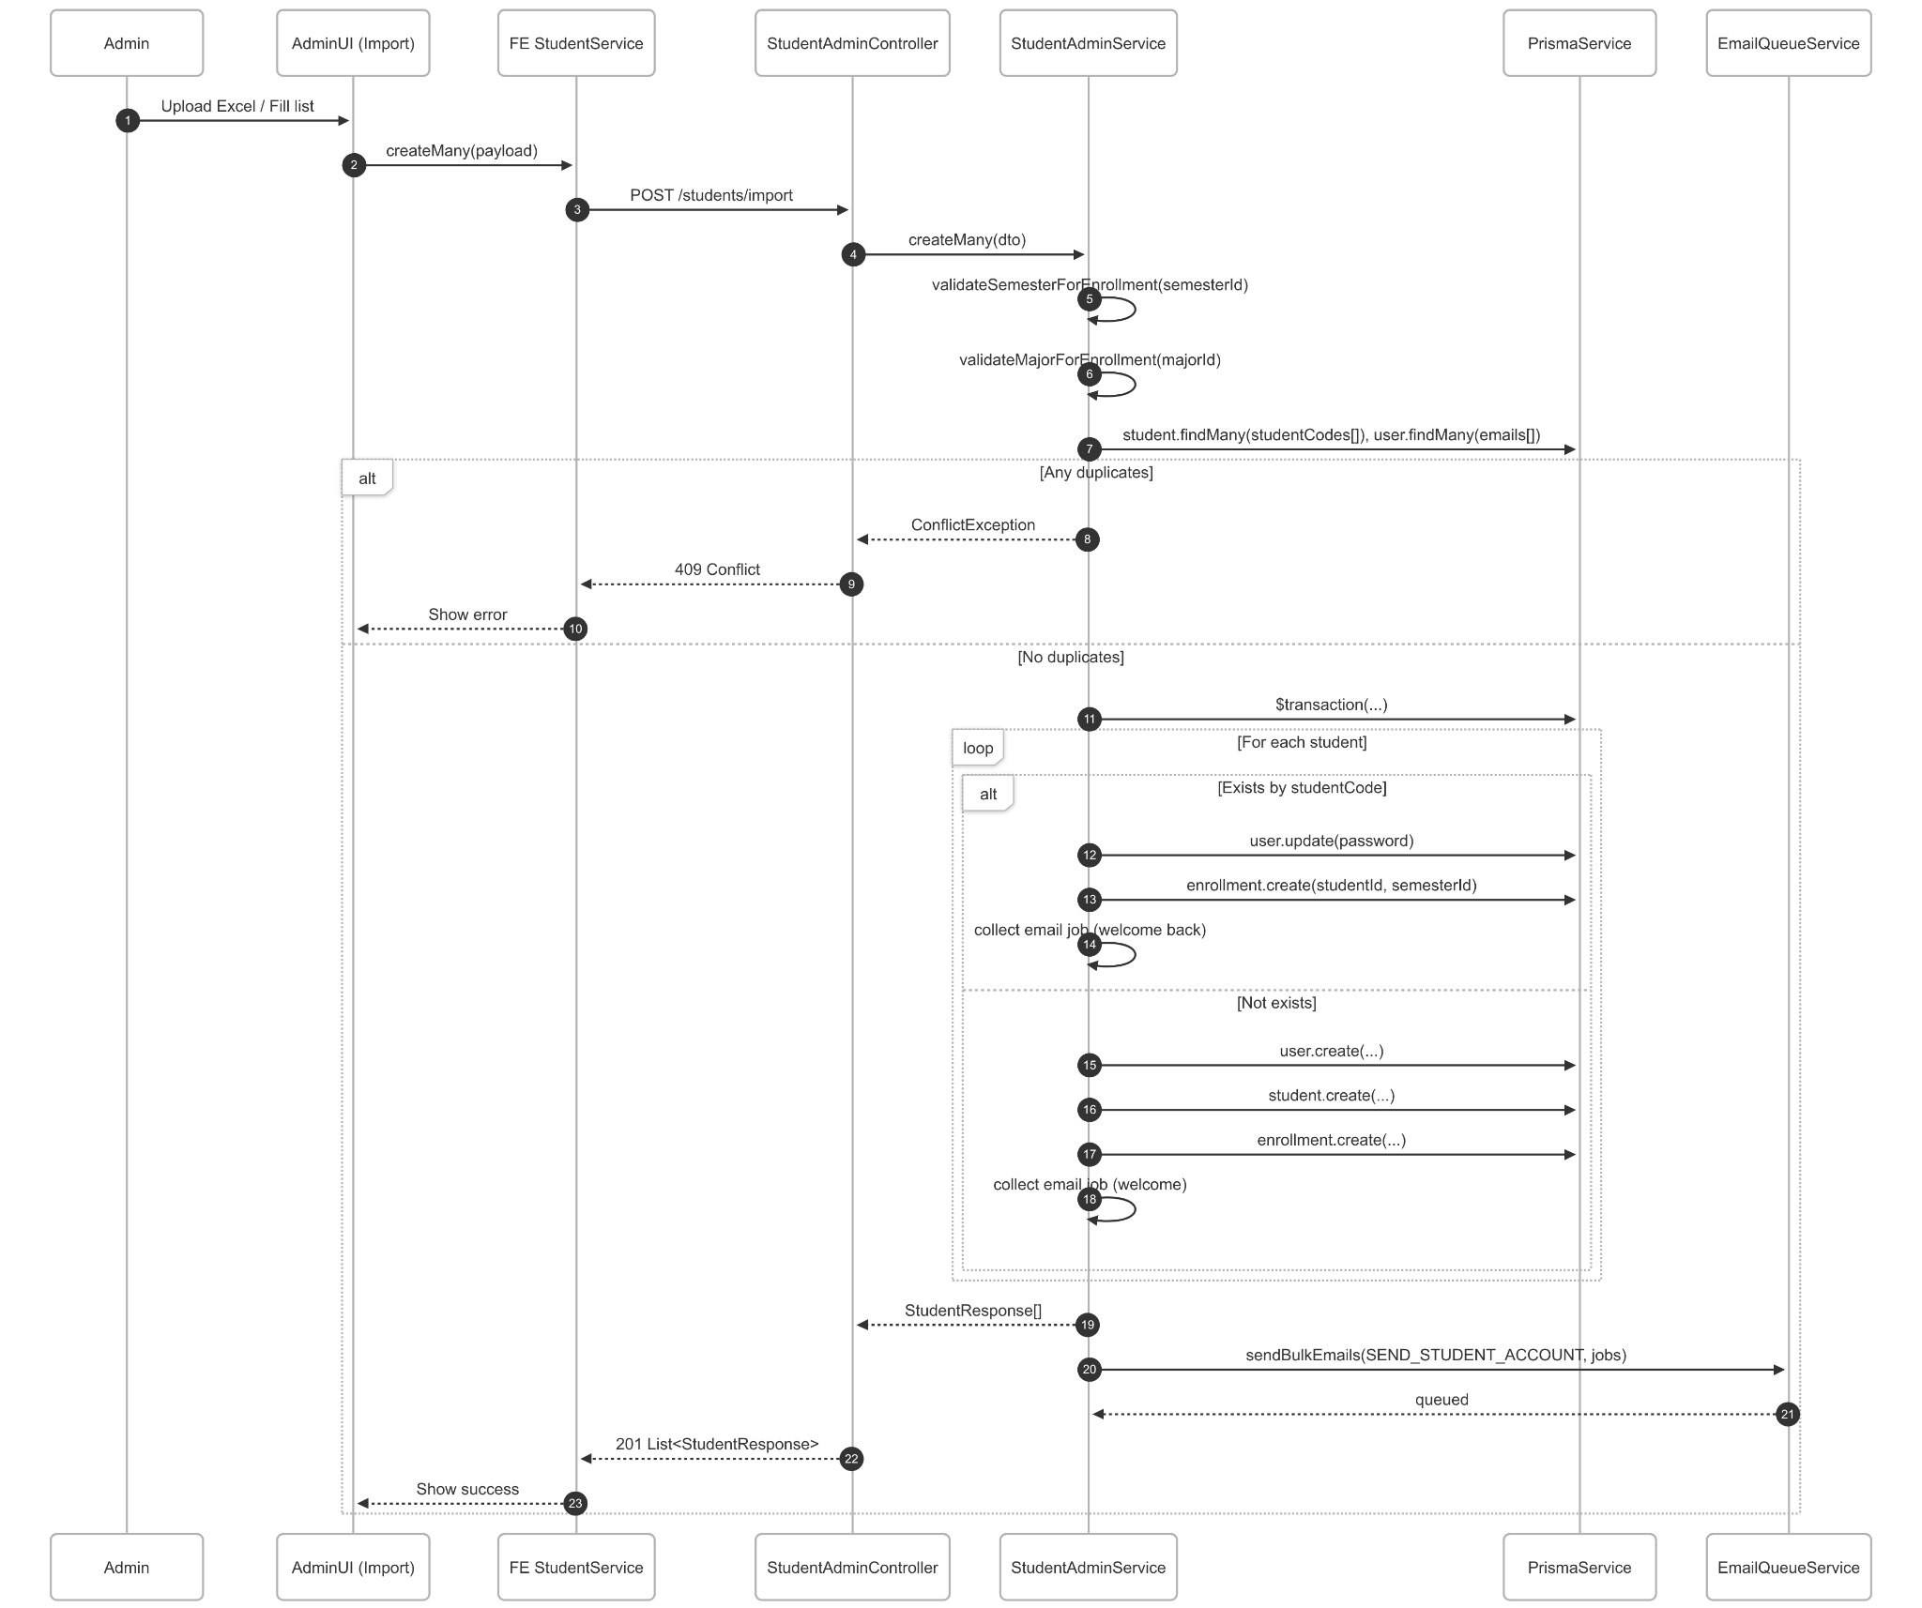](https://drive.google.com/file/d/1DkaCDbnjeIgpBOZrDwLQRbPUCYd6VFrA/view?usp=drive_link)

###### Figure IV.C.2.c.(2) - Import Students Accounts Sequence Diagram

* + - * 1. Update Student

[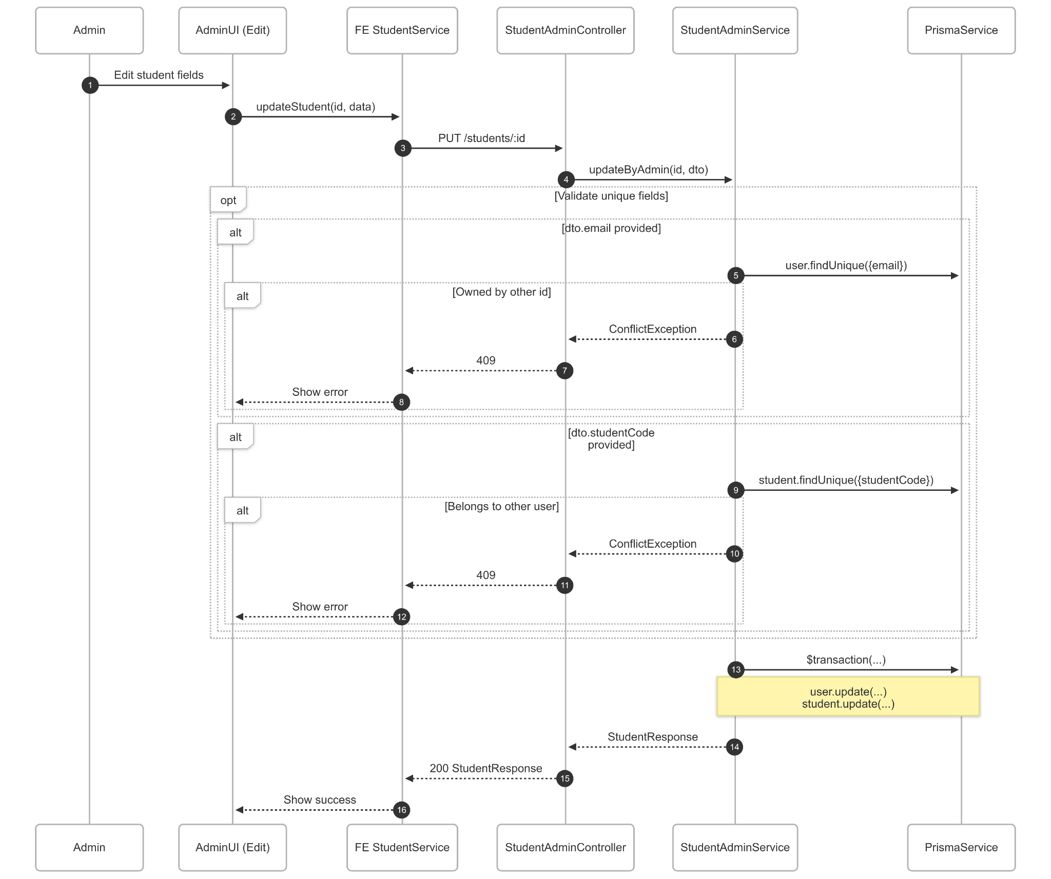](https://drive.google.com/file/d/1ZjW7EwX43rcI2-UsqPFYTYrCr6ZqC43Q/view?usp=drive_link)

###### Figure IV.C.2.c.(3) - Update Student Accounts Sequence Diagram

* + - * 1. Toggle Status

[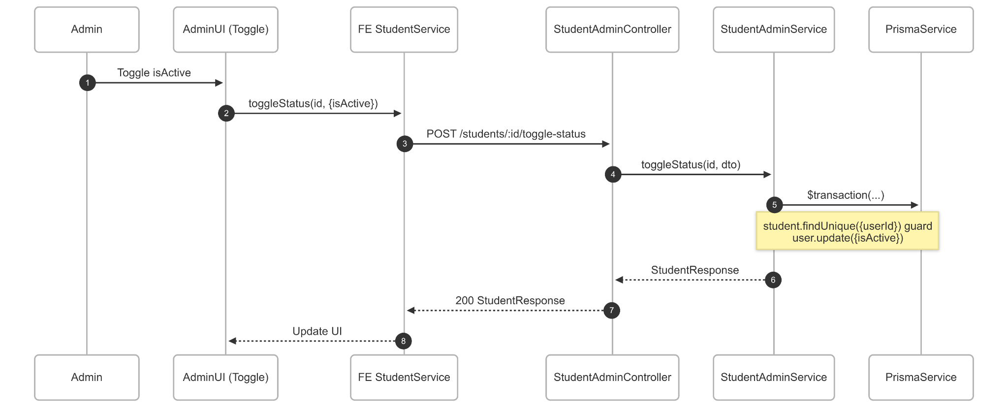](https://drive.google.com/file/d/1zsmBcinB7BSGjVTb1Zi5u4dfv2qC6IWB/view?usp=drive_link)

###### Figure IV.C.2.c.(4) - Toggle Status Accounts Sequence Diagram

* + - * 1. Delete Student

[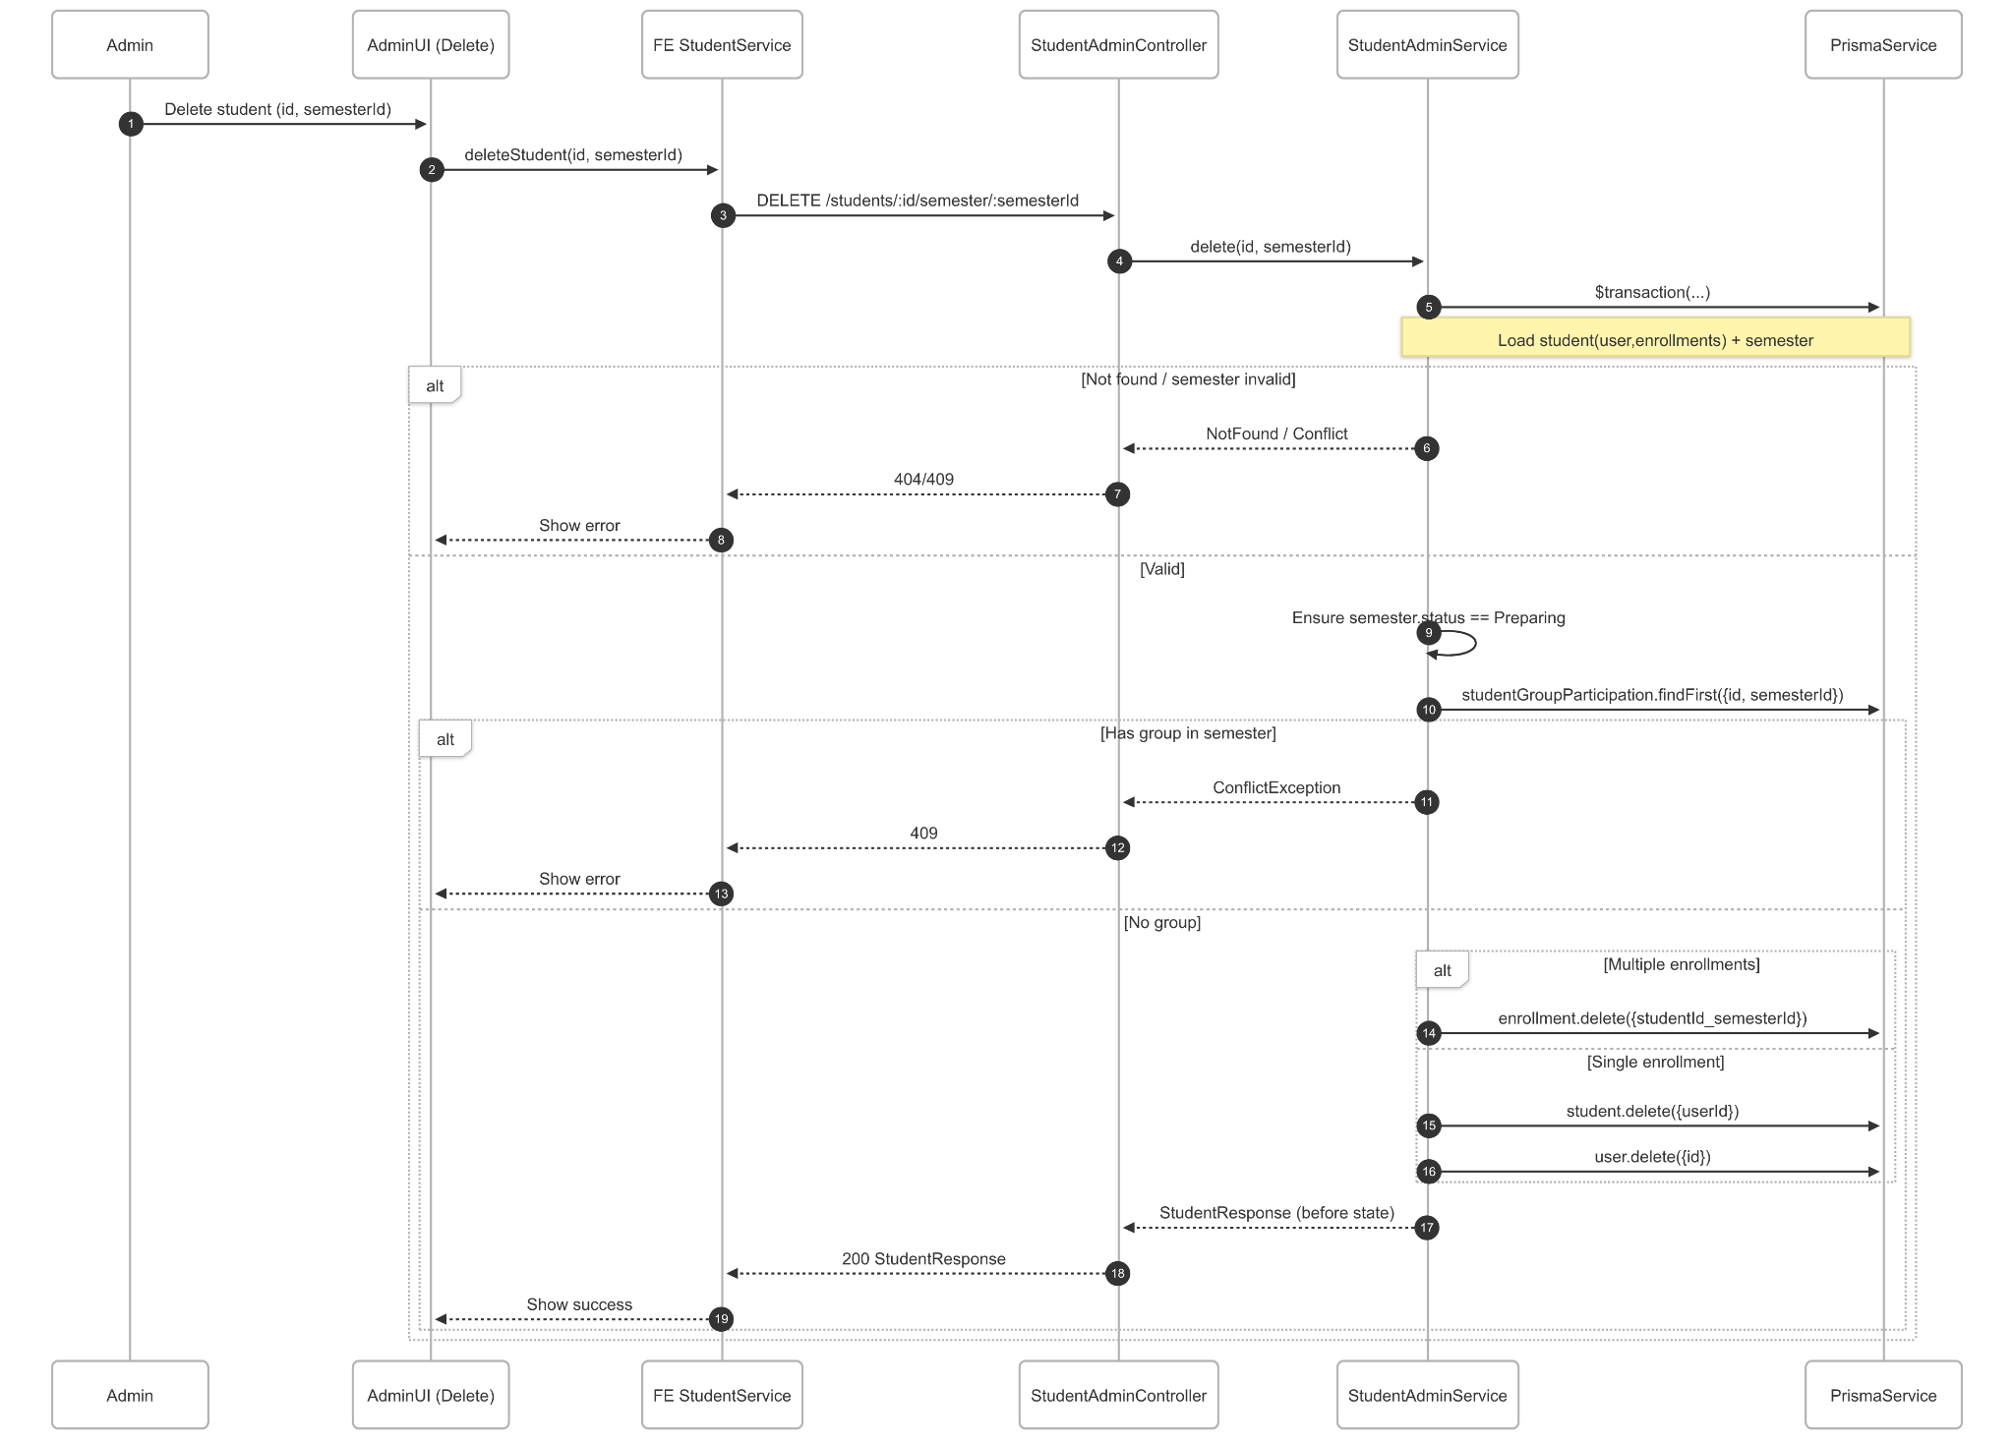](https://drive.google.com/file/d/1eKwqtDn7IvGvqYy0pxMMAokV4qxPutzL/view?usp=drive_link)

###### Figure IV.C.2.c.(5) - Delete Student Accounts Sequence Diagram

* + - * 1. View Student (List/Detail/Semester/Without Group)

[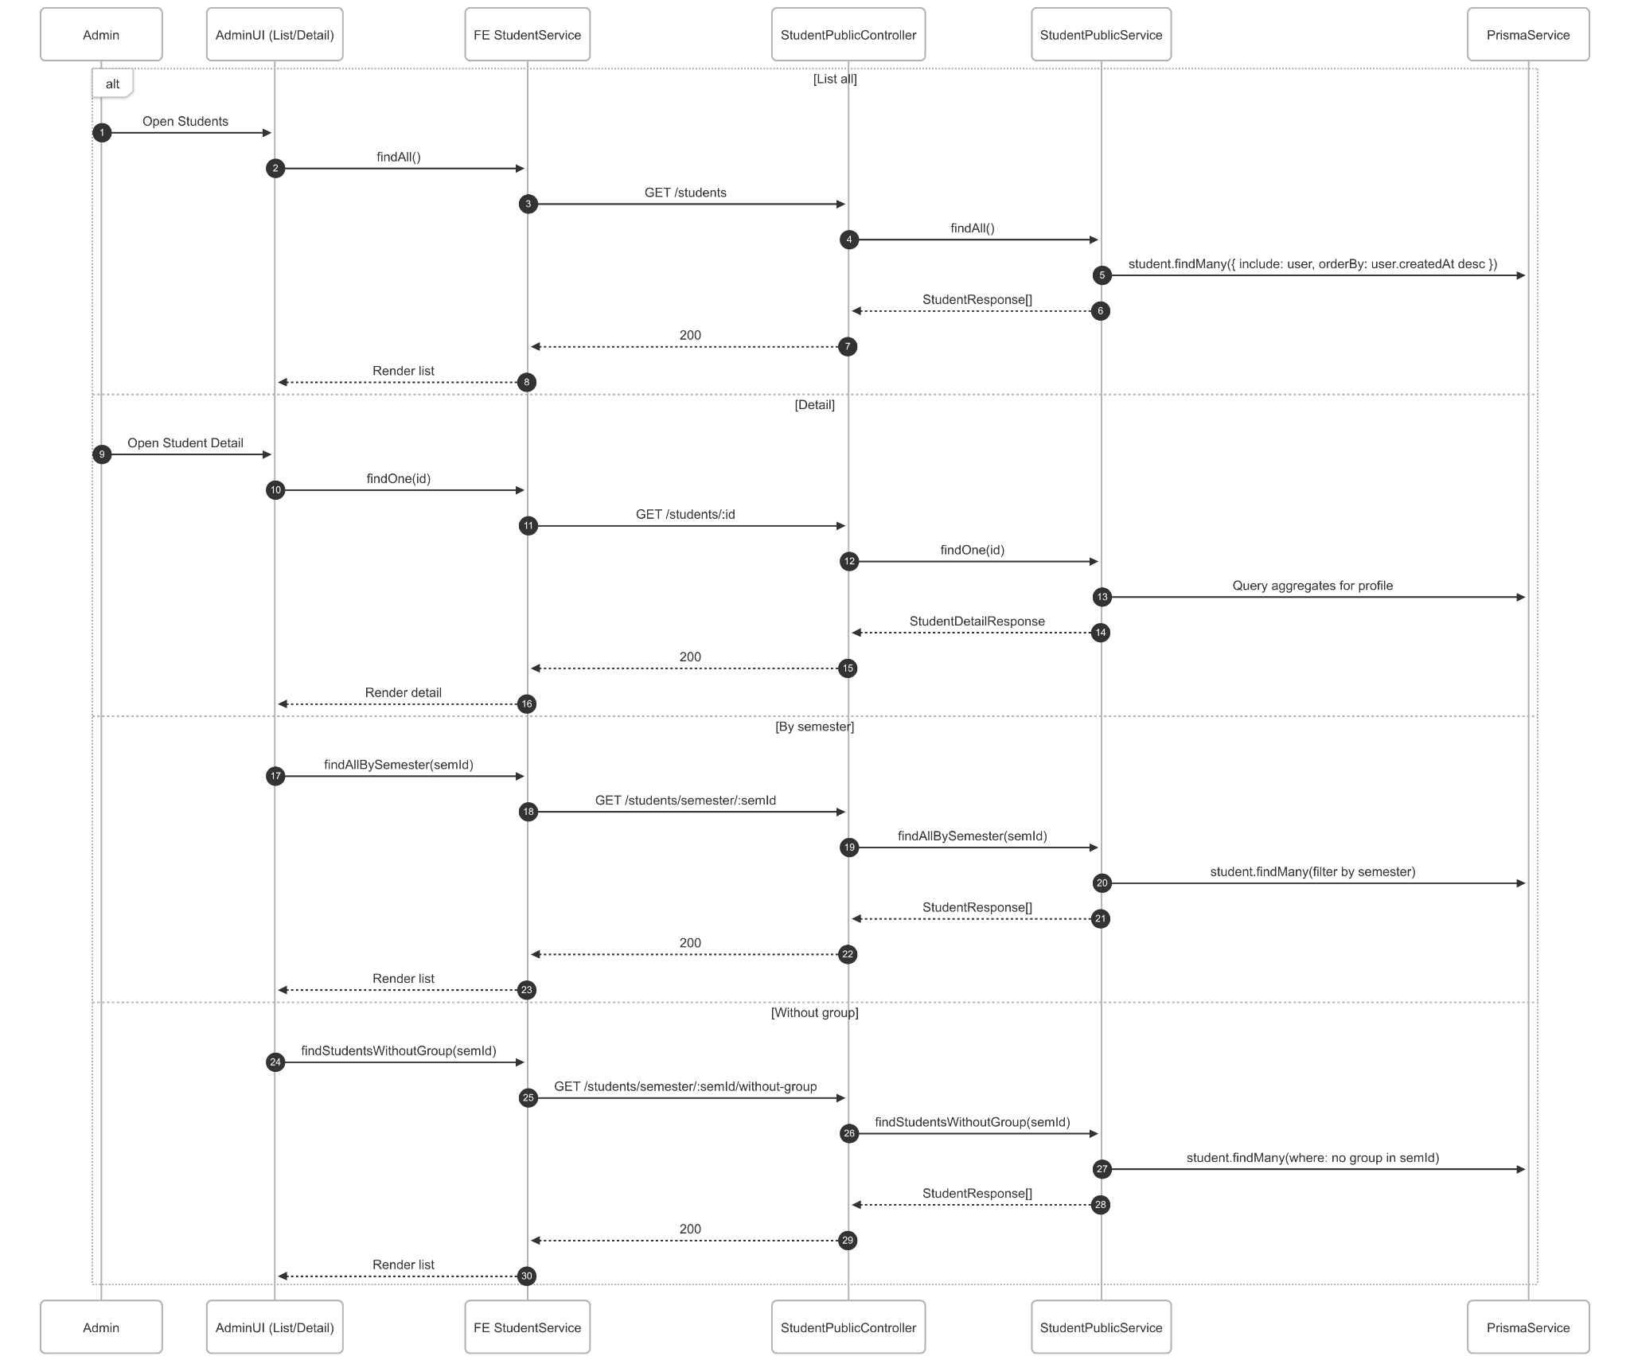](https://drive.google.com/file/d/1yKsjH9Ty0rNgyx3qKFax_h7jsjFWcgwn/view?usp=drive_link)

###### Figure IV.C.2.c.(6) - View Student Accounts Sequence Diagram

### Admin Manage Lecturer Accounts

#### Class Diagram

[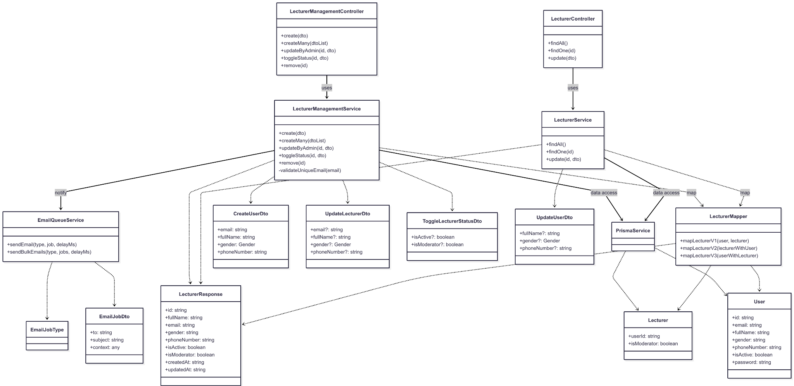](https://drive.google.com/file/d/1auXbRJt-XFVb7I7vClC5VdStcx2yvXpP/view?usp=drive_link)

###### Figure IV.C.3.a - Admin Manage Lecturer Accounts Class Diagram

#### Class Diagram Specification

| **No** | **Class** | **Method** | **Description** |
| --- | --- | --- | --- |
| 1 | LecturerManagementController | create(dto) | Create lecturer account; returns LecturerResponse. Admin-only. |
| 2 | LecturerManagementController | createMany(dtoList) | Bulk create lecturer accounts; returns list of LecturerResponse. Admin-only. |
| 3 | LecturerManagementController | updateByAdmin(id, dto) | Update lecturer’s user info (email, name, gender, phone). Admin-only. |
| 4 | LecturerManagementController | toggleStatus(id, dto) | Toggle isActive and/or isModerator. Admin-only. |
| 5 | LecturerManagementController | remove(id) | Delete lecturer (user + lecturer). Admin-only. |
| 6 | LecturerController | findAll() | List all lecturers with user info (ordered by createdAt desc). |
| 7 | LecturerController | findOne(id) | Get a lecturer by id (includes user fields). |
| 8 | LecturerController | update(dto) | Lecturer self-update (fullName, gender, phone). Requires LECTURER/MODERATOR. |
| 9 | LecturerManagementService | create(dto) | Generate strong password, hash, create user+lecturer, send welcome email; transactional. |
| 10 | LecturerManagementService | createMany(dtoList) | For each: create user+lecturer or update password; bulk welcome emails; transactional. |
| 11 | LecturerManagementService | updateByAdmin(id, dto) | Update user fields; map to LecturerResponse; transactional. |
| 12 | LecturerManagementService | toggleStatus(id, dto) | Update user.isActive and lecturer.isModerator; transactional. |
| 13 | LecturerManagementService | remove(id) | Delete lecturer and user records; transactional; returns previous state. |
| 14 | LecturerService | findAll() | Query lecturers with user include; map via mapLecturerV2. |
| 15 | LecturerService | findOne(id) | Query lecturer by userId; map via mapLecturerV2. |
| 16 | LecturerService | update(id, dto) | Self-update user fields; map via mapLecturerV1; transactional. |
| 17 | LecturerMapper | mapLecturerV1(user, lecturer) | Compose LecturerResponse from User + Lecturer. |
| 18 | LecturerMapper | mapLecturerV2(lecturerWithUser) | Compose LecturerResponse from Lecturer including User. |
| 19 | LecturerMapper | mapLecturerV3(userWithLecturer) | Compose LecturerResponse from User including Lecturer. |
| 20 | EmailQueueService | sendEmail(type, job, delayMs) | Queue single welcome account email with context. |
| 21 | EmailQueueService | sendBulkEmails(type, jobs, delayMs) | Queue multiple welcome emails efficiently post-import. |
| 22 | PrismaService | $transaction(callback) | Execute multi-step DB operations atomically for consistency. |
| 23 | CreateUserDto | validate() | email (IsEmail, required), fullName (required), gender (enum), phoneNumber (required). |
| 24 | UpdateLecturerDto | validate() | Partial of CreateUserDto; all fields optional (admin update). |
| 25 | ToggleLecturerStatusDto | validate() | Optional isActive and isModerator booleans. |
| 26 | UpdateUserDto | validate() | Partial of CreateUserDto omitting email; optional fullName, gender, phoneNumber. |
| 27 | LecturerResponse | shape() | id, fullName, email, gender, phoneNumber, isActive, isModerator, createdAt, updatedAt. |

##### Table IV.C.3.b - Admin Manage Lecturer Accounts Class Diagram Specification

#### Sequence Diagram

* + - * 1. Create Lecturer

[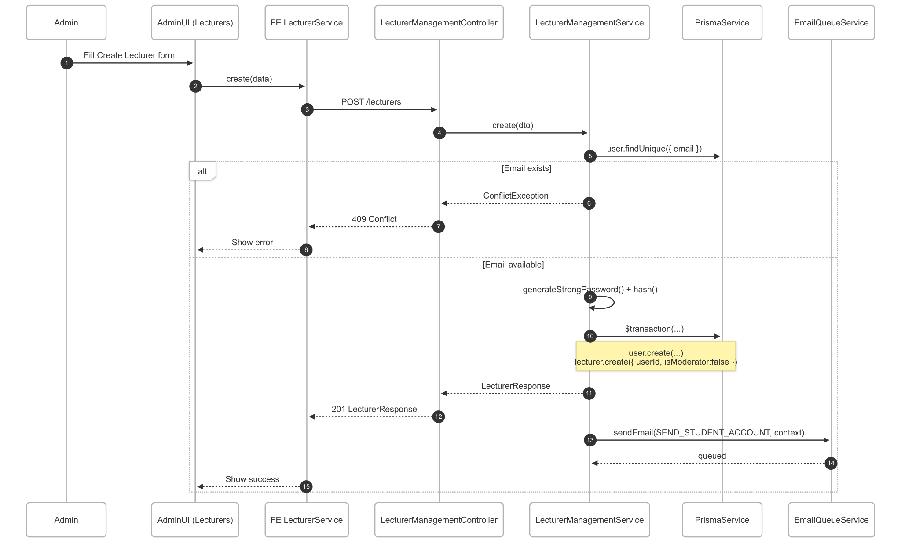](https://drive.google.com/file/d/196NxSFT2j5l55nYjX8XkiLySDHIBJVFs/view?usp=drive_link)

###### Figure IV.C.3.c.(1) - Create Lecturer Accounts Sequence Diagram

* + - * 1. Import Lecturer

[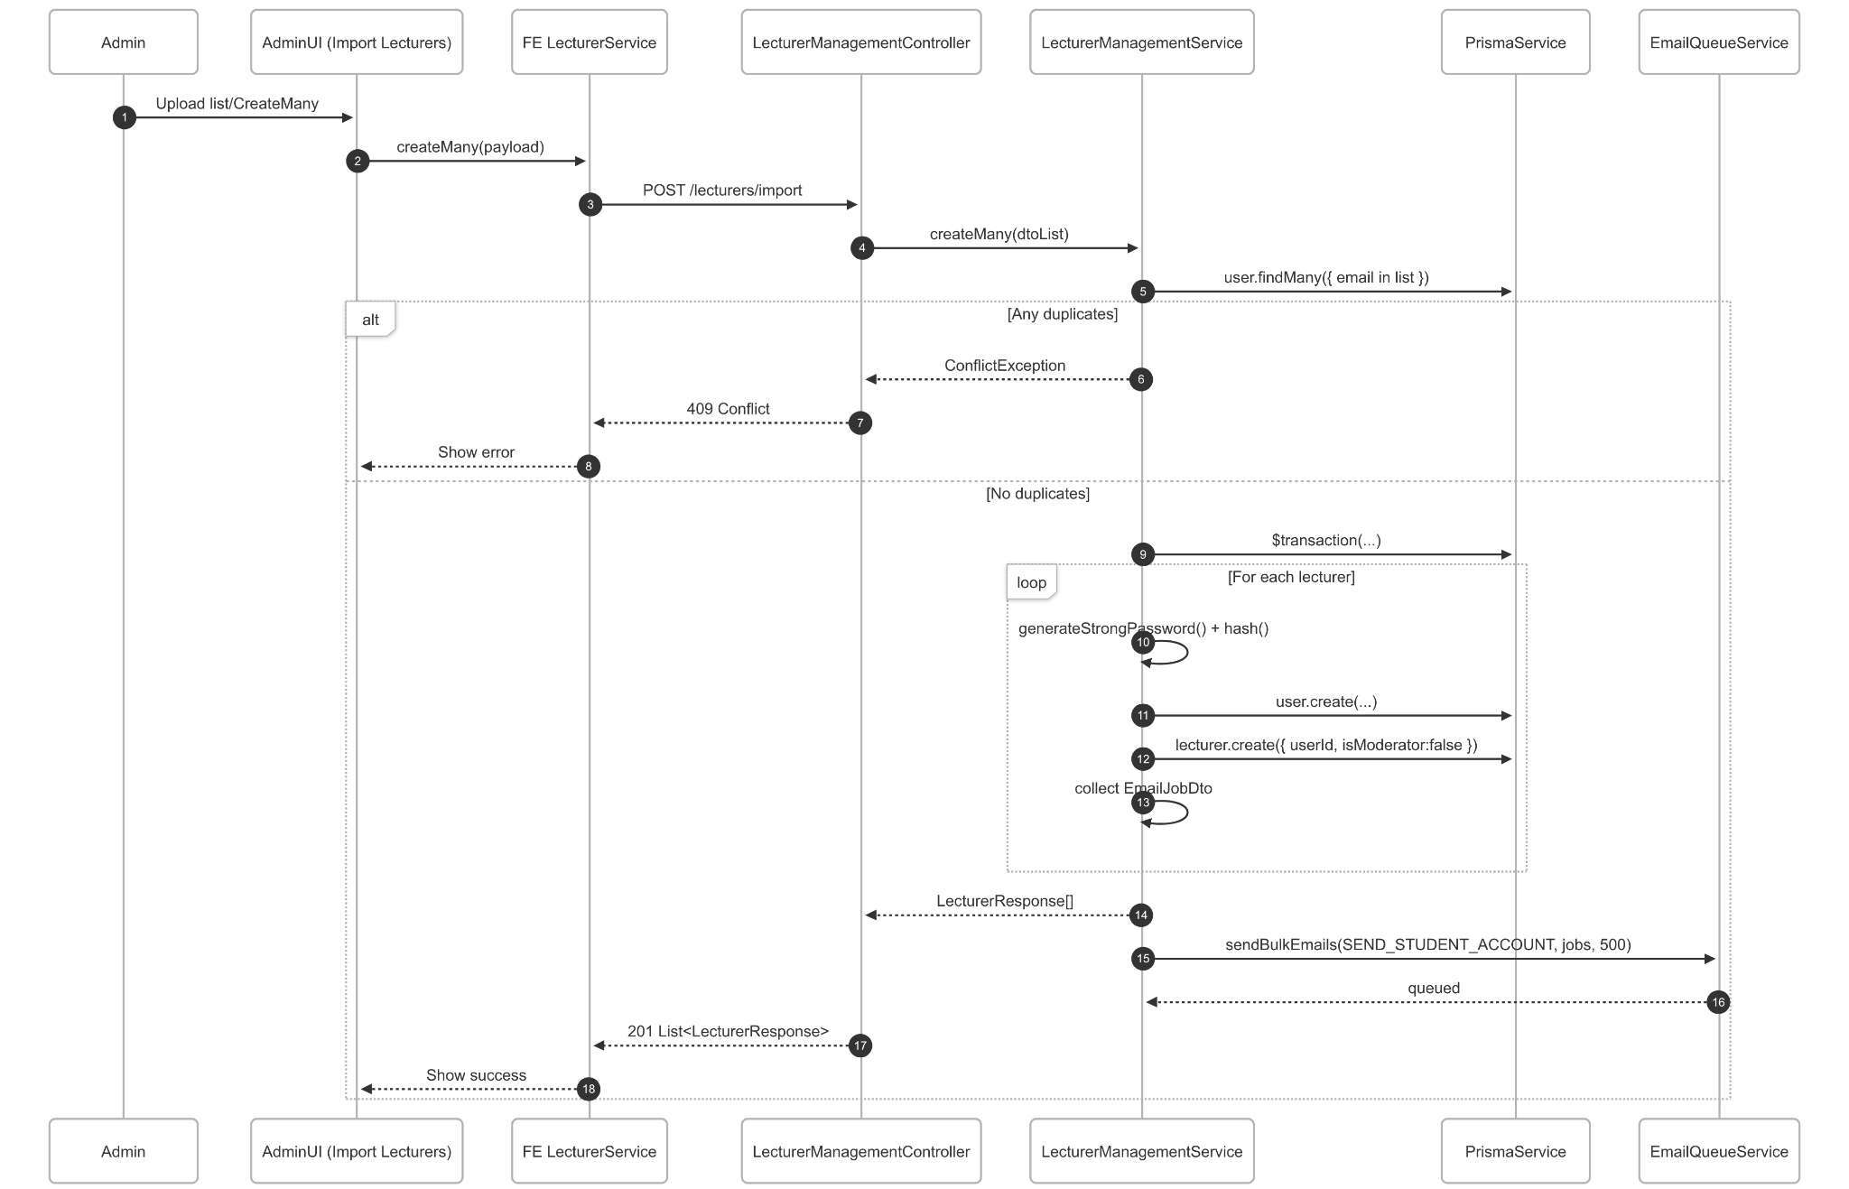](https://drive.google.com/file/d/1HtA9J4fEs3FqTUapXFnId1eUXxIsfKuN/view?usp=drive_link)

###### Figure IV.C.3.c.(2) - Import Lecturer Accounts Sequence Diagram

* + - * 1. Update Lecturer

[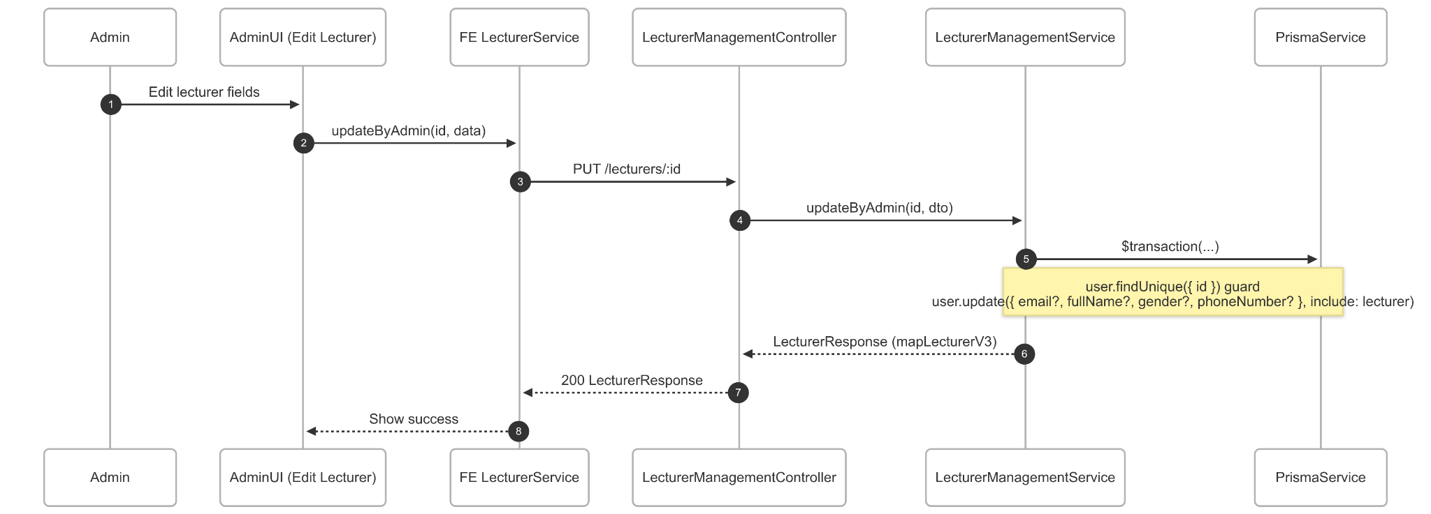](https://drive.google.com/file/d/1lYYVJtnPJ3_ZxseBDjwem4EiX-VBVvAy/view?usp=drive_link)

###### Figure IV.C.3.c.(3) - Update Lecturer Accounts Sequence Diagram

* + - * 1. Toggle Status

[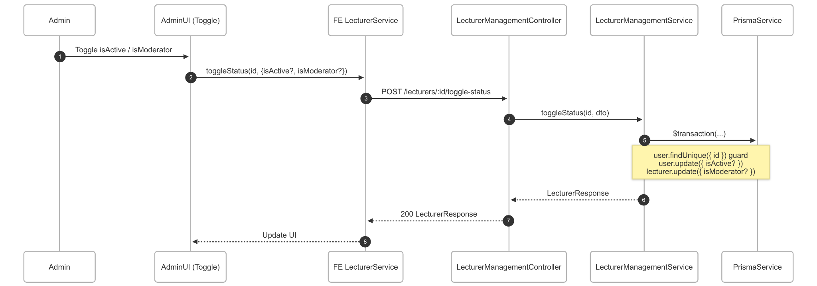](https://drive.google.com/file/d/1FuejphjP_7QGzs_Gyf-Sqg1z3VoxIDBw/view?usp=drive_link)

###### Figure IV.C.3.c.(4) - Toggle Status Lecturer Accounts Sequence Diagram

* + - * 1. Delete Lecturer

[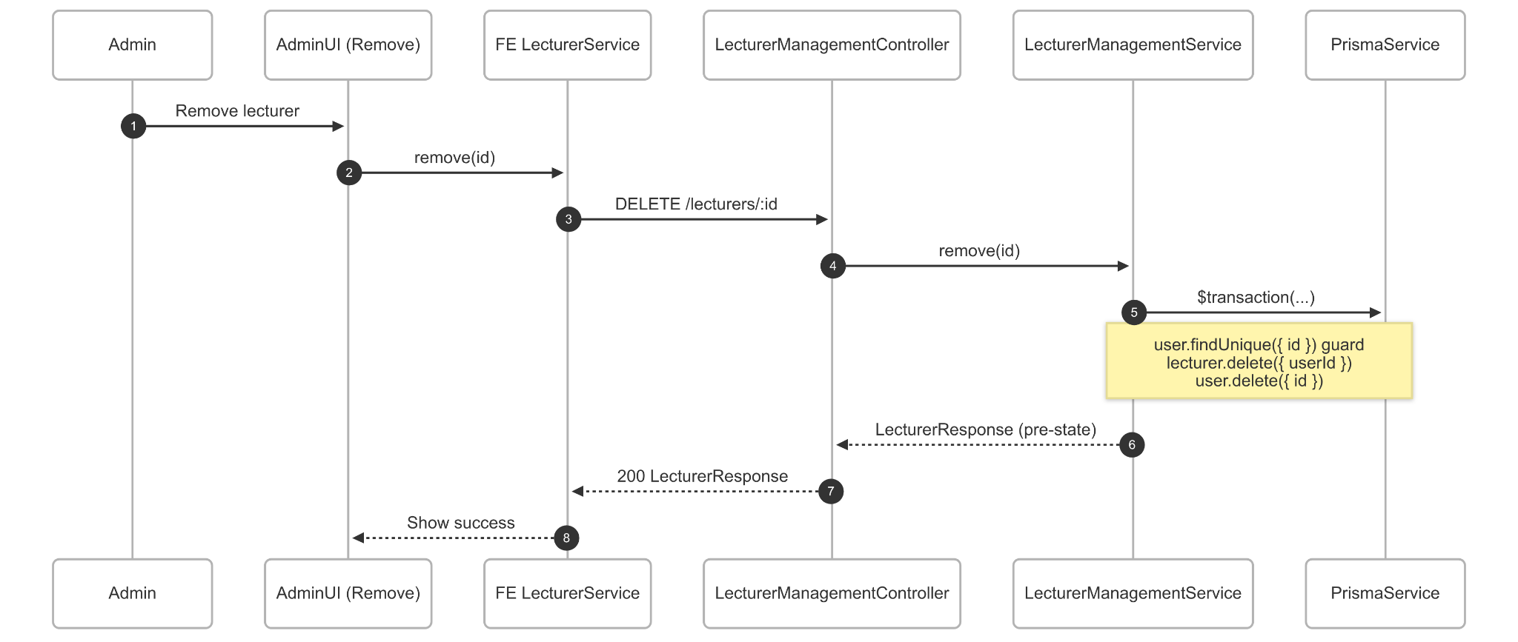](https://drive.google.com/file/d/1GqnuZqSxFEgoaFiPtZ63VBqGclxYyZ81/view?usp=drive_link)

###### Figure IV.C.3.c.(5) - Delete Lecturer Accounts Sequence Diagram

* + - * 1. View Lecturer

[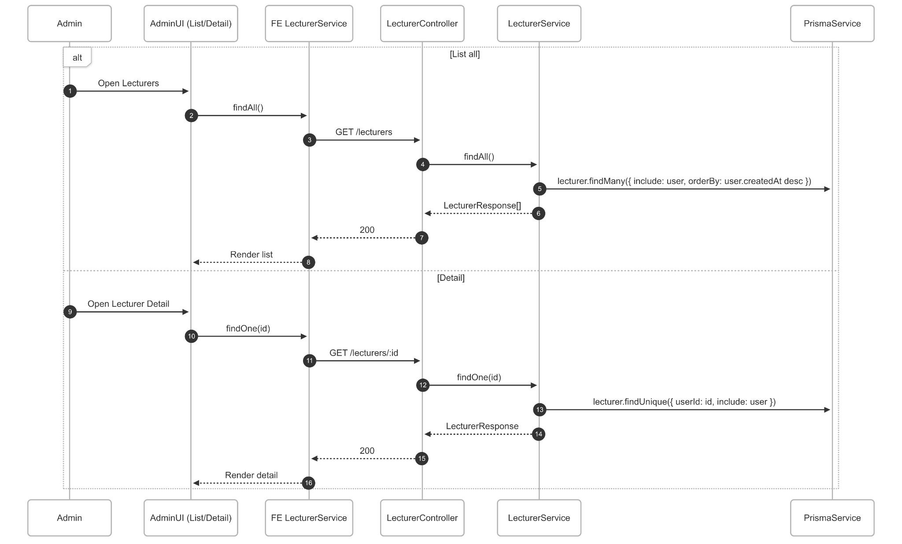](https://drive.google.com/file/d/1vxQiJfxuP1dZmY3j8qXLnn0vPsCjoL6H/view?usp=drive_link)

###### Figure IV.C.3.c.(6) - View Lecturer Accounts Sequence Diagram

### Admin Manage Semesters Settings

#### Class Diagram

[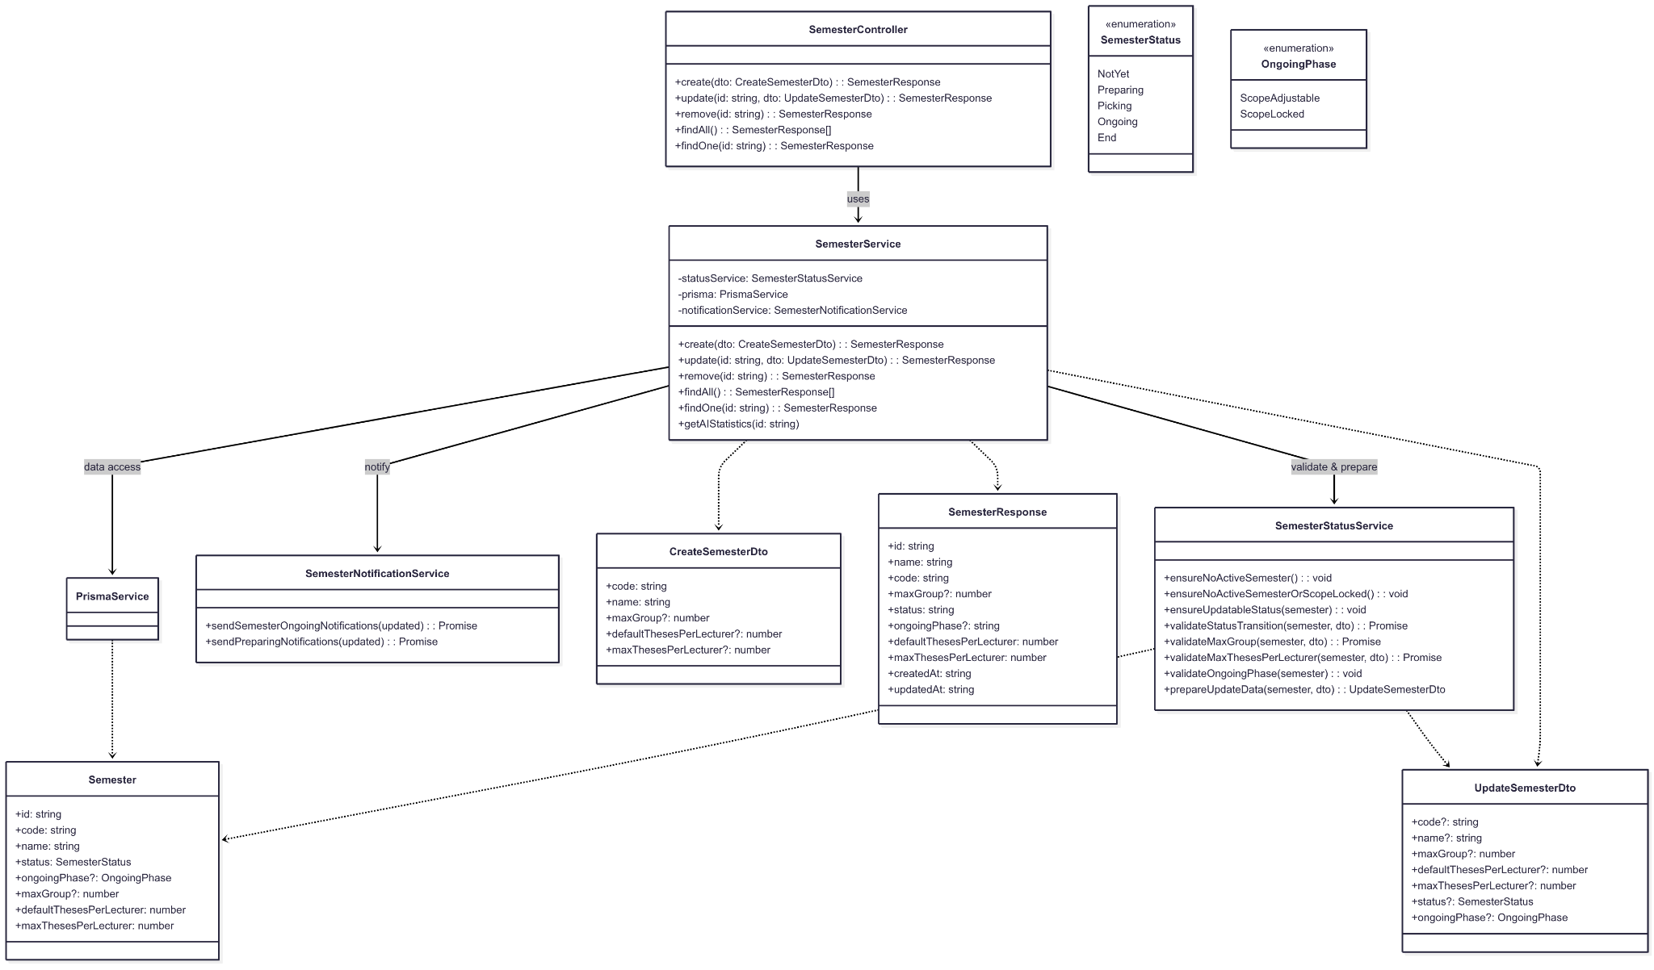](https://drive.google.com/file/d/1v8Fl7nR24JS_22NoaQwZXUqqefLQLKAe/view?usp=drive_link)

###### Figure IV.C.4.a - Admin Manage Semesters Settings Class Diagram

#### Class Diagram Specification

| **No** | **Class** | **Method** | **Description** |
| --- | --- | --- | --- |
| 1 | SemesterController | create(dto) | Create a new semester; admin-only; returns SemesterResponse. |
| 2 | SemesterController | update(id, dto) | Update semester info/status/rules; admin-only; returns SemesterResponse. |
| 3 | SemesterController | remove(id) | Delete semester (only when NotYet); admin-only; returns SemesterResponse. |
| 4 | SemesterController | findAll() | List all semesters; returns SemesterResponse[]. |
| 5 | SemesterController | findOne(id) | Get one semester by id; returns SemesterResponse. |
| 6 | SemesterService | create(dto) | Enforce “no active semester” rule; create semester; return SemesterResponse. |
| 7 | SemesterService | update(id, dto) | Validates transitions and rules via SemesterStatusService; applies updates; cascades effects (e.g., enrollment status); returns SemesterResponse. |
| 8 | SemesterService | remove(id) | Validates deletable status; delete semester; returns pre-state SemesterResponse. |
| 9 | SemesterService | findAll() | Query & map list to SemesterResponse[]. |
| 10 | SemesterService | findOne(id) | Query & map item to SemesterResponse. |
| 11 | SemesterService | getAIStatistics(id) | Get AI metrics/statistics for the semester (read-only helper). |
| 12 | SemesterStatusService | ensureNoActiveSemester() | Blocks create if any semester is active (not NotYet/End). |
| 13 | SemesterStatusService | ensureNoActiveSemesterOrScopeLocked() | Allow creation only if no active semester, or current is Ongoing with ScopeLocked. |
| 14 | SemesterStatusService | ensureUpdatableStatus(semester) | Blocks update if semester is End. |
| 15 | SemesterStatusService | validateStatusTransition(semester, dto) | Enforces status order and domain checks across transitions. |
| 16 | SemesterStatusService | validateMaxGroup(semester, dto) | maxGroup only in Preparing; cannot be less than current groups. |
| 17 | SemesterStatusService | validateMaxThesesPerLecturer(semester, dto) | Only in Preparing; cannot be less than current max per lecturer. |
| 18 | SemesterStatusService | validateOngoingPhase(semester) | ongoingPhase only editable in Ongoing; additional guards. |
| 19 | SemesterStatusService | prepareUpdateData(semester, dto) | Auto-set ongoingPhase=ScopeAdjustable when Picking→Ongoing. |
| 20 | SemesterNotificationService | sendSemesterOngoingNotifications(updated) | Notify stakeholders when status becomes Ongoing (on change). |
| 21 | SemesterNotificationService | sendPreparingNotifications(updated) | Notify lecturers/students for Preparing (on change). |
| 22 | PrismaService | $transaction(cb) | Execute atomic DB operations for create/update/remove flows. |
| 23 | CreateSemesterDto | validate() | code, name (required); optional: maxGroup, defaultThesesPerLecturer, maxThesesPerLecturer (positive). |
| 24 | UpdateSemesterDto | validate() | Partial of create + status: SemesterStatus?, ongoingPhase: OngoingPhase?; business rules enforced in service. |
| 25 | SemesterResponse | shape() | id, name, code, maxGroup?, status, ongoingPhase?, defaultThesesPerLecturer, maxThesesPerLecturer, createdAt, updatedAt. |
| 26 | SemesterStatus (enum) | values() | NotYet, Preparing, Picking, Ongoing, End. |
| 27 | OngoingPhase (enum) | values() | ScopeAdjustable, ScopeLocked. |

##### Table IV.C.4.b - Admin Manage Semesters Settings Class Diagram Specification

#### State Diagram

[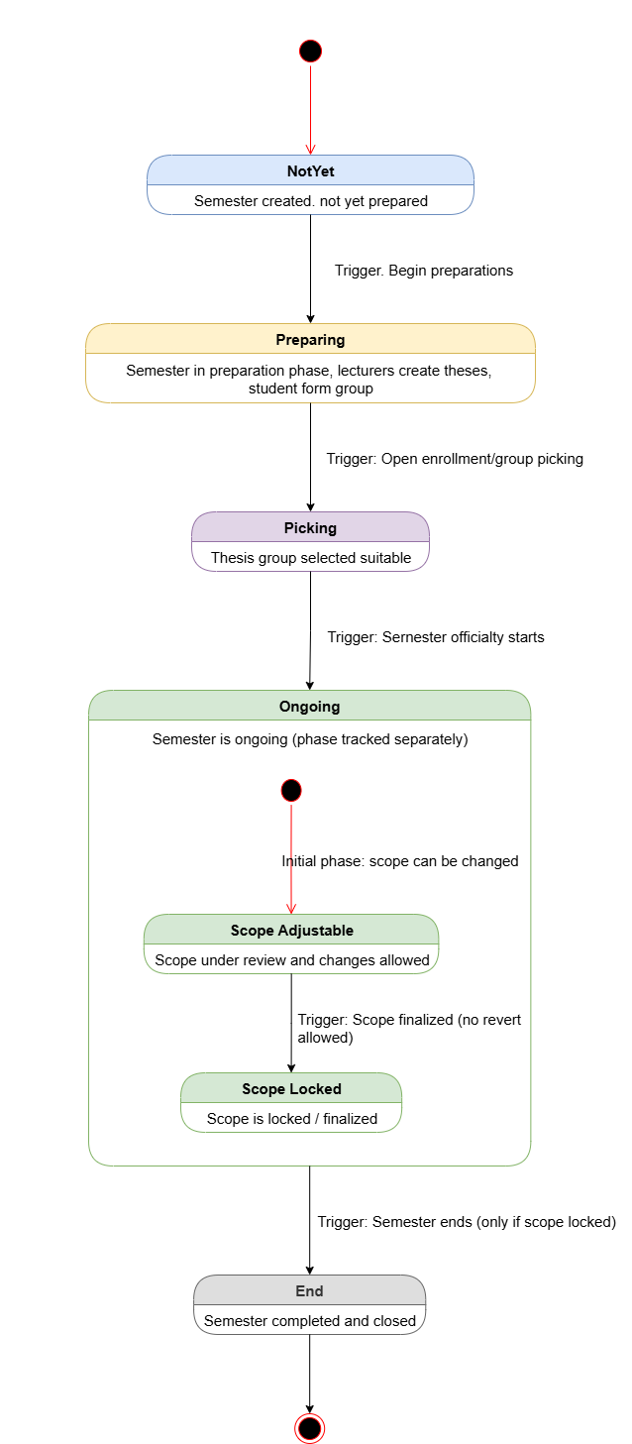](https://drive.google.com/file/d/1rfTk5UESLKaXVd6cY5bIQ3CgW_tlNpB5/view?usp=drive_link)

###### Figure IV.C.4.c - Semester State Diagram

#### Sequence Diagram

* + - * 1. Create Semester

[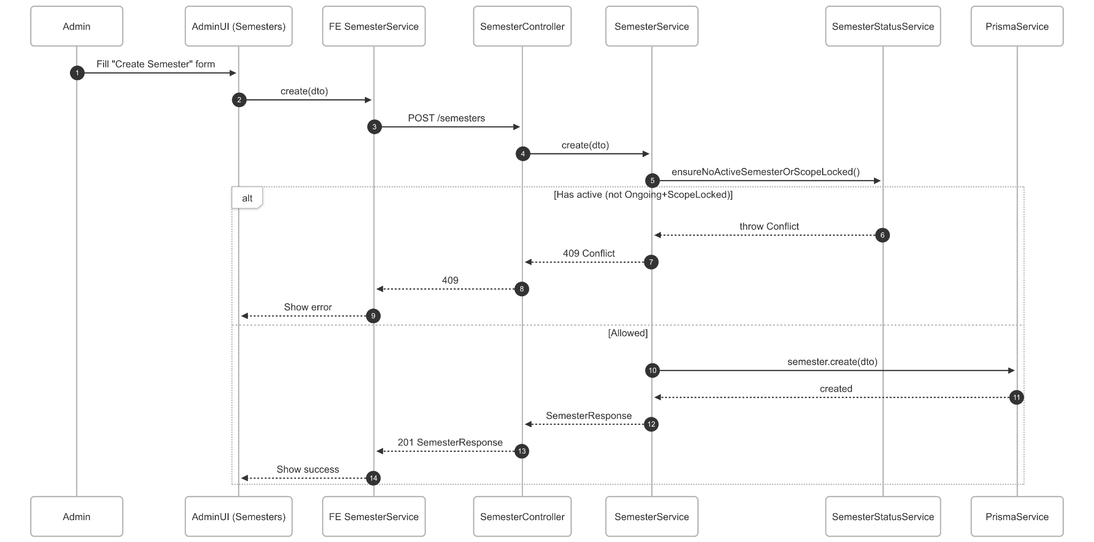](https://drive.google.com/file/d/1YJ9uPYfNvlPd4r-f3L9COEg7Vp6RrhF_/view?usp=drive_link)

###### Figure IV.C.4.d.(1) - Create Semester Sequence Diagram

* + - * 1. Update Semester Information

[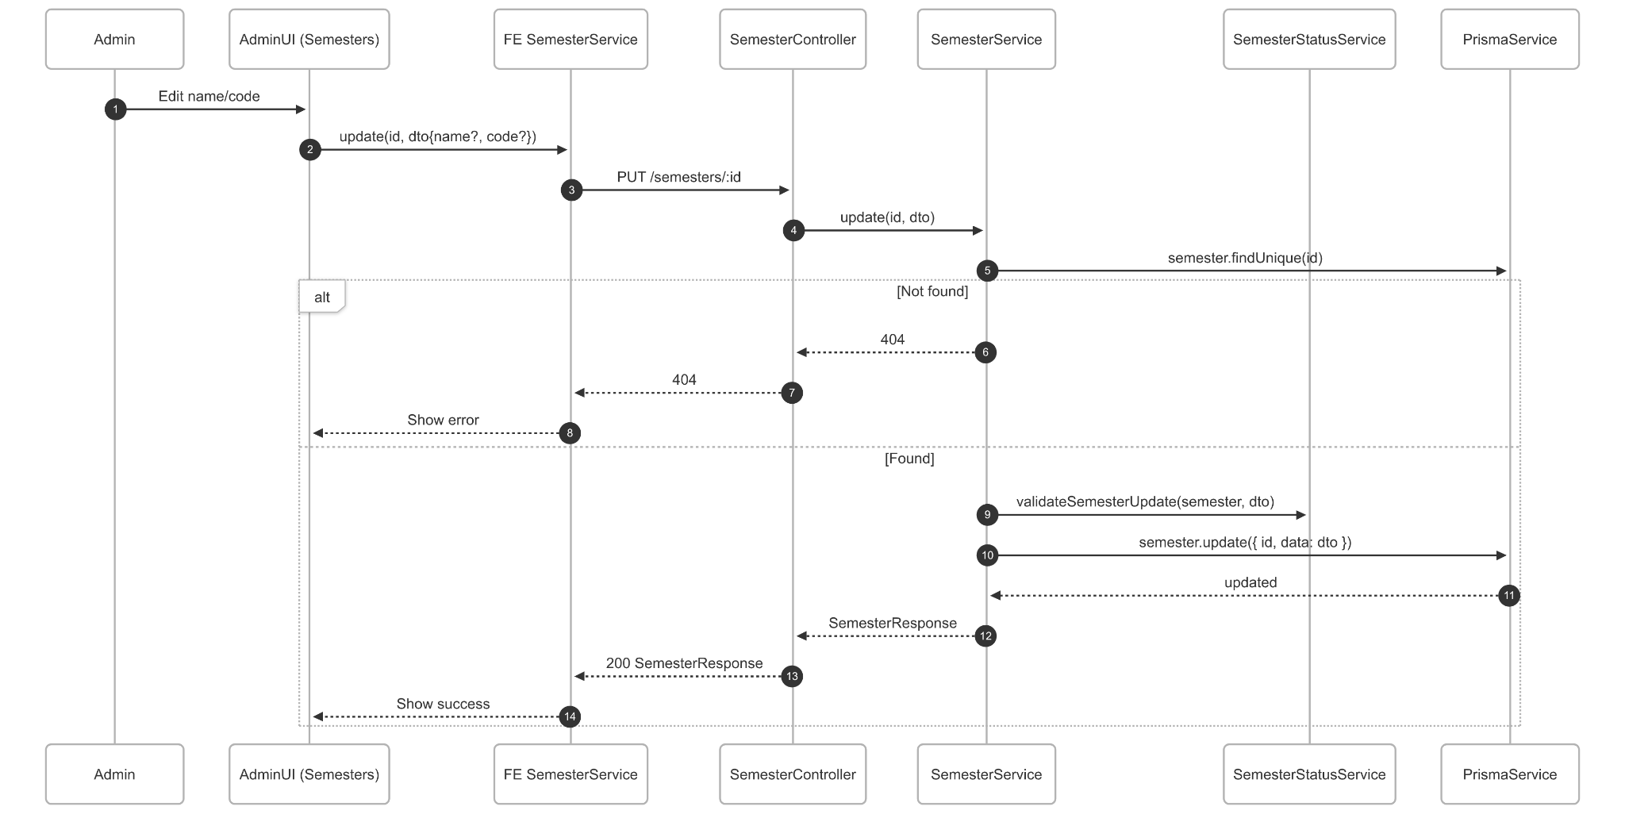](https://drive.google.com/file/d/1RBy73oigtIFLI9BOpj4q-fEu_PGtMwAr/view?usp=drive_link)

###### Figure IV.C.4.d.(2) - Update Semester Sequence Diagram

* + - * 1. Configure Academic Rules (maxGroup, default/max Theses per Lecturer)

[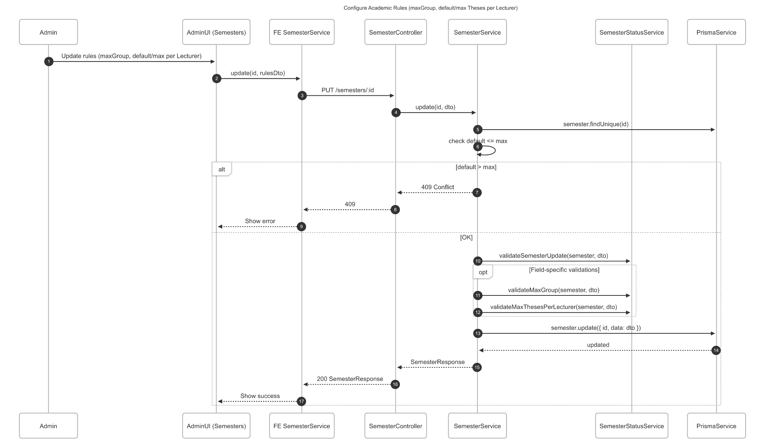](https://drive.google.com/file/d/1aZrx91r-jo8lTrNaW7bZY7Tw29qZXIpV/view?usp=drive_link)

###### Figure IV.C.4.d.(3) - Configure Academic Rules Sequence Diagram

* + - * 1. Update Semester Status

To Picking

[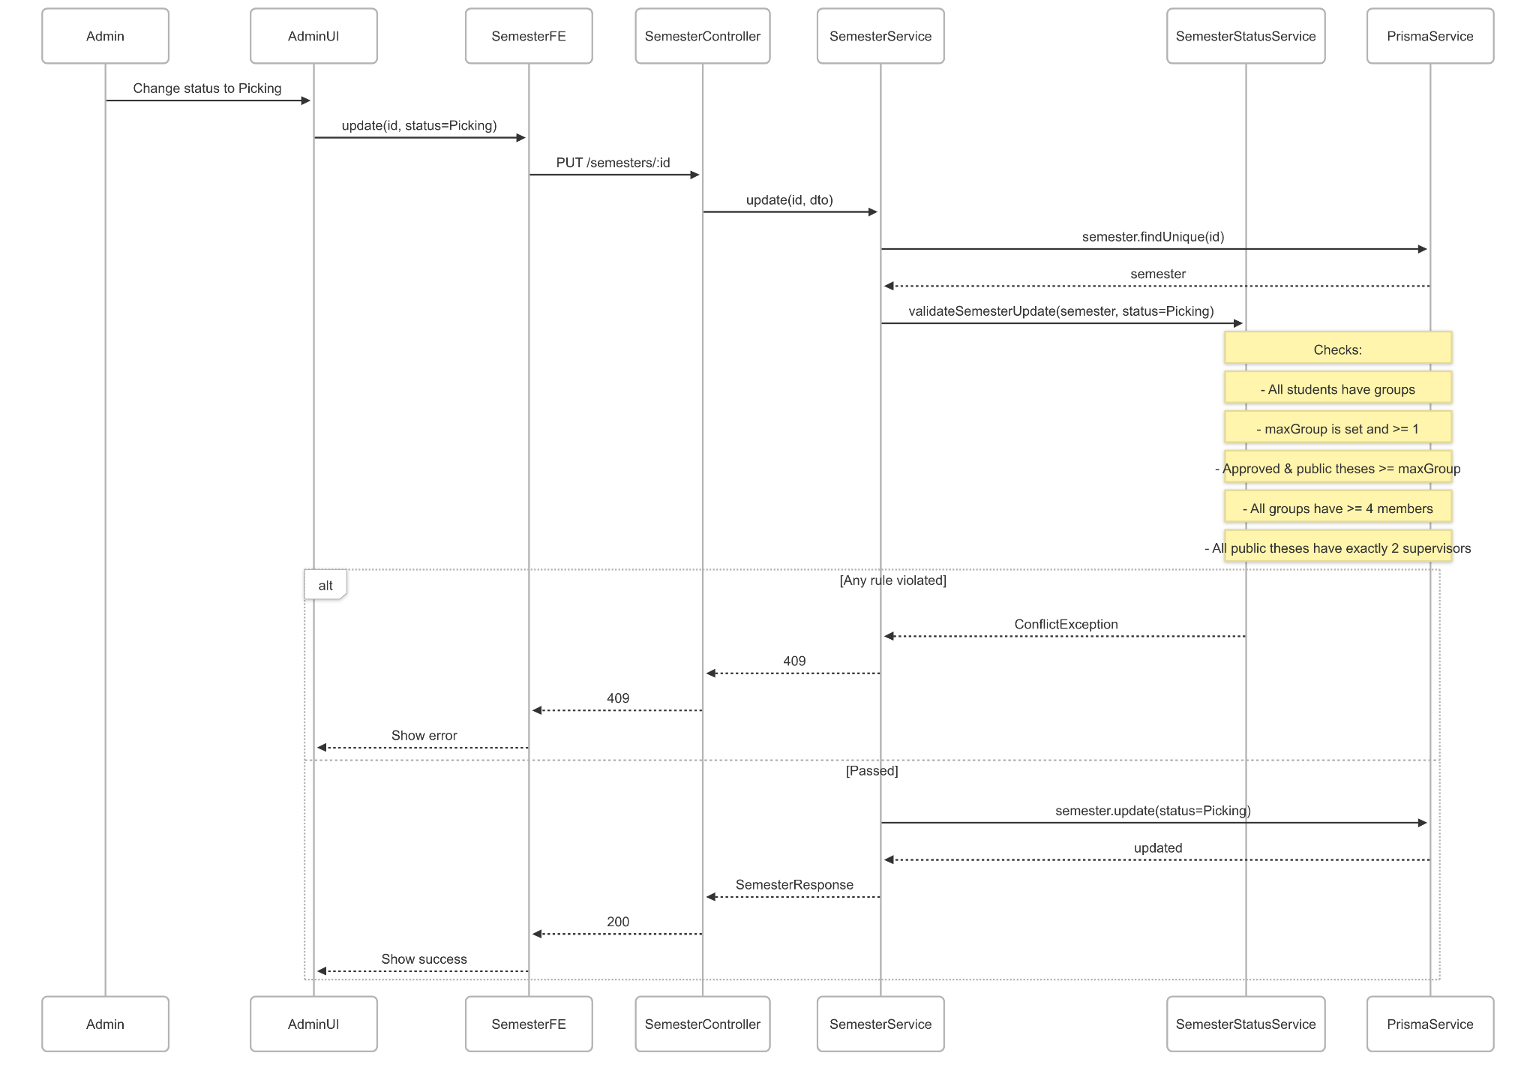](https://drive.google.com/file/d/1fLb-Ghvt1DR__KTgdQy3-hWV4URsIvMJ/view?usp=drive_link)

###### Figure IV.C.4.d.(4).(a) - Update Semester Status To Picking Sequence Diagram

To Ongoing

[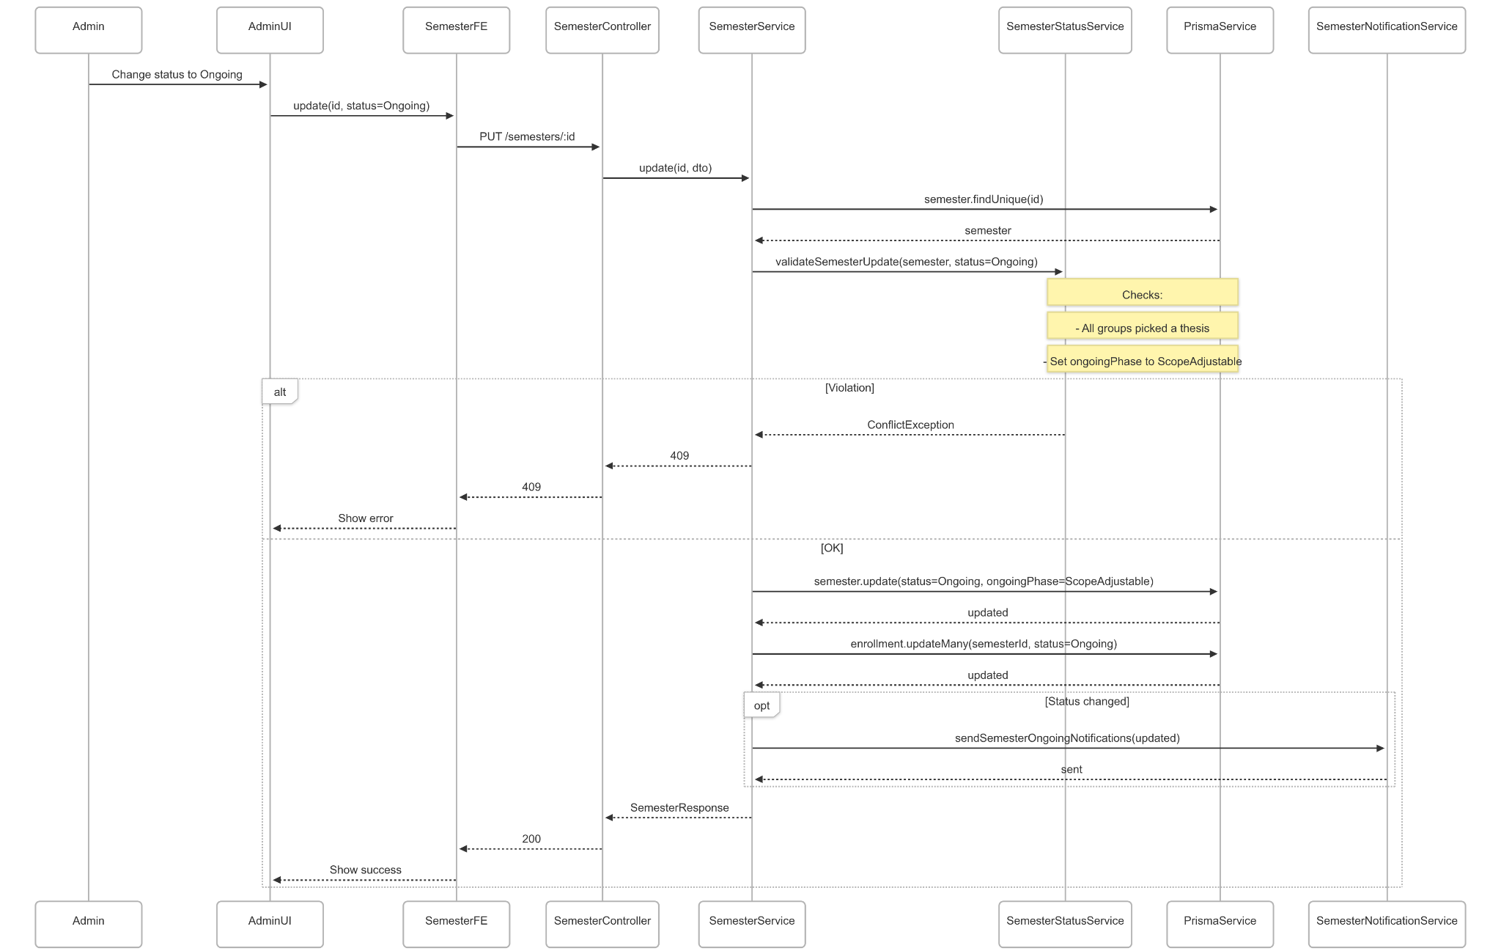](https://drive.google.com/file/d/1x1jUXz9v7T3ZLwsXqdU_QkaYN8mZDH-s/view?usp=drive_link)

###### Figure IV.C.4.d.(4).(b) - Update Semester Status To Ongoing Sequence Diagram

To End

[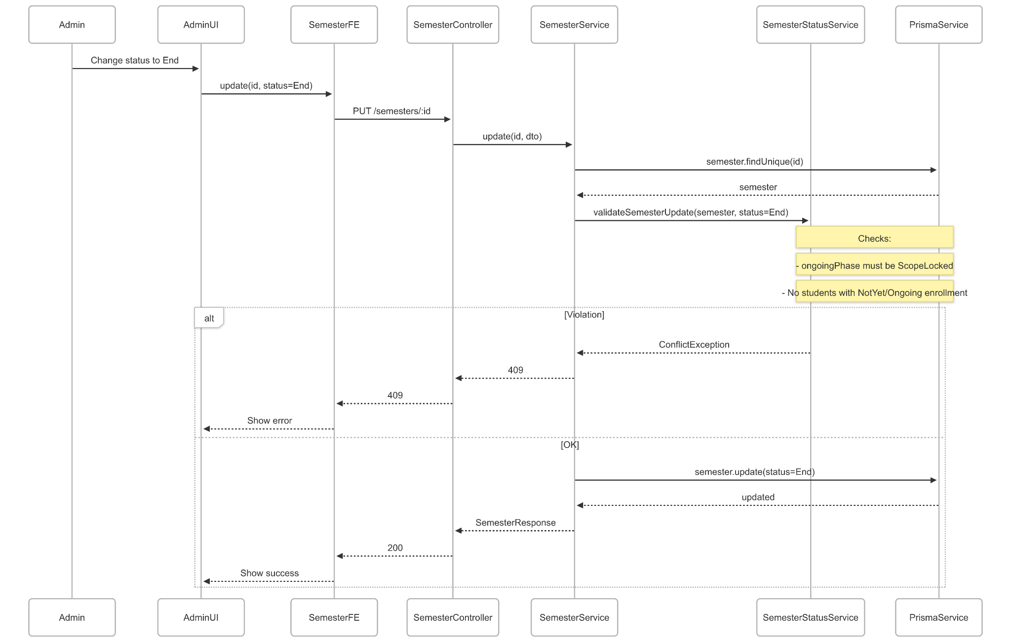](https://drive.google.com/file/d/157dwA5z9e_zGVvoVCCnLDABP3FIcW_1t/view?usp=drive_link)

###### Figure IV.C.4.d.(4).(c) - Update Semester Status To End Sequence Diagram

To Scope Locked Phase

[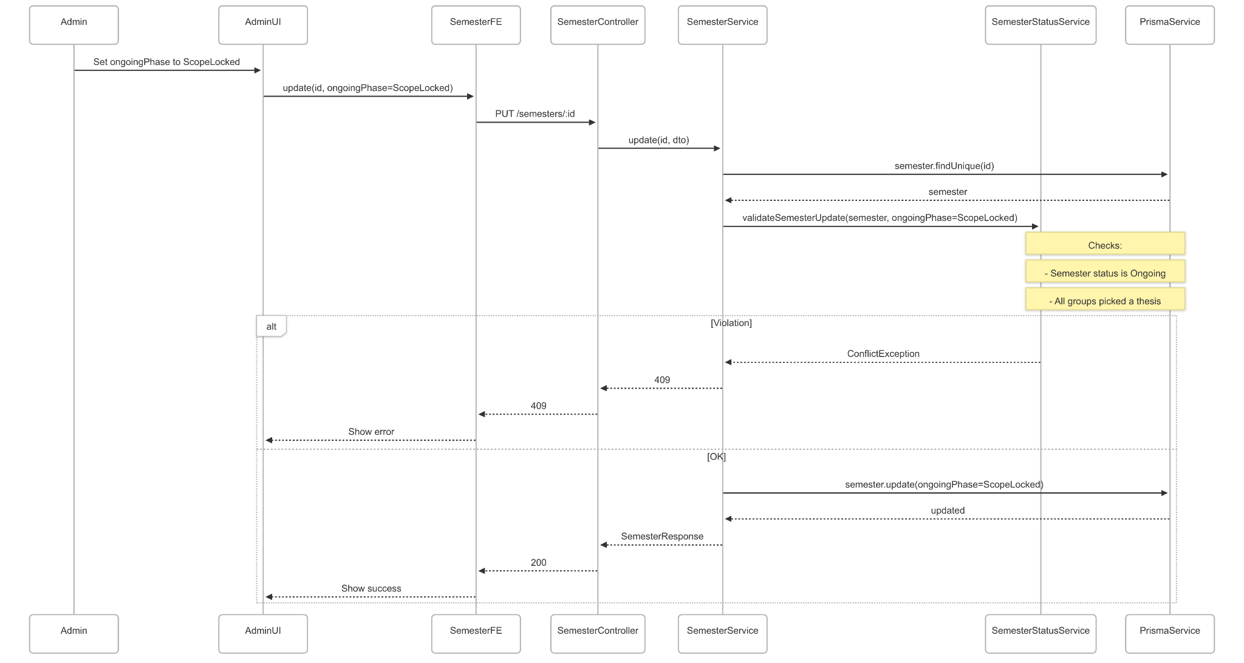](https://drive.google.com/file/d/1P2fnXJgmdsoeXiTYhPA7821OQpz0Ech7/view?usp=drive_link)

###### Figure IV.C.4.d.(4).(d) - Update Semester Status To Scope Locked Phase Sequence Diagram

### Admin Manage Milestones

#### Class Diagram

[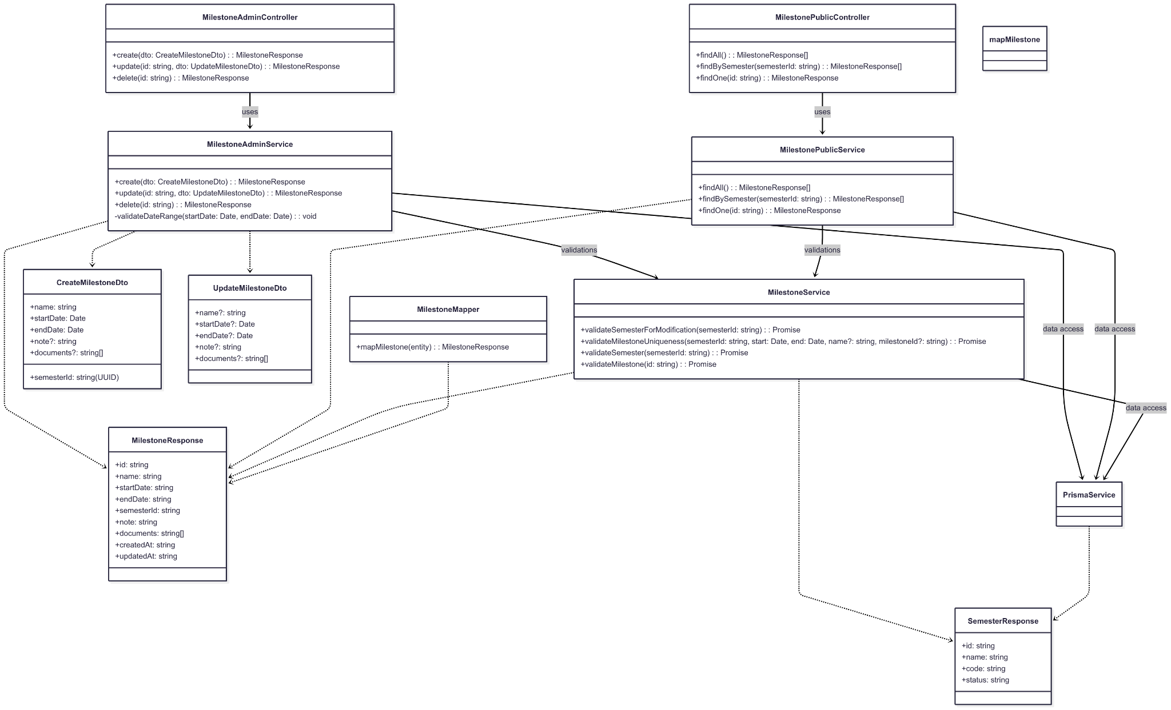](https://drive.google.com/file/d/1zTios1Feb5uZari0TBuYqVM51Iu4mn1T/view?usp=drive_link)

###### Figure IV.C.5.a - Admin Manage Milestones Class Diagram

#### Class Diagram Specification

| **No** | **Class** | **Method** | **Description** |
| --- | --- | --- | --- |
| 1 | MilestoneAdminController | create(dto) | Create a milestone (name, start/end, note, documents, semesterId); admin-only; returns MilestoneResponse. |
| 2 | MilestoneAdminController | update(id, dto) | Edit milestone details (name, dates, note, documents) before start date; admin-only. |
| 3 | MilestoneAdminController | delete(id) | Delete milestone only before its start date and when no submitted submissions exist; admin-only. |
| 4 | MilestonePublicController | findAll() | List all milestones (desc by createdAt). |
| 5 | MilestonePublicController | findBySemester(semesterId) | List milestones of a semester (asc by startDate). |
| 6 | MilestonePublicController | findOne(id) | Get milestones by id. |
| 7 | MilestoneAdminService | create(dto) | Validates semester (must be Ongoing), date range, uniqueness (name/time overlap); creates milestones; seeds submissions for all groups; transactional. |
| 8 | MilestoneAdminService | update(id, dto) | Validates milestone exists, semester Ongoing, before start date, date range, uniqueness; updates milestone; transactional. |
| 9 | MilestoneAdminService | delete(id) | Validates milestone exists, semester Ongoing, before start date, no submitted submissions; deletes related entities safely; transactional. |
| 10 | MilestoneAdminService | validateDateRange(start, end) | Ensures startDate < endDate and coherent boundaries. |
| 11 | MilestonePublicService | findAll() | Fetch and map all milestones to MilestoneResponse[]. |
| 12 | MilestonePublicService | findBySemester(semesterId) | Validate semester, fetch milestones by semester, map to response. |
| 13 | MilestonePublicService | findOne(id) | Validate milestone id, fetch and map single milestone. |
| 14 | MilestoneService | validateSemesterForModification(semesterId) | Ensures semester exists and is Ongoing to allow create/update/delete. |
| 15 | MilestoneService | validateMilestoneUniqueness(semId, start, end, name?, milestoneId?) | Guards duplicate name and overlapping time windows within the same semester; allows self-exclusion on update. |
| 16 | MilestoneService | validateSemester(semesterId) | Loads semester, throws NotFound if missing; returns SemesterResponse. |
| 17 | MilestoneService | validateMilestone(id) | Loads milestone, throws NotFound if missing; returns MilestoneResponse. |
| 18 | PrismaService | $transaction(cb) | Executes DB operations atomically for create/update/delete and seeding submissions. |
| 19 | CreateMilestoneDto | validate() | name (string), startDate/endDate (ISO), semesterId (UUID), optional note (string), documents (string[]). |
| 20 | UpdateMilestoneDto | validate() | Partial of CreateMilestoneDto excluding semesterId; editable fields before start date. |
| 21 | MilestoneResponse | shape() | id, name, startDate, endDate, semesterId, note, documents[], createdAt, updatedAt. |

##### Table IV.C.5.b - Admin Manage Milestones Class Diagram Specification

#### Sequence Diagram

* + - * 1. Create Milestone

[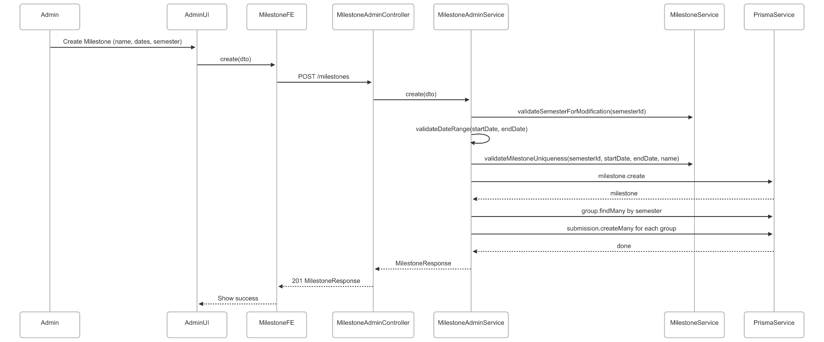](https://drive.google.com/file/d/1wdoO5hHcbZ-aWc8tpybGvZEjeGVR-Bgx/view?usp=drive_link)

###### Figure IV.C.5.c.(1) - Create Milestone Sequence Diagram

* + - * 1. Update Milestone

[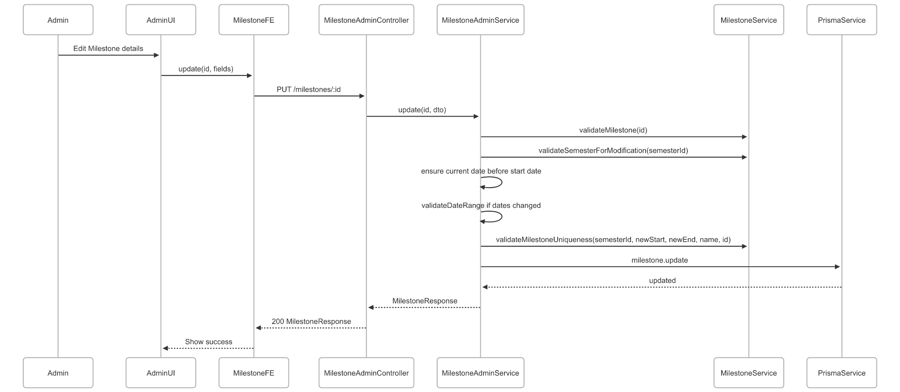](https://drive.google.com/file/d/1l4C033sBX6m8VUzse_zxpFiWAZfA2hAh/view?usp=drive_link)

###### Figure IV.C.5.c.(2) - Update Milestone Sequence Diagram

* + - * 1. View List Milestones

[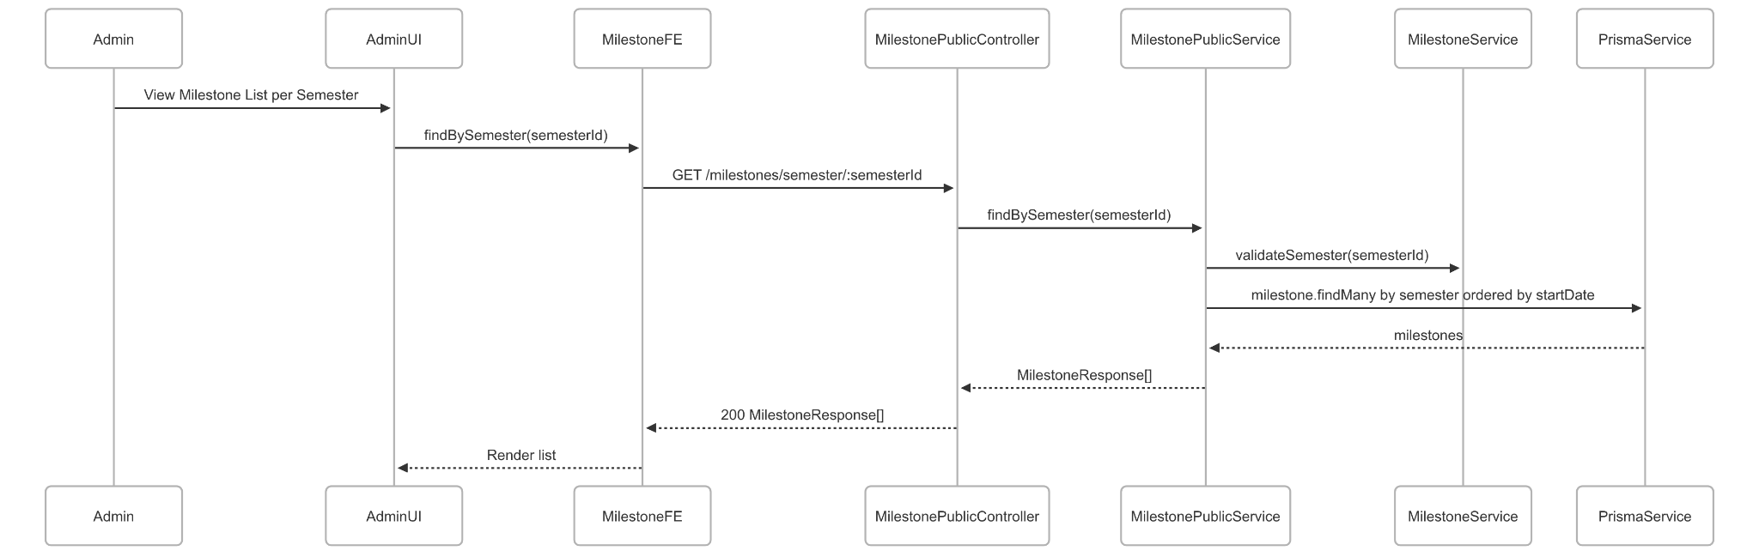](https://drive.google.com/file/d/1f1N58iy57ARMy0o9bXw_6L2fb-1hjOVp/view?usp=drive_link)

###### Figure IV.C.5.c.(3) - View List Milestones Sequence Diagram

* + - * 1. Delete Milestone

[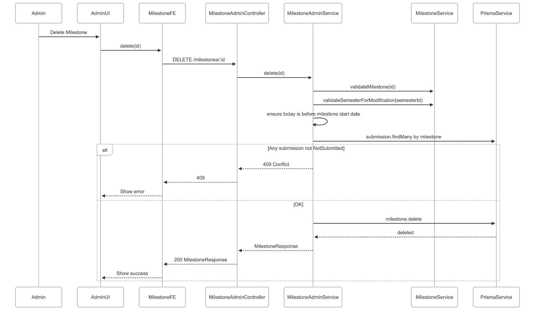](https://drive.google.com/file/d/1IxnANOH84Dxq2hjWM5hGlhPuDFWroJzw/view?usp=drive_link)

###### Figure IV.C.5.c.(4) - Delete Milestone Sequence Diagram

### Admin Generate Reports and Statistics

#### Class Diagram

[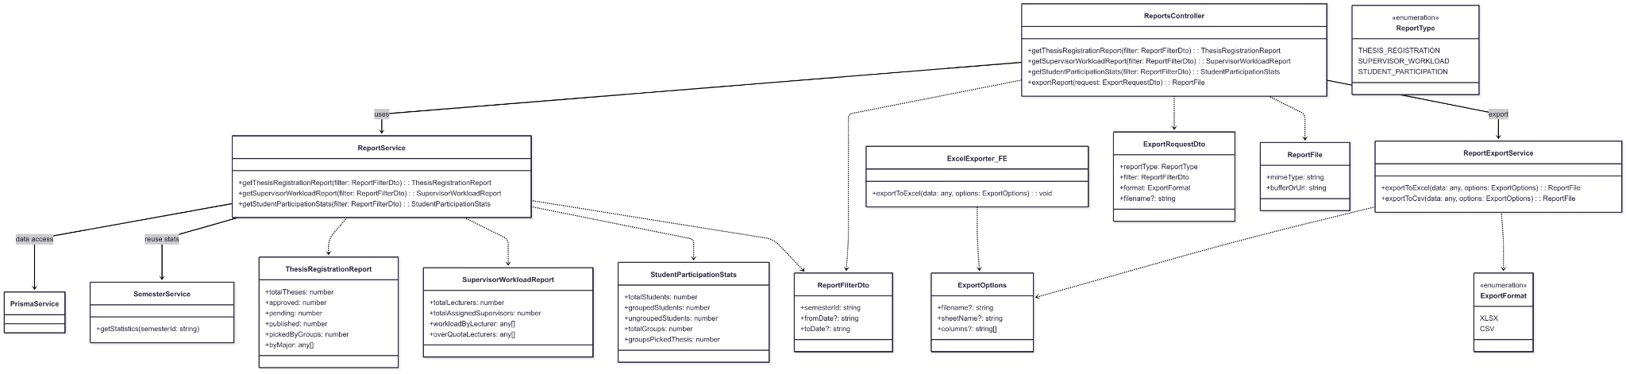](https://drive.google.com/file/d/1x9lsfTCp6uPxV5pEAcBu0uNCKsAhuSE_/view?usp=drive_link)

###### Figure IV.C.6.a - Admin Generate Reports and Statistics Class Diagram

#### Class Diagram Specification

| **No** | **Class** | **Method** | **Description** |
| --- | --- | --- | --- |
| 1 | ReportsController | getThesisRegistrationReport(filter) | Return thesis registration report for a semester/date range. |
| 2 | ReportsController | getSupervisorWorkloadReport(filter) | Return supervisor workload distribution and over-quota lecturers. |
| 3 | ReportsController | getStudentParticipationStats(filter) | Return student participation overview (grouped/ungrouped, groups picked thesis). |
| 4 | ReportsController | exportReport(request) | Generate and return downloadable report file in chosen format. |
| 5 | ReportService | getThesisRegistrationReport(filter) | Query counts (approved/pending/published/picked) and breakdown by major. |
| 6 | ReportService | getSupervisorWorkloadReport(filter) | Aggregate supervision per lecturer; compute totals and over-quota. |
| 7 | ReportService | getStudentParticipationStats(filter) | Aggregate student/group metrics for the semester. |
| 8 | SemesterService | getStatistics(semesterId) | Core stats used by reports (students, theses, groups, supervisors, picked). |
| 9 | ReportExportService | exportToExcel(data, options) | Build XLSX in backend; return ReportFile. |
| 10 | ReportExportService | exportToCsv(data, options) | Build CSV in backend; return ReportFile. |
| 11 | ExcelExporter_FE | exportToExcel(data, options) | Client-side export to XLSX (download), for quick UI export. |
| 12 | ReportFilterDto | validate() | semesterId (required), fromDate/toDate (optional ISO); basic guards. |
| 13 | ExportRequestDto | validate() | reportType, filter, format (XLSX/CSV), filename optional. |
| 14 | ExportOptions | validate() | filename, sheetName, columns (optional) for formatting/selection. |
| 15 | ThesisRegistrationReport | shape() | totalTheses, approved, pending, published, pickedByGroups, byMajor[]. |
| 16 | SupervisorWorkloadReport | shape() | totalLecturers, totalAssignedSupervisors, workloadByLecturer[], overQuotaLecturers[]. |
| 17 | StudentParticipationStats | shape() | totalStudents, groupedStudents, ungroupedStudents, totalGroups, groupsPickedThesis. |
| 18 | ReportFile | shape() | mimeType, bufferOrUrl (binary or presigned URL). |
| 19 | ReportType (enum) | values() | THESIS_REGISTRATION, SUPERVISOR_WORKLOAD, STUDENT_PARTICIPATION. |
| 20 | ExportFormat (enum) | values() | XLSX, CSV. |

##### Table IV.C.6.b - Admin Generate Reports and Statistics Class Diagram Specification

#### Sequence Diagram

* + - * 1. Generate Thesis Registration Report

[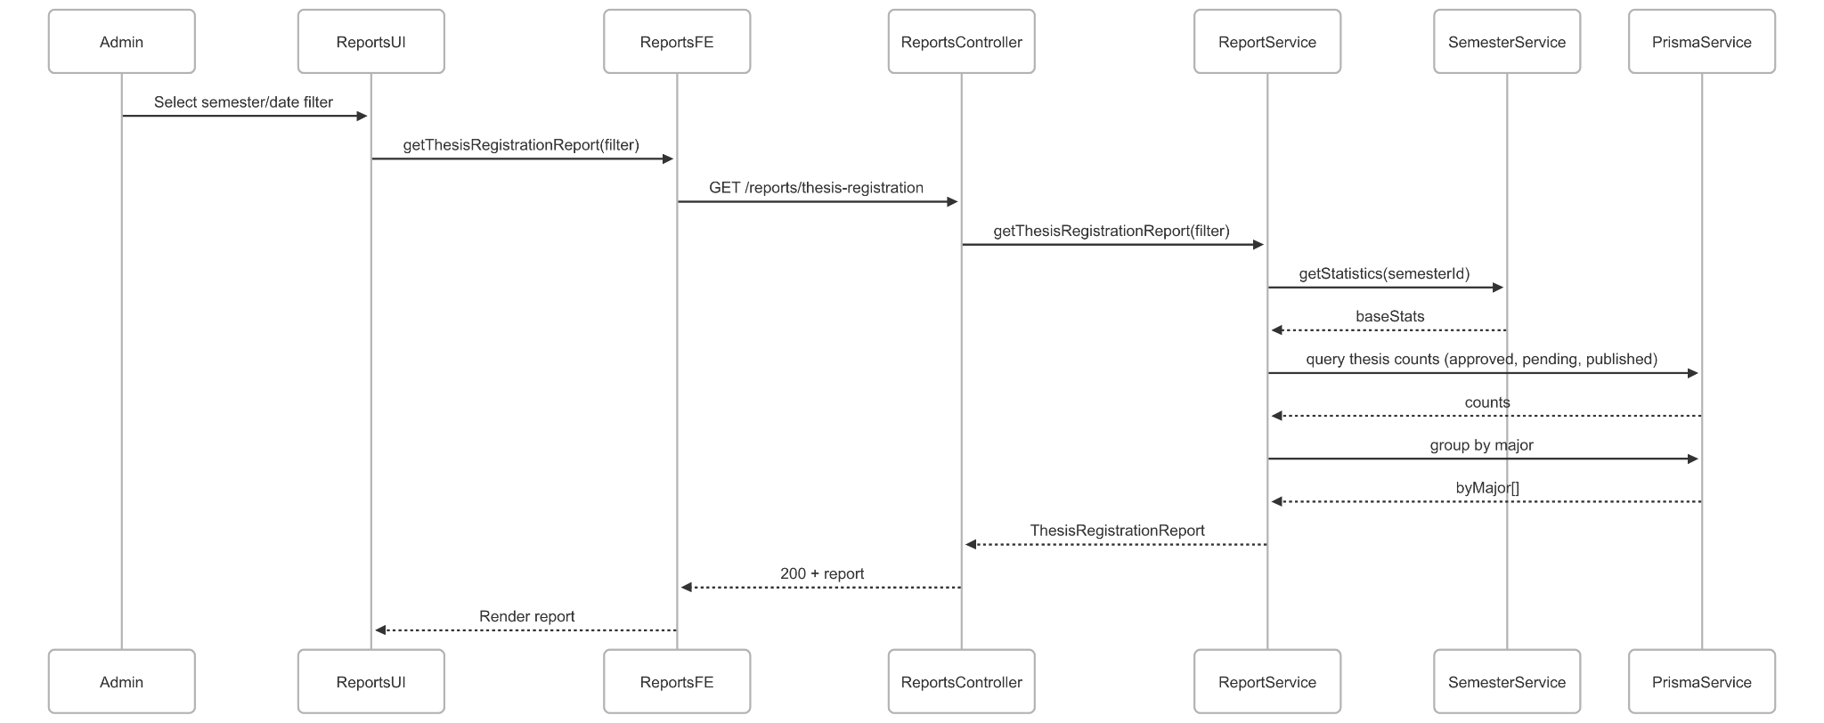](https://drive.google.com/file/d/179q51CKt8FcE2hVaPi9AIs2rjYiOgsKd/view?usp=drive_link)

###### Figure IV.C.6.c.(1) - Generate Thesis Registration Report Sequence Diagram

* + - * 1. View Supervisor Workload Report

[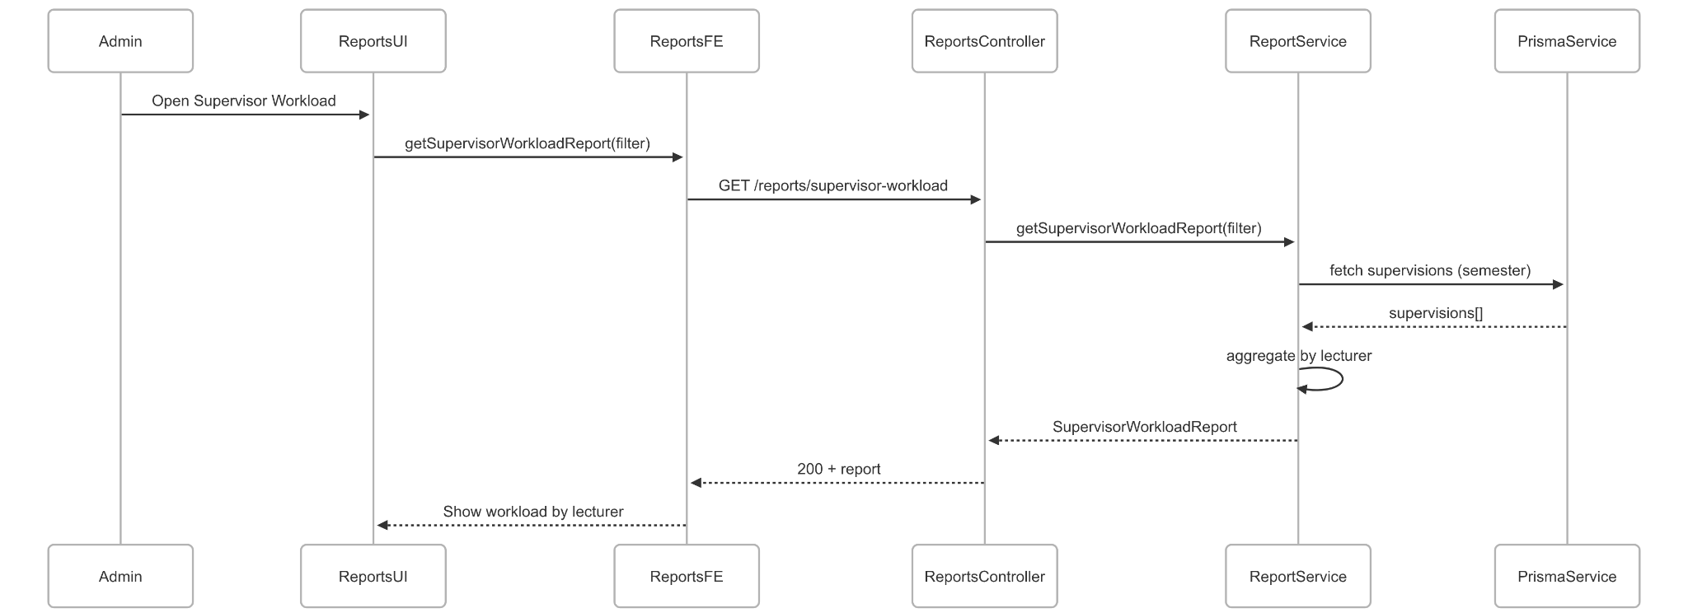](https://drive.google.com/file/d/1VOeBFZBFAh-gmXE5gDmnr0mCnK249UG6/view?usp=drive_link)

###### Figure IV.C.6.c.(2) - View Supervisor Workload Report Sequence Diagram

* + - * 1. View Student Participation Statistics

[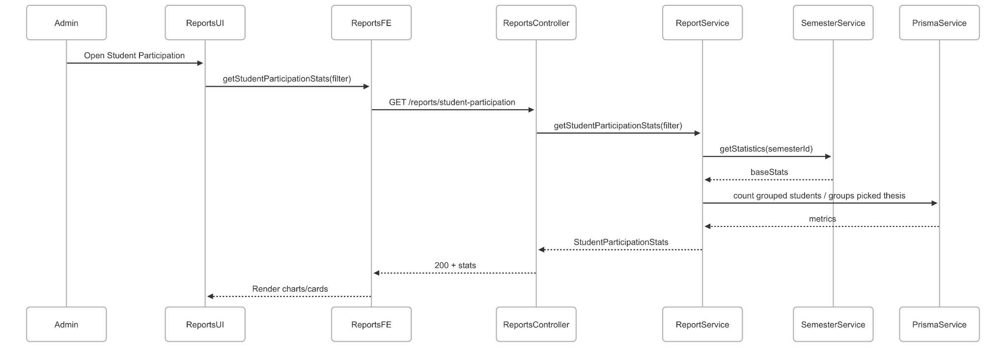](https://drive.google.com/file/d/1EakzSJxI2vvzD71yCt6XWfor3Aoicyt7/view?usp=drive_link)

###### Figure IV.C.6.c.(3) - View Student Participation Statistics Sequence Diagram

* + - * 1. Export Report (Excel/CSV)

[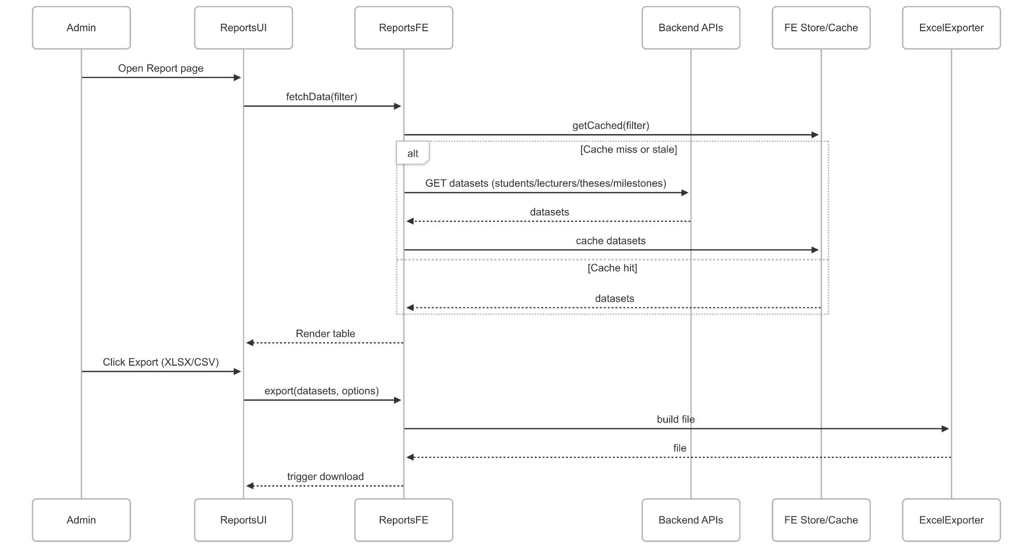](https://drive.google.com/file/d/1amzkjbKHtCy3iXCuQjzQyV1cMNITVNzX/view?usp=drive_link)

###### Figure IV.C.6.c.(4) - Export Report Sequence Diagram

### Admin Update Capstone Defense Results

#### Class Diagram

[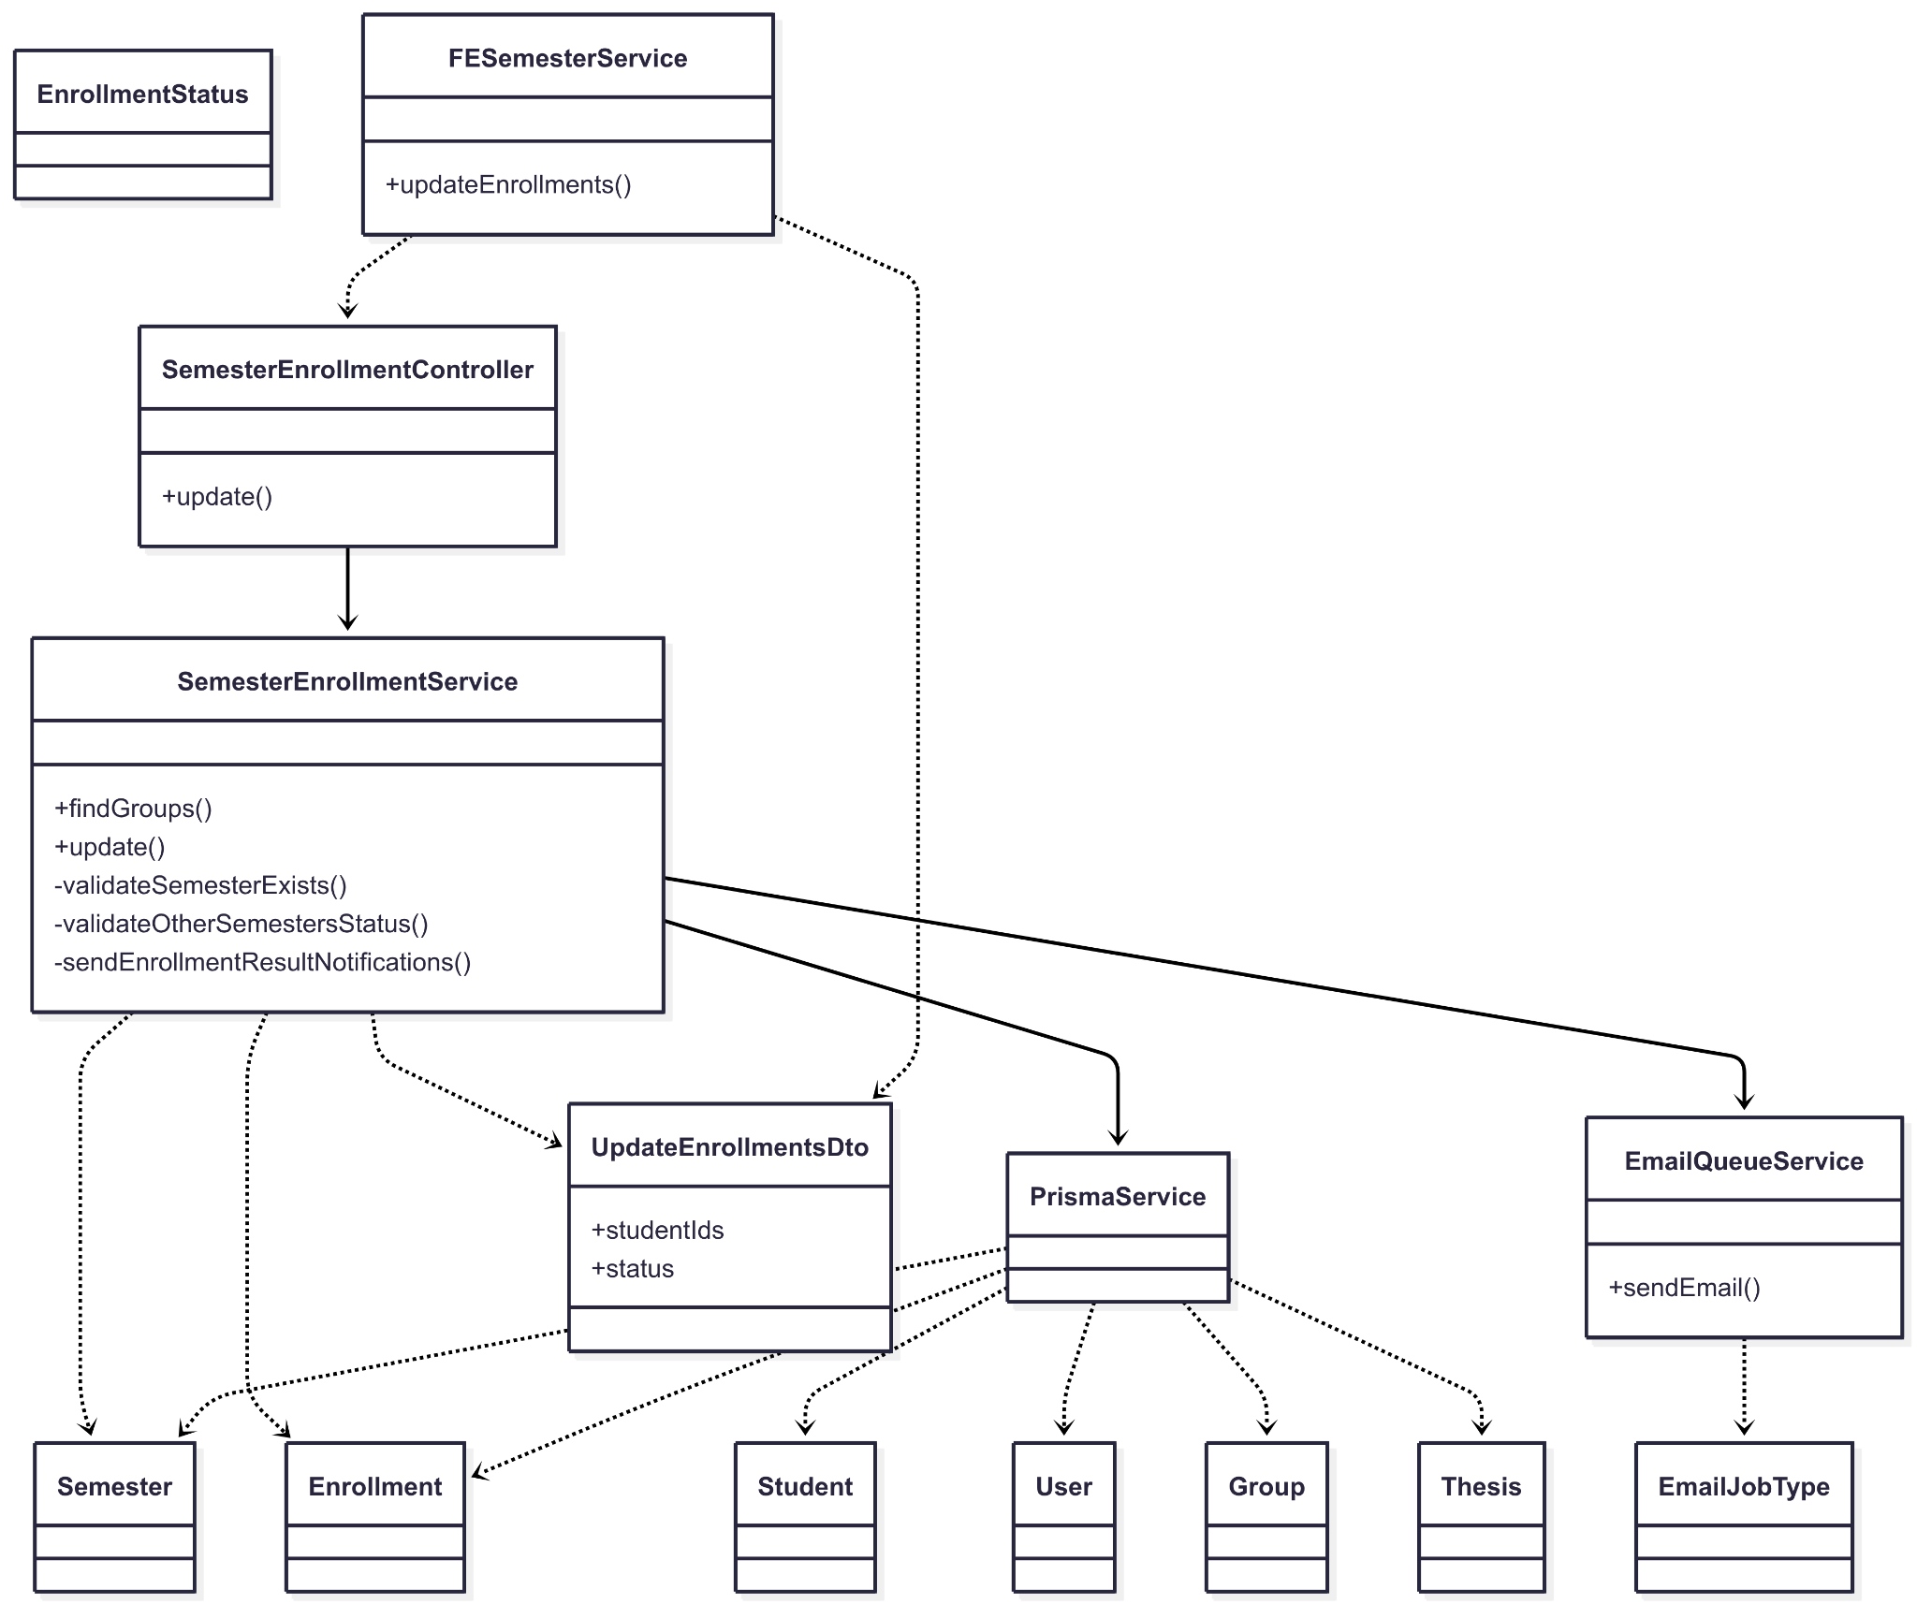](https://drive.google.com/file/d/1kChS-XqjmNEIU08ZnGQdsafT3Ck1qaxA/view?usp=drive_link)

###### Figure IV.C.7.a - Admin Update Capstone Defense Results Class Diagram

#### Class Diagram Specification

| **No** | **Class** | **Method** | **Description** |
| --- | --- | --- | --- |
| 1 | FESemesterService | updateEnrollments(semesterId, { studentIds, status }) | FE calls BE to update defense results (Passed/Failed) for selected students. |
| 2 | useBulkDefenseUpdate (FE) | updateBulkStatus(status, params) | FE bulk-update flow: validate, build studentIds, call updateEnrollments, refresh UI. |
| 3 | useBulkDefenseUpdate (FE) | updateIndividualStatus(statusUpdates, params) | FE per-row updates grouped by status; multiple calls to updateEnrollments; refresh UI. |
| 4 | SemesterEnrollmentController | update(id, dto) | PUT /semesters/:id/enrollments; delegates to service; admin-only; returns 200. |
| 5 | SemesterEnrollmentService | update(id, dto) | Validates semester, other semesters; updates enrollments status in bulk; sends notifications. |
| 6 | SemesterEnrollmentService | findGroups(semesterId) | Fetch groups with nested students/enrollments for result context (read helper). |
| 7 | SemesterEnrollmentService | validateSemesterExists(semester) | Ensure semester exists and is Ongoing with ScopeLocked phase; else 404/409. |
| 8 | SemesterEnrollmentService | validateOtherSemestersStatus(currentId) | Other semesters must be NotYet/End or Ongoing with ScopeLocked; else 409. |
| 9 | SemesterEnrollmentService | sendEnrollmentResultNotifications(studentIds, semesterId, status) | Compose per-student context and enqueue result emails. |
| 10 | PrismaService | enrollment.updateMany(filter, data) | Bulk update Enrollment.status for given semester/studentIds. |
| 11 | PrismaService | semester.findUnique(id) | Load semester for validation. |
| 12 | PrismaService | enrollment.findMany(filter) | Load enrollments for email context. |
| 13 | EmailQueueService | sendEmail(type, job, delayMs) | Queue SEND_ENROLLMENT_RESULT_NOTIFICATION with context (student, thesis, semester). |
| 14 | UpdateEnrollmentsDto | validate() | studentIds: UUID[]; status: one of EnrollmentStatus.Passed/Failed. |
| 15 | EnrollmentStatus (enum) | values() | NotYet, Ongoing, Passed, Failed (used here: Passed/Failed). |
| 16 | Semester | fields() | id, name, code, status, ongoingPhase (must be Ongoing + ScopeLocked to update). |
| 17 | Enrollment | fields() | studentId, semesterId, status. |
| 18 | Student/User/Group/Thesis | fields() | Minimal fields used for email context (names, codes, thesis names). |

##### Table IV.C.7.b - Admin Update Capstone Defense Results Class Diagram Specification

#### Sequence Diagram

* + - * 1. Bulk Update Defense Results

[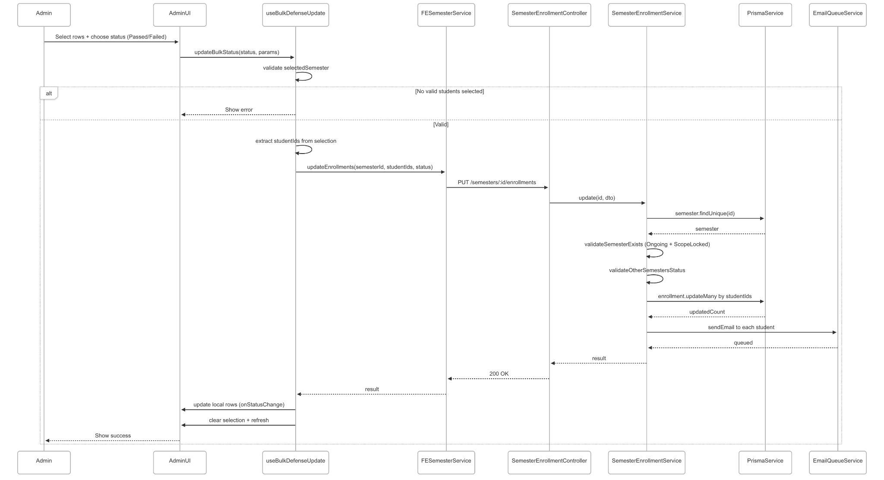](https://drive.google.com/file/d/17CTUUTdbpWl9-D-0XR6PVU10fNqVGpEM/view?usp=drive_link)

###### Figure IV.C.7.c.(1) - Bulk Update Defense Results Sequence Diagram

* + - * 1. Individual Update Defense Results (per-row changes, grouped by status)

[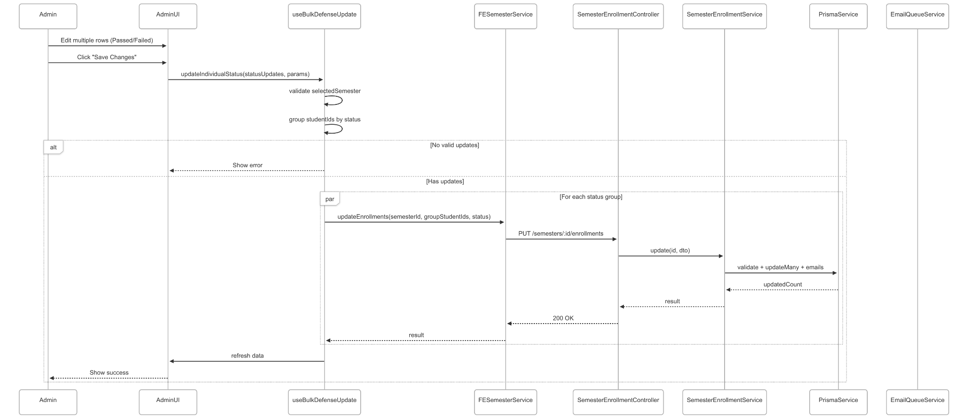](https://drive.google.com/file/d/1Sa3zCrzcOuyPu7U5ThxSzfY-0hveIpAT/view?usp=drive_link)

###### Figure IV.C.7.c.(2) - Individual Update Defense Results Sequence Diagram

### Lecturer View Dashboard

#### Class Diagram

[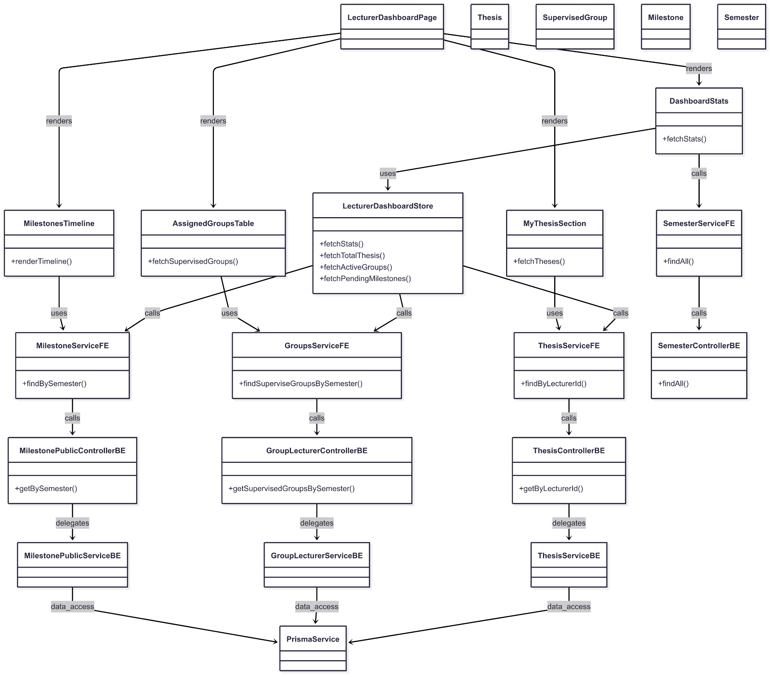](https://drive.google.com/file/d/1vxMdTkz9gH5zg2yiVhMv6rXSITHdx47q/view?usp=drive_link)

###### Figure IV.C.8.a - Lecturer View Dashboard Class Diagram

#### Class Diagram Specification

| **No** | **Class** | **Method** | **Description** |
| --- | --- | --- | --- |
| 1 | LecturerDashboardPage | render() | Layout page that composes stats, milestones timeline, theses list, supervised groups table. |
| 2 | DashboardStats | fetchStats(lecturerId, semesterId) | Triggers store to fetch all KPI cards (total theses, supervised groups, pending milestones). |
| 3 | MilestonesTimeline | renderTimeline(semesterId) | Fetches milestones of current semester and renders a chronological timeline. |
| 4 | MyThesisSection | fetchTheses(lecturerId) | Loads theses created by the lecturer; supports semester filter in UI. |
| 5 | AssignedGroupsTable | fetchSupervisedGroups(semesterId) | Loads groups assigned to the lecturer for the selected semester. |
| 6 | useLecturerDashboardStore | fetchStats(lecturerId, semesterId) | Orchestrates parallel fetches: total theses, supervised groups count, pending milestones. |
| 7 | useLecturerDashboardStore | fetchTotalThesis(lecturerId) | Calls thesis service and computes total theses created by the lecturer. |
| 8 | useLecturerDashboardStore | fetchActiveGroups(semesterId) | Calls groups service; computes number of supervised groups in semester. |
| 9 | useLecturerDashboardStore | fetchPendingMilestones(semesterId) | Calls milestone service; counts milestones whose endDate ≥ today. |
| 10 | ThesisService_FE | findByLecturerId(lecturerId) | GET /theses/lecturer/:lecturerId; returns lecturer’s theses. |
| 11 | GroupsService_FE | findSuperviseGroupsBySemester(semesterId) | GET /groups/supervise/semester/:semesterId; returns supervised groups. |
| 12 | MilestoneService_FE | findBySemester(semesterId) | GET /milestones/semester/:semesterId; returns milestones for timeline. |
| 13 | SemesterService_FE | findAll() | GET /semesters; supports semester dropdown/filter in dashboard. |
| 14 | ThesisController_BE | getByLecturerId(lecturerId) | Endpoint to fetch theses authored by a lecturer. Delegates to ThesisService_BE. |
| 15 | GroupLecturerController_BE | getSupervisedGroupsBySemester(semesterId) | Endpoint to fetch lecturer’s supervised groups in a semester. |
| 16 | MilestonePublicController_BE | getBySemester(semesterId) | Endpoint to fetch milestones by semester for timeline views. |
| 17 | SemesterController_BE | findAll() | Endpoint to list semesters (for filters and context). |
| 18 | ThesisService_BE | findByLecturer(lecturerId) | Data access/business logic to retrieve lecturer’s theses. |
| 19 | GroupLecturerService_BE | findSupervisedGroups(lecturerId, semesterId) | Data access/business logic for supervised groups with relations. |
| 20 | MilestonePublicService_BE | findBySemester(semesterId) | Data access/business logic for milestones ordering by dates. |
| 21 | PrismaService | (ORM) | Backing ORM used by backend services for queries/joins/aggregations. |
| 22 | Thesis | shape() | id, englishName, semesterId, lecturerId, status, createdAt, updatedAt. |
| 23 | SupervisedGroup | shape() | id, code, name, thesis, semester, studentGroupParticipations, createdAt, updatedAt. |
| 24 | Milestone | shape() | id, name, startDate, endDate, semesterId. |
| 25 | Semester | shape() | id, name, code, status. |

##### Table IV.C.8.b - Lecturer View Dashboard Class Diagram Specification

#### Sequence Diagram

* + - * 1. View overall report (theses, supervised groups, pending milestones)

[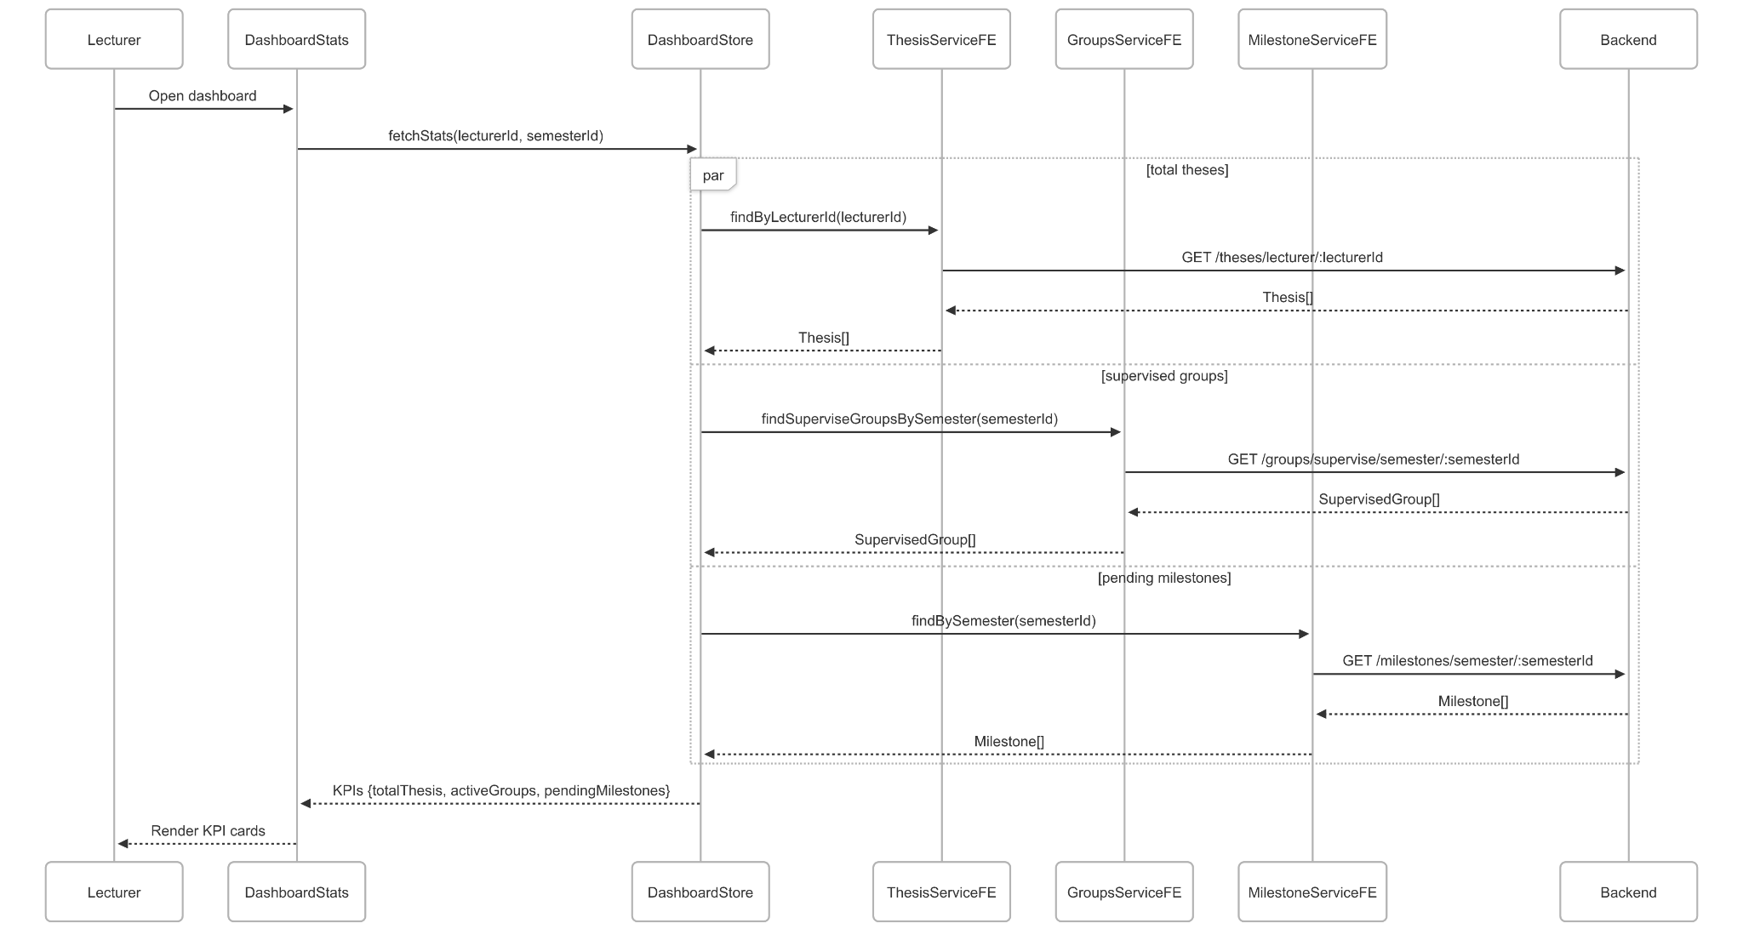](https://drive.google.com/file/d/1Zzc290Dj0v1tJbZWGbBBPCv8krD3IX4G/view?usp=drive_link)

###### Figure IV.C.8.c.(1) - View Overall Report Sequence Diagram

* + - * 1. View Milestones Timeline

[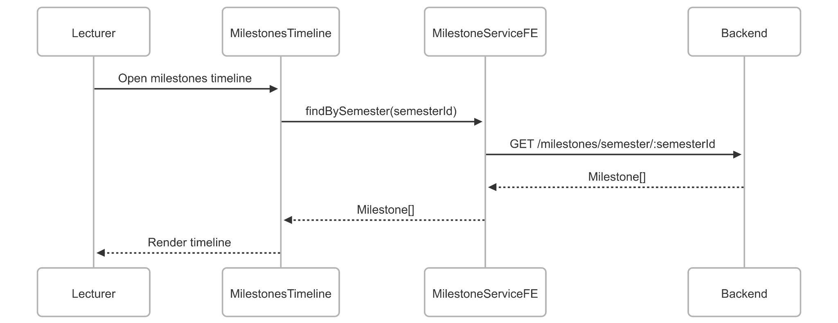](https://drive.google.com/file/d/1qS8hr6Gep4vQS967T8Mk-lTWA9nnBoUg/view?usp=drive_link)

###### Figure IV.C.8.c.(2) - View Milestones Timeline Sequence Diagram

* + - * 1. View list of supervised groups

[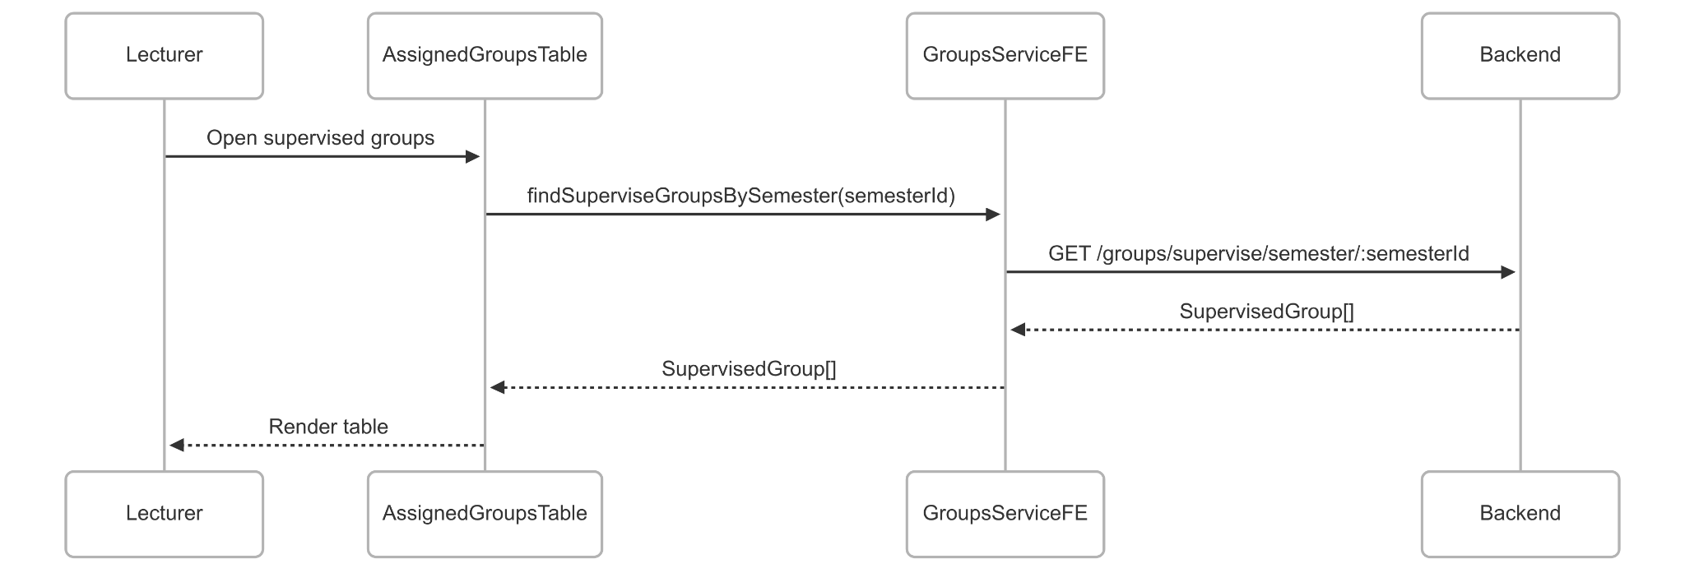](https://drive.google.com/file/d/15SvAXJrbsAwKEl-QIiyXDNBGozR8E-Jf/view?usp=drive_link)

###### Figure IV.C.8.c.(3) - View List Of Supervised Groups Sequence Diagram

### Lecturer Manage Thesis

#### Class Diagram

[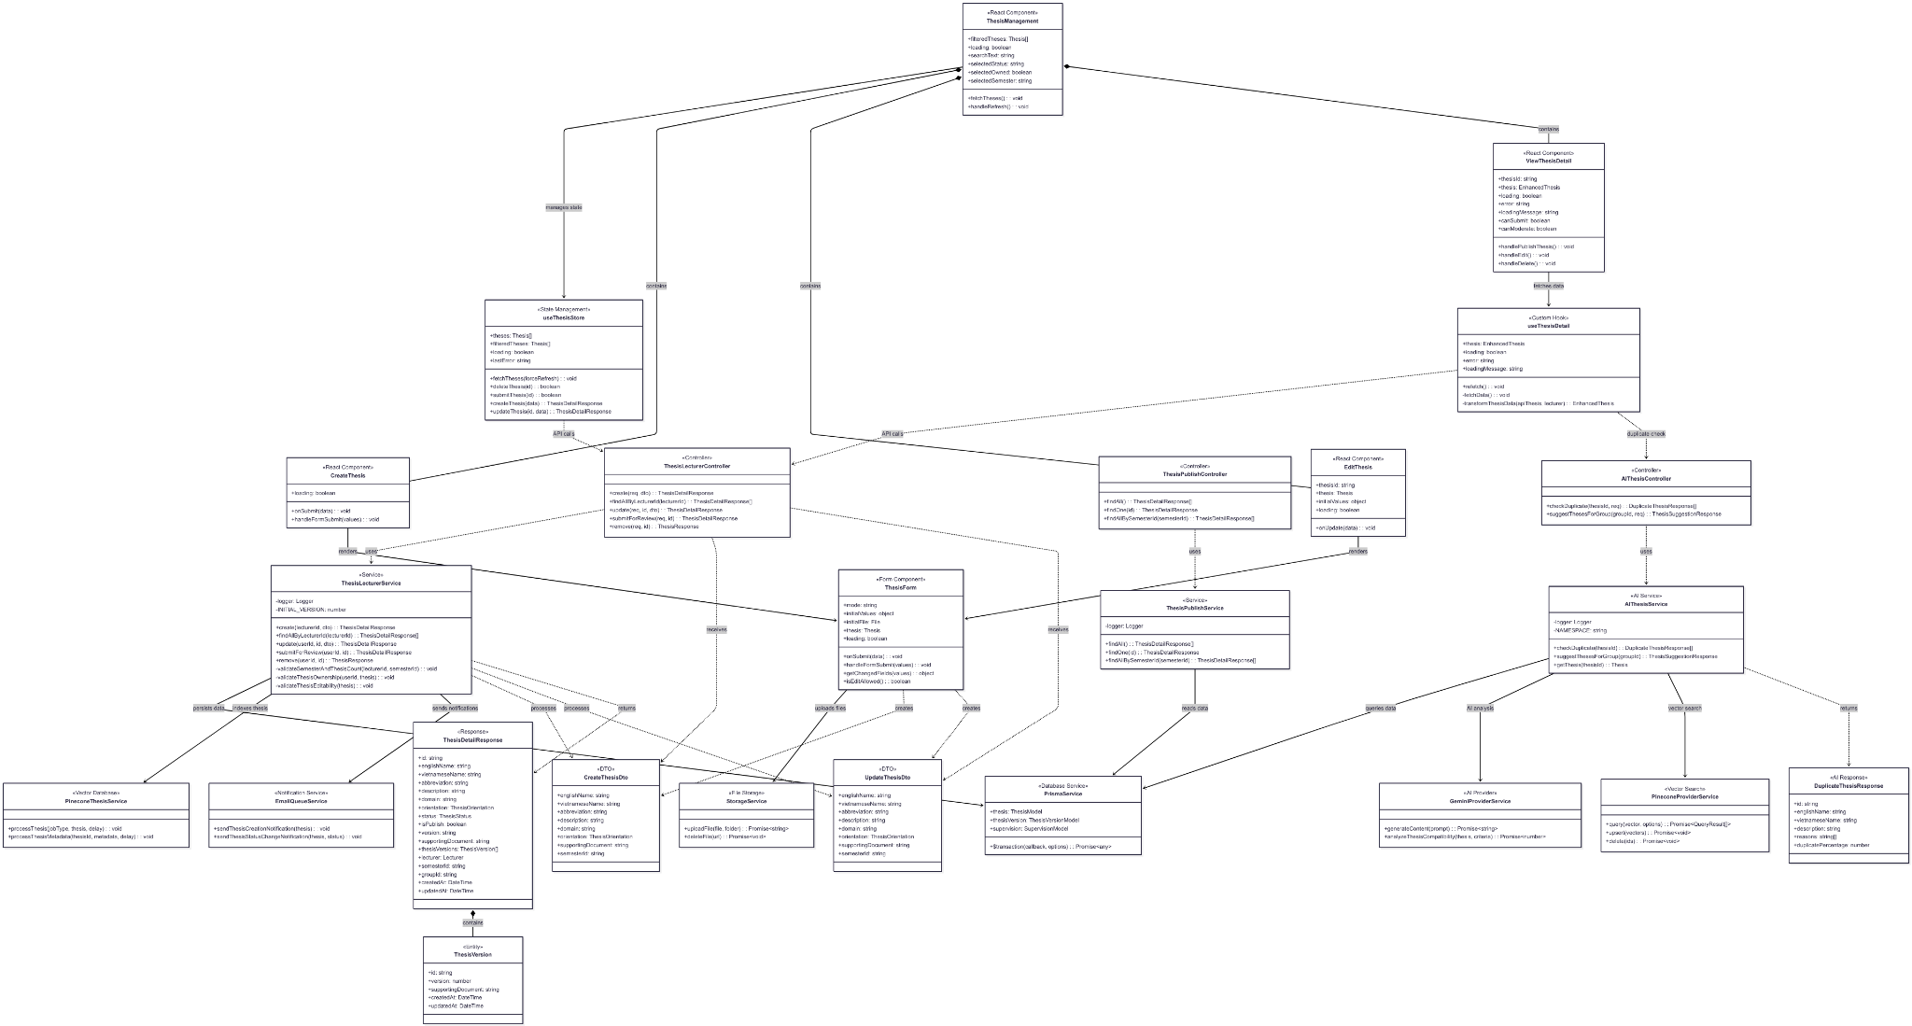](https://drive.google.com/file/d/1B-Oc1xSnfn7ROOBLxTBnI-QYsyfhEr3a/view?usp=drive_link)

###### Figure IV.C.9.a - Lecturer Manage Thesis Class Diagram

#### Class Diagram Specification

| **No** | **Class** | **Method** | **Description** |
| --- | --- | --- | --- |
| 1 | ThesisLecturerController | create(req, dto) | Create a new thesis with validation and initial version setup |
| 2 | ThesisLecturerController | findAllByLecturerId(lecturerId) | Retrieve all theses created by a specific lecturer |
| 3 | ThesisLecturerController | update(req, id, dto) | Update thesis information and create new version if document changed |
| 4 | ThesisLecturerController | submitForReview(req, id) | Submit thesis for moderator review, change status to Pending |
| 5 | ThesisLecturerController | remove(req, id) | Delete thesis with ownership validation and cascade operations |
| 6 | AIThesisController | checkDuplicate(thesisId, req) | Check for potential duplicate theses using AI analysis |
| 7 | AIThesisController | suggestThesesForGroup(groupId, req) | Suggest suitable theses for a specific student group using AI |
| 8 | ThesisPublishController | findAll() | Retrieve all published theses available for students |
| 9 | ThesisPublishController | findOne(id) | Get detailed information of a specific published thesis |
| 10 | ThesisPublishController | findAllBySemesterId(semesterId) | Get all published theses for a specific semester |
| 11 | ThesisLecturerService | create(lecturerId, dto) | Business logic for thesis creation with transaction management |
| 12 | ThesisLecturerService | findAllByLecturerId(lecturerId) | Fetch lecturer's theses with versions and relationships |
| 13 | ThesisLecturerService | update(userId, id, dto) | Update thesis with version control and validation |
| 14 | ThesisLecturerService | submitForReview(userId, id) | Process thesis submission with status change and notifications |
| 15 | ThesisLecturerService | remove(userId, id) | Delete thesis with ownership check and cleanup operations |
| 16 | ThesisLecturerService | validateSemesterAndThesisCount(lecturerId, semesterId) | Validate semester rules and lecturer thesis limits |
| 17 | ThesisLecturerService | validateThesisOwnership(userId, thesis) | Check if user owns the thesis for modification rights |
| 18 | ThesisLecturerService | validateThesisEditability(thesis) | Verify thesis can be edited based on current status |
| 19 | AIThesisService | checkDuplicate(thesisId) | Perform AI-powered duplicate detection with caching |
| 20 | AIThesisService | suggestThesesForGroup(groupId) | Generate AI-based thesis recommendations for groups |
| 21 | AIThesisService | getThesis(thesisId) | Retrieve thesis data for AI processing |
| 22 | ThesisPublishService | findAll() | Get all published theses with caching optimization |
| 23 | ThesisPublishService | findOne(id) | Fetch single published thesis with detailed information |
| 24 | ThesisPublishService | findAllBySemesterId(semesterId) | Retrieve semester-specific published theses |
| 25 | ThesisManagement | fetchTheses() | Load and filter theses based on search criteria |
| 26 | ThesisManagement | handleRefresh() | Force refresh thesis data from server |
| 27 | CreateThesis | onSubmit(data) | Handle thesis creation form submission |
| 28 | CreateThesis | handleFormSubmit(values) | Process and validate thesis creation data |
| 29 | EditThesis | onUpdate(data) | Handle thesis update form submission |
| 30 | ViewThesisDetail | handlePublishThesis() | Toggle thesis publish status with permissions check |
| 31 | ViewThesisDetail | handleEdit() | Navigate to thesis edit page with validation |
| 32 | ViewThesisDetail | handleDelete() | Delete thesis with confirmation and error handling |
| 33 | ThesisForm | handleFormSubmit(values) | Process form data and file uploads |
| 34 | ThesisForm | getChangedFields(values) | Identify modified fields for efficient updates |
| 35 | ThesisForm | isEditAllowed() | Check if thesis editing is permitted based on status |
| 36 | useThesisDetail | fetchData() | Fetch thesis and lecturer data with loading states |
| 37 | useThesisDetail | transformThesisData(apiThesis, lecturer) | Transform API response to enhanced thesis object |
| 38 | useThesisDetail | refetch() | Manually refresh thesis data |
| 39 | useThesisStore | fetchTheses(forceRefresh) | Load theses with optional cache bypass |
| 40 | useThesisStore | deleteThesis(id) | Delete thesis with optimistic updates |
| 41 | useThesisStore | submitThesis(id) | Submit thesis for review with status tracking |
| 42 | useThesisStore | createThesis(data) | Create new thesis with form data processing |
| 43 | useThesisStore | updateThesis(id, data) | Update existing thesis with change detection |
| 44 | PrismaService | $transaction(callback, options) | Execute database operations within transaction |
| 45 | PineconeThesisService | processThesis(jobType, thesis, delay) | Index thesis content for AI search and recommendations |
| 46 | PineconeThesisService | processThesisMetadata(thesisId, metadata, delay) | Update thesis metadata in vector database |
| 47 | EmailQueueService | sendThesisCreationNotification(thesis) | Send email notification for new thesis creation |
| 48 | EmailQueueService | sendThesisStatusChangeNotification(thesis, status) | Notify stakeholders of thesis status changes |
| 49 | StorageService | uploadFile(file, folder) | Upload supporting documents to cloud storage |
| 50 | StorageService | deleteFile(url) | Remove files from cloud storage with cleanup |
| 51 | GeminiProviderService | generateContent(prompt) | Generate AI content using Google Gemini API |
| 52 | GeminiProviderService | analyzeThesisCompatibility(thesis, criteria) | Analyze thesis compatibility using AI algorithms |
| 53 | PineconeProviderService | query(vector, options) | Perform vector similarity search for duplicates |
| 54 | PineconeProviderService | upsert(vectors) | Insert or update thesis vectors in database |
| 55 | PineconeProviderService | delete(ids) | Remove thesis vectors from search index |

##### Table IV.C.9.b - Lecturer Manage Thesis Class Diagram Specification

#### State Diagram

[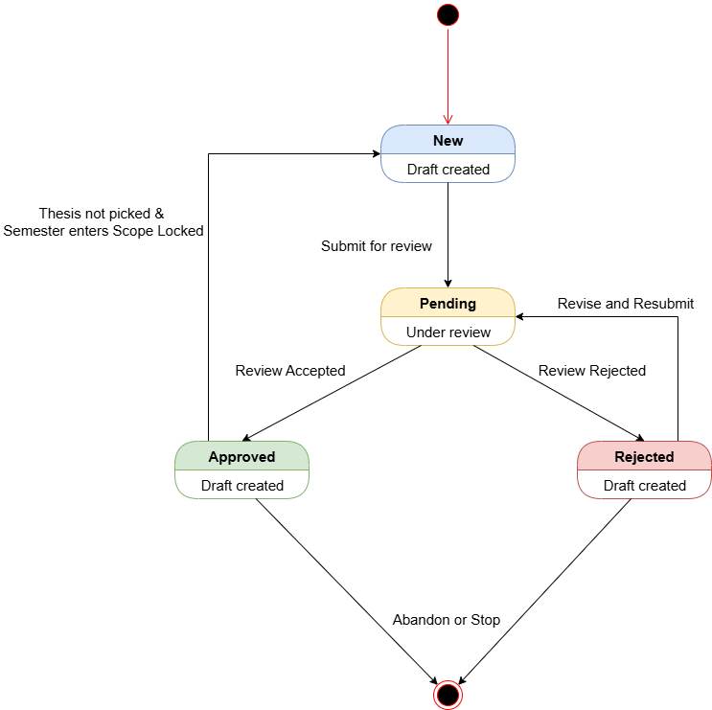](https://drive.google.com/file/d/15cxyXfj2mz6RcavK-pvhxSkdZm2EOm8G/view?usp=drive_link)

###### Figure IV.C.9.c - Thesis State Diagram

#### Sequence Diagram

* + - * 1. Create New Thesis

[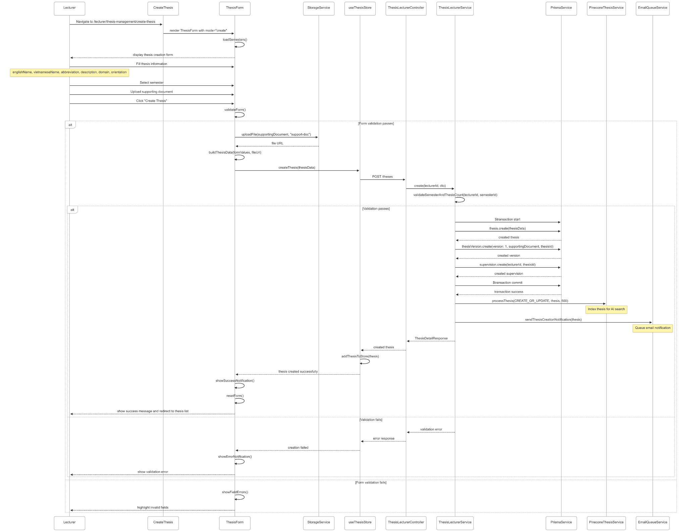](https://drive.google.com/file/d/1m4DFRMy_RkEv9egWBXoozjZFx8MXY75J/view?usp=drive_link)

###### Figure IV.C.9.d.(1) - Create New Thesis Sequence Diagram

* + - * 1. Edit Thesis

[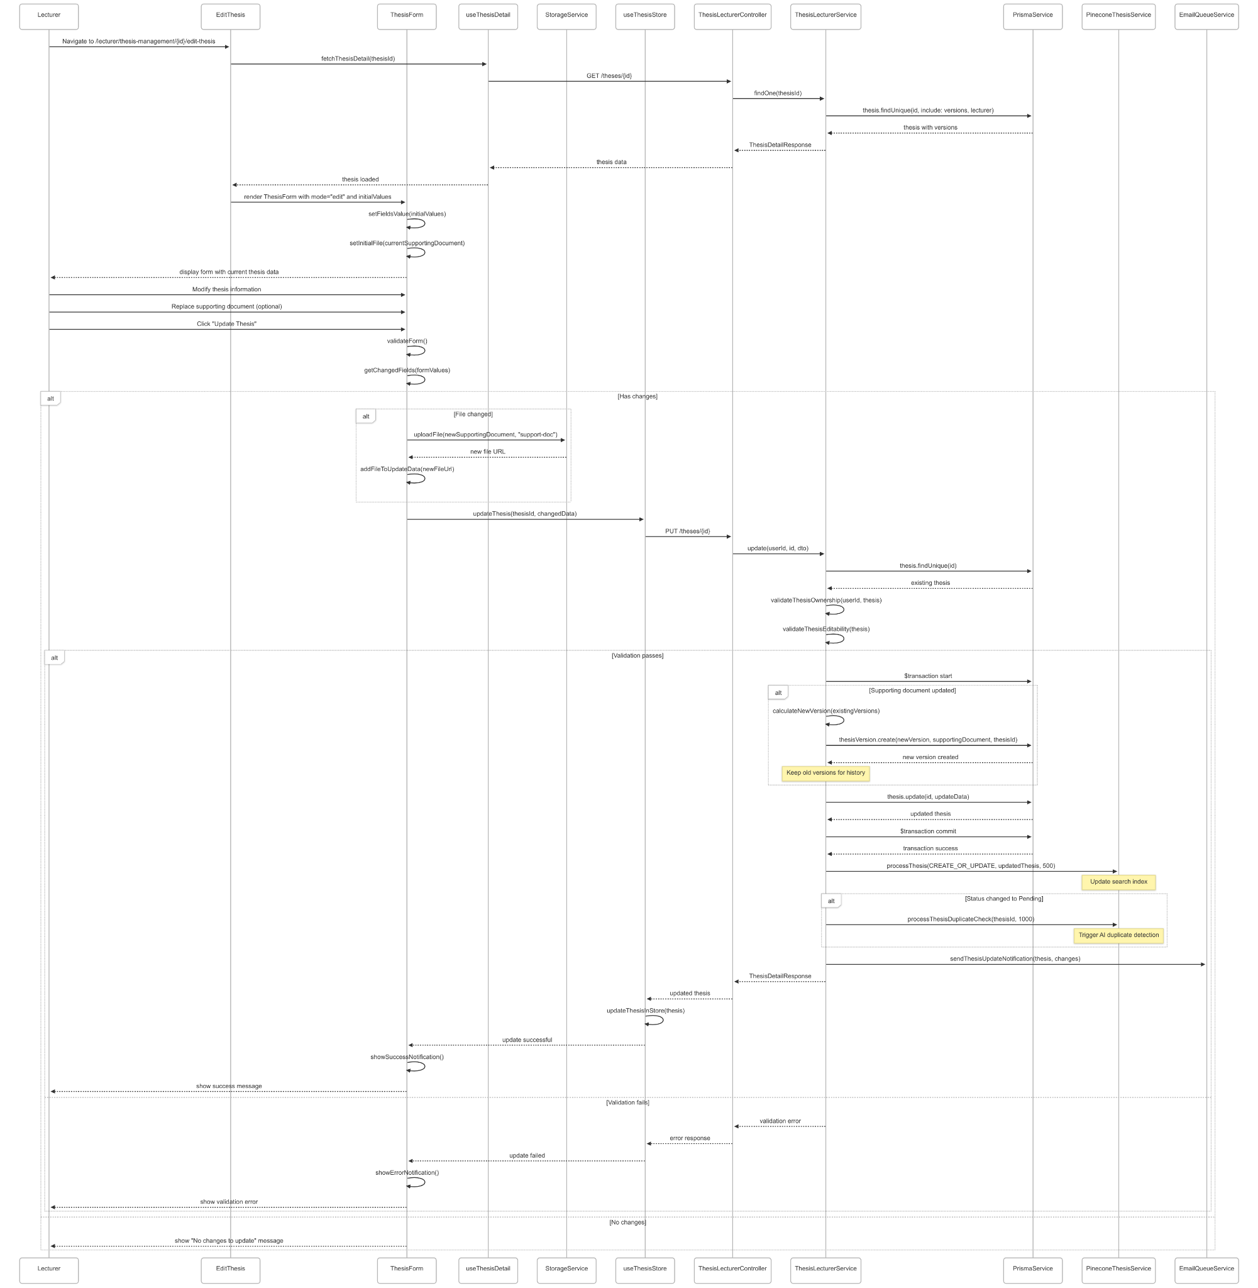](https://drive.google.com/file/d/1CRiT8qTGhalrlys5ZCK4Yy3_5mpuIqxb/view?usp=drive_link)

###### Figure IV.C.9.d.(2) - Edit Thesis Sequence Diagram

* + - * 1. View Thesis Details

[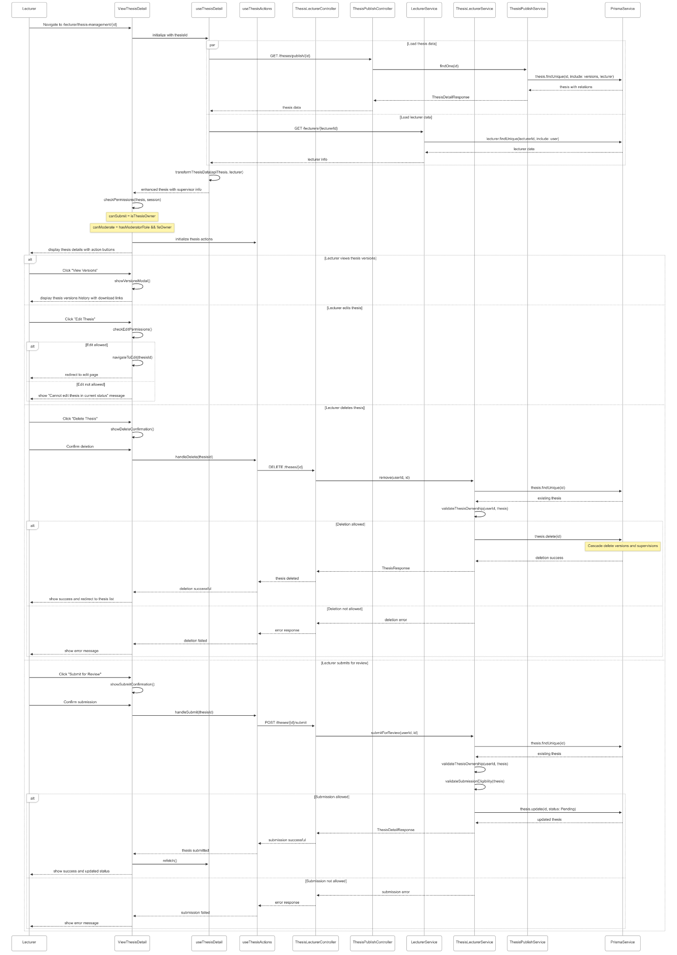](https://drive.google.com/file/d/1KYoBVWj5aAgD3Y9whEMgXKJGlpnH9IXX/view?usp=drive_link)

###### Figure IV.C.9.d.(3) - View Thesis Details Sequence Diagram

* + - * 1. View Thesis Versions

[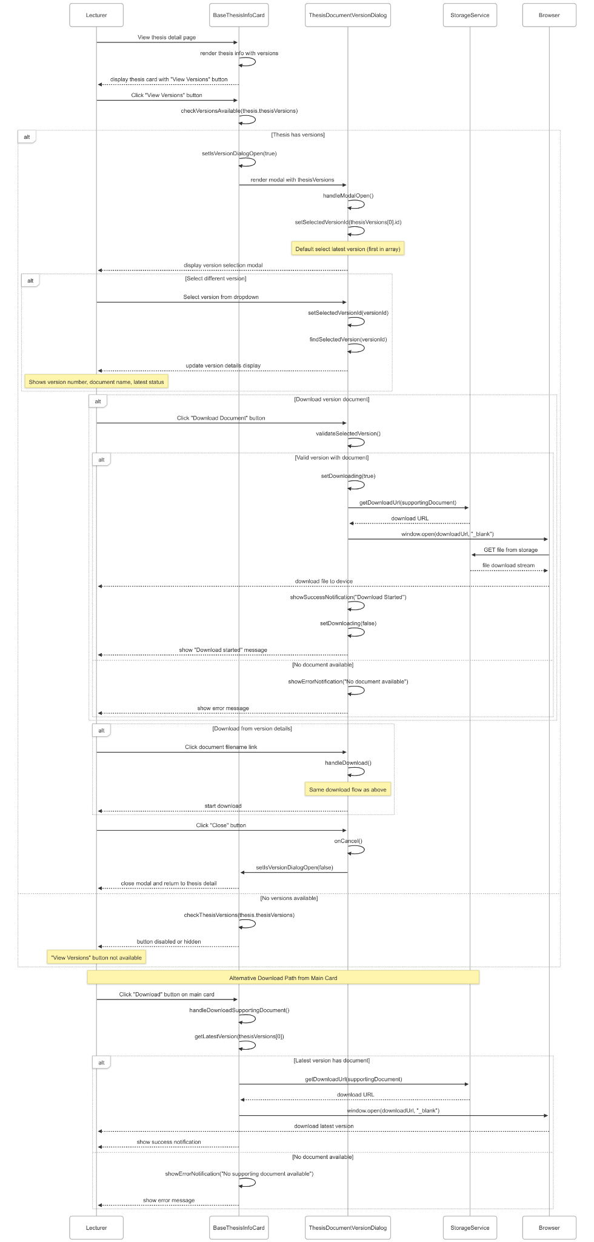](https://drive.google.com/file/d/1BbY2WXHkQYaCA3ur4s6z8mRpm5-V9uXT/view?usp=drive_link)

###### Figure IV.C.9.d.(4) - View Thesis Versions Sequence Diagram

* + - * 1. Duplicate thesis Detection (AI)

[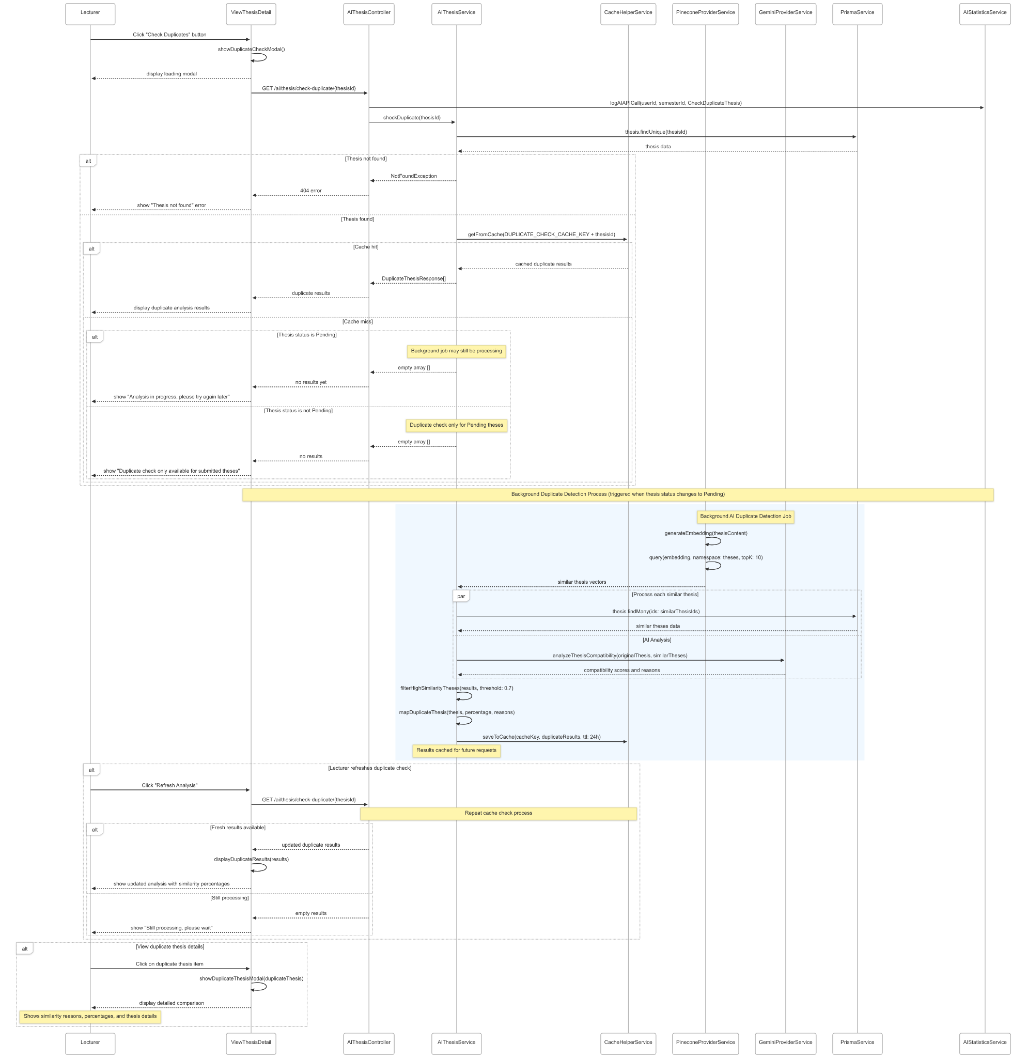](https://drive.google.com/file/d/1etgQJKHpC0CeUniqezK9WzbNH_cCwfnA/view?usp=drive_link)

###### Figure IV.C.9.d.(5) - Duplicate thesis Detection Sequence Diagram

### Moderator Review Thesis Registrations

#### Class Diagram

[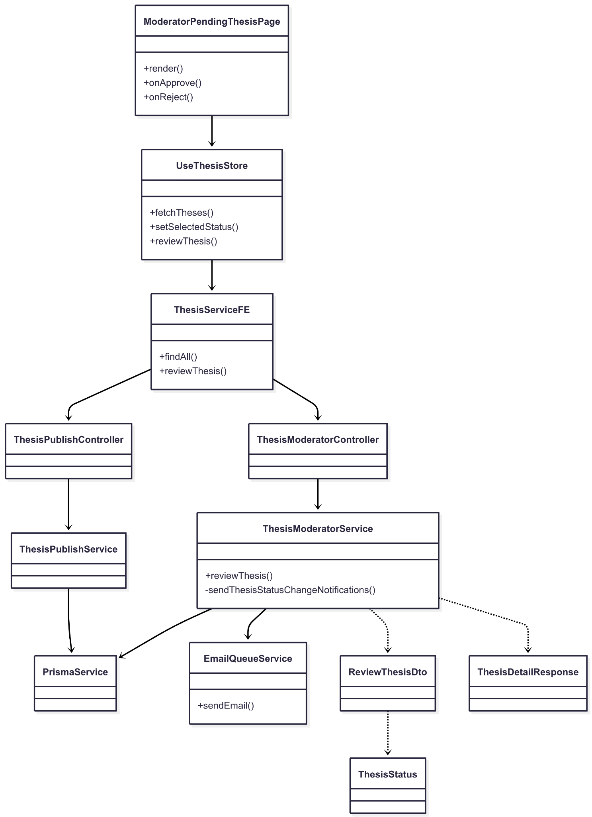](https://drive.google.com/file/d/1SmHa56_k5jp6LAl2qHiv71uRGkcclCjv/view?usp=drive_link)

###### Figure IV.C.10.a - Moderator Review Thesis Registrations Class Diagram

#### Class Diagram Specification

| **No** | **Class** | **Method** | **Description** |
| --- | --- | --- | --- |
| 1 | ModeratorPendingThesisPage | render() | Render pending theses list with Approve/Reject actions. |
| 2 | ModeratorPendingThesisPage | onApprove(id) | Trigger store to approve thesis by id. |
| 3 | ModeratorPendingThesisPage | onReject(id) | Trigger store to reject thesis by id. |
| 4 | UseThesisStore | fetchTheses() | Fetch all theses, cache, and update the filtered list. |
| 5 | UseThesisStore | setSelectedStatus(status) | Set filter (e.g., Pending) to show only items to review. |
| 6 | UseThesisStore | reviewThesis(id, status) | Call FE service to review thesis, update state, notify UI. |
| 7 | ThesisServiceFE | findAll() | GET list of theses for moderation view. |
| 8 | ThesisServiceFE | reviewThesis(id, dto) | POST review action (Approved/Rejected) for thesis id. |
| 9 | ThesisPublishController | findAll() | Return list of theses (with relations) for listing/filtering. |
| 10 | ThesisPublishService | findAll() | Query DB with includes; map to ThesisDetailResponse[]. |
| 11 | ThesisModeratorController | reviewThesis(id, dto) | Endpoint for moderator to approve/reject a thesis. |
| 12 | ThesisModeratorService | reviewThesis(id, dto) | Validate (exists, not published, status Pending), update status, send notifications, return detail. |
| 13 | ThesisModeratorService | sendThesisStatusChangeNotifications() | Send email notifications on status change. |
| 14 | PrismaService | (data access) | Database access used by services. |
| 15 | EmailQueueService | sendEmail(type, job, delayMs) | Queue and send email notifications. |
| 16 | ReviewThesisDto | (property) status | Review input: ThesisStatus = Approved/Rejected |
| 17 | ThesisDetailResponse | (returned) | Detailed thesis response (versions, required skills, lecturer). |
| 18 | ThesisStatus | (enum) | New, Pending, Approved, Rejected. |

##### Table IV.C.10.b - Moderator Review Thesis Registrations Class Diagram Specification

#### Sequence Diagram

* + - * 1. View Pending Thesis Registrations

[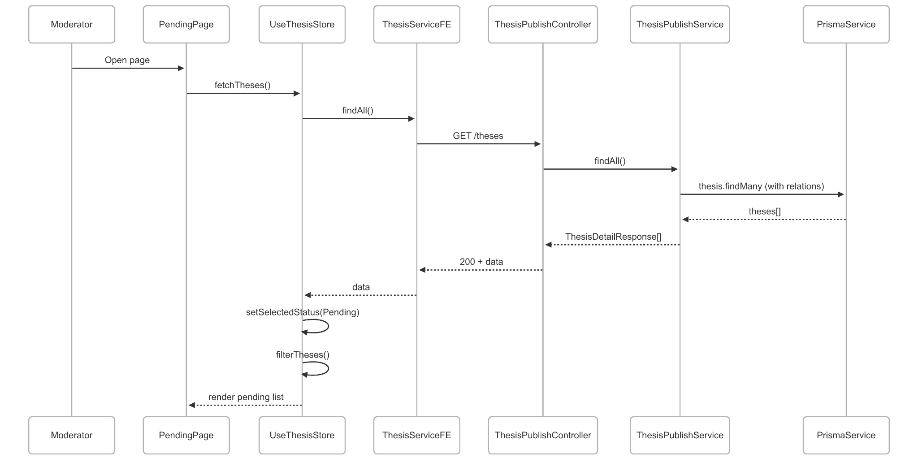](https://drive.google.com/file/d/1Hffnvth3zY_uZQuI4FDEvThNWK8tl9iK/view?usp=drive_link)

###### Figure IV.C.10.c.(1) - View Pending Thesis Registrations Sequence Diagram

* + - * 1. Review Thesis (Approve or Reject)

[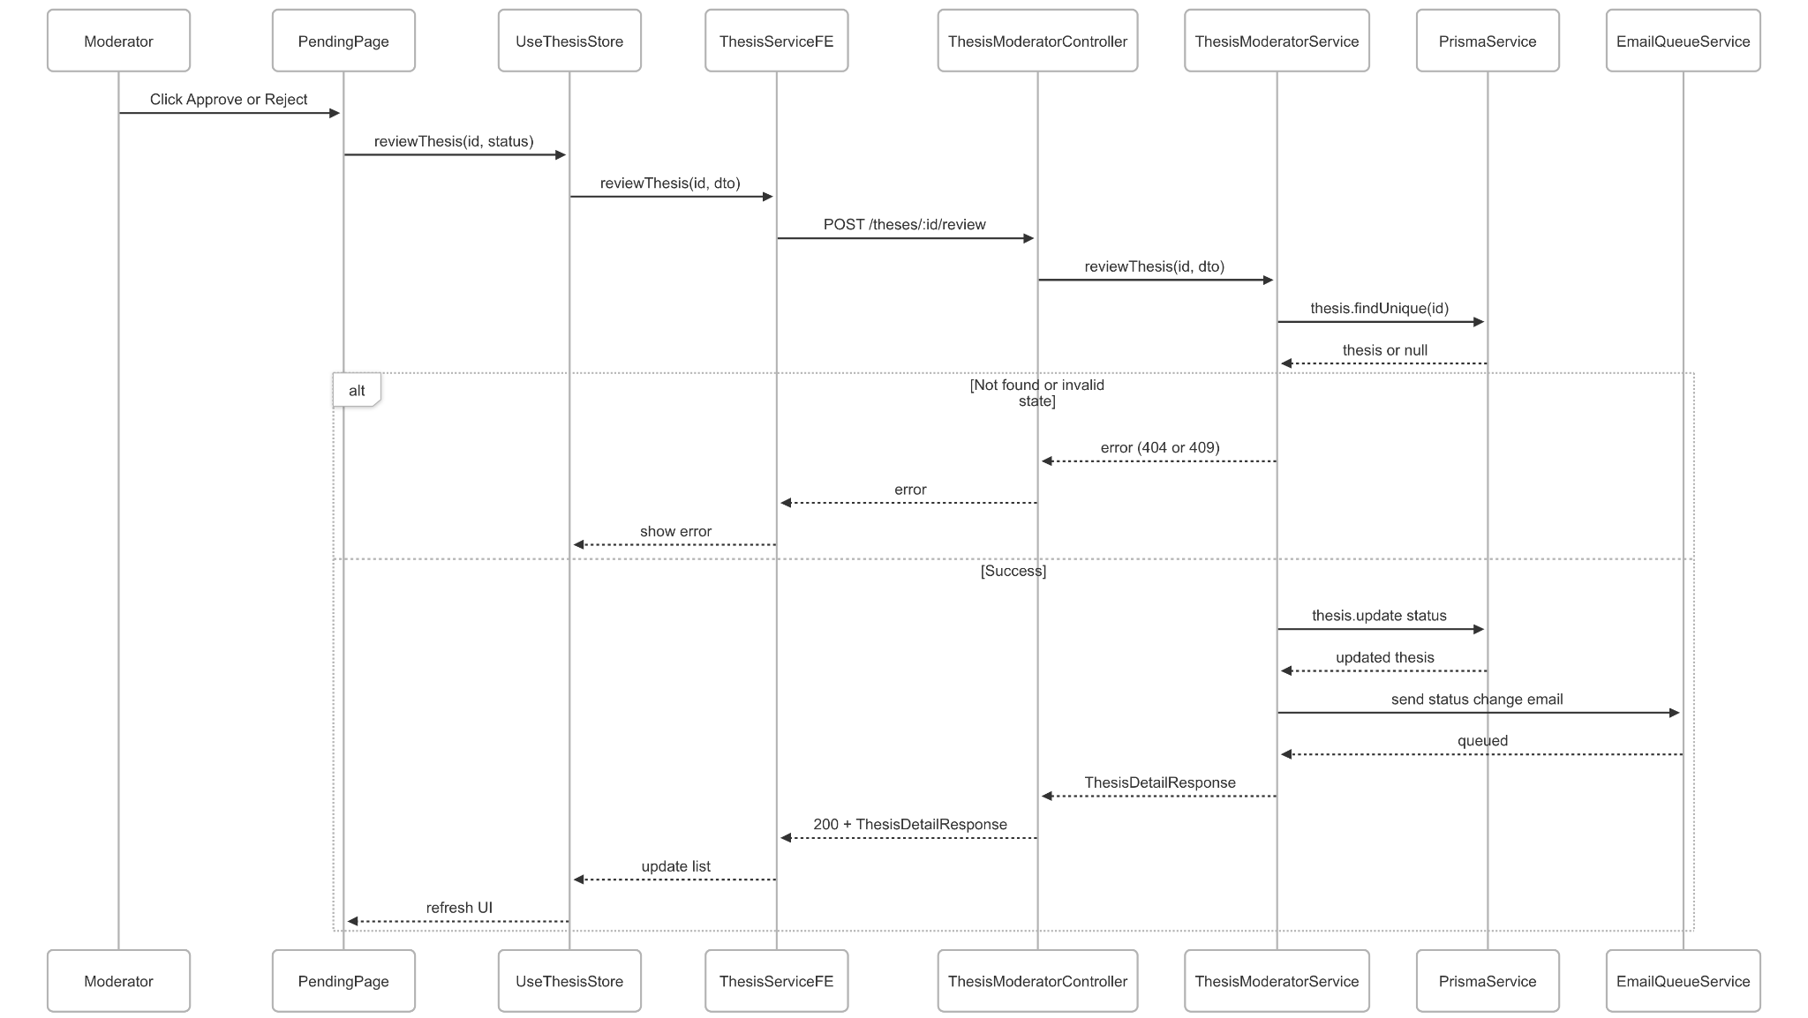](https://drive.google.com/file/d/1Db03w5AMN3OidLfUZs_Qk82hMxlUArEZ/view?usp=drive_link)

###### Figure IV.C.10.c.(2) - Review Thesis Sequence Diagram

### Lecturer Monitor Groups Progress

#### Class Diagram

[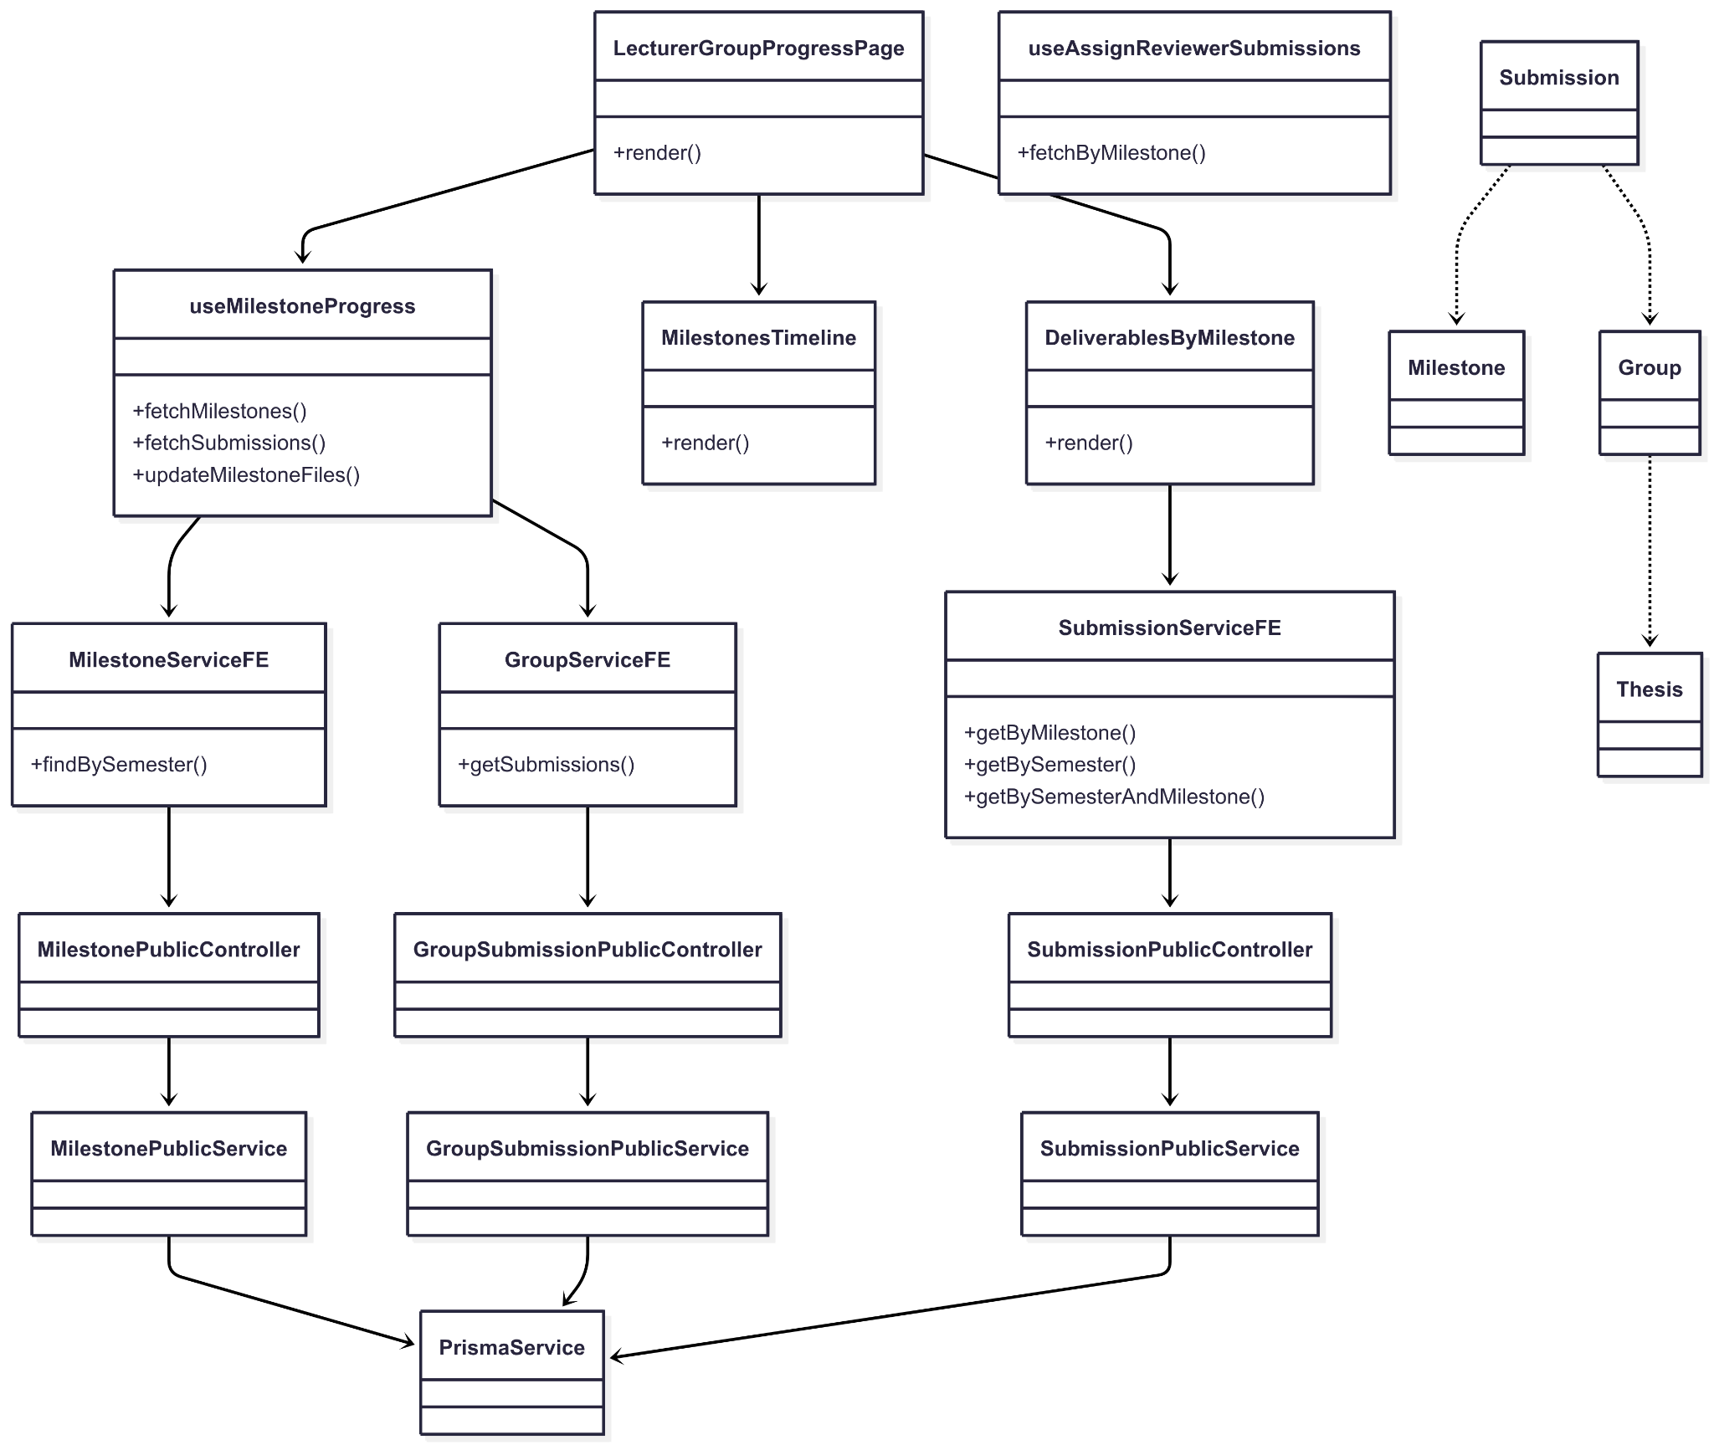](https://drive.google.com/file/d/1CsV0-QOtDTk9V82a4SNfWjZFLqNH7hcA/view?usp=drive_link)

###### Figure IV.C.11.a - Lecturer Monitor Groups Progress Class Diagram

#### Class Diagram Specification

| **No** | **Class** | **Method** | **Description** |
| --- | --- | --- | --- |
| 1 | LecturerGroupProgressPage | render() | Composes timeline, deliverables table, and filters for lecturer monitoring. |
| 2 | MilestonesTimeline | render() | Renders milestone timeline for the selected semester. |
| 3 | DeliverablesByMilestone | render() | Displays deliverables/submissions per milestone with status. |
| 4 | useMilestoneProgress | fetchMilestones(semesterId) | Fetches milestones by semester to drive the timeline UI. |
| 5 | useMilestoneProgress | fetchSubmissions(groupId) | Fetches a group’s submissions across milestones. |
| 6 | useAssignReviewerSubmissions | fetchByMilestone(milestoneId) | Fetches submissions by milestone and maps them to a group table model. |
| 7 | MilestoneServiceFE | findBySemester(semesterId) | Calls API to retrieve milestones for a semester. |
| 8 | GroupServiceFE | getSubmissions(groupId) | Calls API to retrieve all submissions of a group. |
| 9 | SubmissionServiceFE | getByMilestone(milestoneId) | Calls API to retrieve submissions by milestone. |
| 10 | SubmissionServiceFE | getBySemester(semesterId) | Calls API to retrieve submissions by semester. |
| 11 | SubmissionServiceFE | getBySemesterAndMilestone(semesterId, milestoneId) | Calls API to retrieve submissions by semester and milestone. |
| 12 | MilestonePublicController | findBySemester(semesterId) | Endpoint returning milestones for a given semester. |
| 13 | MilestonePublicService | findBySemester(semesterId) | Queries DB for milestones and returns read model. |
| 14 | GroupSubmissionPublicController | findGroupSubmissions(groupId) | Endpoint returning all submissions of a group. |
| 15 | GroupSubmissionPublicController | findSubmissionForMilestone(groupId, milestoneId) | Endpoint returning a group’s submission at a milestone. |
| 16 | GroupSubmissionPublicService | findGroupSubmissions(groupId) | Queries DB for group submissions. |
| 17 | GroupSubmissionPublicService | findSubmissionForMilestone(groupId, milestoneId) | Queries DB for a group’s submission at a milestone. |
| 18 | SubmissionPublicController | getSubmissionsByMilestone(milestoneId) | Endpoint returning submissions by milestone. |
| 19 | SubmissionPublicController | getSubmissionsBySemester(semesterId) | Endpoint returning submissions by semester. |
| 20 | SubmissionPublicController | getSubmissionsBySemesterAndMilestone(semesterId, milestoneId) | Endpoint returning submissions by semester and milestone. |
| 21 | SubmissionPublicService | getSubmissionsForReview(semesterId?, milestoneId?) | Queries DB with optional filters for milestone/semester. |
| 22 | PrismaService | (data access) | Database access used by backend services. |

##### Table IV.C.11.b - Lecturer Monitor Groups Progress Class Diagram Specification

#### Sequence Diagram

* + - * 1. View Timeline (Milestones by semester)

[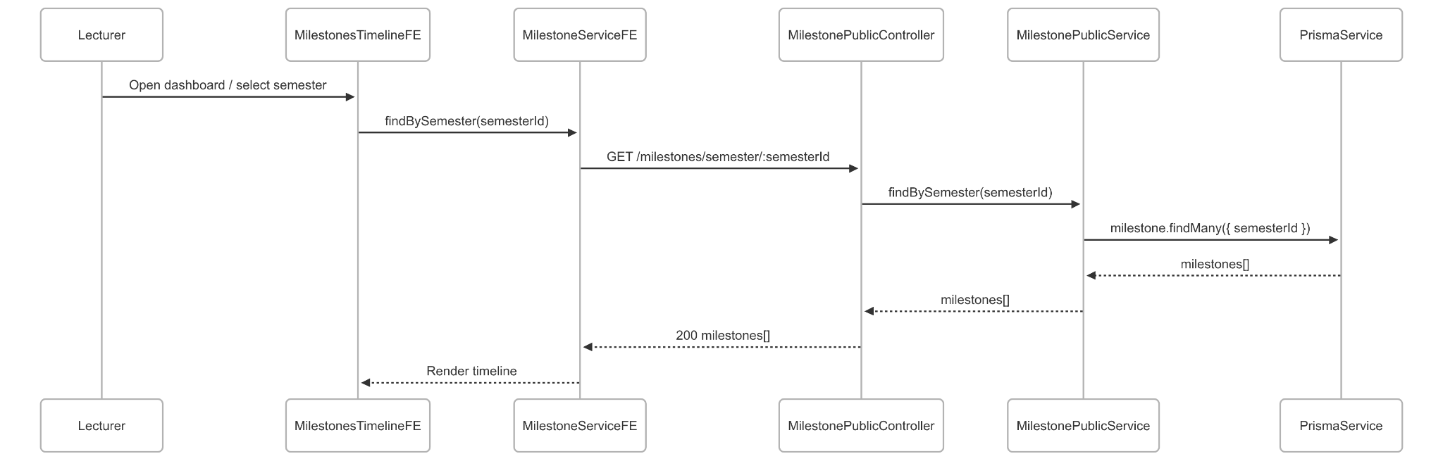](https://drive.google.com/file/d/1qqgWeOiA1amCXkh1FjAqJPnc06aSnGTb/view?usp=drive_link)

###### Figure IV.C.11.c.(1) - View Timeline Sequence Diagram

* + - * 1. View Deliverables by Milestone

[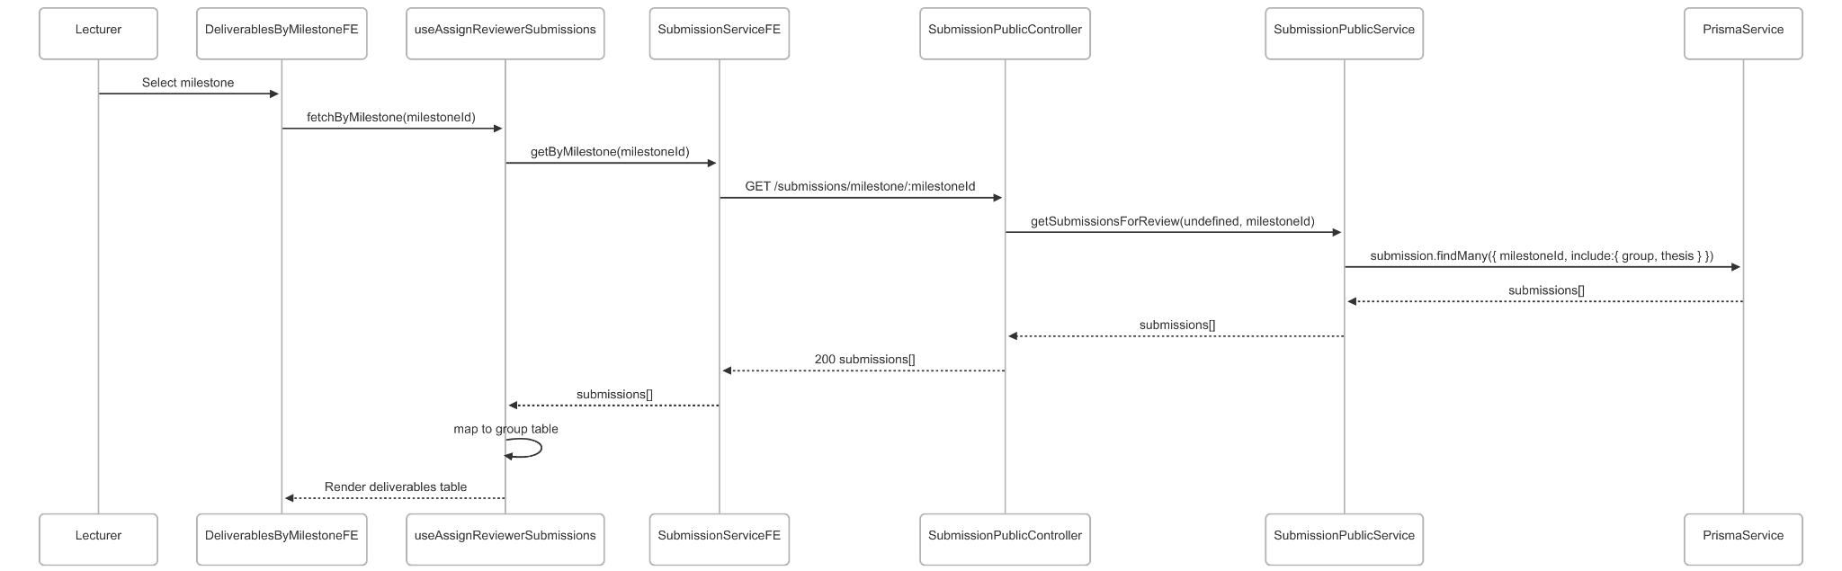](https://drive.google.com/file/d/1bES2a_C-mPU-2ukr2YcQOp0x67gABDJ3/view?usp=drive_link)

###### Figure IV.C.11.c.(2) - View Deliverables by Milestone Sequence Diagram

* + - * 1. View Group Submission Status (across milestones)

[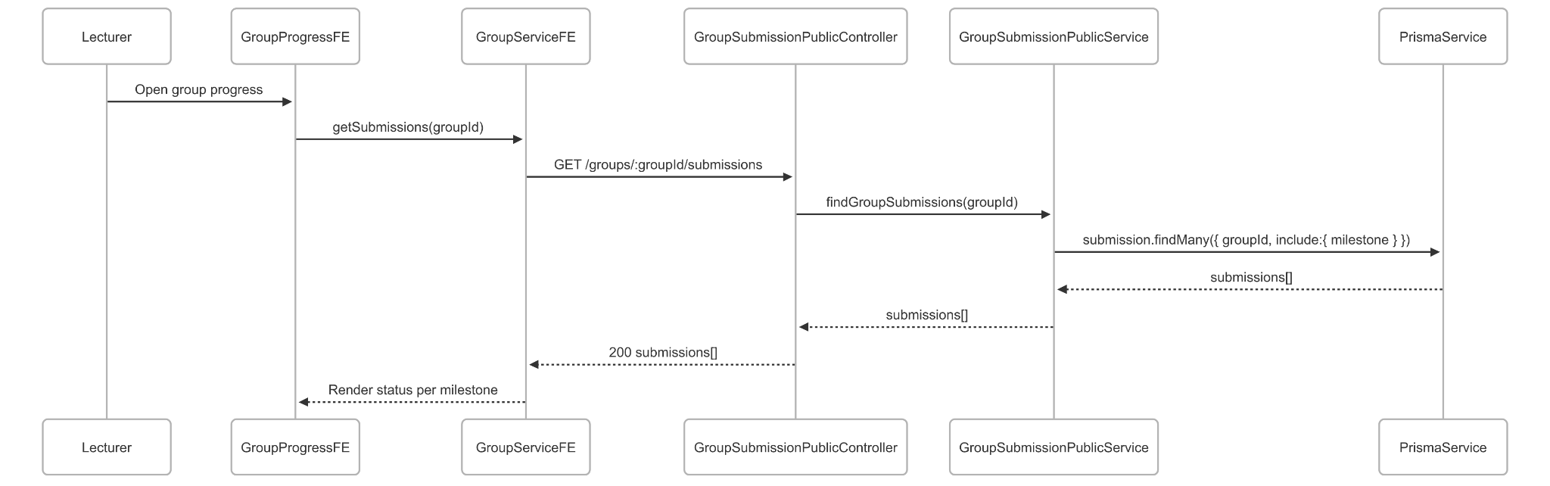](https://drive.google.com/file/d/1bQem-kQ67HIuh0Mf6UJQ64A0Ni_z2QQL/view?usp=drive_link)

###### Figure IV.C.11.c.(3) - View Group Submission Status Sequence Diagram

### Lecturer Evaluate and Comment on Submissions

#### Class Diagram

[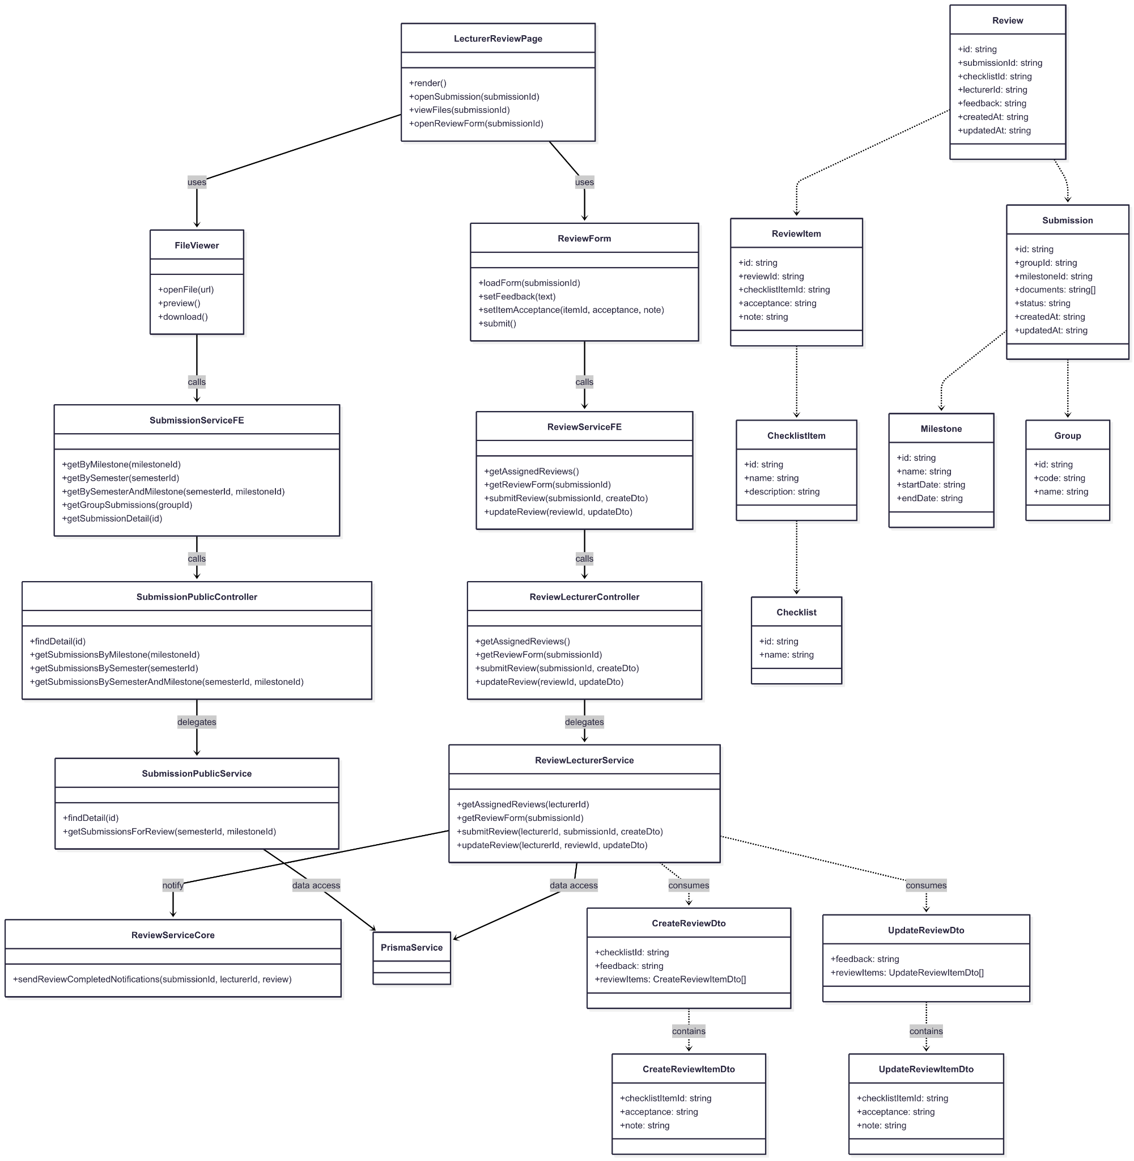](https://drive.google.com/file/d/16sA4KkMkAfPxBsV1PPyNoV38BhJpkpXo/view?usp=drive_link)

###### Figure IV.C.12.a - Lecturer Evaluate and Comment on Submissions Class Diagram

#### Class Diagram Specification

| **No** | **Class** | **Method** | **Description** |
| --- | --- | --- | --- |
| 1 | LecturerReviewPage | render() | Composes file viewer and review form for a selected submission. |
| 2 | LecturerReviewPage | openSubmission(submissionId) | Loads submission detail and review form. |
| 3 | LecturerReviewPage | viewFiles(submissionId) | Opens/preview/downloads submitted files. |
| 4 | LecturerReviewPage | openReviewForm(submissionId) | Opens the checklist-based review form. |
| 5 | ReviewForm | loadForm(submissionId) | Fetches review form (checklist, items) for the submission. |
| 6 | ReviewForm | setFeedback(text) | Edits overall feedback text. |
| 7 | ReviewForm | setItemAcceptance(itemId, acceptance, note) | Sets acceptance and optional note per checklist item. |
| 8 | ReviewForm | submit() | Submits the review with items; persists to the backend. |
| 9 | FileViewer | openFile(url) | Opens a submitted file for viewing. |
| 10 | FileViewer | preview() | Previews supported file types inline. |
| 11 | FileViewer | download() | Triggers file download. |
| 12 | ReviewServiceFE | getAssignedReviews() | Fetches submissions assigned to the lecturer. |
| 13 | ReviewServiceFE | getReviewForm(submissionId) | Fetches the review form for a submission. |
| 14 | ReviewServiceFE | submitReview(submissionId, createDto) | Submits a new review with checklist item acceptances. |
| 15 | ReviewServiceFE | updateReview(reviewId, updateDto) | Updates existing review feedback and/or item acceptances. |
| 16 | SubmissionServiceFE | getSubmissionDetail(id) | Fetches submission detail (group, milestone, docs). |
| 17 | SubmissionServiceFE | getByMilestone(milestoneId) | Lists submissions for a milestone. |
| 18 | SubmissionServiceFE | getBySemester(semesterId) | Lists submissions for a semester. |
| 19 | SubmissionServiceFE | getBySemesterAndMilestone(semesterId, milestoneId) | Lists submissions by both filters. |
| 20 | ReviewLecturerController | getAssignedReviews() | Endpoint: returns assigned reviews for current lecturer. |
| 21 | ReviewLecturerController | getReviewForm(submissionId) | Endpoint: returns checklist/checklistItems for submission. |
| 22 | ReviewLecturerController | submitReview(submissionId, createDto) | Endpoint: creates review + items (when allowed). |
| 23 | ReviewLecturerController | updateReview(reviewId, updateDto) | Endpoint: updates review feedback/items. |
| 24 | ReviewLecturerService | getAssignedReviews(lecturerId) | Loads assignmentReview with submission, group, thesis relations. |
| 25 | ReviewLecturerService | getReviewForm(submissionId) | Loads submission → milestone → checklist → checklistItems. |
| 26 | ReviewLecturerService | submitReview(lecturerId, submissionId, createDto) | Validates assignment, main/secondary rules; creates review and items. |
| 27 | ReviewLecturerService | updateReview(lecturerId, reviewId, updateDto) | Validates ownership; upserts review items and feedback. |
| 28 | ReviewServiceCore | sendReviewCompletedNotifications(submissionId, lecturerId, review) | Send notifications after successful review submission. |
| 29 | SubmissionPublicController | getSubmissionsByMilestone(milestoneId) | Endpoint: lists submissions for a milestone. |
| 30 | SubmissionPublicController | getSubmissionsBySemester(semesterId) | Endpoint: lists submissions for a semester. |
| 31 | SubmissionPublicController | getSubmissionsBySemesterAndMilestone(semesterId, milestoneId) | Endpoint: combined filter. |
| 32 | SubmissionPublicService | getSubmissionsForReview(semesterId?, milestoneId?) | Queries DB with optional filters; returns read models. |
| 33 | PrismaService | (data access) | Backend ORM for all review/submission queries and mutations. |
| 34 | CreateReviewDto | fields() | checklistId, feedback?, reviewItems: CreateReviewItemDto[]. |
| 35 | CreateReviewItemDto | fields() | checklistItemId, acceptance (Yes/No/NotAvailable), note?. |
| 36 | UpdateReviewDto | fields() | feedback?, reviewItems?: UpdateReviewItemDto[]. |
| 37 | UpdateReviewItemDto | fields() | checklistItemId?, acceptance?, note?. |
| 38 | Submission | fields() | id, groupId, milestoneId, documents[], status, createdAt, updatedAt. |
| 39 | Review | fields() | id, submissionId, checklistId, lecturerId, feedback, createdAt, updatedAt. |
| 40 | ReviewItem | fields() | id, reviewId, checklistItemId, acceptance, note. |
| 41 | Checklist | fields() | id, name. |
| 42 | ChecklistItem | fields() | id, name, description. |
| 43 | Milestone | fields() | id, name, startDate, endDate. |
| 44 | Group | fields() | id, code, name. |

##### Table IV.C.12.b - Lecturer Evaluate and Comment on Submissions Class Diagram Specification

#### Sequence Diagram

* + - * 1. Open Submitted Files

[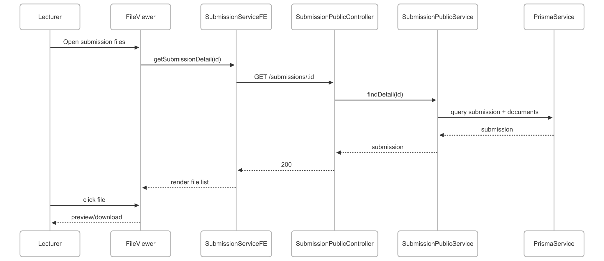](https://drive.google.com/file/d/1brkBZ8u0XHEMz_MSOquJ1_RBaCsjO6oP/view?usp=drive_link)

###### Figure IV.C.12.c.(1) - Open Submitted Files Sequence Diagram

* + - * 1. Load Review Form (Checklist per Milestone)

[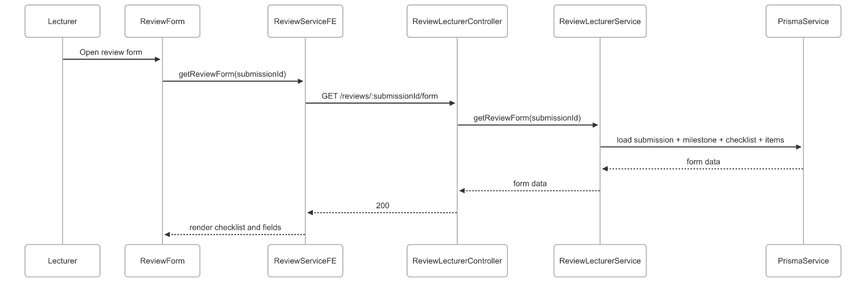](https://drive.google.com/file/d/1xB7eUl4hppMMlbWYun1ZDr_CEUEU7RON/view?usp=drive_link)

###### Figure IV.C.12.c.(2) - Load Review Form Sequence Diagram

* + - * 1. Submit Review (feedback + checklist items)

[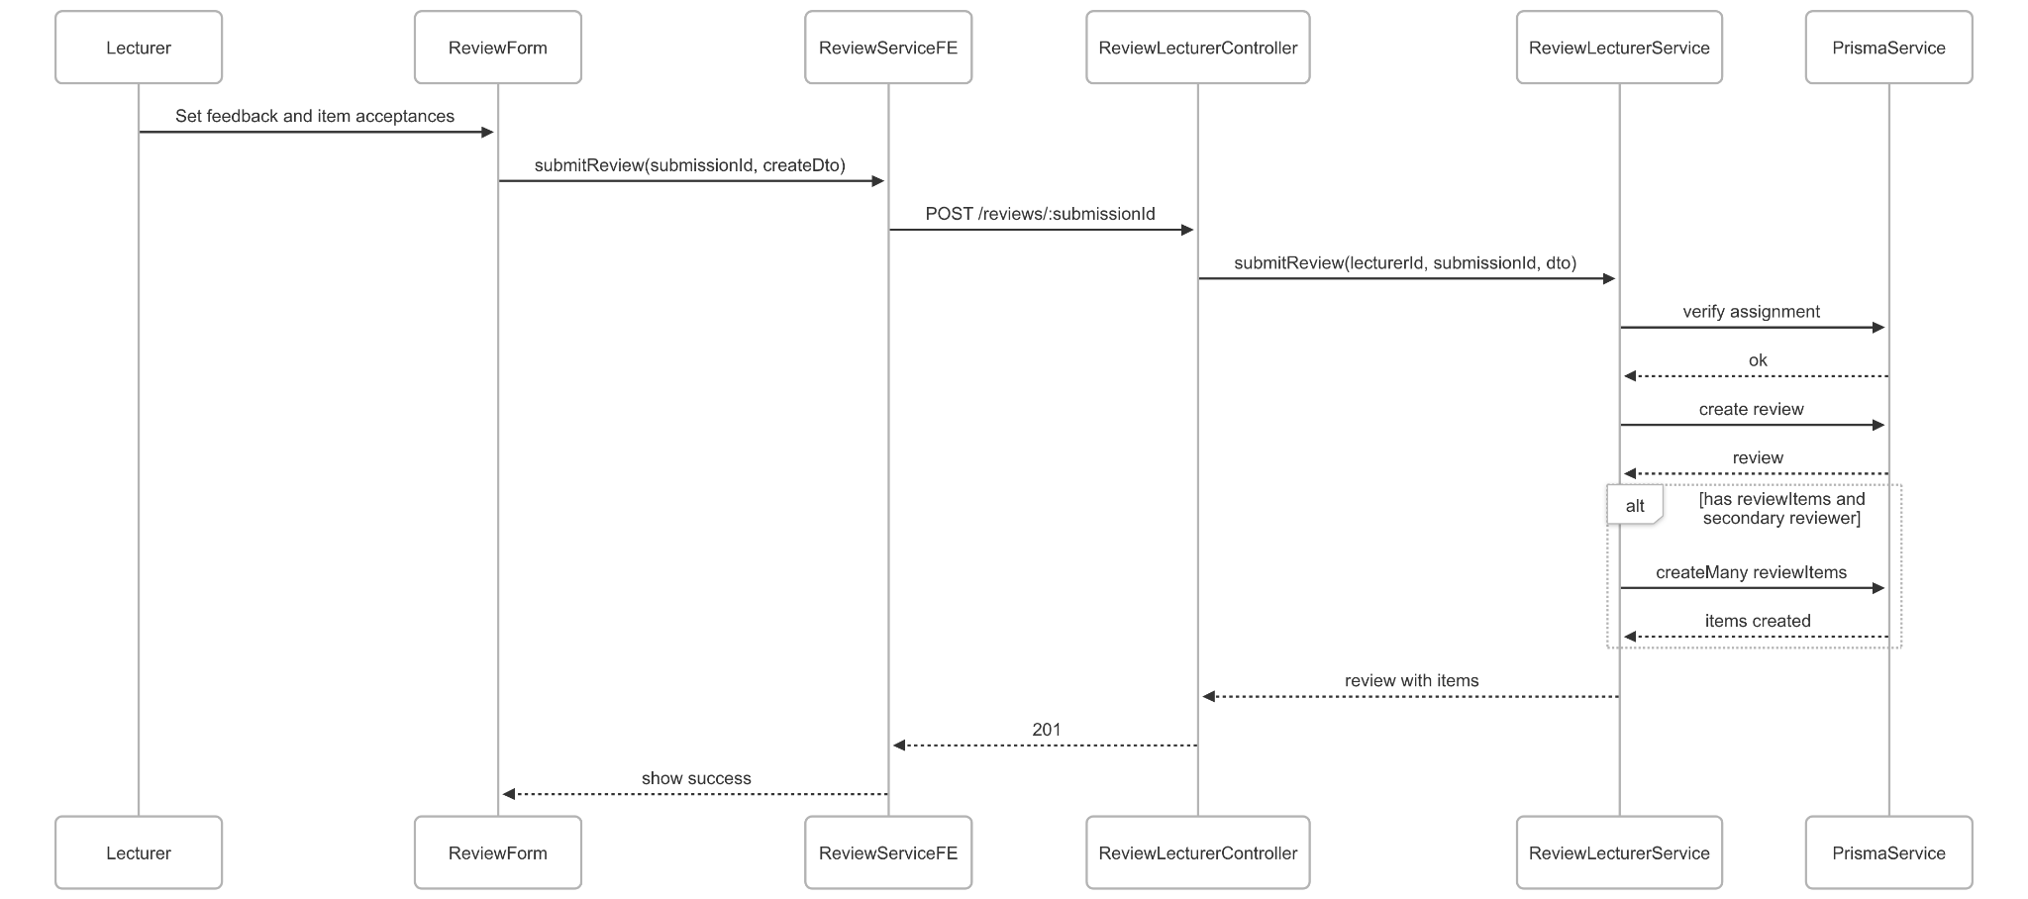](https://drive.google.com/file/d/136p9qfTR3rXx_OWek3jyMMIlj97FCafF/view?usp=drive_link)

###### Figure IV.C.12.c.(3) - Submit Review Sequence Diagram

* + - * 1. Update Review (edit feedback / tick items)

[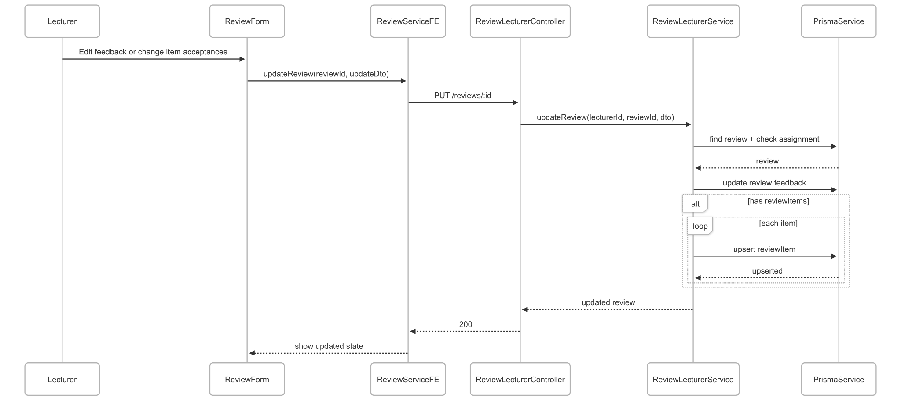](https://drive.google.com/file/d/1tFdvAmatENryAiuYBHbZHWds-J0uPl3G/view?usp=drive_link)

###### Figure IV.C.12.c.(4) - Update Review Sequence Diagram

### Moderator View Moderator’s Dashboard

#### Class Diagram

[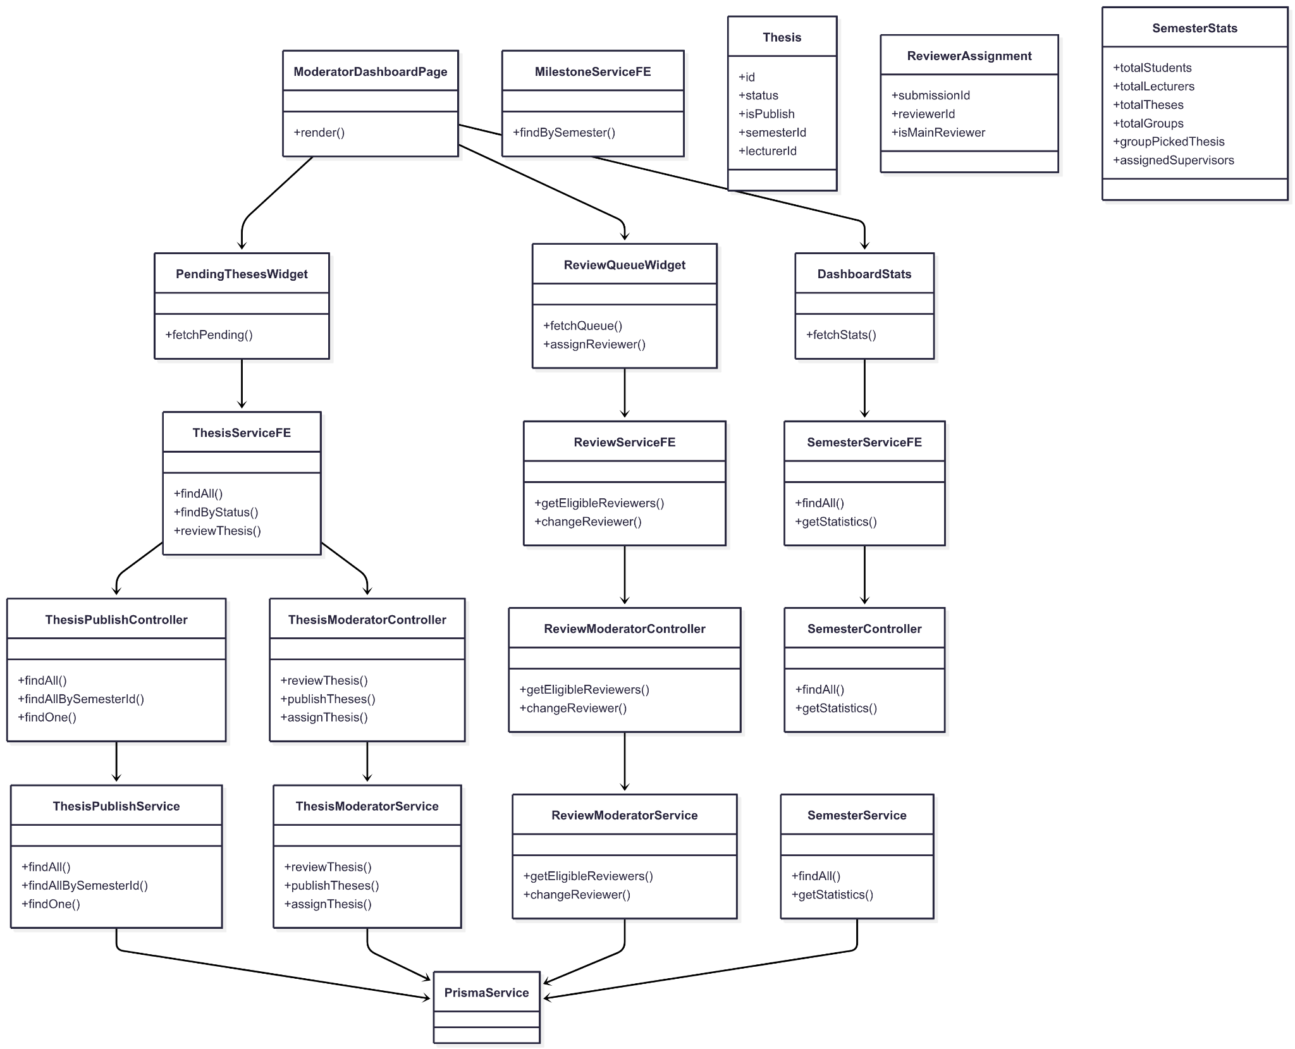](https://drive.google.com/file/d/1mZC-2FJyXkbABFqCVl1DhPpXCBdDppzC/view?usp=drive_link)

###### Figure IV.C.13.a - Moderator View Moderator’s Dashboard Class Diagram

#### Class Diagram Specification

| **No** | **Class** | **Method** | **Description** |
| --- | --- | --- | --- |
| 1 | ModeratorDashboardPage | render() | Composes stats, pending theses, and review queue widgets. |
| 2 | DashboardStats | fetchStats(semesterId) | Loads semester KPIs (students, lecturers, theses, groups, picked). |
| 3 | PendingThesesWidget | fetchPending(semesterId?) | Lists theses in Pending status (optionally filtered by semester). |
| 4 | ReviewQueueWidget | fetchQueue(semesterId?) | Lists submissions awaiting reviewer assignment; supports actions. |
| 5 | ReviewQueueWidget | assignReviewer(submissionId, reviewerId, isMain?) | Assigns/changes reviewer for a submission. |
| 6 | ThesisServiceFE | findAll() | GET all theses for dashboard listing. |
| 7 | ThesisServiceFE | findByStatus(status, semesterId?) | GET theses filtered by status (e.g., Pending). |
| 8 | ThesisServiceFE | reviewThesis(id, {status}) | POST approve/reject a thesis. |
| 9 | ReviewServiceFE | getEligibleReviewers(submissionId) | GET list of eligible reviewers for a submission. |
| 10 | ReviewServiceFE | changeReviewer(submissionId, payload) | PUT change reviewer (main/secondary). |
| 11 | SemesterServiceFE | findAll() | GET all semesters (filters/dropdowns). |
| 12 | SemesterServiceFE | getStatistics(semesterId) | GET semester-wide dashboard statistics. |
| 13 | MilestoneServiceFE | findBySemester(semesterId) | GET milestones (for time windows in widgets/charts). |
| 14 | ThesisPublishController | findAll() | Returns theses with relations for listing. |
| 15 | ThesisPublishController | findAllBySemesterId(semesterId) | Returns theses scoped to a semester. |
| 16 | ThesisPublishService | findAll() | DB query + mapping to response. |
| 17 | ThesisPublishService | findAllBySemesterId(semesterId) | DB query by semester + mapping. |
| 18 | ThesisModeratorController | reviewThesis(id, dto) | Approve/Reject thesis registration. |
| 19 | ThesisModeratorService | reviewThesis(id, dto) | Validates state; updates status; sends notifications. |
| 20 | ReviewModeratorController | getEligibleReviewers(submissionId) | Returns candidates to review a submission. |
| 21 | ReviewModeratorController | changeReviewer(submissionId, dto) | Changes assigned reviewer(s). |
| 22 | ReviewModeratorService | getEligibleReviewers(submissionId) | DB logic to compute eligible reviewers. |
| 23 | ReviewModeratorService | changeReviewer(submissionId, dto) | Updates reviewer assignment(s). |
| 24 | SemesterController | findAll() | Returns list of semesters. |
| 25 | SemesterController | getStatistics(id) | Returns semester statistics for the dashboard. |
| 26 | SemesterService | findAll() | DB read of semesters. |
| 27 | SemesterService | getStatistics(id) | Aggregates KPIs (students, lecturers, theses, groups, picked). |
| 28 | PrismaService | (ORM) | Shared DB access for all backend services. |
| 29 | Thesis | fields() | id, status, isPublish, semesterId, lecturerId, createdAt, updatedAt. |
| 30 | ReviewerAssignment | fields() | submissionId, reviewerId, isMainReviewer, createdAt. |
| 31 | SemesterStats | fields() | totalStudents, totalLecturers, totalTheses, totalGroups, groupPickedThesis, assignedSupervisors. |

##### Table IV.C.13.b - Moderator View Moderator’s Dashboard Class Diagram Specification

#### Sequence Diagram

[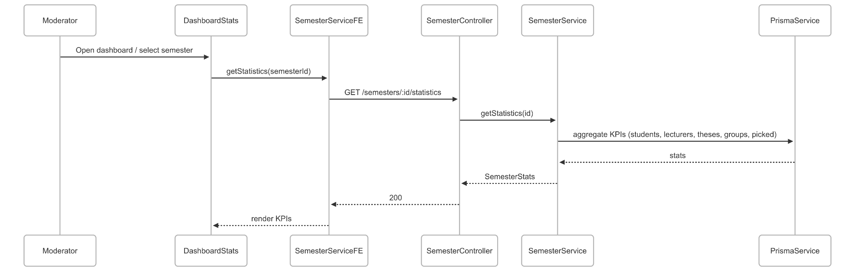](https://drive.google.com/file/d/1jLPwo7KT0m3nTjFfo-hEBwJ6V0IkGJww/view?usp=drive_link)

###### Figure IV.C.13.c - Moderator View Moderator’s Dashboard Sequence Diagram

### Moderator Publish Thesis

#### Class Diagram

[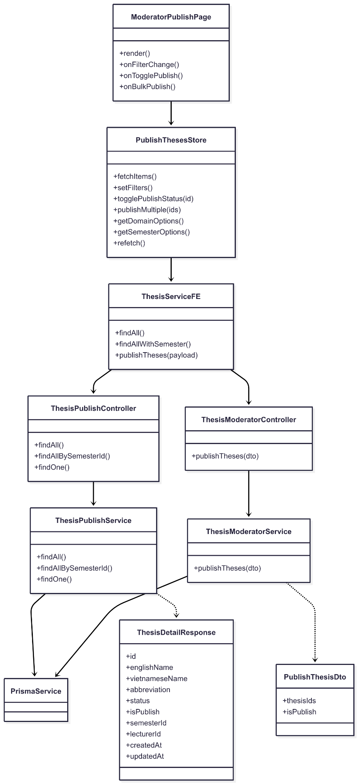](https://drive.google.com/file/d/1RnSOXRFLRbvOxsk0puoFE1Ohikmcwc8A/view?usp=drive_link)

###### Figure IV.C.14.a - Moderator Publish Thesis Class Diagram

#### Class Diagram Specification

| **No** | **Class** | **Method** | **Description** |
| --- | --- | --- | --- |
| 1 | ModeratorPublishPage | render() | Compose filters, table, and actions (toggle/bulk publish). |
| 2 | ModeratorPublishPage | onFilterChange() | Update filters (semester, domain, search). |
| 3 | ModeratorPublishPage | onTogglePublish(id) | Trigger single publish/unpublish action. |
| 4 | ModeratorPublishPage | onBulkPublish(ids, isPublish) | Trigger bulk publish/unpublish. |
| 5 | PublishThesesStore | fetchItems(force?) | Load theses list and cache; supports refresh. |
| 6 | PublishThesesStore | setFilters(filters) | Set UI filters; recompute derived lists. |
| 7 | PublishThesesStore | togglePublishStatus(id) | Call FE service to flip publish flag for one thesis. |
| 8 | PublishThesesStore | publishMultiple(ids) | Call FE service to bulk update publish flags. |
| 9 | PublishThesesStore | getDomainOptions() | Build domain options from current items. |
| 10 | PublishThesesStore | getSemesterOptions() | Build semester options from current items. |
| 11 | PublishThesesStore | refetch() | Hard refresh data from backend. |
| 12 | ThesisServiceFE | findAll() | GET /theses for complete list with relations. |
| 13 | ThesisServiceFE | findAllWithSemester() | GET /theses?include=semester for filter UI. |
| 14 | ThesisServiceFE | publishTheses(payload) | POST /theses/publish to bulk set publish flags. |
| 15 | ThesisPublishController | findAll() | Return theses for listing (with versions/skills/lecturer). |
| 16 | ThesisPublishController | findAllBySemesterId(semesterId) | Return theses scoped by semester. |
| 17 | ThesisPublishController | findOne(id) | Return thesis detail by id. |
| 18 | ThesisPublishService | findAll() | DB query + map to ThesisDetailResponse[]. |
| 19 | ThesisPublishService | findAllBySemesterId(semesterId) | DB query by semester + mapping. |
| 20 | ThesisPublishService | findOne(id) | DB query by id + mapping. |
| 21 | ThesisModeratorController | publishTheses(dto) | Endpoint to bulk publish/unpublish theses. |
| 22 | ThesisModeratorService | publishTheses(dto) | Validate ids; perform bulk update; invalidate caches/logs. |
| 23 | PublishThesisDto | fields() | thesisIds: string[]; isPublish: boolean. |
| 24 | ThesisDetailResponse | fields() | id, englishName, vietnameseName, abbreviation, status, isPublish, semesterId, lecturerId, createdAt, updatedAt. |
| 25 | PrismaService | (ORM) | Shared DB access used by publish and moderator services. |

##### Table IV.C.14.b - Moderator Publish Thesis Class Diagram Specification

#### Sequence Diagram

[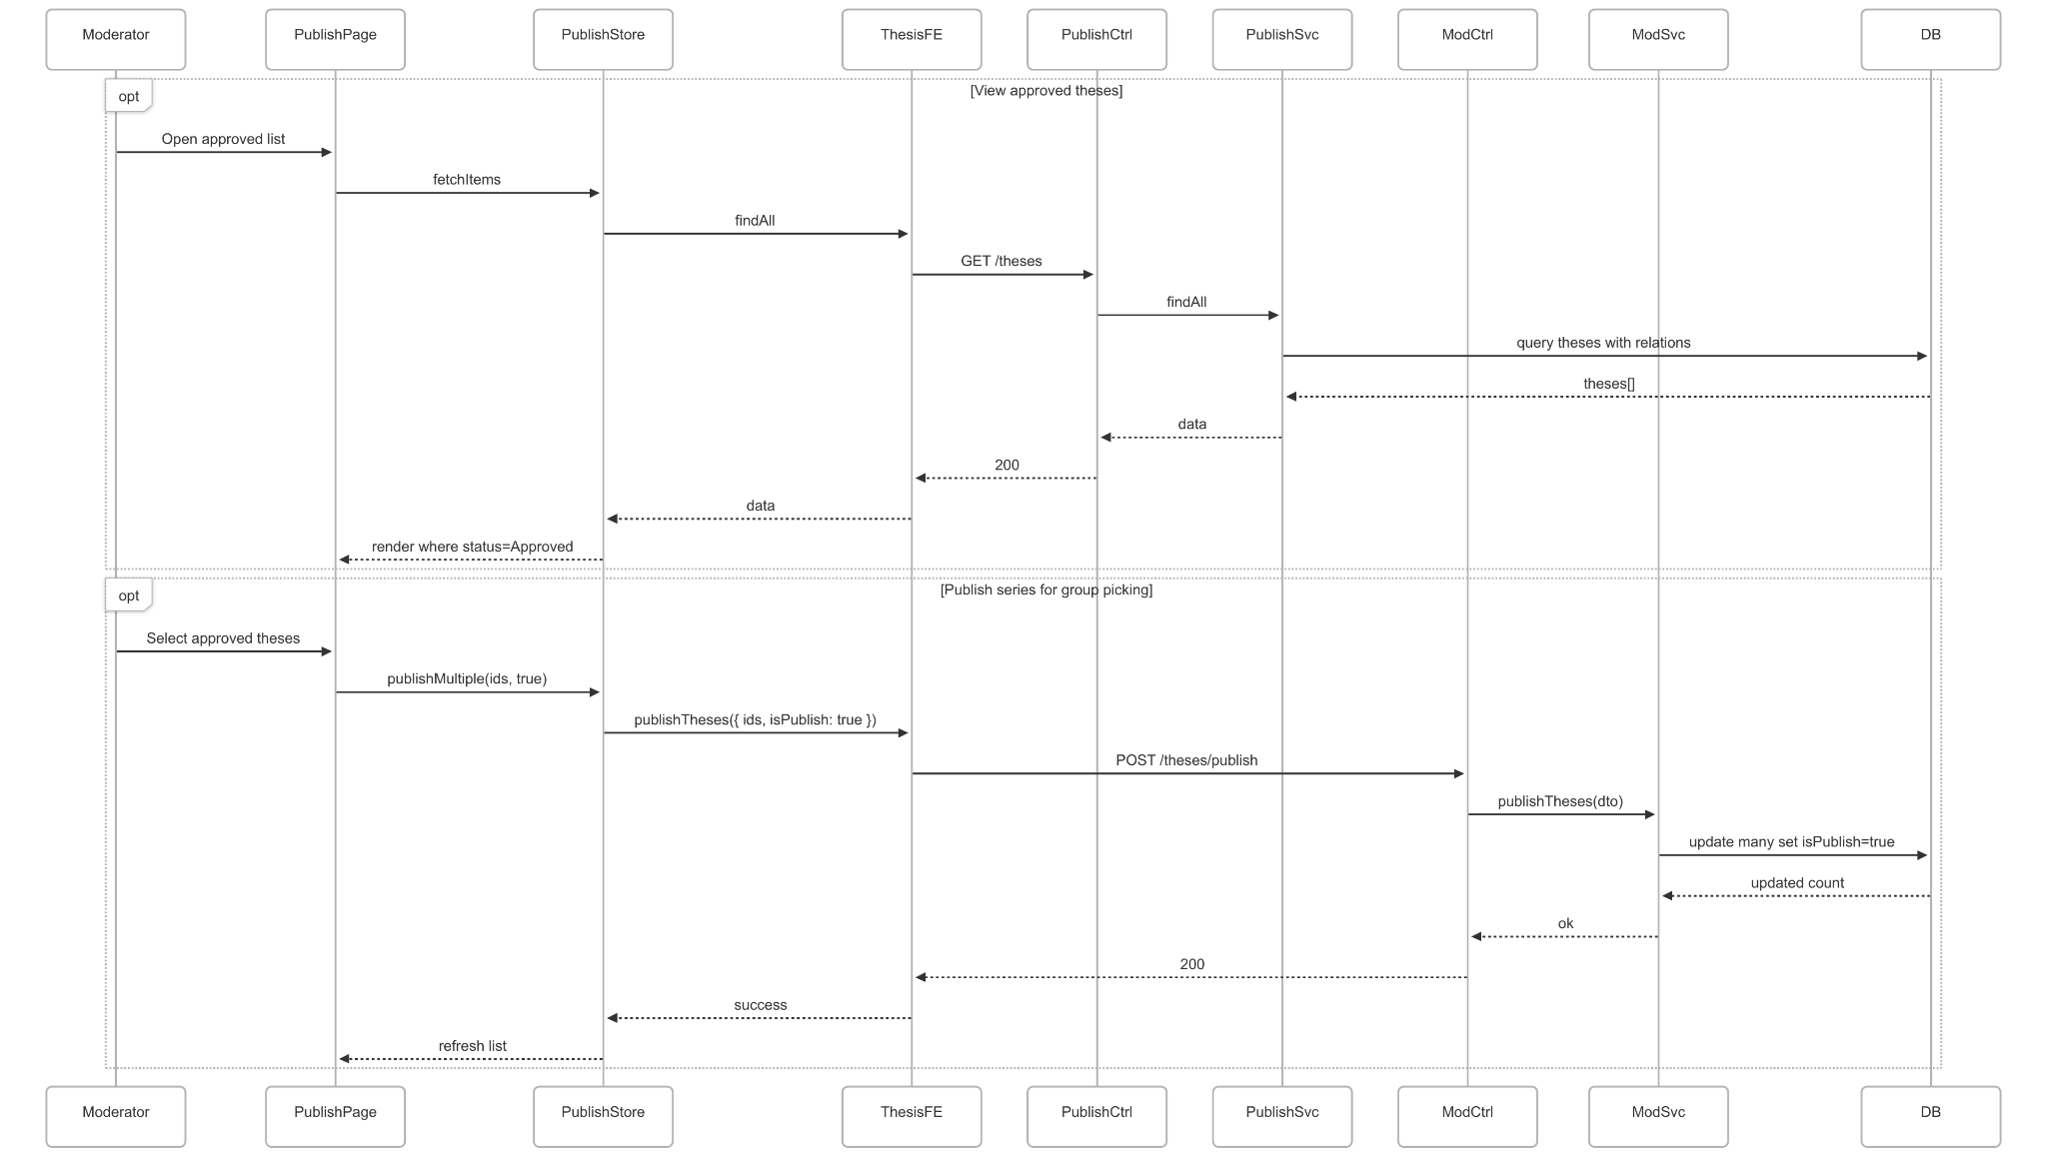](https://drive.google.com/file/d/1RVO55t7Z4CJ2x-gabpldjhtmpT0015HO/view?usp=drive_link)

###### Figure IV.C.14.c - Moderator Publish Thesis Sequence Diagram

### Moderator Manage Groups

#### Class Diagram

[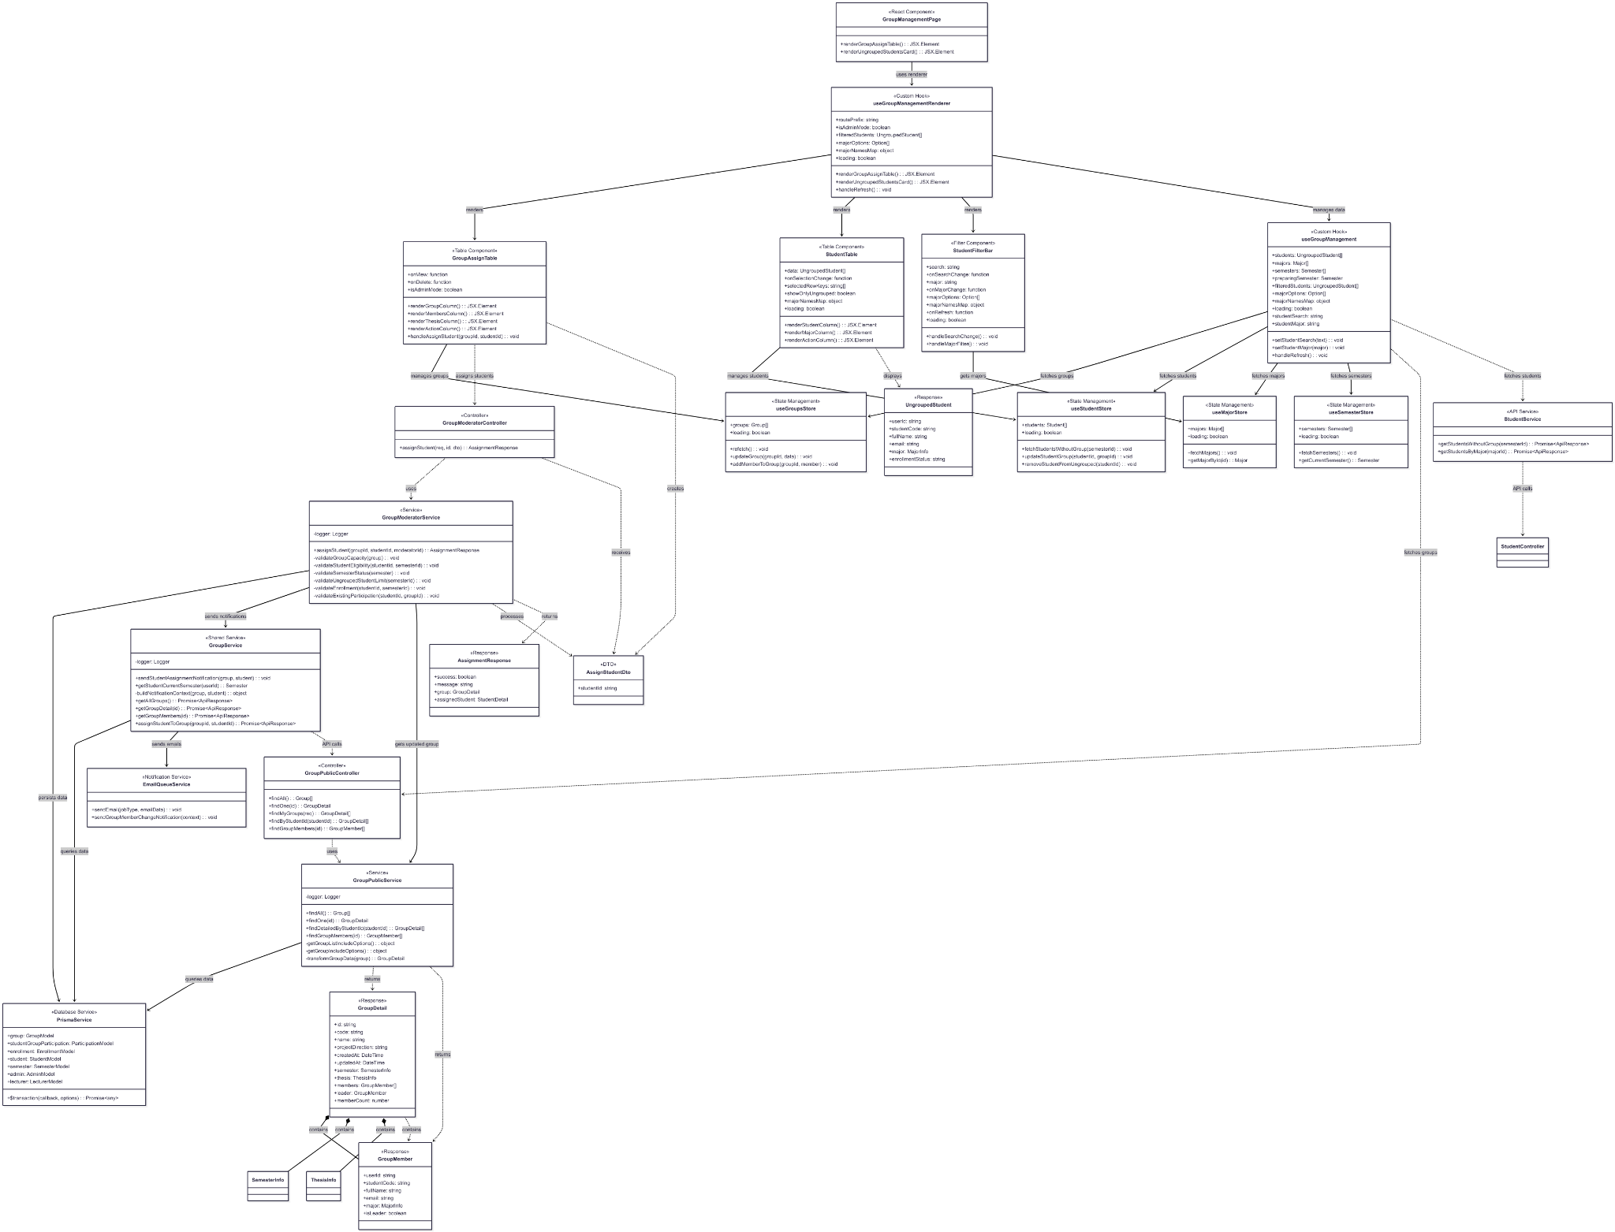](https://drive.google.com/file/d/1dc3JCVaHoTDm9WvXcIVdkiboASBkiR0C/view?usp=drive_link)

###### Figure IV.C.15.a - Moderator Manage Groups Class Diagram

#### Class Diagram Specification

| **No** | **Class** | **Method** | **Description** |
| --- | --- | --- | --- |
| 1 | GroupPublicController | findAll() | Get list of all groups with basic information including member count and leader |
| 2 | GroupPublicController | findOne(id) | Get detailed information of a specific group with all members and thesis |
| 3 | GroupPublicController | findMyGroups(req) | Get detailed groups information for current authenticated user |
| 4 | GroupPublicController | findByStudentId(studentId) | Get groups associated with a specific student across semesters |
| 5 | GroupPublicController | findGroupMembers(id) | Get all members of a specific group with roles and details |
| 6 | GroupModeratorController | assignStudent(req, id, dto) | Assign ungrouped student to existing group with comprehensive validation |
| 7 | GroupPublicService | findAll() | Business logic to fetch all groups with semester, thesis, and member information |
| 8 | GroupPublicService | findOne(id) | Get comprehensive group details with sorted members and leadership info |
| 9 | GroupPublicService | findDetailedByStudentId(studentId) | Fetch detailed group information for specific student with participation history |
| 10 | GroupPublicService | findGroupMembers(id) | Retrieve all group members with user details and participation info |
| 11 | GroupPublicService | getGroupListIncludeOptions() | Build Prisma include options for group list queries with optimized data loading |
| 12 | GroupPublicService | getGroupIncludeOptions() | Build comprehensive Prisma include options for detailed group queries |
| 13 | GroupPublicService | transformGroupData(group) | Transform database group model into frontend-friendly format with computed fields |
| 14 | GroupModeratorService | assignStudent(groupId, studentId, moderatorId) | Execute student assignment with multi-layer validation and notification sending |
| 15 | GroupModeratorService | validateGroupCapacity(group) | Check if group has space for new member (maximum 6 students per group) |
| 16 | GroupModeratorService | validateStudentEligibility(studentId, semesterId) | Verify student is enrolled and not already in another group in same semester |
| 17 | GroupModeratorService | validateSemesterStatus(semester) | Ensure semester is in Preparing status for student assignments |
| 18 | GroupModeratorService | validateUngroupedStudentLimit(semesterId) | Check there are not more than 4 ungrouped students in semester |
| 19 | GroupModeratorService | validateEnrollment(studentId, semesterId) | Verify student is properly enrolled in the semester |
| 20 | GroupModeratorService | validateExistingParticipation(studentId, groupId) | Check student is not already member of the target group |
| 21 | GroupService | sendStudentAssignmentNotification(group, student) | Send email notifications to assigned student and all existing group members |
| 22 | GroupService | getStudentCurrentSemester(userId) | Retrieve current semester enrollment information for student |
| 23 | GroupService | buildNotificationContext(group, student) | Build email context data for group assignment notifications |
| 24 | GroupManagementPage | renderGroupAssignTable() | Render groups table component with assignment and management actions |
| 25 | GroupManagementPage | renderUngroupedStudentsCard() | Render ungrouped students card with filtering and selection capabilities |
| 26 | GroupAssignTable | renderGroupColumn() | Render group information column with code, name, and semester details |
| 27 | GroupAssignTable | renderMembersColumn() | Render group members column with count and leader information |
| 28 | GroupAssignTable | renderThesisColumn() | Render assigned thesis column with thesis title and status |
| 29 | GroupAssignTable | renderActionColumn() | Render action buttons column for viewing details and assignments |
| 30 | GroupAssignTable | handleAssignStudent(groupId, studentId) | Handle student assignment action with confirmation and API call |
| 31 | StudentTable | renderStudentColumn() | Render student information column with name, code, and contact details |
| 32 | StudentTable | renderMajorColumn() | Render student major column with major name and code |
| 33 | StudentTable | renderActionColumn() | Render action buttons for assigning student to groups |
| 34 | StudentFilterBar | handleSearchChange() | Handle student search input with debounced filtering |
| 35 | StudentFilterBar | handleMajorFilter() | Handle major filter selection for student list |
| 36 | useGroupManagementRenderer | renderGroupAssignTable() | Utility function to render groups table with shared logic |
| 37 | useGroupManagementRenderer | renderUngroupedStudentsCard() | Utility function to render ungrouped students with shared filtering |
| 38 | useGroupManagement | handleRefresh() | Refresh all data including groups, students, majors, and semesters |
| 39 | useGroupManagement | setStudentSearch(text) | Update student search filter with real-time filtering |
| 40 | useGroupManagement | setStudentMajor(major) | Update major filter selection for student list |
| 41 | PrismaService | $transaction(callback, options) | Execute multiple database operations within atomic transaction |
| 42 | EmailQueueService | sendEmail(jobType, emailData) | Queue email notification for asynchronous delivery |
| 43 | EmailQueueService | sendGroupMemberChangeNotification(context) | Send notification emails for group membership changes |
| 44 | useGroupsStore | refetch() | Refresh groups data from server and update store state |
| 45 | useGroupsStore | updateGroup(groupId, data) | Update specific group data in store after changes |
| 46 | useGroupsStore | addMemberToGroup(groupId, member) | Add new member to group in store state after assignment |
| 47 | useStudentStore | fetchStudentsWithoutGroup(semesterId) | Fetch students who are not assigned to any group in semester |
| 48 | useStudentStore | updateStudentGroup(studentId, groupId) | Update student's group assignment in store state |
| 49 | useStudentStore | removeStudentFromUngrouped(studentId) | Remove student from ungrouped list after assignment |
| 50 | useMajorStore | fetchMajors() | Fetch all majors for filtering and display purposes |
| 51 | useMajorStore | getMajorById(id) | Get specific major information by ID for display |
| 52 | useSemesterStore | fetchSemesters() | Fetch all semesters for filtering and validation |
| 53 | useSemesterStore | getCurrentSemester() | Get current active semester for data filtering |
| 54 | GroupService | getAllGroups() | Frontend API service method to fetch all groups via HTTP |
| 55 | GroupService | getGroupDetail(id) | Frontend API service method to fetch detailed group information |
| 56 | GroupService | getGroupMembers(id) | Frontend API service method to fetch group members list |
| 57 | GroupService | assignStudentToGroup(groupId, studentId) | Frontend API service method to assign student to group |
| 58 | StudentService | getStudentsWithoutGroup(semesterId) | Frontend API service method to fetch ungrouped students |
| 59 | StudentService | getStudentsByMajor(majorId) | Frontend API service method to fetch students by major filter |

##### Table IV.C.15.b - Moderator Manage Groups Class Diagram Specification

#### Sequence Diagram

* + - * 1. View Current List Groups & Ungrouped Students

[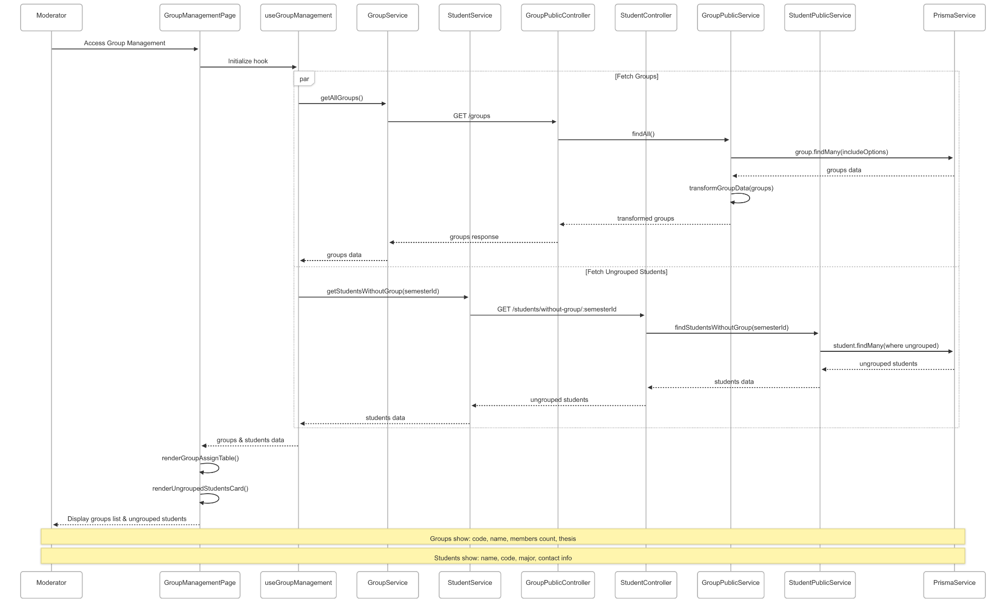](https://drive.google.com/file/d/1-iuXwL14ZtEZfqg17Hevgx3yGvBe8cBO/view?usp=drive_link)

###### Figure IV.C.15.c.(1) - View Current List Groups & Ungrouped Students Sequence Diagram

* + - * 1. View Group Details & Assign Student to Group

[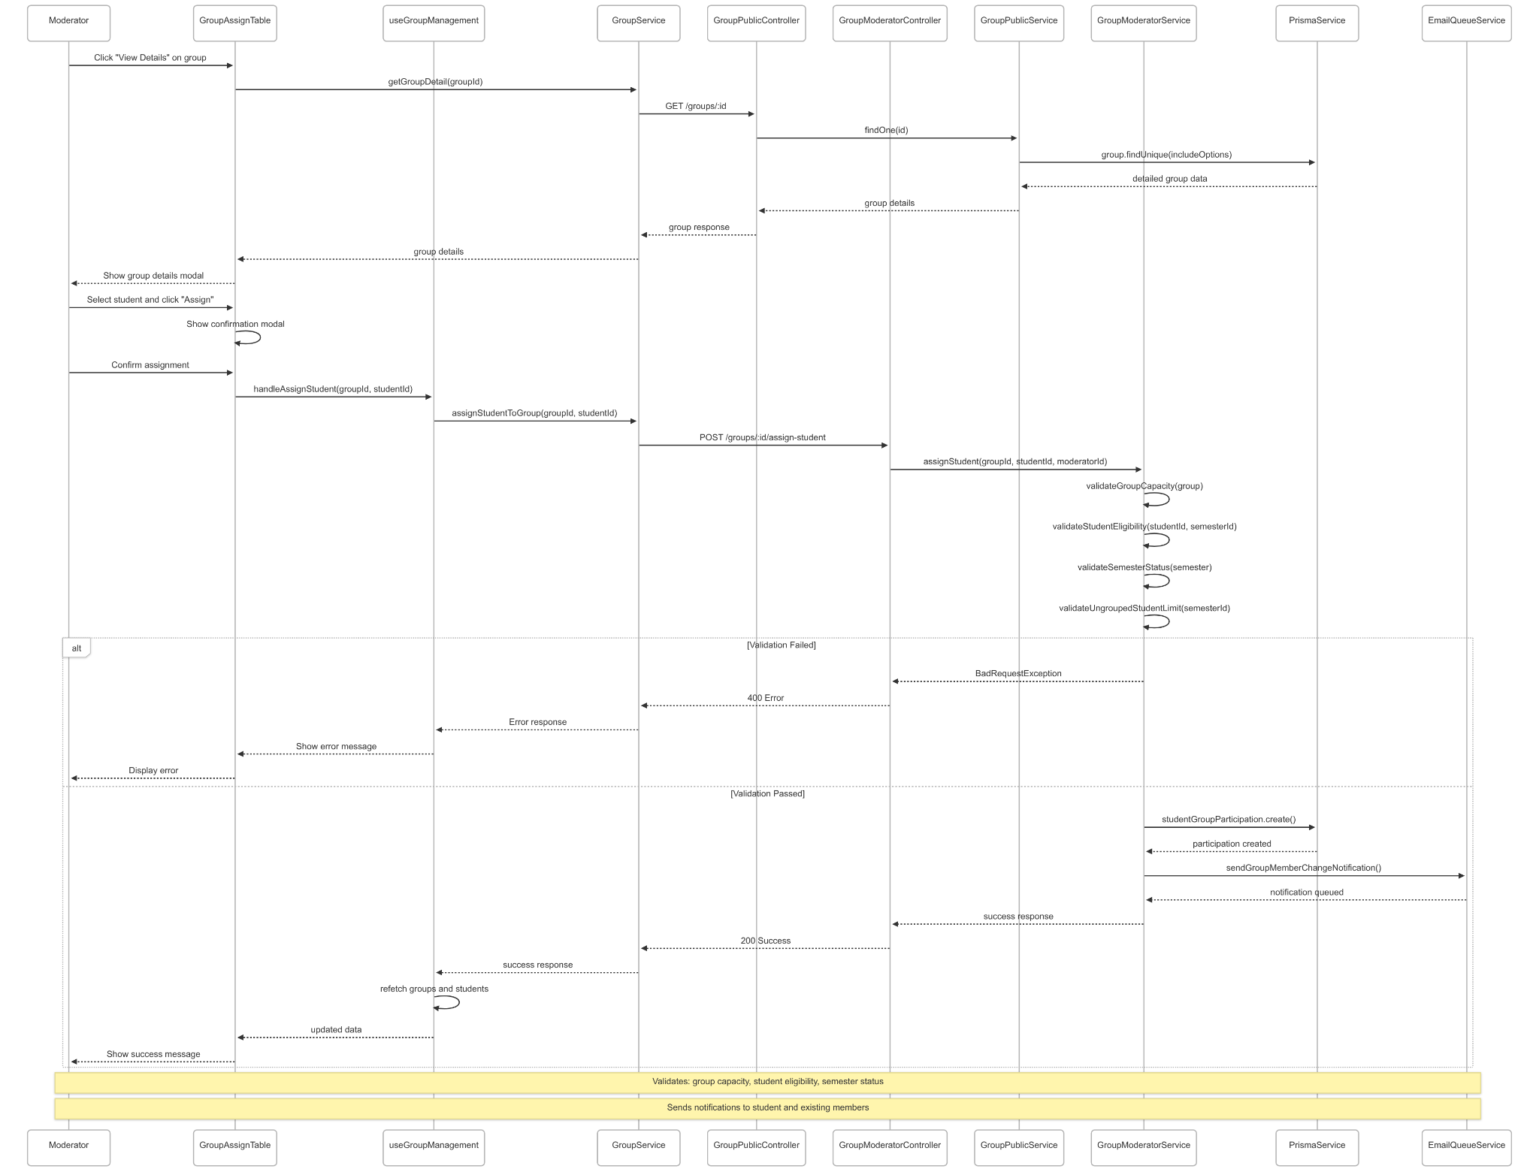](https://drive.google.com/file/d/1nqYd-FxBC4x3Jtv3h3KozdvObPS0Wo5u/view?usp=drive_link)

###### Figure IV.C.15.c.(2) - View Group Details & Assign Student to Group Sequence Diagram

### Moderator Assign Supervision

#### Class Diagram

[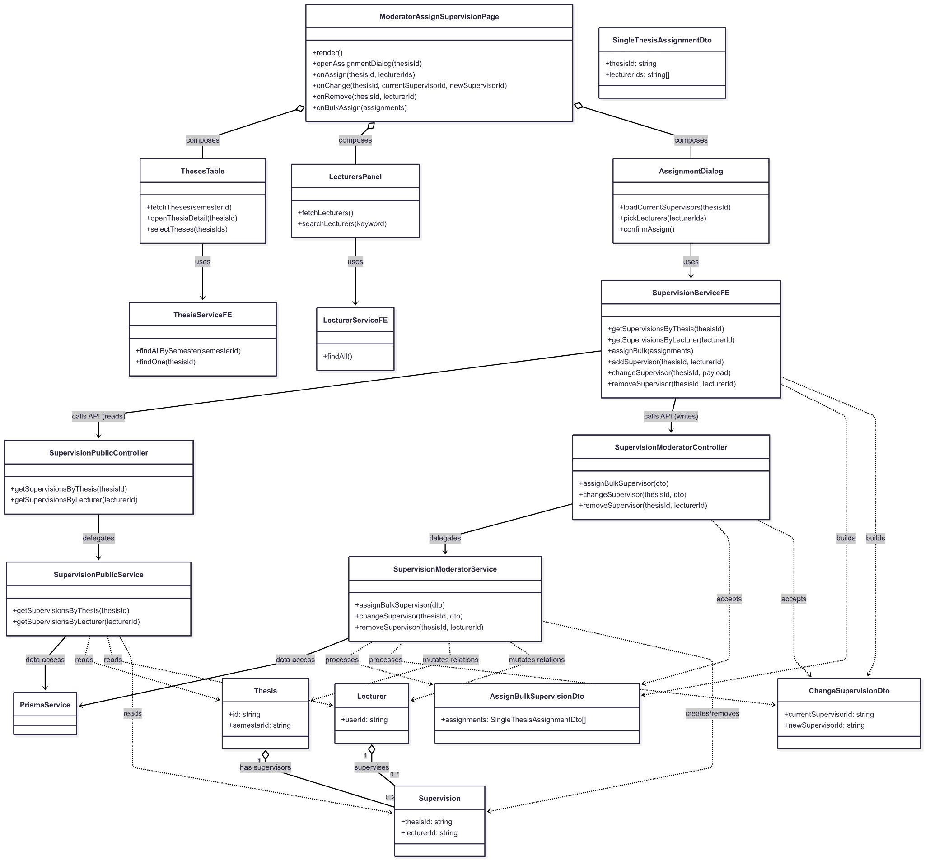](https://drive.google.com/file/d/1IFwVTjex5ppPYOpvLXPAEV-WrpVJ_tHw/view?usp=drive_link)

###### Figure IV.C.16.a - Moderator Assign Supervision Class Diagram

#### Class Diagram Specification

| **No** | **Class** | **Method** | **Description** |
| --- | --- | --- | --- |
| 1 | ModeratorAssignSupervisionPage | render() | Render page layout (theses list, lecturers panel, assignment dialog). |
| 2 | ModeratorAssignSupervisionPage | openAssignmentDialog(thesisId) | Open dialog and load current supervisors for a thesis. |
| 3 | ModeratorAssignSupervisionPage | onAssign(thesisId, lecturerIds) | Assign one or multiple lecturers to a thesis. |
| 4 | ModeratorAssignSupervisionPage | onRemove(thesisId, lecturerId) | Remove a supervisor from a thesis. |
| 5 | ModeratorAssignSupervisionPage | onBulkAssign(thesisIds, lecturerIds) | Bulk-assign supervisors to multiple theses. |
| 6 | ThesesTable | fetchTheses(semesterId) | Load theses list scoped to a semester. |
| 7 | ThesesTable | selectTheses(thesisIds) | Select theses for bulk-assign actions. |
| 8 | ThesesTable | openThesisDetail(thesisId) | Open detail of a thesis to review supervisors. |
| 9 | LecturersPanel | fetchLecturers() | Load lecturers available for supervision. |
| 10 | LecturersPanel | searchLecturers(keyword) | Search lecturers by name or email. |
| 11 | AssignmentDialog | loadCurrentSupervisors(thesisId) | Load current supervisors for display in dialog. |
| 12 | AssignmentDialog | pickLecturers(lecturerIds) | Stage lecturers to be assigned. |
| 13 | AssignmentDialog | confirmAssign() | Confirm and execute assignment. |
| 14 | ThesisServiceFE | findAllBySemester(semesterId) | Fetch theses by semester (for table/filter). |
| 15 | ThesisServiceFE | findOne(thesisId) | Fetch thesis detail (for dialog/context). |
| 16 | LecturerServiceFE | findAll() | Fetch all lecturers (for panel/options). |
| 17 | SupervisionServiceFE | getSupervisionsByThesis(thesisId) | Fetch supervisors of a thesis. |
| 18 | SupervisionServiceFE | getSupervisionsByLecturer(lecturerId) | Fetch theses supervised by a lecturer. |
| 19 | SupervisionServiceFE | assignBulk(thesisIds, lecturerIds) | Bulk-assign supervisors to theses. |
| 20 | SupervisionServiceFE | addSupervisor(thesisId, lecturerId) | Assign a single supervisor to a thesis. |
| 21 | SupervisionServiceFE | removeSupervisor(thesisId, lecturerId) | Remove a supervisor from a thesis. |
| 22 | SupervisionModeratorController | assignBulk(thesisIds, lecturerIds) | API endpoint to bulk-assign supervisors. |
| 23 | SupervisionModeratorController | addSupervisor(thesisId, lecturerId) | API endpoint to add a supervisor. |
| 24 | SupervisionModeratorController | removeSupervisor(thesisId, lecturerId) | API endpoint to remove a supervisor. |
| 25 | SupervisionModeratorService | assignBulk(thesisIds, lecturerIds) | Business logic to bulk-assign supervisors. |
| 26 | SupervisionModeratorService | addSupervisor(thesisId, lecturerId) | Business logic to add a supervisor. |
| 27 | SupervisionModeratorService | removeSupervisor(thesisId, lecturerId) | Business logic to remove a supervisor. |
| 28 | SupervisionPublicController | getSupervisionsByThesis(thesisId) | API endpoint to read supervisors by thesis. |
| 29 | SupervisionPublicService | getSupervisionsByThesis(thesisId) | Query supervisors linked to a thesis. |
| 30 | SupervisionPublicController | getSupervisionsByLecturer(lecturerId) | API endpoint to read theses by lecturer. |
| 31 | SupervisionPublicService | getSupervisionsByLecturer(lecturerId) | Query theses linked to a lecturer. |
| 32 | PrismaService | query(sqlOrBuilder) | Shared ORM/data access for supervision operations. |

##### Table IV.C.16.b - Moderator Assign Supervision Class Diagram Specification

#### Sequence Diagram

* + - * 1. View list supervisor

[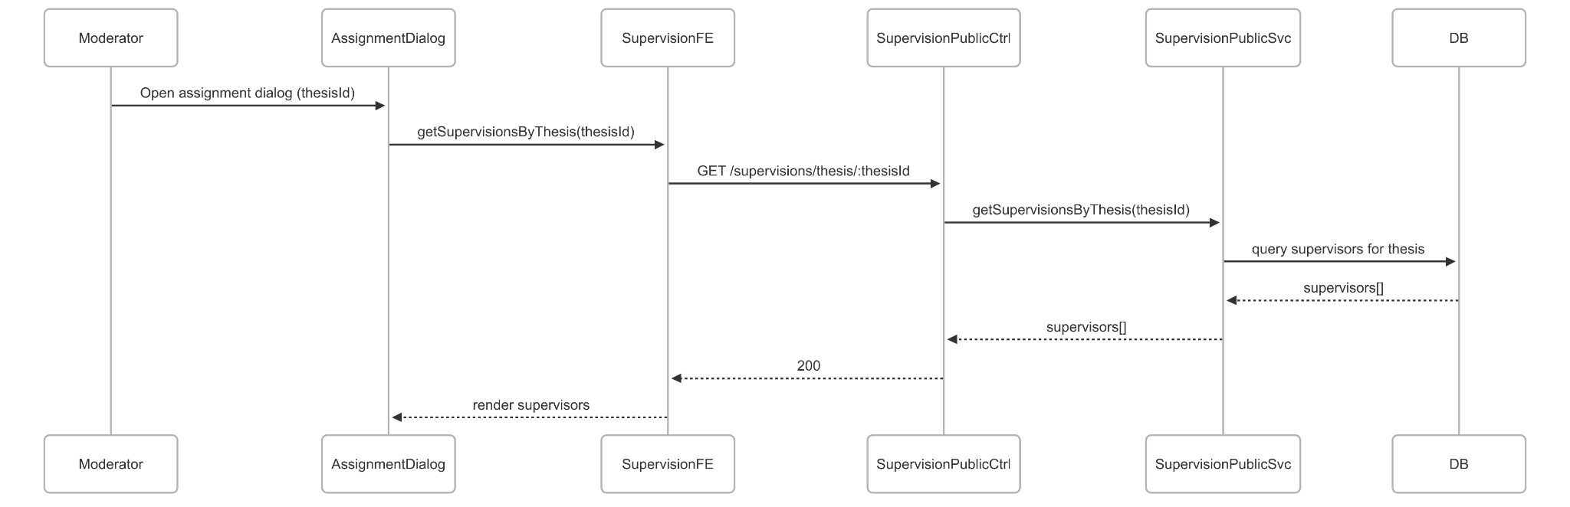](https://drive.google.com/file/d/1HUcUKocwTBkpX8ujUTxKCZCQvZqt72Nj/view?usp=drive_link)

###### Figure IV.C.16.c.(1) - View List Supervisor Sequence Diagram

* + - * 1. Assign single supervisor

[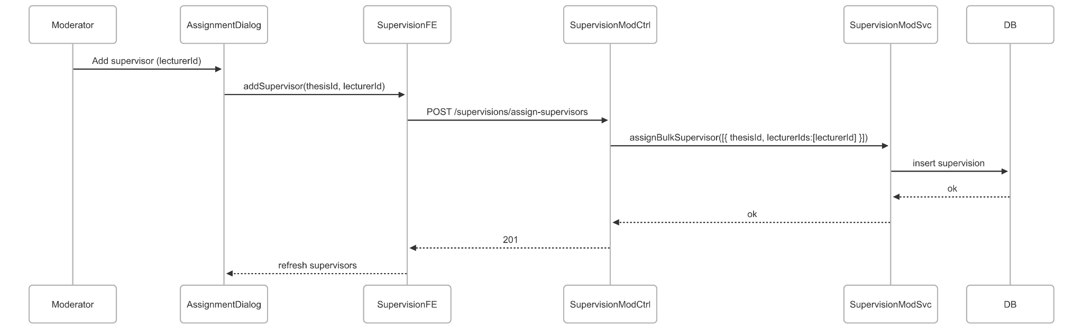](https://drive.google.com/file/d/1cW9hbe7B_atThTBDcTXCPCPmn20gjPEI/view?usp=drive_link)

###### Figure IV.C.16.c.(2) - Assign Single Supervisor Sequence Diagram

* + - * 1. Remove supervisor

[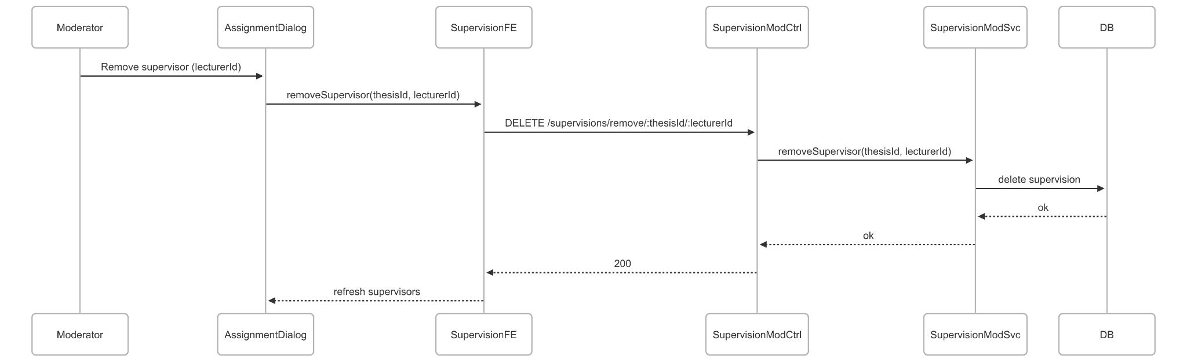](https://drive.google.com/file/d/1hBbWtmmehGI_i79tdvomHIPusJlXFuHO/view?usp=drive_link)

###### Figure IV.C.16.c.(3) - Remove Supervisor Sequence Diagram

* + - * 1. Change supervisor

[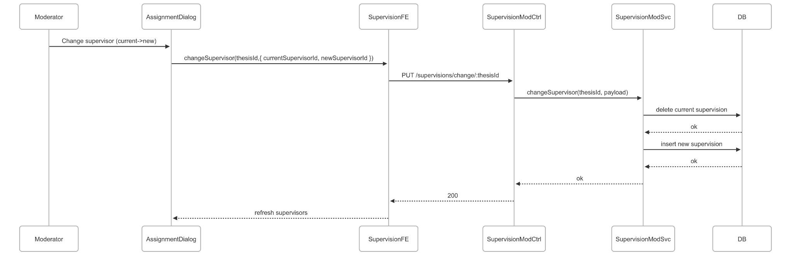](https://drive.google.com/file/d/1ihVgxvEnlK5IdDgrYbbdccPPm3u7znAS/view?usp=drive_link)

###### Figure IV.C.16.c.(4) - Change Supervisor Sequence Diagram

* + - * 1. Bulk assign supervisors

[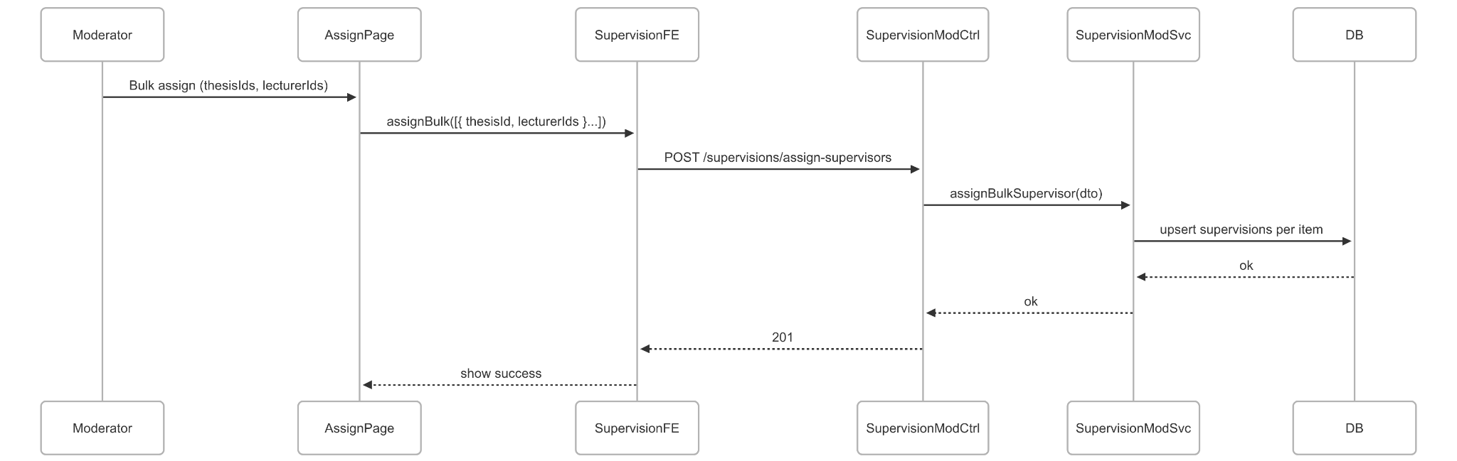](https://drive.google.com/file/d/1M6UvWF3HCzaC018Gp_R1ZY-dOCe0k-5k/view?usp=drive_link)

###### Figure IV.C.16.c.(5) - Bulk Assign Supervisors Sequence Diagram

### Moderator Assign Reviewer

#### Class Diagram

[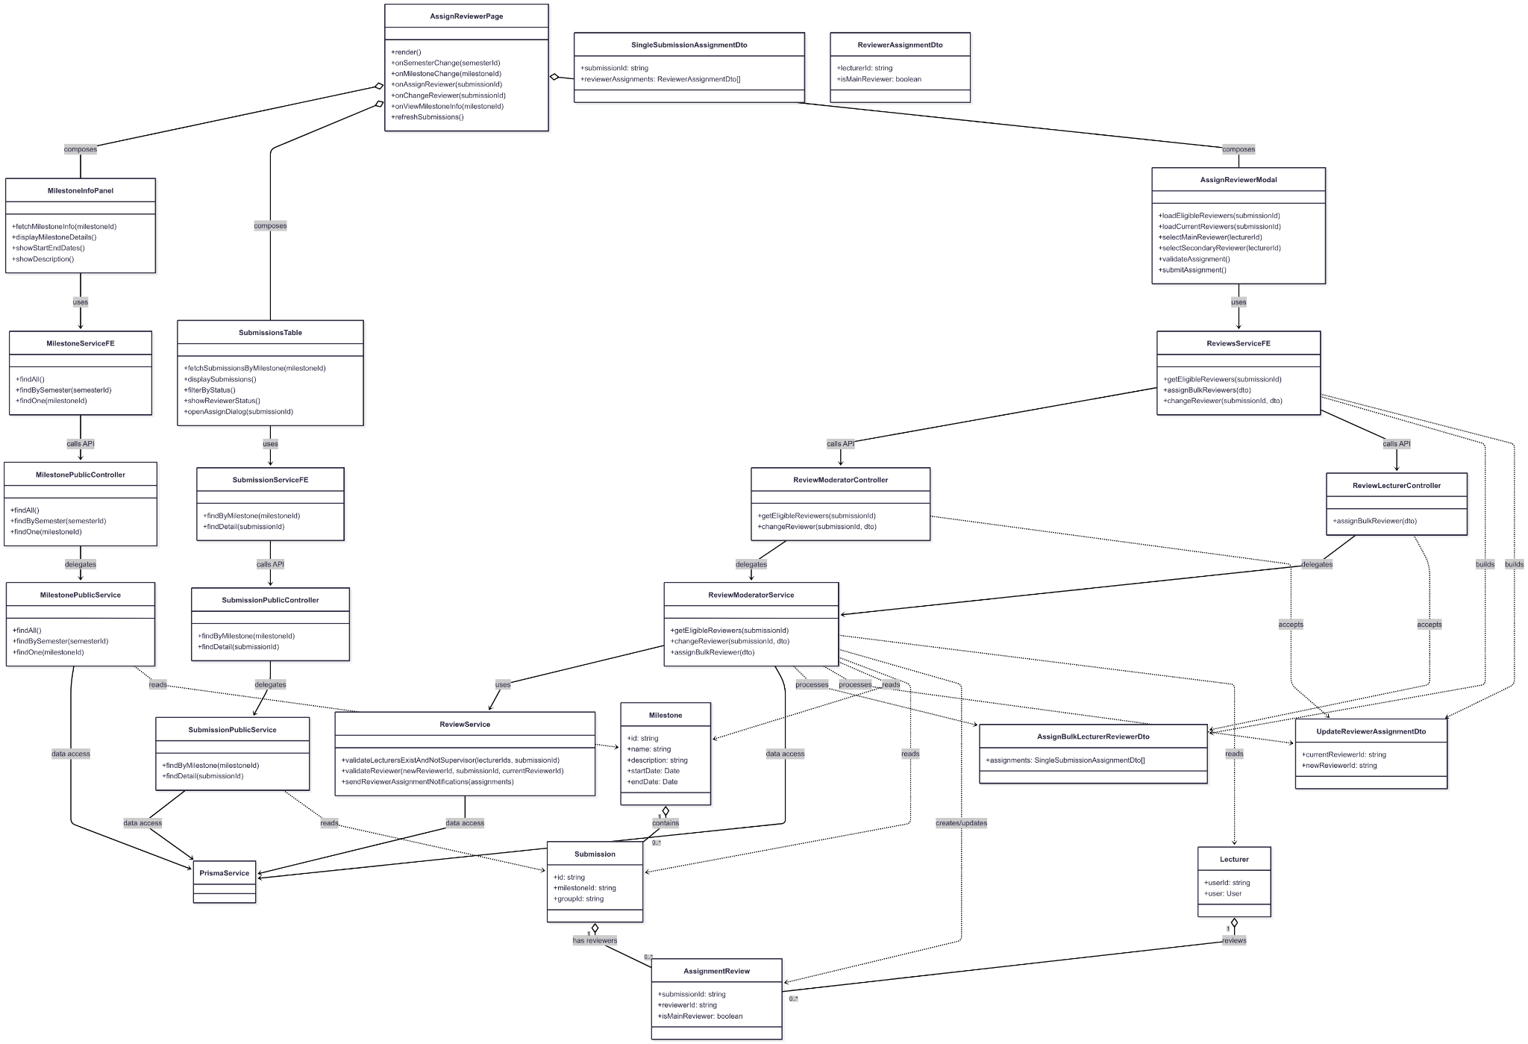](https://drive.google.com/file/d/1v675BxC96kquHtTEhYhNEFzTBcPk3zRX/view?usp=drive_link)

###### Figure IV.C.17.a - Moderator Assign Reviewer Class Diagram

#### Class Diagram Specification

| **No** | **Class** | **Method** | **Description** |
| --- | --- | --- | --- |
| 1 | AssignReviewerPage | render() | Render main page for reviewer assignment management |
| 2 | AssignReviewerPage | onSemesterChange(semesterId) | Handle semester selection change and refresh data |
| 3 | AssignReviewerPage | onMilestoneChange(milestoneId) | Handle milestone selection change and load submissions |
| 4 | AssignReviewerPage | onAssignReviewer(submissionId) | Open assign reviewer modal for new assignment |
| 5 | AssignReviewerPage | onChangeReviewer(submissionId) | Open modal to change existing reviewer assignment |
| 6 | AssignReviewerPage | onViewMilestoneInfo(milestoneId) | Display milestone information panel |
| 7 | AssignReviewerPage | refreshSubmissions() | Refresh submissions table data |
| 8 | MilestoneInfoPanel | fetchMilestoneInfo(milestoneId) | Fetch and display milestone details |
| 9 | MilestoneInfoPanel | displayMilestoneDetails() | Show milestone name, description, dates |
| 10 | MilestoneInfoPanel | showStartEndDates() | Display milestone start and end dates |
| 11 | MilestoneInfoPanel | showDescription() | Display milestone description and requirements |
| 12 | SubmissionsTable | fetchSubmissionsByMilestone(milestoneId) | Load submissions for selected milestone |
| 13 | SubmissionsTable | displaySubmissions() | Render submissions table with group info |
| 14 | SubmissionsTable | filterByStatus() | Filter submissions by reviewer assignment status |
| 15 | SubmissionsTable | showReviewerStatus() | Display current reviewer assignment status |
| 16 | SubmissionsTable | openAssignDialog(submissionId) | Open reviewer assignment dialog |
| 17 | AssignReviewerModal | loadEligibleReviewers(submissionId) | Fetch eligible lecturers for reviewer assignment |
| 18 | AssignReviewerModal | loadCurrentReviewers(submissionId) | Load currently assigned reviewers |
| 19 | AssignReviewerModal | selectMainReviewer(lecturerId) | Select main reviewer for submission |
| 20 | AssignReviewerModal | selectSecondaryReviewer(lecturerId) | Select secondary reviewer for submission |
| 21 | AssignReviewerModal | validateAssignment() | Validate reviewer selection (exactly 2, different lecturers) |
| 22 | AssignReviewerModal | submitAssignment() | Submit reviewer assignment to backend |
| 23 | ReviewsServiceFE | getEligibleReviewers(submissionId) | Get list of eligible reviewers for submission |
| 24 | ReviewsServiceFE | assignBulkReviewers(dto) | Assign reviewers to multiple submissions |
| 25 | ReviewsServiceFE | changeReviewer(submissionId, dto) | Change reviewer assignment for submission |
| 26 | MilestoneServiceFE | findAll() | Get all milestones |
| 27 | MilestoneServiceFE | findBySemester(semesterId) | Get milestones by semester |
| 28 | MilestoneServiceFE | findOne(milestoneId) | Get specific milestone details |
| 29 | SubmissionServiceFE | findByMilestone(milestoneId) | Get submissions by milestone |
| 30 | SubmissionServiceFE | findDetail(submissionId) | Get detailed submission information |
| 31 | ReviewModeratorController | getEligibleReviewers(submissionId) | API endpoint to get eligible reviewers |
| 32 | ReviewModeratorController | changeReviewer(submissionId, dto) | API endpoint to change reviewer assignment |
| 33 | ReviewLecturerController | assignBulkReviewer(dto) | API endpoint to assign reviewers in bulk |
| 34 | MilestonePublicController | findAll() | API endpoint to get all milestones |
| 35 | MilestonePublicController | findBySemester(semesterId) | API endpoint to get milestones by semester |
| 36 | MilestonePublicController | findOne(milestoneId) | API endpoint to get milestone details |
| 37 | SubmissionPublicController | findByMilestone(milestoneId) | API endpoint to get submissions by milestone |
| 38 | SubmissionPublicController | findDetail(submissionId) | API endpoint to get submission details |
| 39 | ReviewModeratorService | getEligibleReviewers(submissionId) | Get lecturers eligible to review submission |
| 40 | ReviewModeratorService | changeReviewer(submissionId, dto) | Change reviewer assignment with validation |
| 41 | ReviewModeratorService | assignBulkReviewer(dto) | Assign multiple reviewers with business rules |
| 42 | ReviewService | validateLecturersExistAndNotSupervisor(lecturerIds, submissionId) | Validate lecturers exist and are not supervisors |
| 43 | ReviewService | validateReviewer(newReviewerId, submissionId, currentReviewerId) | Validate single reviewer assignment |
| 44 | ReviewService | sendReviewerAssignmentNotifications(assignments) | Send email notifications to assigned reviewers |
| 45 | MilestonePublicService | findAll() | Retrieve all milestones from database |
| 46 | MilestonePublicService | findBySemester(semesterId) | Retrieve milestones for specific semester |
| 47 | MilestonePublicService | findOne(milestoneId) | Retrieve specific milestone details |
| 48 | SubmissionPublicService | findByMilestone(milestoneId) | Retrieve submissions for specific milestone |
| 49 | SubmissionPublicService | findDetail(submissionId) | Retrieve detailed submission information |

##### Table IV.C.17.b - Moderator Assign Reviewer Class Diagram Specification

#### Sequence Diagram

* + - * 1. View Milestone Information

[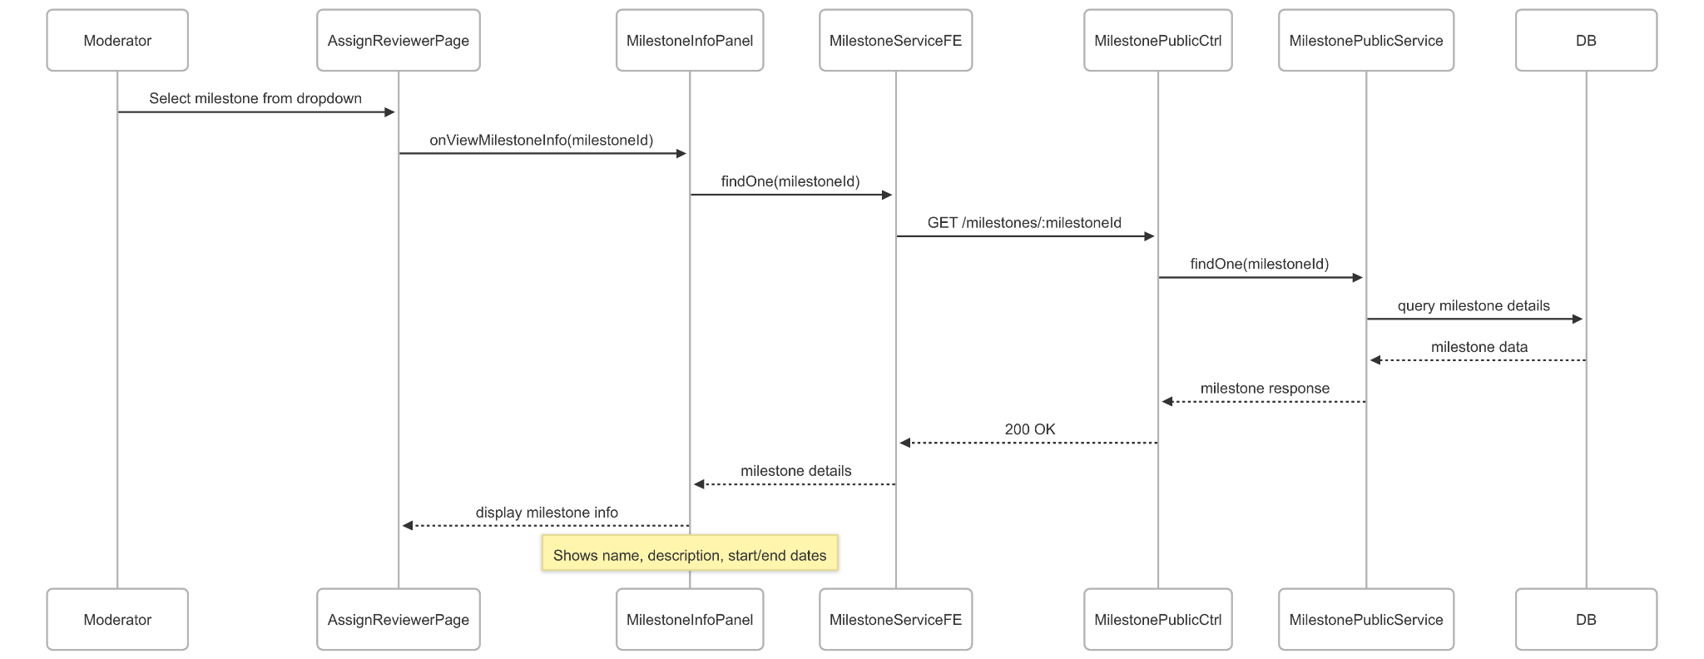](https://drive.google.com/file/d/1QpabQHlc9OZruIWbtEQ5tae34spc9hhM/view?usp=drive_link)

###### Figure IV.C.17.c.(1) - View Milestone Information Sequence Diagram

* + - * 1. Load Submissions by Milestone

[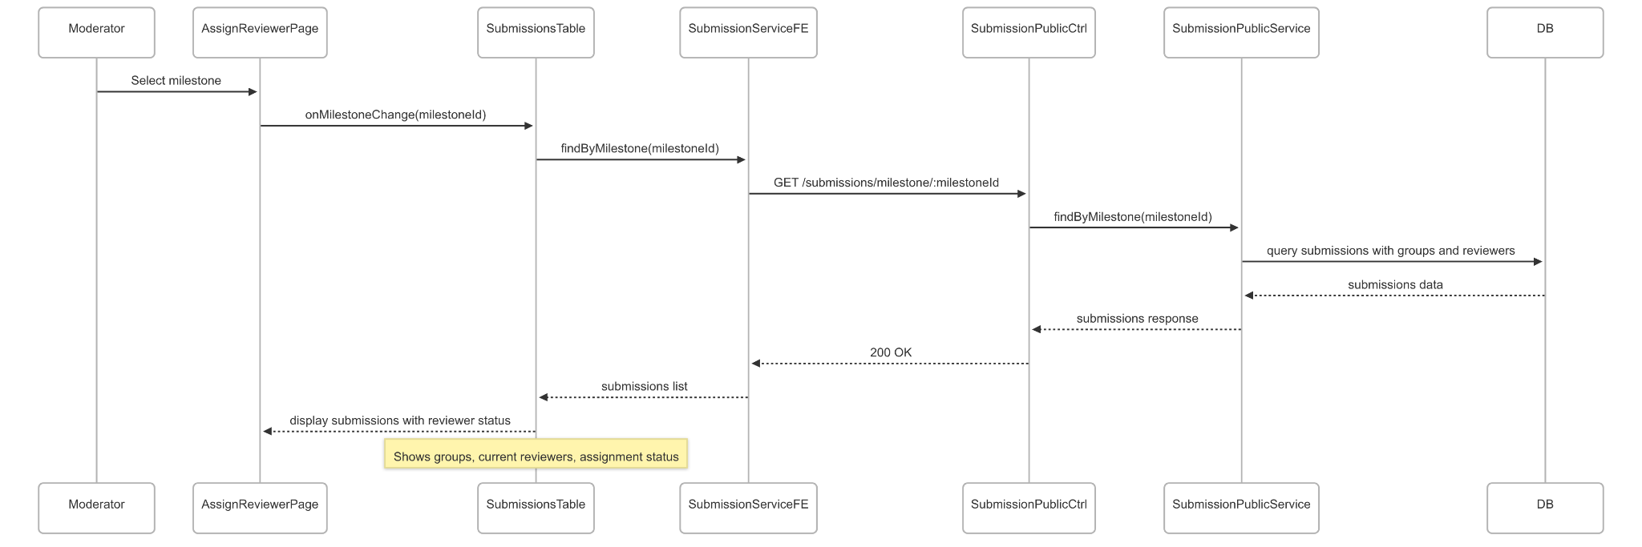](https://drive.google.com/file/d/1jYHl8r5LWhiRYf9Cvb5TjaOqy1XA7O28/view?usp=drive_link)

###### Figure IV.C.17.c.(2) - Load Submissions by Milestone Sequence Diagram

* + - * 1. Get Eligible Reviewers

[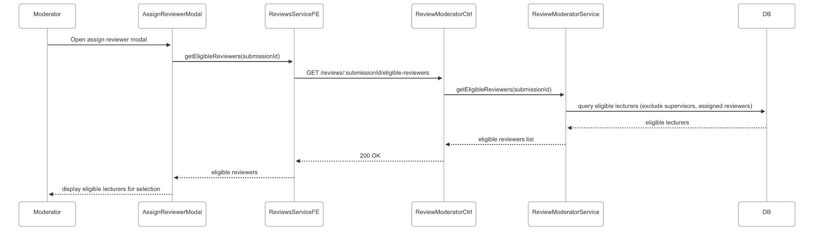](https://drive.google.com/file/d/1p_5etuDN14I7qy6W2xO8y8MptYhgRe-L/view?usp=drive_link)

###### Figure IV.C.17.c.(3) - Get Eligible Reviewers Sequence Diagram

* + - * 1. Assign Reviewers

[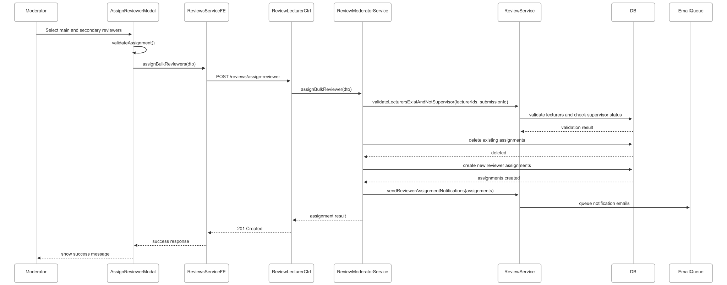](https://drive.google.com/file/d/15HaTNvquz6RczR-CkWgRCkRgqfM3D217/view?usp=drive_link)

###### Figure IV.C.17.c.(4) - Assign Reviewers Sequence Diagram

* + - * 1. Change Reviewer Assignment

[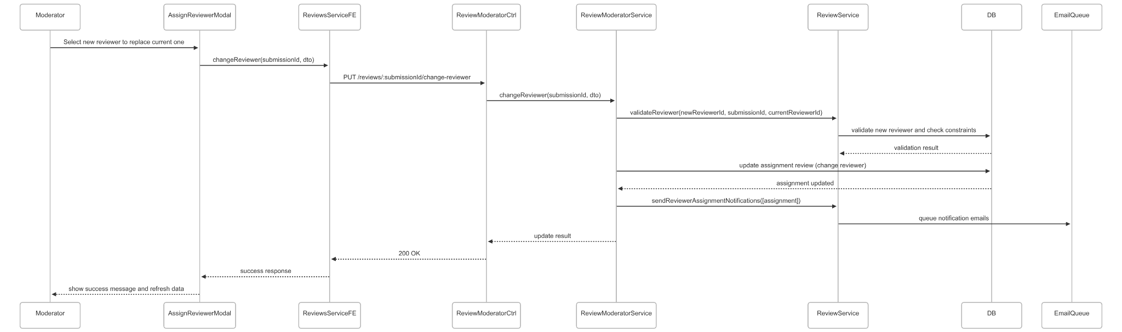](https://drive.google.com/file/d/1lB18N0CYP8sjFIxxpDZQhfWEQvvJOiEU/view?usp=drive_link)

###### Figure IV.C.17.c.(5) - Change Reviewer Assignment Sequence Diagram

### Moderator Manage Checklist for each Milestone

#### Class Diagram

[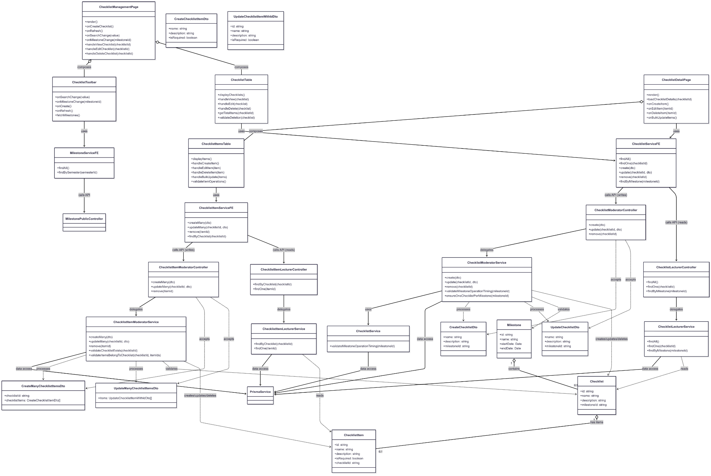](https://drive.google.com/file/d/1_e_6zkt7LYr8yke0p5dSMb11M7FCwBik/view?usp=drive_link)

###### Figure IV.C.18.a - Moderator Manage Checklist for each Milestone Class Diagram

#### Class Diagram Specification

| **No** | **Class** | **Method** | **Description** |
| --- | --- | --- | --- |
| 1 | ChecklistManagementPage | render() | Render main checklist management page with toolbar and table |
| 2 | ChecklistManagementPage | onCreateChecklist() | Navigate to create checklist page |
| 3 | ChecklistManagementPage | onRefresh() | Refresh checklist data from server |
| 4 | ChecklistManagementPage | onSearchChange(value) | Handle search input change and filter checklists |
| 5 | ChecklistManagementPage | onMilestoneChange(milestoneId) | Filter checklists by selected milestone |
| 6 | ChecklistManagementPage | handleViewChecklist(checklistId) | Navigate to checklist detail view page |
| 7 | ChecklistManagementPage | handleEditChecklist(checklistId) | Navigate to checklist edit page |
| 8 | ChecklistManagementPage | handleDeleteChecklist(checklistId) | Delete checklist with confirmation dialog |
| 9 | ChecklistToolbar | onSearchChange(value) | Handle search input change |
| 10 | ChecklistToolbar | onMilestoneChange(milestoneId) | Handle milestone filter selection |
| 11 | ChecklistToolbar | onCreate() | Trigger create new checklist action |
| 12 | ChecklistToolbar | onRefresh() | Trigger data refresh action |
| 13 | ChecklistToolbar | fetchMilestones() | Load available milestones for filter dropdown |
| 14 | ChecklistTable | displayChecklists() | Render checklist table with data |
| 15 | ChecklistTable | handleView(checklist) | Handle view checklist action |
| 16 | ChecklistTable | handleEdit(checklist) | Handle edit checklist action |
| 17 | ChecklistTable | handleDelete(checklist) | Handle delete checklist with validation |
| 18 | ChecklistTable | getTotalItems(checklistId) | Get total number of items in checklist |
| 19 | ChecklistTable | validateDeletion(checklist) | Validate if checklist can be deleted (no items) |
| 20 | ChecklistDetailPage | render() | Render checklist detail page with items management |
| 21 | ChecklistDetailPage | loadChecklistDetails(checklistId) | Load checklist and its items |
| 22 | ChecklistDetailPage | onCreateItem() | Open create new checklist item dialog |
| 23 | ChecklistDetailPage | onEditItem(itemId) | Open edit checklist item dialog |
| 24 | ChecklistDetailPage | onDeleteItem(itemId) | Delete specific checklist item |
| 25 | ChecklistDetailPage | onBulkUpdateItems() | Update multiple checklist items at once |
| 26 | ChecklistItemsTable | displayItems() | Render checklist items table |
| 27 | ChecklistItemsTable | handleCreateItem() | Handle create new item action |
| 28 | ChecklistItemsTable | handleEditItem(item) | Handle edit item action |
| 29 | ChecklistItemsTable | handleDeleteItem(item) | Handle delete item action |
| 30 | ChecklistItemsTable | handleBulkUpdate(items) | Handle bulk update of multiple items |
| 31 | ChecklistItemsTable | validateItemOperations() | Validate item operations before execution |
| 32 | ChecklistServiceFE | findAll() | Get all checklists |
| 33 | ChecklistServiceFE | findOne(checklistId) | Get specific checklist details |
| 34 | ChecklistServiceFE | create(dto) | Create new checklist |
| 35 | ChecklistServiceFE | update(checklistId, dto) | Update existing checklist |
| 36 | ChecklistServiceFE | remove(checklistId) | Delete checklist |
| 37 | ChecklistServiceFE | findByMilestone(milestoneId) | Get checklists for specific milestone |
| 38 | ChecklistItemServiceFE | createMany(dto) | Create multiple checklist items |
| 39 | ChecklistItemServiceFE | updateMany(checklistId, dto) | Update multiple checklist items |
| 40 | ChecklistItemServiceFE | remove(itemId) | Delete specific checklist item |
| 41 | ChecklistItemServiceFE | findByChecklist(checklistId) | Get items for specific checklist |
| 42 | MilestoneServiceFE | findAll() | Get all milestones |
| 43 | MilestoneServiceFE | findBySemester(semesterId) | Get milestones for specific semester |
| 44 | ChecklistModeratorController | create(dto) | API endpoint to create new checklist |
| 45 | ChecklistModeratorController | update(checklistId, dto) | API endpoint to update checklist |
| 46 | ChecklistModeratorController | remove(checklistId) | API endpoint to delete checklist |
| 47 | ChecklistLecturerController | findAll() | API endpoint to get all checklists |
| 48 | ChecklistLecturerController | findOne(checklistId) | API endpoint to get checklist details |
| 49 | ChecklistLecturerController | findByMilestone(milestoneId) | API endpoint to get checklists by milestone |
| 50 | ChecklistItemModeratorController | createMany(dto) | API endpoint to create multiple checklist items |
| 51 | ChecklistItemModeratorController | updateMany(checklistId, dto) | API endpoint to update multiple checklist items |
| 52 | ChecklistItemModeratorController | remove(itemId) | API endpoint to delete checklist item |
| 53 | ChecklistItemLecturerController | findByChecklist(checklistId) | API endpoint to get items by checklist |
| 54 | ChecklistItemLecturerController | findOne(itemId) | API endpoint to get specific item details |
| 55 | ChecklistModeratorService | create(dto) | Create checklist with milestone validation |
| 56 | ChecklistModeratorService | update(checklistId, dto) | Update checklist with business rules |
| 57 | ChecklistModeratorService | remove(checklistId) | Delete checklist and cascade items |
| 58 | ChecklistModeratorService | validateMilestoneOperationTiming(milestoneId) | Validate milestone timing for operations |
| 59 | ChecklistModeratorService | ensureOneChecklistPerMilestone(milestoneId) | Ensure only one checklist per milestone |
| 60 | ChecklistLecturerService | findAll() | Retrieve all checklists from database |
| 61 | ChecklistLecturerService | findOne(checklistId) | Retrieve specific checklist with items |
| 62 | ChecklistLecturerService | findByMilestone(milestoneId) | Retrieve checklists for milestone |
| 63 | ChecklistItemModeratorService | createMany(dto) | Create multiple items with transaction |
| 64 | ChecklistItemModeratorService | updateMany(checklistId, dto) | Update multiple items with validation |
| 65 | ChecklistItemModeratorService | remove(itemId) | Delete specific checklist item |
| 66 | ChecklistItemModeratorService | validateChecklistExists(checklistId) | Validate checklist exists before operations |
| 67 | ChecklistItemModeratorService | validateItemsBelongToChecklist(checklistId, itemIds) | Validate items belong to checklist |
| 68 | ChecklistItemLecturerService | findByChecklist(checklistId) | Retrieve items for specific checklist |
| 69 | ChecklistItemLecturerService | findOne(itemId) | Retrieve specific checklist item details |
| 70 | ChecklistService | validateMilestoneOperationTiming(milestoneId) | Shared validation for milestone timing constraints |

##### Table IV.C.18.b - Moderator Manage Checklist for each Milestone Class Diagram Specification

#### Sequence Diagram

* + - * 1. Create New Checklist

[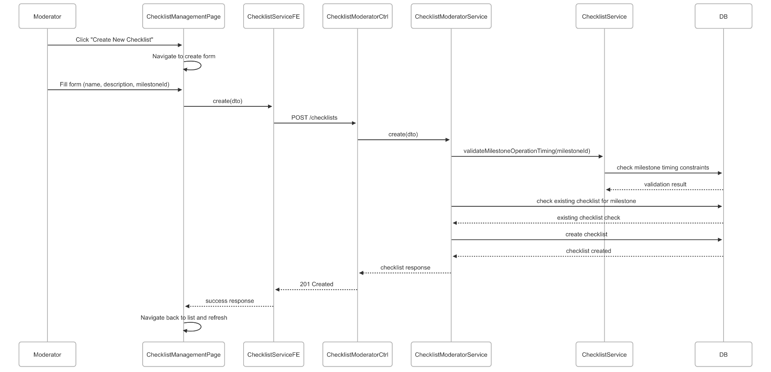](https://drive.google.com/file/d/10L5wFehS3MREh-H4LXI2mEawN3nQvH5q/view?usp=drive_link)

###### Figure IV.C.18.c.(1) - Create New Checklist Sequence Diagram

* + - * 1. View Checklist Details

[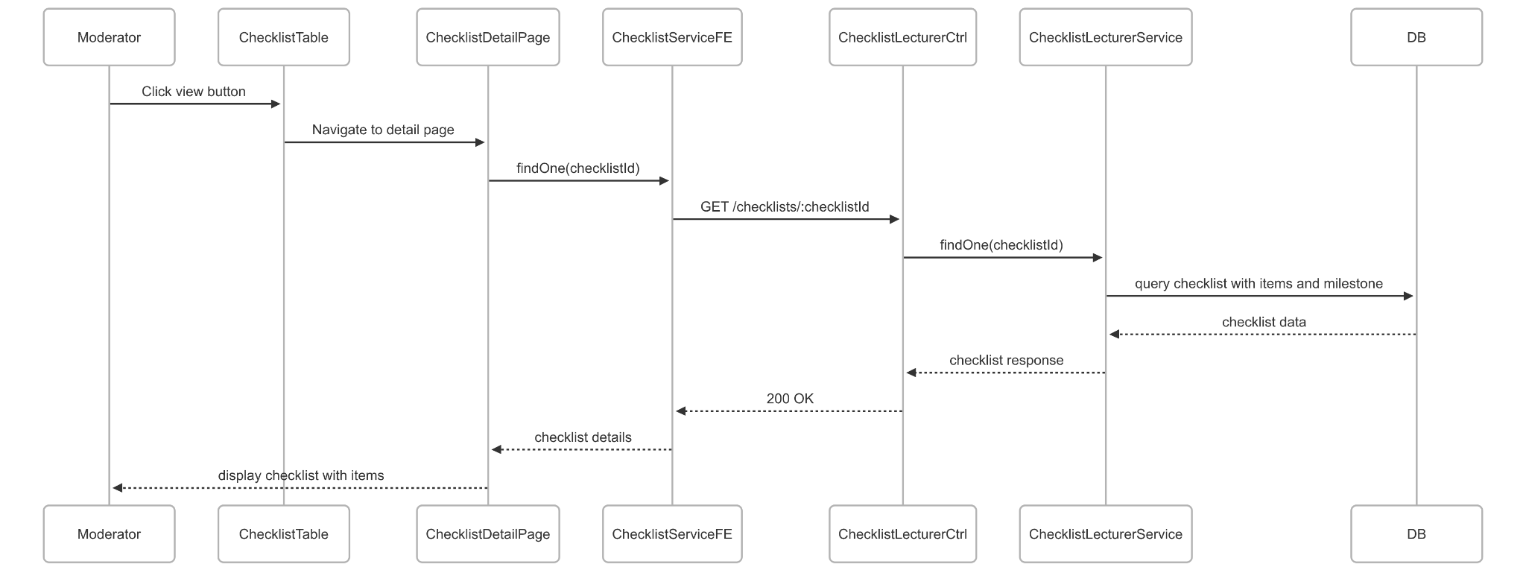](https://drive.google.com/file/d/1n24ZX7cdRwp9TZc5PLIo-D-ULFL0rZUU/view?usp=drive_link)

###### Figure IV.C.18.c.(2) - View Checklist Details Sequence Diagram

* + - * 1. Update Checklist

[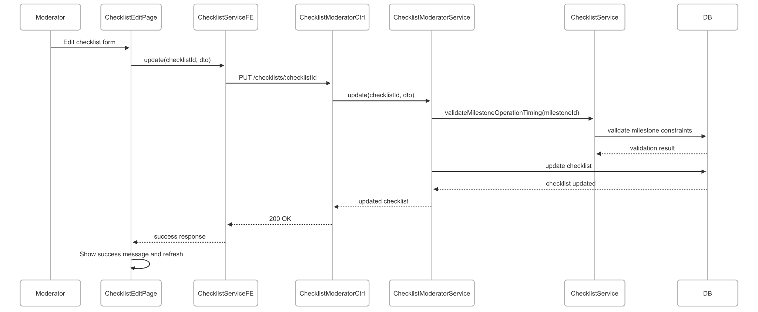](https://drive.google.com/file/d/1EE0QUft-JBp1fBBCk_hxPC2jiYVh-xZz/view?usp=drive_link)

###### Figure IV.C.18.c.(3) - Update Checklist Sequence Diagram

* + - * 1. Delete Checklist

[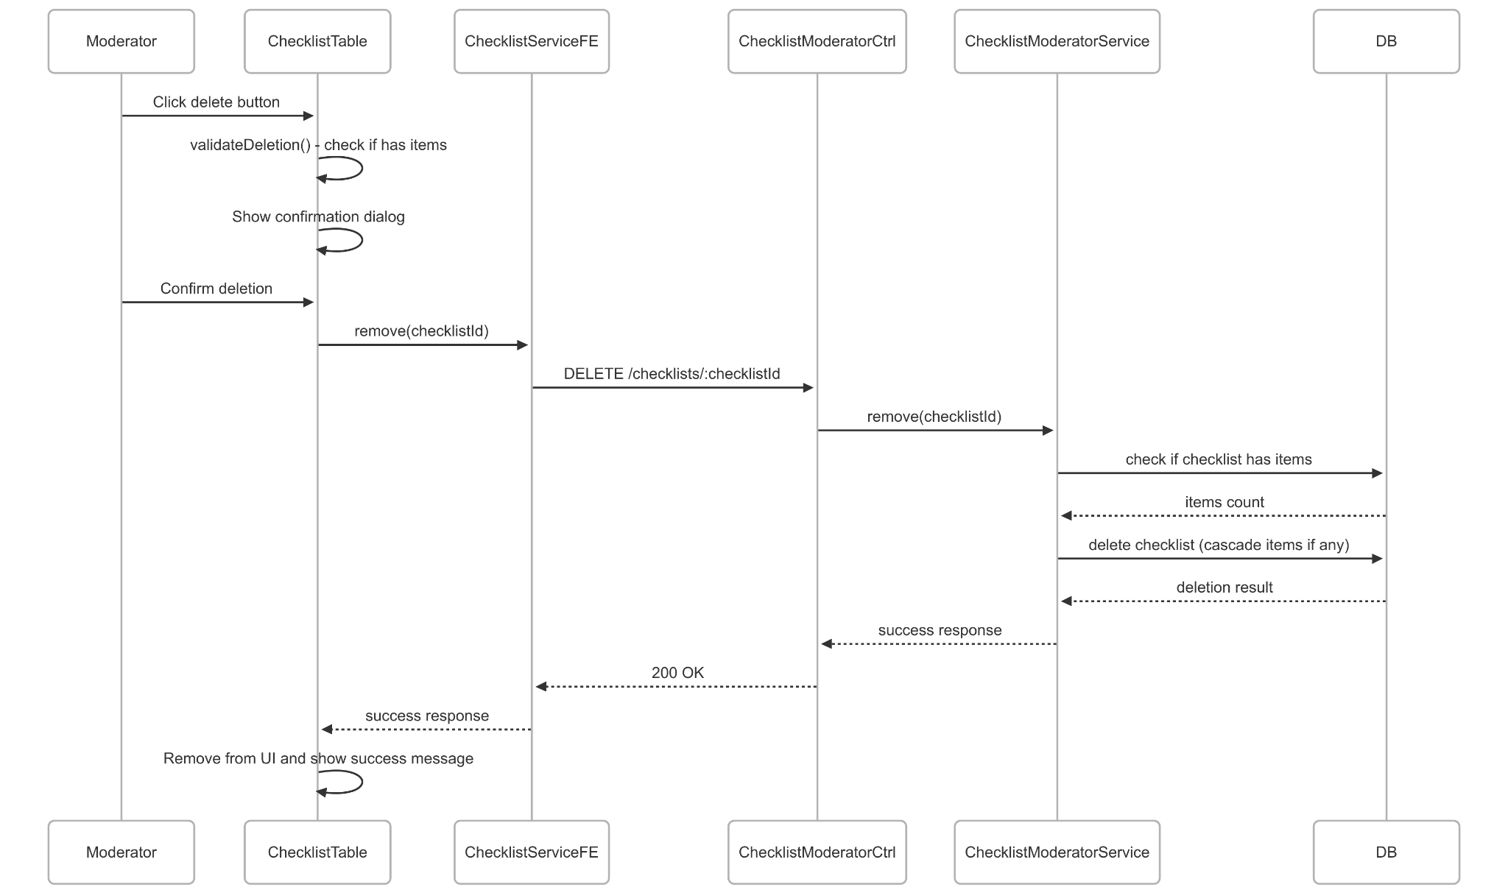](https://drive.google.com/file/d/1ouSrwYTjhz4tdMr-B3vgOoSOoZ-2ddJS/view?usp=drive_link)

###### Figure IV.C.18.c.(4) - Delete Checklist Sequence Diagram

* + - * 1. Create Multiple Checklist Items

[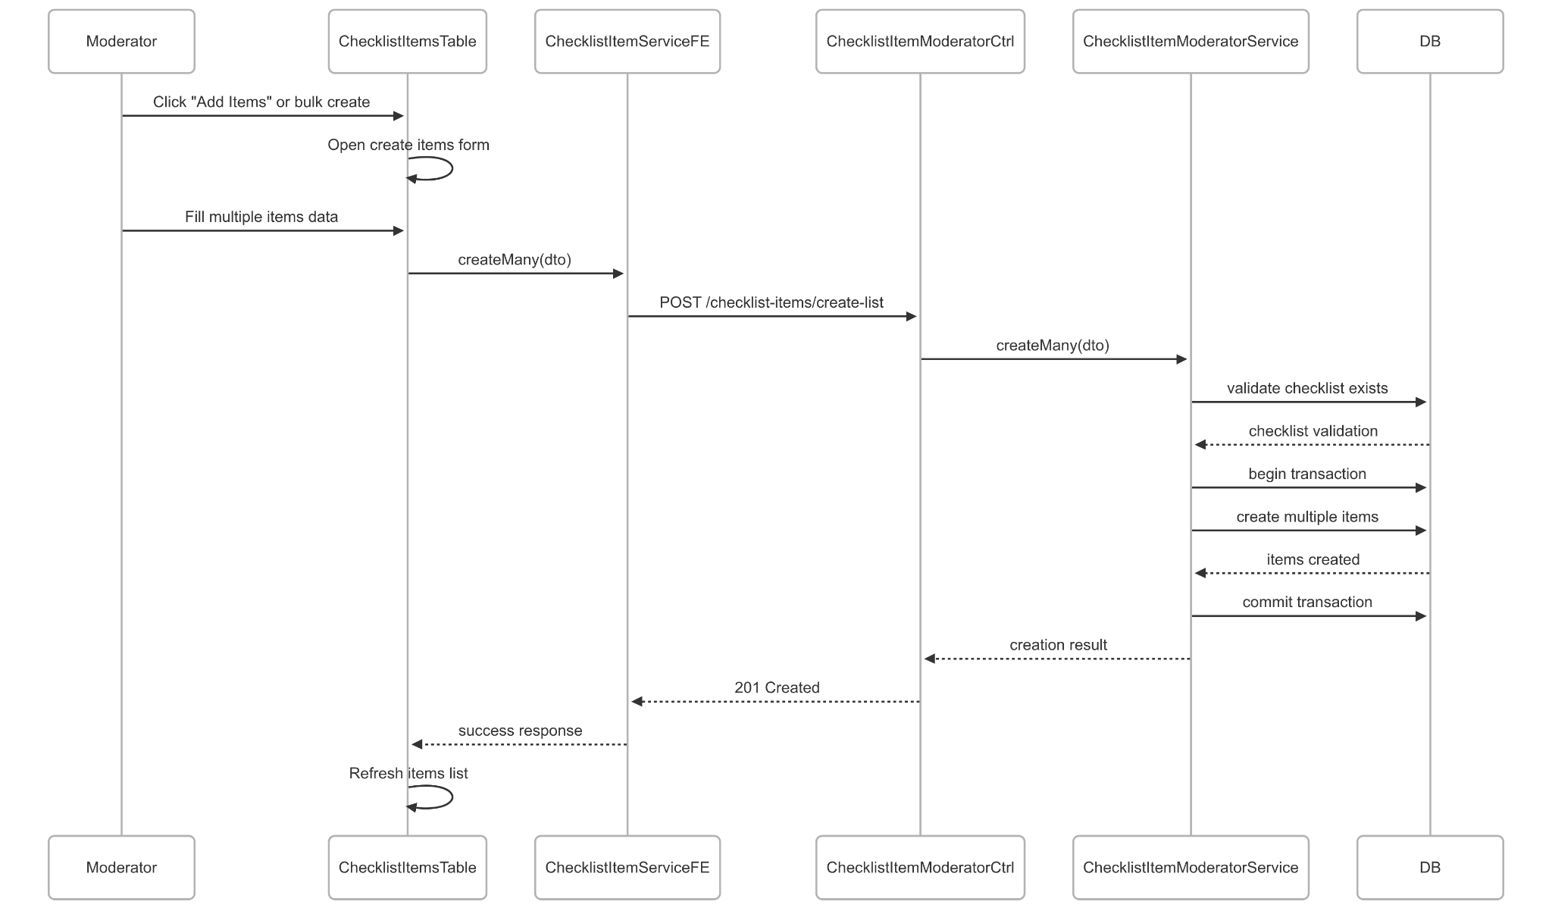](https://drive.google.com/file/d/1hqbxhIDAbS7ijMk5zKnD0pnSKAG37UX4/view?usp=drive_link)

###### Figure IV.C.18.c.(5) - Create Multiple Checklist Items Sequence Diagram

* + - * 1. Update Multiple Checklist Items

[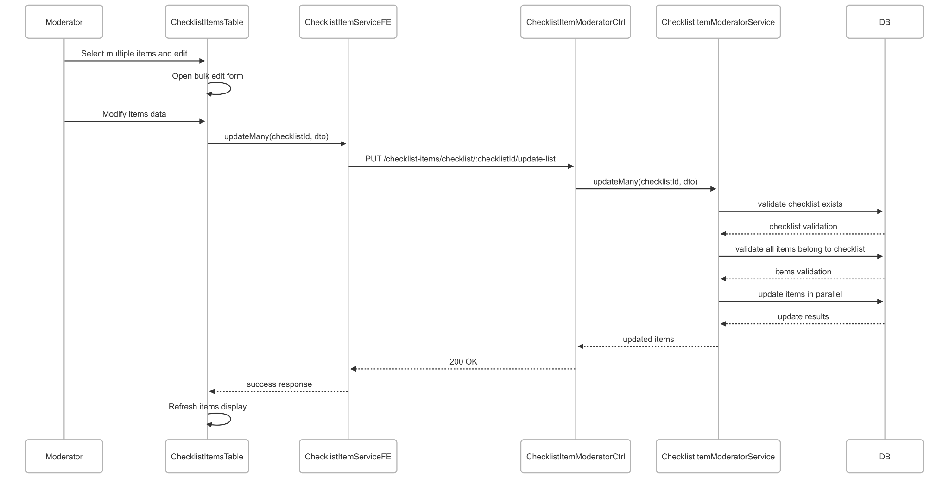](https://drive.google.com/file/d/1nwHZA7lnth2pG9HyHXAniIgr1Qmjm8zJ/view?usp=drive_link)

###### Figure IV.C.18.c.(6) - Update Multiple Checklist Items Sequence Diagram

* + - * 1. Delete Checklist Item

[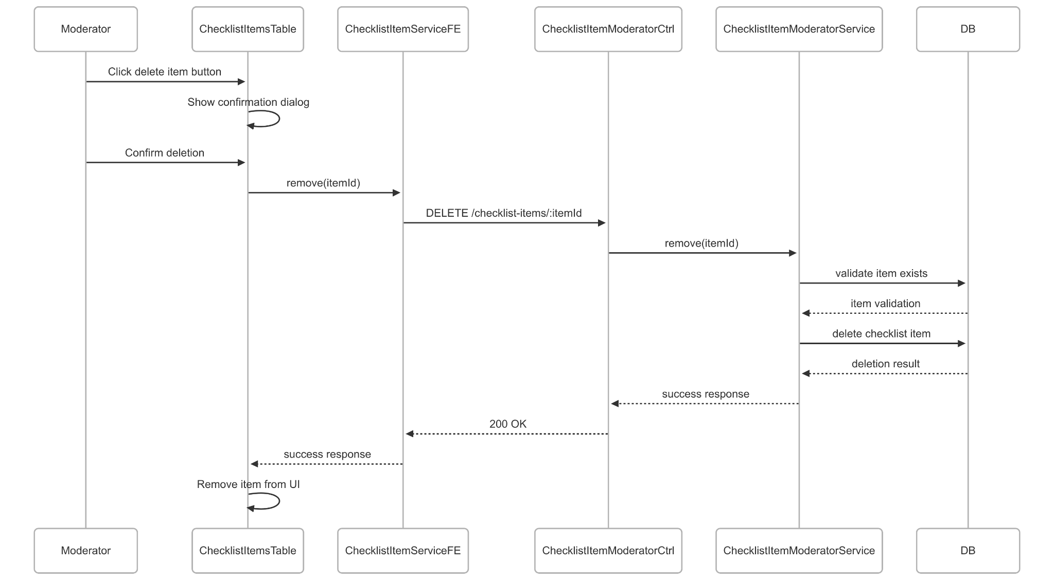](https://drive.google.com/file/d/1nkp3NLEImLAcietu-NB77wpKdybDBgvY/view?usp=drive_link)

###### Figure IV.C.18.c.(7) - Delete Checklist Item Sequence Diagram

### Student Discover Suggested Theses (AI-Based)

#### Class Diagram

[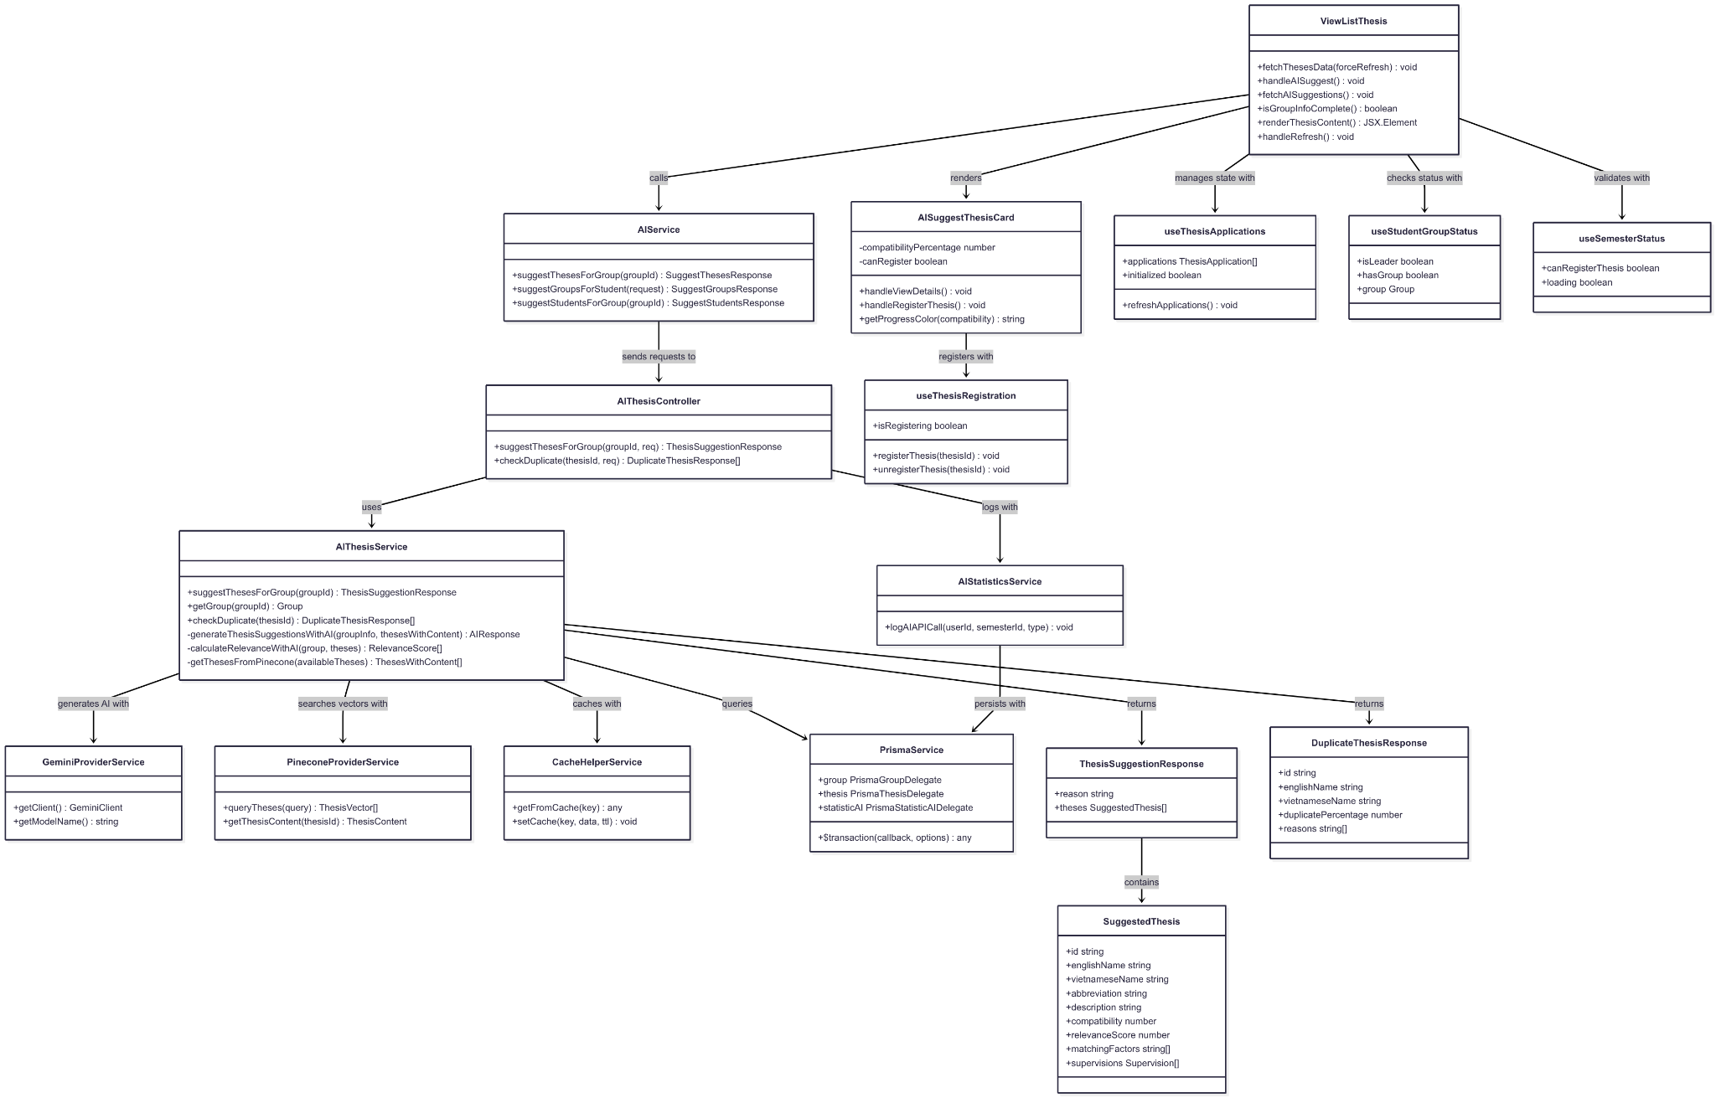](https://drive.google.com/file/d/1DDLQ5bRFs0Tz0TMxjXIYiLHVgDd8wj0-/view?usp=drive_link)

###### Figure IV.C.19.a - Student Discover Suggested Theses Class Diagram

#### Class Diagram Specification

| **No** | **Class** | **Method** | **Description** |
| --- | --- | --- | --- |
| 1 | AIThesisController | suggestThesesForGroup(groupId, req) | API endpoint to get AI-powered thesis suggestions for a specific group |
| 2 | AIThesisController | checkDuplicate(thesisId, req) | API endpoint to check for duplicate theses using AI analysis |
| 3 | AIThesisService | suggestThesesForGroup(groupId) | Core business logic to generate AI-powered thesis recommendations based on group profile |
| 4 | AIThesisService | getGroup(groupId) | Retrieve group information with members, skills, and responsibilities |
| 5 | AIThesisService | checkDuplicate(thesisId) | Analyze thesis for potential duplicates using AI and vector similarity |
| 6 | AIThesisService | generateThesisSuggestionsWithAI(groupInfo, thesesWithContent) | Private method to generate thesis suggestions using Gemini AI |
| 7 | AIThesisService | calculateRelevanceWithAI(group, theses) | Private method to calculate relevance scores between group and theses using AI |
| 8 | AIThesisService | getThesesFromPinecone(availableTheses) | Private method to retrieve thesis content from Pinecone vector database |
| 9 | AIStatisticsService | logAIAPICall(userId, semesterId, type) | Log AI API usage for statistics and tracking purposes |
| 10 | GeminiProviderService | getClient() | Get configured Gemini AI client instance |
| 11 | GeminiProviderService | getModelName() | Get the configured Gemini AI model name |
| 12 | PineconeProviderService | queryTheses(query) | Query thesis vectors from Pinecone database for semantic search |
| 13 | PineconeProviderService | getThesisContent(thesisId) | Retrieve specific thesis content from Pinecone vector store |
| 14 | CacheHelperService | getFromCache(key) | Retrieve cached data to optimize duplicate check performance |
| 15 | CacheHelperService | setCache(key, data, ttl) | Store data in cache with time-to-live for performance optimization |
| 16 | ViewListThesis | fetchThesesData(forceRefresh) | Fetch available theses data from backend API |
| 17 | ViewListThesis | handleAISuggest() | Handle AI suggestion button click with group validation |
| 18 | ViewListThesis | fetchAISuggestions() | Fetch AI-powered thesis suggestions for current group |
| 19 | ViewListThesis | isGroupInfoComplete() | Check if group has required information for accurate AI suggestions |
| 20 | ViewListThesis | renderThesisContent() | Render thesis list or AI suggestions based on current view mode |
| 21 | ViewListThesis | handleRefresh() | Refresh thesis data and clear current state |
| 22 | AISuggestThesisCard | handleViewDetails() | Navigate to detailed thesis view page |
| 23 | AISuggestThesisCard | handleRegisterThesis() | Handle thesis registration for group leader |
| 24 | AISuggestThesisCard | getProgressColor(compatibility) | Get color for compatibility progress bar based on score |
| 25 | AIService | suggestThesesForGroup(groupId) | Frontend service method to call AI thesis suggestion API |
| 26 | AIService | suggestGroupsForStudent(request) | Frontend service method to get AI group suggestions for student |
| 27 | AIService | suggestStudentsForGroup(groupId) | Frontend service method to get AI student suggestions for group |
| 28 | useThesisApplications | refreshApplications() | Refresh thesis applications data from backend |
| 29 | useStudentGroupStatus | isLeader | Property indicating if current user is group leader |
| 30 | useStudentGroupStatus | hasGroup | Property indicating if current user has a group |
| 31 | useSemesterStatus | canRegisterThesis | Property indicating if thesis registration is allowed in current semester |
| 32 | useThesisRegistration | registerThesis(thesisId) | Register thesis for current group |
| 33 | useThesisRegistration | unregisterThesis(thesisId) | Unregister thesis from current group |
| 34 | PrismaService | $transaction(callback, options) | Execute database operations within atomic transaction |
| 35 | ThesisSuggestionResponse | reason | Property containing AI explanation for thesis recommendations |
| 36 | ThesisSuggestionResponse | theses | Property containing array of suggested theses with compatibility scores |
| 37 | SuggestedThesis | compatibility | Property containing AI-calculated compatibility score (0-1) |
| 38 | SuggestedThesis | relevanceScore | Property containing relevance score (0-100) based on group profile |
| 39 | SuggestedThesis | matchingFactors | Property containing array of specific reasons for thesis recommendation |
| 40 | DuplicateThesisResponse | duplicatePercentage | Property containing AI-calculated duplication percentage |
| 41 | DuplicateThesisResponse | reasons | Property containing specific reasons for duplication detection |

##### Table IV.C.19.b - Student Discover Suggested Theses Class Diagram Specification

#### Sequence Diagram

[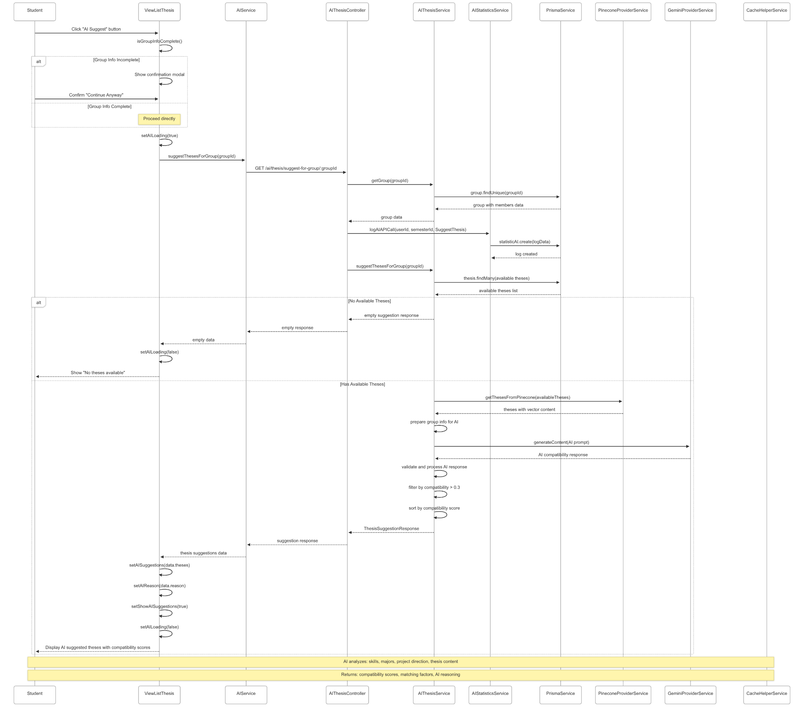](https://drive.google.com/file/d/1jKs2OVYyx98SHSM3AsHS1wsppoDJ59jk/view?usp=drive_link)

###### Figure IV.C.19.c - Student Discover Suggested Theses Sequence Diagram

### Student Join Groups

#### Class Diagram

[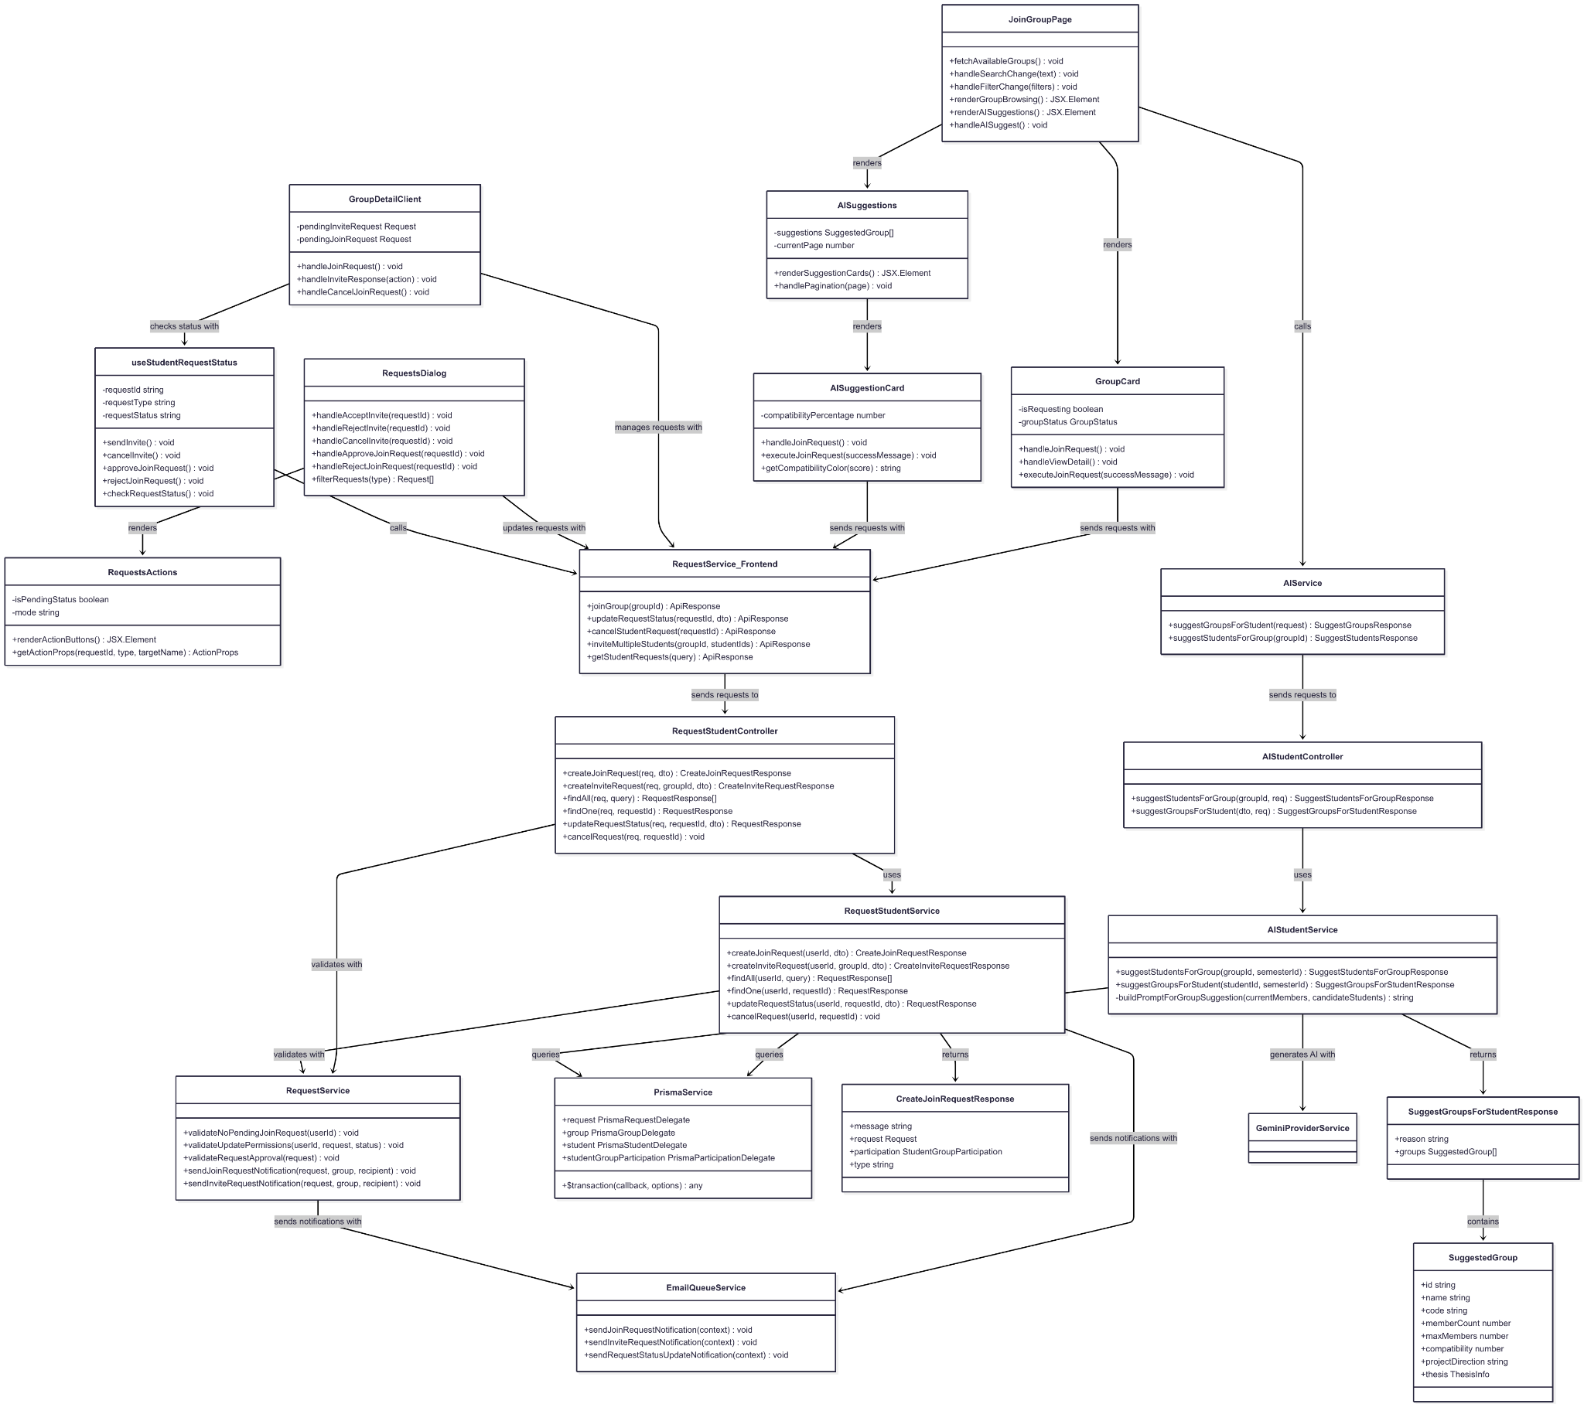](https://drive.google.com/file/d/1TGHpvfW9rsA4YcuJzrI1qoDWeLeXawqk/view?usp=drive_link)

###### Figure IV.C.20.a - Student Join Group Class Diagram

#### Class Diagram Specification

| **No** | **Class** | **Method** | **Description** |
| --- | --- | --- | --- |
| 1 | RequestStudentController | createJoinRequest(req, dto) | API endpoint to handle student join group requests with smart auto-join or request creation logic |
| 2 | RequestStudentController | createInviteRequest(req, groupId, dto) | API endpoint to create invitation requests from group leaders to students |
| 3 | RequestStudentController | findAll(req, query) | API endpoint to retrieve all requests for current student with filtering options |
| 4 | RequestStudentController | findOne(req, requestId) | API endpoint to get detailed information of specific request by ID |
| 5 | RequestStudentController | updateRequestStatus(req, requestId, dto) | API endpoint to update request status (approve/reject/cancel) with validation |
| 6 | RequestStudentController | cancelRequest(req, requestId) | API endpoint to cancel pending requests by student |
| 7 | RequestStudentService | createJoinRequest(userId, dto) | Business logic for joining groups with auto-join for empty groups or request creation |
| 8 | RequestStudentService | createInviteRequest(userId, groupId, dto) | Business logic for creating invitation requests with validation and notifications |
| 9 | RequestStudentService | findAll(userId, query) | Retrieve all requests for student with filtering by type and status |
| 10 | RequestStudentService | findOne(userId, requestId) | Get detailed request information with group and student data |
| 11 | RequestStudentService | updateRequestStatus(userId, requestId, dto) | Update request status with permission validation and group participation creation |
| 12 | RequestStudentService | cancelRequest(userId, requestId) | Cancel pending request with proper validation and cleanup |
| 13 | AIStudentController | suggestStudentsForGroup(groupId, req) | API endpoint to get AI-powered student suggestions for group formation |
| 14 | AIStudentController | suggestGroupsForStudent(dto, req) | API endpoint to get AI-powered group suggestions for student based on profile |
| 15 | AIStudentService | suggestStudentsForGroup(groupId, semesterId) | Generate AI-powered student suggestions based on group needs and compatibility |
| 16 | AIStudentService | suggestGroupsForStudent(studentId, semesterId) | Generate AI-powered group suggestions based on student skills and preferences |
| 17 | AIStudentService | buildPromptForGroupSuggestion(currentMembers, candidateStudents) | Private method to build AI prompt for group suggestion analysis |
| 18 | RequestService | validateNoPendingJoinRequest(userId) | Validate that student has no existing pending join requests |
| 19 | RequestService | validateUpdatePermissions(userId, request, status) | Validate user permissions to update request status based on role and ownership |
| 20 | RequestService | validateRequestApproval(request) | Validate that request can be approved based on group capacity and semester status |
| 21 | RequestService | sendJoinRequestNotification(request, group, recipient) | Send email notification to group leader about new join request |
| 22 | RequestService | sendInviteRequestNotification(request, group, recipient) | Send email notification to student about invitation from group |
| 23 | JoinGroupPage | fetchAvailableGroups() | Fetch and display available groups for joining with pagination |
| 24 | JoinGroupPage | handleSearchChange(text) | Handle search input changes for group filtering |
| 25 | JoinGroupPage | handleFilterChange(filters) | Handle filter changes for group browsing (major, semester, etc.) |
| 26 | JoinGroupPage | renderGroupBrowsing() | Render group browsing interface with cards and filters |
| 27 | JoinGroupPage | renderAISuggestions() | Render AI-suggested groups section with reasoning |
| 28 | JoinGroupPage | handleAISuggest() | Handle AI suggestion button click and fetch recommendations |
| 29 | GroupCard | handleJoinRequest() | Handle join button click with confirmation modal |
| 30 | GroupCard | handleViewDetail() | Navigate to detailed group view page |
| 31 | GroupCard | executeJoinRequest(successMessage) | Execute join request API call with error handling |
| 32 | AISuggestions | renderSuggestionCards() | Render AI-suggested group cards with compatibility scores |
| 33 | AISuggestions | handlePagination(page) | Handle pagination for AI suggestions display |
| 34 | AISuggestionCard | handleJoinRequest() | Handle join request for AI-suggested group |
| 35 | AISuggestionCard | executeJoinRequest(successMessage) | Execute join request with compatibility-based logic |
| 36 | AISuggestionCard | getCompatibilityColor(score) | Get color coding for compatibility score display |
| 37 | GroupDetailClient | handleJoinRequest() | Handle join request from group detail page |
| 38 | GroupDetailClient | handleInviteResponse(action) | Handle accept/reject actions for received invitations |
| 39 | GroupDetailClient | handleCancelJoinRequest() | Handle cancellation of pending join request |
| 40 | RequestsDialog | handleAcceptInvite(requestId) | Handle accepting invitation with group membership creation |
| 41 | RequestsDialog | handleRejectInvite(requestId) | Handle rejecting invitation with status update |
| 42 | RequestsDialog | handleCancelInvite(requestId) | Handle canceling sent invitation by group leader |
| 43 | RequestsDialog | handleApproveJoinRequest(requestId) | Handle approving join request by group leader |
| 44 | RequestsDialog | handleRejectJoinRequest(requestId) | Handle rejecting join request by group leader |
| 45 | RequestsDialog | filterRequests(type) | Filter requests by type (Join/Invite) for display |
| 46 | RequestsActions | renderActionButtons() | Render appropriate action buttons based on request type and user role |
| 47 | RequestsActions | getActionProps(requestId, type, targetName) | Get action button properties based on context |
| 48 | useStudentRequestStatus | sendInvite() | Send invitation to student from current group |
| 49 | useStudentRequestStatus | cancelInvite() | Cancel sent invitation to student |
| 50 | useStudentRequestStatus | approveJoinRequest() | Approve incoming join request as group leader |
| 51 | useStudentRequestStatus | rejectJoinRequest() | Reject incoming join request as group leader |
| 52 | useStudentRequestStatus | checkRequestStatus() | Check current request status between student and group |
| 53 | RequestService_Frontend | joinGroup(groupId) | Frontend service method to send join group API request |
| 54 | RequestService_Frontend | updateRequestStatus(requestId, dto) | Frontend service method to update request status |
| 55 | RequestService_Frontend | cancelStudentRequest(requestId) | Frontend service method to cancel student request |
| 56 | RequestService_Frontend | inviteMultipleStudents(groupId, studentIds) | Frontend service method to send multiple invitations |
| 57 | RequestService_Frontend | getStudentRequests(query) | Frontend service method to fetch student requests with filtering |
| 58 | AIService | suggestGroupsForStudent(request) | Frontend service method to get AI group suggestions |
| 59 | AIService | suggestStudentsForGroup(groupId) | Frontend service method to get AI student suggestions |
| 60 | PrismaService | $transaction(callback, options) | Execute database operations within atomic transaction |
| 61 | EmailQueueService | sendJoinRequestNotification(context) | Queue join request notification email for delivery |
| 62 | EmailQueueService | sendInviteRequestNotification(context) | Queue invitation notification email for delivery |
| 63 | EmailQueueService | sendRequestStatusUpdateNotification(context) | Queue request status update notification email |
| 64 | CreateJoinRequestResponse | message | Property containing success/info message about join request result |
| 65 | CreateJoinRequestResponse | type | Property indicating result type (auto_join or request_sent) |
| 66 | SuggestGroupsForStudentResponse | reason | Property containing AI explanation for group recommendations |
| 67 | SuggestGroupsForStudentResponse | groups | Property containing array of suggested groups with compatibility scores |
| 68 | SuggestedGroup | compatibility | Property containing AI-calculated compatibility score for group matching |
| 69 | SuggestedGroup | memberCount | Property showing current number of members in suggested group |
| 70 | SuggestedGroup | projectDirection | Property containing group's project direction for matching assessment |

##### Table IV.C.20.b - Student Join Group Class Diagram Specification

#### Sequence Diagram

* + - * 1. Join Existing Group (Auto-join for Empty Group)

[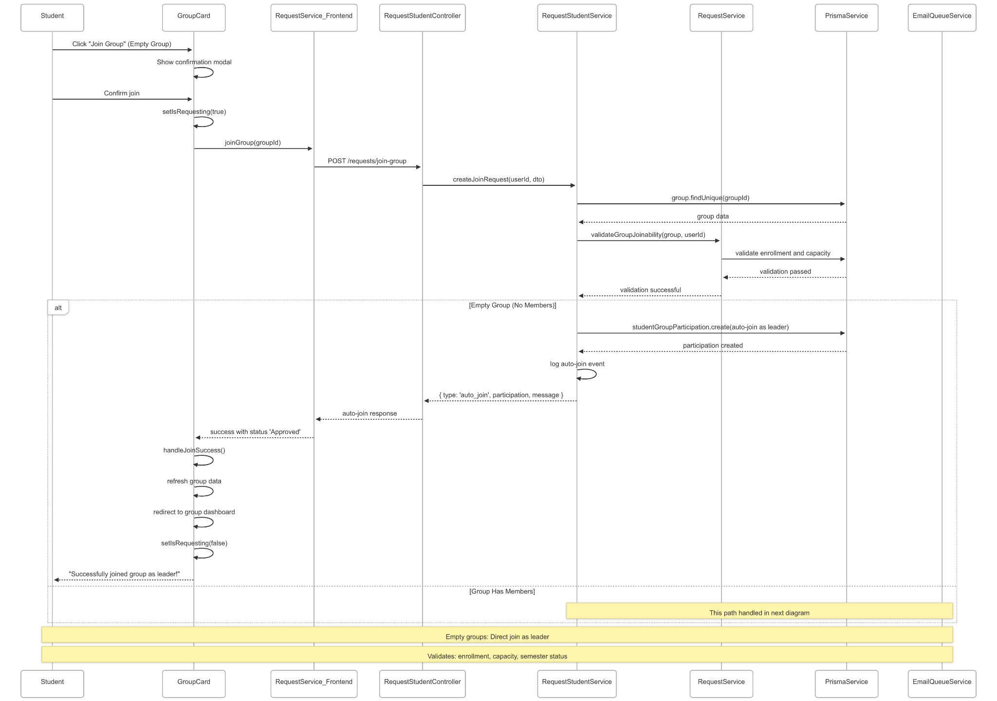](https://drive.google.com/file/d/13_t7q_YDBceaxJvqvzxXFIr74Q8HOkIH/view?usp=drive_link)

###### Figure IV.C.20.c.(1) - Join Existing Group Sequence Diagram

* + - * 1. Send Join Request (Group with Members)

[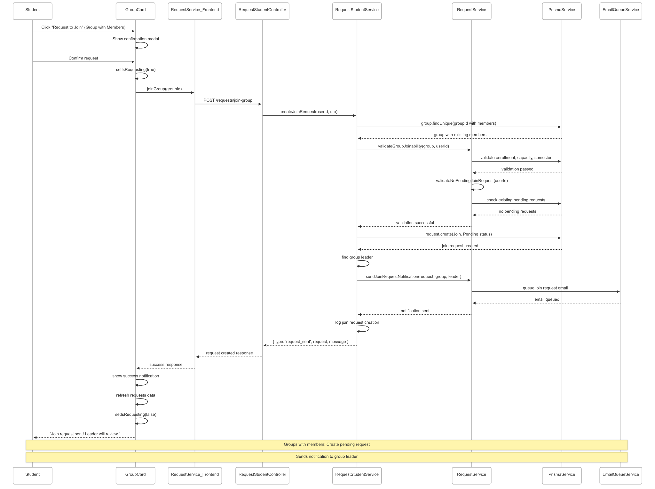](https://drive.google.com/file/d/1ORVqk61fIxb-bwb4PLNTc8FCGO-BE3KL/view?usp=drive_link)

###### Figure IV.C.20.c.(2) - Send Join Request Sequence Diagram

* + - * 1. AI Group Suggestions

[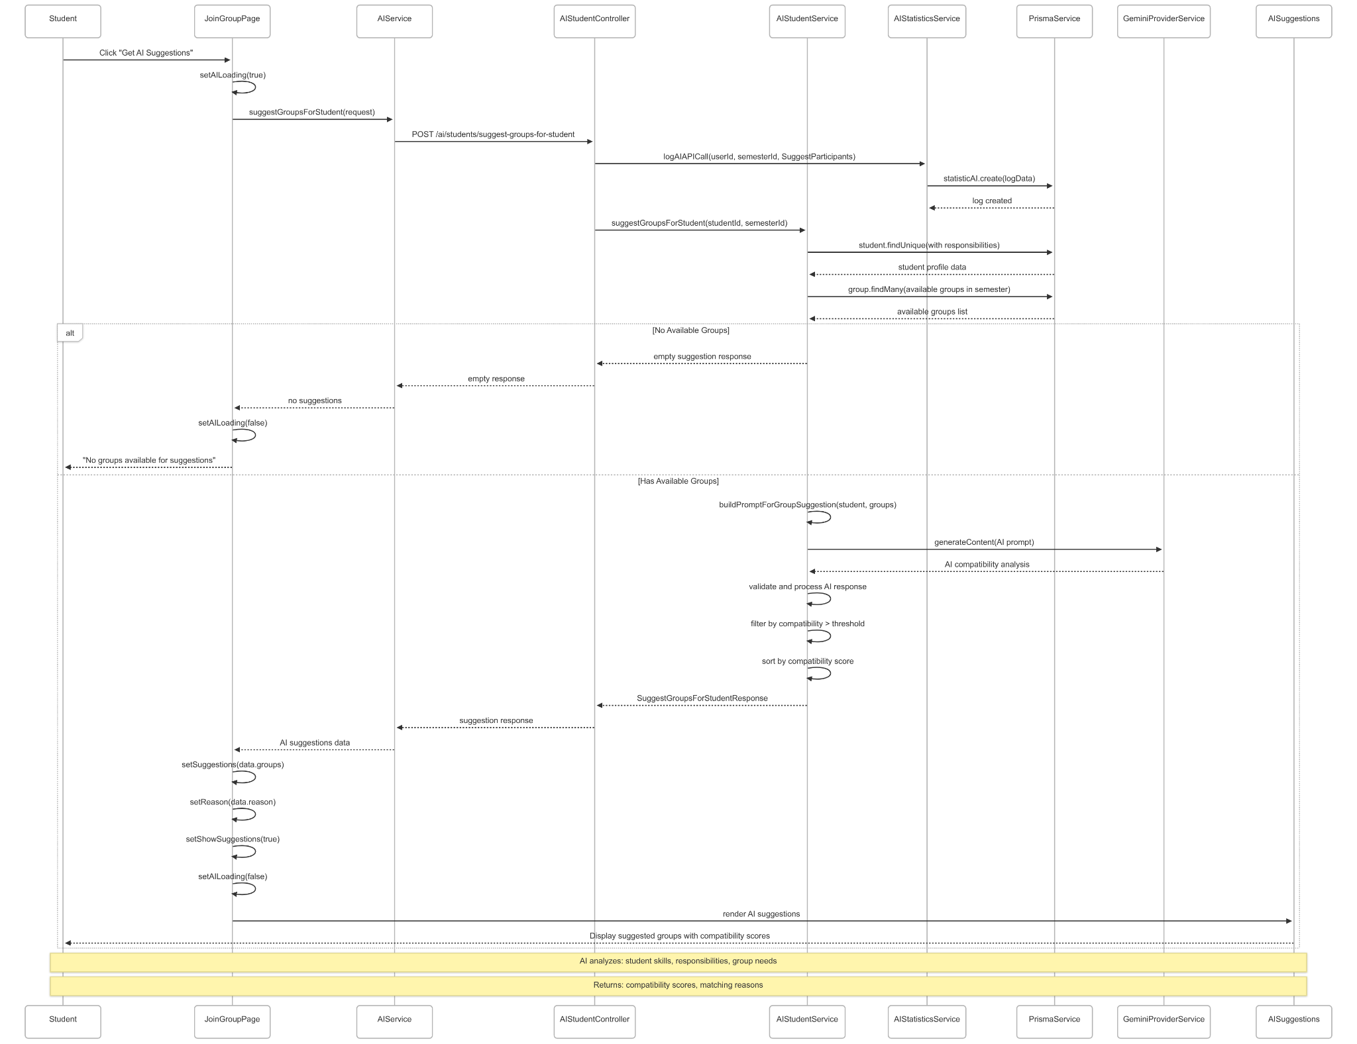](https://drive.google.com/file/d/15A6m7O63hmyfx_ubRYyq5GWJwwi2-2o-/view?usp=drive_link)

###### Figure IV.C.20.c.(3) - AI Group Suggestions Sequence Diagram

* + - * 1. Accept Invitation

[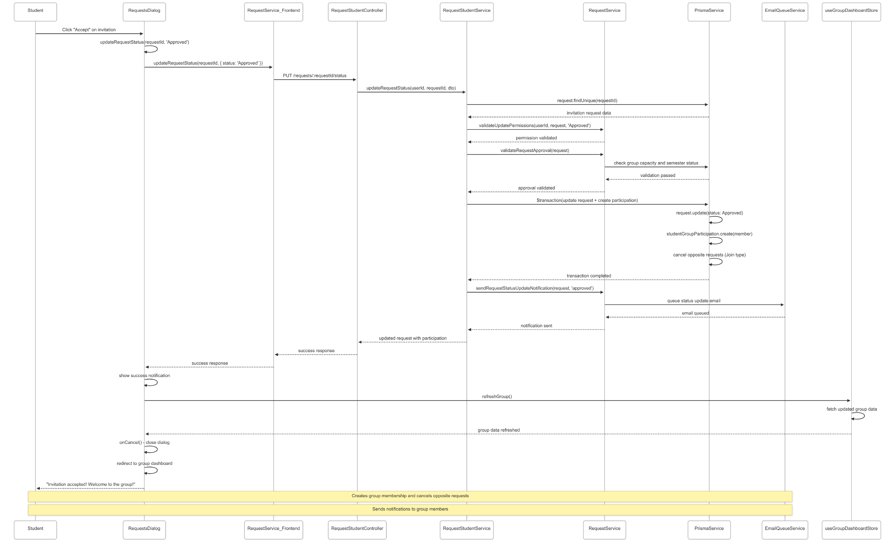](https://drive.google.com/file/d/1eM8J2a6mtvqka3nkIGaBrIfluUNy5glQ/view?usp=drive_link)

###### Figure IV.C.20.c.(4) - Accept Invitation Sequence Diagram

* + - * 1. Cancel Join Request

[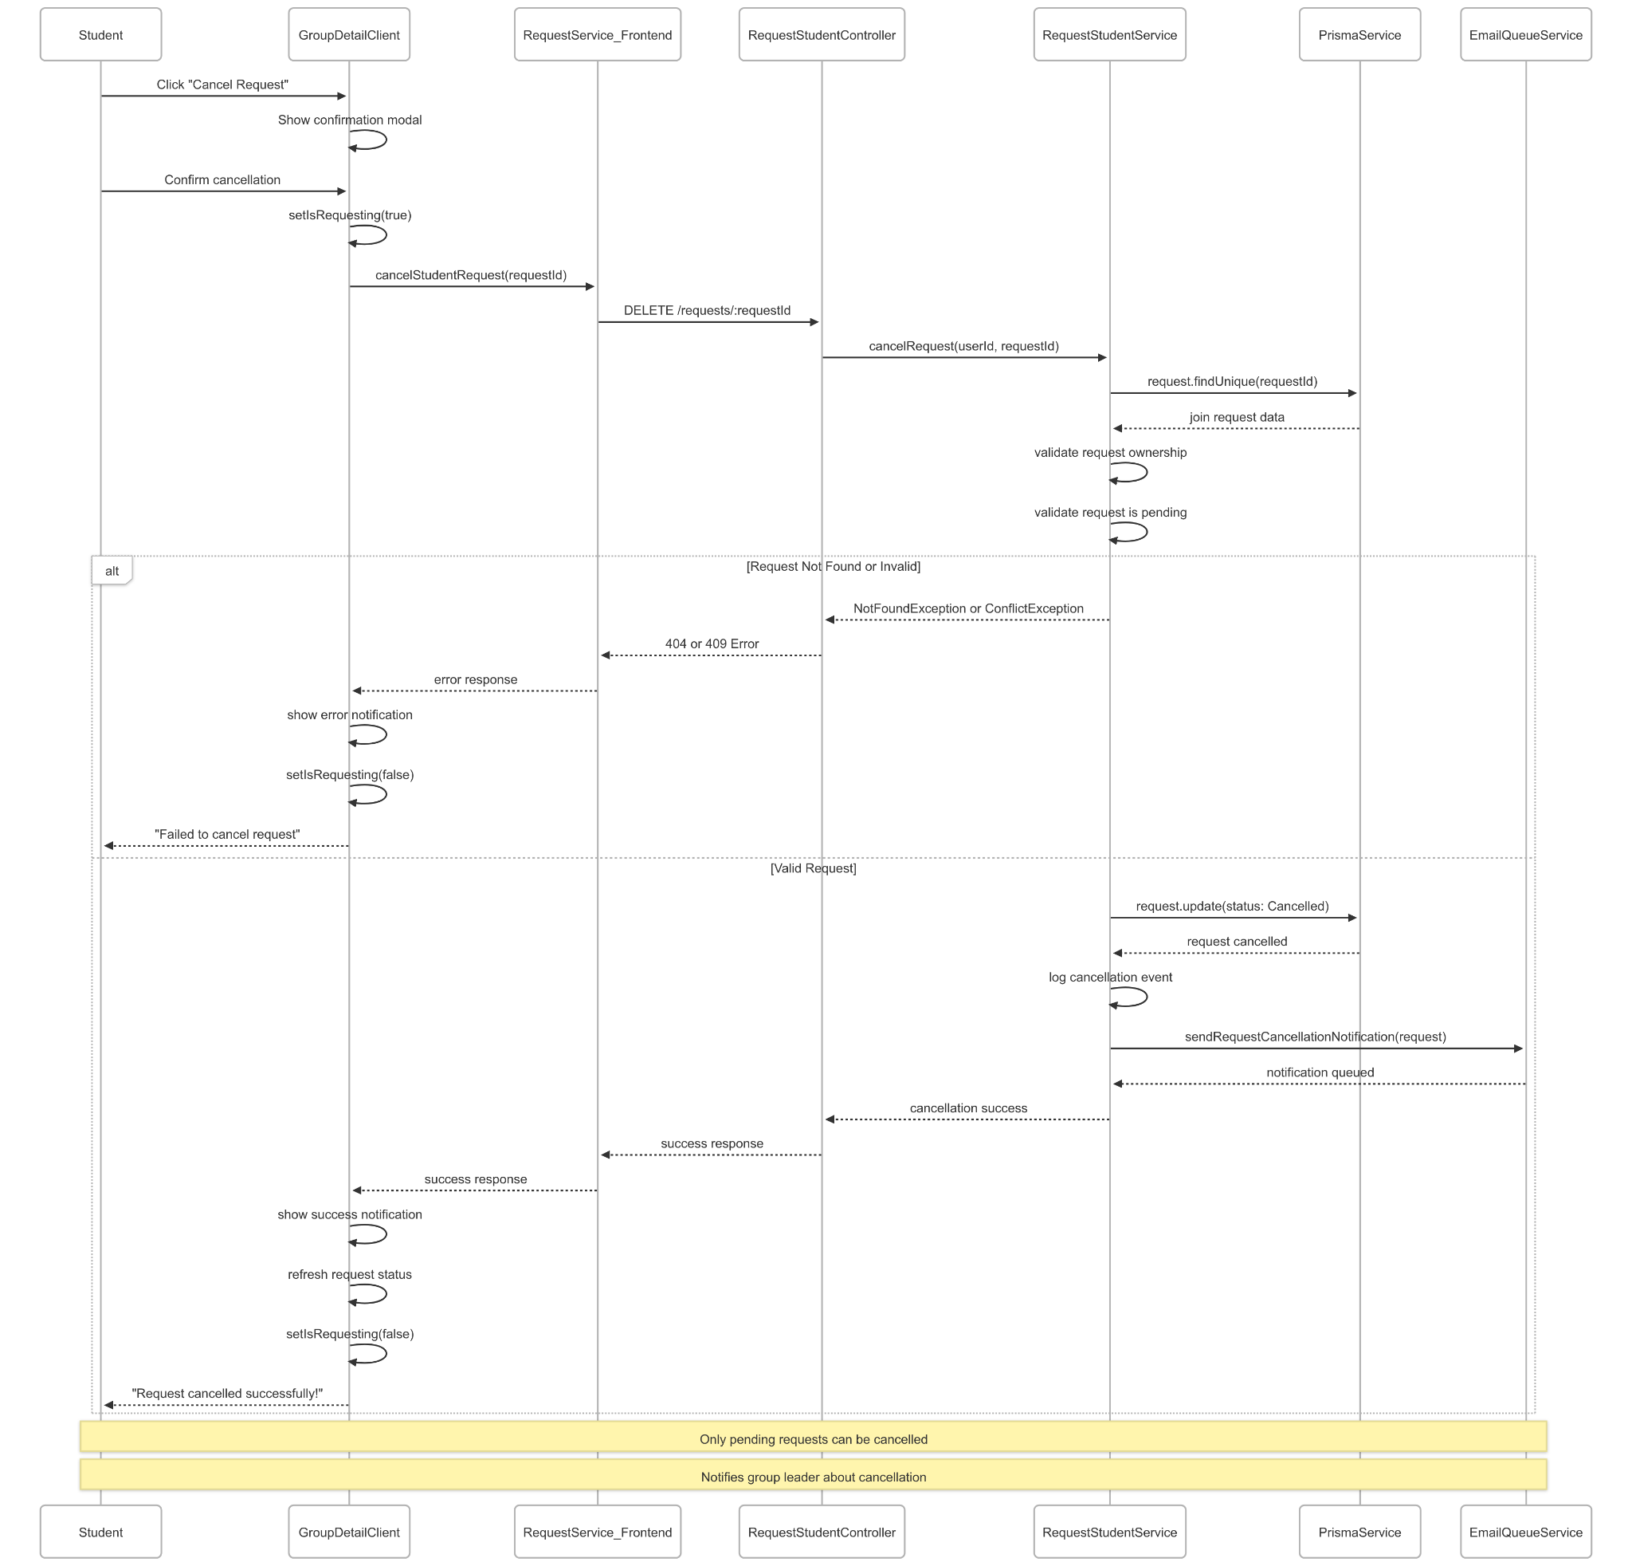](https://drive.google.com/file/d/1zaJA7gj8ohI-kCKfOD1m3qdAsK3DhTE8/view?usp=drive_link)

###### Figure IV.C.20.c.(5) - Cancel Join Request Sequence Diagram

* + - * 1. View Group Members

[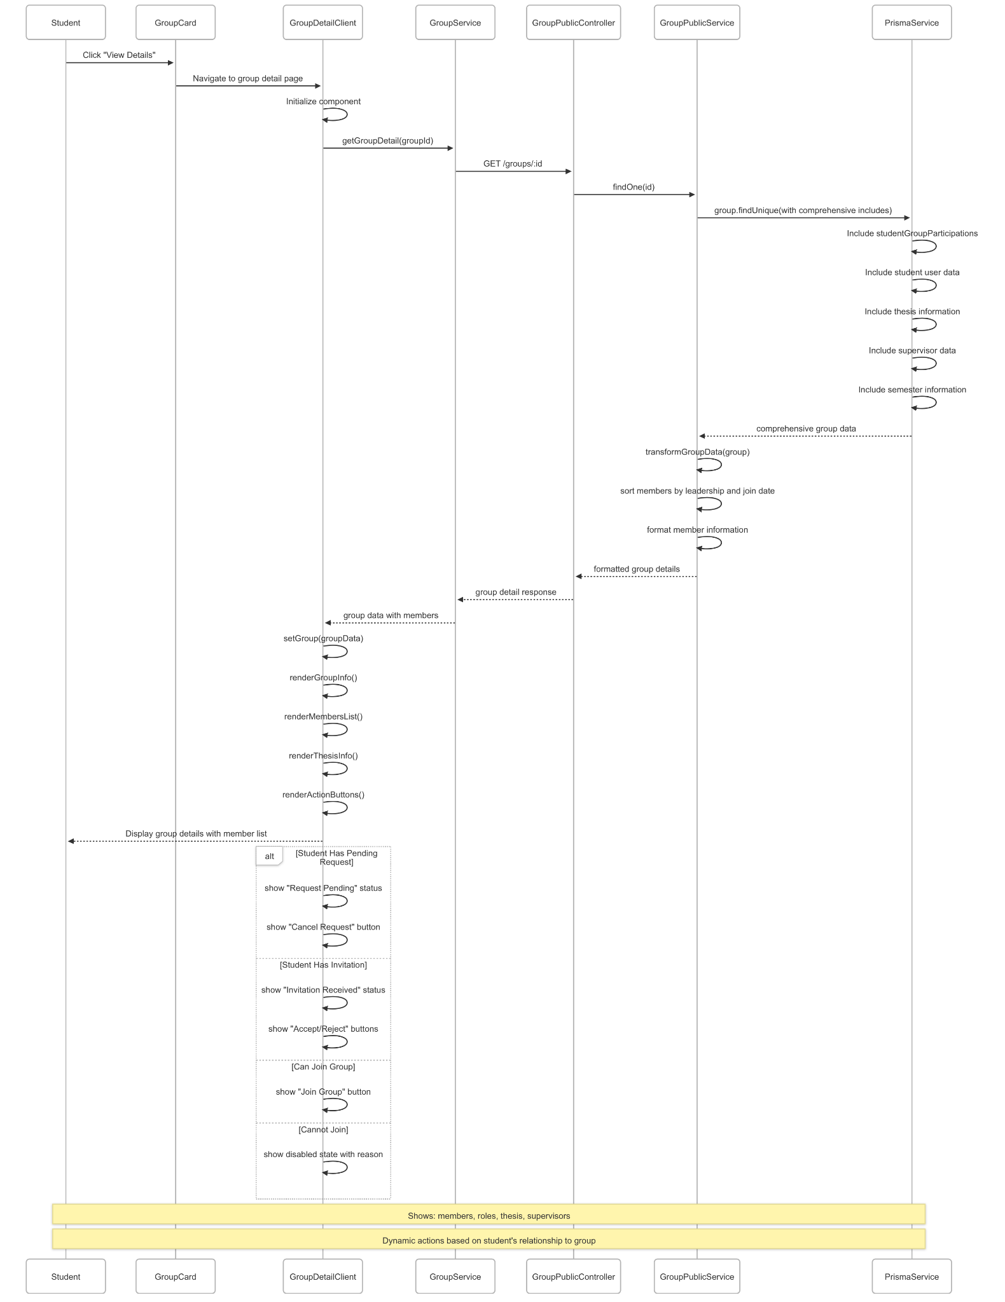](https://drive.google.com/file/d/1d3fK6ivvAWISD_8TIiRohhPOOWxtEN4n/view?usp=drive_link)

###### Figure IV.C.20.c.(6) - View Group Members Sequence Diagram

### Student Send Request to Apply Thesis

#### Class Diagram

[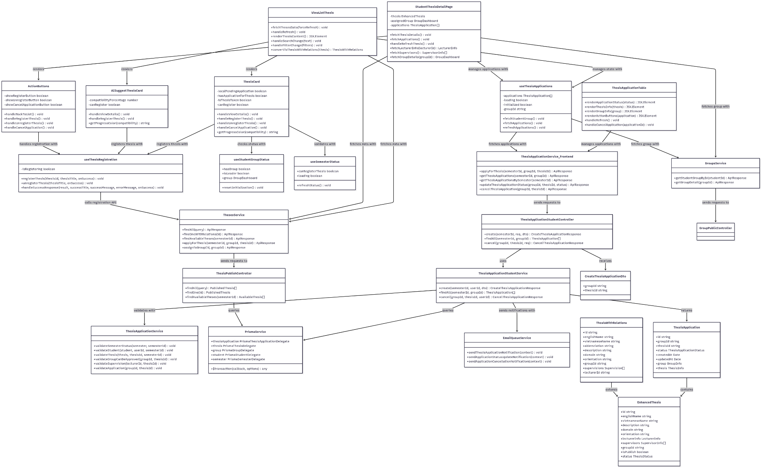](https://drive.google.com/file/d/1RkGi54yKlTLqZuOoCMCqlUWVmsyWB7er/view?usp=drive_link)

###### Figure IV.C.21.a - Student Send Request to Apply Thesis Class Diagram

#### Class Diagram Specification

| **No** | **Class** | **Method** | **Description** |
| --- | --- | --- | --- |
| 1 | ThesisApplicationStudentController | create(semesterId, req, dto) | API endpoint to create thesis application request from student group leader |
| 2 | ThesisApplicationStudentController | findAll(semesterId, groupId) | API endpoint to retrieve all thesis applications for specific group in semester |
| 3 | ThesisApplicationStudentController | cancel(groupId, thesisId, req) | API endpoint to cancel pending thesis application by group leader |
| 4 | ThesisApplicationStudentService | create(semesterId, userId, dto) | Business logic for creating thesis application with comprehensive validation |
| 5 | ThesisApplicationStudentService | findAll(semesterId, groupId) | Business logic to retrieve thesis applications with group and thesis details |
| 6 | ThesisApplicationStudentService | cancel(groupId, thesisId, userId) | Business logic for canceling thesis application with cleanup operations |
| 7 | ThesisApplicationService | validateSemesterStatus(semester, semesterId) | Validate that semester is in Picking phase for thesis applications |
| 8 | ThesisApplicationService | validateStudent(student, userId, semesterId) | Validate student enrollment and eligibility for thesis application |
| 9 | ThesisApplicationService | validateThesis(thesis, thesisId, semesterId) | Validate thesis availability, publication status, and assignment status |
| 10 | ThesisApplicationService | validateGroupCanBeApproved(groupId, thesisId) | Validate that group can be approved for specific thesis application |
| 11 | ThesisApplicationService | validateSupervision(lecturerId, thesisId) | Validate lecturer supervision relationship with thesis |
| 12 | ThesisApplicationService | validateApplication(groupId, thesisId) | Validate existing application status between group and thesis |
| 13 | ThesisPublishController | findAll(query) | API endpoint to retrieve all published theses with filtering options |
| 14 | ThesisPublishController | findOne(id) | API endpoint to get detailed information of specific published thesis |
| 15 | ThesisPublishController | findAvailableTheses(semesterId) | API endpoint to get available theses for application in specific semester |
| 16 | ViewListThesis | fetchThesesData(forceRefresh) | Fetch available theses data from backend with optional cache refresh |
| 17 | ViewListThesis | handleRefresh() | Handle refresh button click to reload thesis data |
| 18 | ViewListThesis | renderThesisContent() | Render thesis list or AI suggestions based on current view mode |
| 19 | ViewListThesis | handleSearchChange(text) | Handle search input changes for thesis filtering |
| 20 | ViewListThesis | handleFilterChange(filters) | Handle filter changes for thesis browsing (domain, supervisor, etc.) |
| 21 | ViewListThesis | convertToThesisWithRelations(thesis) | Convert thesis data to include relations for UI display |
| 22 | ThesisCard | handleViewDetails() | Navigate to detailed thesis view page |
| 23 | ThesisCard | handleRegisterThesis() | Handle thesis application submission with confirmation modal |
| 24 | ThesisCard | handleUnregisterThesis() | Handle thesis unregistration for assigned theses |
| 25 | ThesisCard | handleCancelApplication() | Handle cancellation of pending thesis application |
| 26 | ThesisCard | getProgressColor(compatibility) | Get color coding for compatibility or status display |
| 27 | AISuggestThesisCard | handleViewDetails() | Navigate to detailed view of AI-suggested thesis |
| 28 | AISuggestThesisCard | handleRegisterThesis() | Handle application for AI-suggested thesis |
| 29 | AISuggestThesisCard | getProgressColor(compatibility) | Get color coding for AI compatibility score display |
| 30 | StudentThesisDetailPage | fetchThesisDetails() | Fetch comprehensive thesis details with relations |
| 31 | StudentThesisDetailPage | fetchApplications() | Fetch thesis applications for current student group |
| 32 | StudentThesisDetailPage | handleRefreshThesis() | Handle refresh action to reload thesis and application data |
| 33 | StudentThesisDetailPage | fetchLecturerInfo(lecturerId) | Fetch detailed lecturer information for thesis |
| 34 | StudentThesisDetailPage | fetchSupervisors() | Fetch supervisor information for thesis |
| 35 | StudentThesisDetailPage | fetchGroupDetails(groupId) | Fetch detailed group information if thesis is assigned |
| 36 | ActionButtons | handleBackToList() | Navigate back to thesis list page |
| 37 | ActionButtons | handleRegisterThesis() | Handle thesis application submission from detail page |
| 38 | ActionButtons | handleUnregisterThesis() | Handle thesis unregistration from detail page |
| 39 | ActionButtons | handleCancelApplication() | Handle application cancellation from detail page |
| 40 | ThesisApplicationTable | renderApplicationStatus(status) | Render application status with appropriate styling and icons |
| 41 | ThesisApplicationTable | renderThesisInfo(thesis) | Render thesis information in table format |
| 42 | ThesisApplicationTable | renderGroupInfo(group) | Render group information in table format |
| 43 | ThesisApplicationTable | renderActionButtons(application) | Render action buttons based on application status |
| 44 | ThesisApplicationTable | handleRefresh() | Refresh thesis applications data |
| 45 | ThesisApplicationTable | handleCancelApplication(applicationId) | Handle cancellation of specific application |
| 46 | useThesisRegistration | registerThesis(thesisId, thesisTitle, onSuccess) | Handle thesis registration with confirmation modal and API call |
| 47 | useThesisRegistration | unregisterThesis(thesisTitle, onSuccess) | Handle thesis unregistration with confirmation modal |
| 48 | useThesisRegistration | handleSuccessResponse(result, successTitle, successMessage, errorMessage, onSuccess) | Handle API response with success/error notifications |
| 49 | useThesisApplications | fetchStudentGroup() | Fetch student's group information for application context |
| 50 | useThesisApplications | fetchApplications() | Fetch thesis applications for student's group |
| 51 | useThesisApplications | refreshApplications() | Refresh applications data and update state |
| 52 | useStudentGroupStatus | hasGroup | Property indicating if student is member of a group |
| 53 | useStudentGroupStatus | isLeader | Property indicating if student is group leader |
| 54 | useStudentGroupStatus | resetInitialization() | Reset group status initialization for data refresh |
| 55 | useSemesterStatus | canRegisterThesis | Property indicating if thesis registration is allowed in current semester |
| 56 | useSemesterStatus | refreshStatus() | Refresh semester status information |
| 57 | ThesisApplicationService_Frontend | applyForThesis(semesterId, groupId, thesisId) | Frontend service method to submit thesis application |
| 58 | ThesisApplicationService_Frontend | getThesisApplications(semesterId, groupId) | Frontend service method to fetch group's thesis applications |
| 59 | ThesisApplicationService_Frontend | getThesisApplicationsBySemester(semesterId) | Frontend service method to fetch all applications in semester |
| 60 | ThesisApplicationService_Frontend | updateThesisApplicationStatus(groupId, thesisId, status) | Frontend service method to update application status |
| 61 | ThesisApplicationService_Frontend | cancelThesisApplication(groupId, thesisId) | Frontend service method to cancel thesis application |
| 62 | ThesesService | findAll(query) | Frontend service method to fetch all available theses with filtering |
| 63 | ThesesService | findOneWithRelations(id) | Frontend service method to fetch detailed thesis with relations |
| 64 | ThesesService | findAvailableTheses(semesterId) | Frontend service method to fetch available theses for semester |
| 65 | ThesesService | applyForThesis(semesterId, groupId, thesisId) | Frontend service method to submit thesis application |
| 66 | ThesesService | assignToGroup(id, groupId) | Frontend service method to assign thesis to group |
| 67 | GroupsService | getStudentGroupById(studentId) | Frontend service method to fetch student's group information |
| 68 | GroupsService | getGroupDetail(groupId) | Frontend service method to fetch detailed group information |
| 69 | PrismaService | $transaction(callback, options) | Execute database operations within atomic transaction |
| 70 | EmailQueueService | sendThesisApplicationNotification(context) | Queue thesis application notification email for delivery |
| 71 | EmailQueueService | sendApplicationStatusUpdateNotification(context) | Queue application status update notification email |
| 72 | EmailQueueService | sendApplicationCancellationNotification(context) | Queue application cancellation notification email |
| 73 | CreateThesisApplicationDto | groupId | Property containing group ID for thesis application |
| 74 | CreateThesisApplicationDto | thesisId | Property containing thesis ID for application |
| 75 | ThesisApplication | status | Property indicating current application status (Pending, Approved, Rejected, Cancelled) |
| 76 | ThesisApplication | createdAt | Property containing application creation timestamp |
| 77 | ThesisApplication | group | Property containing group information for application |
| 78 | ThesisApplication | thesis | Property containing thesis information for application |
| 79 | EnhancedThesis | lecturerInfo | Property containing detailed lecturer information |
| 80 | EnhancedThesis | supervisors | Property containing array of supervisor information |
| 81 | EnhancedThesis | isPublish | Property indicating if thesis is published and available |
| 82 | EnhancedThesis | groupId | Property containing assigned group ID if thesis is taken |
| 83 | ThesisWithRelations | supervisions | Property containing supervision relationships |
| 84 | ThesisWithRelations | abbreviation | Property containing thesis abbreviation for display |
| 85 | ThesisWithRelations | orientation | Property containing thesis orientation (AI, SE, Neutral) |

##### Table IV.C.21.b - Student Send Request to Apply Thesis Class Diagram Specification

#### Sequence Diagram

* + - * 1. Send Request Apply Thesis from Thesis List

[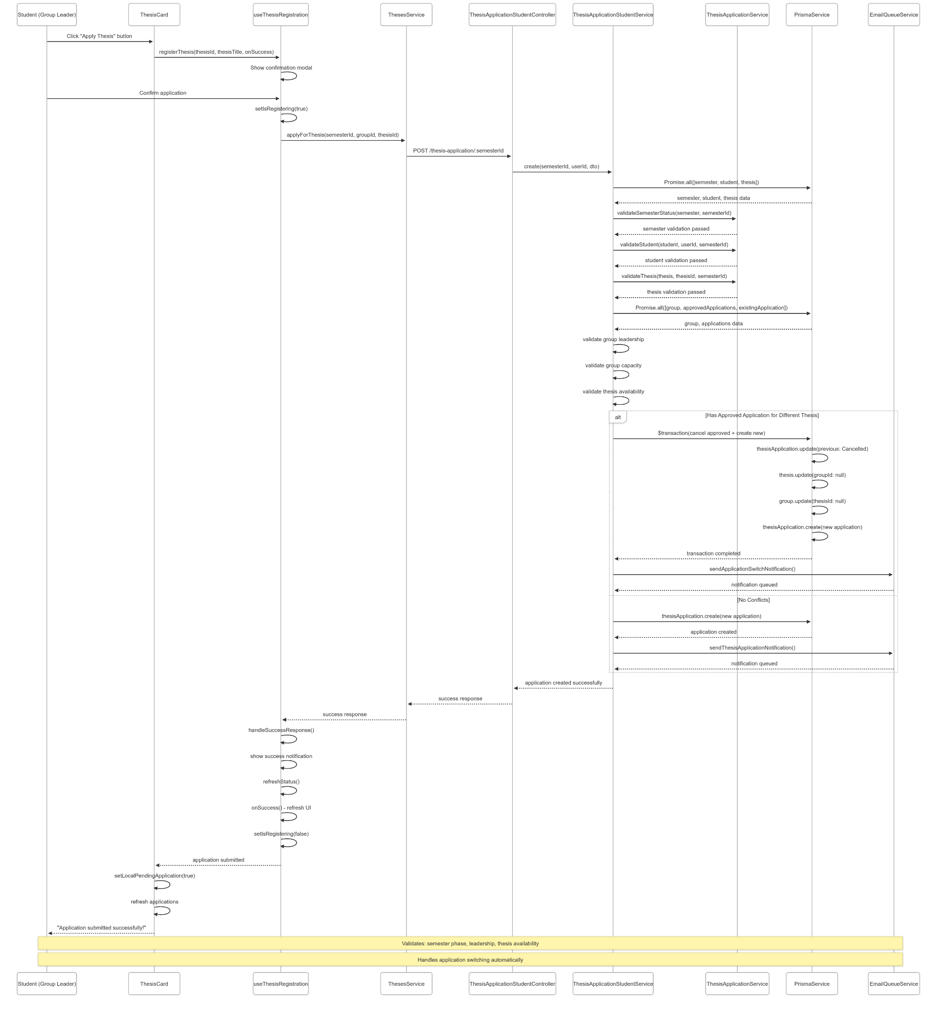](https://drive.google.com/file/d/1TxQ8Tn46ucwrCrsqh2BTavzecdHp3YQm/view?usp=drive_link)

###### Figure IV.C.21.c.(1) -Send Request Apply Thesis from Thesis List Sequence Diagram

* + - * 1. View Thesis Details

[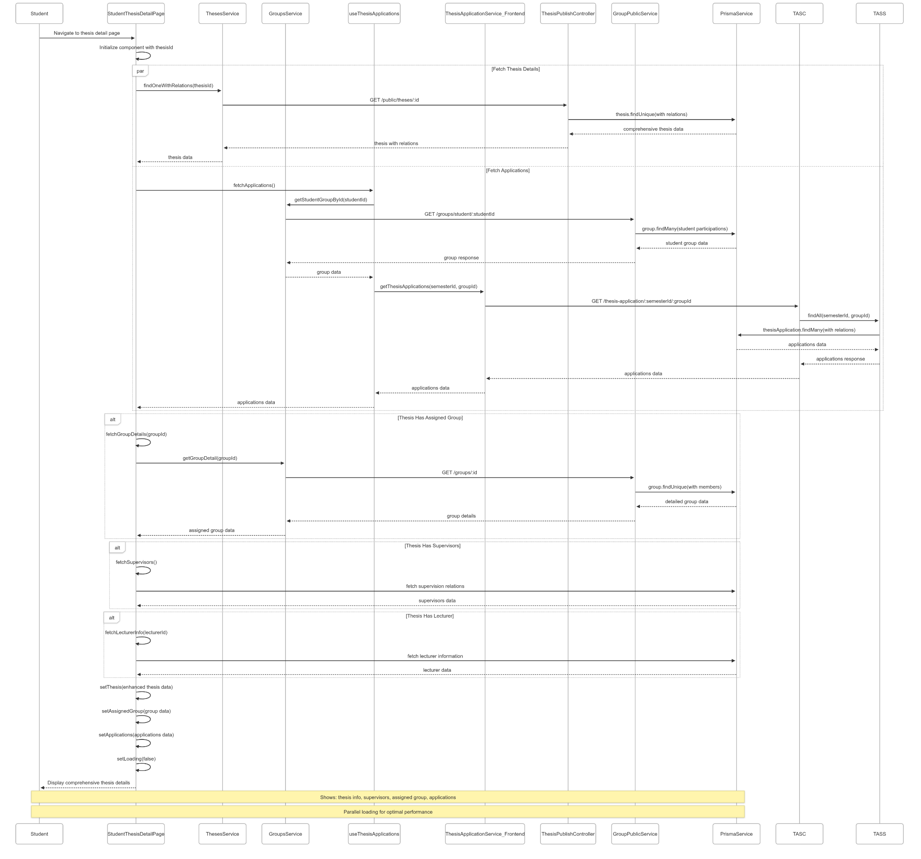](https://drive.google.com/file/d/1BJQkn2uBLnV8_1NAINW5Se5QJDjISWH4/view?usp=drive_link)

###### Figure IV.C.21.c.(2) - View Thesis Details Sequence Diagram

* + - * 1. View Thesis Applications Status

[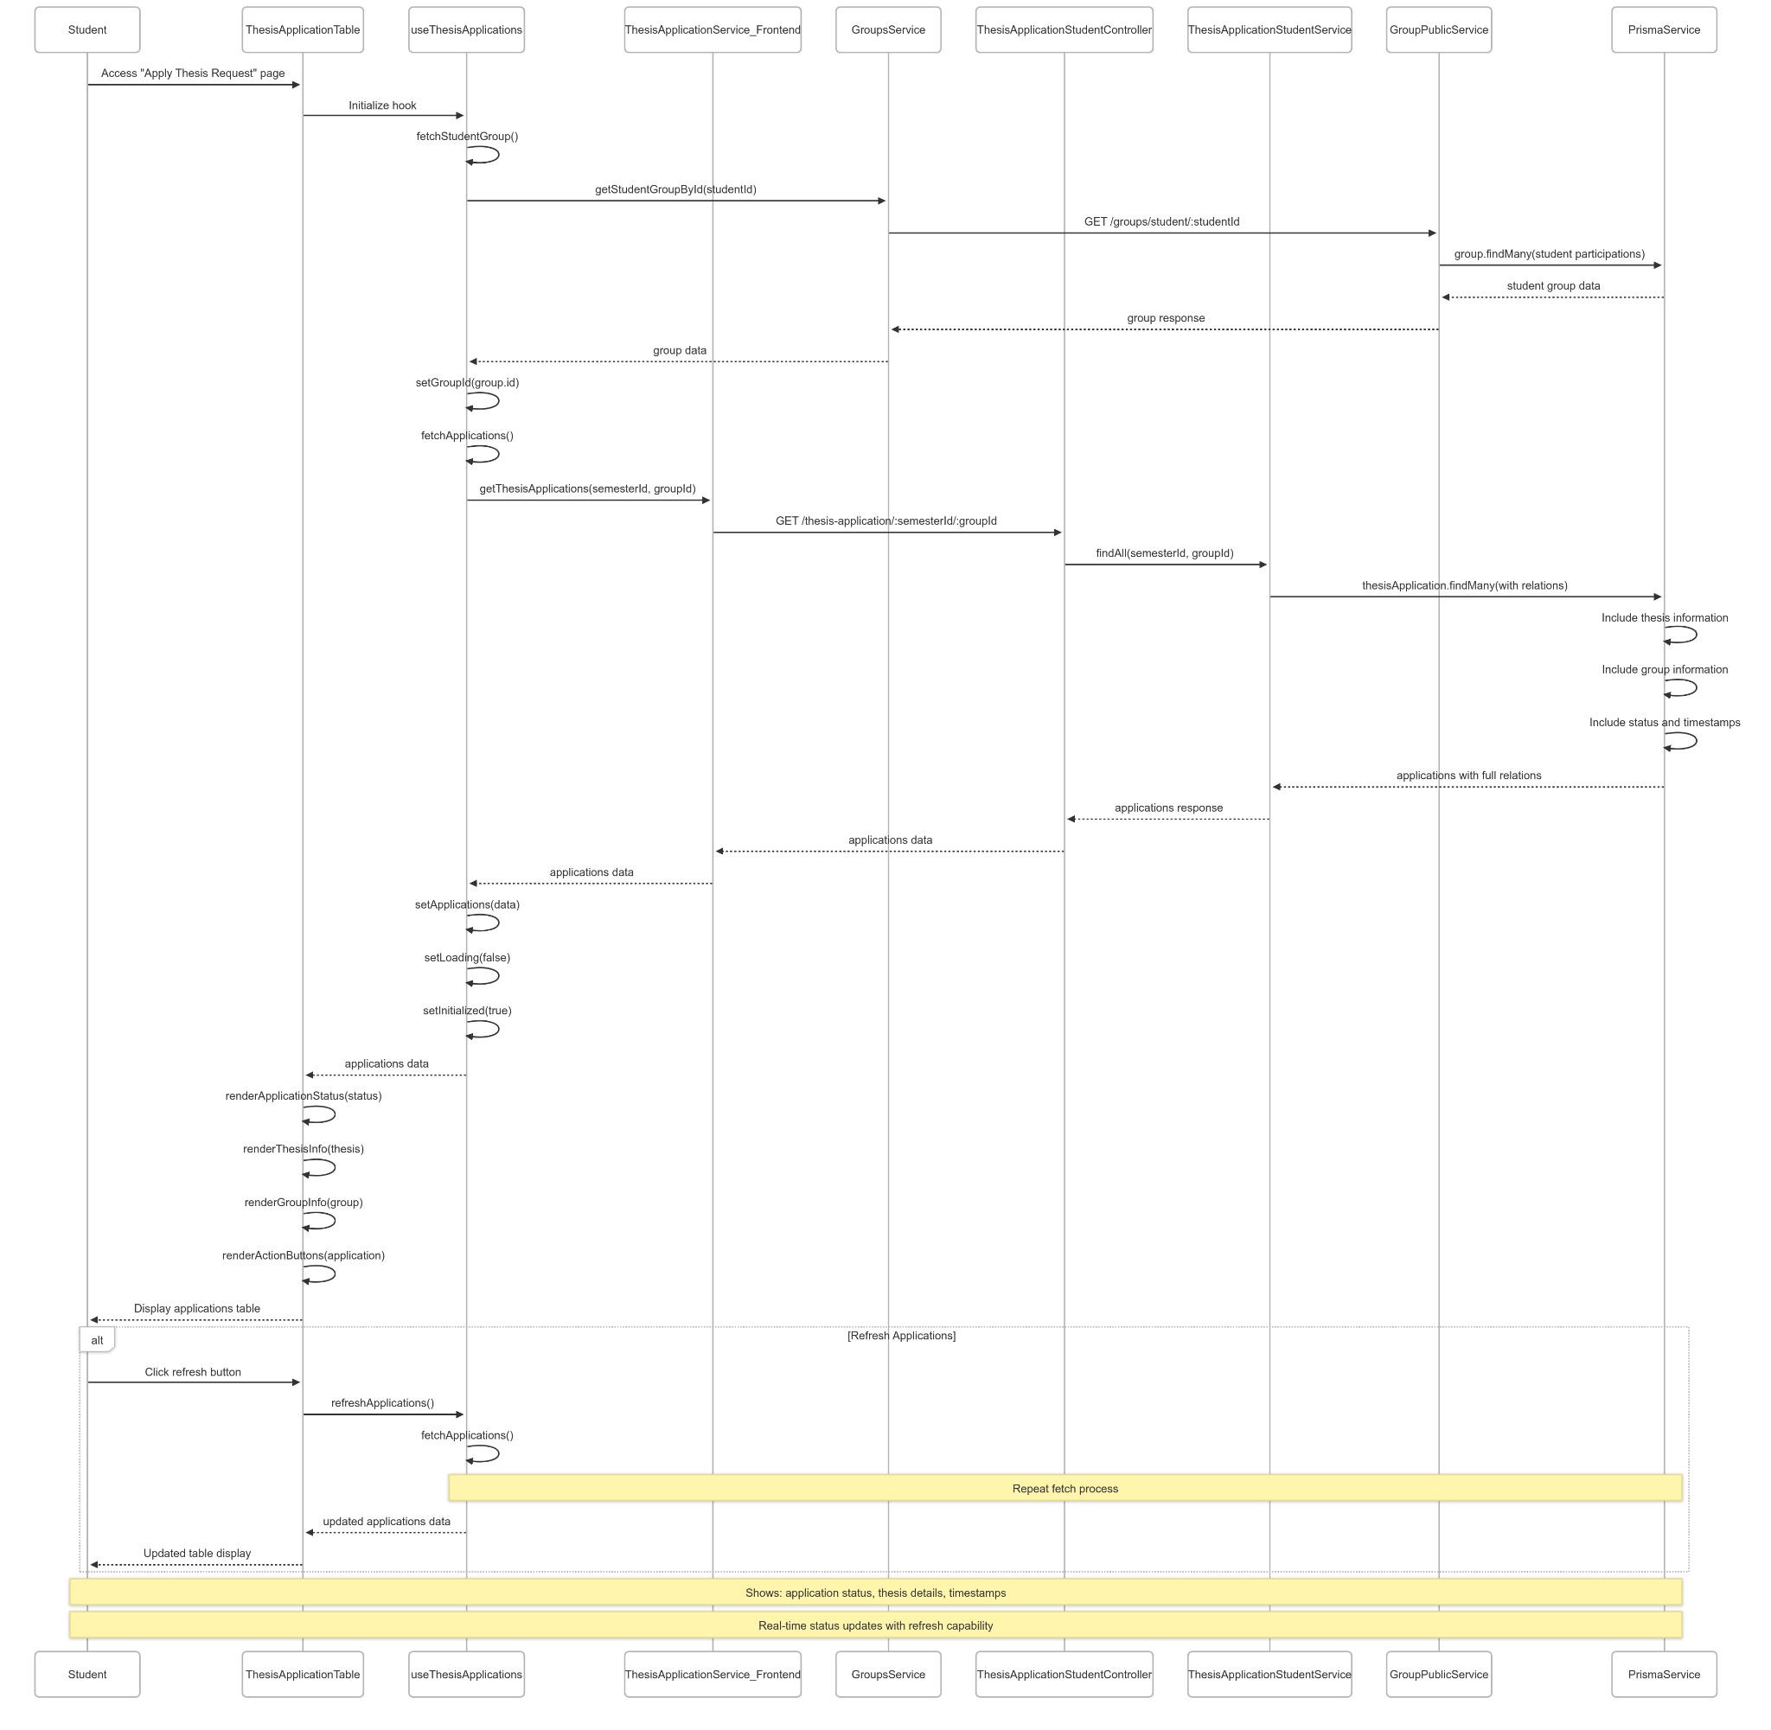](https://drive.google.com/file/d/1TgOQyMVzGW9X-aWUi7C0szeb_SIfph-C/view?usp=drive_link)

###### Figure IV.C.21.c.(3) - View Thesis Applications Status Sequence Diagram

* + - * 1. Cancel Thesis Application

[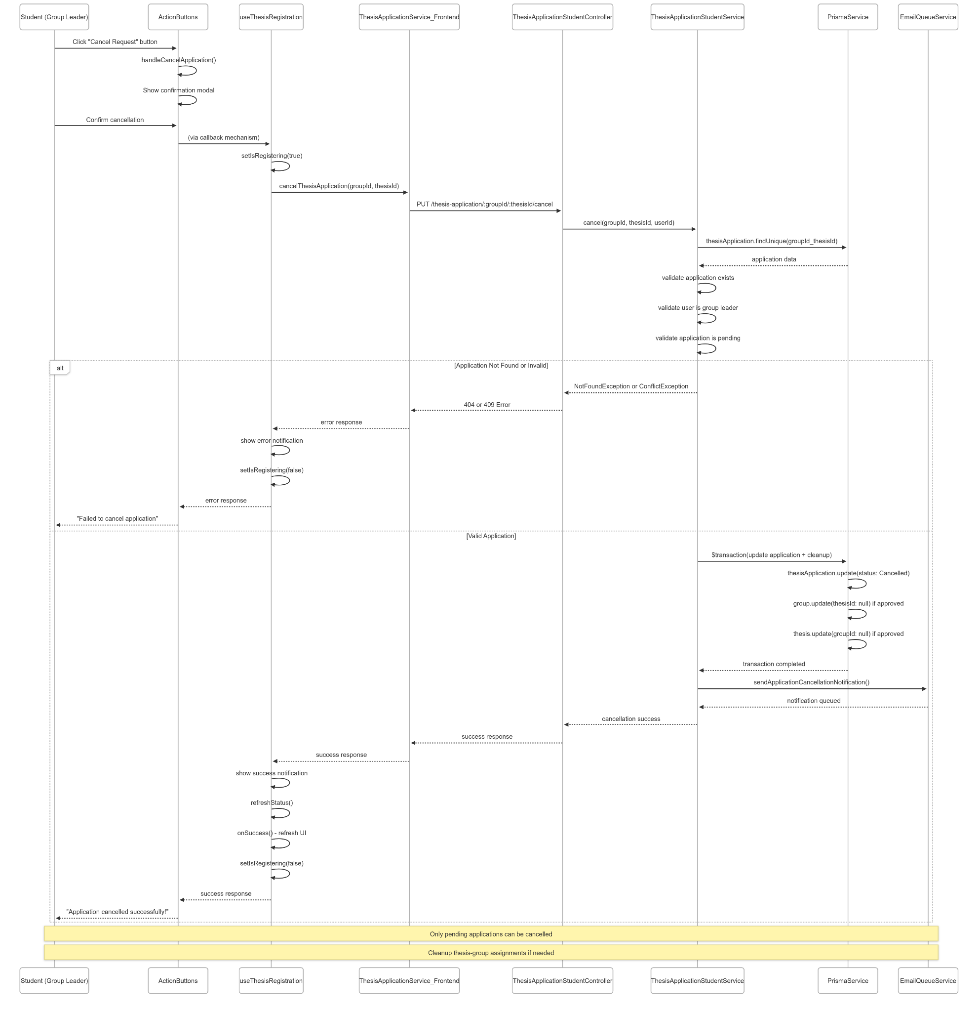](https://drive.google.com/file/d/14Igao31xmYrFXVxMw8lHM1CFugKke7yZ/view?usp=drive_link)

###### Figure IV.C.21.c.(4) - Cancel Thesis Application Sequence Diagram

* + - * 1. Unpick Thesis (After Approved Application)

[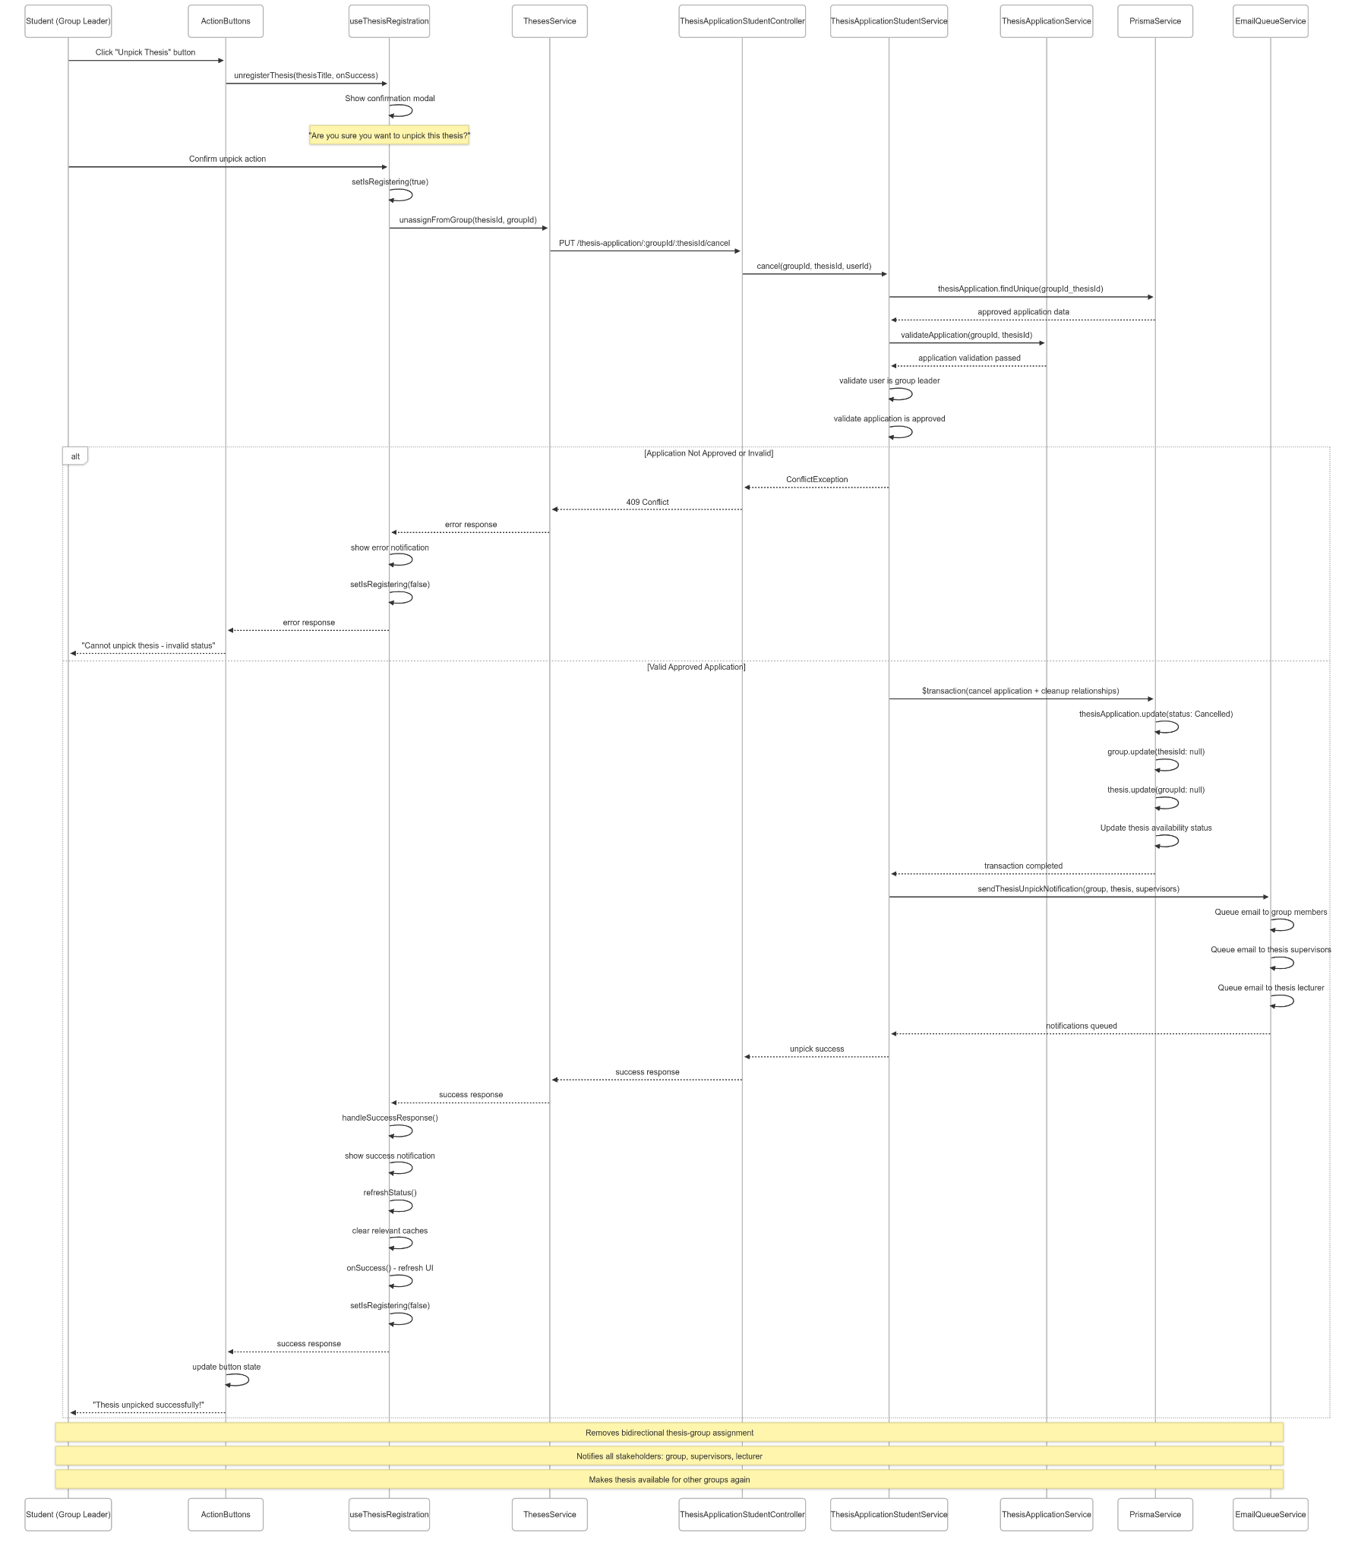](https://drive.google.com/file/d/1y6EtkeT-jVtUR85noMX3vkNiHM9yNiVB/view?usp=drive_link)

###### Figure IV.C.21.c.(5) - Unpick Thesis Sequence Diagram

### Student Track Progress and Submit Milestones

#### Class Diagram

[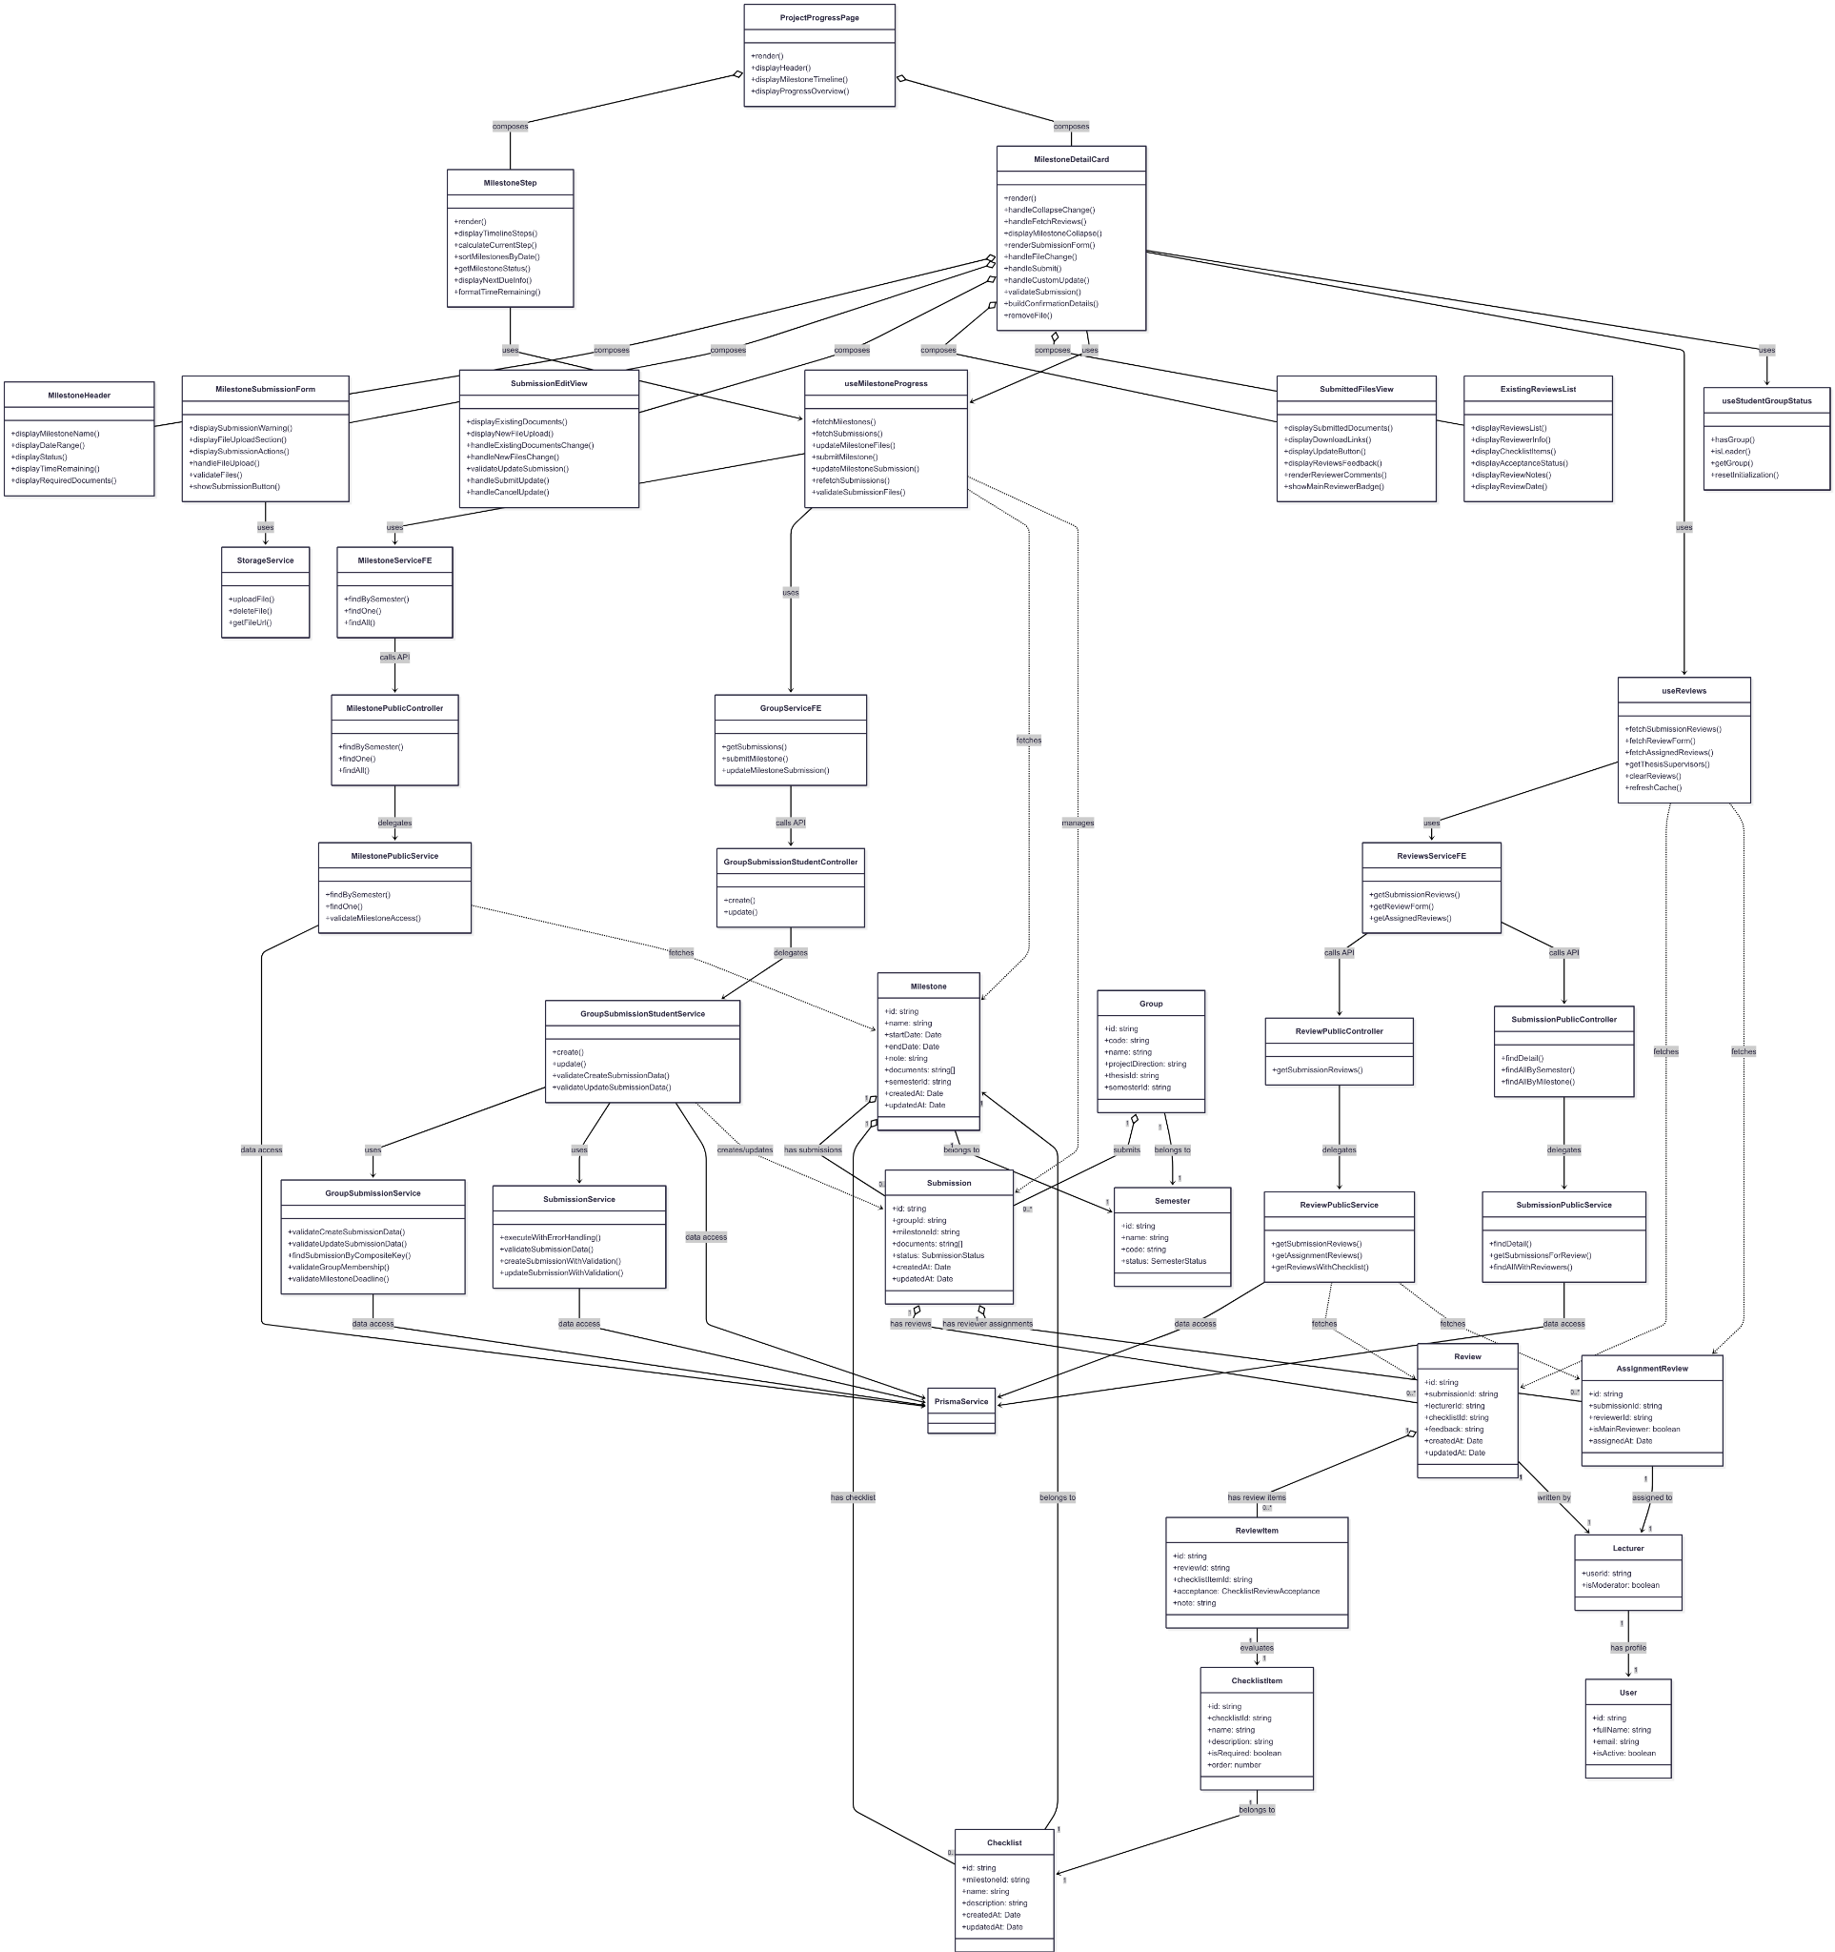](https://drive.google.com/file/d/16niGmWFIe_7FVgavZivCSrpGL2h-1I2N/view?usp=drive_link)

###### Figure IV.C.22.a - Student Track Progress and Submit Milestones Class Diagram

#### Class Diagram Specification

| **No** | **Class** | **Method** | **Description** |
| --- | --- | --- | --- |
| 1 | ProjectProgressPage | render() | Main page component displaying milestone timeline and progress overview |
| 2 | ProjectProgressPage | displayHeader() | Display page header with title and description for progress tracking |
| 3 | ProjectProgressPage | displayMilestoneTimeline() | Display the milestone timeline component showing project phases |
| 4 | ProjectProgressPage | displayProgressOverview() | Display progress overview card with thesis completion status |
| 5 | MilestoneStep | render() | Render the milestone timeline as a step-by-step progress indicator |
| 6 | MilestoneStep | displayTimelineSteps() | Display milestones as steps with finish/process/wait status |
| 7 | MilestoneStep | calculateCurrentStep() | Calculate which milestone is currently active or next |
| 8 | MilestoneStep | sortMilestonesByDate() | Sort milestones chronologically by start date |
| 9 | MilestoneStep | getMilestoneStatus() | Determine milestone status (Ended, In Progress, Upcoming) |
| 10 | MilestoneStep | displayNextDueInfo() | Display next due milestone with countdown timer |
| 11 | MilestoneStep | formatTimeRemaining() | Format time remaining until milestone deadline |
| 12 | MilestoneDetailCard | render() | Render collapsible cards for each milestone with submission forms |
| 13 | MilestoneDetailCard | handleCollapseChange() | Handle milestone panel expansion and fetch reviews |
| 14 | MilestoneDetailCard | handleFetchReviews() | Fetch reviewer feedback when milestone panel is opened |
| 15 | MilestoneDetailCard | displayMilestoneCollapse() | Display milestone information in collapsible panels |
| 16 | MilestoneDetailCard | renderSubmissionForm() | Render appropriate submission form based on status |
| 17 | MilestoneDetailCard | handleFileChange() | Handle file selection and validation for uploads |
| 18 | MilestoneDetailCard | handleSubmit() | Handle milestone submission with file upload |
| 19 | MilestoneDetailCard | handleCustomUpdate() | Handle updating existing submissions with new files |
| 20 | MilestoneDetailCard | validateSubmission() | Validate submission requirements before upload |
| 21 | MilestoneDetailCard | buildConfirmationDetails() | Build confirmation message for submission actions |
| 22 | MilestoneDetailCard | removeFile() | Remove selected file from upload list |
| 23 | MilestoneHeader | displayMilestoneName() | Display the milestone name and identifier |
| 24 | MilestoneHeader | displayDateRange() | Display milestone start and end dates |
| 25 | MilestoneHeader | displayStatus() | Display current milestone status (active, upcoming, ended) |
| 26 | MilestoneHeader | displayTimeRemaining() | Display countdown to milestone deadline |
| 27 | MilestoneHeader | displayRequiredDocuments() | Display list of required documents for milestone |
| 28 | MilestoneSubmissionForm | displaySubmissionWarning() | Display warning messages for submission requirements |
| 29 | MilestoneSubmissionForm | displayFileUploadSection() | Display file upload interface with drag-and-drop |
| 30 | MilestoneSubmissionForm | displaySubmissionActions() | Display submit and cancel buttons |
| 31 | MilestoneSubmissionForm | handleFileUpload() | Handle file selection and preview |
| 32 | MilestoneSubmissionForm | validateFiles() | Validate selected files before submission |
| 33 | MilestoneSubmissionForm | showSubmissionButton() | Show submit button based on eligibility |
| 34 | SubmissionEditView | displayExistingDocuments() | Display currently submitted documents with remove options |
| 35 | SubmissionEditView | displayNewFileUpload() | Display interface for adding new files to submission |
| 36 | SubmissionEditView | handleExistingDocumentsChange() | Handle changes to existing document selection |
| 37 | SubmissionEditView | handleNewFilesChange() | Handle new file selection for update |
| 38 | SubmissionEditView | validateUpdateSubmission() | Validate update submission requirements |
| 39 | SubmissionEditView | handleSubmitUpdate() | Submit updated submission with existing and new files |
| 40 | SubmissionEditView | handleCancelUpdate() | Cancel update mode and reset form |
| 41 | SubmittedFilesView | displaySubmittedDocuments() | Display list of submitted documents with download links |
| 42 | SubmittedFilesView | displayDownloadLinks() | Provide download functionality for submitted files |
| 43 | SubmittedFilesView | displayUpdateButton() | Show update submission button if allowed |
| 44 | SubmittedFilesView | displayReviewsFeedback() | Display reviewer feedback and comments |
| 45 | SubmittedFilesView | renderReviewerComments() | Render individual reviewer comments with timestamps |
| 46 | SubmittedFilesView | showMainReviewerBadge() | Highlight main reviewer with special badge |
| 47 | ExistingReviewsList | displayReviewsList() | Display list of all reviews for the submission |
| 48 | ExistingReviewsList | displayReviewerInfo() | Display reviewer name and role information |
| 49 | ExistingReviewsList | displayChecklistItems() | Display checklist items with acceptance status |
| 50 | ExistingReviewsList | displayAcceptanceStatus() | Display acceptance status for each checklist item |
| 51 | ExistingReviewsList | displayReviewNotes() | Display reviewer notes and feedback |
| 52 | ExistingReviewsList | displayReviewDate() | Display review submission date and time |
| 53 | useMilestoneProgress | fetchMilestones() | Fetch all milestones for current semester |
| 54 | useMilestoneProgress | fetchSubmissions() | Fetch all submissions for current group |
| 55 | useMilestoneProgress | updateMilestoneFiles() | Update local file state for milestone |
| 56 | useMilestoneProgress | submitMilestone() | Submit milestone with file upload to storage |
| 57 | useMilestoneProgress | updateMilestoneSubmission() | Update existing milestone submission |
| 58 | useMilestoneProgress | refetchSubmissions() | Refresh submission data after changes |
| 59 | useMilestoneProgress | validateSubmissionFiles() | Validate files before submission |
| 60 | useReviews | fetchSubmissionReviews() | Fetch reviewer feedback for specific submission |
| 61 | useReviews | fetchReviewForm() | Fetch review form structure with checklist |
| 62 | useReviews | fetchAssignedReviews() | Fetch all reviews assigned to current lecturer |
| 63 | useReviews | getThesisSupervisors() | Get supervisors for thesis to understand review context |
| 64 | useReviews | clearReviews() | Clear review data from state |
| 65 | useReviews | refreshCache() | Refresh cached review data |
| 66 | useStudentGroupStatus | hasGroup() | Check if student belongs to a group |
| 67 | useStudentGroupStatus | isLeader() | Check if student is group leader |
| 68 | useStudentGroupStatus | getGroup() | Get current student's group information |
| 69 | useStudentGroupStatus | resetInitialization() | Reset group status initialization |
| 70 | MilestoneServiceFE | findBySemester() | Fetch milestones for specific semester |
| 71 | MilestoneServiceFE | findOne() | Fetch single milestone details |
| 72 | MilestoneServiceFE | findAll() | Fetch all available milestones |
| 73 | GroupServiceFE | getSubmissions() | Fetch all submissions for specific group |
| 74 | GroupServiceFE | submitMilestone() | Submit milestone deliverables with documents |
| 75 | GroupServiceFE | updateMilestoneSubmission() | Update existing milestone submission |
| 76 | ReviewsServiceFE | getSubmissionReviews() | Fetch reviewer feedback for submission |
| 77 | ReviewsServiceFE | getReviewForm() | Fetch review form structure with checklist items |
| 78 | ReviewsServiceFE | getAssignedReviews() | Fetch reviews assigned to current user |
| 79 | StorageService | uploadFile() | Upload file to Supabase storage and return URL |
| 80 | StorageService | deleteFile() | Delete file from Supabase storage |
| 81 | StorageService | getFileUrl() | Generate download URL for stored file |
| 82 | MilestonePublicController | findBySemester() | API endpoint to get milestones by semester |
| 83 | MilestonePublicController | findOne() | API endpoint to get single milestone details |
| 84 | MilestonePublicController | findAll() | API endpoint to get all milestones |
| 85 | GroupSubmissionStudentController | create() | API endpoint to create new milestone submission |
| 86 | GroupSubmissionStudentController | update() | API endpoint to update existing milestone submission |
| 87 | ReviewPublicController | getSubmissionReviews() | API endpoint to get reviews for specific submission |
| 88 | SubmissionPublicController | findDetail() | API endpoint to get detailed submission information |
| 89 | SubmissionPublicController | findAllBySemester() | API endpoint to get submissions by semester |
| 90 | SubmissionPublicController | findAllByMilestone() | API endpoint to get submissions by milestone |
| 91 | MilestonePublicService | findBySemester() | Business logic to fetch milestones for semester |
| 92 | MilestonePublicService | findOne() | Business logic to fetch single milestone |
| 93 | MilestonePublicService | validateMilestoneAccess() | Validate user access to milestone data |
| 94 | GroupSubmissionStudentService | create() | Business logic to create milestone submission |
| 95 | GroupSubmissionStudentService | update() | Business logic to update milestone submission |
| 96 | GroupSubmissionStudentService | validateCreateSubmissionData() | Validate data for creating new submission |
| 97 | GroupSubmissionStudentService | validateUpdateSubmissionData() | Validate data for updating existing submission |
| 98 | GroupSubmissionService | validateCreateSubmissionData() | Validate submission creation requirements |
| 99 | GroupSubmissionService | validateUpdateSubmissionData() | Validate submission update requirements |
| 100 | GroupSubmissionService | findSubmissionByCompositeKey() | Find submission by group and milestone combination |
| 101 | GroupSubmissionService | validateGroupMembership() | Validate student membership in group |
| 102 | GroupSubmissionService | validateMilestoneDeadline() | Validate submission against milestone deadline |
| 103 | ReviewPublicService | getSubmissionReviews() | Business logic to fetch reviews for submission |
| 104 | ReviewPublicService | getAssignmentReviews() | Business logic to fetch reviewer assignments |
| 105 | ReviewPublicService | getReviewsWithChecklist() | Business logic to fetch reviews with checklist items |
| 106 | SubmissionPublicService | findDetail() | Business logic to fetch detailed submission information |
| 107 | SubmissionPublicService | getSubmissionsForReview() | Business logic to fetch submissions for review purposes |
| 108 | SubmissionPublicService | findAllWithReviewers() | Business logic to fetch submissions with reviewer information |
| 109 | SubmissionService | executeWithErrorHandling() | Execute submission operations with comprehensive error handling |
| 110 | SubmissionService | validateSubmissionData() | Validate submission data integrity |
| 111 | SubmissionService | createSubmissionWithValidation() | Create submission with full validation |
| 112 | SubmissionService | updateSubmissionWithValidation() | Update submission with full validation |
| 113 | PrismaService | Database operations | Provide data access layer for all milestone and submission operations |

##### Table IV.C.22.b - Student Track Progress and Submit Milestones Class Diagram Specification

#### Sequence Diagram

* + - * 1. View Milestone Deadlines

[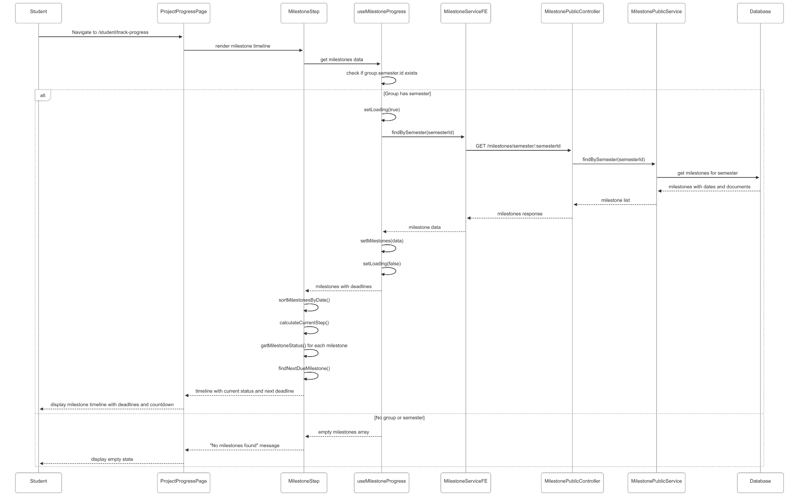](https://drive.google.com/file/d/1GWHfFNvyTvz3-ugudevjPIaVMB8cae5-/view?usp=drive_link)

###### Figure IV.C.22.c.(1) - View Milestone Deadlines Sequence Diagram

* + - * 1. Upload Deliverables

[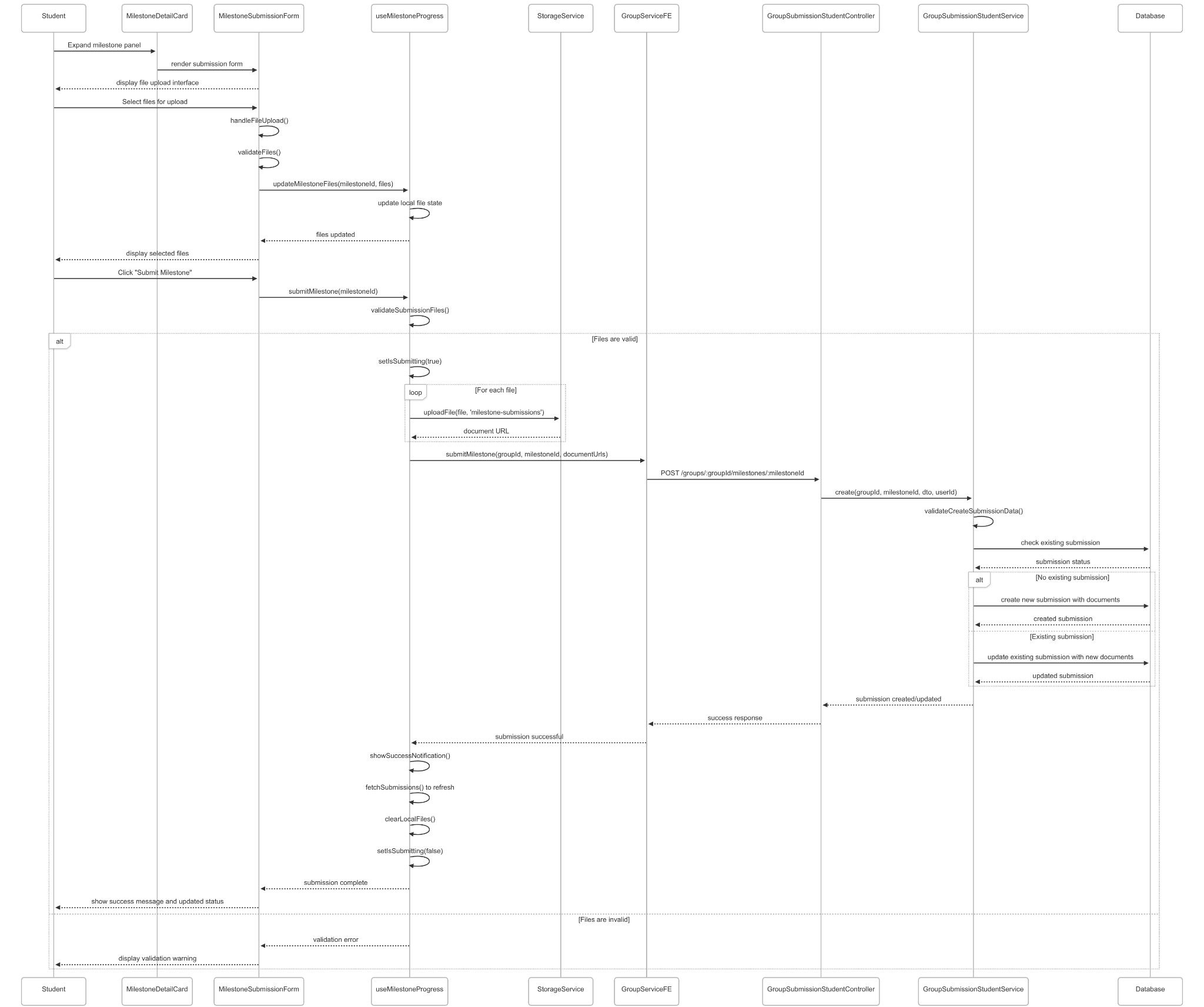](https://drive.google.com/file/d/1q3qewhNInfaSstO3vWWFfNMgmlsLNmyI/view?usp=drive_link)

###### Figure IV.C.22.c.(2) - Upload Deliverables Sequence Diagram

* + - * 1. View Reviewer Feedback and Checklist

[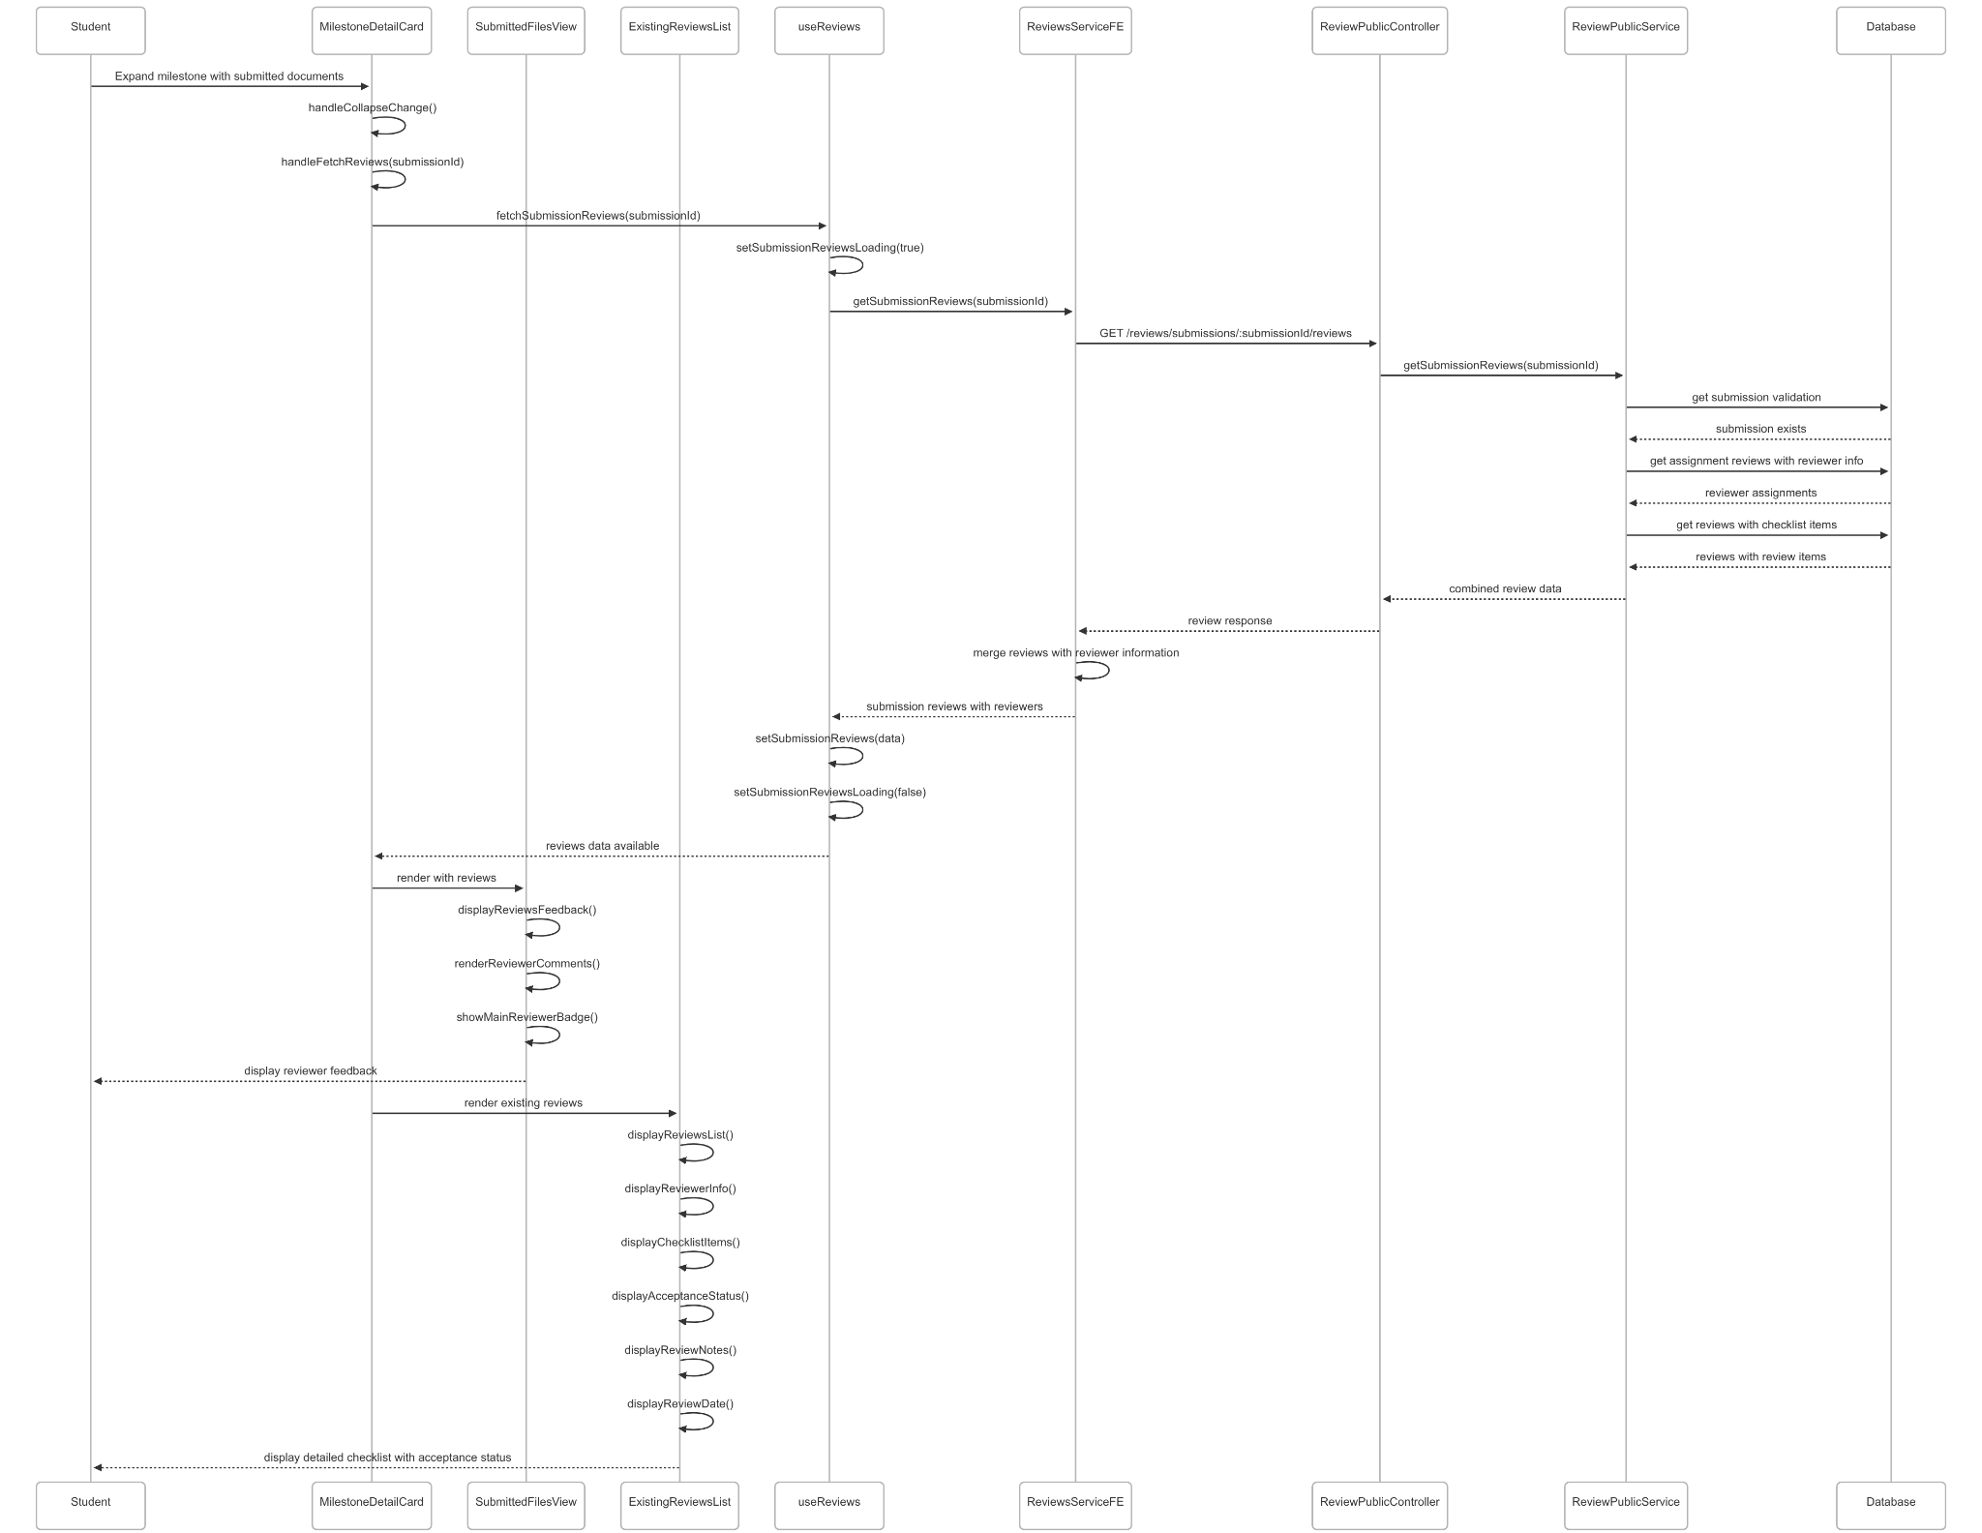](https://drive.google.com/file/d/1sHUjILfA1l6zwTJ219yo7GkyxH9g-Bmk/view?usp=drive_link)

###### Figure IV.C.22.c.(3) - View Reviewer Feedback and Checklist Sequence Diagram

* + - * 1. View Reviewer for each Milestone

[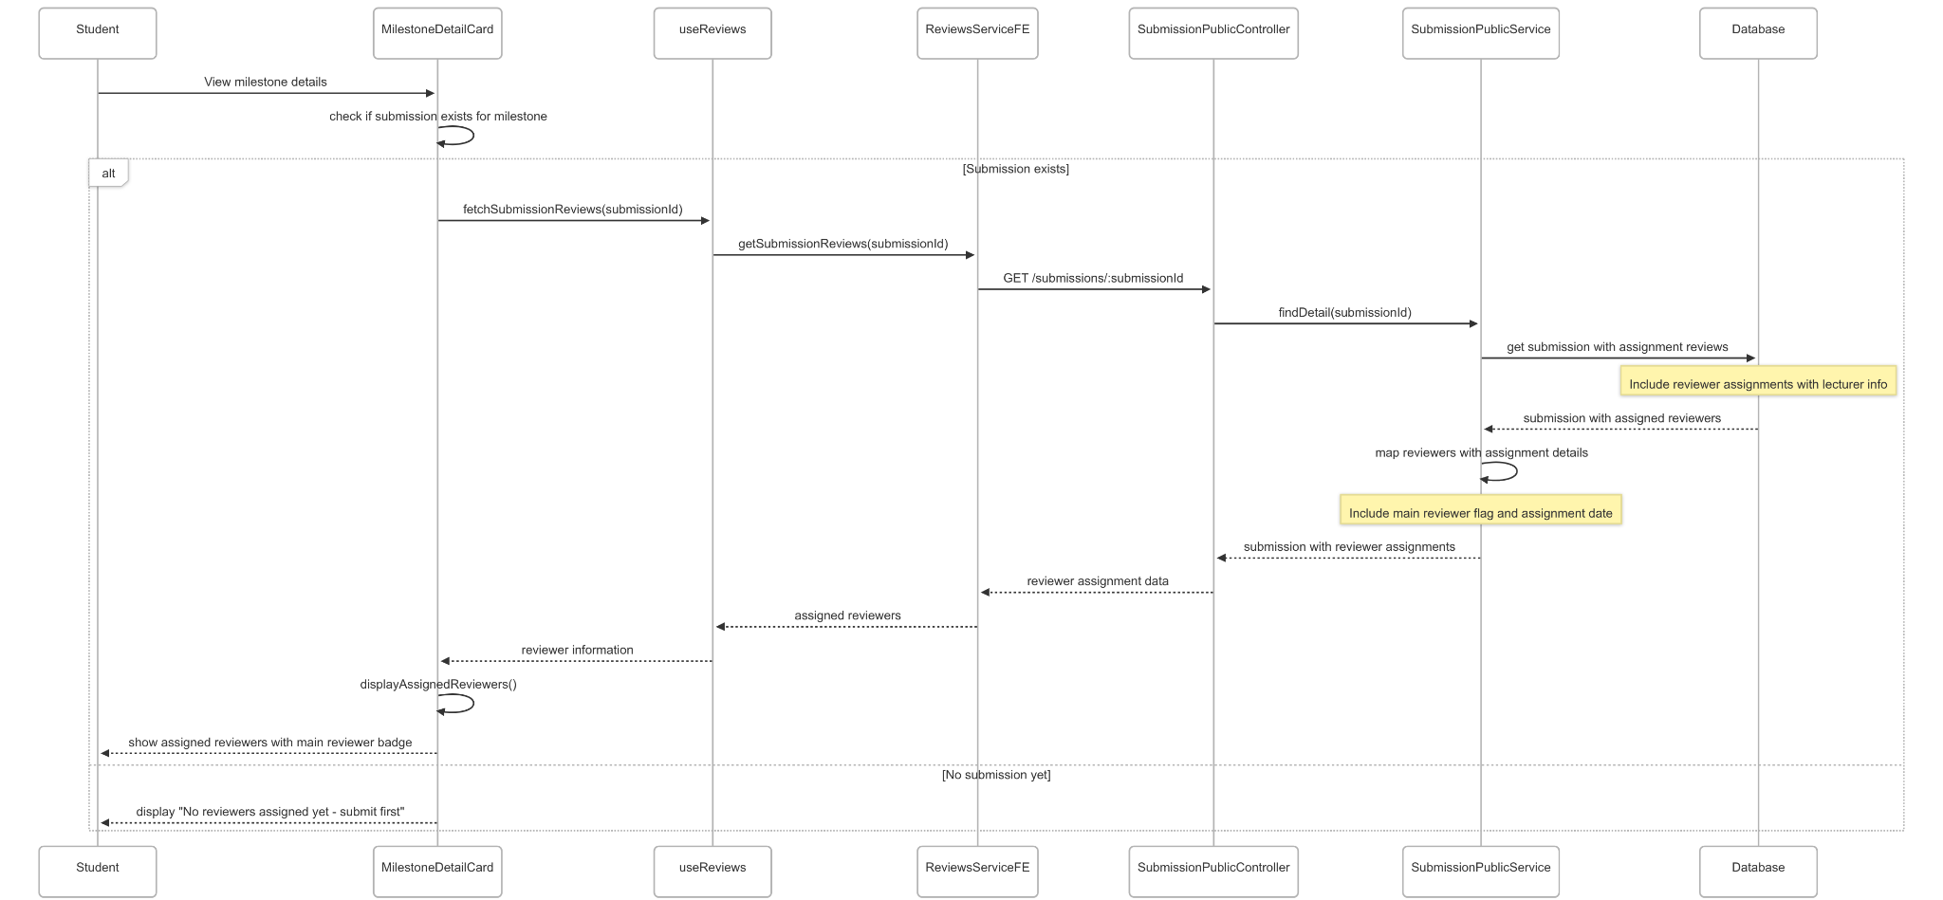](https://drive.google.com/file/d/1xWND5jTWYBtt6w-a3sjpUvW1gTh-Zt9l/view?usp=drive_link)

###### Figure IV.C.22.c.(4) - View Reviewer for each Milestone Sequence Diagram

* + - * 1. Update Milestone Submission

[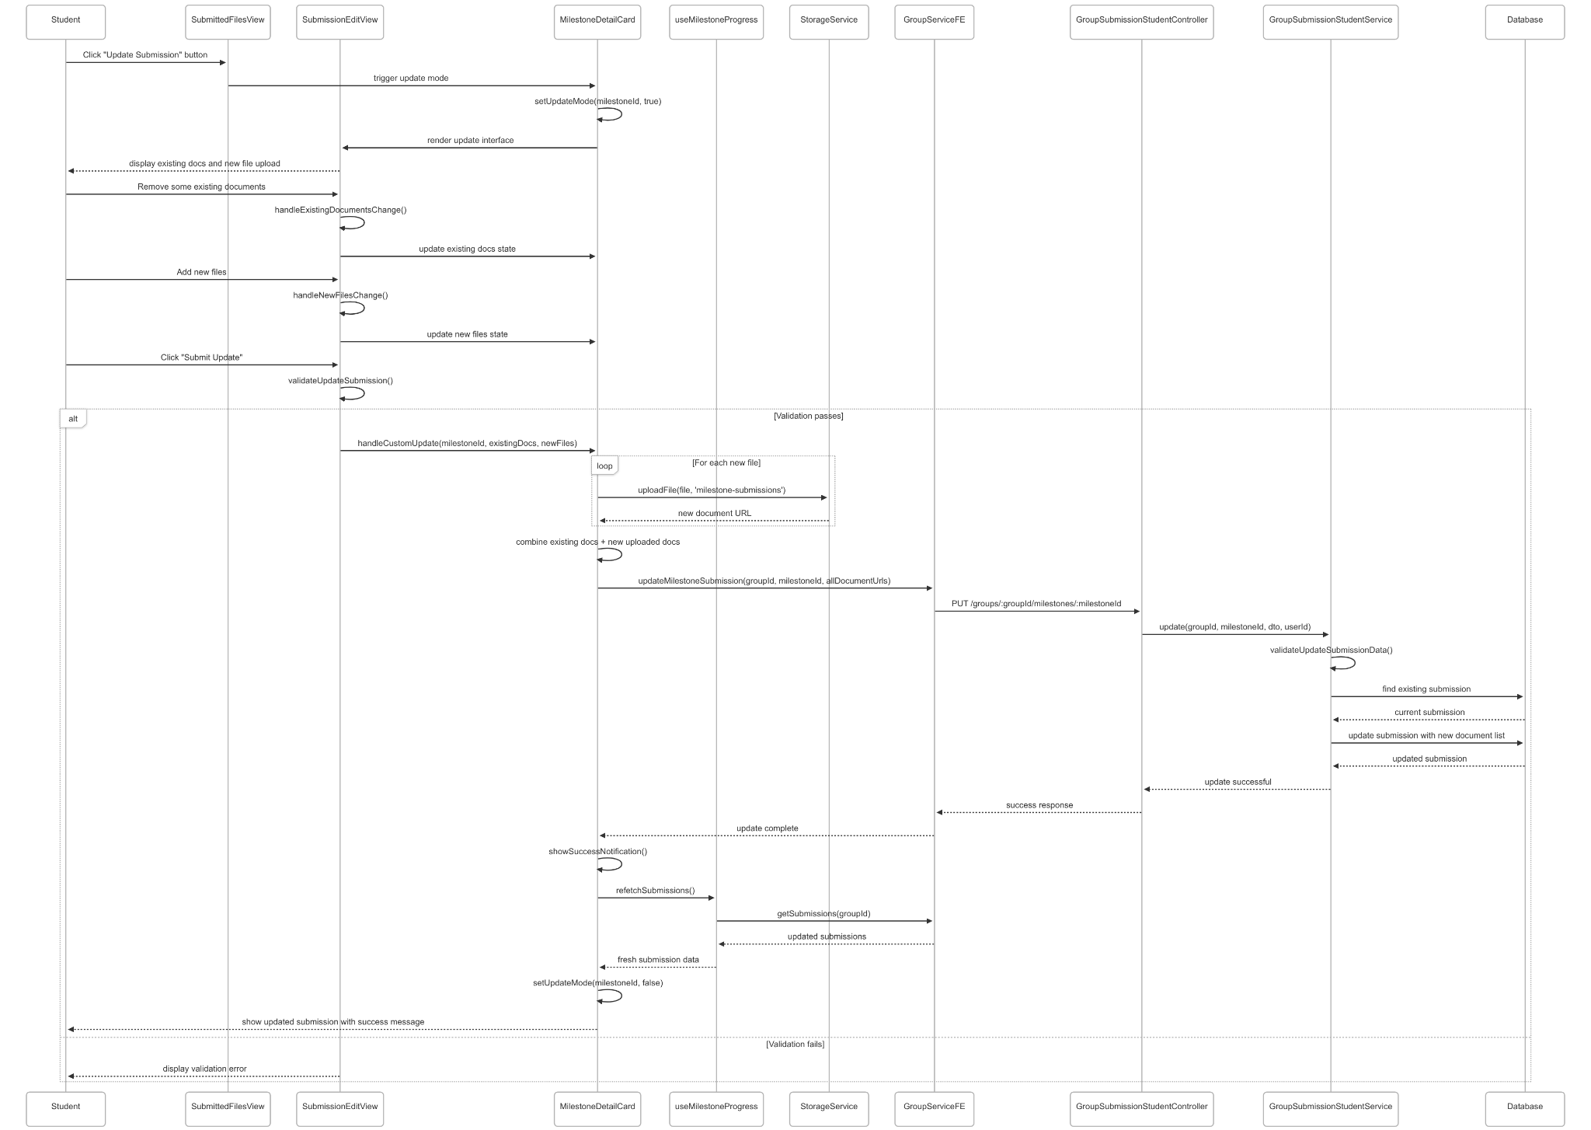](https://drive.google.com/file/d/1SZZy4nHh_w_0q8x3iDvNJaaw667reLV8/view?usp=drive_link)

###### Figure IV.C.22.c.(5) - Update Milestone Submission Sequence Diagram

### Student View Group Dashboard

#### Class Diagram

[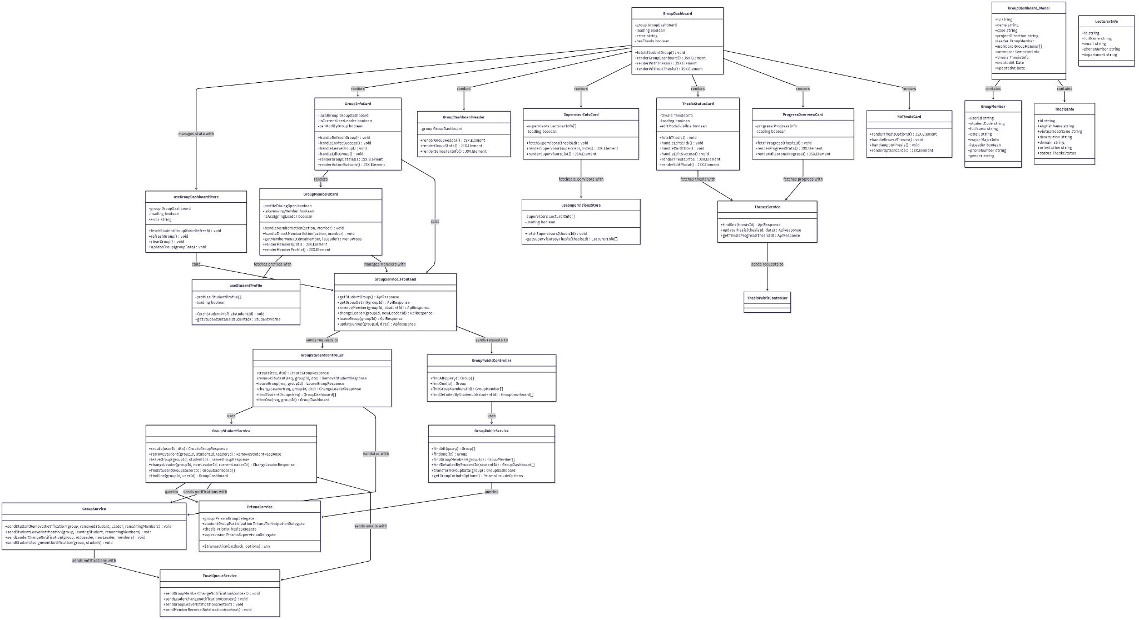](https://drive.google.com/file/d/1NI_Rbf2wtDsgHZo-ezkv8RdhEcSR04sP/view?usp=drive_link)

###### Figure IV.C.23.a - Student View Group Dashboard Class Diagram

#### Class Diagram Specification

| **No** | **Class** | **Method** | **Description** |
| --- | --- | --- | --- |
| 1 | GroupStudentController | create(req, dto) | API endpoint to create new student group with validation and member assignment |
| 2 | GroupStudentController | removeStudent(req, groupId, dto) | API endpoint for group leader to remove member from group |
| 3 | GroupStudentController | leaveGroup(req, groupId) | API endpoint for student to leave their current group |
| 4 | GroupStudentController | changeLeader(req, groupId, dto) | API endpoint to transfer group leadership to another member |
| 5 | GroupStudentController | findStudentGroups(req) | API endpoint to get all groups for current student |
| 6 | GroupStudentController | findOne(req, groupId) | API endpoint to get detailed group information |
| 7 | GroupStudentService | create(userId, dto) | Business logic for creating group with comprehensive validation |
| 8 | GroupStudentService | removeStudent(groupId, studentId, leaderId) | Business logic for removing member with leadership validation and cleanup |
| 9 | GroupStudentService | leaveGroup(groupId, studentId) | Business logic for student leaving group with proper cleanup and notifications |
| 10 | GroupStudentService | changeLeader(groupId, newLeaderId, currentLeaderId) | Business logic for transferring leadership with validation and notifications |
| 11 | GroupStudentService | findStudentGroups(userId) | Retrieve all groups associated with specific student |
| 12 | GroupStudentService | findOne(groupId, userId) | Get detailed group information with member permissions |
| 13 | GroupPublicController | findAll(query) | API endpoint to retrieve all public groups with filtering options |
| 14 | GroupPublicController | findOne(id) | API endpoint to get detailed public group information |
| 15 | GroupPublicController | findGroupMembers(id) | API endpoint to get all members of specific group |
| 16 | GroupPublicController | findDetailedByStudentId(studentId) | API endpoint to get detailed group information for specific student |
| 17 | GroupPublicService | findAll(query) | Business logic to retrieve public groups with filtering and pagination |
| 18 | GroupPublicService | findOne(id) | Get comprehensive group details with relations and member information |
| 19 | GroupPublicService | findGroupMembers(groupId) | Retrieve all group members with detailed user and academic information |
| 20 | GroupPublicService | findDetailedByStudentId(studentId) | Get detailed group information including participations and roles |
| 21 | GroupPublicService | transformGroupData(group) | Transform database group model into frontend-friendly format |
| 22 | GroupPublicService | getGroupIncludeOptions() | Build Prisma include options for comprehensive group queries |
| 23 | GroupService | sendStudentRemovalNotification(group, removedStudent, leader, remainingMembers) | Send email notifications when member is removed from group |
| 24 | GroupService | sendStudentLeaveNotification(group, leavingStudent, remainingMembers) | Send email notifications when student leaves group |
| 25 | GroupService | sendLeaderChangeNotification(group, oldLeader, newLeader, members) | Send email notifications when group leadership changes |
| 26 | GroupService | sendStudentAssignmentNotification(group, student) | Send email notifications when student is assigned to group |
| 27 | GroupDashboard | fetchStudentGroup() | Initialize and fetch student's group information |
| 28 | GroupDashboard | renderGroupDashboard() | Render main dashboard layout with conditional content |
| 29 | GroupDashboard | renderWithThesis() | Render dashboard layout for groups with assigned thesis |
| 30 | GroupDashboard | renderWithoutThesis() | Render dashboard layout for groups without thesis |
| 31 | GroupInfoCard | handleRefreshGroup() | Refresh group information and update local state |
| 32 | GroupInfoCard | handleInviteSuccess() | Handle successful member invitation and refresh data |
| 33 | GroupInfoCard | handleLeaveGroup() | Handle group leaving action with confirmation and cleanup |
| 34 | GroupInfoCard | handleEditGroup() | Handle group information editing with validation |
| 35 | GroupInfoCard | renderGroupDetails() | Render group information including name, code, and project direction |
| 36 | GroupInfoCard | renderActionButtons() | Render action buttons based on user permissions and group state |
| 37 | GroupMembersCard | handleMemberAction(action, member) | Handle member actions (remove, assign leader) with confirmation |
| 38 | GroupMembersCard | handleDirectMemberAction(action, member) | Execute member actions directly with proper validation |
| 39 | GroupMembersCard | getMemberMenuItems(member, isLeader) | Generate context menu items based on member and user permissions |
| 40 | GroupMembersCard | renderMembersList() | Render list of group members with roles and action menus |
| 41 | GroupMembersCard | renderMemberProfile() | Render detailed member profile in modal dialog |
| 42 | GroupDashboardHeader | renderGroupHeader() | Render group dashboard header with title and navigation |
| 43 | GroupDashboardHeader | renderGroupStats() | Render group statistics including member count and status |
| 44 | GroupDashboardHeader | renderSemesterInfo() | Render current semester information and status |
| 45 | SupervisorInfoCard | fetchSupervisors(thesisId) | Fetch supervisor information for assigned thesis |
| 46 | SupervisorInfoCard | renderSupervisor(supervisor, index) | Render individual supervisor information card |
| 47 | SupervisorInfoCard | renderSupervisorsList() | Render complete list of thesis supervisors |
| 48 | ThesisStatusCard | fetchThesis() | Fetch detailed thesis information and status |
| 49 | ThesisStatusCard | handleEditClick() | Handle thesis edit button click and open edit modal |
| 50 | ThesisStatusCard | handleCardClick() | Handle thesis card click for navigation to detail page |
| 51 | ThesisStatusCard | handleEditSuccess() | Handle successful thesis edit and refresh data |
| 52 | ThesisStatusCard | renderThesisInfo() | Render thesis information including title, domain, and status |
| 53 | ThesisStatusCard | renderEditModal() | Render thesis editing modal with form validation |
| 54 | ProgressOverviewCard | fetchProgress(thesisId) | Fetch progress information for assigned thesis |
| 55 | ProgressOverviewCard | renderProgressStats() | Render overall progress statistics and completion rates |
| 56 | ProgressOverviewCard | renderMilestoneProgress() | Render milestone-based progress tracking |
| 57 | NoThesisCard | renderThesisOptions() | Render options for groups without assigned thesis |
| 58 | NoThesisCard | handleBrowseTheses() | Handle navigation to thesis browsing page |
| 59 | NoThesisCard | handleApplyThesis() | Handle navigation to thesis application process |
| 60 | NoThesisCard | renderOptionCards() | Render thesis selection option cards with actions |
| 61 | useGroupDashboardStore | fetchStudentGroup(forceRefresh) | Fetch student's group information with optional cache refresh |
| 62 | useGroupDashboardStore | refreshGroup() | Refresh group data and update store state |
| 63 | useGroupDashboardStore | clearGroup() | Clear group data from store (used when leaving group) |
| 64 | useGroupDashboardStore | updateGroup(groupData) | Update group information in store state |
| 65 | useSupervisionsStore | fetchSupervisors(thesisId) | Fetch supervisor information for specific thesis |
| 66 | useSupervisionsStore | getSupervisorsByThesis(thesisId) | Get cached supervisor information for thesis |
| 67 | useStudentProfile | fetchStudentProfile(studentId) | Fetch detailed student profile information |
| 68 | useStudentProfile | getStudentDetails(studentId) | Get cached student profile details |
| 69 | GroupService_Frontend | getStudentGroup() | Frontend service method to fetch student's group information |
| 70 | GroupService_Frontend | getGroupDetail(groupId) | Frontend service method to fetch detailed group information |
| 71 | GroupService_Frontend | removeMember(groupId, studentId) | Frontend service method to remove member from group |
| 72 | GroupService_Frontend | changeLeader(groupId, newLeaderId) | Frontend service method to change group leadership |
| 73 | GroupService_Frontend | leaveGroup(groupId) | Frontend service method for student to leave group |
| 74 | GroupService_Frontend | updateGroup(groupId, data) | Frontend service method to update group information |
| 75 | ThesesService | findOne(thesisId) | Frontend service method to fetch detailed thesis information |
| 76 | ThesesService | updateThesis(thesisId, data) | Frontend service method to update thesis information |
| 77 | ThesesService | getThesisProgress(thesisId) | Frontend service method to fetch thesis progress information |
| 78 | PrismaService | $transaction(callback, options) | Execute database operations within atomic transaction |
| 79 | EmailQueueService | sendGroupMemberChangeNotification(context) | Queue email notification for group member changes |
| 80 | EmailQueueService | sendLeaderChangeNotification(context) | Queue email notification for leadership changes |
| 81 | EmailQueueService | sendGroupLeaveNotification(context) | Queue email notification for group leave events |
| 82 | EmailQueueService | sendMemberRemovalNotification(context) | Queue email notification for member removal events |

##### Table IV.C.23.b - Student View Group Dashboard Class Diagram Specification

#### Sequence Diagram

* + - * 1. View Group Dashboard

[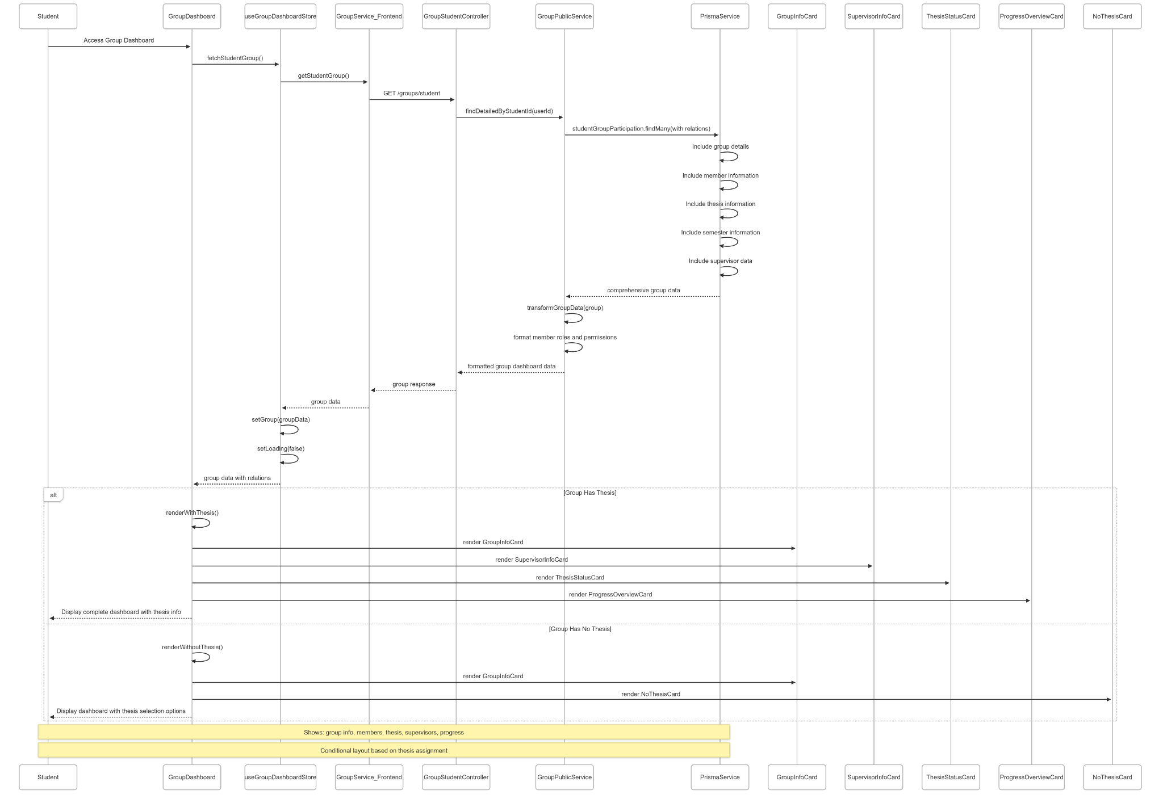](https://drive.google.com/file/d/1ztkR1E2AsP38x-BgSFiNrEF4VhVN3Fuk/view?usp=drive_link)

###### Figure IV.C.23.c.(1) - View Group Dashboard Sequence Diagram

* + - * 1. Assign Leader

[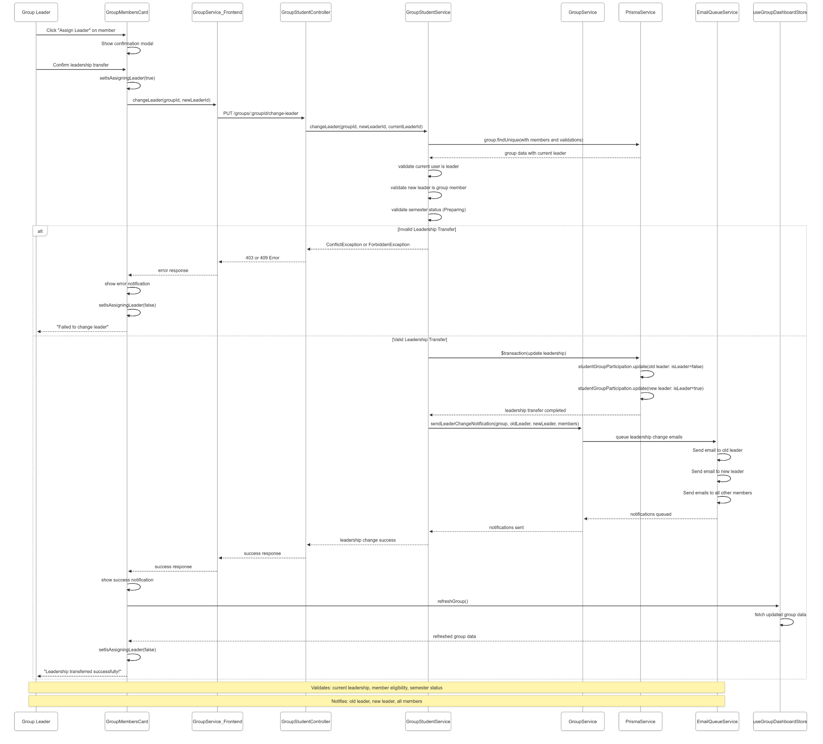](https://drive.google.com/file/d/1Ib0h_kh9tmWJHRSBa2hU2J7R_YoSU5ny/view?usp=drive_link)

###### Figure IV.C.23.c.(2) - Assign Leader Sequence Diagram

* + - * 1. Remove Member

[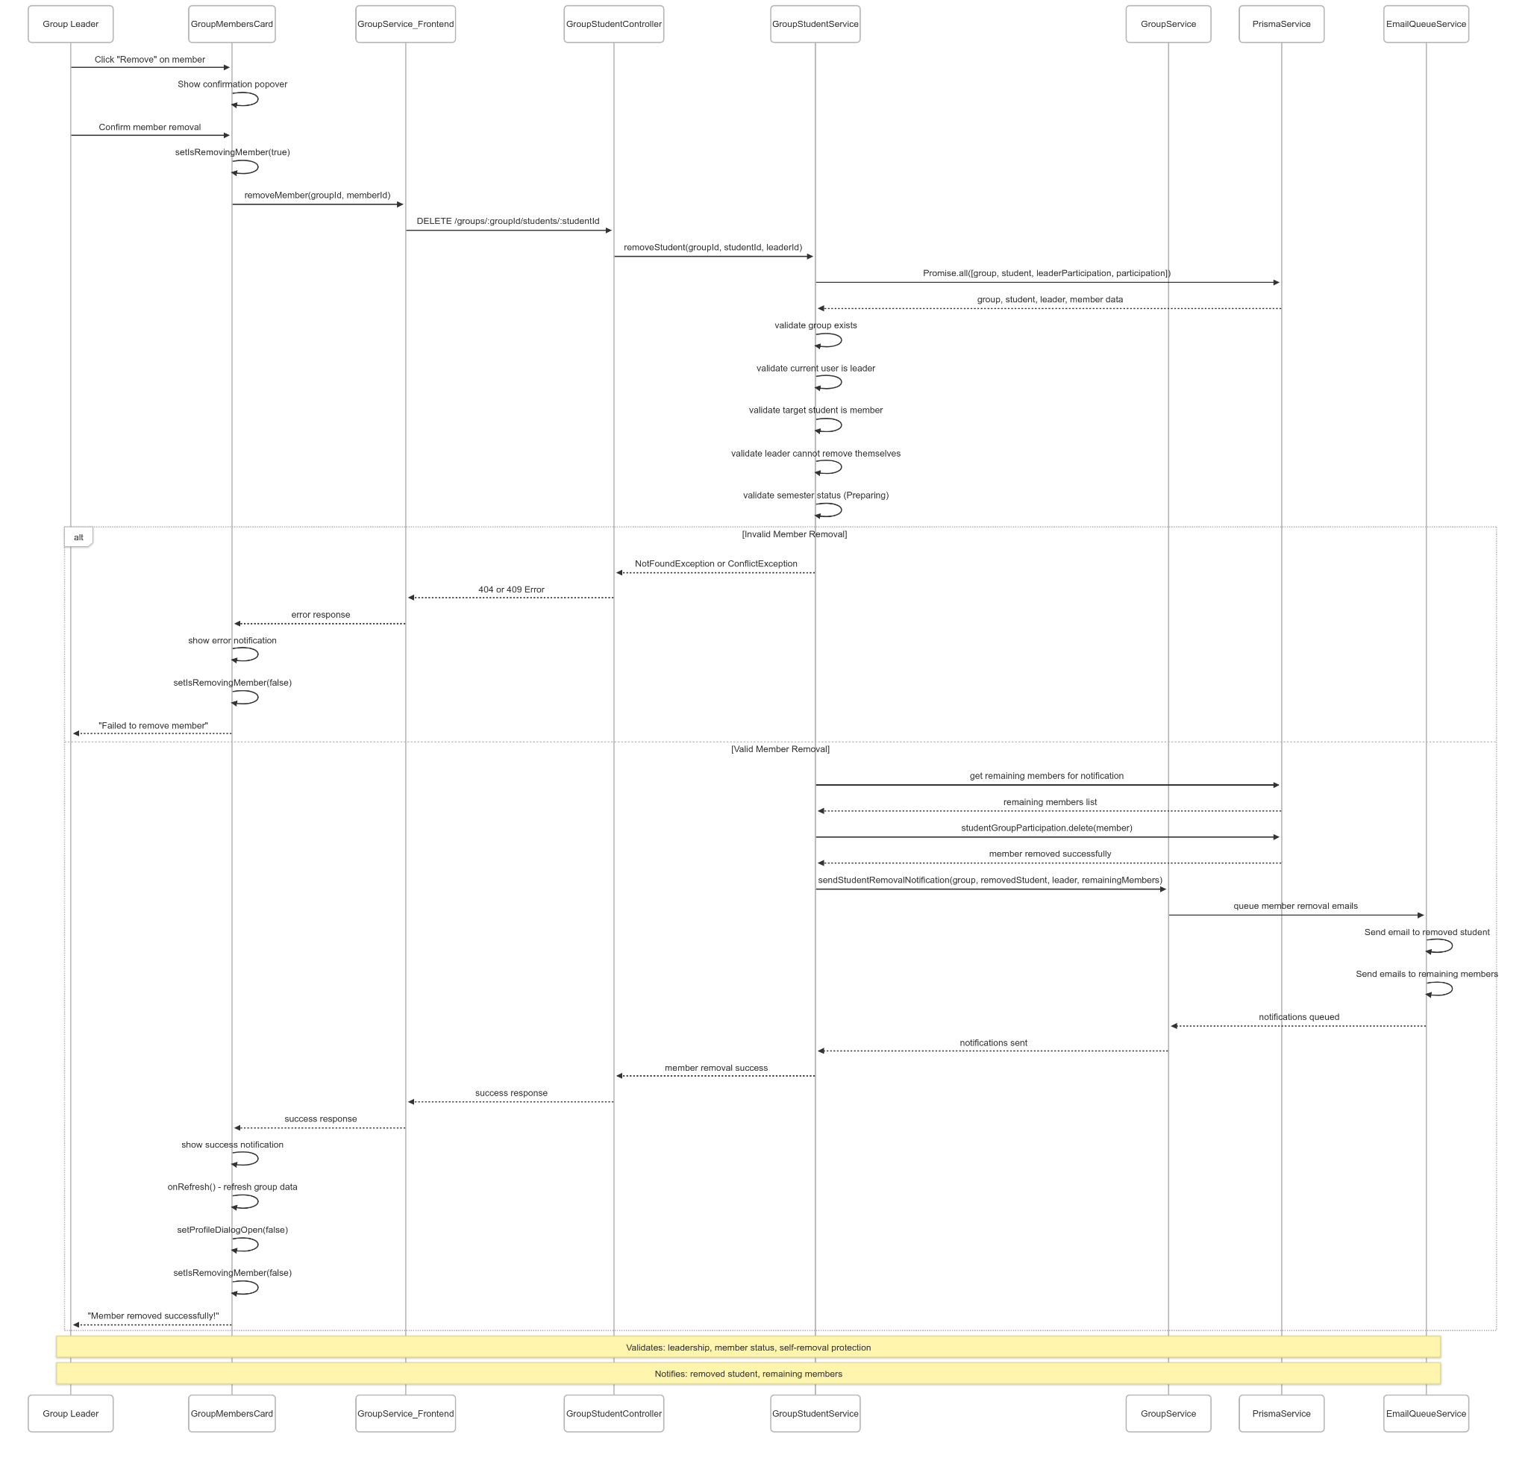](https://drive.google.com/file/d/134OMbOAx_64COCreHykxcDVQQTrqObIc/view?usp=drive_link)

###### Figure IV.C.23.c.(3) - Remove Member Sequence Diagram

* + - * 1. Leave Group

[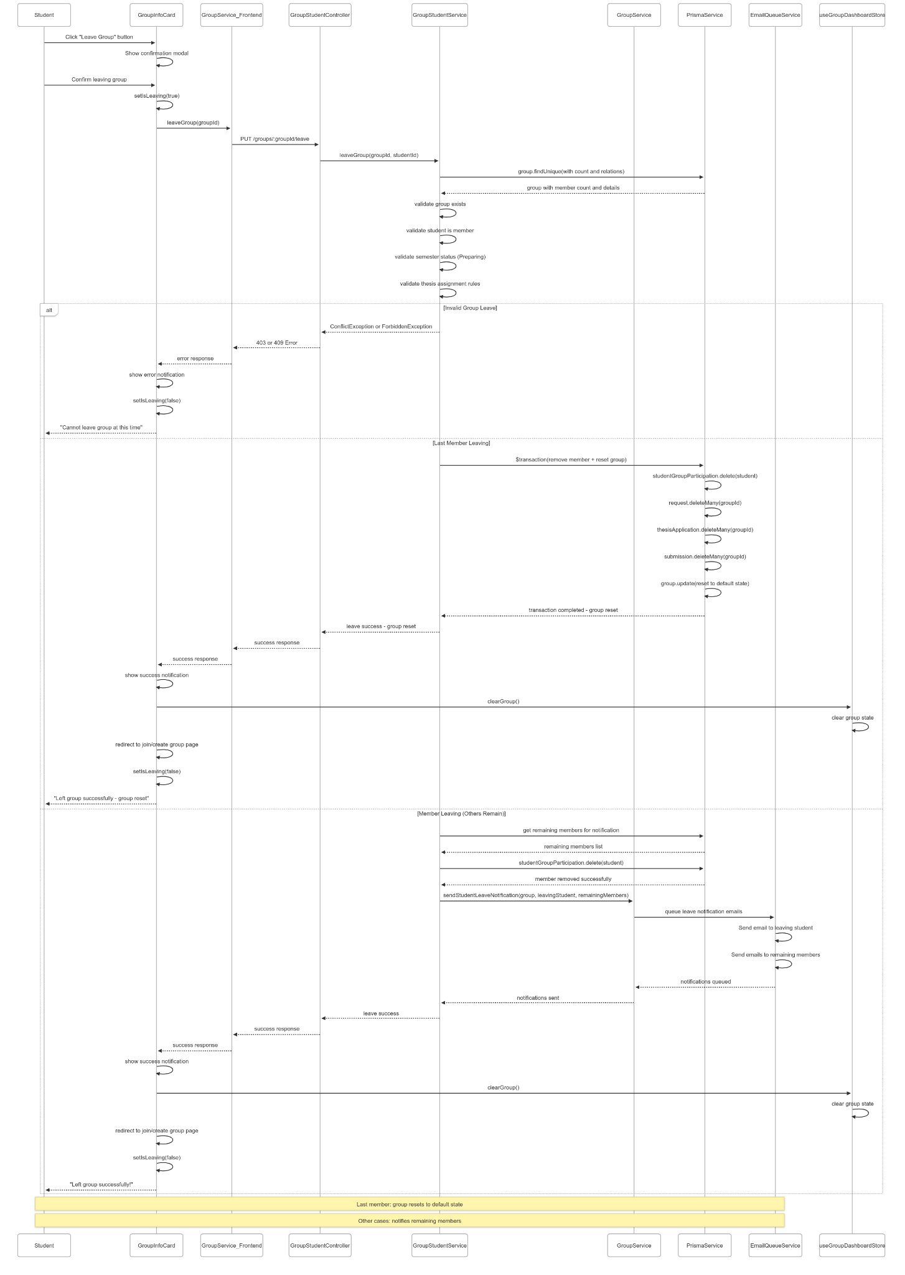](https://drive.google.com/file/d/1a_dC0xPWrQU_Onp7_BqtKE16p-MjWDzu/view?usp=drive_link)

###### Figure IV.C.23.c.(4) - Leave Group Sequence Diagram

* + - * 1. View Thesis Information

[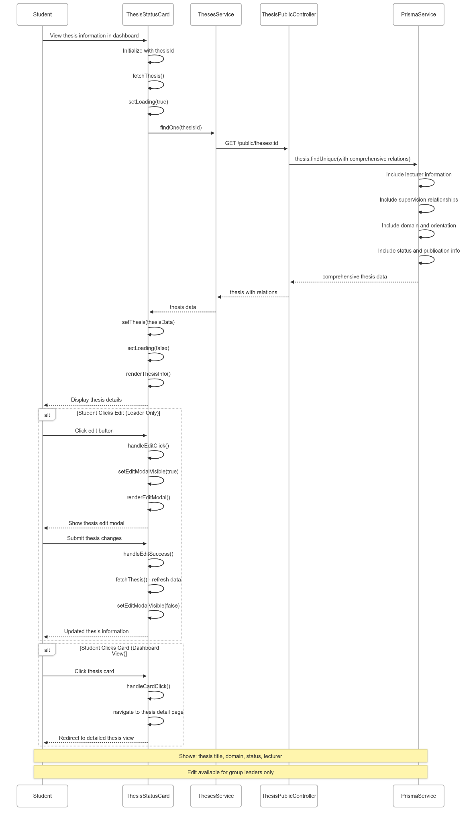](https://drive.google.com/file/d/1gQU49_8DA0Su4_BJv5mZBKZ0JzJVbgLo/view?usp=drive_link)

###### Figure IV.C.23.c.(5) - View Thesis Information Sequence Diagram

* + - * 1. View Supervisors Information

[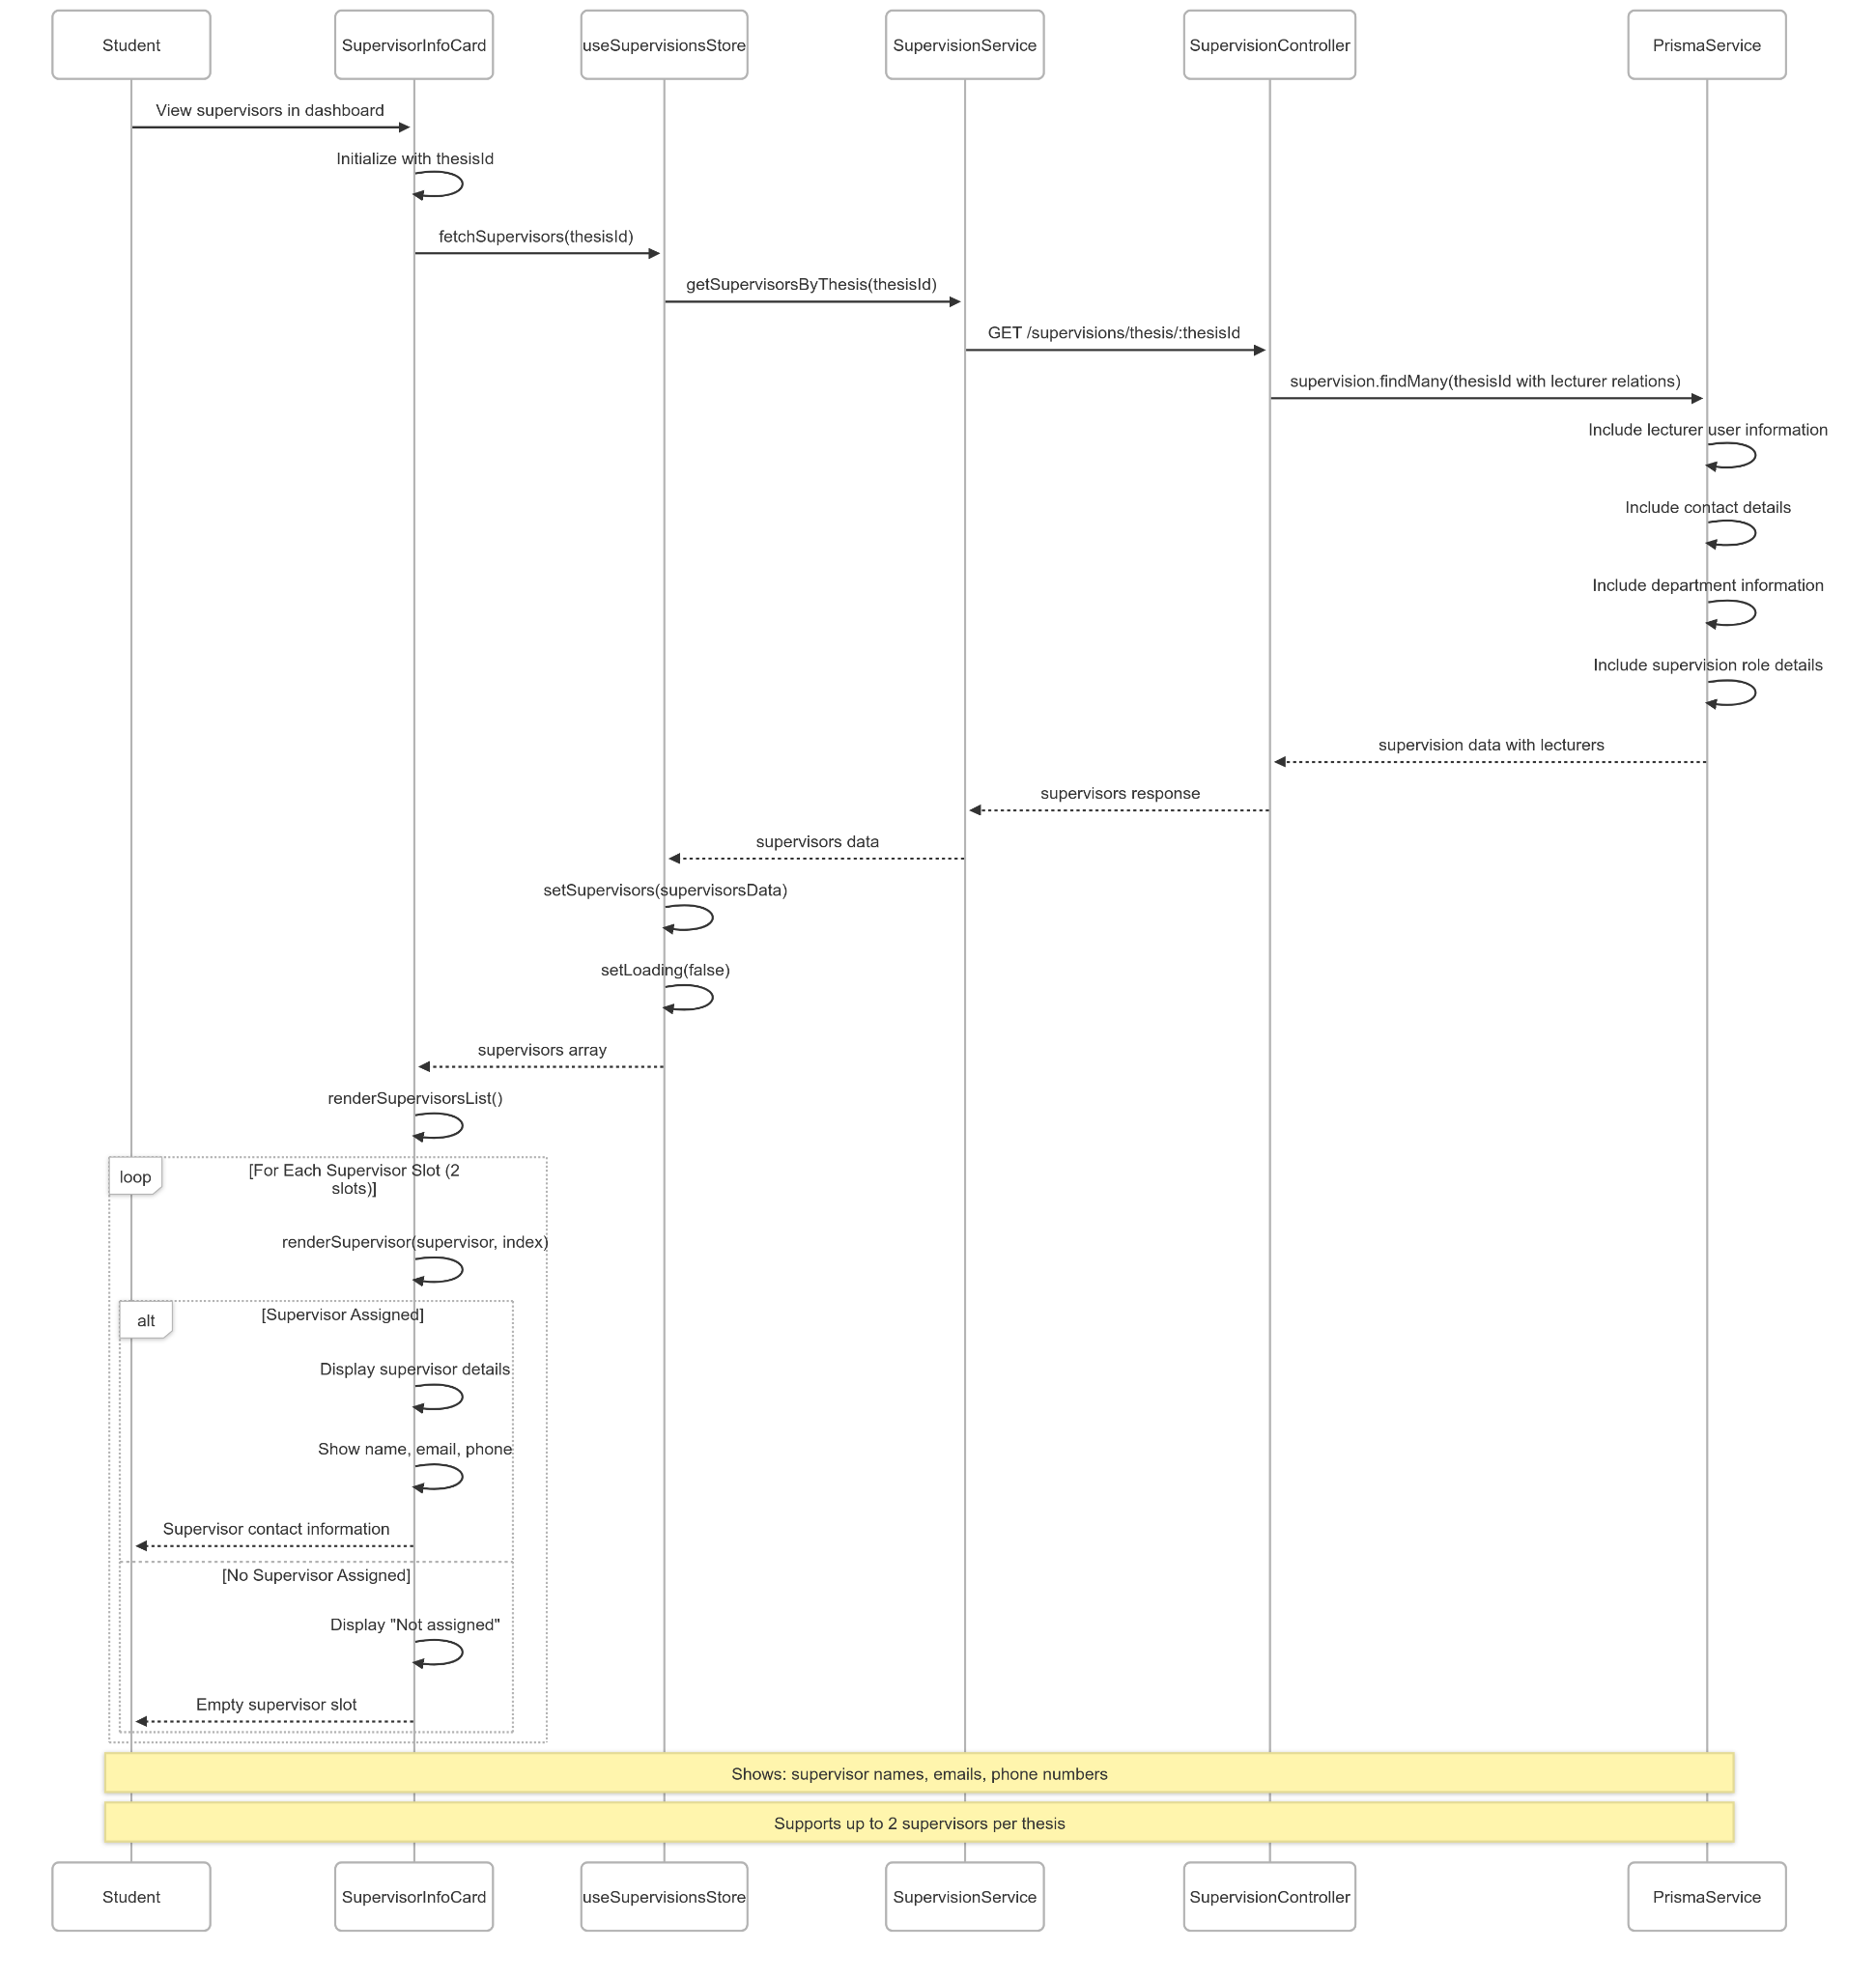](https://drive.google.com/file/d/16brXzqWpYWqpOxbYEiYg3Z8RBjM-yJ_Z/view?usp=drive_link)

###### Figure IV.C.23.c.(6) - View Supervisors Information Sequence Diagram

* + - * 1. View Progress Overview

[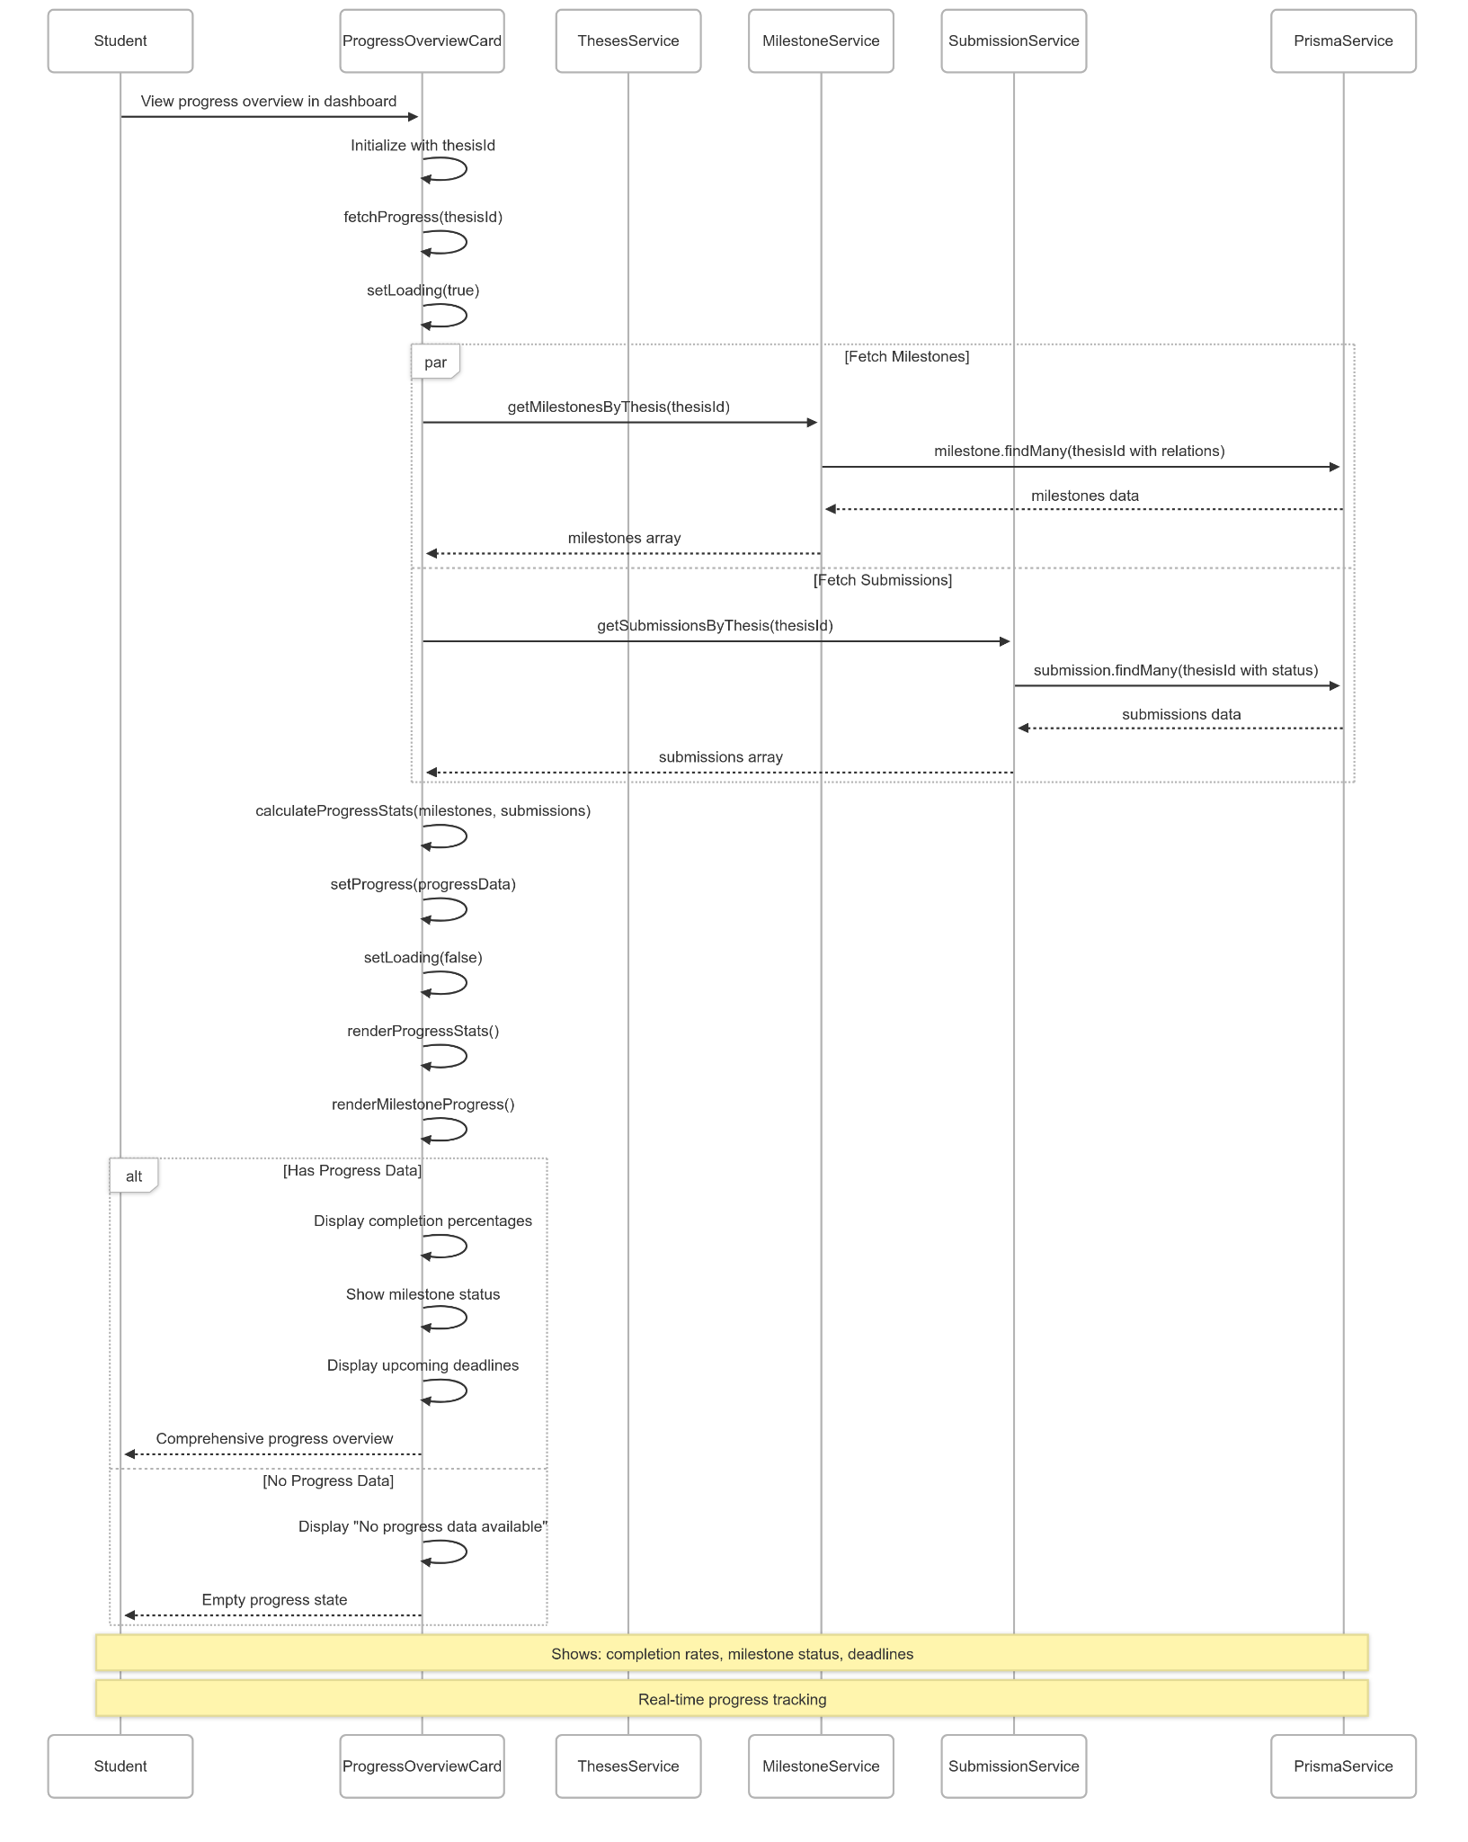](https://drive.google.com/file/d/1OPLWAGLGg_d50J3BzxjZcNq1WOlzAuB3/view?usp=drive_link)

###### Figure IV.C.23.c.(7) - View Progress Overview Sequence Diagram

### User Manage Personal Account

#### Class Diagram

[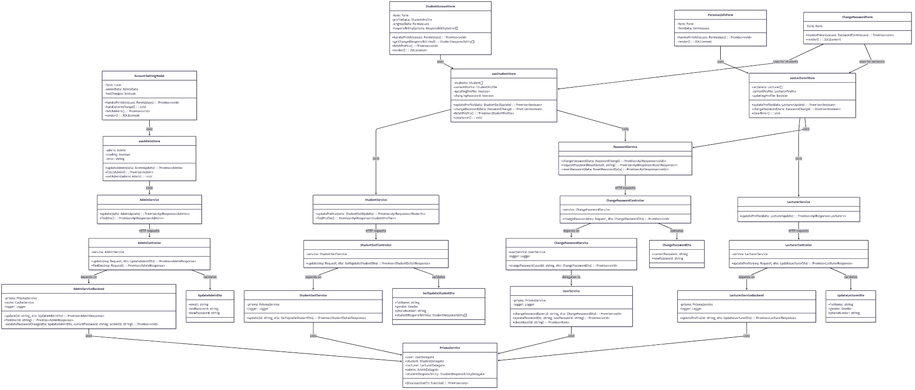](https://drive.google.com/file/d/1BPK5eTryWBPCao9ZyfYLzMhIeWQQ0Bdj/view?usp=drive_link)

###### Figure IV.C.24.a - User Manage Personal Account Class Diagram

#### Class Diagram Specification

| **No** | **Class** | **Method** | **Description** |
| --- | --- | --- | --- |
| 1 | StudentAccountForm | handleFinish(values: FormValues) | Process student profile update form submission with validation and changed fields detection |
| 2 | StudentAccountForm | getChangedResponsibilities() | Compare current and original responsibilities to detect changes for update |
| 3 | StudentAccountForm | fetchProfile() | Retrieve current student profile data and populate form fields |
| 4 | StudentAccountForm | render() | Render student account settings form with profile fields and responsibilities |
| 5 | PersonalInfoForm | handleFinish(values: FormValues) | Process lecturer profile update form submission with phone number normalization |
| 6 | PersonalInfoForm | render() | Render lecturer personal information form with validation rules |
| 7 | AccountSettingModal | handleFinish(values: FormValues) | Process admin account update including email and password change validation |
| 8 | AccountSettingModal | handleFormChange() | Detect form field changes to enable/disable save button |
| 9 | AccountSettingModal | fetchAdmin() | Retrieve current admin data and populate form fields |
| 10 | AccountSettingModal | render() | Render admin account settings modal with email and password fields |
| 11 | ChangePasswordForm | handleFinish(values: PasswordFormValues) | Process password change form submission with validation and confirmation |
| 12 | ChangePasswordForm | render() | Render password change form with current and new password fields |
| 13 | useStudentStore | updateProfile(data: StudentSelfUpdate) | Update student profile information and handle API response |
| 14 | useStudentStore | changePassword(data: PasswordChange) | Change student password and auto-logout for security |
| 15 | useStudentStore | fetchProfile() | Fetch current student profile with enrollments and responsibilities |
| 16 | useStudentStore | clearError() | Clear error state for form validation |
| 17 | useLecturerStore | updateProfile(data: LecturerUpdate) | Update lecturer profile information with success notification |
| 18 | useLecturerStore | changePassword(data: PasswordChange) | Change lecturer password using shared password service |
| 19 | useLecturerStore | clearError() | Clear error state for form validation |
| 20 | useAdminStore | updateAdmin(data: AdminUpdate) | Update admin account with email/password change and auto-logout on password change |
| 21 | useAdminStore | fetchAdmin() | Fetch current admin profile information |
| 22 | useAdminStore | setAdmin(admin: Admin) | Update admin state with new data |
| 23 | StudentService | updateProfile(data: StudentSelfUpdate) | Send student profile update request to backend API |
| 24 | StudentService | findProfile() | Retrieve student profile information from backend |
| 25 | LecturerService | updateProfile(data: LecturerUpdate) | Send lecturer profile update request to backend API |
| 26 | AdminService | update(data: AdminUpdate) | Send admin account update request to backend API |
| 27 | AdminService | findOne() | Retrieve current admin profile information |
| 28 | PasswordService | changePassword(data: PasswordChange) | Send password change request for all user roles |
| 29 | PasswordService | requestPasswordReset(email: string) | Request password reset OTP via email |
| 30 | PasswordService | resetPassword(data: ResetPasswordData) | Reset password using OTP and new password |
| 31 | StudentSelfController | update(req: Request, dto: SelfUpdateStudentDto) | Handle student profile update API endpoint with role validation |
| 32 | LecturerController | updateProfile(req: Request, dto: UpdateLecturerDto) | Handle lecturer profile update API endpoint with authentication |
| 33 | AdminController | update(req: Request, dto: UpdateAdminDto) | Handle admin account update API endpoint with admin role validation |
| 34 | AdminController | findOne(req: Request) | Handle get admin profile API endpoint |
| 35 | ChangePasswordController | changePassword(req: Request, dto: ChangePasswordDto) | Handle password change API endpoint for all non-admin roles |
| 36 | StudentSelfService | update(id: string, dto: SelfUpdateStudentDto) | Update student profile with transaction handling and responsibility management |
| 37 | LecturerServiceBackend | updateProfile(id: string, dto: UpdateLecturerDto) | Update lecturer profile information in database |
| 38 | AdminServiceBackend | update(id: string, dto: UpdateAdminDto) | Update admin account with email/password validation and cache management |
| 39 | AdminServiceBackend | findOne(id: string) | Retrieve admin profile with caching |
| 40 | AdminServiceBackend | validatePasswordChange(dto: UpdateAdminDto, currentPassword: string, adminId: string) | Validate password change requirements and current password verification |
| 41 | ChangePasswordService | changePassword(userId: string, dto: ChangePasswordDto) | Delegate password change to UserService with error handling |
| 42 | UserService | changePassword(userId: string, dto: ChangePasswordDto) | Change user password with validation and hashing |
| 43 | UserService | updatePassword(id: string, newPassword: string) | Update user password with hash |
| 44 | UserService | checkRole(id: string) | Determine user role from database relationships |

##### Table IV.C.24.b - User Manage Personal Account Class Diagram Specification

#### Sequence Diagram

* + - * 1. Student Update Personal Information

[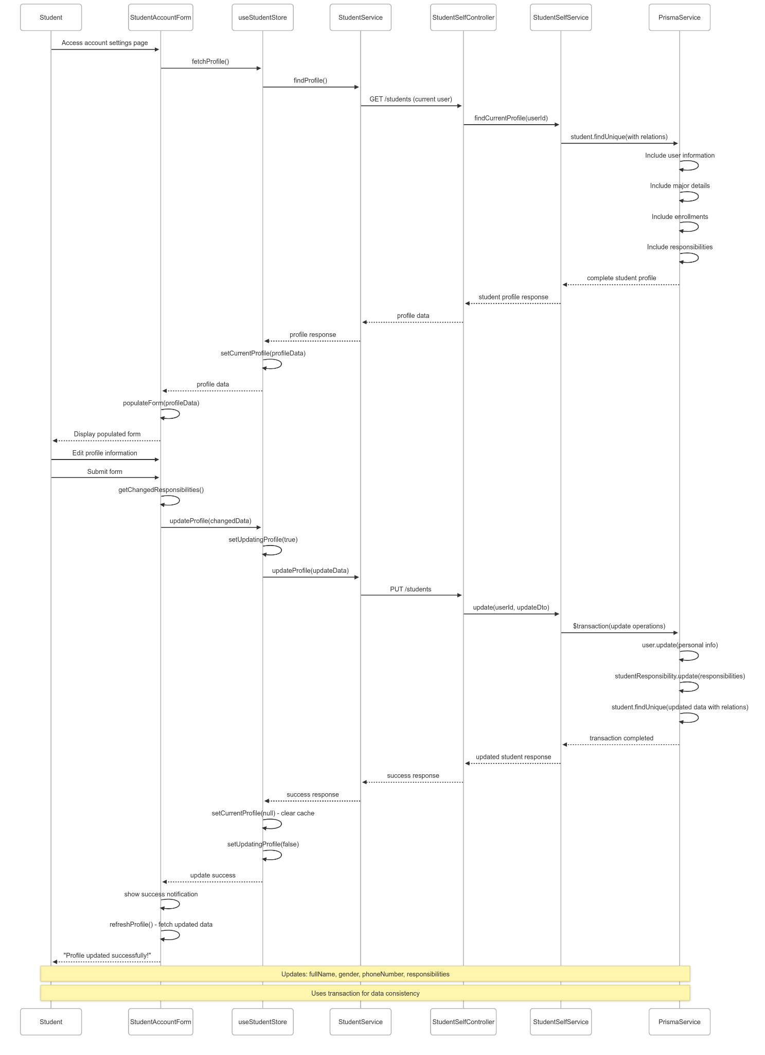](https://drive.google.com/file/d/1NsfeFt0tsjvQm3b0k8L-AFuYJ65s44EM/view?usp=drive_link)

###### Figure IV.C.24.c.(1) - Student Update Personal Information Sequence Diagram

* + - * 1. Lecturer Update Personal Profile

[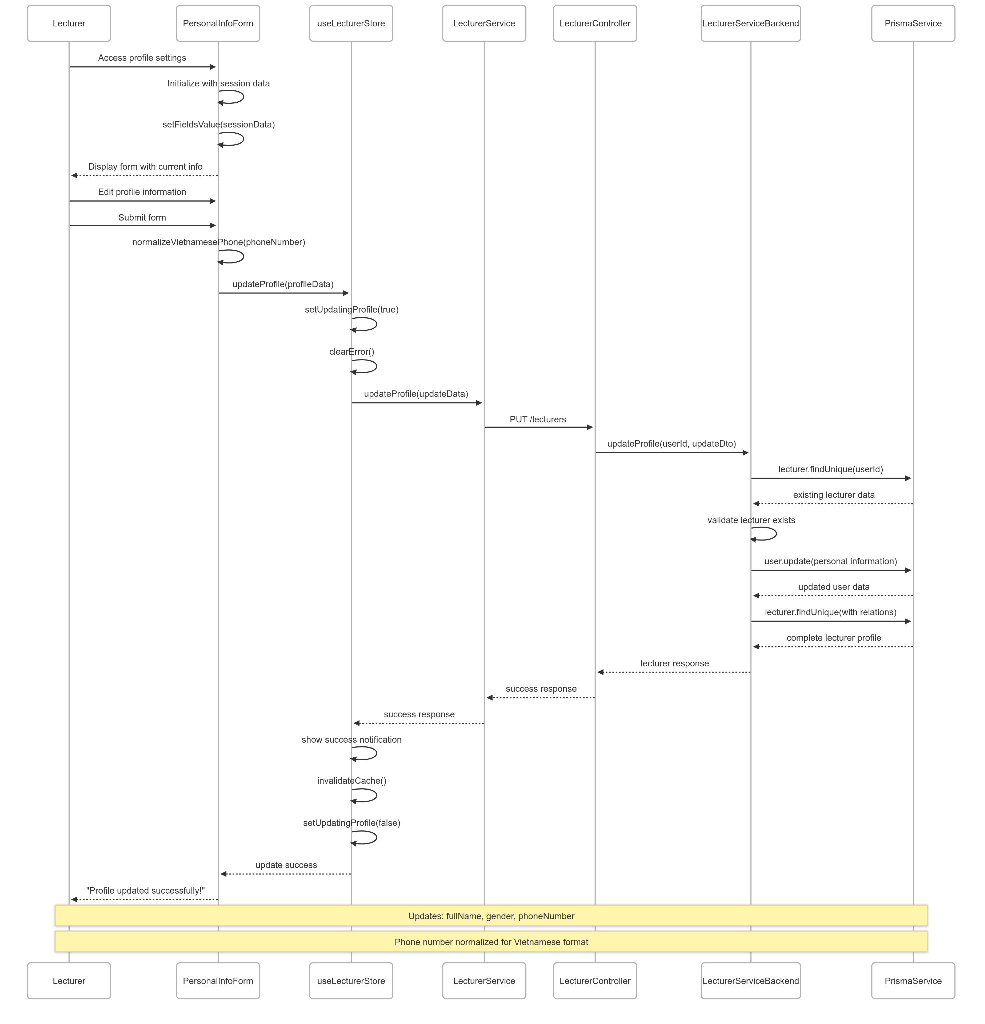](https://drive.google.com/file/d/1xU0LgEYqCe3ShRQGmiB4LPz_XjCOdPko/view?usp=drive_link)

###### Figure IV.C.24.c.(2) - Lecturer Update Personal Profile Sequence Diagram

* + - * 1. Admin Update Account Settings

[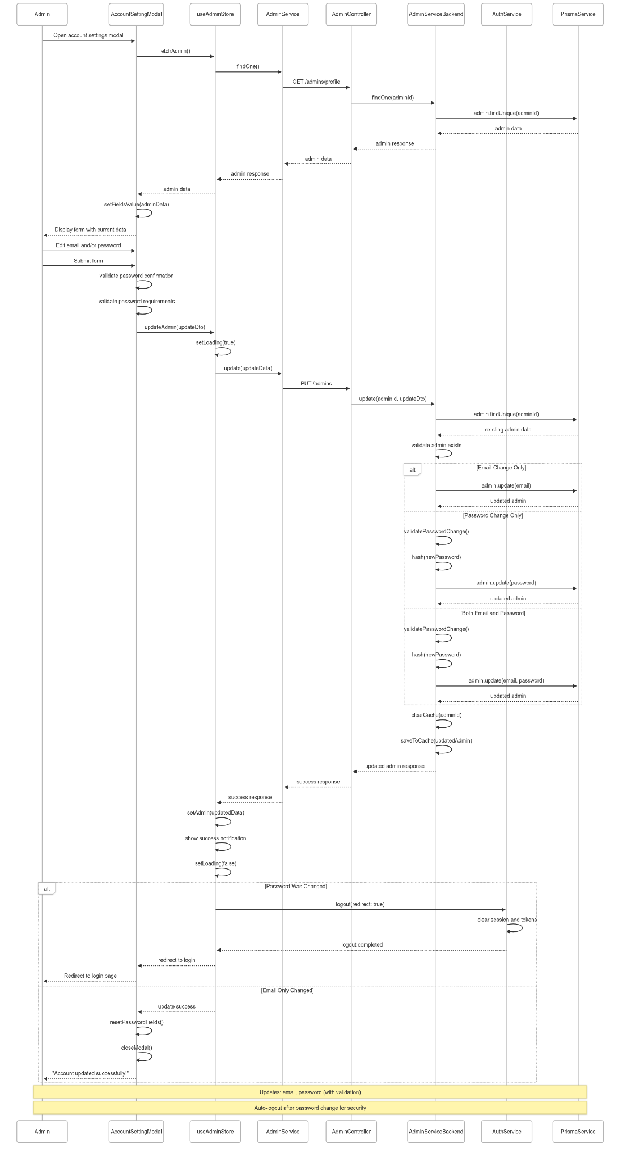](https://drive.google.com/file/d/1c397EfpXJnLtvgOxp1r19Eoj0aCQsOmS/view?usp=drive_link)

###### Figure IV.C.24.c.(3) - Admin Update Account Settings Sequence Diagram

* + - * 1. Change Password (Shared across all roles)

[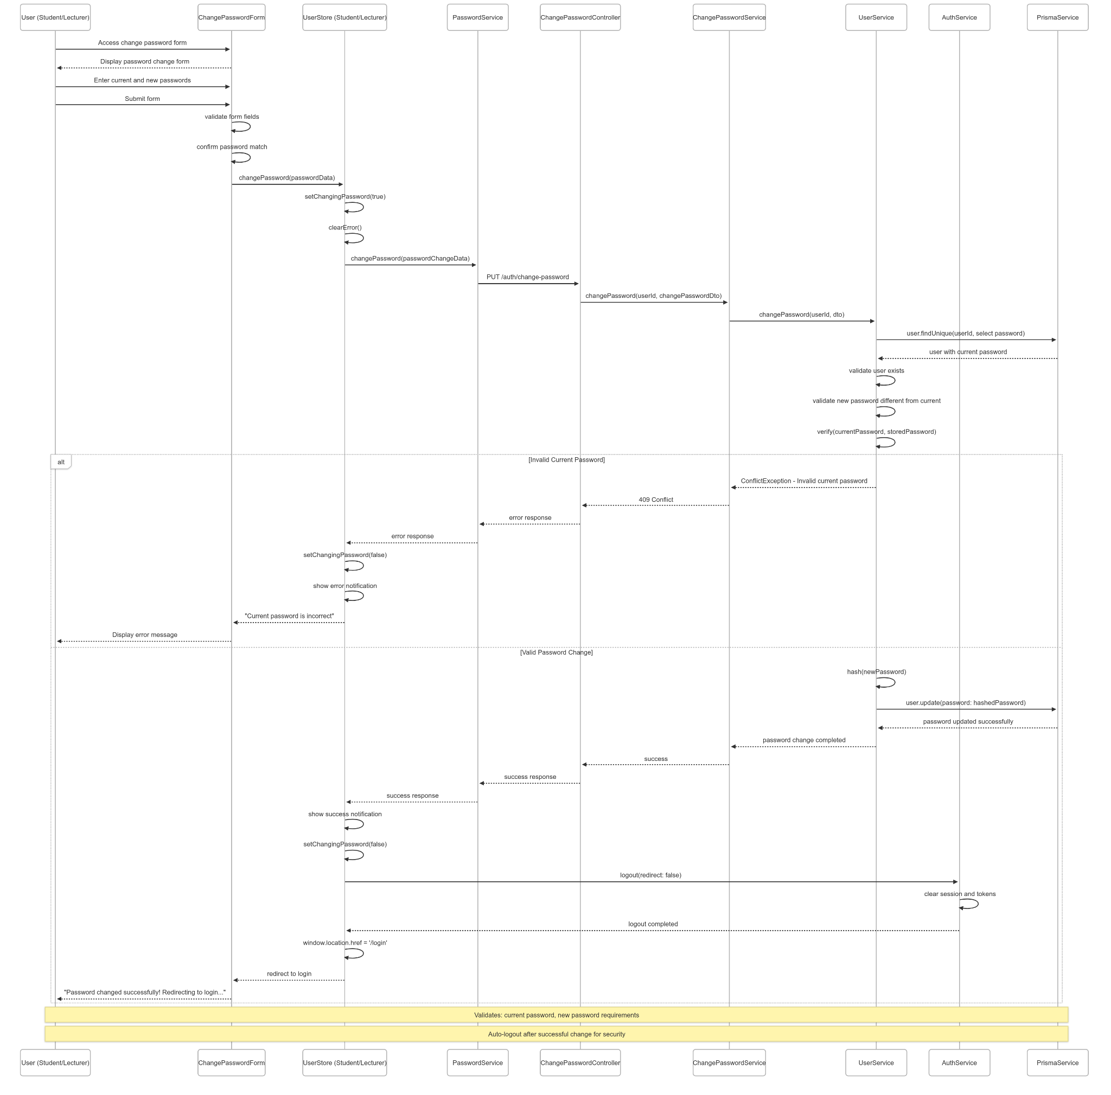](https://drive.google.com/file/d/1hKG9MlJFHMWp7VOLeTysF1LPPcBqJB9N/view?usp=drive_link)

###### Figure IV.C.24.c.(4) - Change Password Sequence Diagram

### Admin Create Empty Groups For Student

#### Class Diagram

[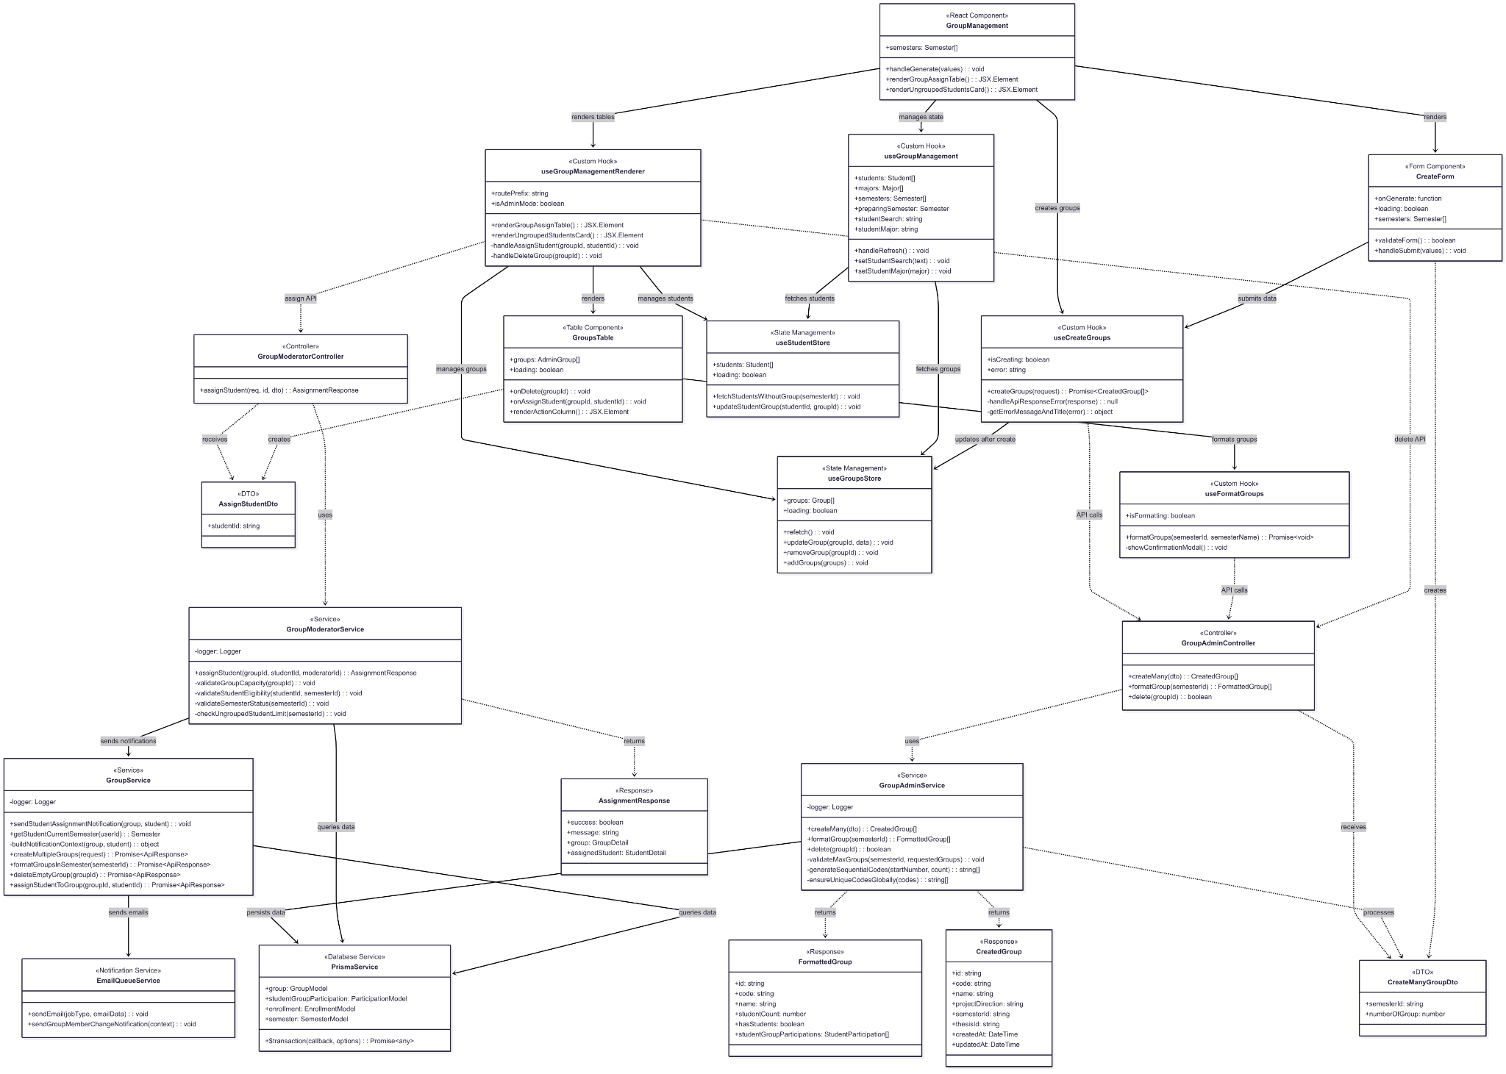](https://drive.google.com/file/d/1ek7LBbEA3VXLvszbFQJOyHHi0pkpL8bF/view?usp=drive_link)

###### Figure IV.C.25.a - Admin Create Empty Groups For Student Class Diagram

#### Class Diagram Specification

| **No** | **Class** | **Method** | **Description** |
| --- | --- | --- | --- |
| 1 | GroupAdminController | createMany(dto) | Create multiple empty groups for a semester with auto-generated codes |
| 2 | GroupAdminController | formatGroup(semesterId) | Format and reorganize groups in a semester with standardized codes |
| 3 | GroupAdminController | delete(groupId) | Delete an empty group that has no student participations |
| 4 | GroupModeratorController | assignStudent(req, id, dto) | Assign a student to an existing group with validation and notifications |
| 5 | GroupAdminService | createMany(dto) | Business logic for bulk group creation with validation and transaction management |
| 6 | GroupAdminService | formatGroup(semesterId) | Reorganize groups by priority and update codes in standardized format |
| 7 | GroupAdminService | delete(groupId) | Delete empty group with safety checks and cascade cleanup |
| 8 | GroupAdminService | validateMaxGroups(semesterId, requestedGroups) | Validate maximum groups allowed based on student enrollment ratio |
| 9 | GroupAdminService | generateSequentialCodes(startNumber, count) | Generate sequential 3-digit group codes starting from specified number |
| 10 | GroupAdminService | ensureUniqueCodesGlobally(codes) | Ensure generated codes are unique across all semesters globally |
| 11 | GroupModeratorService | assignStudent(groupId, studentId, moderatorId) | Assign student to group with comprehensive validation and notifications |
| 12 | GroupModeratorService | validateGroupCapacity(groupId) | Check if group has space for new member (max 6 students) |
| 13 | GroupModeratorService | validateStudentEligibility(studentId, semesterId) | Verify student can be assigned to group in specified semester |
| 14 | GroupModeratorService | validateSemesterStatus(semesterId) | Ensure semester is in Preparing status for group assignments |
| 15 | GroupModeratorService | checkUngroupedStudentLimit(semesterId) | Validate there are not more than 4 ungrouped students in semester |
| 16 | GroupService | sendStudentAssignmentNotification(group, student) | Send email notifications to assigned student and all group members |
| 17 | GroupService | getStudentCurrentSemester(userId) | Retrieve current semester enrollment information for a student |
| 18 | GroupService | buildNotificationContext(group, student) | Build email context data for group assignment notifications |
| 19 | GroupManagement | handleGenerate(values) | Handle form submission for creating multiple empty groups |
| 20 | GroupManagement | renderGroupAssignTable() | Render table component for displaying and managing groups |
| 21 | GroupManagement | renderUngroupedStudentsCard() | Render card component showing students without groups |
| 22 | CreateForm | validateForm() | Validate form inputs for group creation (semester and count) |
| 23 | CreateForm | handleSubmit(values) | Process form submission and trigger group creation |
| 24 | GroupsTable | onDelete(groupId) | Handle delete action for empty groups with confirmation |
| 25 | GroupsTable | onAssignStudent(groupId, studentId) | Handle student assignment to group action |
| 26 | GroupsTable | renderActionColumn() | Render action buttons column for group management operations |
| 27 | useCreateGroups | createGroups(request) | Execute API call to create multiple groups with error handling |
| 28 | useCreateGroups | handleApiResponseError(response) | Process API error responses and show appropriate messages |
| 29 | useCreateGroups | getErrorMessageAndTitle(error) | Extract user-friendly error messages from API errors |
| 30 | useFormatGroups | formatGroups(semesterId, semesterName) | Format groups in semester with user confirmation and progress tracking |
| 31 | useFormatGroups | showConfirmationModal() | Display confirmation dialog before executing format operation |
| 32 | useGroupManagement | handleRefresh() | Refresh all group and student data from server |
| 33 | useGroupManagement | setStudentSearch(text) | Update student search filter text |
| 34 | useGroupManagement | setStudentMajor(major) | Update student major filter selection |
| 35 | useGroupManagementRenderer | renderGroupAssignTable() | Render groups table with admin-specific actions enabled |
| 36 | useGroupManagementRenderer | renderUngroupedStudentsCard() | Render card showing students available for group assignment |
| 37 | useGroupManagementRenderer | handleAssignStudent(groupId, studentId) | Process student assignment to group with API call |
| 38 | useGroupManagementRenderer | handleDeleteGroup(groupId) | Process group deletion with confirmation and API call |
| 39 | PrismaService | $transaction(callback, options) | Execute multiple database operations within a transaction |
| 40 | EmailQueueService | sendEmail(jobType, emailData) | Queue email for sending with specified job type and data |
| 41 | EmailQueueService | sendGroupMemberChangeNotification(context) | Send notification emails for group membership changes |
| 42 | GroupService | createMultipleGroups(request) | API service method to create multiple groups via HTTP request |
| 43 | GroupService | formatGroupsInSemester(semesterId) | API service method to format groups in specified semester |
| 44 | GroupService | deleteEmptyGroup(groupId) | API service method to delete empty group via HTTP request |
| 45 | GroupService | assignStudentToGroup(groupId, studentId) | API service method to assign student to group via HTTP request |
| 46 | useGroupsStore | refetch() | Refresh groups data from server and update store state |
| 47 | useGroupsStore | updateGroup(groupId, data) | Update specific group data in store state |
| 48 | useGroupsStore | removeGroup(groupId) | Remove group from store state after deletion |
| 49 | useGroupsStore | addGroups(groups) | Add new groups to store state after creation |
| 50 | useStudentStore | fetchStudentsWithoutGroup(semesterId) | Fetch students who are not assigned to any group in semester |
| 51 | useStudentStore | updateStudentGroup(studentId, groupId) | Update student's group assignment in store state |

##### Table IV.C.25.b - Admin Create Empty Groups For Student Class Diagram Specification

#### Sequence Diagram

* + - * 1. Bulk Create Empty Groups

[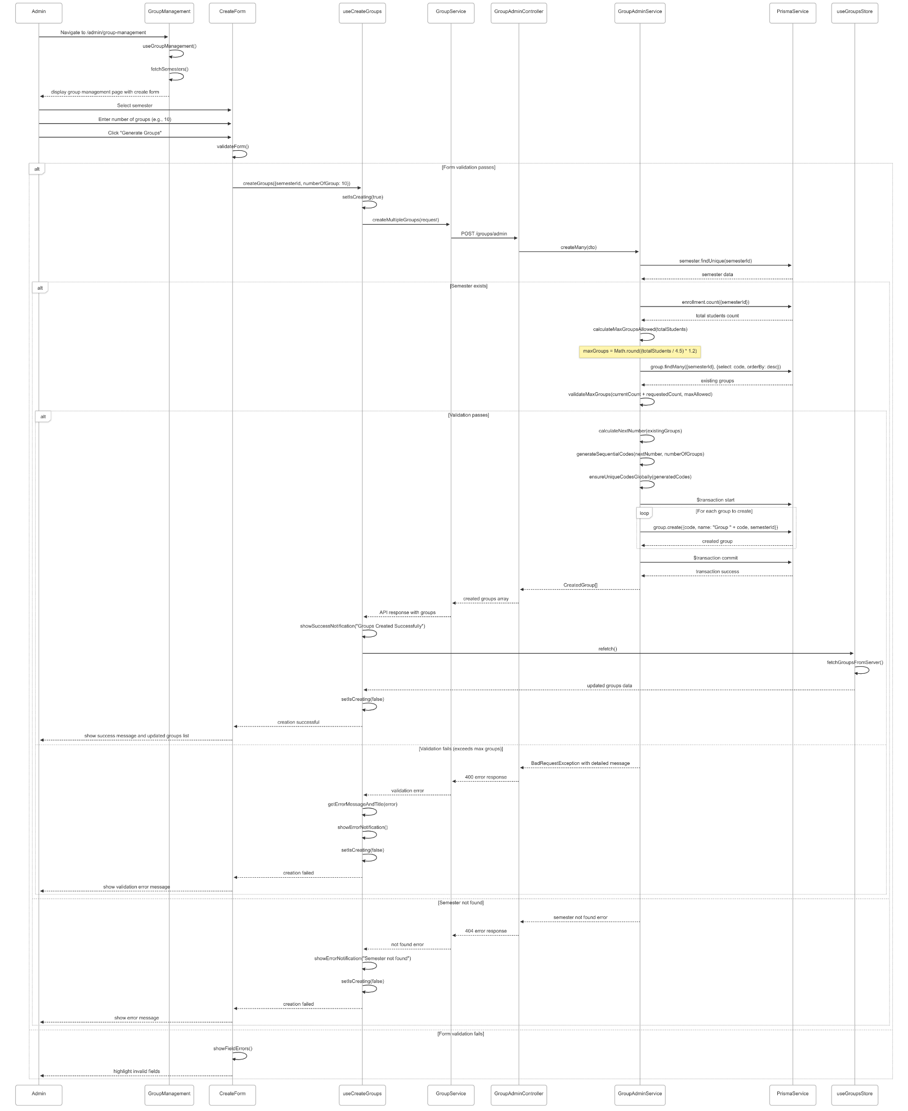](https://drive.google.com/file/d/1LSVpOfCar4PyMxbqxVms7Z3uqNLMG0BD/view?usp=drive_link)

###### Figure IV.C.25.c.(1) - Bulk Create Empty Groups Sequence Diagram

* + - * 1. Format Groups (Sort and Update Codes)

[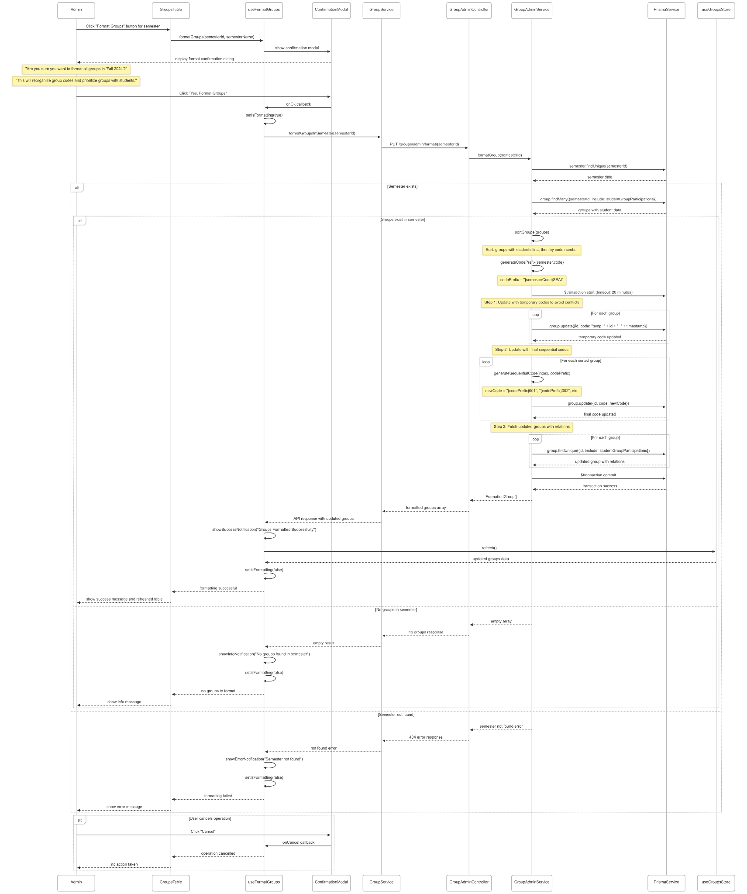](https://drive.google.com/file/d/1iOq4M1bhEQbZweqJzfpZAXzIAr7IWYyj/view?usp=drive_link)

###### Figure IV.C.25.c.(2) - Format Groups Sequence Diagram

* + - * 1. Delete Empty Group

[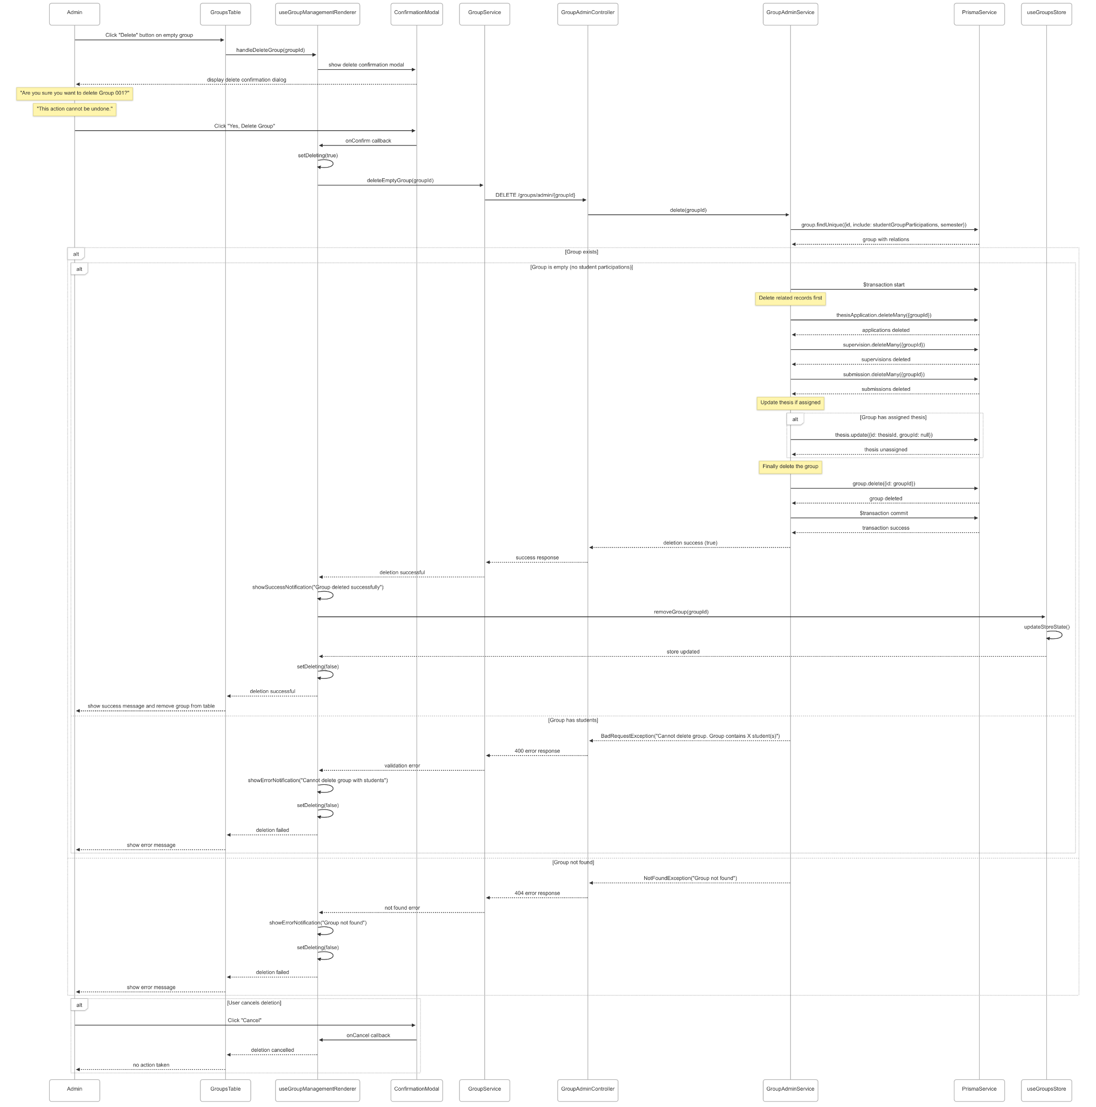](https://drive.google.com/file/d/1xgAoYxEzXbL5LN5pJwk4ksalE3iT6Cre/view?usp=drive_link)

###### Figure IV.C.25.c.(3) - Delete Empty Group Sequence Diagram

* + - * 1. Assign Student to Group

[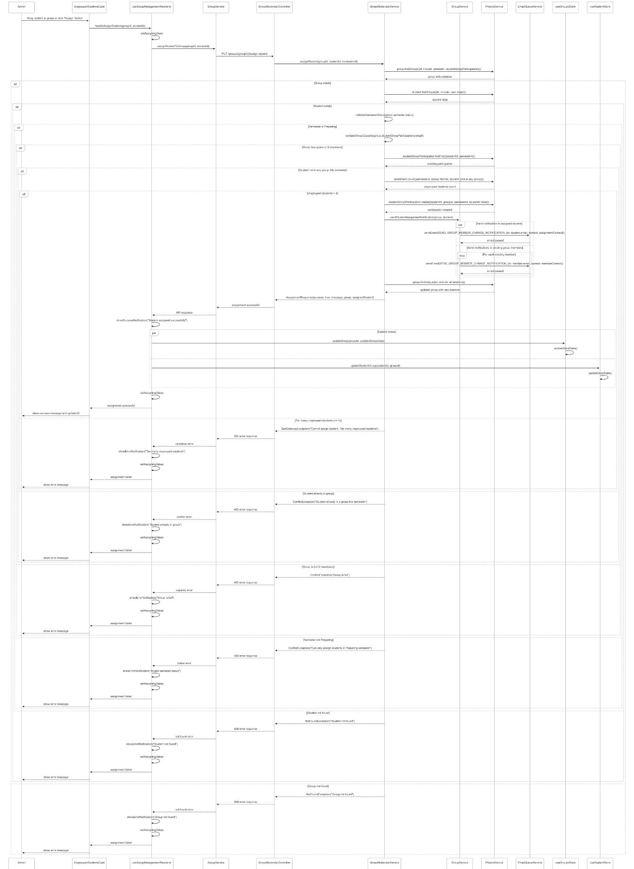](https://drive.google.com/file/d/17k1qSvVGYOpbIh5zxAyBbh5khx3oBULU/view?usp=drive_link)

###### Figure IV.C.25.c.(4) - Assign Student to Group Sequence Diagram

### Supervisor Review Request Apply Thesis

#### Class Diagram

[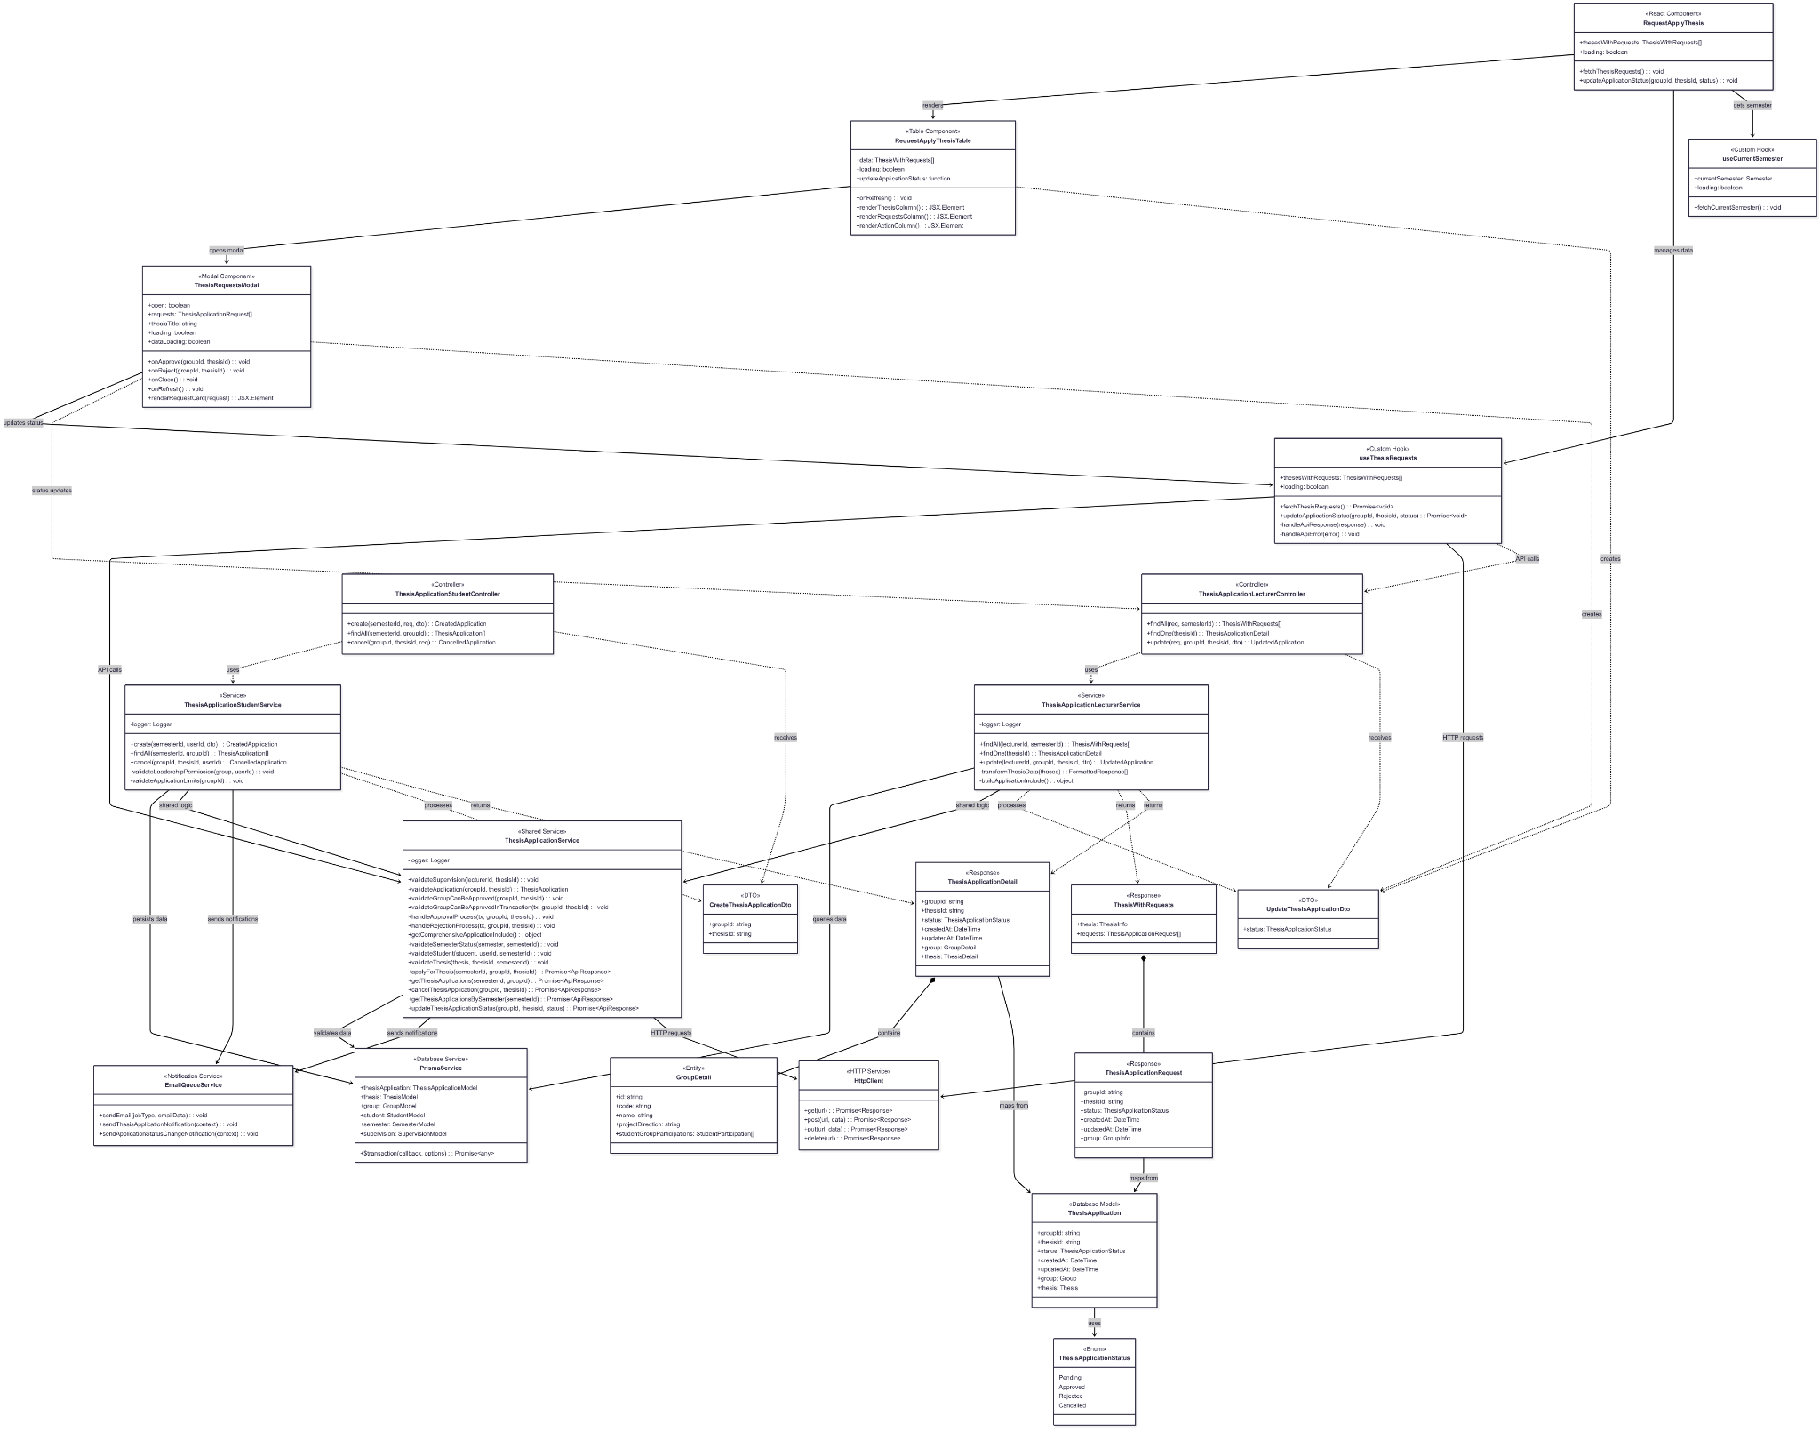](https://drive.google.com/file/d/1u7PfWaKj6vEVYVL0X8ANLxk6YTdW1CrL/view?usp=drive_link)

###### Figure IV.C.26.a - Supervisor Review Request Apply Thesis Class Diagram

#### Class Diagram Specification

| **No** | **Class** | **Method** | **Description** |
| --- | --- | --- | --- |
| 1 | ThesisApplicationLecturerController | findAll(req, semesterId) | Get all thesis applications for lecturer by semester with thesis and group details |
| 2 | ThesisApplicationLecturerController | findOne(thesisId) | Get detailed information of thesis applications for a specific thesis |
| 3 | ThesisApplicationLecturerController | update(req, groupId, thesisId, dto) | Update thesis application status (approve or reject) with validation |
| 4 | ThesisApplicationStudentController | create(semesterId, req, dto) | Create new thesis application from student group leader |
| 5 | ThesisApplicationStudentController | findAll(semesterId, groupId) | Get all thesis applications for a specific group in semester |
| 6 | ThesisApplicationStudentController | cancel(groupId, thesisId, req) | Cancel pending thesis application by group leader |
| 7 | ThesisApplicationLecturerService | findAll(lecturerId, semesterId) | Business logic to fetch thesis applications for lecturer's supervised theses |
| 8 | ThesisApplicationLecturerService | findOne(thesisId) | Get comprehensive thesis application details with all related data |
| 9 | ThesisApplicationLecturerService | update(lecturerId, groupId, thesisId, dto) | Process approval or rejection with transaction and notification handling |
| 10 | ThesisApplicationLecturerService | transformThesisData(theses) | Transform database results into frontend-friendly format |
| 11 | ThesisApplicationLecturerService | buildApplicationInclude() | Build Prisma include object for comprehensive data fetching |
| 12 | ThesisApplicationStudentService | create(semesterId, userId, dto) | Create thesis application with validation and notification sending |
| 13 | ThesisApplicationStudentService | findAll(semesterId, groupId) | Fetch all applications for group with status and thesis information |
| 14 | ThesisApplicationStudentService | cancel(groupId, thesisId, userId) | Cancel application with leadership validation and status update |
| 15 | ThesisApplicationStudentService | validateLeadershipPermission(group, userId) | Ensure only group leaders can create or cancel applications |
| 16 | ThesisApplicationStudentService | validateApplicationLimits(groupId) | Check group hasn't exceeded application limits or has approved thesis |
| 17 | ThesisApplicationService | validateSupervision(lecturerId, thesisId) | Verify lecturer supervises the thesis before allowing review actions |
| 18 | ThesisApplicationService | validateApplication(groupId, thesisId) | Check application exists and retrieve current status |
| 19 | ThesisApplicationService | validateGroupCanBeApproved(groupId, thesisId) | Pre-approval validation to ensure group is eligible for thesis |
| 20 | ThesisApplicationService | validateGroupCanBeApprovedInTransaction(tx, groupId, thesisId) | Transaction-safe validation to prevent race conditions during approval |
| 21 | ThesisApplicationService | handleApprovalProcess(tx, groupId, thesisId) | Execute approval workflow including thesis assignment and notifications |
| 22 | ThesisApplicationService | handleRejectionProcess(tx, groupId, thesisId) | Execute rejection workflow with status update and notifications |
| 23 | ThesisApplicationService | getComprehensiveApplicationInclude() | Build comprehensive Prisma include for full application data |
| 24 | ThesisApplicationService | validateSemesterStatus(semester, semesterId) | Ensure semester allows thesis applications (Preparing or Picking status) |
| 25 | ThesisApplicationService | validateStudent(student, userId, semesterId) | Verify student is enrolled and eligible in the semester |
| 26 | ThesisApplicationService | validateThesis(thesis, thesisId, semesterId) | Validate thesis exists, is published, and belongs to correct semester |
| 27 | RequestApplyThesis | fetchThesisRequests() | Load thesis applications data for current semester |
| 28 | RequestApplyThesis | updateApplicationStatus(groupId, thesisId, status) | Handle approve or reject action with UI feedback |
| 29 | RequestApplyThesisTable | renderThesisColumn() | Render thesis information column with title and details |
| 30 | RequestApplyThesisTable | renderRequestsColumn() | Render applications count and status summary column |
| 31 | RequestApplyThesisTable | renderActionColumn() | Render action buttons for reviewing applications |
| 32 | ThesisRequestsModal | onApprove(groupId, thesisId) | Handle approval action with confirmation and API call |
| 33 | ThesisRequestsModal | onReject(groupId, thesisId) | Handle rejection action with confirmation and API call |
| 34 | ThesisRequestsModal | renderRequestCard(request) | Render individual application card with group and status info |
| 35 | useThesisRequests | fetchThesisRequests() | Fetch thesis applications from API with error handling |
| 36 | useThesisRequests | updateApplicationStatus(groupId, thesisId, status) | Update application status via API with success/error notifications |
| 37 | useThesisRequests | handleApiResponse(response) | Process API response and update component state |
| 38 | useThesisRequests | handleApiError(error) | Handle API errors and show user-friendly error messages |
| 39 | useCurrentSemester | fetchCurrentSemester() | Get current active semester for filtering applications |
| 40 | PrismaService | $transaction(callback, options) | Execute multiple database operations within atomic transaction |
| 41 | EmailQueueService | sendEmail(jobType, emailData) | Queue email notification for asynchronous delivery |
| 42 | EmailQueueService | sendThesisApplicationNotification(context) | Send notification when new application is created |
| 43 | EmailQueueService | sendApplicationStatusChangeNotification(context) | Send notification when application status changes |
| 44 | ThesisApplicationService | applyForThesis(semesterId, groupId, thesisId) | Frontend API service method to create thesis application |
| 45 | ThesisApplicationService | getThesisApplications(semesterId, groupId) | Frontend API service method to fetch group applications |
| 46 | ThesisApplicationService | cancelThesisApplication(groupId, thesisId) | Frontend API service method to cancel pending application |
| 47 | ThesisApplicationService | getThesisApplicationsBySemester(semesterId) | Frontend API service method to fetch all semester applications |
| 48 | ThesisApplicationService | updateThesisApplicationStatus(groupId, thesisId, status) | Frontend API service method to approve or reject application |
| 49 | HttpClient | get(url) | Execute HTTP GET request with authentication and error handling |
| 50 | HttpClient | post(url, data) | Execute HTTP POST request with data payload and authentication |
| 51 | HttpClient | put(url, data) | Execute HTTP PUT request for data updates with authentication |

##### Table IV.C.26.b - Supervisor Review Request Apply Thesis Class Diagram Specification

#### Sequence Diagram

* + - * 1. View List Application Thesis from Groups

[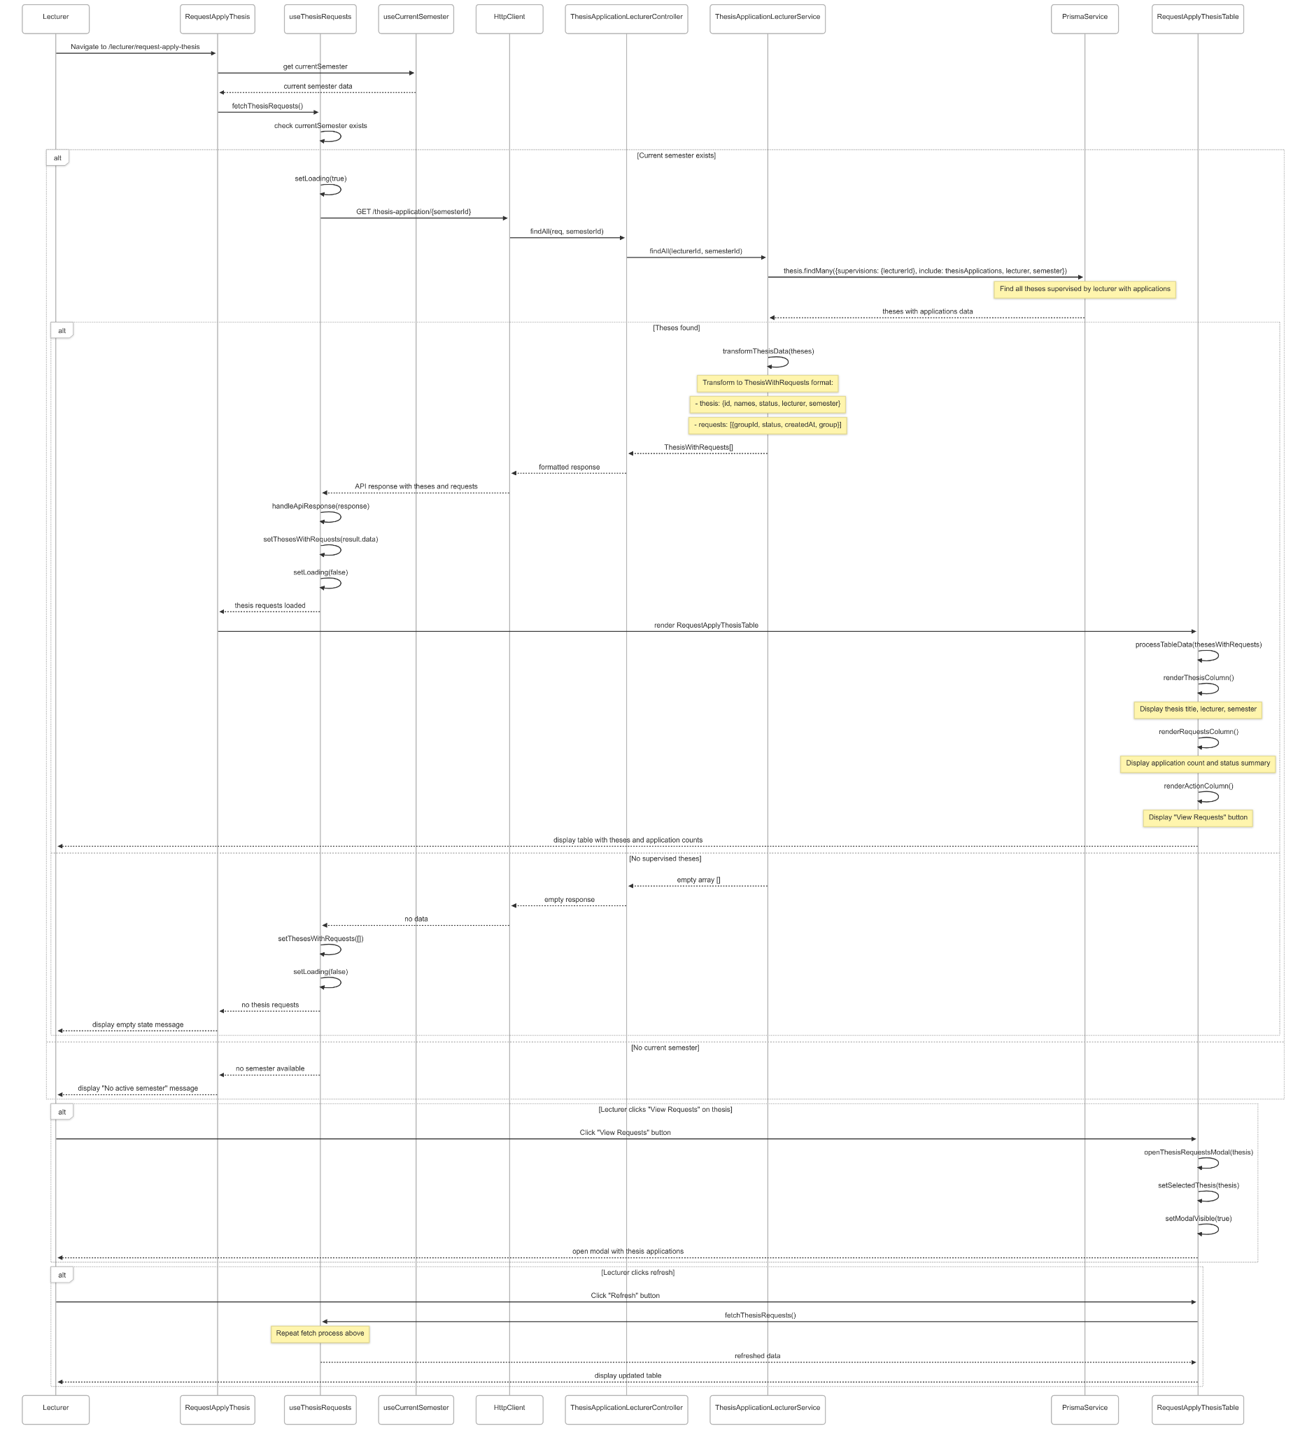](https://drive.google.com/file/d/1_Xovon9ek3-uX4vLxaXi0N4rroHToJWH/view?usp=drive_link)

###### Figure IV.C.26.c.(1) - View List Application Thesis from Groups Sequence Diagram

* + - * 1. Approve Request Apply Thesis

[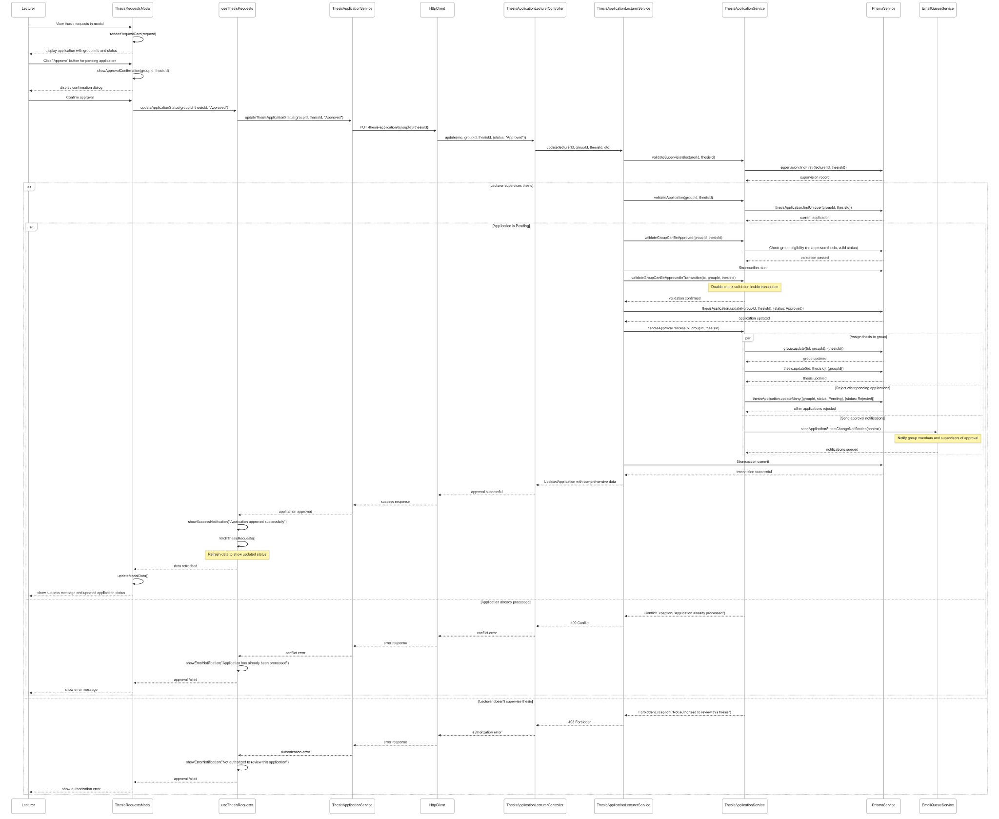](https://drive.google.com/file/d/1WAN1g7xttm8MSjVq2vV1xdTX6jiXi5NP/view?usp=drive_link)

###### Figure IV.C.26.c.(2) - Approve Request Apply Thesis Sequence Diagram

* + - * 1. Reject Request Apply Thesis

[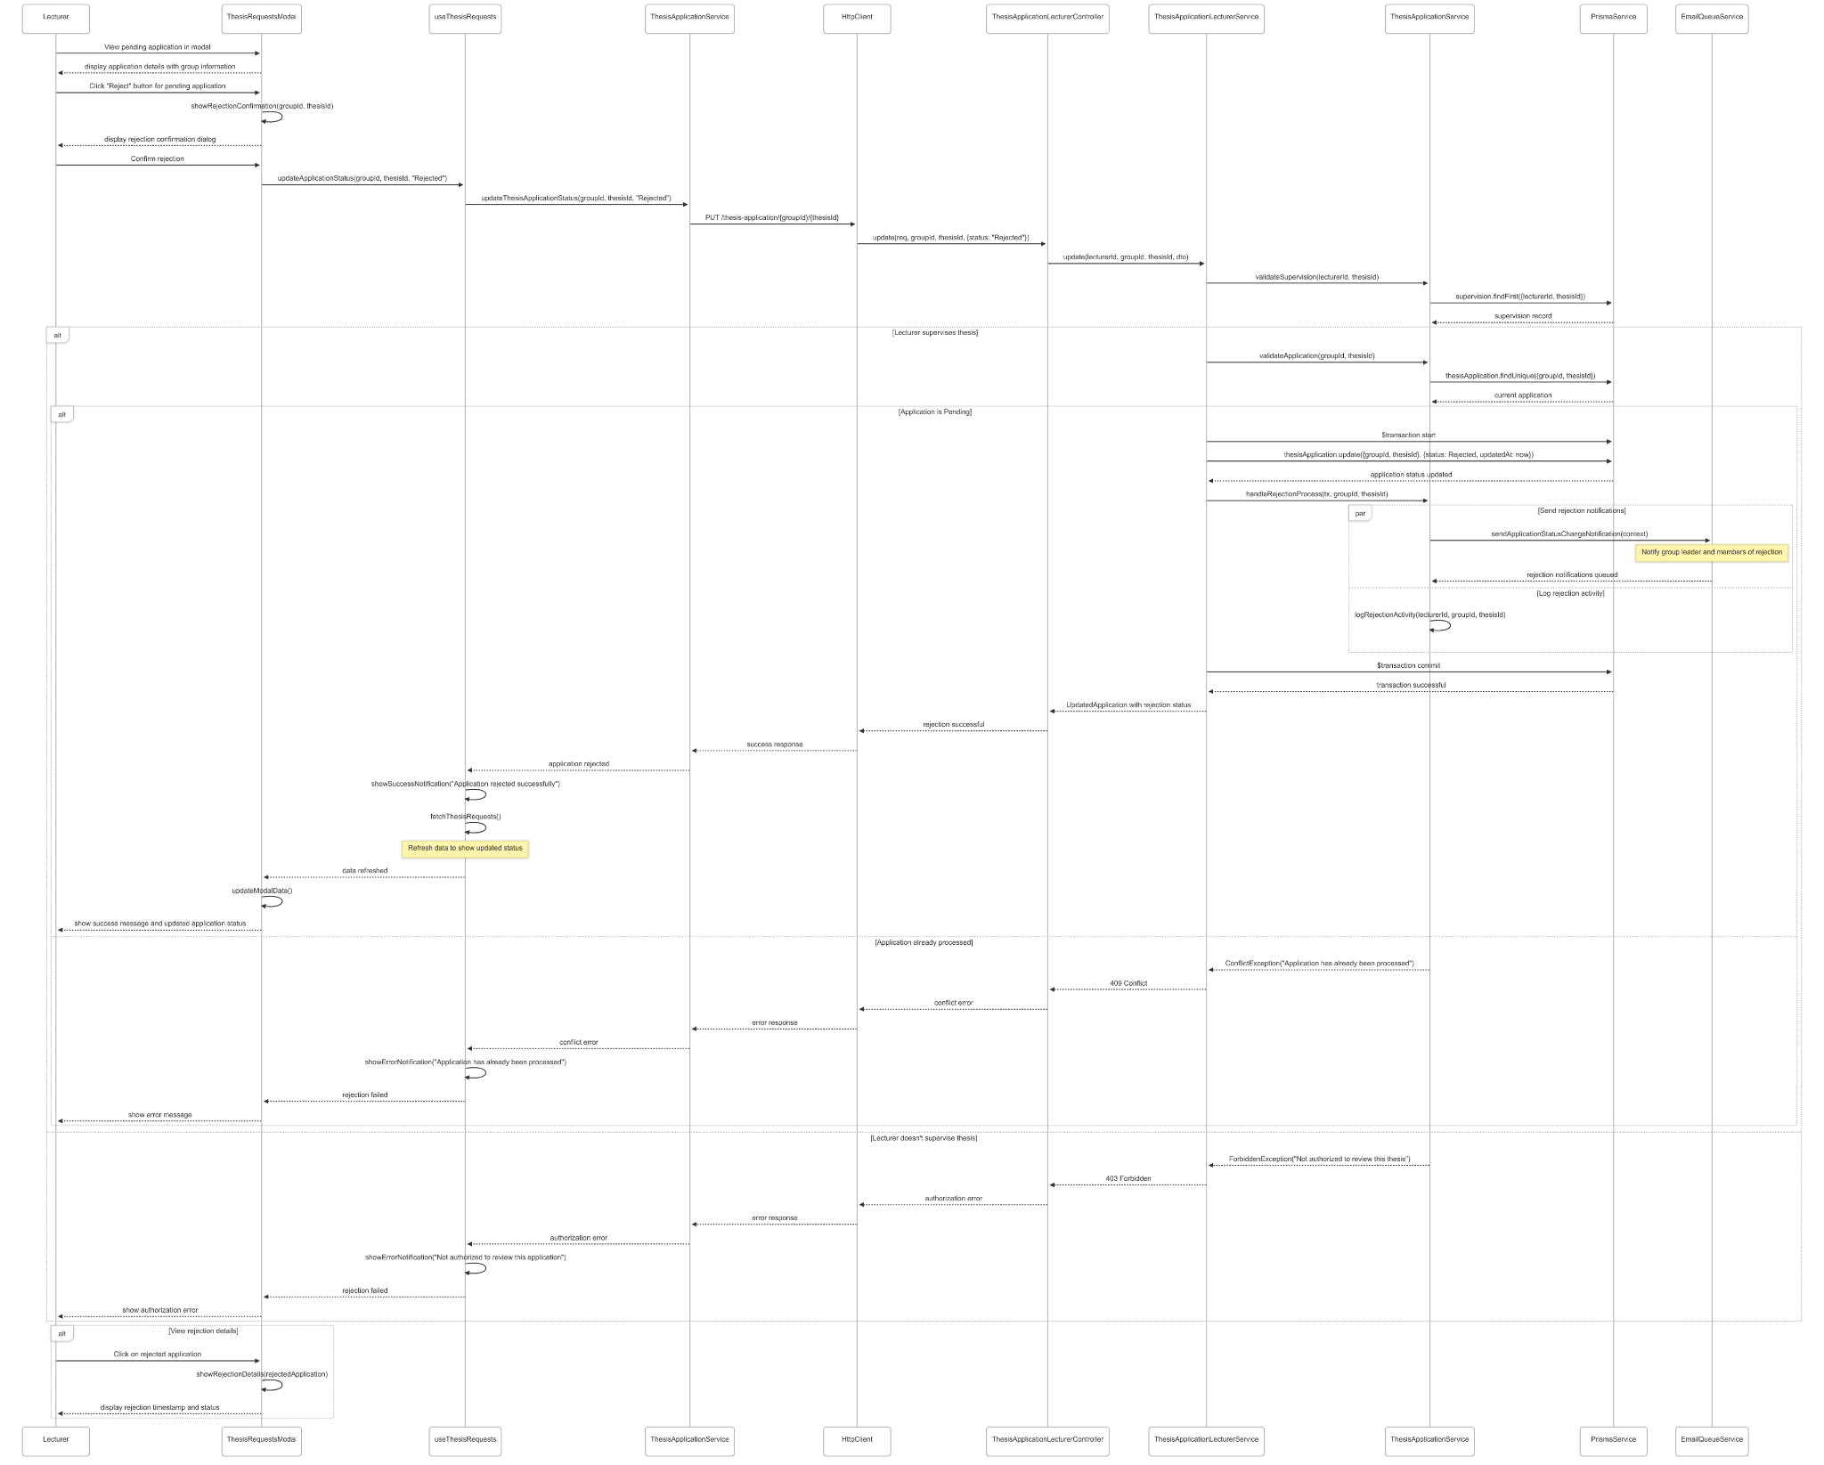](https://drive.google.com/file/d/1FrZyZzjkFjyUUiAKpulx-Q_6evflWUvv/view?usp=drive_link)

###### Figure IV.C.26.c.(3) - Reject Request Apply Thesis Sequence Diagram

### Student Invite Members To Group

#### Class Diagram

[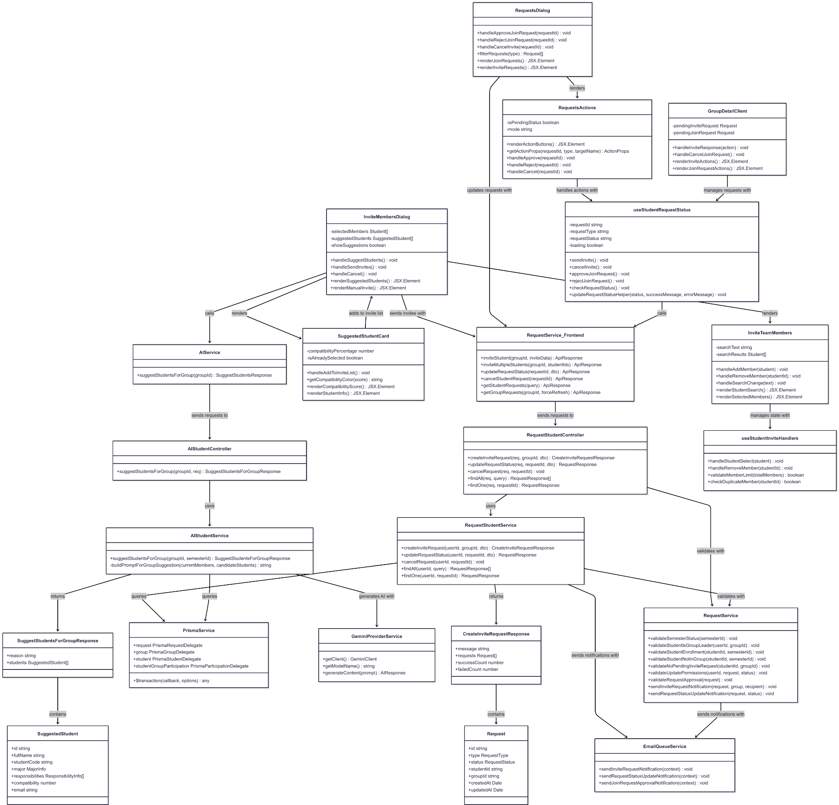](https://drive.google.com/file/d/1Nor9pB7jKAu4MRguvRFJuvkh39Qmp2L8/view?usp=drive_link)

###### Figure IV.C.27.a - Student Invite Members To Group Class Diagram

#### Class Diagram Specification

| **No** | **Class** | **Method** | **Description** |
| --- | --- | --- | --- |
| 1 | RequestStudentController | createInviteRequest(req, groupId, dto) | API endpoint to create invitation requests from group leader to multiple students |
| 2 | RequestStudentController | updateRequestStatus(req, requestId, dto) | API endpoint to update request status (approve/reject join requests, accept/reject invitations) |
| 3 | RequestStudentController | cancelRequest(req, requestId) | API endpoint to cancel pending invitation or join request |
| 4 | RequestStudentController | findAll(req, query) | API endpoint to retrieve all requests for current user with filtering options |
| 5 | RequestStudentController | findOne(req, requestId) | API endpoint to get detailed information of specific request by ID |
| 6 | RequestStudentService | createInviteRequest(userId, groupId, dto) | Business logic for creating multiple invitation requests with validation and notifications |
| 7 | RequestStudentService | updateRequestStatus(userId, requestId, dto) | Business logic for updating request status with permission validation and group participation creation |
| 8 | RequestStudentService | cancelRequest(userId, requestId) | Business logic for canceling pending requests with proper validation and cleanup |
| 9 | RequestStudentService | findAll(userId, query) | Retrieve all requests for user with filtering by type, status, and group |
| 10 | RequestStudentService | findOne(userId, requestId) | Get detailed request information with group and student data |
| 11 | AIStudentController | suggestStudentsForGroup(groupId, req) | API endpoint to get AI-powered student suggestions for group member invitations |
| 12 | AIStudentService | suggestStudentsForGroup(groupId, semesterId) | Generate AI-powered student suggestions based on group composition and needs |
| 13 | AIStudentService | buildPromptForGroupSuggestion(currentMembers, candidateStudents) | Private method to build AI prompt for analyzing student-group compatibility |
| 14 | RequestService | validateSemesterStatus(semesterId) | Validate that semester is in Preparing status for invitation operations |
| 15 | RequestService | validateStudentIsGroupLeader(userId, groupId) | Validate that user is the leader of the group before allowing invitations |
| 16 | RequestService | validateStudentEnrollment(studentId, semesterId) | Validate that student is enrolled in the same semester as the group |
| 17 | RequestService | validateStudentNotInGroup(studentId, semesterId) | Validate that student is not already in another group in the same semester |
| 18 | RequestService | validateNoPendingInviteRequest(studentId, groupId) | Validate that no pending invitation exists between student and group |
| 19 | RequestService | validateUpdatePermissions(userId, request, status) | Validate user permissions to update request status based on role and ownership |
| 20 | RequestService | validateRequestApproval(request) | Validate that request can be approved based on group capacity and semester status |
| 21 | RequestService | sendInviteRequestNotification(request, group, recipient) | Send email notification to student about invitation from group |
| 22 | RequestService | sendRequestStatusUpdateNotification(request, status) | Send email notification about request status changes to relevant parties |
| 23 | InviteMembersDialog | handleSuggestStudents() | Handle AI suggestion button click and fetch AI-powered student recommendations |
| 24 | InviteMembersDialog | handleSendInvites() | Handle sending multiple invitations to selected students with validation |
| 25 | InviteMembersDialog | handleCancel() | Handle dialog cancellation and reset all state variables |
| 26 | InviteMembersDialog | renderSuggestedStudents() | Render AI-suggested students section with compatibility scores |
| 27 | InviteMembersDialog | renderManualInvite() | Render manual student search and selection interface |
| 28 | InviteTeamMembers | handleAddMember(student) | Handle adding student to invitation list with duplicate and capacity validation |
| 29 | InviteTeamMembers | handleRemoveMember(studentId) | Handle removing student from invitation list |
| 30 | InviteTeamMembers | handleSearchChange(text) | Handle search input changes for student filtering |
| 31 | InviteTeamMembers | renderStudentSearch() | Render student search interface with autocomplete functionality |
| 32 | InviteTeamMembers | renderSelectedMembers() | Render table of selected students with remove actions |
| 33 | SuggestedStudentCard | handleAddToInviteList() | Handle adding AI-suggested student to invitation list |
| 34 | SuggestedStudentCard | getCompatibilityColor(score) | Get color coding for compatibility score display |
| 35 | SuggestedStudentCard | renderCompatibilityScore() | Render compatibility score with progress bar and percentage |
| 36 | SuggestedStudentCard | renderStudentInfo() | Render student information including name, code, major, and skills |
| 37 | RequestsDialog | handleApproveJoinRequest(requestId) | Handle approving join request from student with group membership creation |
| 38 | RequestsDialog | handleRejectJoinRequest(requestId) | Handle rejecting join request from student |
| 39 | RequestsDialog | handleCancelInvite(requestId) | Handle canceling sent invitation by group leader |
| 40 | RequestsDialog | filterRequests(type) | Filter requests by type (Join/Invite) for display in appropriate sections |
| 41 | RequestsDialog | renderJoinRequests() | Render incoming join requests section with approve/reject actions |
| 42 | RequestsDialog | renderInviteRequests() | Render sent invitations section with cancel actions |
| 43 | RequestsActions | renderActionButtons() | Render appropriate action buttons based on request type, status, and user role |
| 44 | RequestsActions | getActionProps(requestId, type, targetName) | Get action button properties and handlers based on context |
| 45 | RequestsActions | handleApprove(requestId) | Handle approve action for join requests |
| 46 | RequestsActions | handleReject(requestId) | Handle reject action for join requests |
| 47 | RequestsActions | handleCancel(requestId) | Handle cancel action for sent invitations |
| 48 | GroupDetailClient | handleInviteResponse(action) | Handle accept/reject actions for received invitations |
| 49 | GroupDetailClient | handleCancelJoinRequest() | Handle cancellation of pending join request |
| 50 | GroupDetailClient | renderInviteActions() | Render accept/reject buttons for received invitations |
| 51 | GroupDetailClient | renderJoinRequestActions() | Render cancel button for pending join requests |
| 52 | useStudentRequestStatus | sendInvite() | Send invitation to student from current group |
| 53 | useStudentRequestStatus | cancelInvite() | Cancel sent invitation to student |
| 54 | useStudentRequestStatus | approveJoinRequest() | Approve incoming join request as group leader |
| 55 | useStudentRequestStatus | rejectJoinRequest() | Reject incoming join request as group leader |
| 56 | useStudentRequestStatus | checkRequestStatus() | Check current request status between student and group |
| 57 | useStudentRequestStatus | updateRequestStatusHelper(status, successMessage, errorMessage) | Helper method to update request status with error handling |
| 58 | useStudentInviteHandlers | handleStudentSelect(student) | Handle student selection from search results |
| 59 | useStudentInviteHandlers | handleRemoveMember(studentId) | Handle removing student from selected members list |
| 60 | useStudentInviteHandlers | validateMemberLimit(totalMembers) | Validate that total members doesn't exceed group capacity limit |
| 61 | useStudentInviteHandlers | checkDuplicateMember(studentId) | Check if student is already in the selected members list |
| 62 | RequestService_Frontend | inviteStudent(groupId, inviteData) | Frontend service method to send single student invitation |
| 63 | RequestService_Frontend | inviteMultipleStudents(groupId, studentIds) | Frontend service method to send multiple student invitations |
| 64 | RequestService_Frontend | updateRequestStatus(requestId, dto) | Frontend service method to update request status |
| 65 | RequestService_Frontend | cancelStudentRequest(requestId) | Frontend service method to cancel student request |
| 66 | RequestService_Frontend | getStudentRequests(query) | Frontend service method to fetch student requests with filtering |
| 67 | RequestService_Frontend | getGroupRequests(groupId, forceRefresh) | Frontend service method to fetch group requests with optional cache refresh |
| 68 | AIService | suggestStudentsForGroup(groupId) | Frontend service method to get AI-powered student suggestions |
| 69 | PrismaService | $transaction(callback, options) | Execute database operations within atomic transaction |
| 70 | EmailQueueService | sendInviteRequestNotification(context) | Queue invitation notification email for delivery |
| 71 | EmailQueueService | sendRequestStatusUpdateNotification(context) | Queue request status update notification email |
| 72 | EmailQueueService | sendJoinRequestApprovalNotification(context) | Queue join request approval notification email |
| 73 | GeminiProviderService | getClient() | Get configured Gemini AI client instance |
| 74 | GeminiProviderService | getModelName() | Get the configured Gemini AI model name |
| 75 | GeminiProviderService | generateContent(prompt) | Generate AI content based on provided prompt |
| 76 | CreateInviteRequestResponse | message | Property containing success message about invitation results |
| 77 | CreateInviteRequestResponse | successCount | Property containing number of successfully sent invitations |
| 78 | CreateInviteRequestResponse | failedCount | Property containing number of failed invitation attempts |
| 79 | SuggestStudentsForGroupResponse | reason | Property containing AI explanation for student recommendations |
| 80 | SuggestStudentsForGroupResponse | students | Property containing array of suggested students with compatibility scores |
| 81 | SuggestedStudent | compatibility | Property containing AI-calculated compatibility score for group matching |
| 82 | SuggestedStudent | responsibilities | Property containing student's skills and responsibility levels |
| 83 | SuggestedStudent | major | Property containing student's academic major information |
| 84 | Request | type | Property indicating request type (Join or Invite) |
| 85 | Request | status | Property indicating current request status (Pending, Approved, Rejected, Cancelled) |

##### Table IV.C.27.b - Student Invite Members To Group Class Diagram Specification

#### Sequence Diagram

* + - * 1. AI Suggest Members

[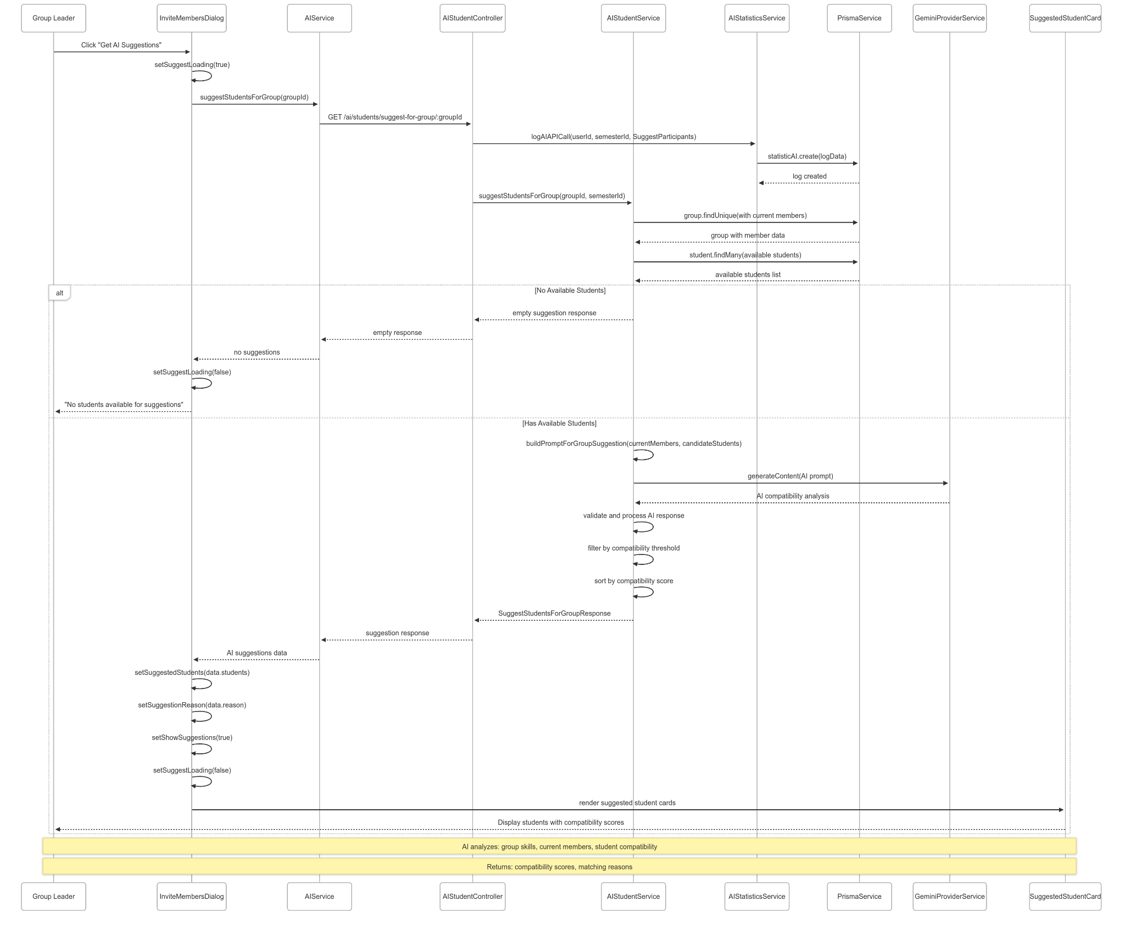](https://drive.google.com/file/d/1EWd0L4d28S16MjSLALYFCcA36S3dqRNO/view?usp=drive_link)

###### Figure IV.C.27.c.(1) - AI Suggest Members Sequence Diagram

* + - * 1. Send Multiple Invitations

[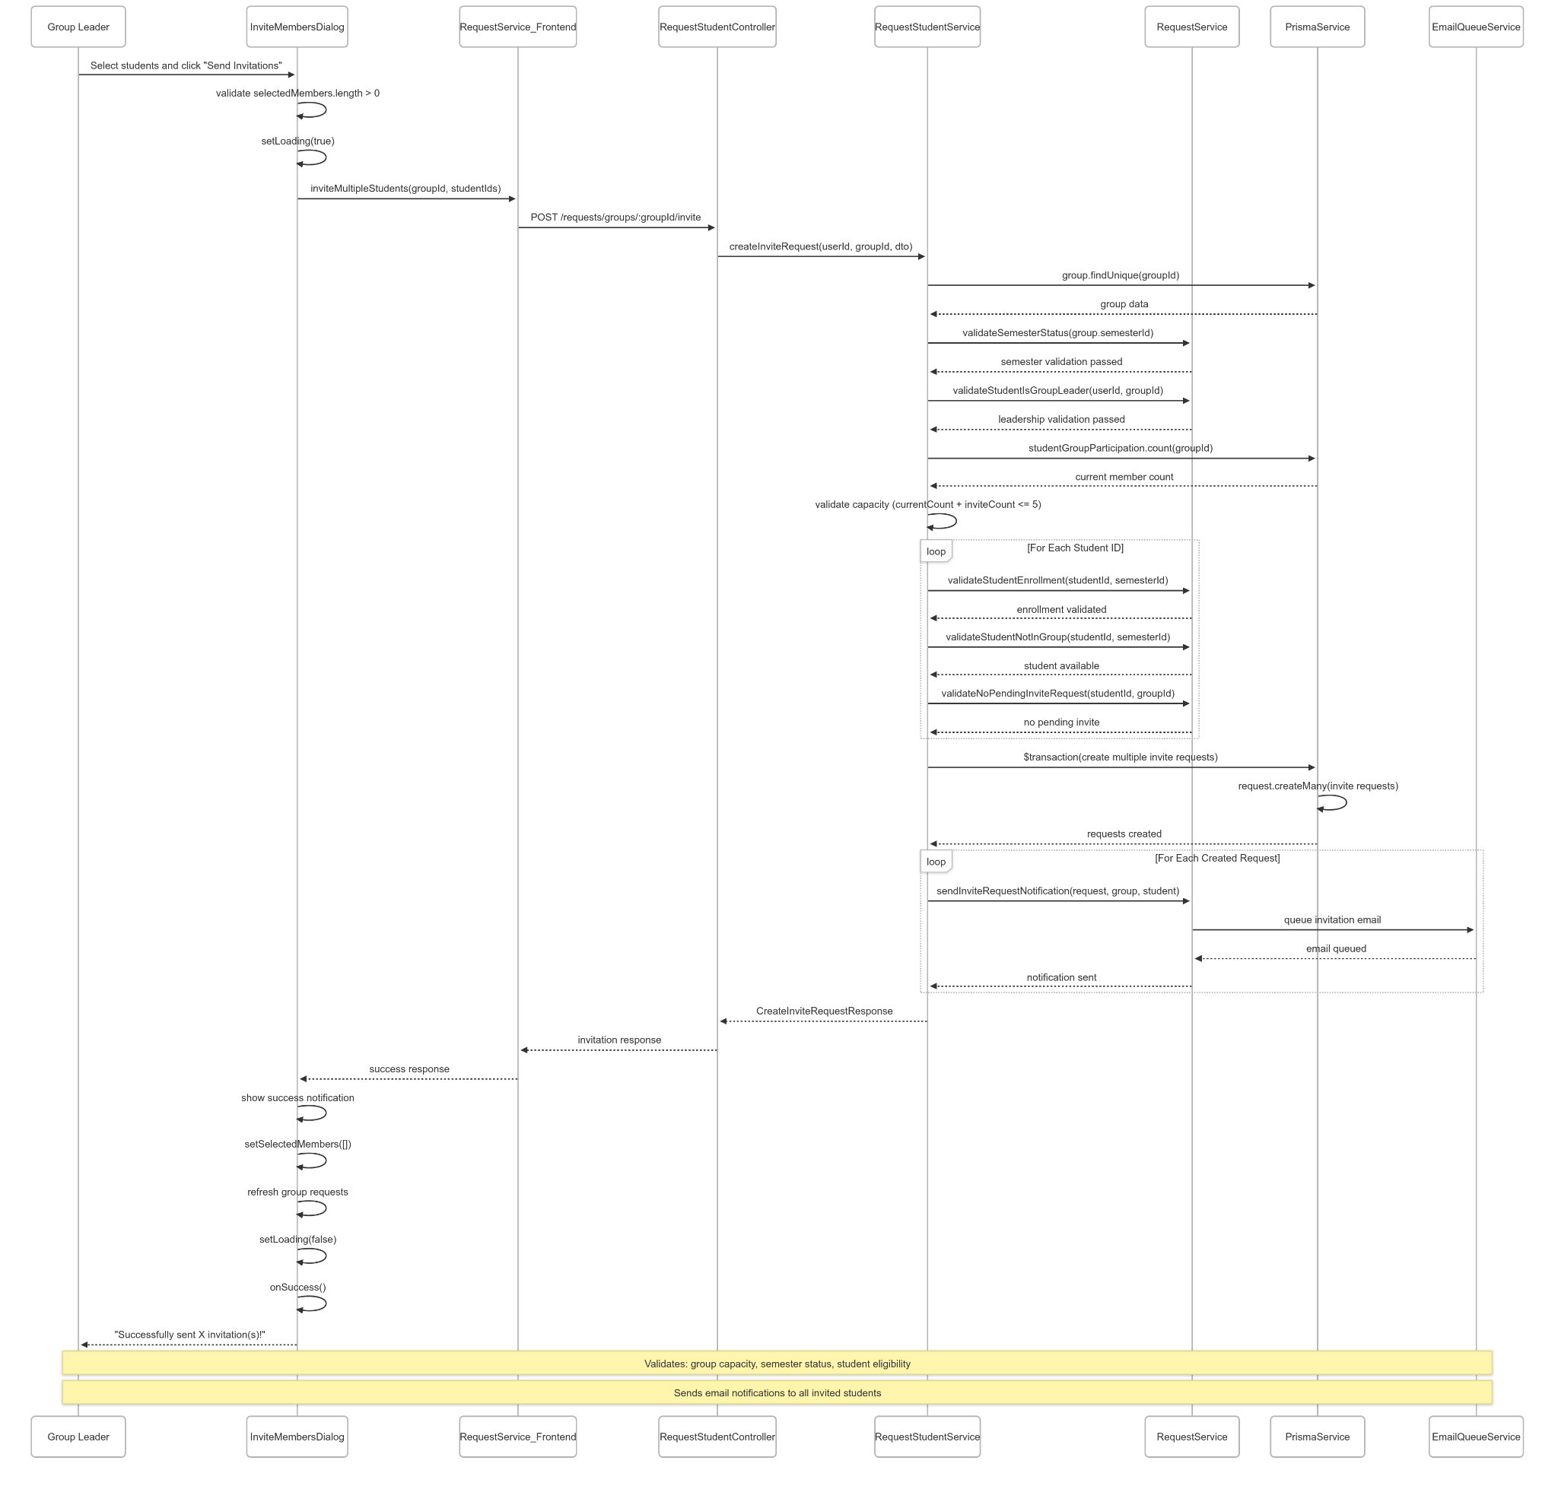](https://drive.google.com/file/d/197p4xcns_K2mSfRIQhI5n8AUQylB-elR/view?usp=drive_link)

###### Figure IV.C.27.c.(2) - Send Multiple Invitations Sequence Diagram

* + - * 1. Accept Join Request (by Group Leader)

[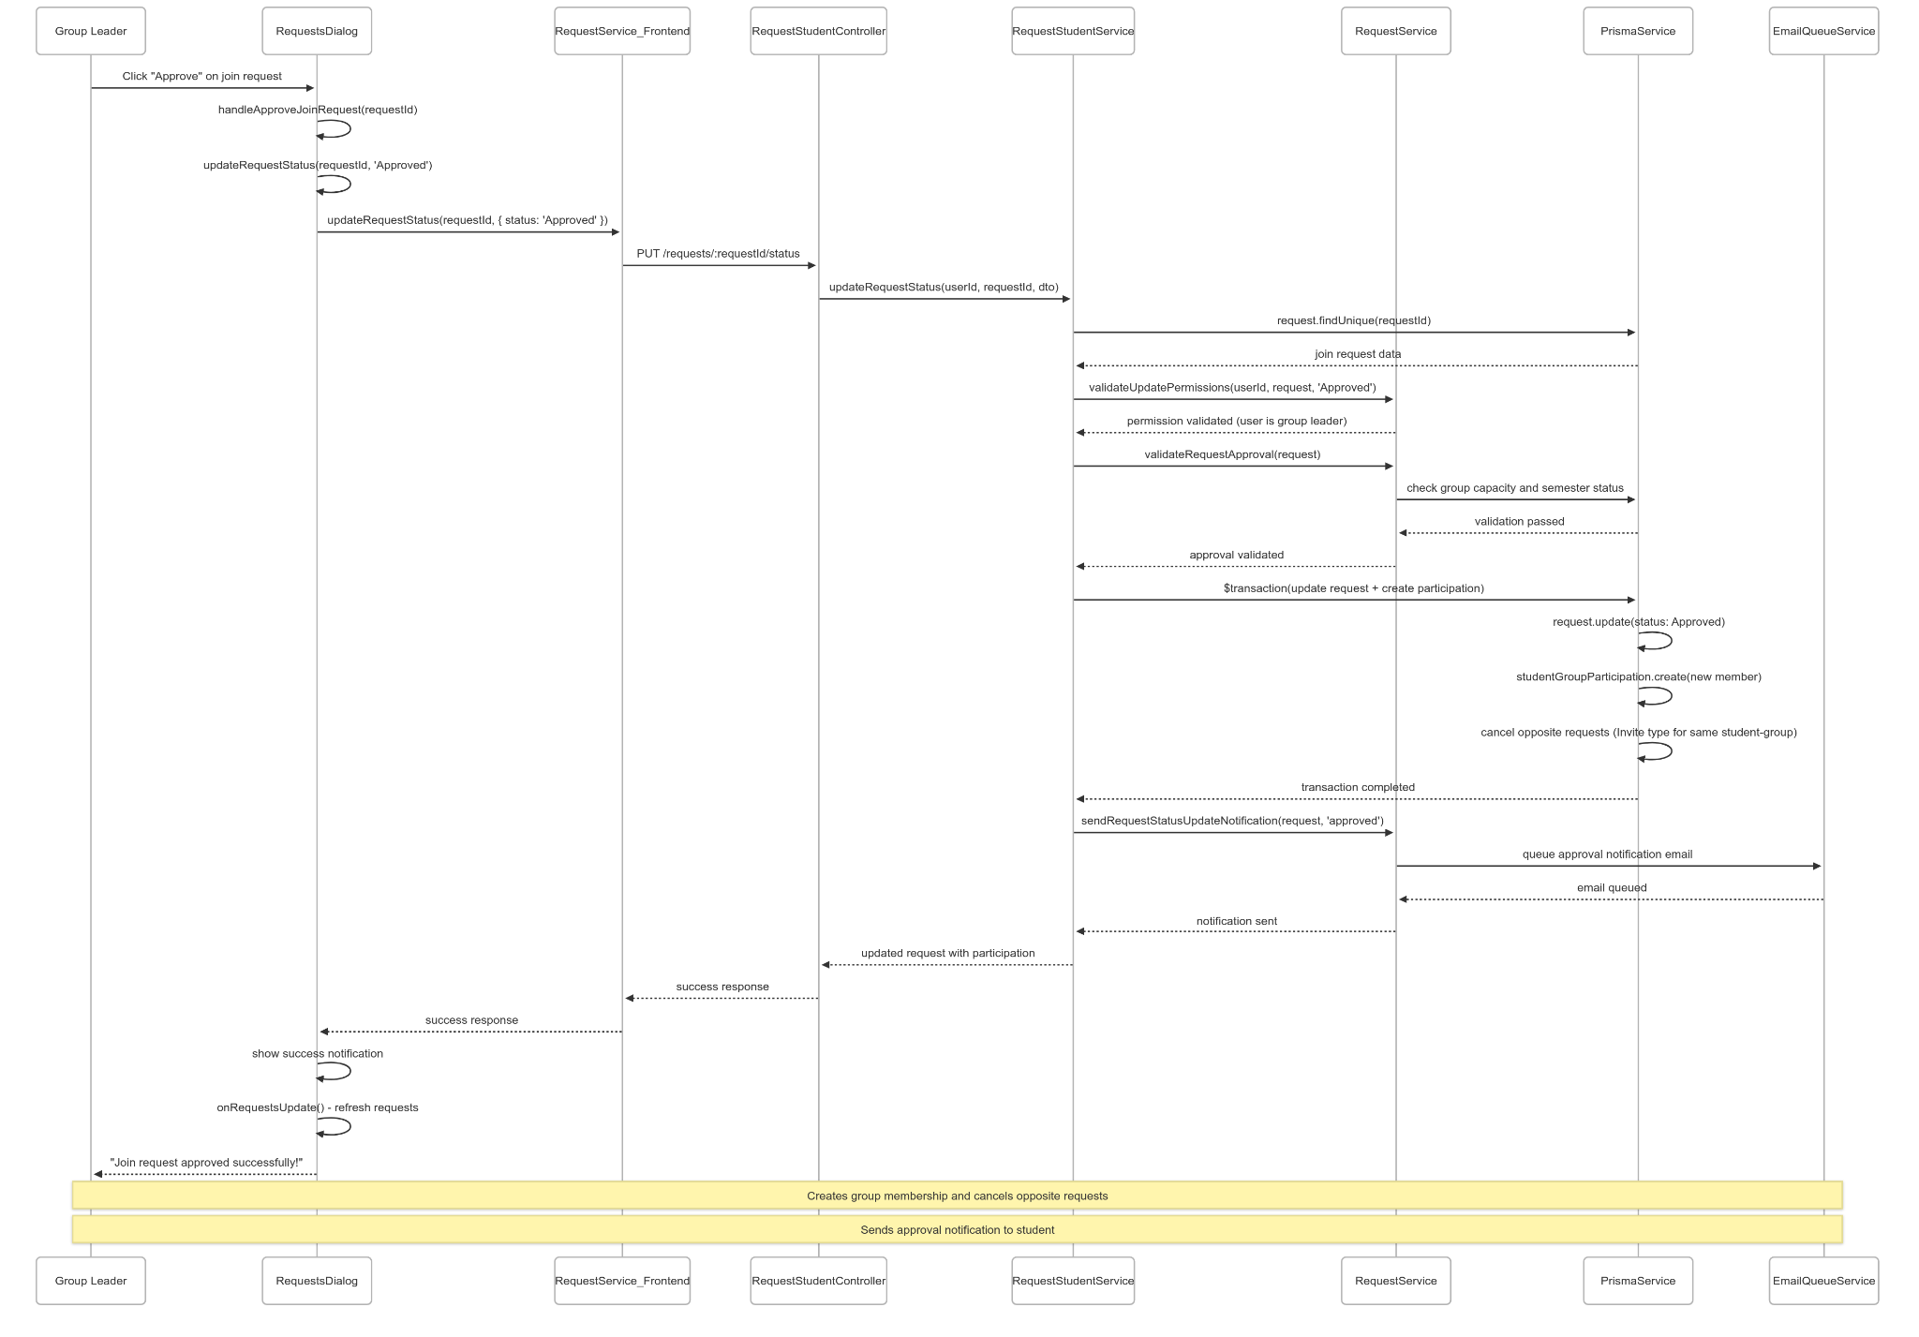](https://drive.google.com/file/d/1Zfan41yk3Pbc5HhlH2HhIT1hhDNV3p3k/view?usp=drive_link)

###### Figure IV.C.27.c.(3) - Accept Join Request Sequence Diagram

* + - * 1. Reject Join Request (by Group Leader)

[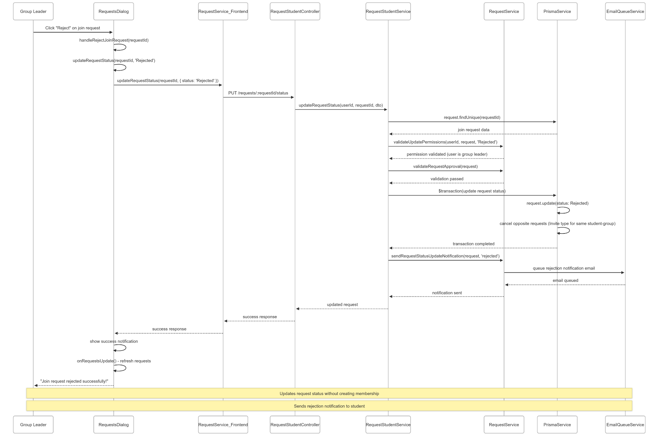](https://drive.google.com/file/d/1rzcWj1nBlcJqOIfdQYfvR0wX2atkDAIa/view?usp=drive_link)

###### Figure IV.C.27.c.(4) - Reject Join Request Sequence Diagram

* + - * 1. Cancel Invitation (by Group Leader)

[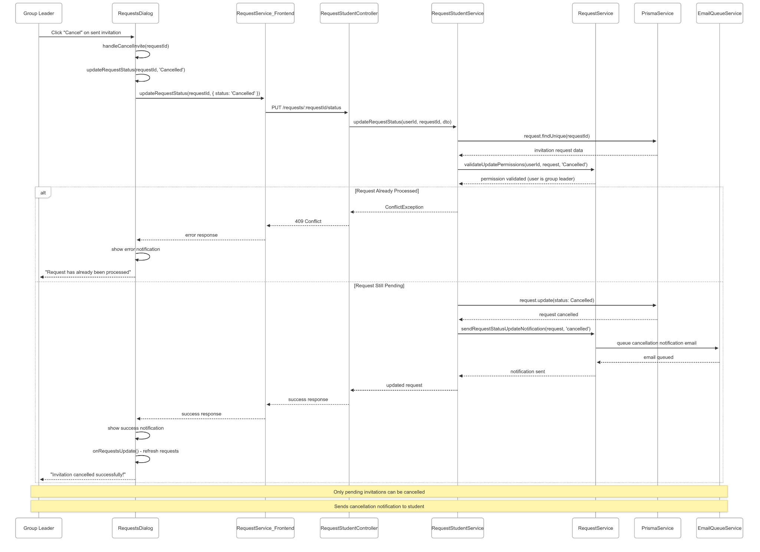](https://drive.google.com/file/d/17J2hceqhDjXGIPRSB04Pu_e2mBi1y7v7/view?usp=drive_link)

###### Figure IV.C.27.c.(5) - Cancel Invitation Sequence Diagram

# Software Testing Documentation

## Scope of Testing

| **Feature** | **Function** | **Role** | **Description** |
| --- | --- | --- | --- |
| **Authentication** | User Login | Student && Lecturer | Check that users can authenticate with email and password, with roles determined dynamically. |
| Admin Login | Admin | Ensure admin can authenticate with username and password, receiving access token and refresh token for admin access. |
| Request Password Reset | All Roles | Ensure OTP code is sent to the user's email for password reset (valid for 10 minutes). |
| Verify OTP and Reset Password | All Roles | Verify OTP code validation and automatic password generation with email delivery. |
| Change Password | All Roles | Test that authenticated users can change their password with current password verification. |
| Remember Me | All Roles | Remember Me keeps users logged in across sessions and browser restarts without re-entering credentials, until they manually log out or the session expires. |
| **Admin Students Management** | Students Management | Admin | Ensure view and manage list of all students. |
| Create New Student Manual | Admin | Ensure admin can create or enroll students in semesters (PREPARING status only). |
| Create New Student Import from Excel | Admin | Test batch import of students for specific semester and major. |
| **Admin Lecture Management** | Lecture Management | Admin | Ensure view and manage list of lecturers. |
| Create New Lecture Manual | Admin | Ensure admin can create lecturer accounts with auto-generated passwords and email notifications. |
| Create New Lecture Import from Excel | Admin | Test bulk import of multiple lecturer accounts from array data. |
| **Admin Group Management** | Generate Empty Groups | Admin | Ensure the number of groups created matches the number of students in the system. |
| Format Group Code | Admin | Ensure the group code follows the correct sequential format. |
| Delete Group | Admin | Ensure the admin process successfully deletes a group. |
| View Ungrouped Students | Admin | Ensure the admin can view all students without a group when the semester status is “preparing.” |
| Assign Student to Group | Admin | Ensure the admin process assigns ungrouped students to appropriate groups without exceeding the maximum number of members per group. |
| **Admin User Management** | Edit User | Admin | Ensure admin process edit student/lecturer information, deactivate/reactivate user accounts. |
| Delete User | Admin | Ensure the admin process deletes student/lecturer information. |
| **Semester Management** | Create Semester | Admin | Ensure admin can create new semesters with unique names and codes. |
| Edit Semester | Admin | Test semester status transitions and business rule enforcement (NotYet → Preparing → Picking → Ongoing → End). |
| Delete Semester | Admin | Verify admin can delete semesters in NotYet status with no related data. |
| **Milestone Management** | Create Milestone | Admin | Test milestone creation during Ongoing semester with date validation. |
| Edit Milestone | Admin | Ensure milestones can be updated before start date with overlap prevention. |
| Delete Milestone | Admin | Verify milestone deletion with submission status validation. |
| **Admin Account Settings** | Account Settings | Admin | Test admin can update password with proper validation. |
| **Student Account Setting** | Update Student Profile | Student | Test that students can update their own profile information including full name, gender, phone number, responsibility levels (with proficiency levels).  Cannot modify student code, email, or major (admin-only fields). |
| Change Password | Student | Verify students can change their password by providing current password and new password with proper validation and complexity requirements. |
| **Student View List Thesis** | View All Published Theses | Student | Test students can retrieve all published and approved theses available for selection in their semester. Verify filtering by semester and published / unpublished. |
| View Thesis Details | Student | Ensure students can access detailed thesis information including description, requirements, supporting documents, and supervisor details before making selection decisions. |
| **Student Edit Group Info** | Update Group Details | Student (Leader) | Test group leaders can modify group name, project direction, during PREPARING status only. |
| Leadership Restrictions | Student (Leader) | Verify only group leaders can edit group information, and updates are restricted based on semester status and group assignment status. |
| **Student Group Action** | Change Group Leadership | Student (Leader) | Test current leaders can transfer leadership to existing group members during PREPARING status with proper email notifications. |
| Remove Group Members | Student (Leader) | Verify leaders can remove other members (not themselves) with email notifications and proper validation of group state. |
| Leave Group | Student (Leader) | Ensure students can leave groups during PREPARING status. If the student is the leader, they must manually transfer the leadership role to another member before leaving. If the group has only one member, it will become an empty group after the student leaves. |
| Delete Group | Student (Leader) | Ensure leaders can delete groups only during PREPARING status when no thesis is assigned and no submissions exist. |
| Pick Thesis | Student (Leader) | Test thesis selection during PICKING status, ensuring the thesis is published, approved, and not already assigned to another group. |
| Unpick Thesis | Student (Leader) | Verify leaders can remove assigned thesis during PICKING status with proper notifications to group members and thesis lecturer. |
| **Student Thesis Edit** | Update Thesis Information | Student (Leader) | Test that a thesis can be modified with all details, including title, description, domain, orientation, and supporting document, with proper validation and versioning. |
| **Student Tracking Progress** | View Milestone Timeline | Student | Test students can view all milestones for their semester including start/end dates, requirements, and submission status. |
| Submit Milestone Work | Student (Leader) | Test group leaders can submit assignments for milestones with document attachments before milestone start dates during ONGOING semester. |
| Update Submissions | Student (Leader) | Verify leaders can update existing submissions with new documents before milestone deadlines, with transaction consistency and cache invalidation. |
| Track Submission Status | Student | Verify students can monitor submission status across all milestones and view assignment reviews from lecturers. |
| Review Feedback Access | Student | Ensure students can access detailed feedback from reviewers including checklist evaluations and general comments on their submissions. |
| **Lecturer Dashboard** | View Assigned Reviews | Lecturer | Test lecturers can access all submissions assigned to them for review with group details and milestone information. |
| Track Supervision Load | Lecturer | Verify lecturers can view all theses they are supervising and associated groups with member details and progress tracking. |
| Statistics Overview | Lecturer | Ensure lecturers can access statistics about their supervised groups, pending reviews, and thesis management activities. |
| **Lecturer View List Thesis** | View All Theses | Lecturer | Test lecturers can retrieve a comprehensive list of all thesis projects with detailed information including status, supervision, and assignment details. |
| **Manager Lecturer Thesis Status** | Review Thesis Proposals | Moderator | Test moderators can review submitted thesis proposals and approve or reject them with status updates and email notifications. |
| **Lecturer Create Thesis** | Create New Thesis | Lecturer | Test thesis creation with all required fields: titles, description, domain orientation and supporting documents. Verify automatic supervisor assignment. |
| Validate Creation Limits | Lecturer | vEnsure system enforces maximum thesis limits per lecturer per semester (maxThesesPerLecturer) with proper error handling. |
| **Lecturer Public Thesis** | Publish/Unpublish Theses | Moderator | Verify moderators can publish approved theses for student selection or unpublish them, with validation for supervisor requirements (exactly 2 supervisors). |
| Publication Management | Moderator | Verify thesis publication workflow from creation through approval to student availability with proper status transitions. |
| **Lecturer Edit Thesis** | Update Thesis Information | Lecturer | Test thesis creators can modify all thesis details including titles, description, domain, and orientation with proper validation and versioning. |
| Permission Validation | Lecturer | Ensure only thesis creators or assigned lecturers can edit thesis proposals with proper authorization checks. |
| Version Management | Lecturer | Verify new versions are created when supporting documents are updated with proper version tracking and history. |
| **Lecturer Delete Thesis** | Delete Thesis Proposal | Lecturer | Test lecturers can delete only NEW or REJECTED theses with proper authorization checks and cascade deletion of related data. |
| Status Validation | Lecturer | Ensure deletion is restricted to specific status states and proper error handling for invalid deletion attempts. |
| **Lecturer Thesis Version Control** | View Version History | Lecturer | Test lecturers can view all groups they supervise in a semester with complete member details and thesis assignment status. |
| **Lecturer Group Progress** | Monitor Supervised Groups | Lecturer | Test lecturers can view all groups they supervise in a semester with complete member details and thesis assignment status. |
| Track Group Submissions | Lecturer | Verify lecturers can monitor submission progress across milestones for all supervised groups with detailed submission information. |
| **Manager Role Assign Supervisor** | Bulk Supervisor Assignment | Moderator | Test moderators can assign exactly 2 lecturers as supervisors to multiple theses with validation for thesis status, semester status, and lecturer availability. |
| Change Supervisor | Moderator | Verify moderators can replace existing supervisors with new ones for approved theses with proper notification system. |
| **Manager Role Assign Student** | Assign Student to Group | Moderator | Test moderators can assign individual students to existing groups with validation for group capacity, semester status, and student enrollment. |
| Validate Assignment Rules | Moderator | Verify enforcement of assignment rules: max 6 members per group, semester PREPARING status, and student not already in another group. |
| **Lecturer Profile Settings** | Update Own Profile | Lecturer | Test lecturers can update their personal information including full name, contact details, and preferences with proper validation. |
| Lecturer Management | Admin | Verify administrators can update any lecturer profile with extended permissions including email modification and role changes. |
| **Lecturer Change Password** | Change Own Password | Lecturer | est lecturers can change their password by providing current password and new password with complexity validation and security requirements. |
| **Lecturer Role Checklist Management** | Create Checklists | Moderator | Test moderators can create checklists with milestone assignment, ensuring each milestone can have only one checklist and proper validation. |
| Manage Checklist Items | Moderator | Verify creation, update, and deletion of checklist items in bulk operations with transaction consistency and validation. |
| **Manager Role Assign Lecturer Review** | Bulk Reviewer Assignment | Moderator | Test moderators can assign exactly 2 lecturers as reviewers to multiple submissions with validation for eligibility and conflict of interest (not supervisors). |
| Change Reviewer Assignment | Moderator | Verify moderators can replace assigned reviewers with new eligible lecturers with proper notification system and validation. |
| Reviewer Eligibility | Moderator | Ensure proper filtering of eligible reviewers excluding supervisors and already assigned reviewers for each submission. |
| **Lecturer Group Review** | Submit Reviews | Lecturer | Test assigned reviewers can submit reviews with checklist evaluation and general feedback, with restrictions for main reviewers (feedback only). |
| Review Form Access | Lecturer | Verify lecturers can access review forms with milestone checklists and submission details for assigned reviews. |
| Update Reviews | Lecturer | Ensure reviewers can update their submitted reviews with modified feedback and checklist item evaluations. |
| **Lecturer Check Similar Thesis** | AI Duplicate Detection | Lecturer | Test AI-powered duplicate thesis detection with similarity scoring and matching analysis against existing thesis database. |
| Similarity Analysis | Lecturer | Verify detailed similarity analysis with confidence levels, matching criteria, and comprehensive thesis comparison results. |
| **Student Get Suggestions Member** | AI Member Suggestions | Student | Test AI-powered group suggestions for students based on their skills and project directions. |
| Group Formation Assistance | Student | Verify AI analysis considers group requirements, skill gaps, and member composition to suggest compatible students for optimal team formation. |
| **Student AI Suggest Thesis** | AI Thesis Recommendations | Student | Test AI-powered thesis suggestions for groups based on member responsibility levels, project directions, and thesis orientation. |
| Recommendation Algorithm | Student | Verify that the AI considers group capabilities, project direction, member responsibility levels, and thesis orientation to determine the most suitable thesis |
| **Student Chat Bot** | Student Chat Bot | Student | Ensure that students can use the chatbot to receive guidance on using the system with predefined questions. |

##### Table V.A - Scope of testing

## Test Strategy

### Testing Types

| **Objective** | **Technique** | **Completion criteria** |
| --- | --- | --- |
| Verify and validate each individual code unit including API controllers, service functions, database operations, authentication logic, and business rule implementations | Unit testing | Most of the methods and classes covered by tests. Database query functions validated completely. Authentication and authorization logic tested thoroughly. Business rule implementations verified. Error handling functions covered comprehensively. |
| Testing complete user workflows and business processes including user registration, authentication, group management, thesis selection, submission processes, review workflows, and administrative functions in real application environment | End-to-end testing | All critical user workflows functional end-to-end. Student, lecturer, and admin processes working completely. Cross-platform functionality verified. System performance acceptable under normal and peak conditions. Data integrity maintained across all operations. Business processes completed successfully. |
| Check correct interaction between API services, database systems, authentication services, email notifications, file storage, caching mechanisms, and external service integrations | Integration testing | API-database communication validated completely. Authentication workflow tested across all modules. File management operations working properly. Email notification system functional. Cache synchronization maintained consistently. All service integrations verified. |
| Testing API contracts, data exchange formats, request and response validation, system boundary communications, and service interface compatibility | Interface testing | All API endpoints respond with correct status codes and data formats. Data exchange schemas validated completely. Service interfaces compatible across system boundaries. Mobile and web interfaces are functional. Error responses follow established standards consistently. |

##### Table V.B.1 - Testing Types

### Test Levels

| **Type of Tests** |  | **Test Level** | |  |
| --- | --- | --- | --- | --- |
| **Unit** | **Integration** | **System** | **Acceptance** |
| Unit testing | X |  |  |  |
| Interface testing | X | X |  |  |
| Integration testing |  | X |  |  |
| End-to-end testing |  |  |  | X |

##### Table V.B.2 - Test Levels

### Supporting Tools

| **Purpose** | **Tool** | **Provider** | **Version** |
| --- | --- | --- | --- |
| API testing | Postman/Swagger | Open Source | Latest stable |

##### Table V.B.3 - Supporting Tools

## Test Plan

### Human Resources

| **Worker** | **Role** | **Specific Responsibilities/Comments** |
| --- | --- | --- |
| ThuyNT | Member | Planning, design, writing manual test cases based on project requirements.  Execute tests and reports (functionality, user interface, performance, and compatibility).  Record, categorize, and track bugs in the defect management system (Github/Excel).  Support the team in reproducing and verifying bugs after fixes. |
| ChuongDQ | Member | Execute test and report. |
| NghiaHT | Member | Execute test and report. |
| BinhHD | Member | Execute test and report. |

##### Table V.C.1 - Human Resources

### Test Environment

| **Purpose** | **Tool** | **Provider** | **Version** |
| --- | --- | --- | --- |
| Test case & bug management | Github | GitHub | Latest |
| Spreadsheet for test case tracking | Google sheet | Google | Latest |
| API testing | Postman/ Swagger | Postman | Latest |
| UI testing | Chrome DevTools | Google | Latest |

##### Table V.C.2 - Test Environment

### Test Milestones

| **Milestone Task** | **Start Date** | **End Date** |
| --- | --- | --- |
| Requirement Analysis  Test Case Design | 15/07/2025 | 25/07/2025 |
| Test Execution  Bug Fix Verification | 25/07/2025 | 17/08/2025 |
| Final Report Submission | 18/08/2025 | 21/08/2025 |

##### Table V.C.3 - Test Milestones

### Test Case

#### Unit Test Cases

[SP25QN10_Unit Test Report_v4.](https://docs.google.com/spreadsheets/d/1UOMn8aLTlE1DnQ1mYsDTIAA_RzorrbVE/edit?usp=drive_link&ouid=105929623010463713111&rtpof=true&sd=true)0

|  |
| --- |

###### Figure V.C.4.a.(1,2,3) - Unit Test Cases

#### Test Report

[*SP25QN10_Test Report_v5.0*](https://docs.google.com/spreadsheets/d/1RNC5OQd3U1rMCUj_7by_RyUEZ4FU7BrT/edit?gid=807597666#gid=807597666)

|  |
| --- |

###### Figure V.C.4.b.(1,2) - Test Report

# Release Package & User Guides

## Deliverable Package

| **#** | **Deliverable Item** | **Description** |
| --- | --- | --- |
| 1 | Source code | There are three parts:   * Backend: [GitHub](https://github.com/5-logic/the-sync-backend) * Frontend: [GitHub](https://github.com/5-logic/the-sync-frontend) * Deployment:[GitHub](https://github.com/5-logic/the-sync-deployment) |
| 2 | Final Report Document | The final report is prepared using Google Docs and is stored in Google Drive for sharing and version control |
| 3 | Test Cases Document | The test case documentation is managed using Google Docs and Google Sheets. It includes all test cases for functionality validation. |

##### Table VI.A - Deliverable Package

## Installation Guides

### System Requirements

#### Hardware requirements

| **#** | **Minimum** | **Recommended** |
| --- | --- | --- |
| Internet connection | LAN Cable, Wi-Fi (4 Mbps) | LAN Cable, Wi-Fi (4 Mbps) |
| Processor | 1.8GHz | Multi-core |
| Memory | 4GB | 8GB or higher |
| Storage | 128GB | 256GB or higher |

##### Table VI.B.1.a - Hardware requirements

#### Software requirements

| **Component** | **Name and Version** | **Description** |
| --- | --- | --- |
| OS | Ubuntu Server 20.04 LTS | OS for machine |
| Browser | Latest version | Web browser for web application |
| NodeJS Runtime | NodeJS 20.19.2 | Runtime for Backend & Frontend |
| PostgreSQL | PostgreSQL 17 | Database |
| Redis | Redis 8 | Cache & data for queue |
| Pinecone | Pinecone latest | Vector database |
| Supabase Storage | Supabase Storage latest | Store files |

##### Table VI.B1.b - Software requirements

### Installation Instruction

#### Backend

* Prerequisites:
  + Node.js v20.19.2
  + pnpm v10+
  + PostgreSQL v17+
* Setup Steps:
  + Clone repository
    - git clone <https://github.com/FiveLogic/the-sync-backend.git>
    - cd the-sync-backend
  + Install dependencies
    - pnpm install --frozen-lockfile
  + Environment setup
    - Copy .env.example to .env
    - Setup your values: Database URL, Redis, SMTP, Pinecone, Gemini API keys
  + Database setup
    - pnpm prisma:generate
    - pnpm prisma:dev
  + Seed initial data
    - pnpm seed
  + Start development server
    - pnpm start:dev
  + Access application
    - API: <http://localhost:4000>
    - Swagger docs: <http://localhost:4000/swagger>
* Additional Commands:
  + pnpm build — Build for production
  + pnpm prisma:studio — Database GUI
  + pnpm lint — Code quality check

#### Frontend

* System Requirements:
  + Node.js v20.19.2 (exact version)
  + pnpm v10 or later
  + Operating System: Windows / macOS / Linux
* Installation Steps:
  + Install Prerequisites
    - npm install -g pnpm
  + Clone Repository
    - git clone <https://github.com/FiveLogic/the-sync-frontend.git>
    - cd the-sync-frontend
  + Install Dependencies
    - pnpm install --frozen-lockfile
  + Environment setup
    - Copy .env.example to .env
    - Setup your values: Backend URL, Supabase key, Chatbase key
  + Start Development Server
    - pnpm dev
  + Access Application
    - Open browser and access: <http://localhost:3000>
* Available Commands:
  + pnpm dev — Run development server
  + pnpm build — Build production
  + pnpm start — Start production server
  + pnpm lint — Run linting

## User Manual

### Overview

#### Workflow 1: Semester status: Preparing

* Role: Admin
  + Create semester
  + Import students & lecturers
  + Create empty groups
* Role: Lecturer
  + Create thesis
  + Submit thesis
* Role: Moderator
  + Approval / Reject thesis
  + Assign supervisors
  + Publish thesis
* Role: Student
  + Update profile
  + Join group (Manual or AI suggest)
  + Accept / Reject invitations
* Role: Student (Leader)
  + Update group information
  + Invite members (Manual or AI suggest)
  + Accept / Reject join requests
* Role: Admin
  + Assign students without group

#### Workflow 2: Semester status: Picking

* Role: Student (Leader)
  + Choose thesis (Manual or AI suggest)
  + Send request to supervisors for applying thesis
* Role: Lecturer (Supervisor)
  + Approval / Reject requests from groups

#### Workflow 3: Semester status: Ongoing

* Role: Admin
  + Create milestones
* Role: Moderator
  + Create checklists for reviewing
  + Assign lecturers for each group in each milestone
* Role: Student (Leader)
  + Submit deliverables
* Role: Lecturer
  + Review, submit checklist review and feedback
* Role: Admin
  + Export thesis registration file
  + Update defense results for all students

### Workflow 1

#### Role: Admin

* Create semester
  + Step 1: Click `Semester Settings` on sidebar  
    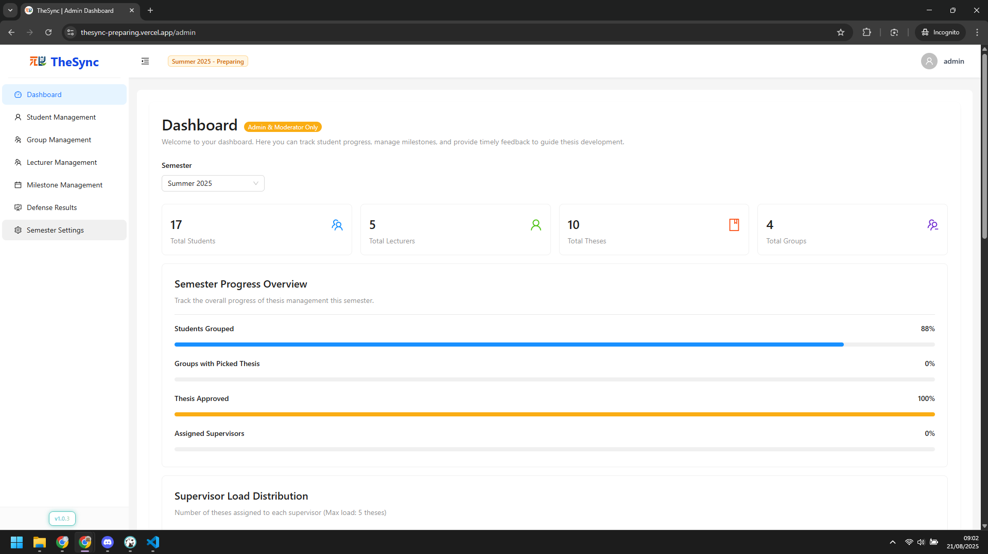

###### Figure VI.C.2.a - Create semester - Step 1

* + Step 2: Input value in `Add New Semester` section and click `Create Semester`  
    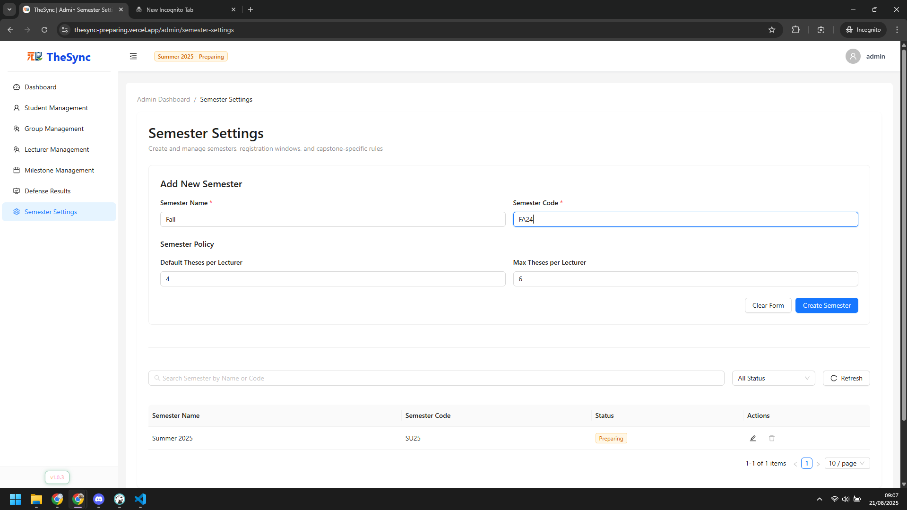

###### Figure VI.C.2.a - Create semester - Step 2

* Import students & lecturers
  + Step 1: Click `Student Management` on sidebar  
    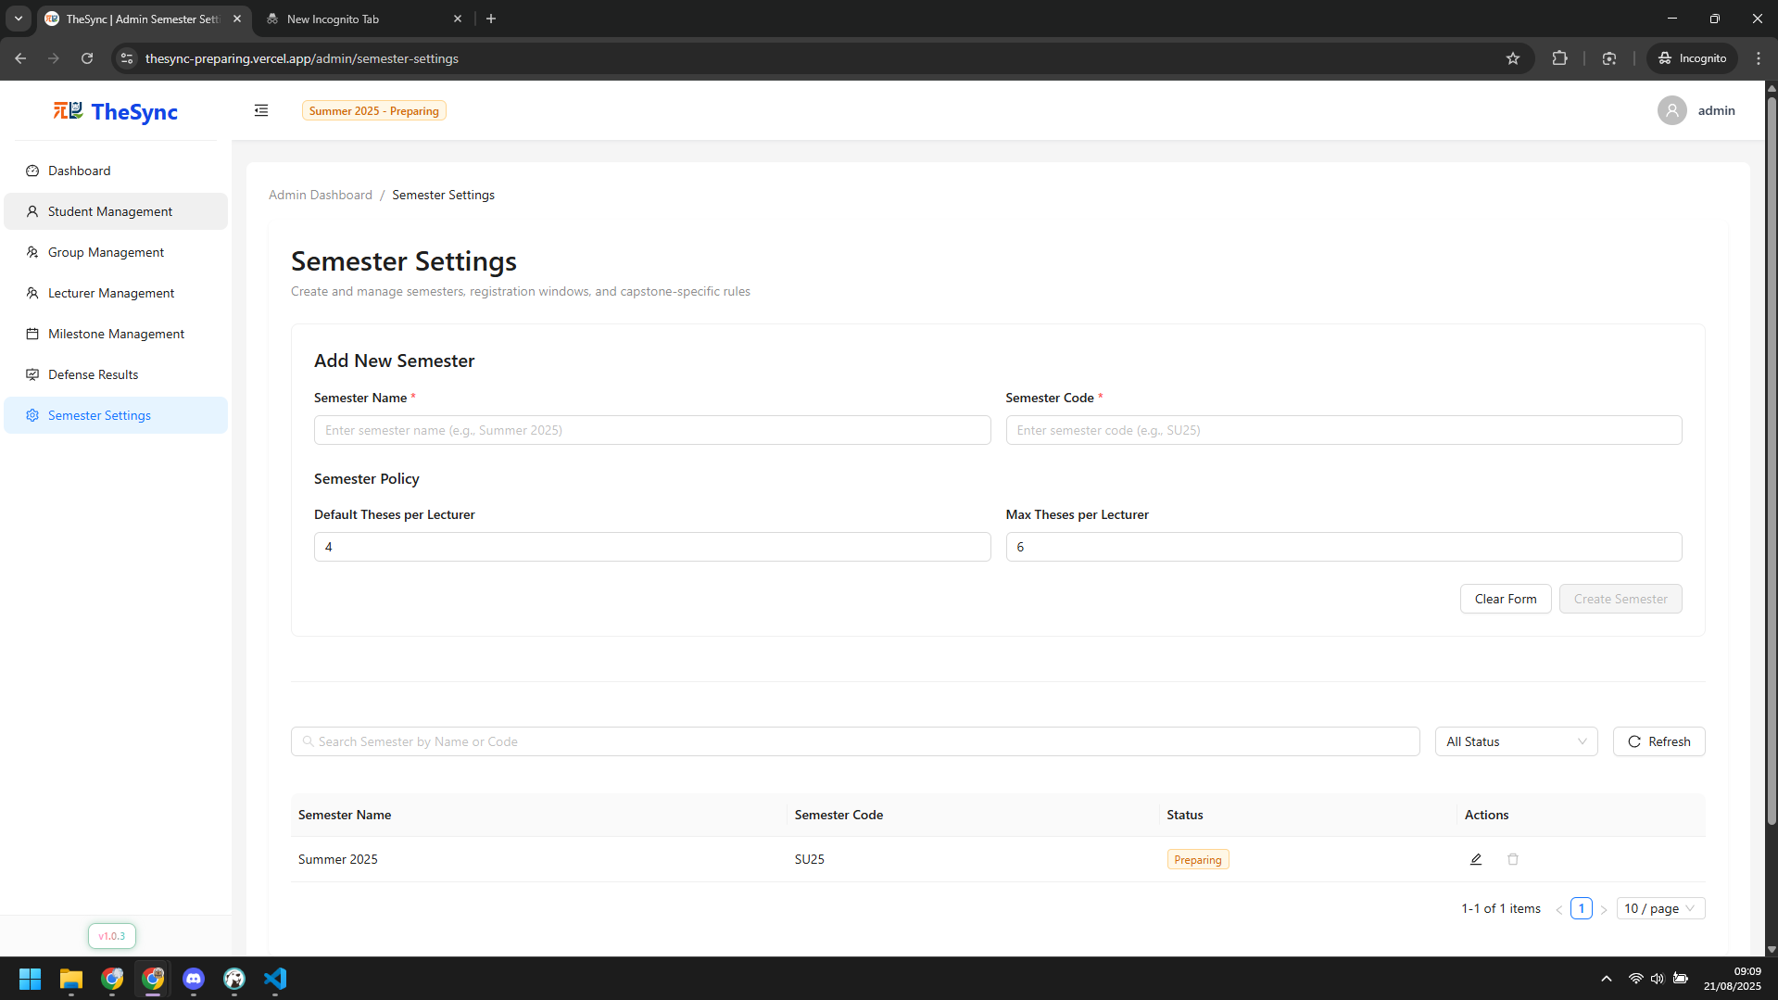

###### Figure VI.C.2.a - Import students & lecturers - Step 1

* + Step 2: Click `Create New Student` button  
    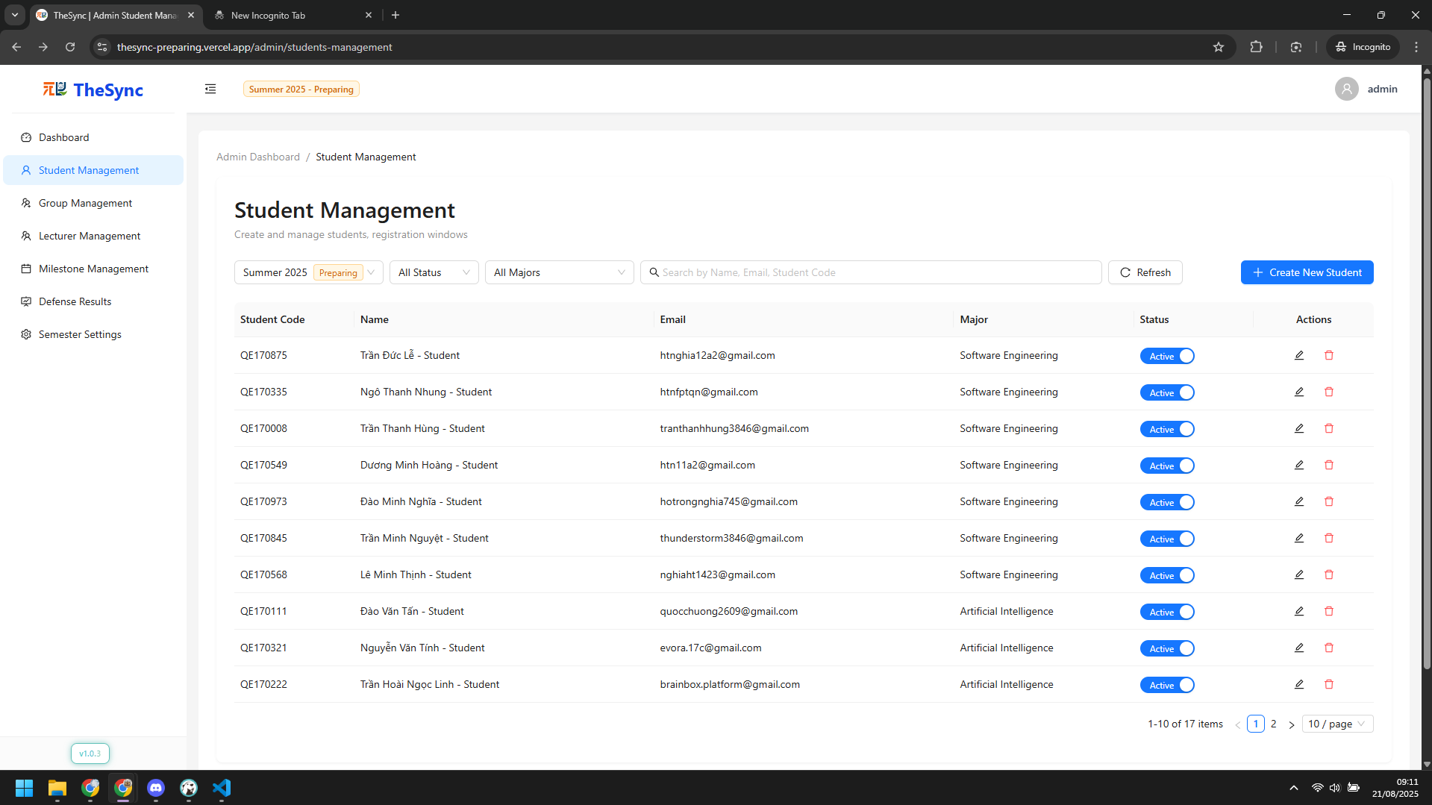

###### Figure VI.C.2.a - Import students & lecturers - Step 2

* + Step 3: Enter student information and click `Create Student`  
    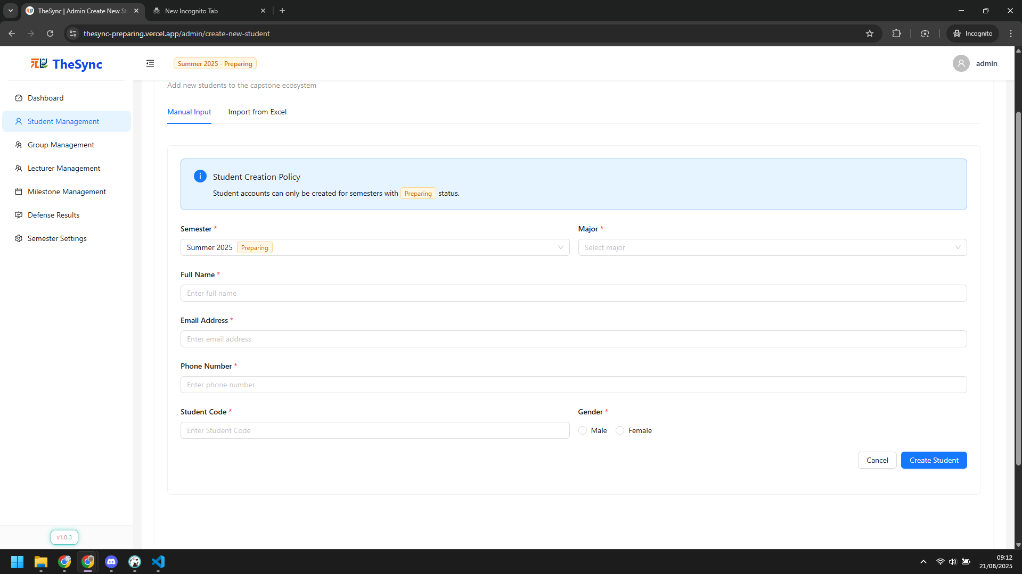

###### Figure VI.C.2.a - Import students & lecturers - Step 3

* + Step 4: Or use `Import from Excel` feature  
    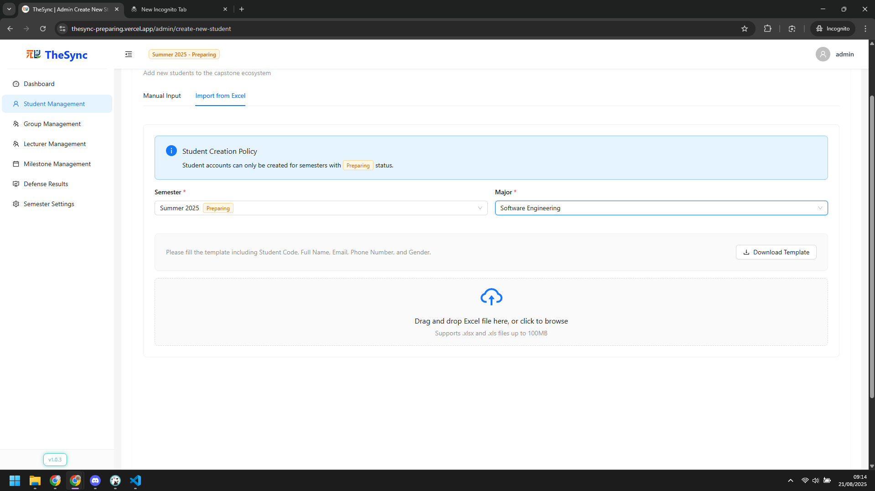

###### Figure VI.C.2.a - Import students & lecturers - Step 4

* Create empty groups
  + Step 1: Click `Group Management` on sidebar  
    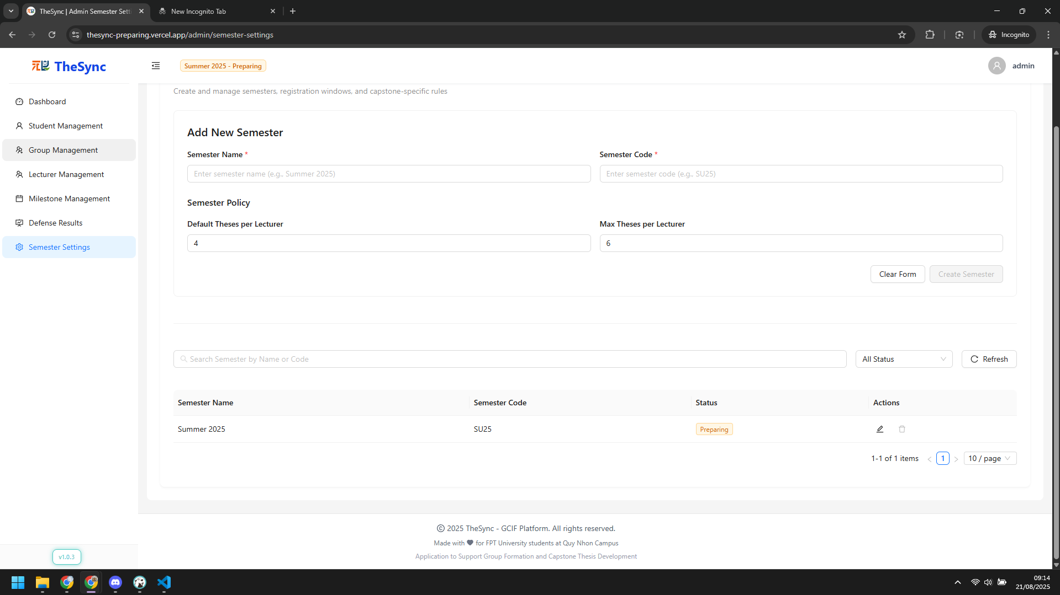

###### Figure VI.C.2.a - Create empty groups - Step 1

* + Step 2: Choose semester, enter number of groups and click `Generate` button  
    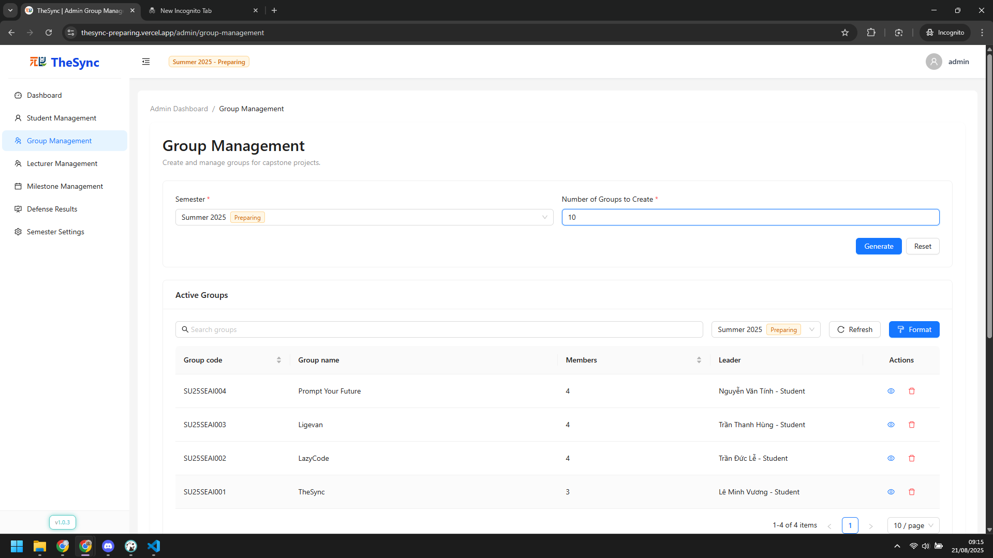

###### Figure VI.C.2.a - Create empty groups - Step 2

#### Role: Lecturer

* Create thesis
  + Step 1: Click `Thesis Management` on sidebar  
    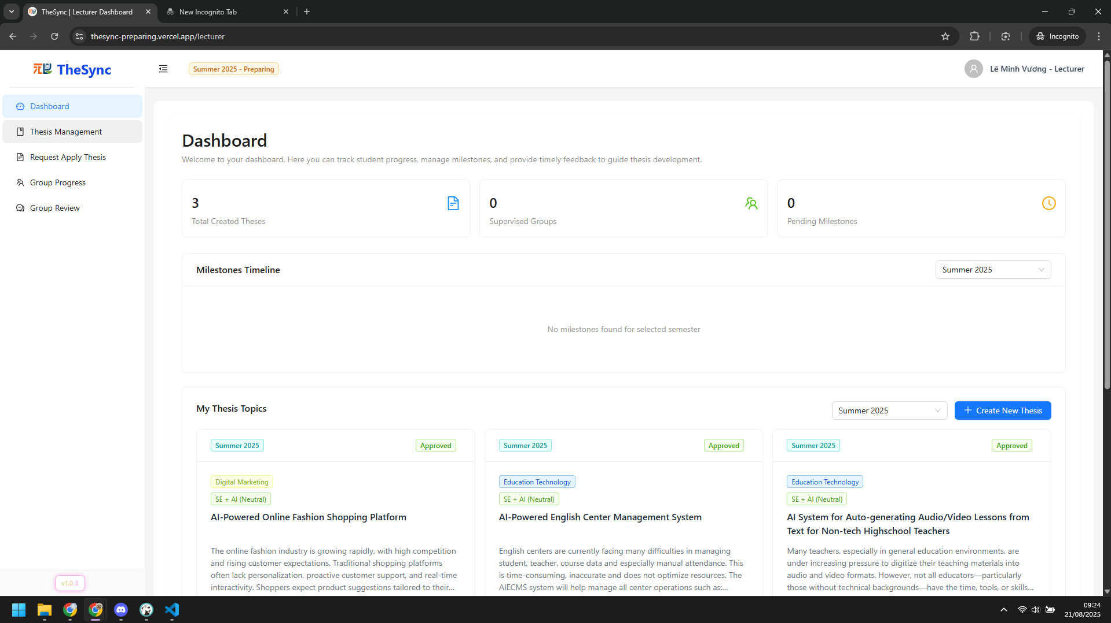

###### Figure VI.C.2.b - Create thesis - Step 1

* + Step 2: Click `Create Thesis` button  
    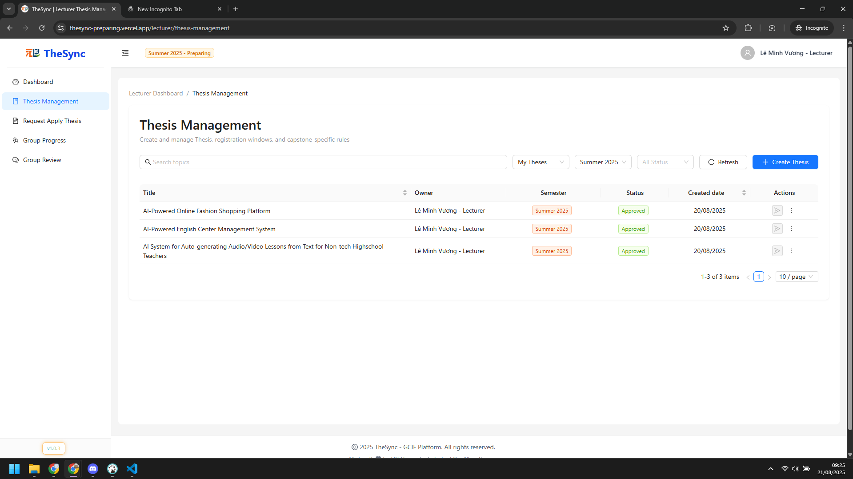

###### Figure VI.C.2.b - Create thesis - Step 2

* + Step 3: Enter thesis information and click `Create Thesis` button  
    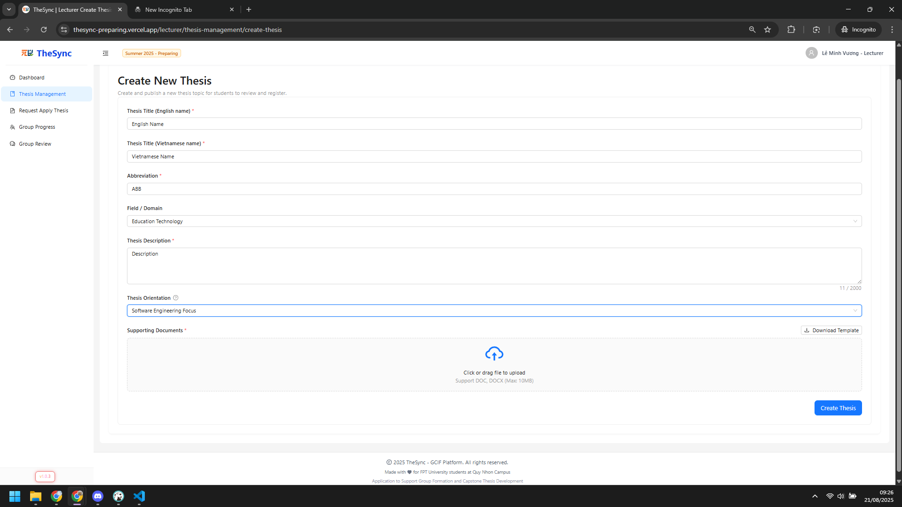

###### Figure VI.C.2.b - Create thesis - Step 3

* Submit thesis
  + Step 1: Click `Thesis Management` on sidebar  
    

###### Figure VI.C.2.b - Submit thesis - Step 1

* + Step 2: Click `Register Submit` and confirm to submit  
    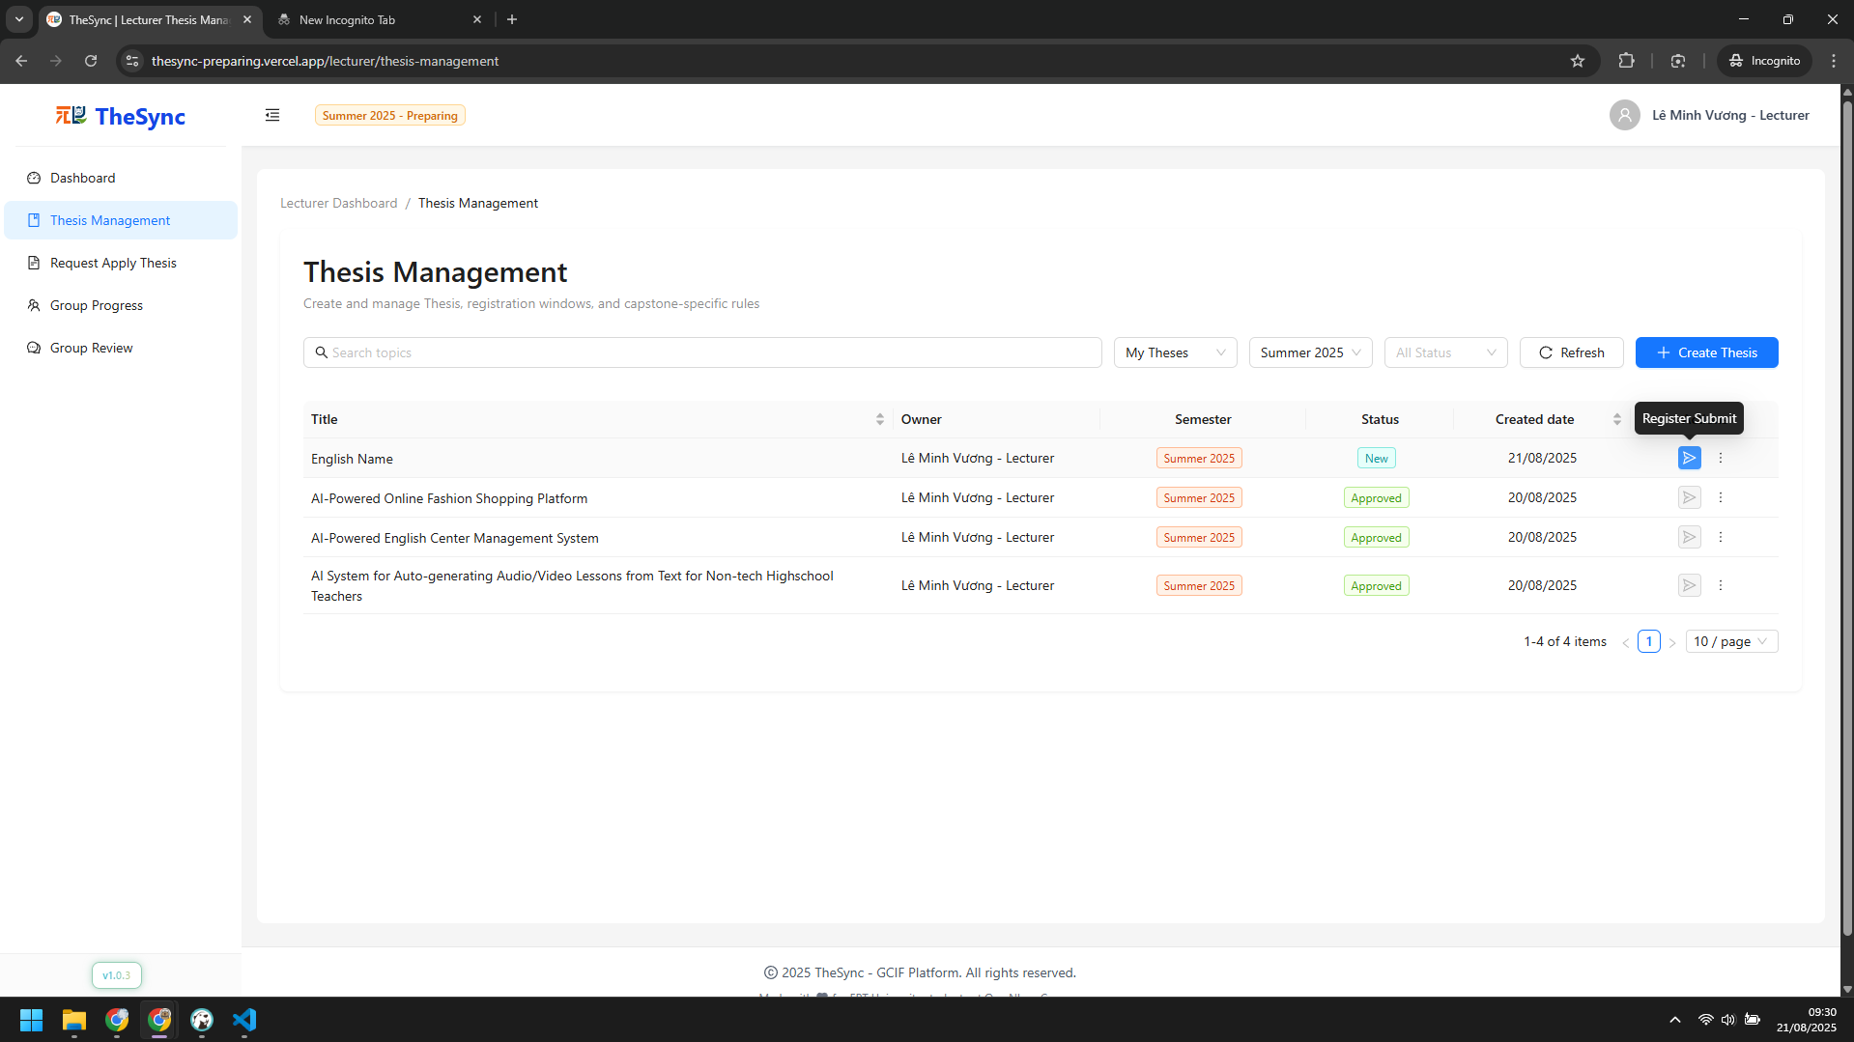

###### Figure VI.C.2.b - Submit thesis - Step 2

#### Role: Moderator

* Approval / Reject thesis
  + Step 1:Click `Theses Registration` on sidebar  
    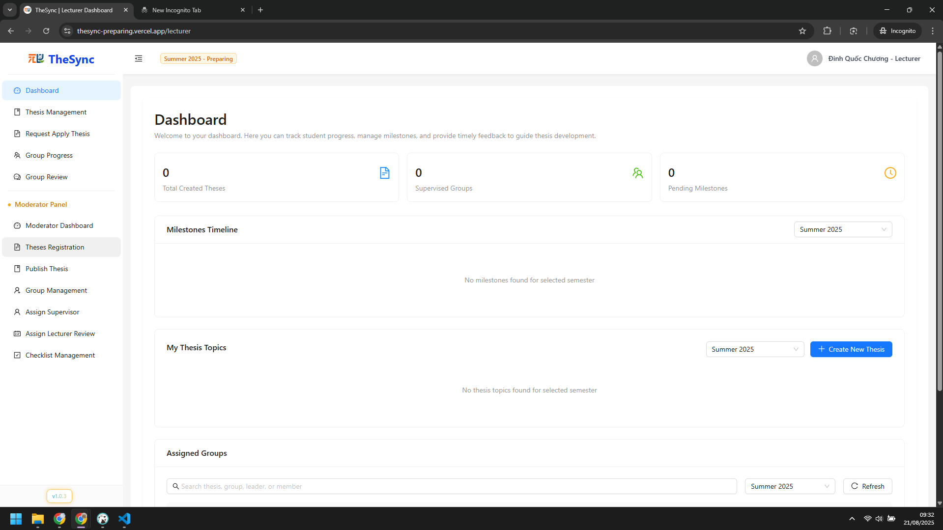

###### Figure VI.C.2.c - Approval / Reject thesis - Step 1

* + Step 2: Choose Approval or Reject at Action column  
    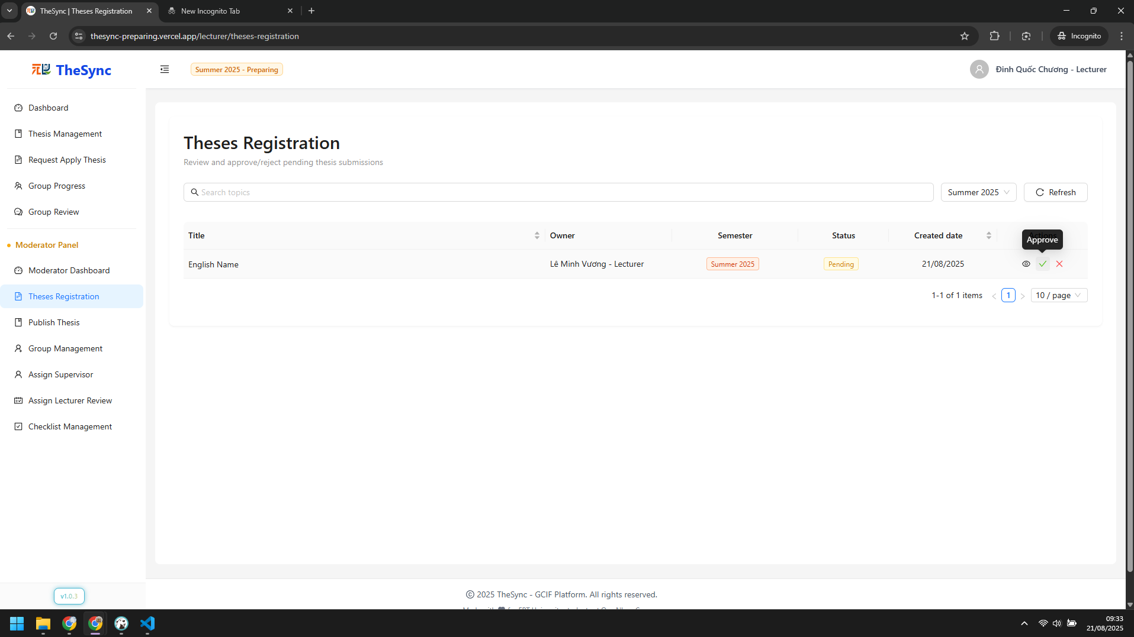

###### Figure VI.C.2.c - Approval / Reject thesis - Step 2

* Assign supervisors
  + Step 1: Click `Assign Supervisor` on sidebar  
    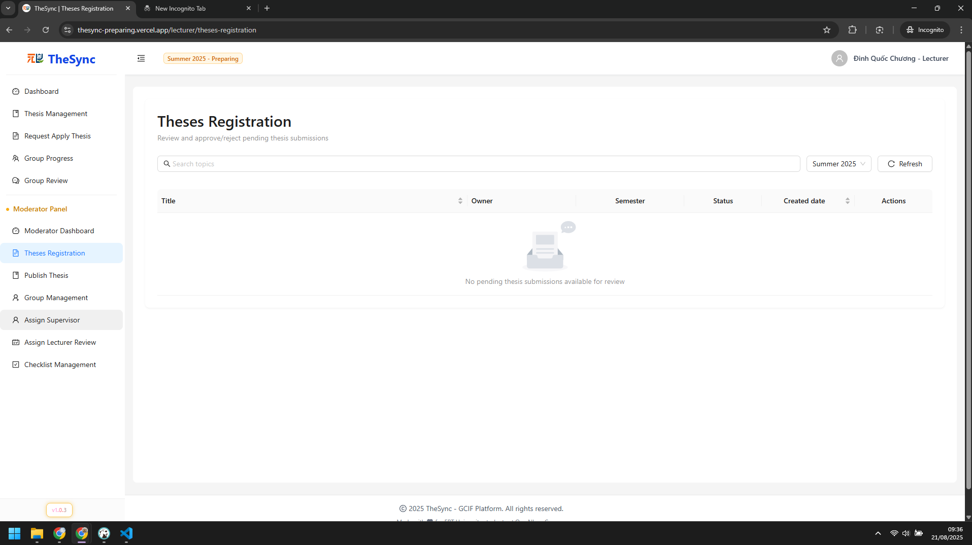

###### Figure VI.C.2.c - Assign supervisors - Step 1

* + Step 2: Click `Assign` button  
    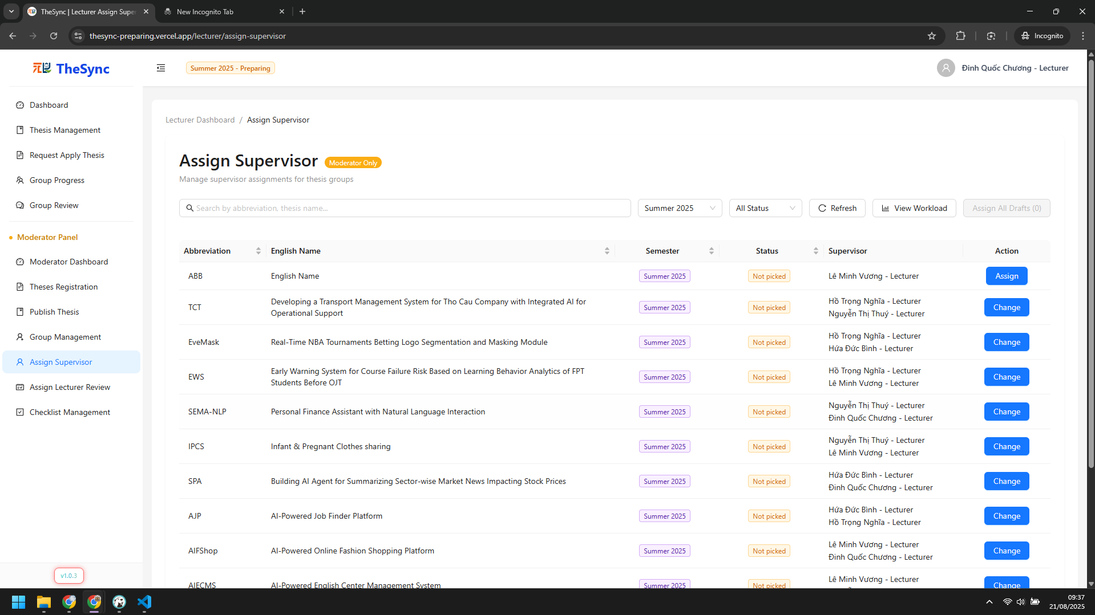

###### Figure VI.C.2.c - Assign supervisors - Step 2

* + Step 3: Choose lecturers to supervise and click `Assign Now` button  
    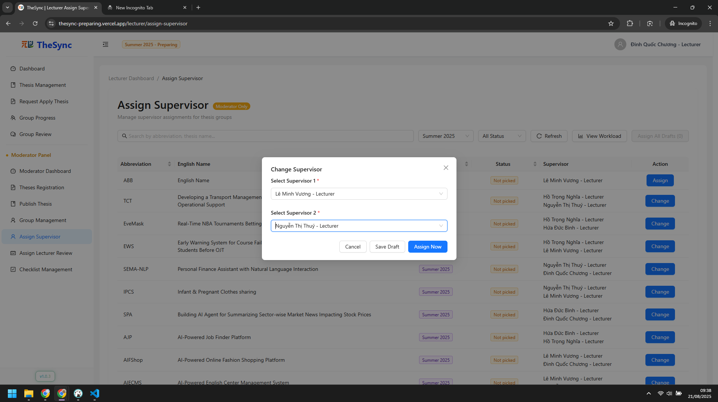

###### Figure VI.C.2.c - Assign supervisors - Step 3

* Publish thesis
  + Step 1: Click `Publish Thesis` on sidebar  
    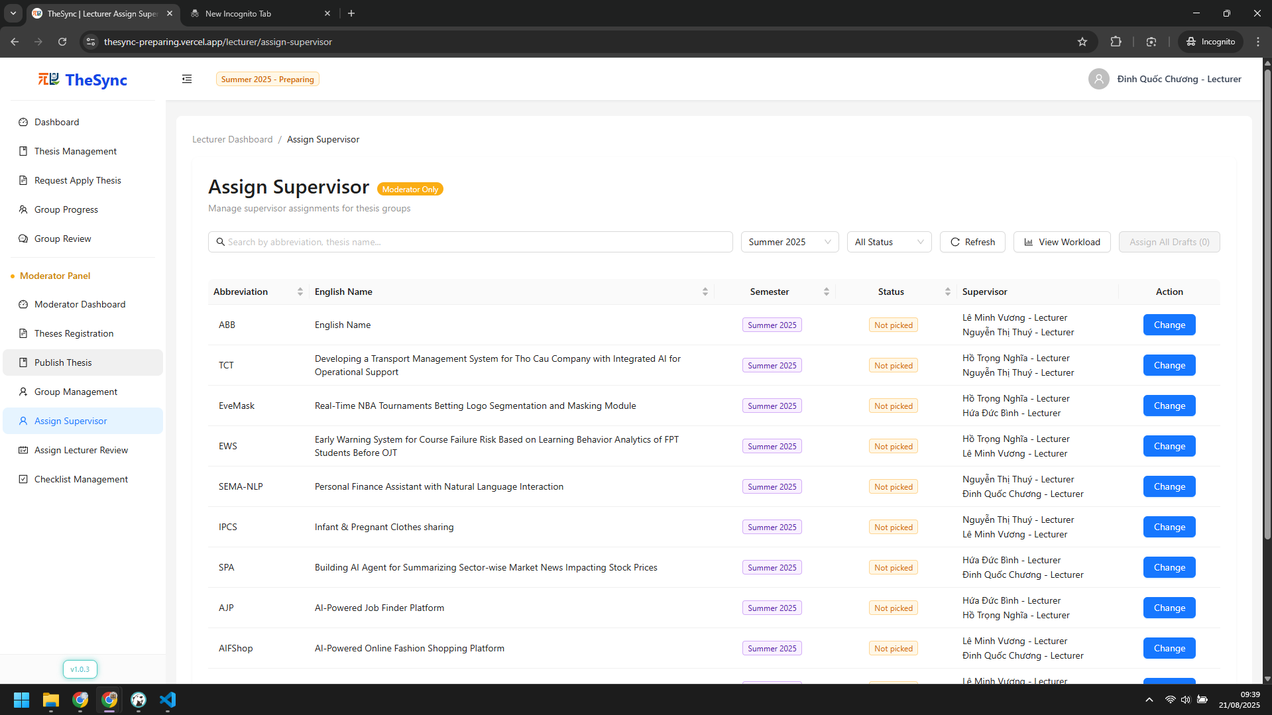

###### Figure VI.C.2.c - Publish thesis - Step 1

* + Step 2: Select all theses need to be published and click `Publish Selected` button  
    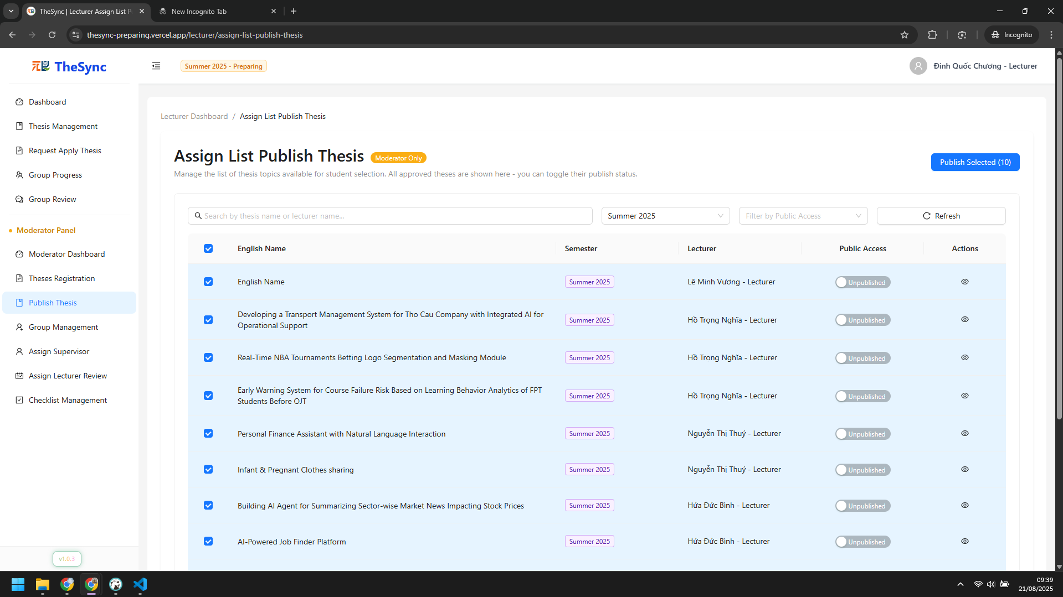

###### Figure VI.C.2.c - Publish thesis - Step 2

#### Role: Student

* Update profile
  + Step 1: Click student name and choose `Settings`  
    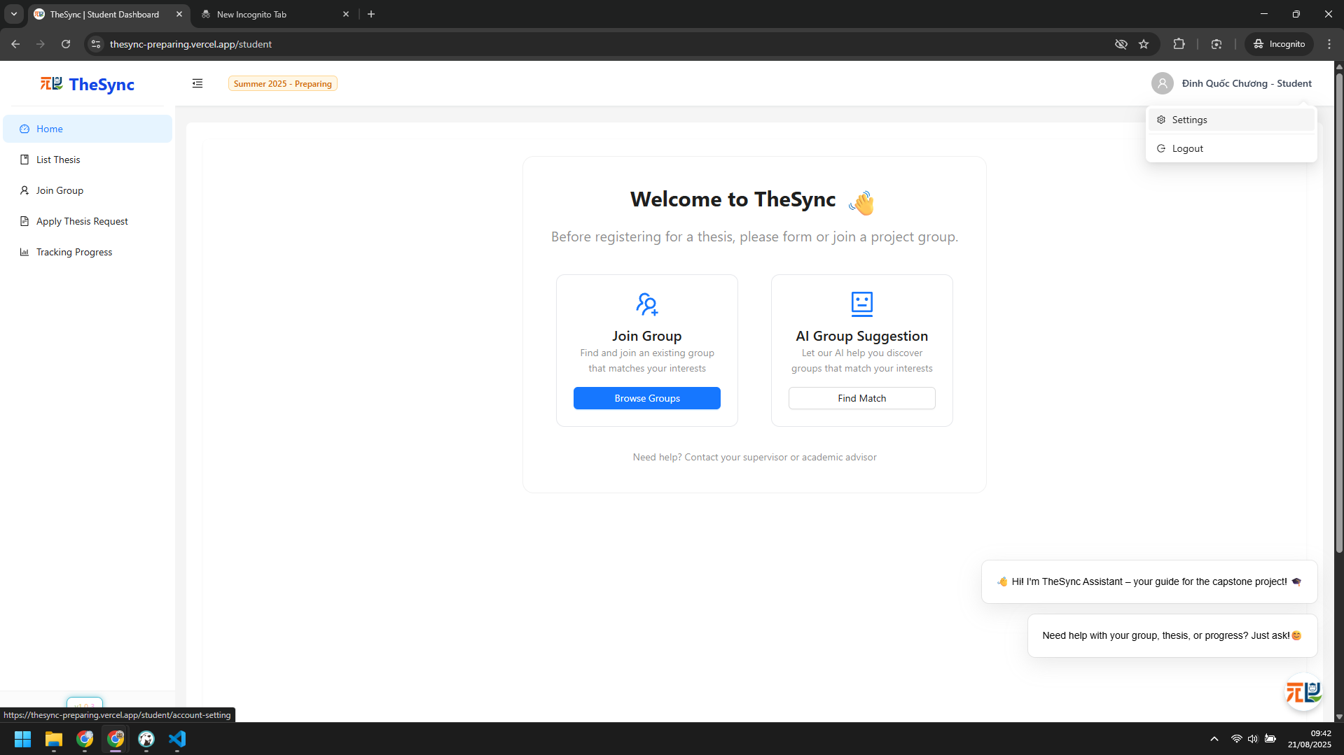

###### Figure VI.C.2.d - Update profile - Step 1

* + Step 2: Change student information and click `Save Profile Change` button below  
    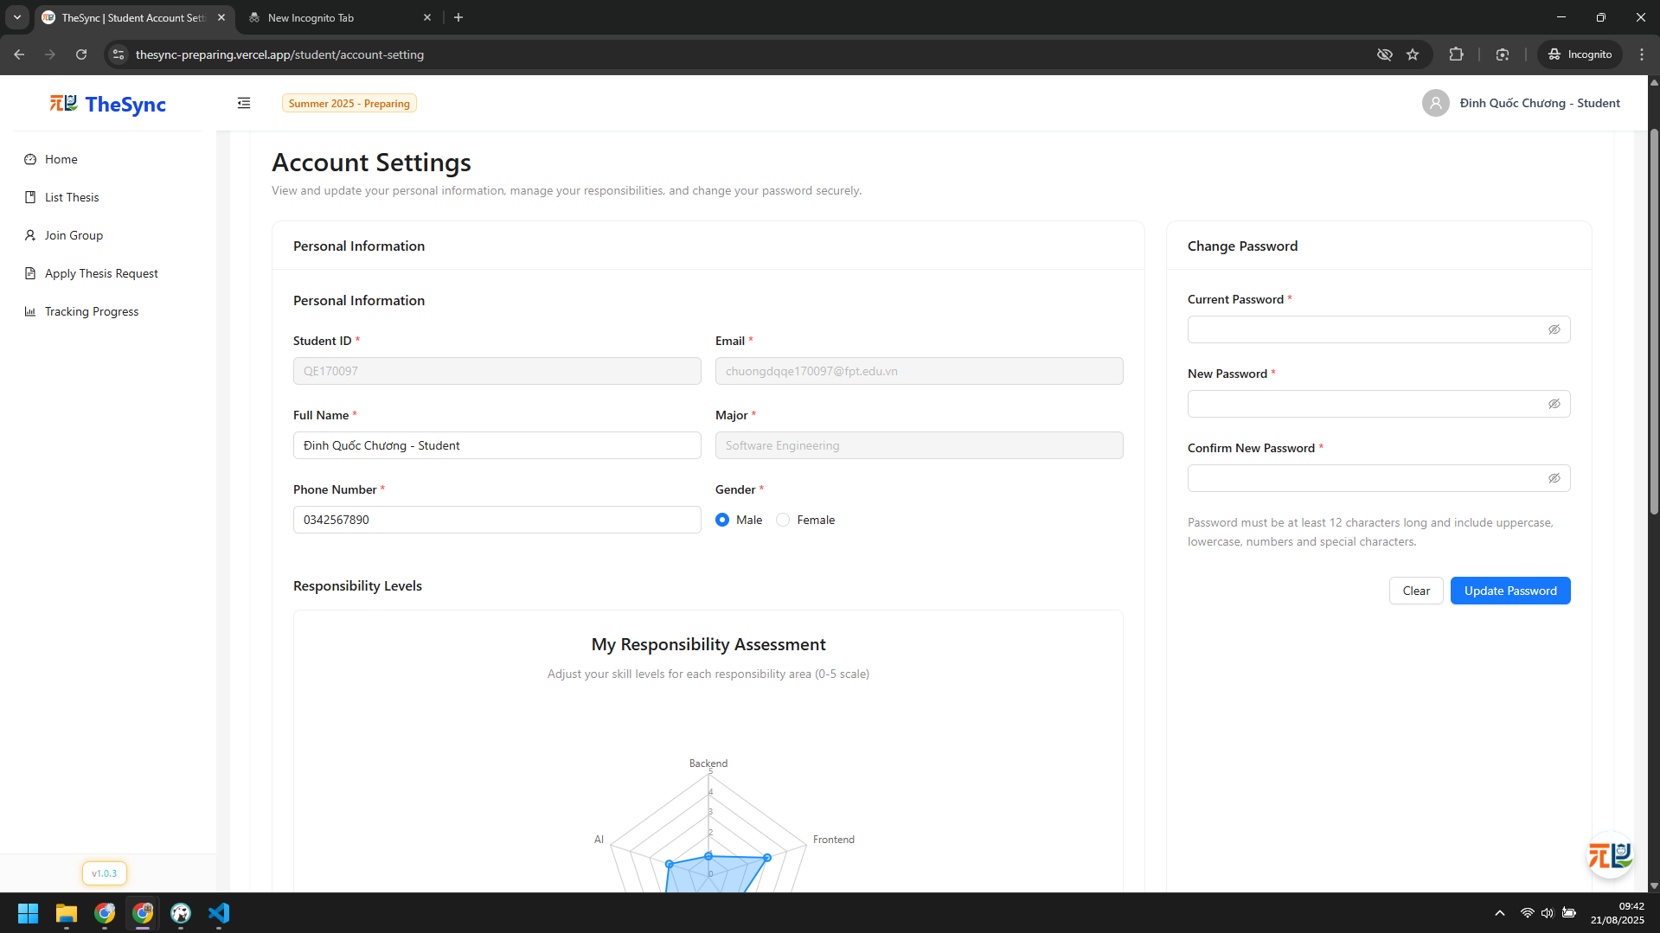

###### Figure VI.C.2.d - Update profile - Step 2

* Join group (Manual or AI suggest)
  + Step 1: Click `Join Group` on sidebar  
    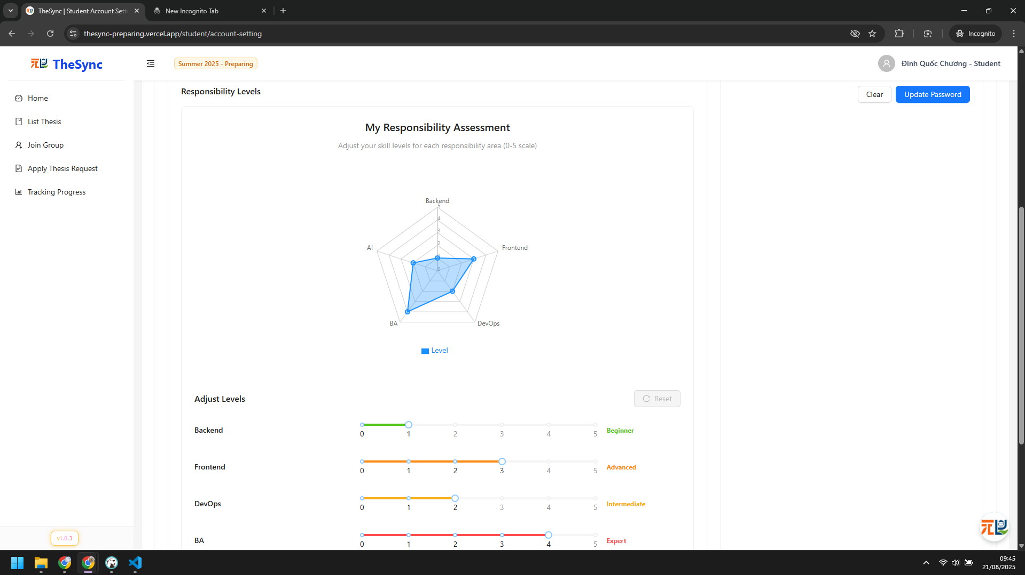

###### Figure VI.C.2.d - Join group - Step 1

* + Step 2: Click `Request to Join` to send request to group  
    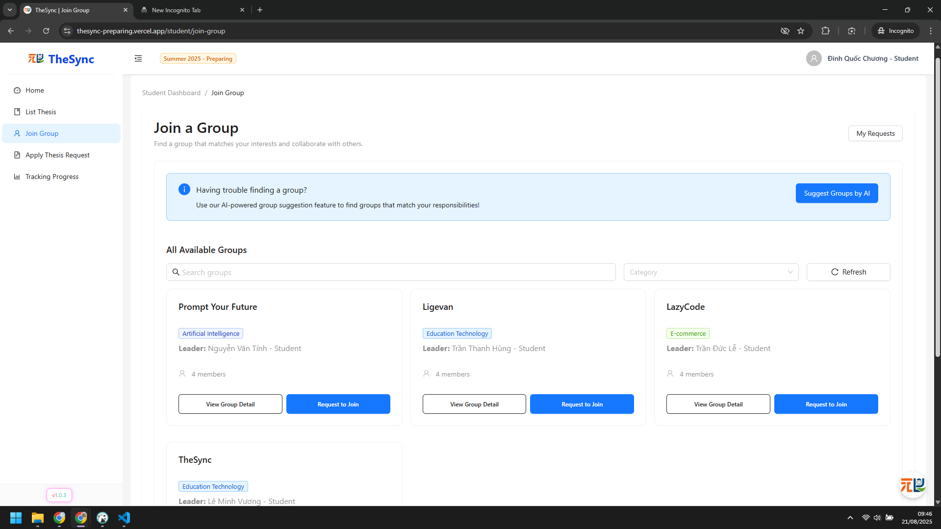

###### Figure VI.C.2.d - Join group - Step 2

* + Step 3: Click `Suggest Groups by AI` button to use AI suggestion, below is result  
    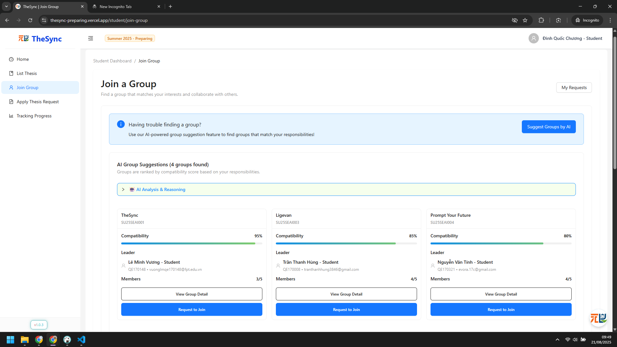

###### Figure VI.C.2.d - Join group - Step 3

* Accept / Reject invitations
  + Step 1: Click `Join Group` on sidebar  
    

###### Figure VI.C.2.d - Accept / Reject invitations - Step 1

* + Step 2: Click `My Requests` button  
    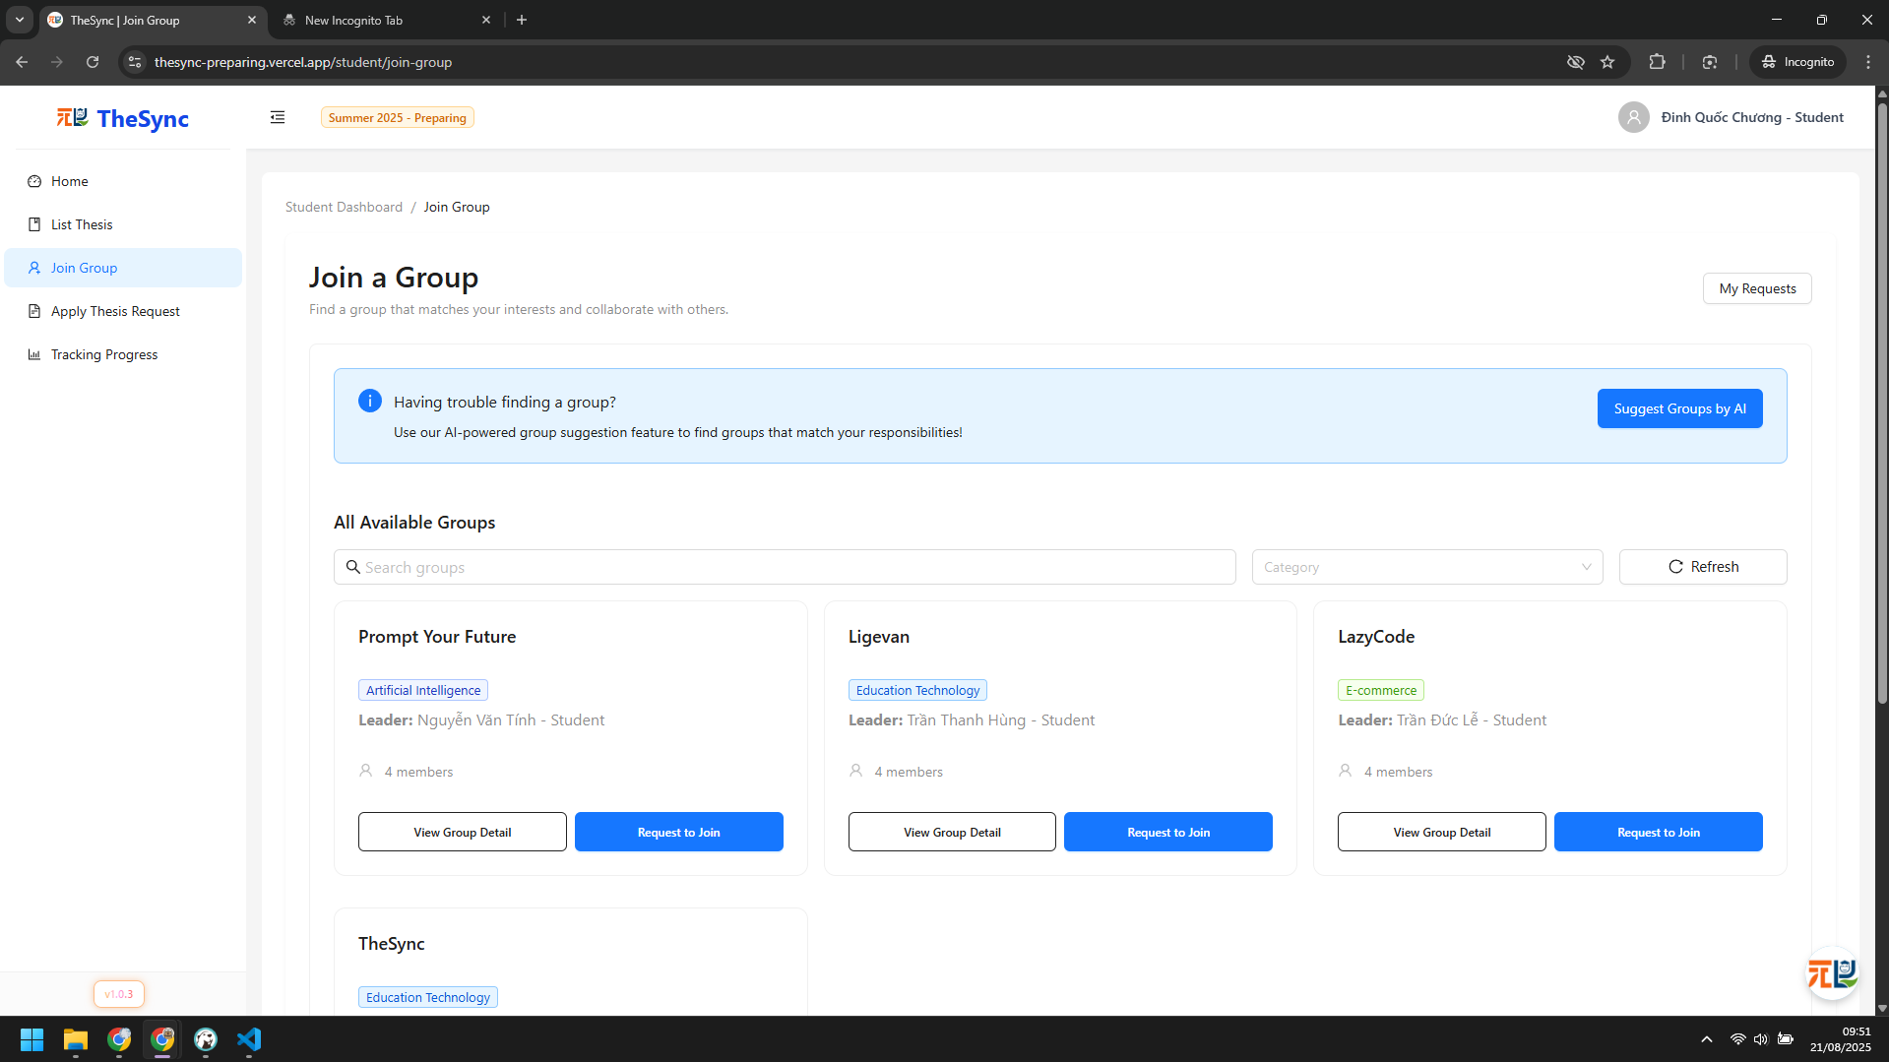

###### Figure VI.C.2.d - Accept / Reject invitations - Step 2

* + Step 3: Accept or Reject invitations  
    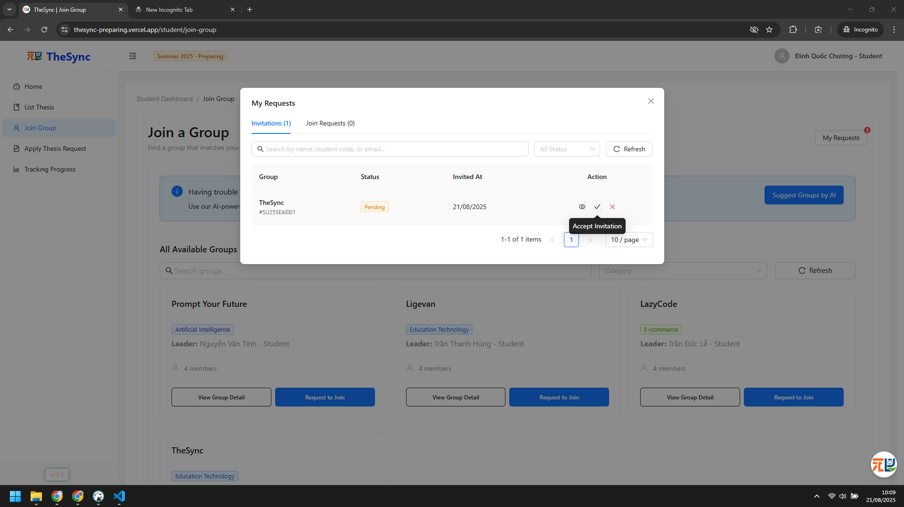

###### Figure VI.C.2.d - Accept / Reject invitations - Step 3

#### Role: Student (Leader)

* Update group information
  + Step 1: Click `Group Dashboard` on sidebar  
    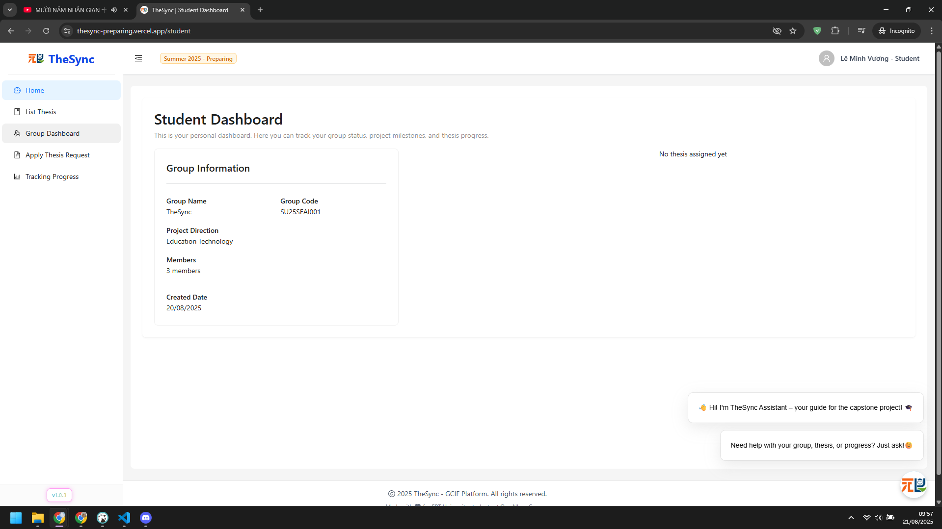

###### Figure VI.C.2.e - Update group information - Step 1

* + Step 2: Click `Edit Group Info` button  
    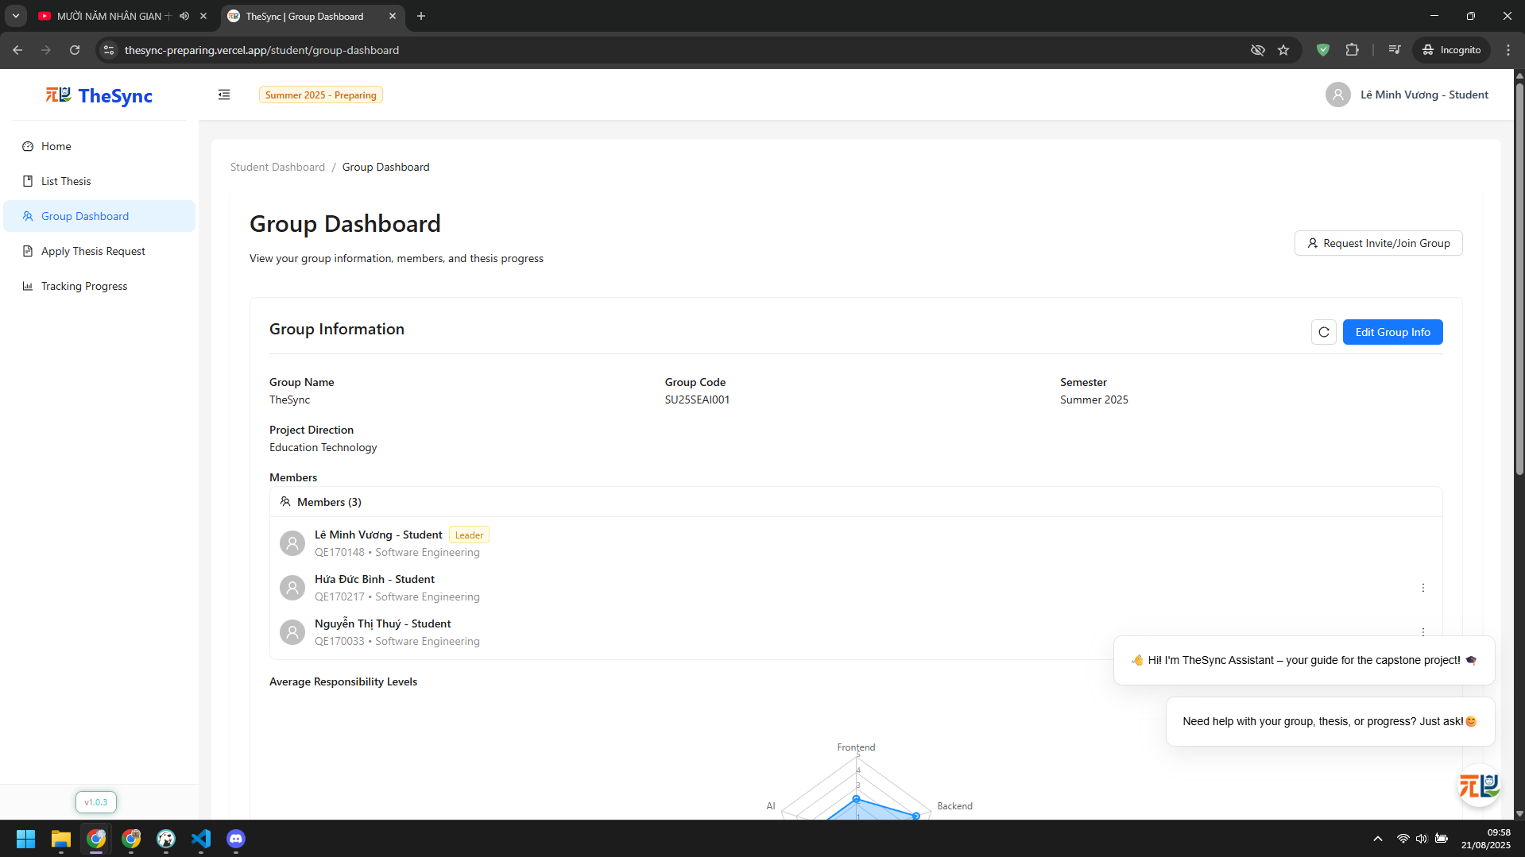

###### Figure VI.C.2.e - Update group information - Step 2

* + Step 3: Change information and click `Update Group` button  
    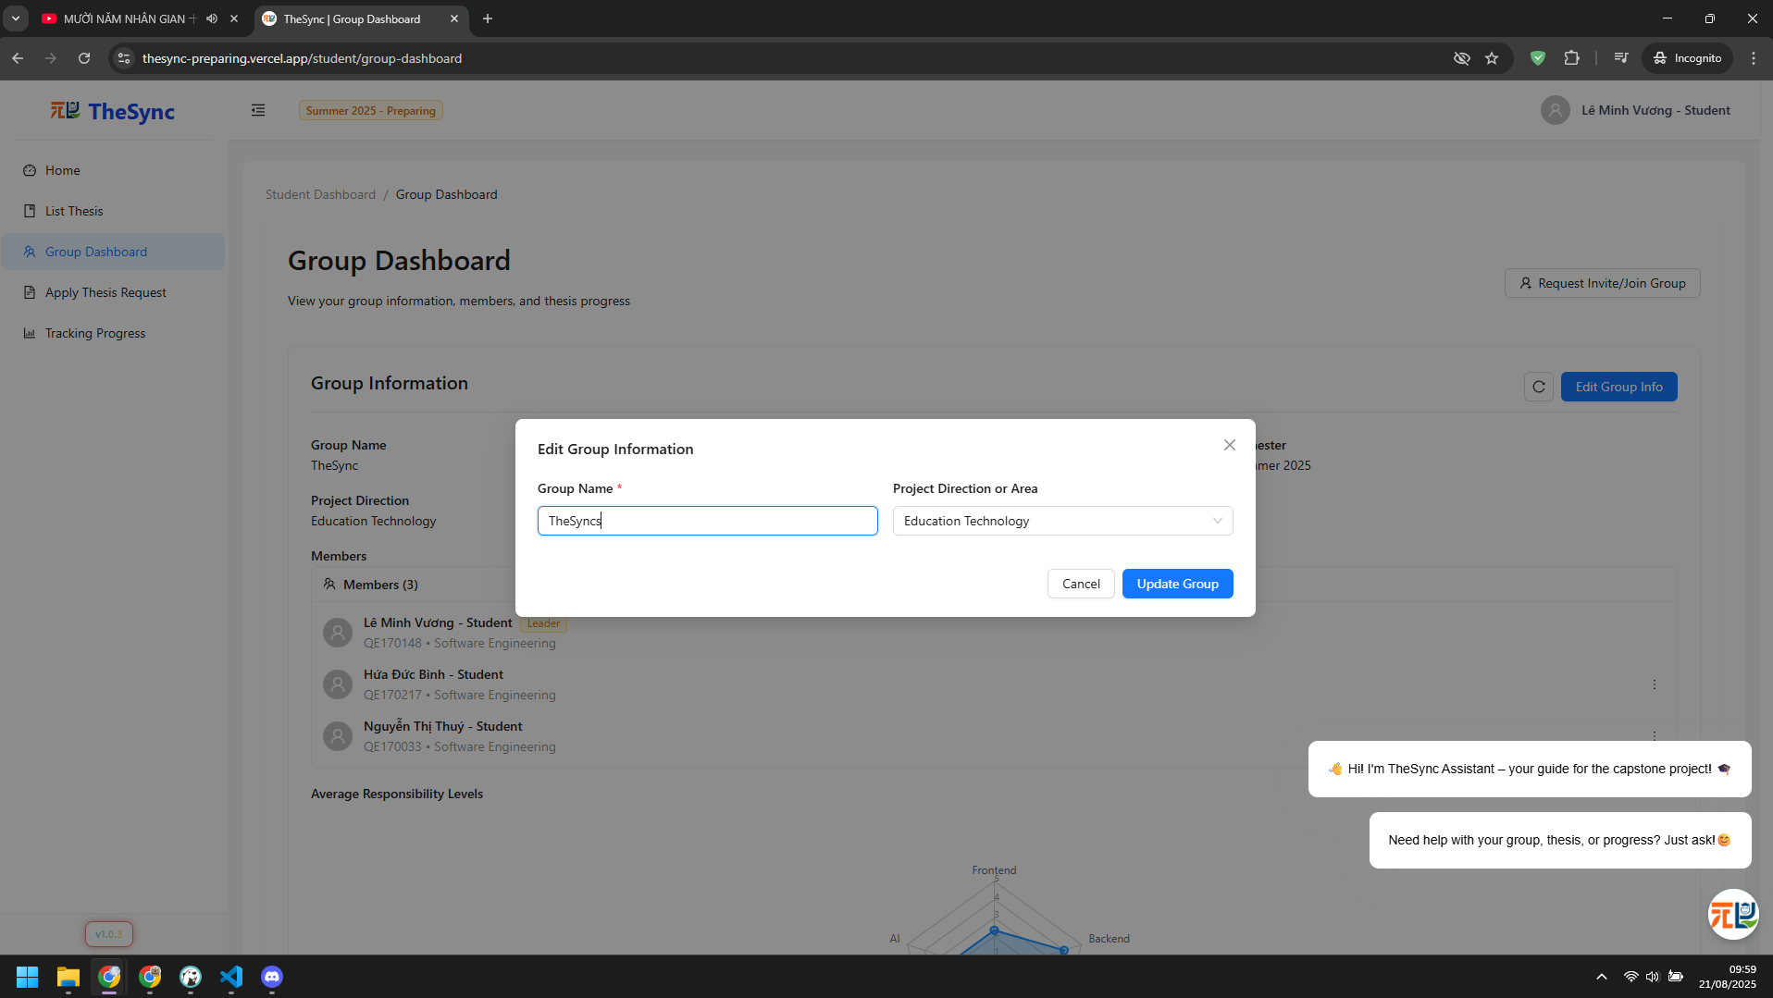

###### Figure VI.C.2.e - Update group information - Step 3

* Invite members (Manual or AI suggest)
  + Step 1: In Group Dashboard, click `Invite Members` button  
    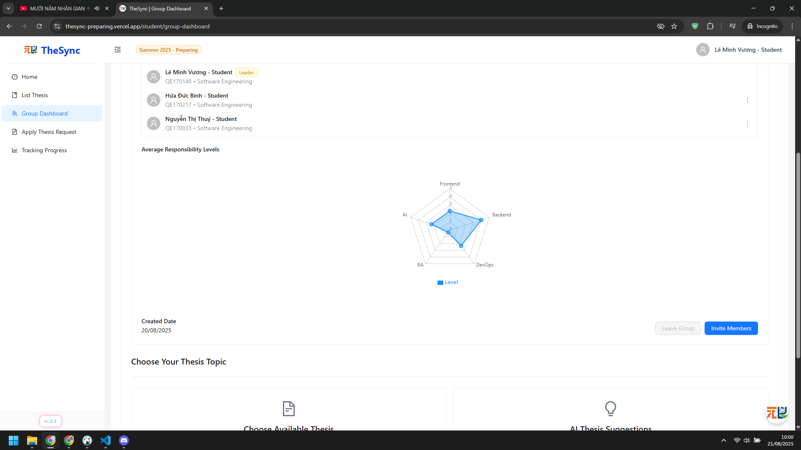

###### Figure VI.C.2.e - Invite members - Step 1

* + Step 2: Enter email student that want to invite  
    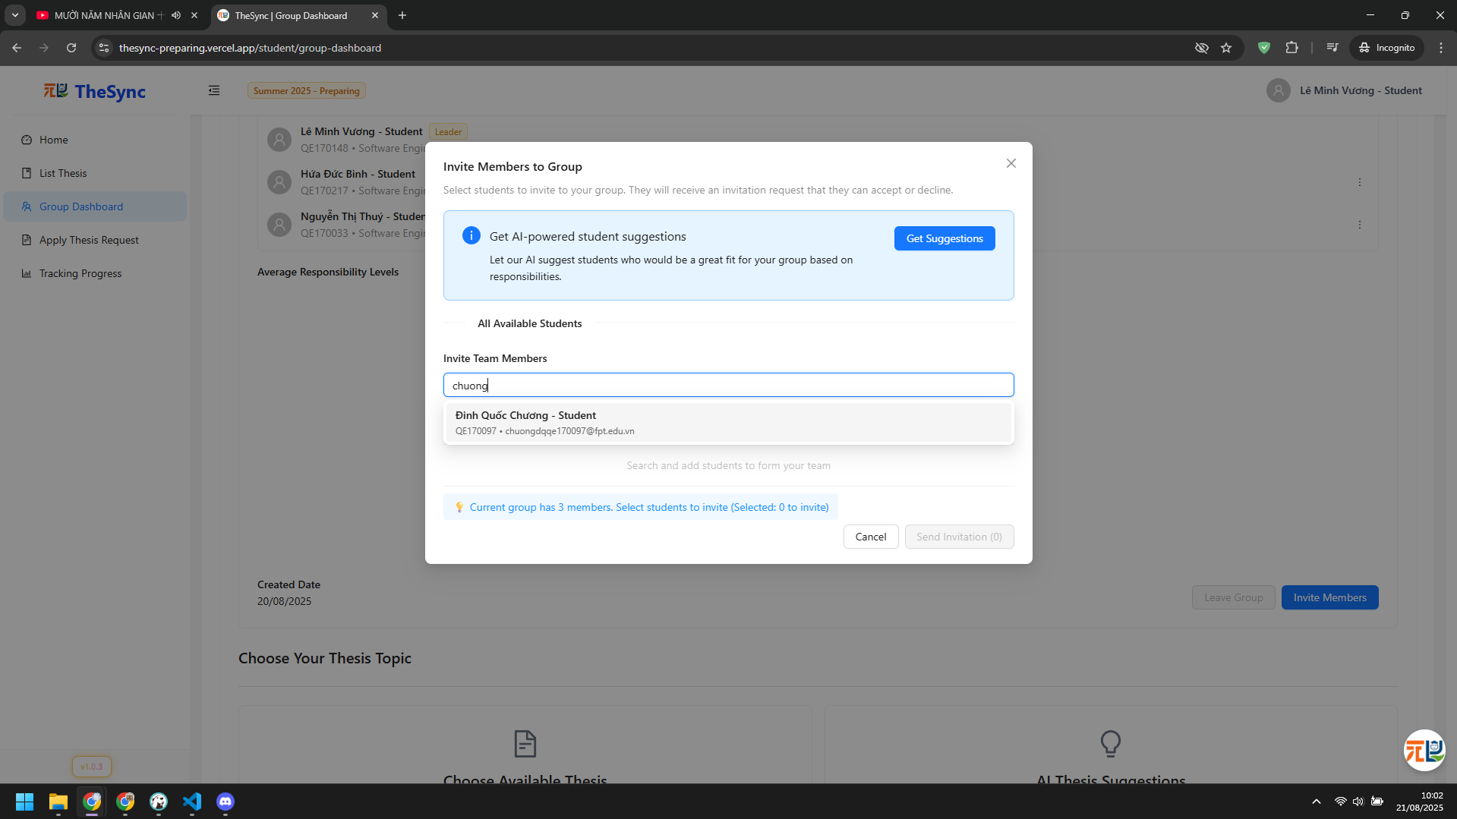

###### Figure VI.C.2.e - Invite members - Step 2

* + Step 3: Click `Send Invitation` button  
    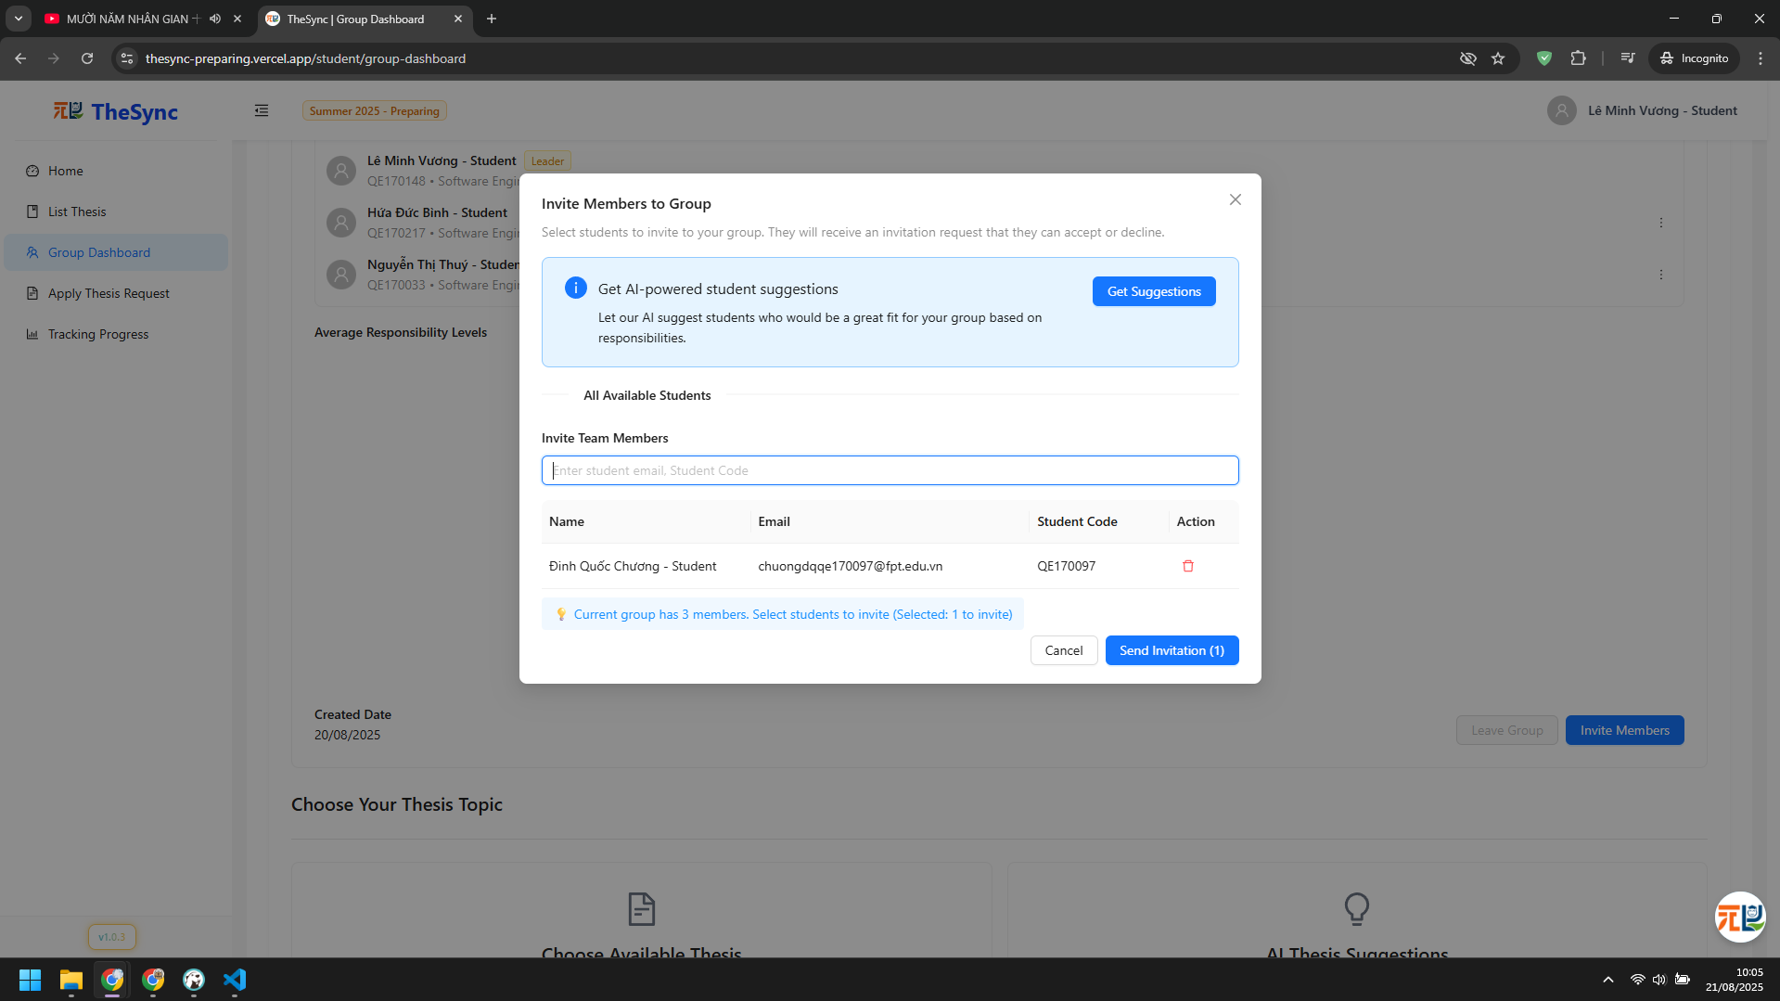

###### Figure VI.C.2.e - Invite members - Step 3

* + Step 4: Click `Get Suggestions` button to use AI suggestion, below is result  
    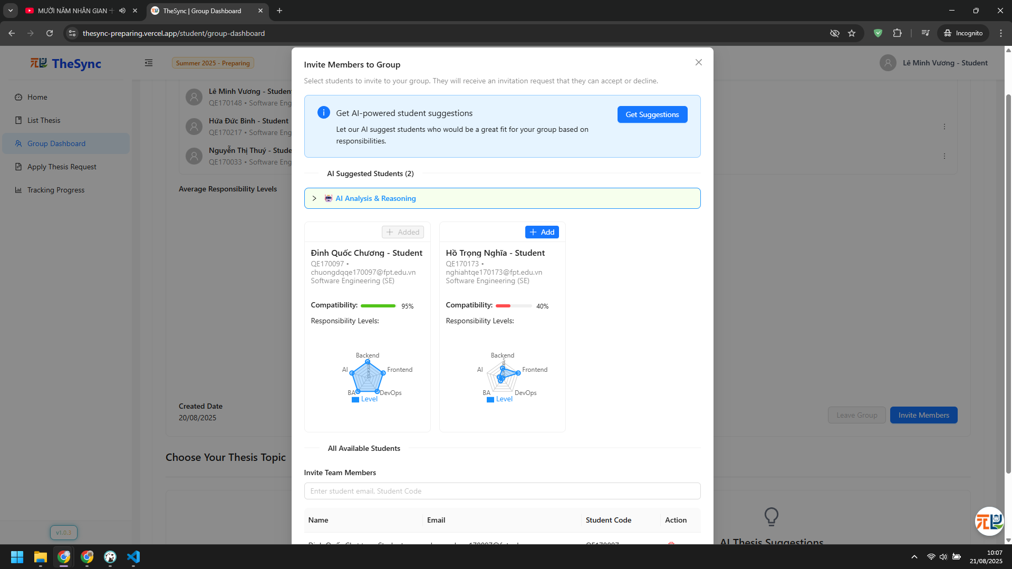

###### Figure VI.C.2.e - Invite members - Step 4

* Accept / Reject join requests
  + Step 1: In `Group Dashboard`, click `Request Invite/Join Group` button  
    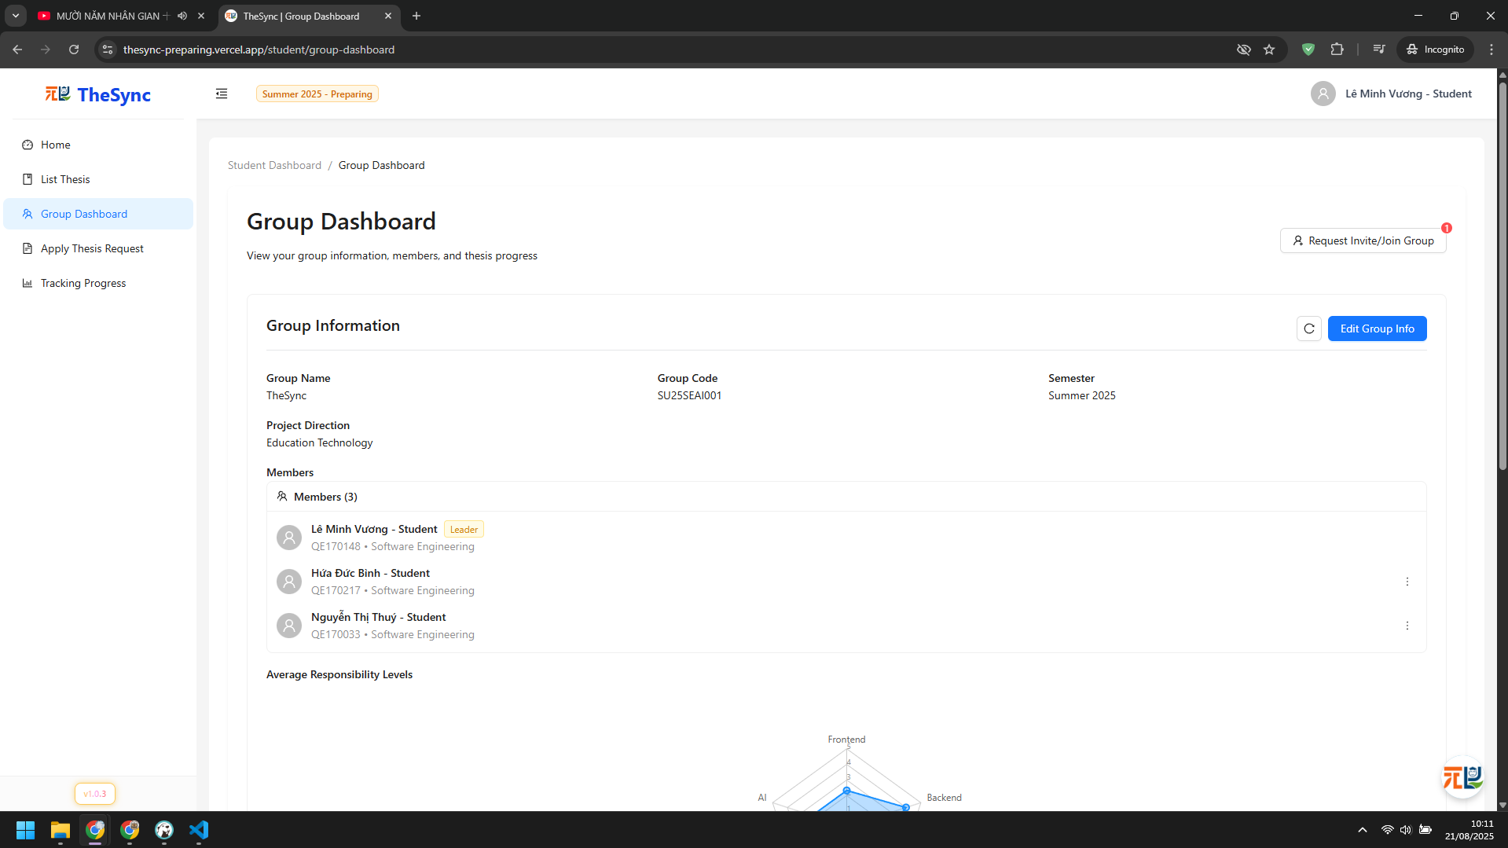

###### Figure VI.C.2.e - Accept / Reject join requests - Step 1

* + Step 2: Approval or Reject requests  
    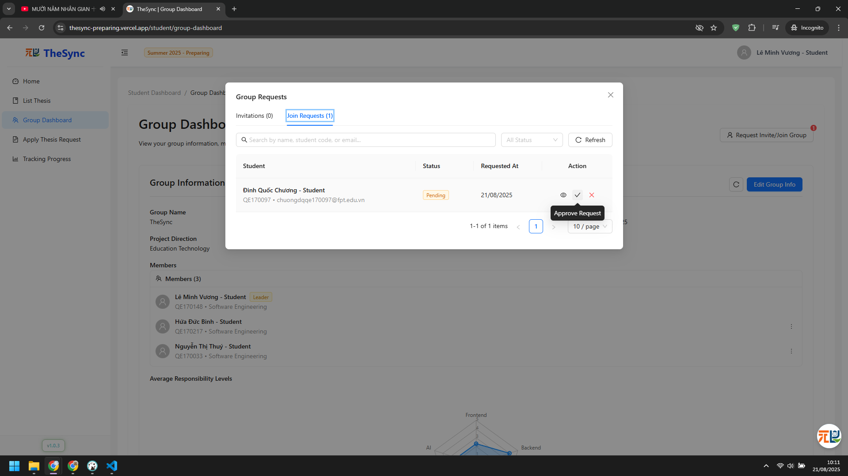

###### Figure VI.C.2.e - Accept / Reject join requests - Step 2

#### Role: Admin

* Assign students without group:
  + Step 1: Click `Group Management` on sidebar  
    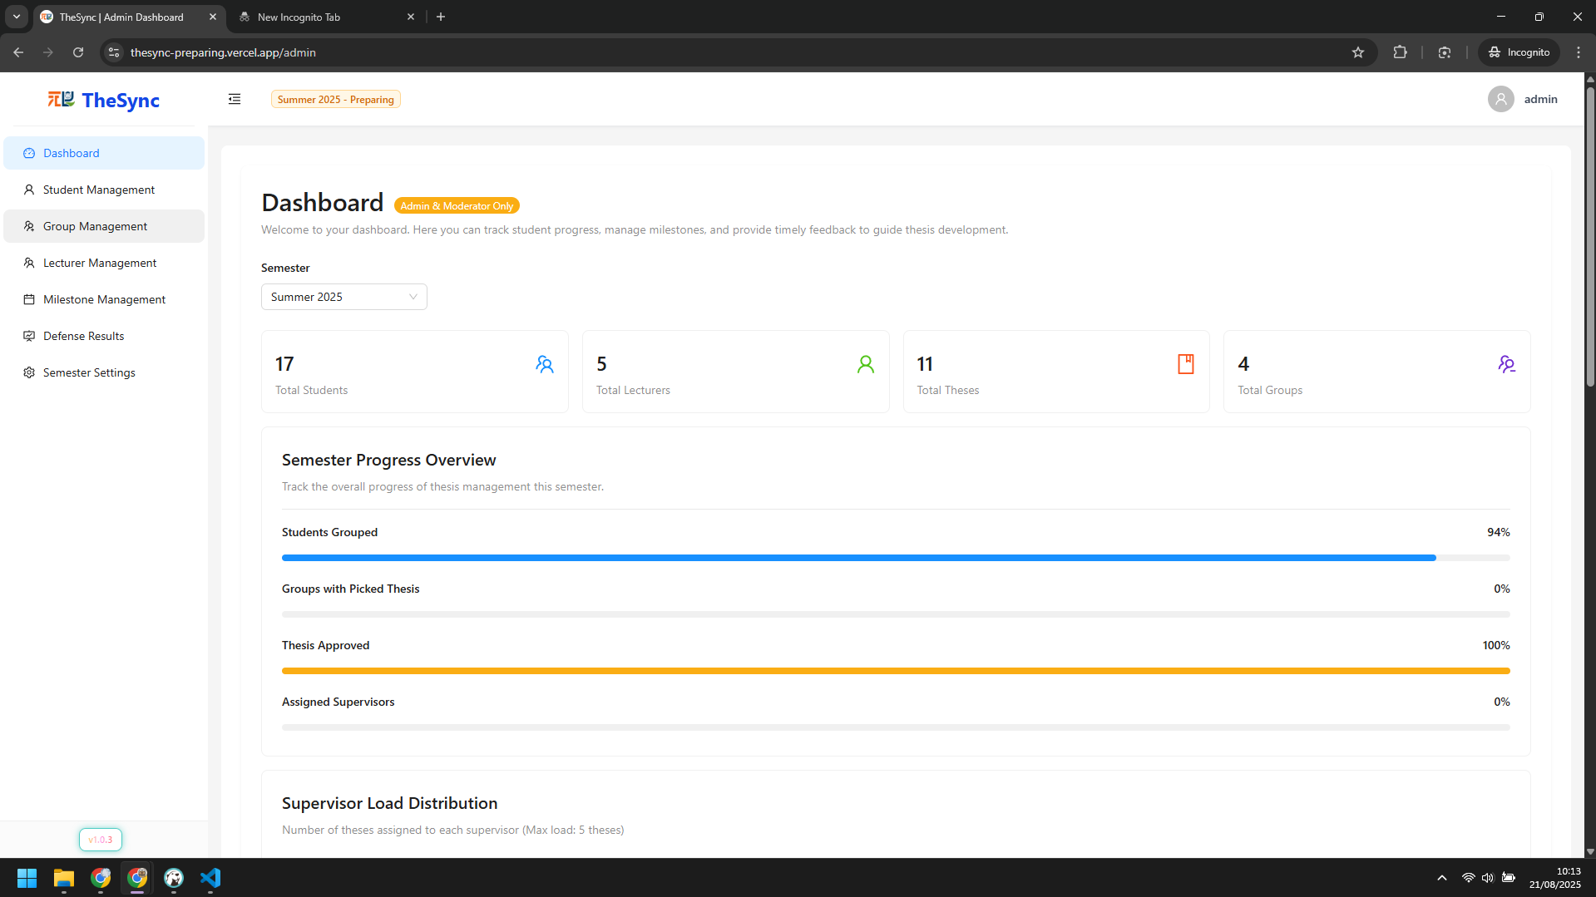

###### Figure VI.C.2.f - Assign students without group - Step 1

* + Step 2: Choose group to assign  
    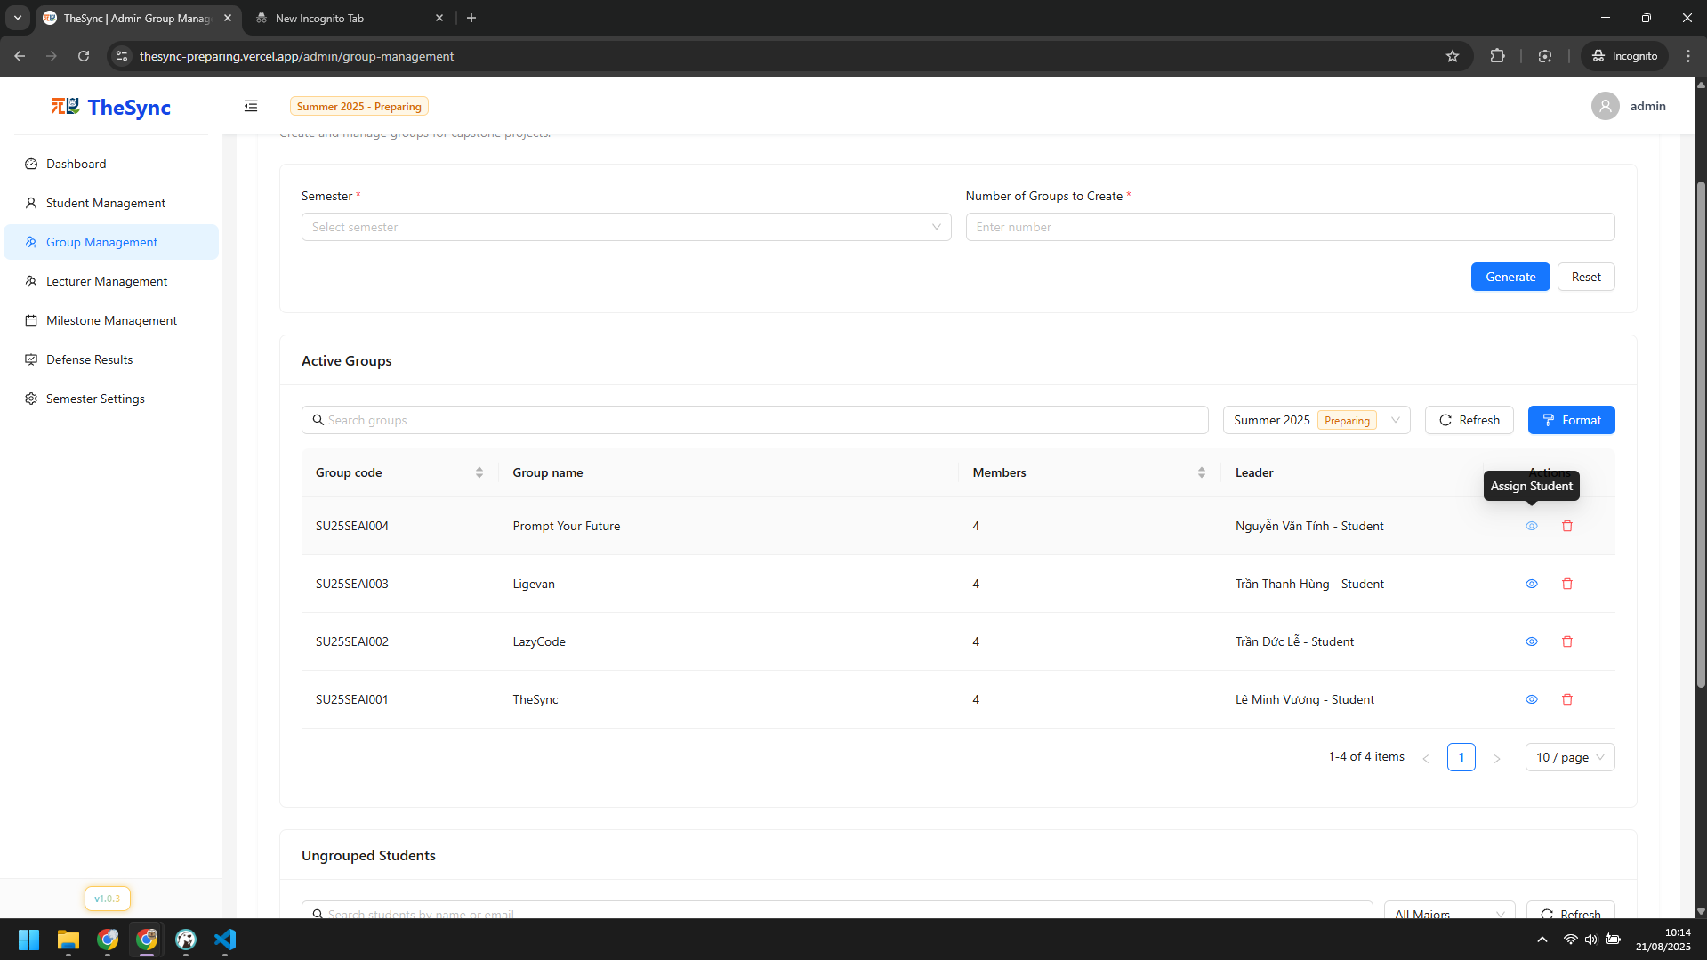

###### Figure VI.C.2.f - Assign students without group - Step 2

* + Step 3: Choose student that want to assign and click `Assign To Group` button  
    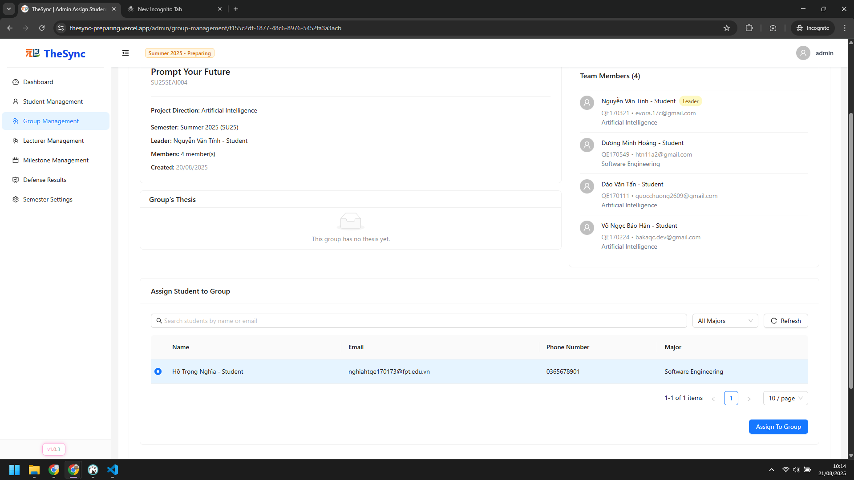

###### Figure VI.C.2.f - Assign without group - Step 3

### Workflow 2

#### Role: Student (Leader)

* Choose thesis (Manual or AI suggest)
* Step 1: Click `List Thesis` on sidebar  
  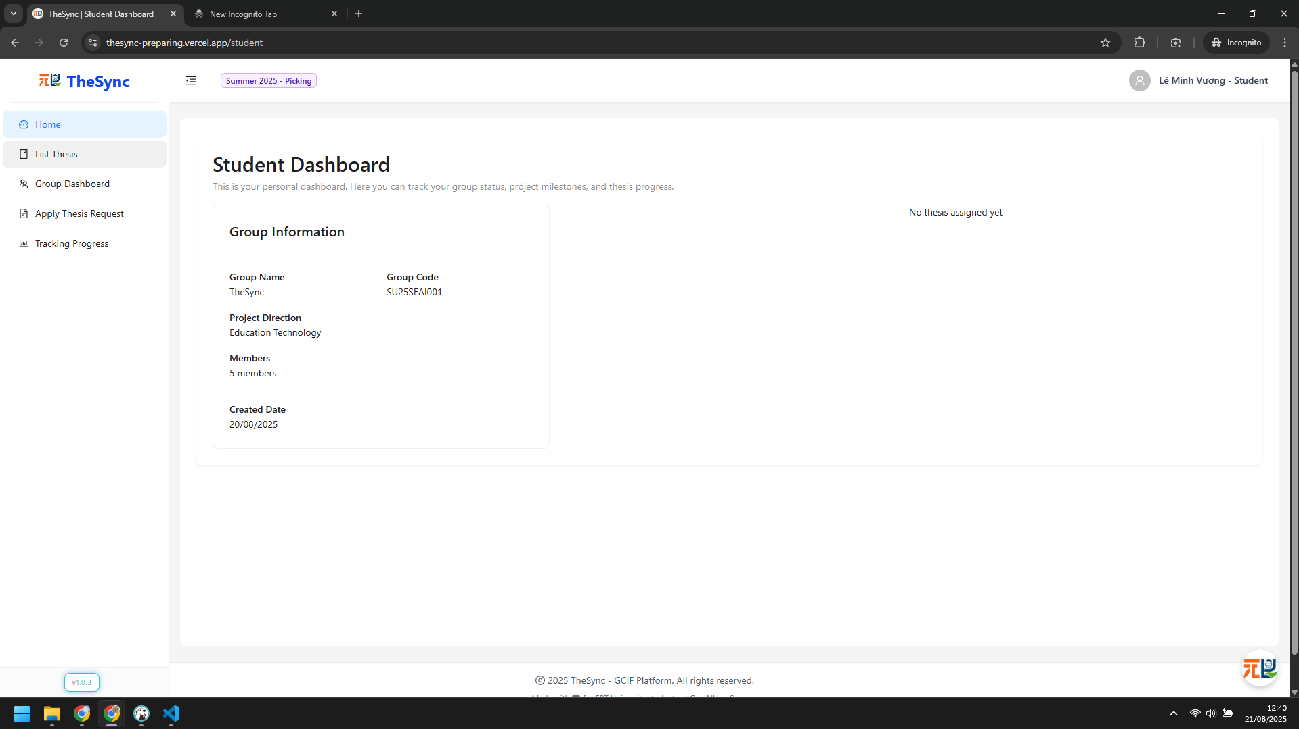

###### Figure VI.C.3.a - Choose thesis - Step 1

* Step 2: Click `Apply Thesis` and choose `Submit Application` button  
  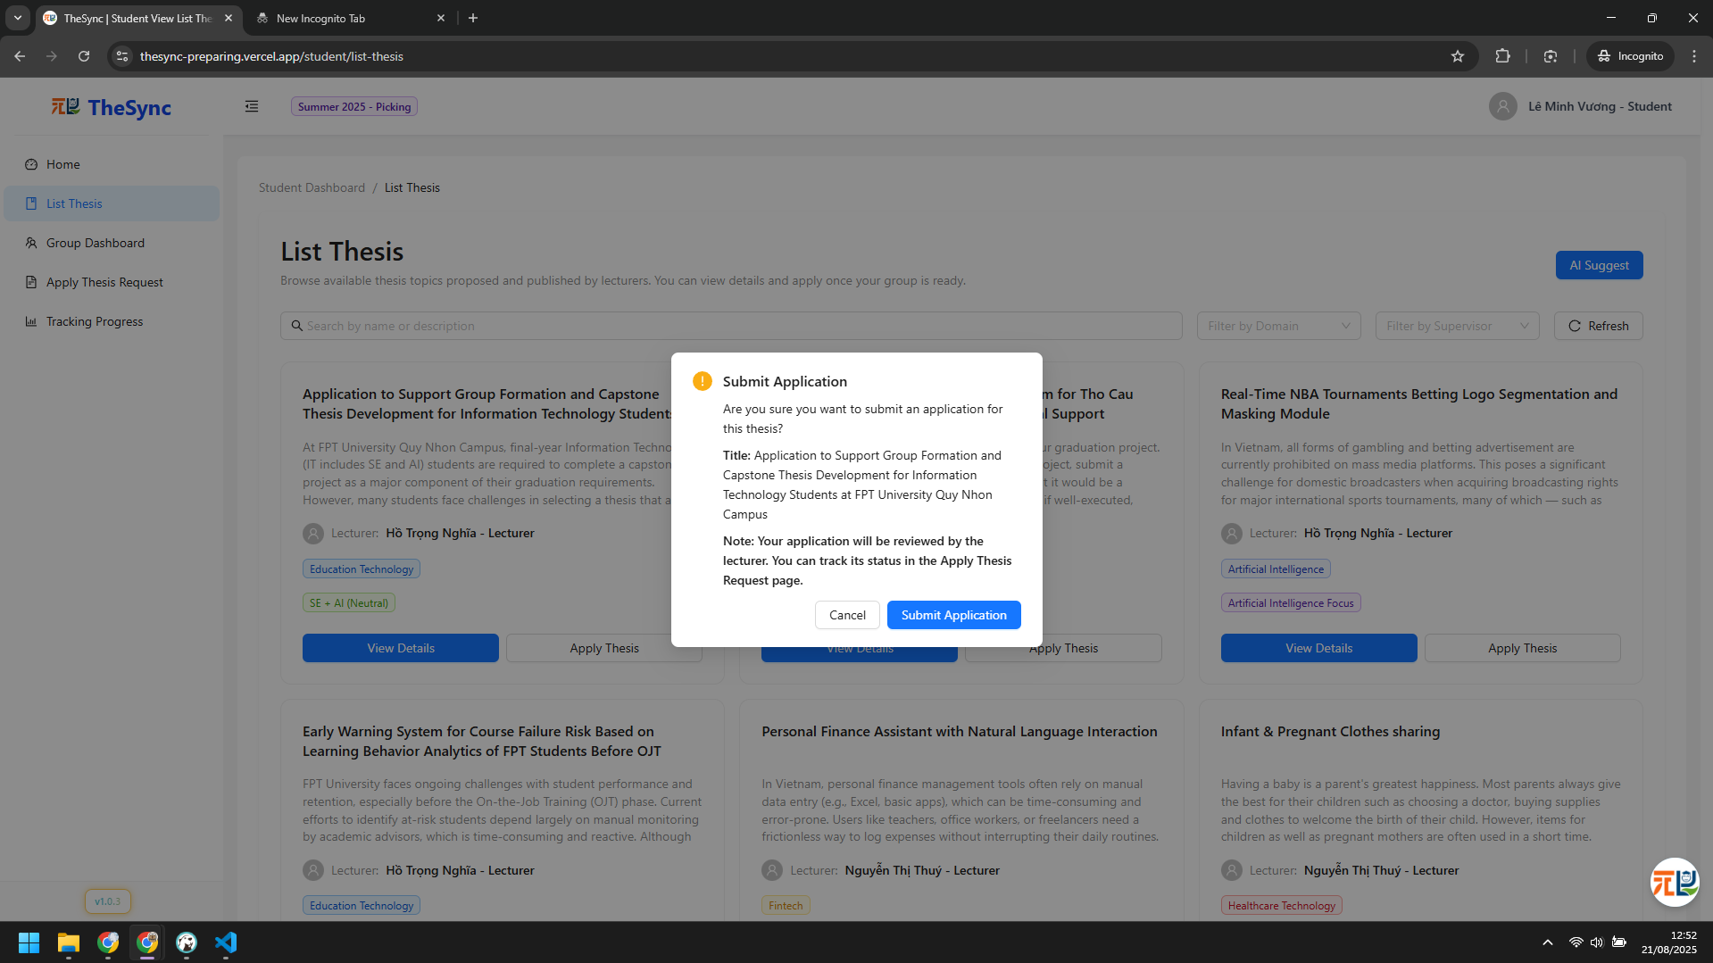

###### Figure VI.C.3.a - Choose thesis - Step 2

* Step 3: Click `Ai Suggest` button to use AI suggestion, result below  
  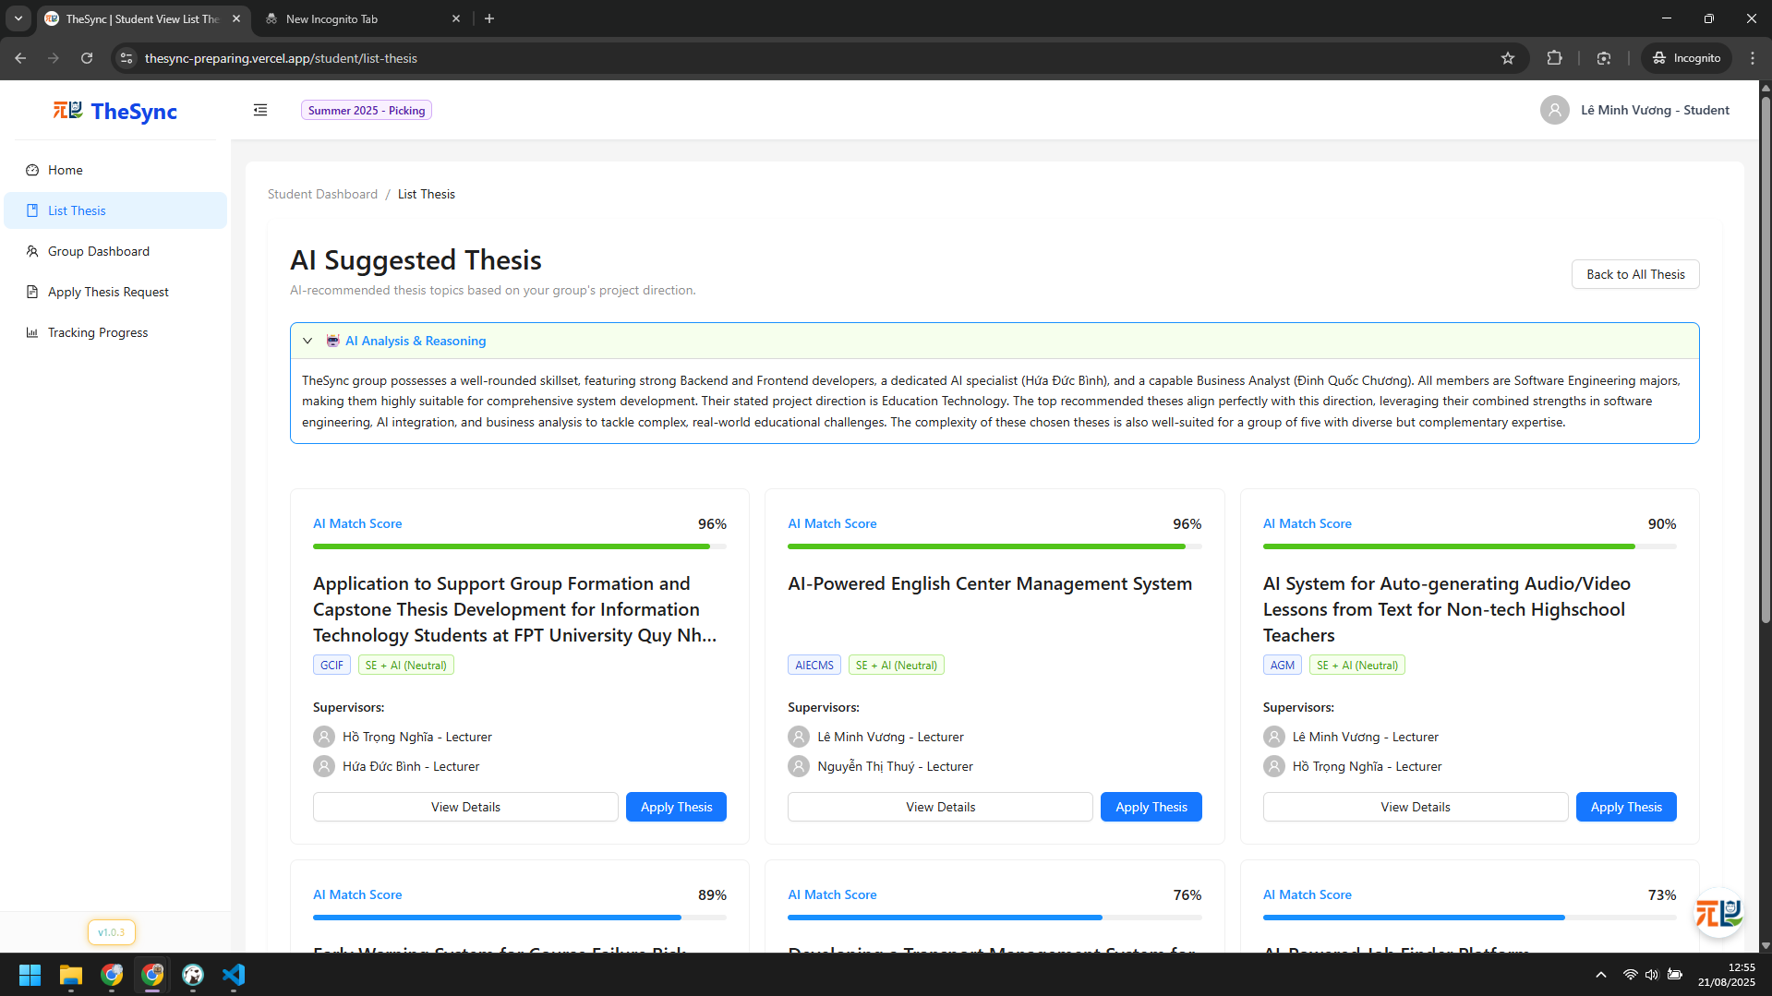

###### Figure VI.C.3.a - Choose thesis - Step 3

* Send request to supervisors for applying thesis
* Step 1: Choose `Apply Thesis Request` on sidebar  
  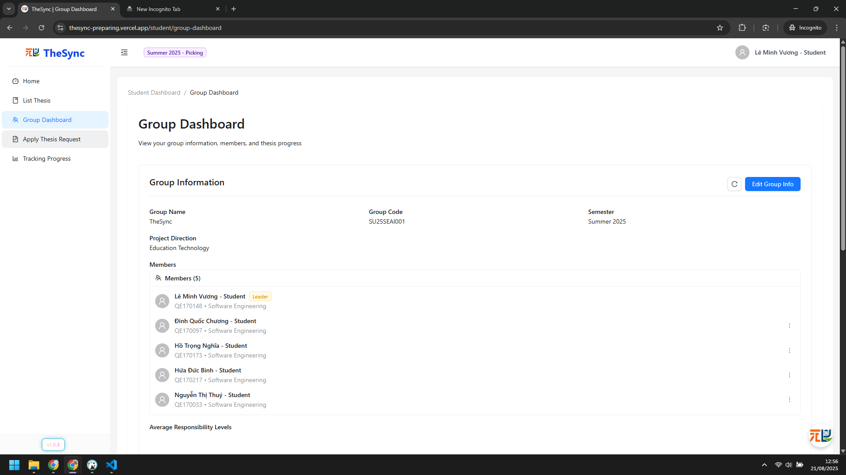

###### Figure VI.C.3.a - Send request to supervisors for applying thesis - Step 1

* Step 2: Result  
  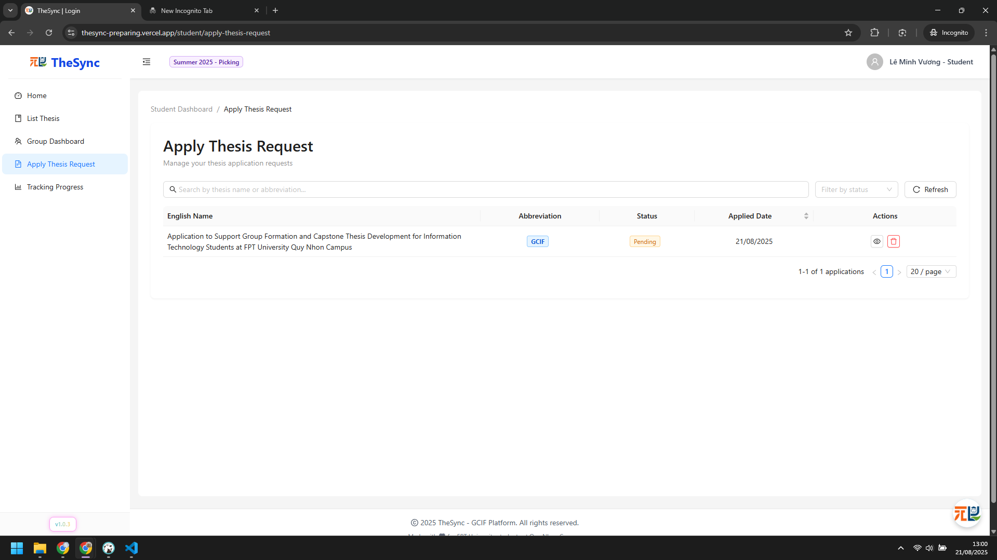

###### Figure VI.C.3.a - Send request to supervisors for applying thesis - Step 2

#### Role: Lecturer (Supervisor)

* Approval / Reject requests from groups
* Step 1: Click `Request Apply Thesis` on sidebar  
  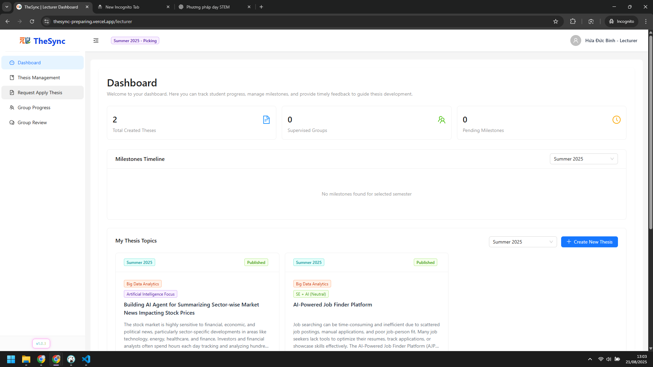

###### Figure VI.C.3.b - Approval / Reject requests from groups - Step 1

* Step 2: Click `View Requests` button  
  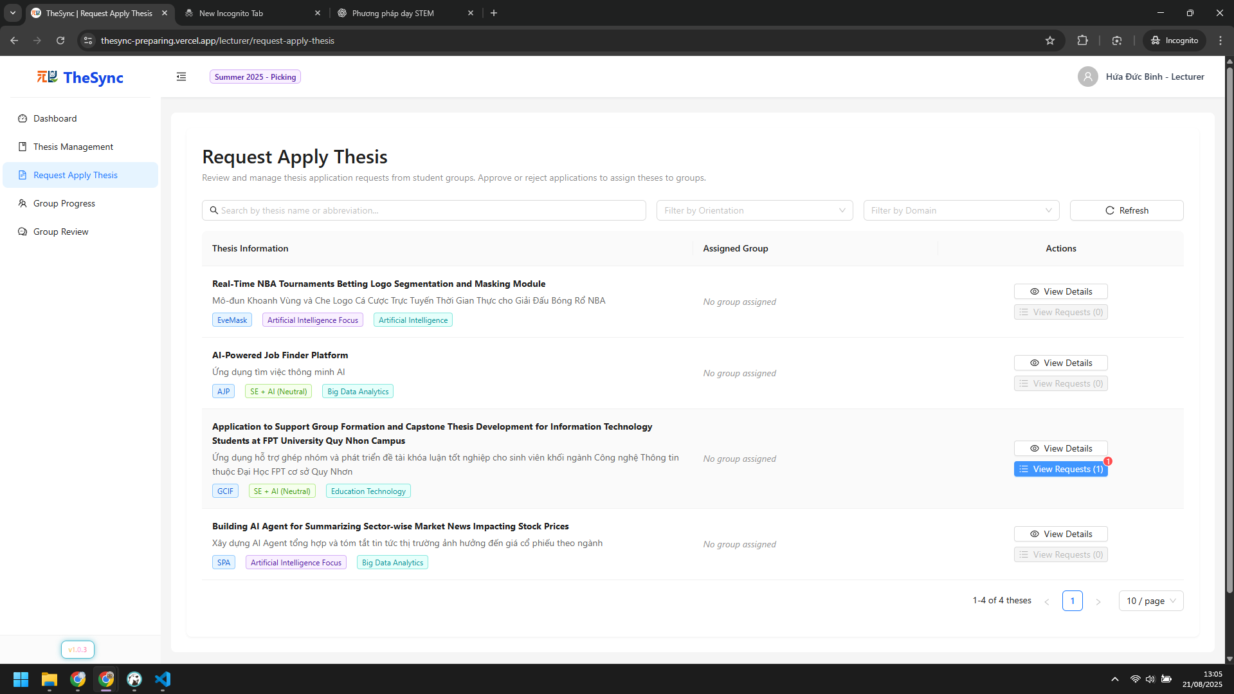

###### Figure VI.C.3.b - Approval / Reject requests from groups - Step 2

* Step 3: Click `Approve` or `Reject` button  
  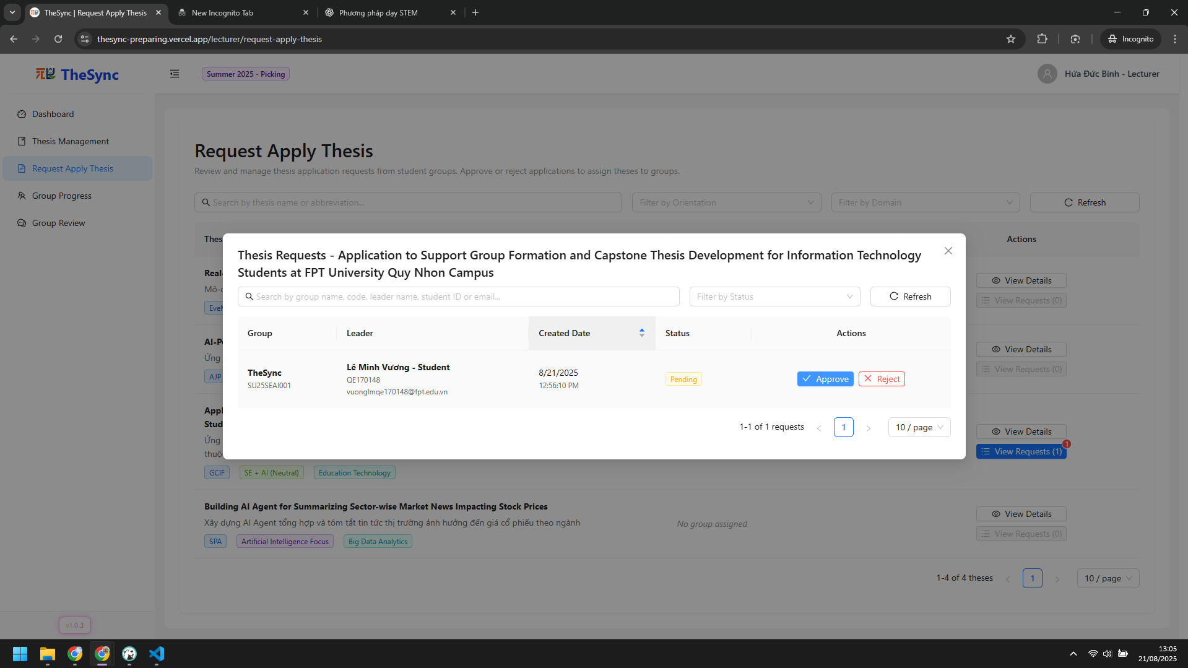

###### Figure VI.C.3.b - Approval / Reject requests from groups - Step 3

### Workflow 3

#### Role: Admin

* Create milestones
* Step 1: Click `Milestone Management` on sidebar  
  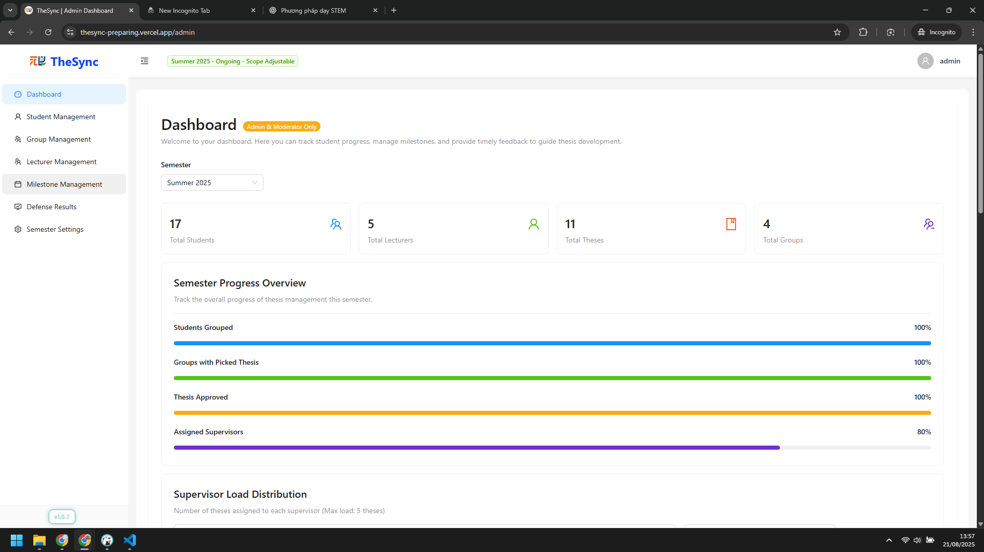

###### Figure VI.C.4.a - Create milestones - Step 1

* Step 2: Enter milestone information and click `Create New Milestone` button  
  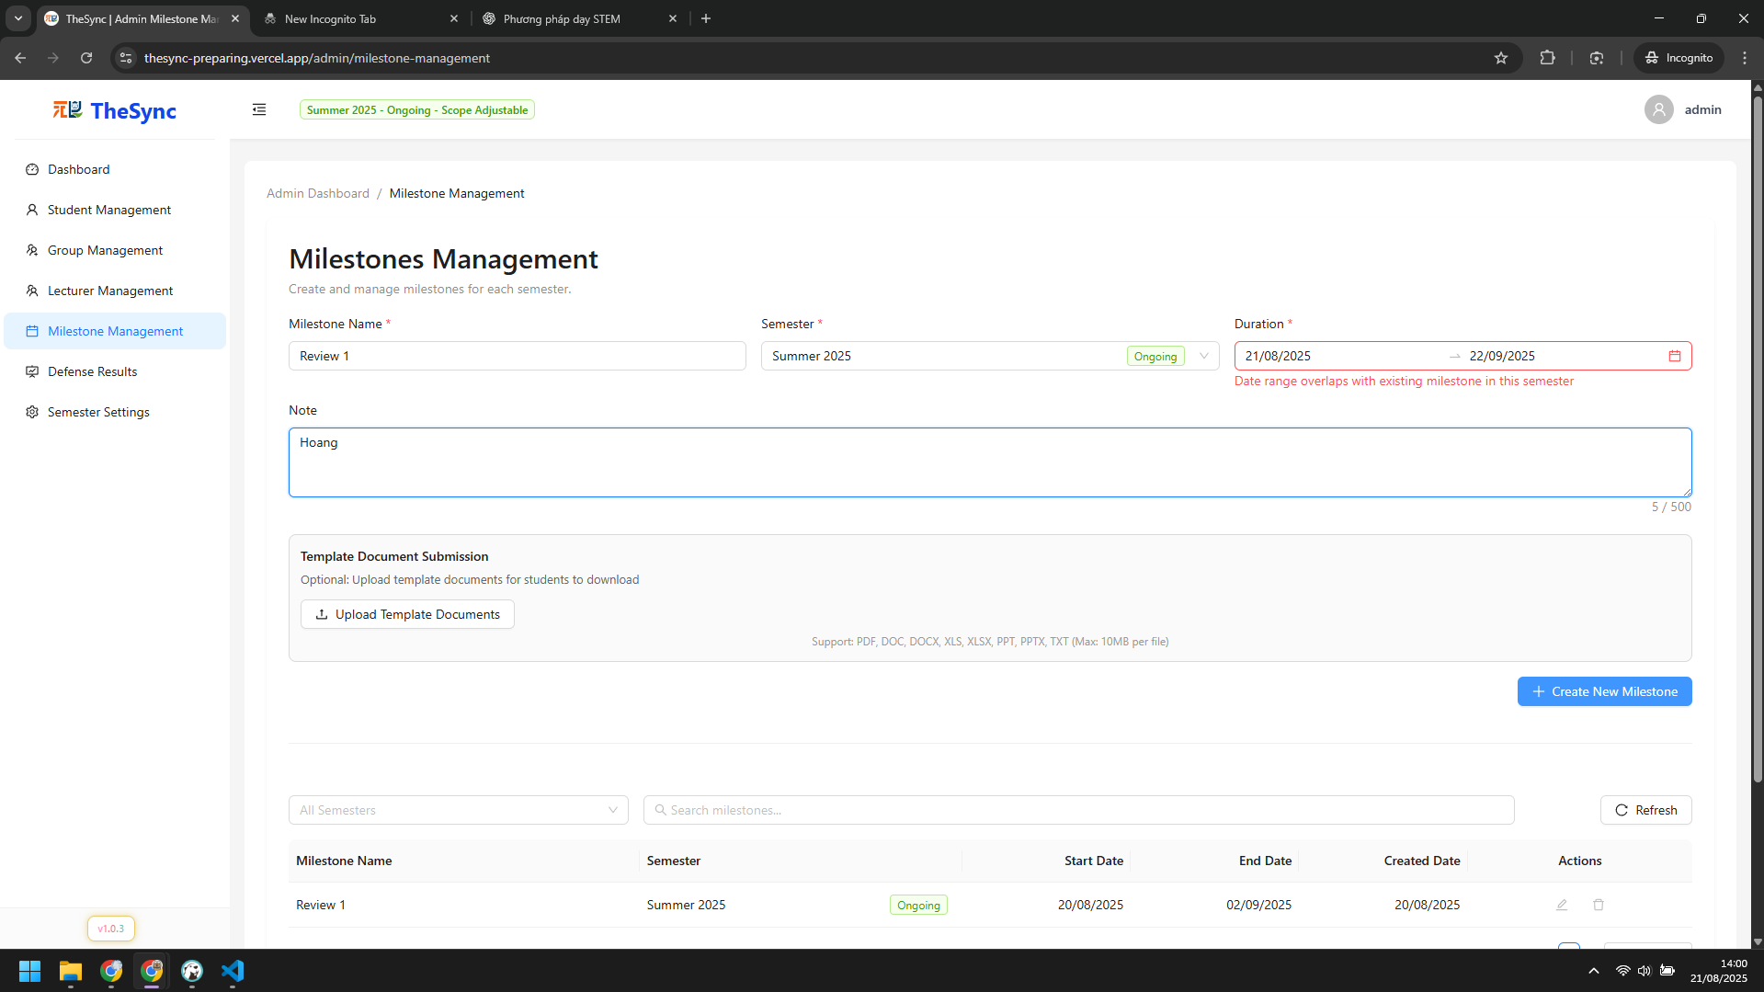

###### Figure VI.C.4.a - Create milestones - Step 2

#### Role: Moderator

* Create checklists for reviewing
* Step 1: Click `Checklist Management` on sidebar, result below  
  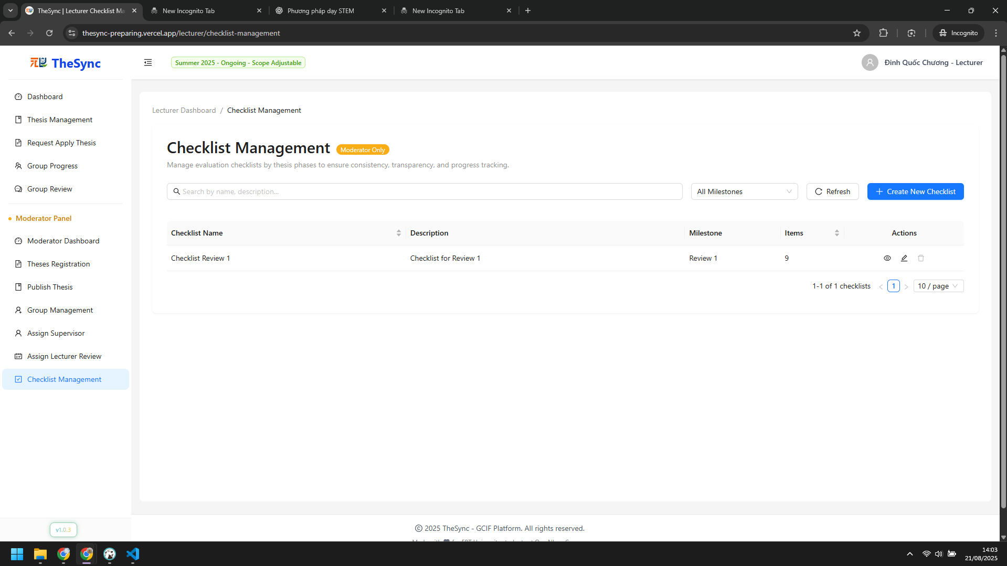

###### Figure VI.C.4.b - Create checklists for reviewing - Step 1

* Step 2: Click `Create New Checklist` button  
  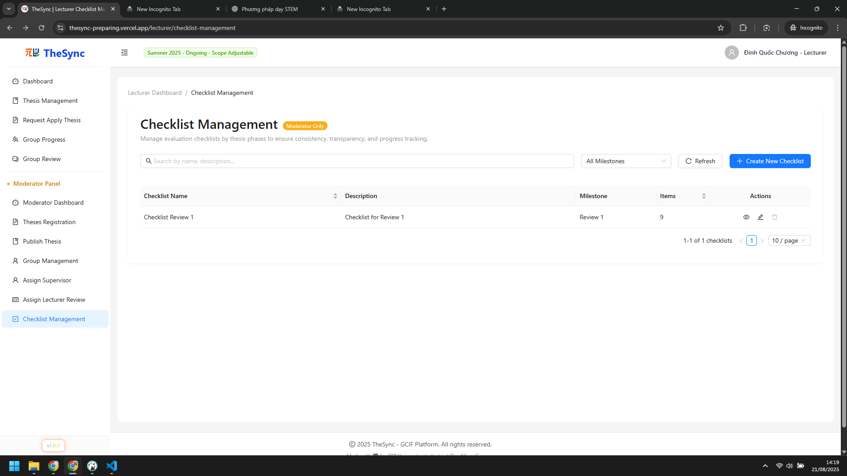

###### Figure VI.C.4.b - Create checklists for reviewing - Step 2

* Step 3: Enter checklist information and checklist items, then click `Save All` button  
  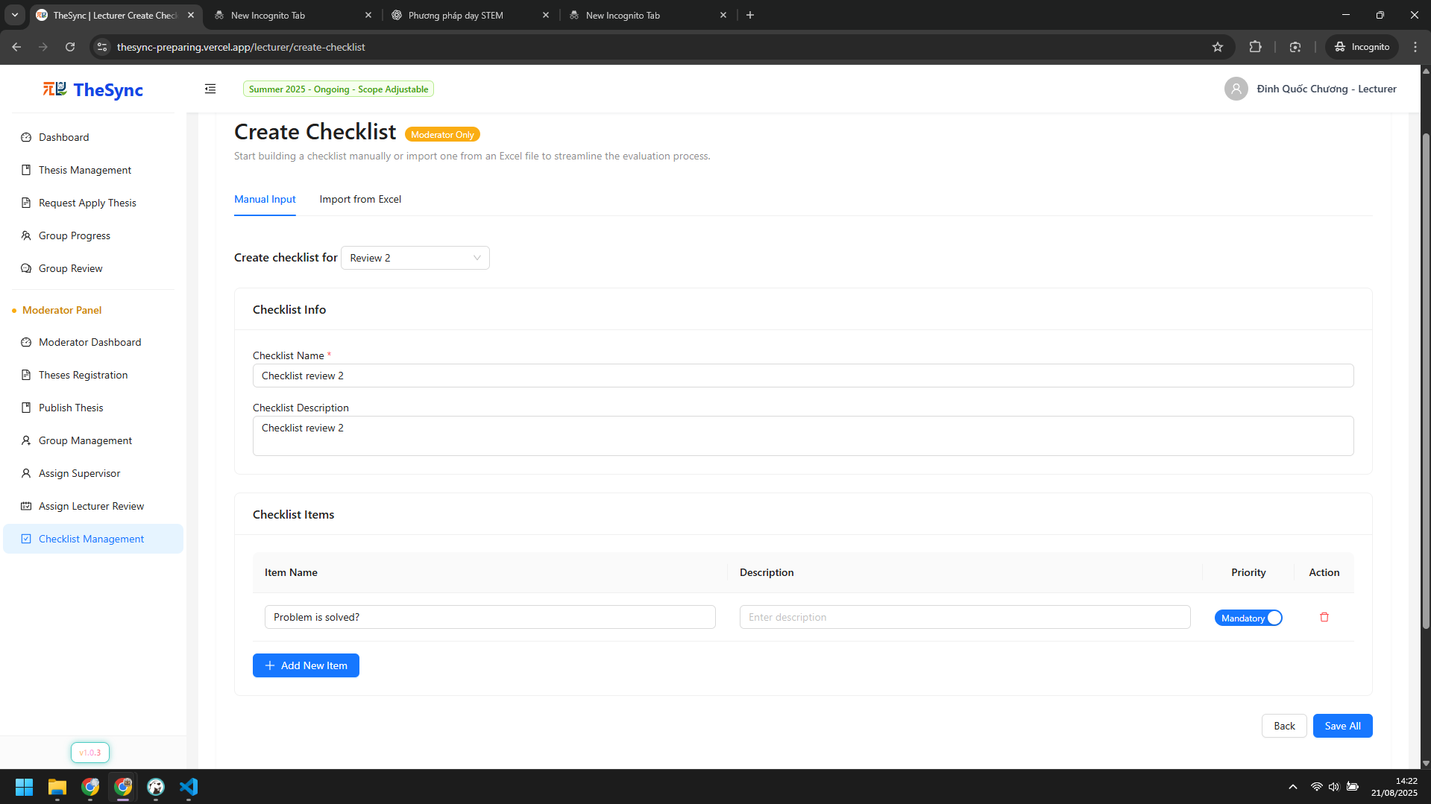

###### Figure VI.C.4.b - Create checklists for reviewing - Step 3

* Assign lecturers for each group in each milestone
* Step 1: Click `Assign Lecturer Review` on sidebar  
  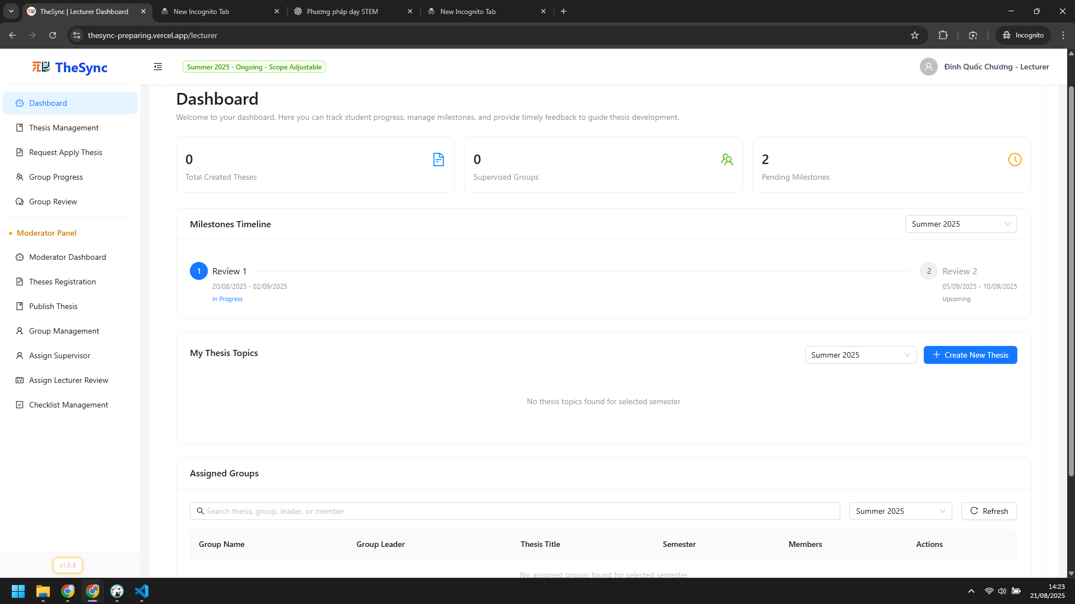

###### Figure VI.C.4.b - Assign lecturers for each group in each milestone - Step 1

* Step 2: Click `Assign` button for each group  
  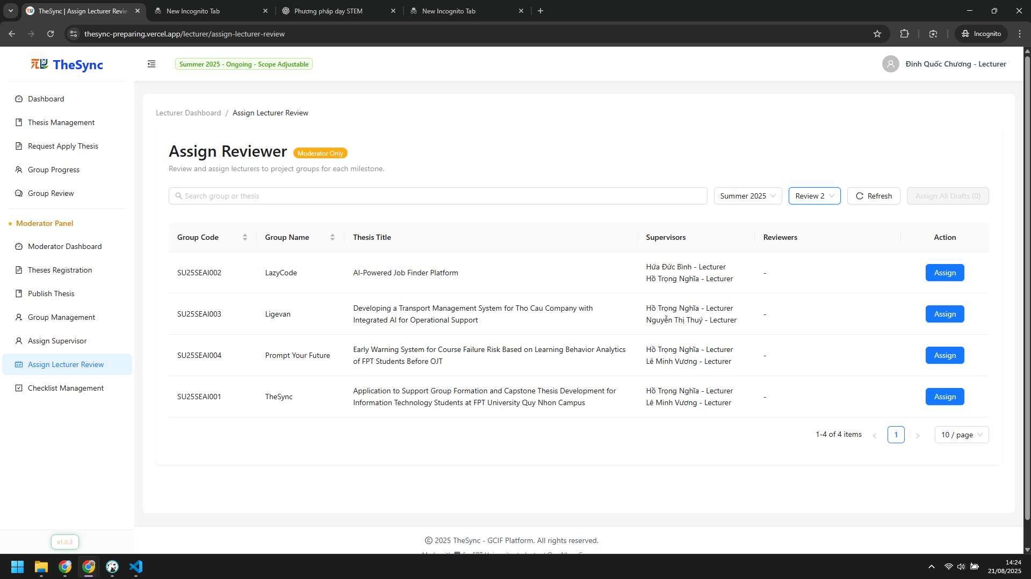

###### Figure VI.C.4.b - Assign lecturers for each group in each milestone - Step 2

* Step 3: Choose lecturer to review and click `Assign` button  
  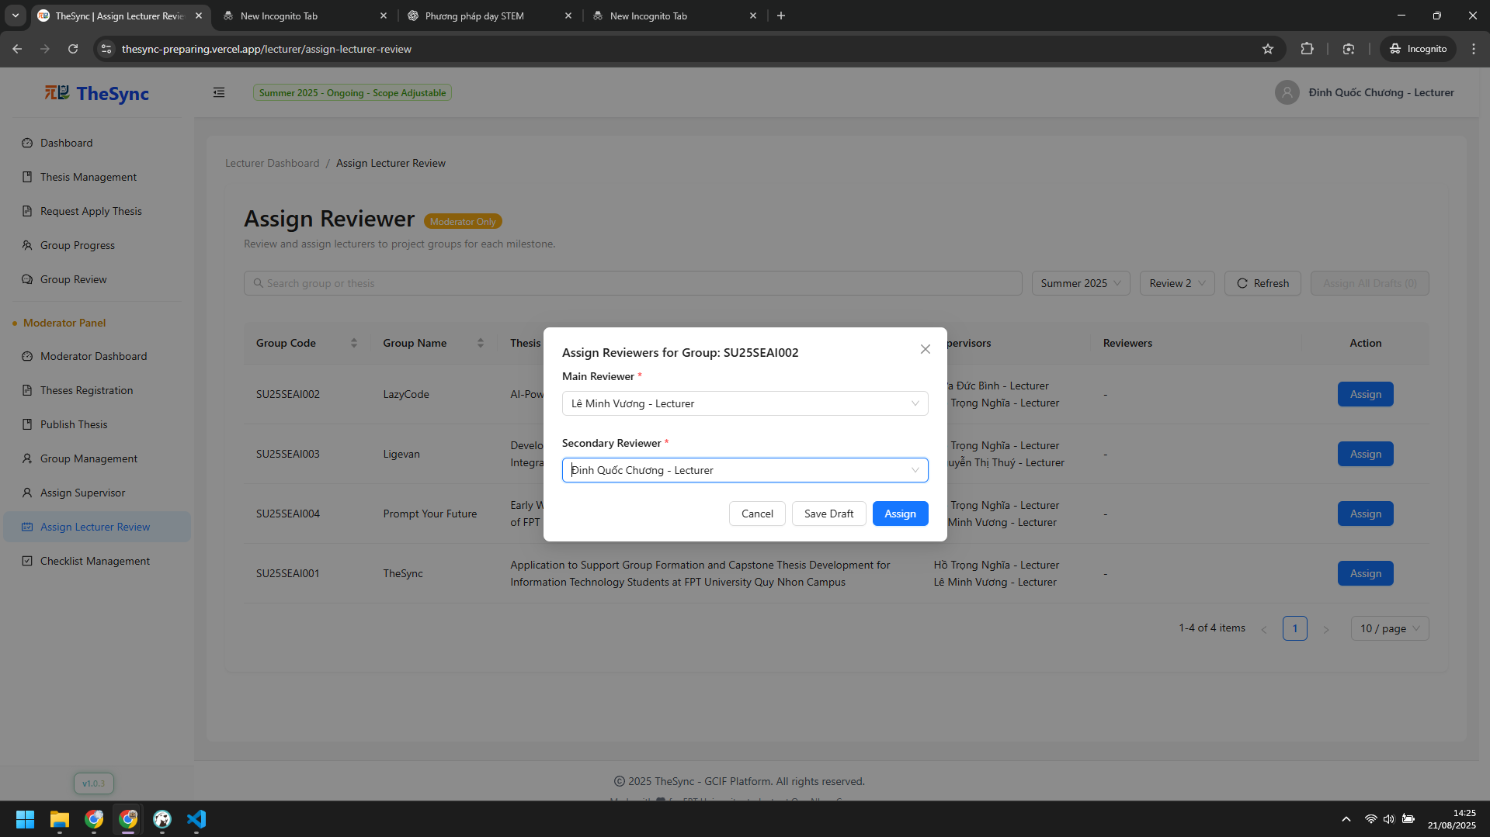

###### Figure VI.C.4.b - Assign lecturers for each group in each milestone - Step 3

#### Role: Student (Leader)

* Submit deliverables
* Step 1: Click `Tracking Process` on sidebar  
  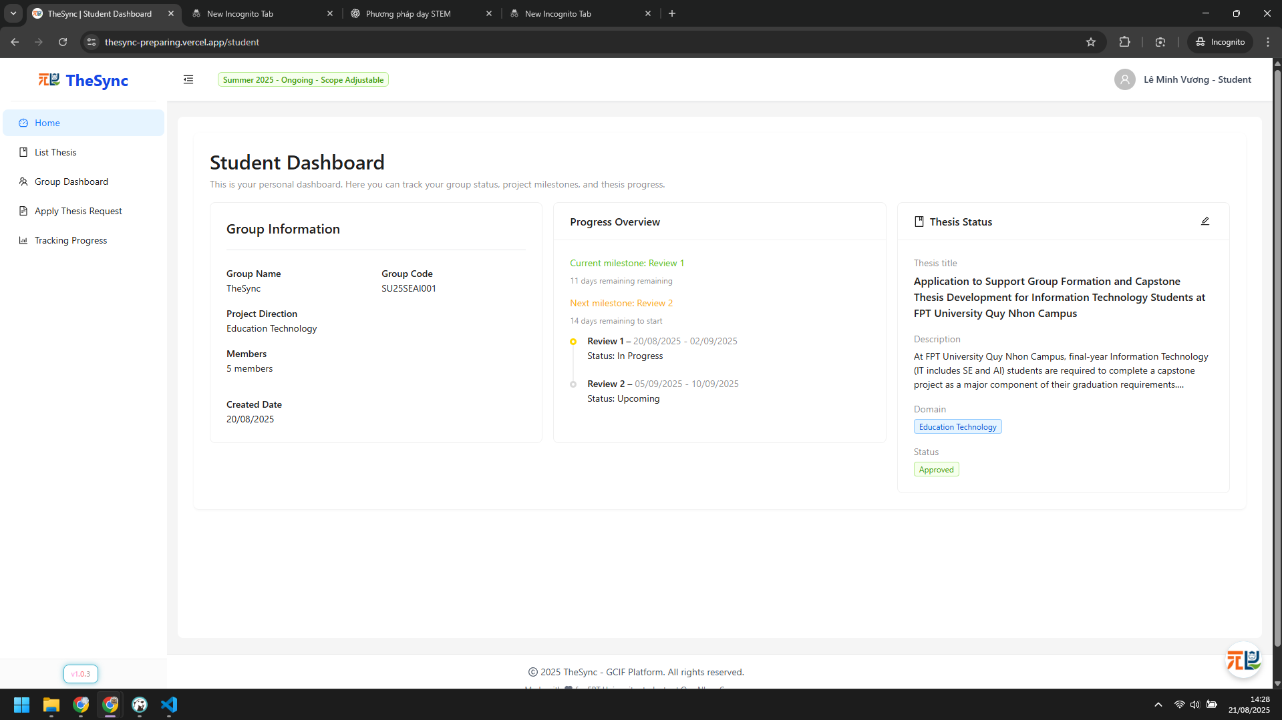

###### Figure VI.C.4.c - Submit deliverables - Step 1

* Step 2: Drag files and click `Submit Milestone` button  
  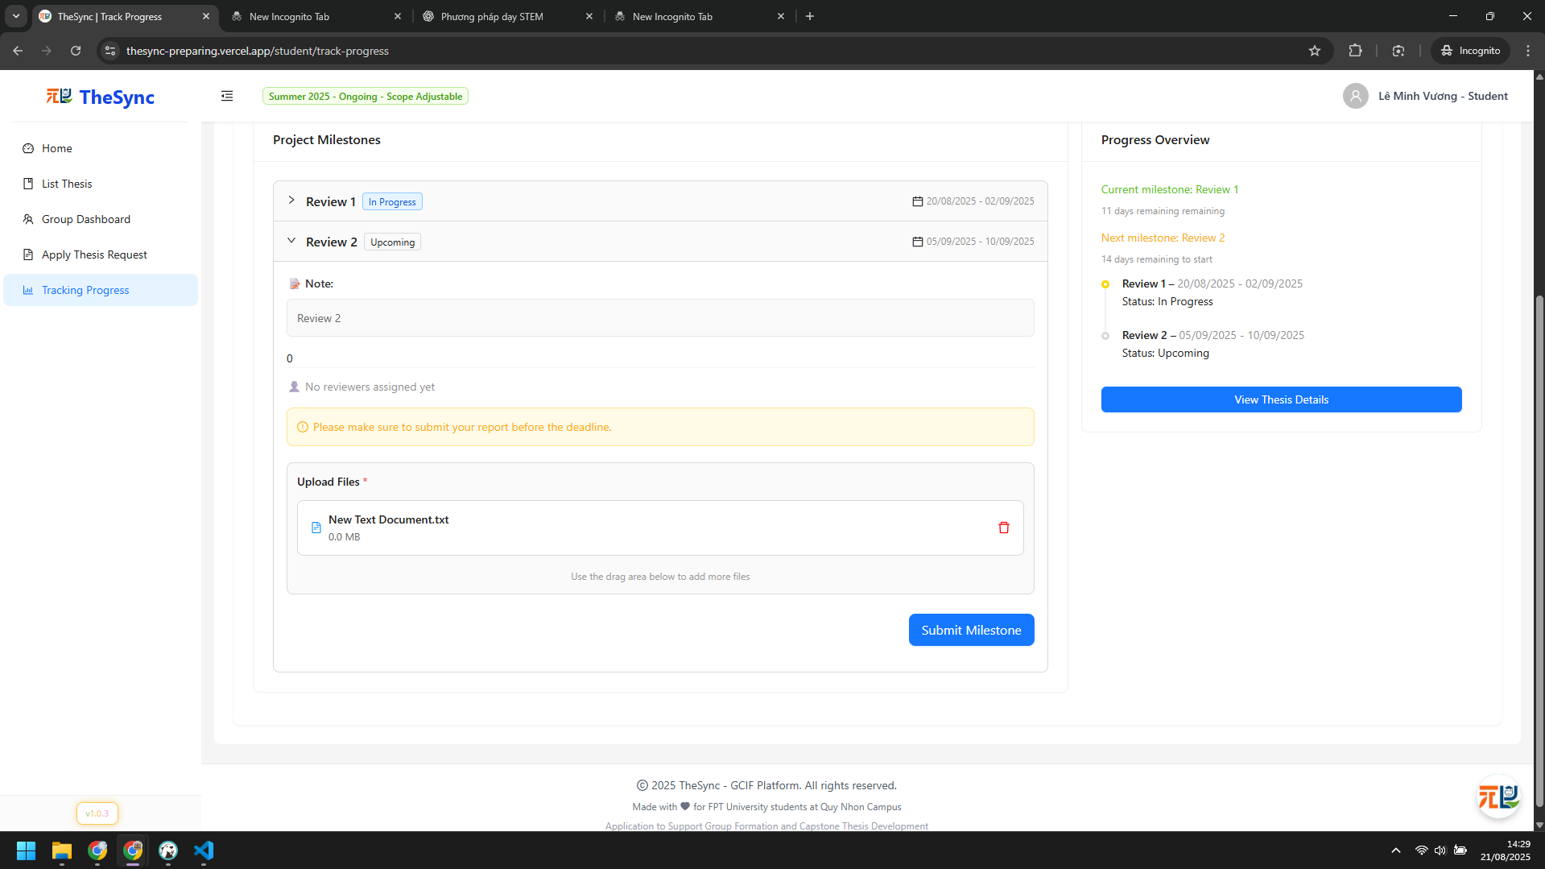

###### Figure VI.C.4.c - Submit deliverables - Step 2

#### Role: Lecturer

* Review, submit checklist review and feedback
* Step 1: Click `Group Review` on sidebar  
  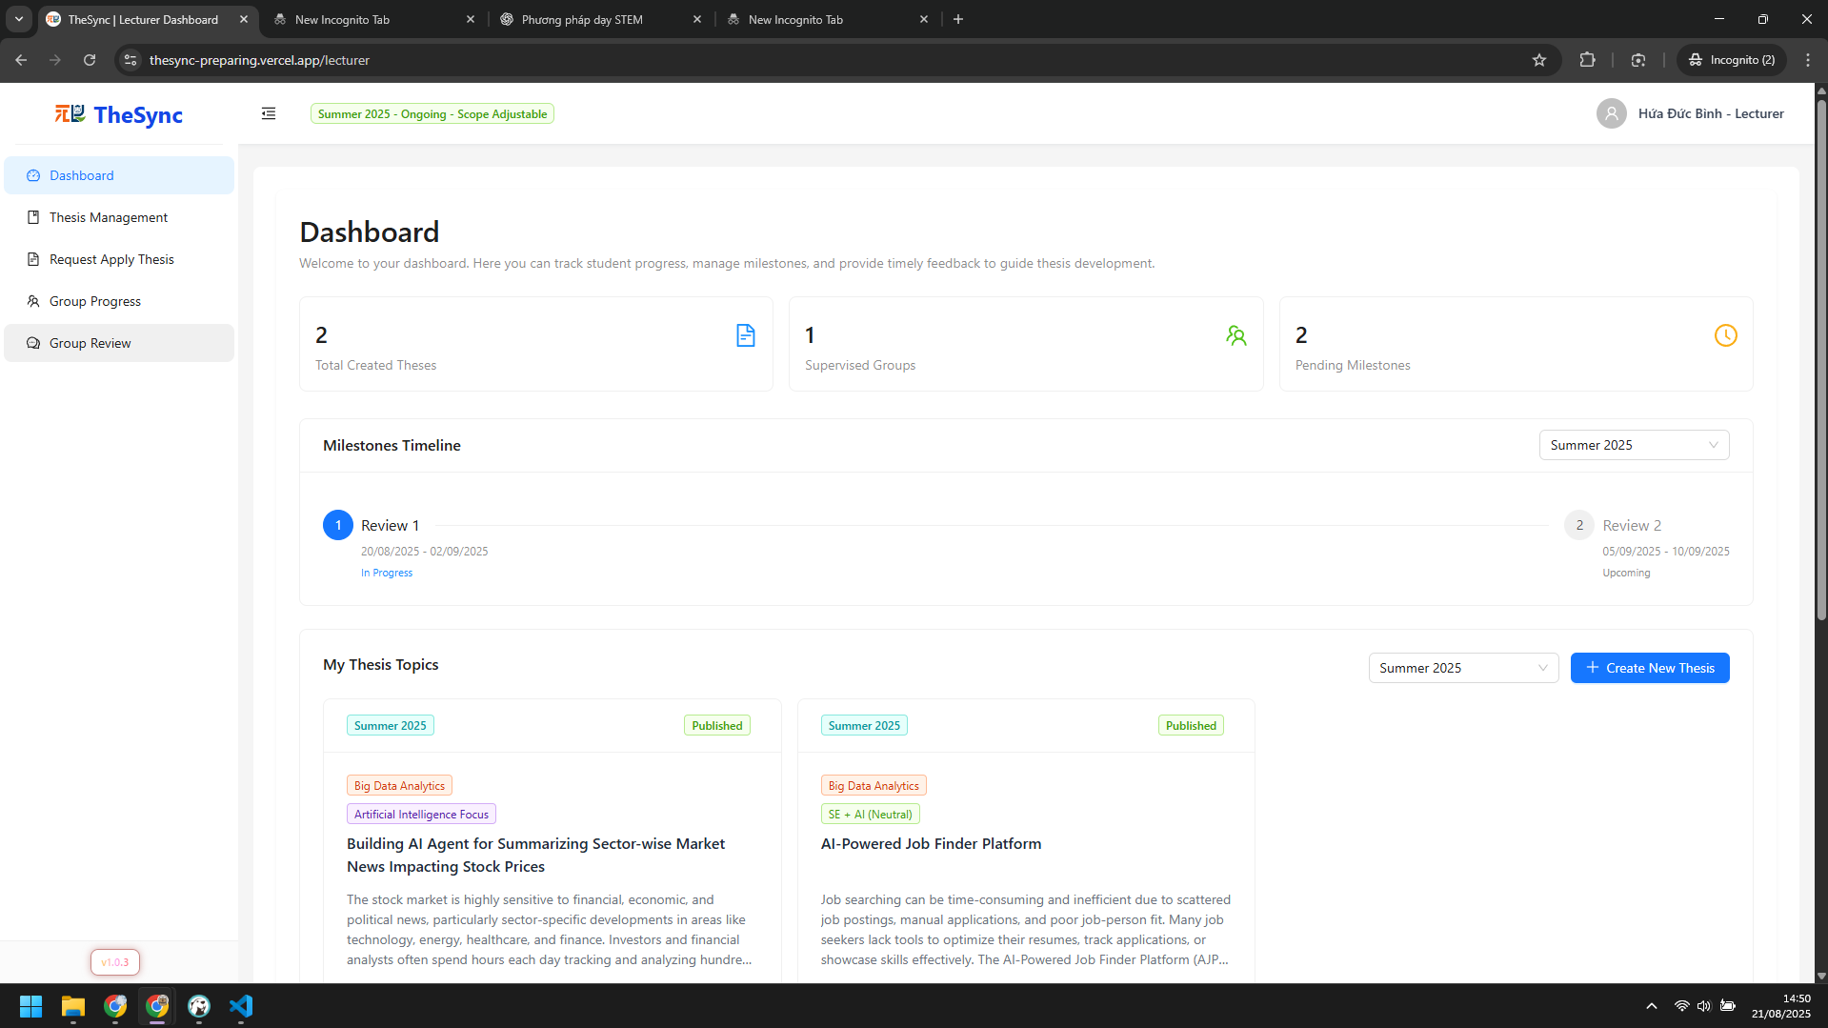

###### Figure VI.C.4.d - Review, submit checklist review and feedback - Step 1

* Step 2: Choose a group to review  
  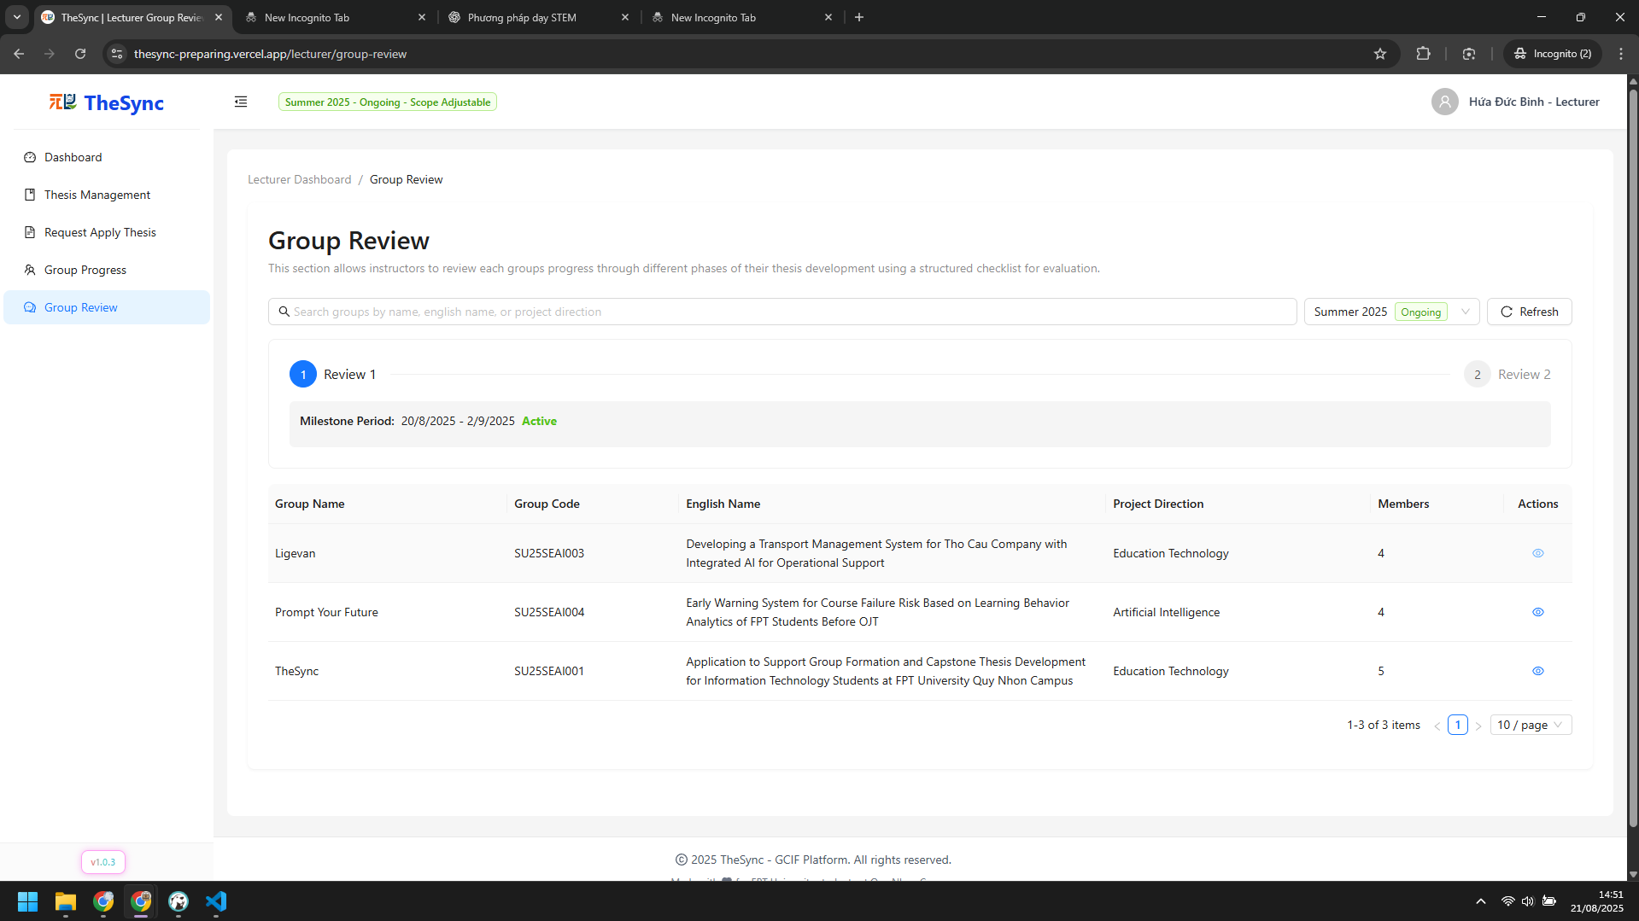

###### Figure VI.C.4.d - Review, submit checklist review and feedback - Step 2

* Step 3: Review and click `Submit Review` button to submit  
  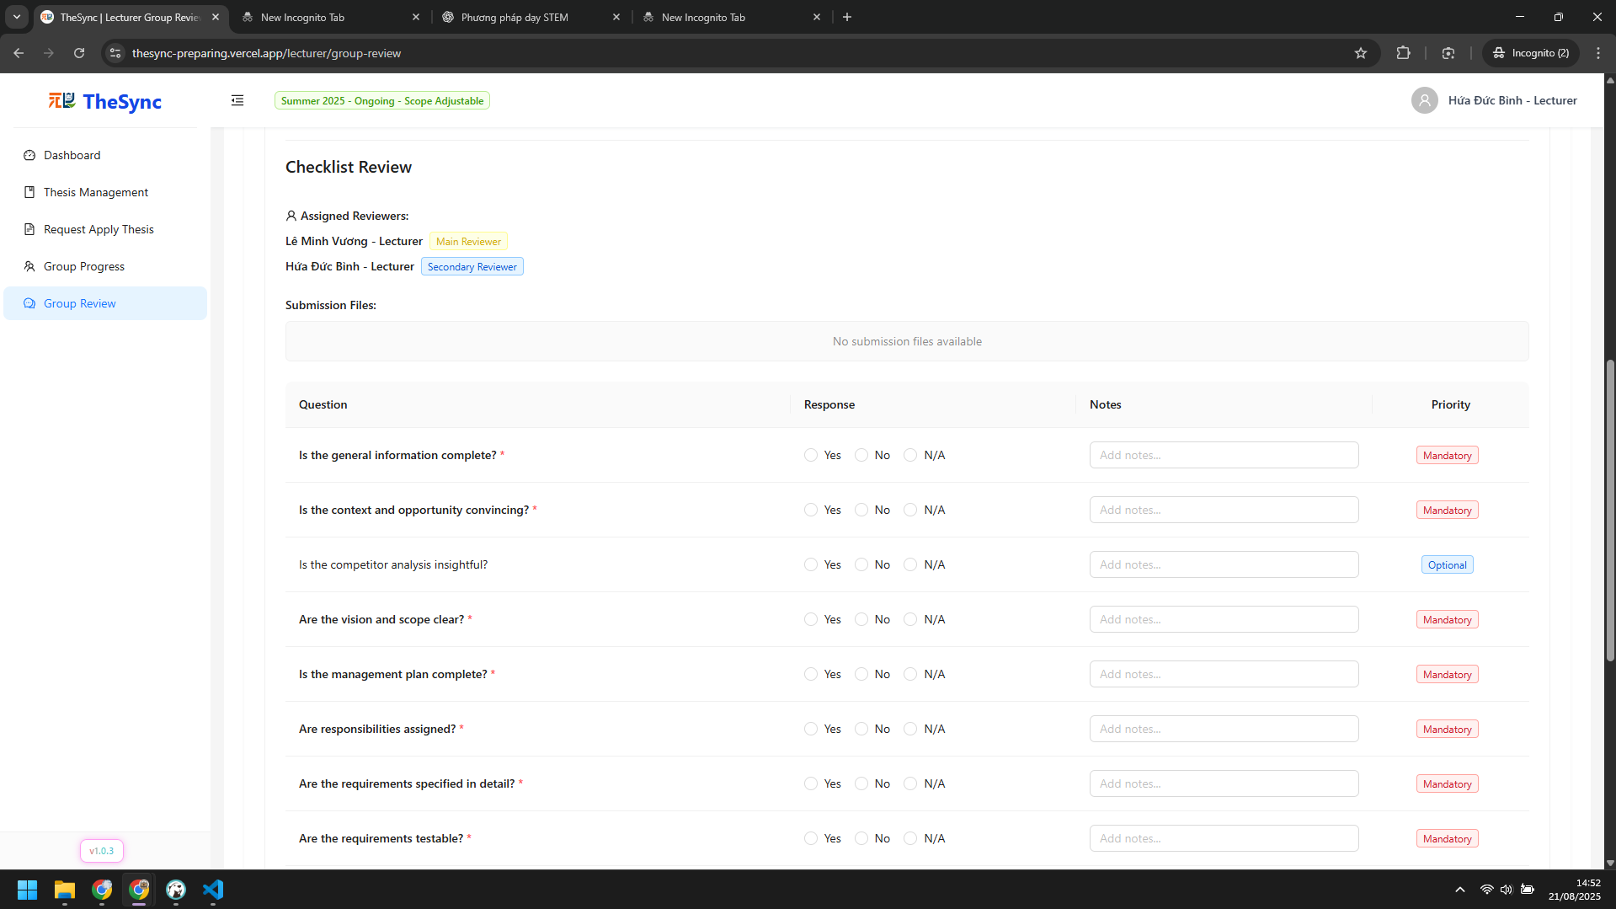

###### Figure VI.C.4.d - Review, submit checklist review and feedback - Step 3

#### Role: Admin

* Export thesis registration file
* Step 1: In dashboard, click `Export Excel` button  
  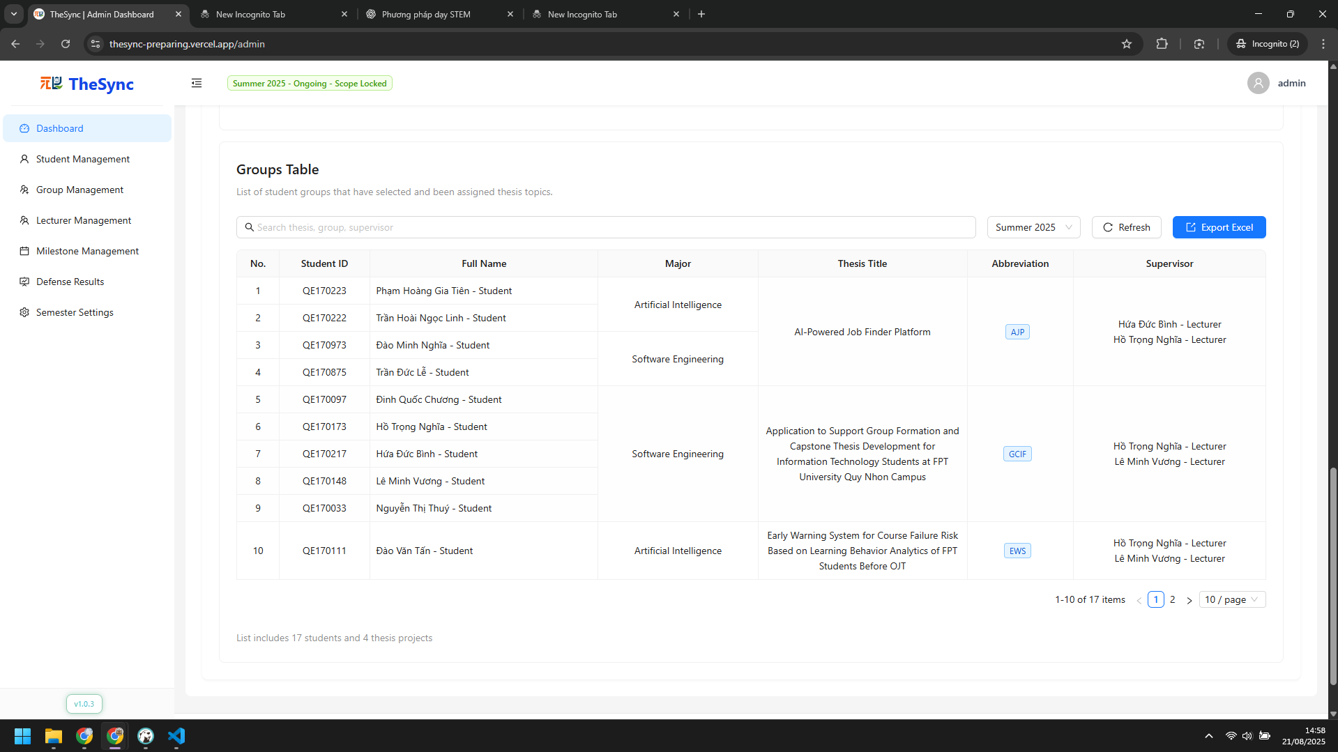

###### Figure VI.C.4.e - Export thesis registration file - Step 1

* Update defense results for all students
* Step 1: Click `Defense Results` on sidebar  
  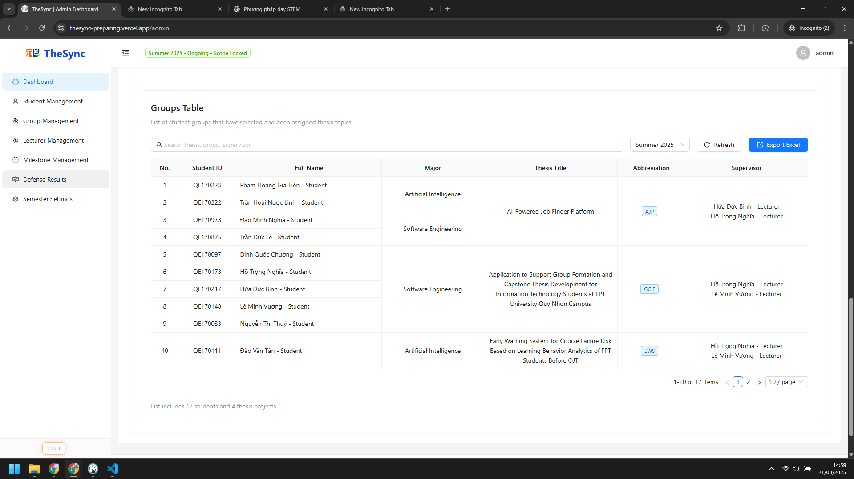

###### Figure VI.C.4.e - Update defense results for all students - Step 1

* Step 2: Choose Pass or Failed for each student  
  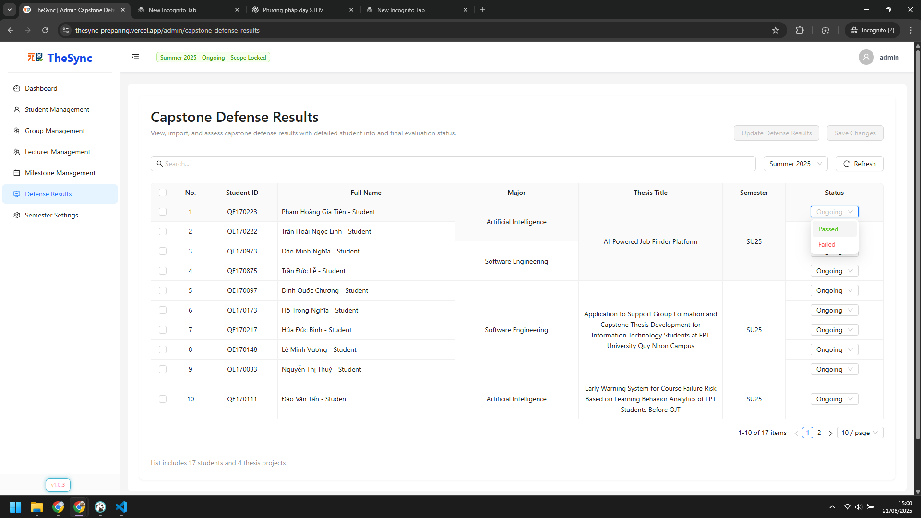

###### Figure VI.C.4.e - Update defense results for all students - Step 2

* Step 3: Click `Save changes` button to save  
  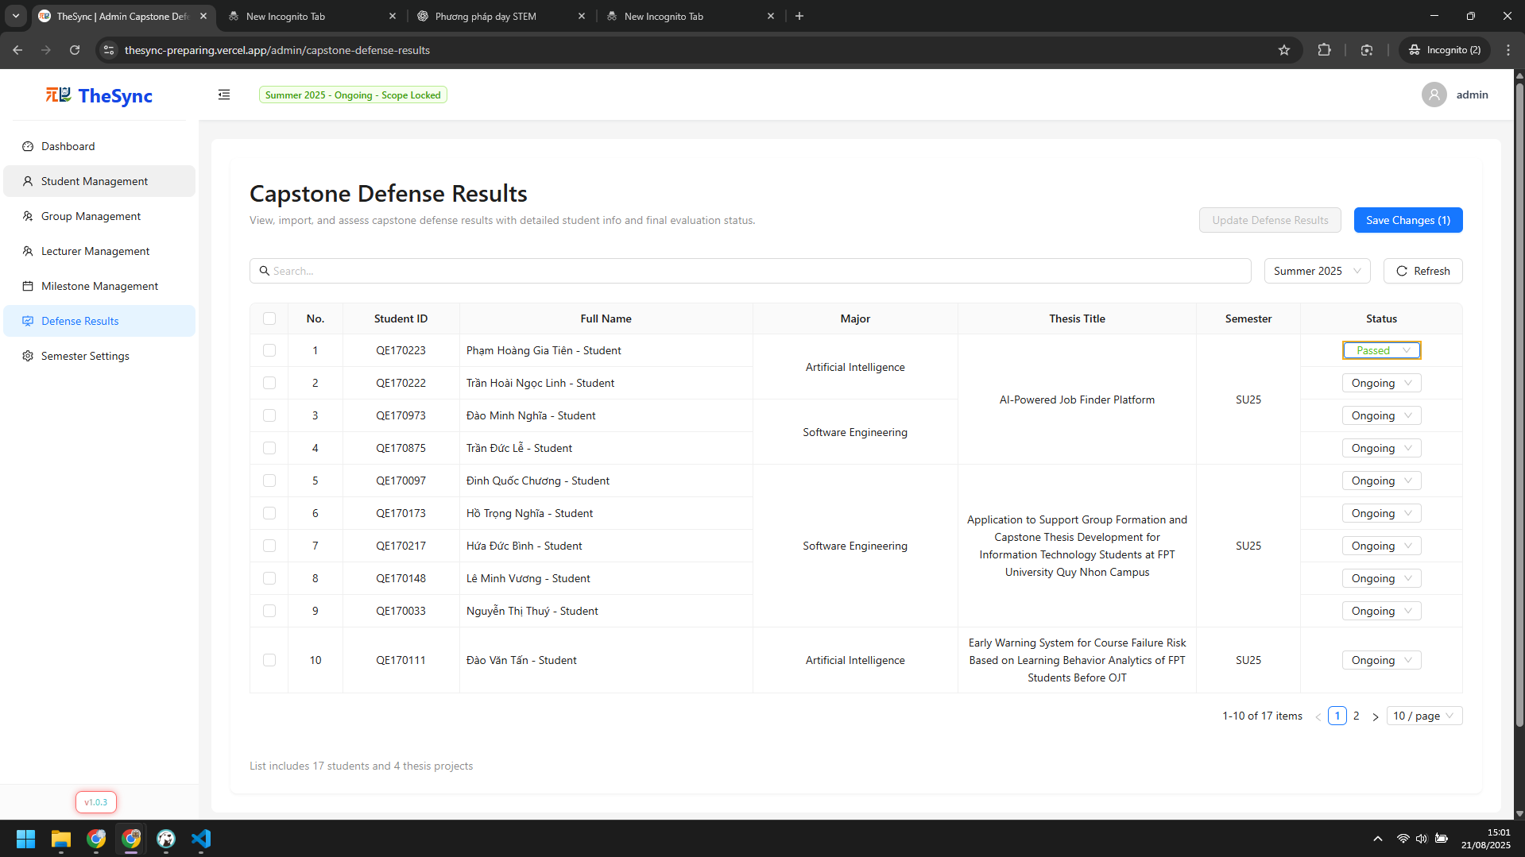

###### Figure VI.C.4.e - Update defense results for all students - Step 3